|  |  |  |
| --- | --- | --- |
| ../ama%20university.png../AMAOEd.png | Course Code | Type Course Code Here |
| Description | Computer Programming 2 |
| College / Department:  **Online Education** | Laboratory  Exercise No. | 004 |
| **LABORATORY EXERCISE** | | Page 1 of 3 |



**Instructions:**

• Upload your solution to the link provided on the course page.

• You may submit the java file, or the rar or zip file.

• For the java file, your filename must be in this format: Lab4_<lastname_firstname>.java

Example: **Lab4_Blanco_Maria.java**

• For multiple java files, save them into one folder. The folder name should be in this format:

Lab4_<lastname_firstname>, Example: **Lab4_Blanco_Maria**

Compress the folder into .rar or .zip format before uploading.

• For projects created using NetBeans, the project name should be in this format:

Lab4_<lastname_firstname>, Example: **Lab4_Blanco_Maria**

Compress the project folder into .rar or .zip format before uploading.

• **DO NOT SUBMIT THE WORD FILE. Failure to follow the instructions will mean a deduction**

**from your score.**

Write the program base on the given instructions.

**1. Exam Program**

Create a program that allows the user to take exam. The exam should have 5 questions (You can ask any questions). The questions are in multiple choice form and the choices are numbers. The program will display the questions one by one, and then the user can enter the correct number that corresponds to his answer. Every time the user answers question the program will check if it is correct, if the answer is correct the program will print "Correct!" otherwise it will display "Incorrect!" and the correct answer. Once the user is done with all the questions, the program will display the score and the equivalent percentage that the user got. For example:

|  |  |  |
| --- | --- | --- |
| ../ama%20university.png../AMAOEd.png | Course Code | Type Course Code Here |
| Description | Computer Programming 2 |
| College / Department:  **Online Education** | Laboratory  Exercise No. | 004 |
| **LABORATORY EXERCISE** | | Page 2 of 3 |

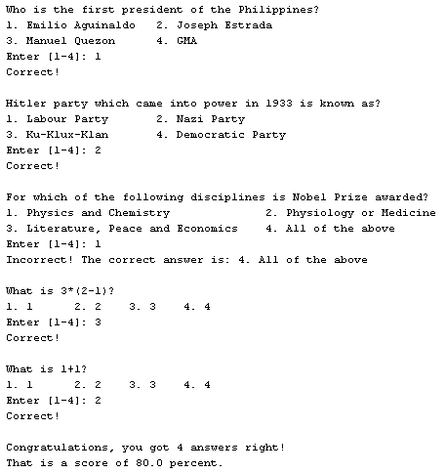

**2. Factorial**

Create a program that computes for the factorial of a number. Factorial is the product of an integer and all the integers below it; e.g., factorial four ( 4! ) is equal to 24 (4*3*2*1=24). The factorial of 0 and 1 is 1. Negative values are invalid input. The program should display an error message and should loop back to data entry when an invalid input is encountered.

Sample Output:





|  |  |  |
| --- | --- | --- |
| ../ama%20university.png../AMAOEd.png | Course Code | Type Course Code Here |
| Description | Computer Programming 2 |
| College / Department:  **Online Education** | Laboratory  Exercise No. | 004 |
| **LABORATORY EXERCISE** | | Page 3 of 3 |

**3. Number to Words**

Create a program that converts number to words. The program will prompt the user to input a number and display the equivalent number in words. The program can accept numbers from 1 to 100,000. Negative numbers, zero and numbers greater than 100,000 are invalid input. The program should display the message “Number is out of range!” should loop back to data entry when an invalid input is encountered.

Sample Output:





**4. Print Half Pyramid using \***

Create a program that prints half pyramid using *. The program will prompt the user to input a number, the user’s input will be the number of * that will serve as the base of the half pyramid. Values less than 2 are invalid input. The program should display an error message and should loop back to data entry when an invalid input is encountered.

Sample Output:

