|  |  |  |
| --- | --- | --- |
| ../ama%20university.png../AMAOEd.png | Course Code | Type Course Code Here |
| Description | Computer Programming 2 |
| College / Department:  **Online Education** | Laboratory  Exercise No. | 005 |
| **LABORATORY EXERCISE** | | Page 1 of 5 |



**Instructions:**

• Upload your solution to the link provided on the course page.

• You may submit the java file, or the rar or zip file.

• For the java file, your filename must be in this format: Lab5_<lastname_firstname>.java

Example: **Lab5_Blanco_Maria.java**

• For multiple java files, save them into one folder. The folder name should be in this format:

Lab5_<lastname_firstname>, Example: **Lab5_Blanco_Maria**

Compress the folder into .rar or .zip format before uploading.

• For projects created using NetBeans, the project name should be in this format:

Lab5_<lastname_firstname>, Example: **Lab5_Blanco_Maria**

Compress the project folder into .rar or .zip format before uploading.

• **DO NOT SUBMIT THE WORD FILE. Failure to follow the instructions will mean a deduction**

**from your score.**

Write the program base on the given instruction as shown below

1. **Minimum and Maximum Number in the Array**

Create a program that displays the minimum and maximum number to the elements stored in the array. You are required to use an array and loop statement for this activity.

The program should prompt the user to enter 10 numbers. Those numbers should be stored in an array. Traverse the array using loop statement to find the minimum and maximum number. Then display the found minimum and maximum number. For example,

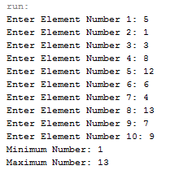

|  |  |  |
| --- | --- | --- |
| ../ama%20university.png../AMAOEd.png | Course Code | Type Course Code Here |
| Description | Computer Programming 2 |
| College / Department:  **Online Education** | Laboratory  Exercise No. | 005 |
| **LABORATORY EXERCISE** | | Page 2 of 5 |

1. **Odd and Even Numbers in the Array**

Create a program that displays the odd and even numbers from the elements stored in the array. You are required to use an array and loop statement for this activity.

The program should prompt the user to enter 10 numbers. Those numbers should be stored in an array. Traverse the array using loop statement to identify the odd and even numbers. Then display the even and odd numbers separately. For example,

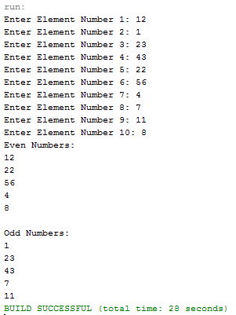

|  |  |  |
| --- | --- | --- |
| ../ama%20university.png../AMAOEd.png | Course Code | Type Course Code Here |
| Description | Computer Programming 2 |
| College / Department:  **Online Education** | Laboratory  Exercise No. | 005 |
| **LABORATORY EXERCISE** | | Page 3 of 5 |

1. **Sorting Array**

Create a program that sort array of numbers in ascending or descending order. The program should prompt the user to enter length of the array, then prompt the user to enter a list of numbers. The value that the user has entered in the length of the array will be the basis for the number of times the user will enter. For example, the user has entered 3 for the length of the array, the user again will be asked to enter 3 numbers. After the user enters a list of numbers, ask the user if it’s going to sort the array in ascending or descending order. Then display the sorted number based from the user's choice. For example:

Sorting 4 elements array in ascending order:

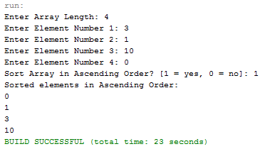

|  |  |  |
| --- | --- | --- |
| ../ama%20university.png../AMAOEd.png | Course Code | Type Course Code Here |
| Description | Computer Programming 2 |
| College / Department:  **Online Education** | Laboratory  Exercise No. | 005 |
| **LABORATORY EXERCISE** | | Page 4 of 5 |

Sorting 10 elements array in descending order:

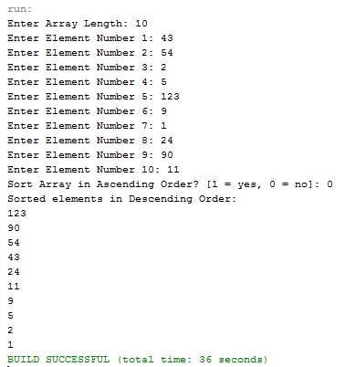

|  |  |  |
| --- | --- | --- |
| ../ama%20university.png../AMAOEd.png | Course Code | Type Course Code Here |
| Description | Computer Programming 2 |
| College / Department:  **Online Education** | Laboratory  Exercise No. | 005 |
| **LABORATORY EXERCISE** | | Page 5 of 5 |

**4. Student Information List**

Given the following multidimensional array that contains Student information list:

String entry = {{"010", "John", "Male", "21"},

{"011", "Mary", "Female", "25"},

{"012", "Joseph", "Male", "24"},

{"013", "Peter", "Male", "22"}};

Use nested loops in dsiplaying the entries on screen with the following format:

ID: 010

Name: John

Gender: Male

Age: 21

ID: 011

Name: Mary

Gender: Female

Age: 25

ID: 012

Name: Joseph

Gender: Male

Age: 24

ID: 013

Name: Peter

Gender: Male

Age: 22