# Week007 – Machine Problem 2

**Objective/s:**

At the end of this activity, you should be able to:

* define a class
* instantiate objects of the class
* invoke the methods of the class
* implement the required output

**What to Prepare for the Activity:**

* NetBeans IDE 8.2
* JDK8 (Java Development Kit 8)

**Procedure:**

* Create a NetBeans project for this activity. The project name should be as follows:

Project Name: MP2_<lastname_firstname>

Example: **MP2_Blanco_Maria**

* The class names to be created are the following:
  + Math (the main class that contains the main method)
  + Fraction (the class where attributes and methods are defined)
* Compress the NetBeans project into .rar or .zip format and then **upload to the link provided in the LMS.**
* **Only NetBeans project compressed in .rar or .zip format will be accepted. All other formats will be graded with 0.**

Write a Java program with the following specifications:

1. Define 2 private attributes in Fraction class, the numerator and the denominator. Define the constructor for this class.
2. Define the setters (mutators) and the getters (accessors) for the Fraction class.
3. Define also the following custom methods in the Fraction class:
4. showFractionForm
5. determineLowestTerm
6. determineDecimalEquivalent
7. determineFractionType
8. The fraction types are as follows:
   1. Proper Fraction – numerator is less than the denominator
   2. Improper Fraction – numerator is greater than the denominator, but the quotient is a real number (ex: 3.45)
   3. Whole Number – numerator is greater than the denominator, but the quotient has no decimal part
9. Create a main class named Math. This class should contain the main method.
10. Instantiate an object of the Fraction class in the main method.
11. Invoke the methods of the Fraction class in the main method to display the requirements as shown in the sample output:

Sample Output:

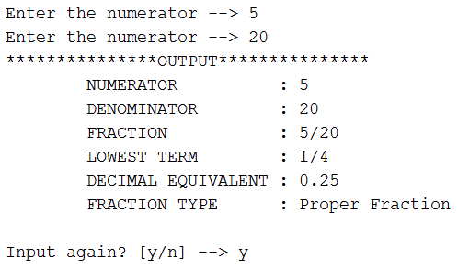

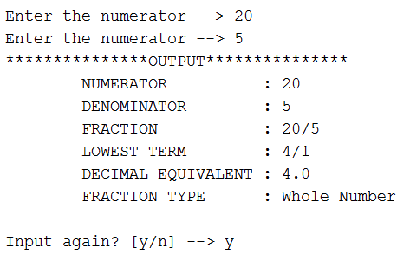

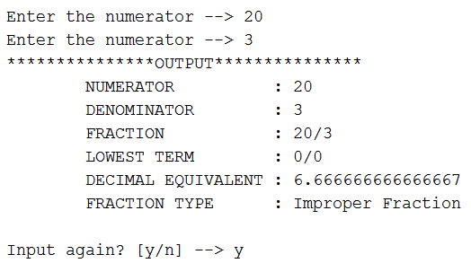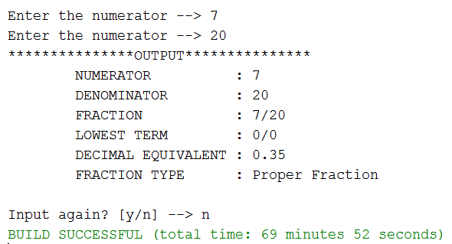

1. The program should loop back to data entry upon confirmation by the user and will terminate as confirmed by the user.
2. Assume that the program user will only input integer values.