# Week012 – Machine Problem 4

**Objective/s:**

At the end of this activity, you should be able to:

* create a graphical user interface with Java events

**What to Prepare for the Activity:**

* NetBeans IDE 8.2
* JDK8 (Java Development Kit 8)

**Procedure:**

* Create a NetBeans project for this activity. The project name should be as follows:

Project Name: MP4_<lastname_firstname>

Example: **MP4_Blanco_Maria**

* Compress the NetBeans project into .rar or .zip format and then **upload to the link provided in the LMS.**
* **Only NetBeans project compressed in .rar or .zip format will be accepted. All other formats will be graded with 0.**

Create a Java GUI with events of a Simple Calculator as follows:

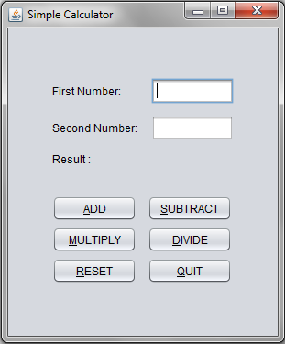 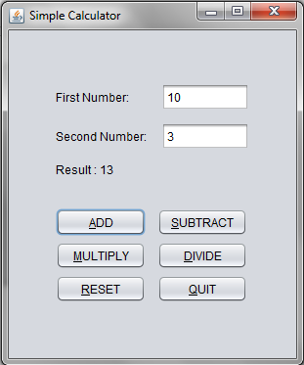

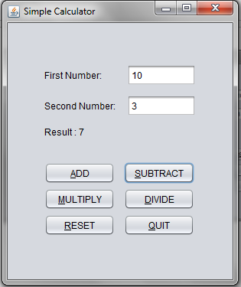 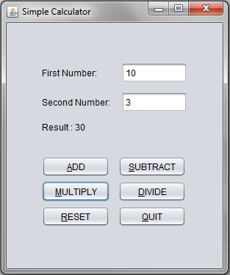

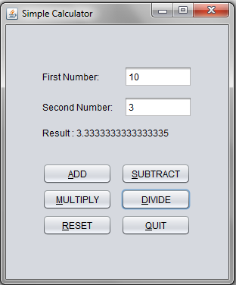 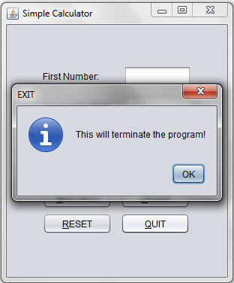

1. The simple calculator should be able to display the computed result based on the operation.
2. The Reset button should clear all values entered and displayed.
3. When the Quit button is clicked, a JOptionPane window will display an information as shown before the program terminates.
4. The program codes should be hard-coded.