

**CS 319**

**Object- Oriented Software Engineering**

**Analysis Report**

IQ Puzzler Pro

Unknown - Group 1-I

Derviş Mehmed Barutçu

Elif Beril Şaylı

Giray Baha Kezer

Zeynep Ayça Çam

Zeynep Hande Arpakuş

**Table of Contents**

1. Introduction  
2. Overview

2.1 Game Modes

2.1.1 Single Player Mode

2.1.2 Multiplayer Mode

2.2 Boards

2.2.1 Black Board

2.2.2 Gray Board

2.2.3 Pyramid with Black Board

2.3 Levels  
3. Functional requirements

3.1 Play Game

3.1.1 Single Player Mode

3.1.2 Multiplayer Mode

3.2 How to Play

3.3 Options

3.4 Credits

4. Nonfunctional requirements

4.1 Game Performance

4.2 User-Friendly Interface

4.3 Extendibility

4.3.1 Player Modes

4.3.2 Bonuses  
5. System models  
 5.1. Use case model  
 5.2. Dynamic models

5.2.1 Sequence Diagram

5.2.1.1 Overall Sequence Diagram

5.2.1.2 Setting Sequence Diagram

5.2.2 Activity Diagram  
 5.3. Object and class model  
 5.4. User interface - navigational paths and screen mock-ups

5.4.1 Main Menu Screen

5.4.2 Leaderboard Screen

5.4.3 Settings Screen

5.4.4 Start Game Screen

5.4.5 Board Screen

5.4.6 Mode Selection Screen

5.4.7 Levels Screen

5.4.8 Game Screen

5.4.9 Paused Screen

5.4.10 Finish Screen

6. References

**1. Introduction:**

IQ Puzzler Pro is a board game which improves players intelligence. It is beneficial especially for children in terms of concentration skill. This game appeals up to 6 to adult. In this Project, we are going to adapt the original IQPuzzlerPro board game to the digital platform.

The game will include different game mods and each game mode, there will be different difficulty levels. In addition, each difficulty level has one unlocked level. Other levels will be locked. The user must unlock all levels in order to finish the game.

The goal of each level is to fit each of the puzzle pieces together onto the board. In each level, we give some of the pieces on their correct places and we expect from user to fill the blanks with remaining pieces.

**2. Overview:**

The purpose of the game is to create several shapes with the puzzle pieces. There will be 12 puzzle pieces in different shapes and colors. Some of the puzzle pieces placed their correct places in advance and the user asked to fill the rest of the shape. The user can rotate, move and flip the puzzle pieces. In order to move the shape, the user must use the left click of the mouse and drag the shape to the desired place. In order to flip the shape, the user must use the right click of the mouse. In order to rotate the shape, the user must hold right click of the mouse and use mouse wheel at the same time.

We record the time of user complete the level. Thus, the user can pause the game and then continue the game anytime he/she wants. Also, there will be music during the game, the user can use the setting menu to close it or change it.

**2.1 Game Modes**

The user will select the game mode before he/she starts the game. There will be two game modes in the game which are single player mode and multiplayer mode.

**2.1.1 Single Player Mode**

In single player mode, the purpose of the user will be the opening unlock levels. If the user chooses to play in this mode, he/she first enter a name to the game. Then the user selects the board that he/she wants to play. After then, the user selects the difficulty he/she wants to play with it. In each difficulty level, there will be several levels. Only the first level will be unlocked. Thus, the user has to start at this level. As the user completes the levels, next level will become unlocked. After all levels will be unlocked and finished successfully, the user completes the game. In addition, the game will record the time user complete each level and move count of pieces in each level will holded and score is computed with them. Score of the user is hold on to the leaderboard. In order to go up in the leaderboard, the user must complete the level as soon as possible with minimum moves.

**2.1.2 Multiplayer Mode**

In multiplayer mode, there will be several users than play the game. Users must enter their name. In addition, as in the singleplayer mode, they select a board and a difficulty level to play the game. After they select them, the game will give them a random level in this difficulty level with the board they select. Users start to play at the same level in order. Each of the users time to complete the level will be recorded. After they all complete the level, user that complete the level in shorter time win the game. In this mode, there can be four users at most and two users at least.

**2.2 Boards**

Users can select the board they want to play. There will be 3 option in this section. Two of them is different boards with 2d gameplay (black and gray boards) and one of them is 3d gameplay with the blackboard.

**2.2.1 Black Board**

Black board will be an 11x5 grid. The user must complete all places in the board with the puzzle pieces.

**2.2.2 Gray Board**

The user again must fill all places on the board.

**2.2.3 Pyramid with Black Board**

The user must create a pyramid shape on the blackboard. Not all the places must be filled on the board in this time. Only a subsection of them will be used.

**2.3 Levels**

In the game, each board has a different difficulty level. They are easy, medium and hard levels. The user selects one of them to play. In easy mode, there will be more pieces placed in advance. In medium mode, there will be fewer pieces played in advance compare to easy levels. In hard mode, there will few pieced placed in advance. In each difficulty level, as levels are unlocked, they become more difficult compared to the previous ones.

**3. Functional Requirements:**

**3.1 Play game**

When player open the application, he\she can choose whether players play our game as single player or multiplayer. After they choose how they want to play the game, they need to select board from two options, then in terms of what board players chose, levels will show up. Afterwards, game screen, where one board into middle of the screen and twelve pieces are around it, comes and players should select pieces and place them correctly by rotating or flipping them. When players fill all empty places with correctly pieces, game will be finished. Thus, we have two option for boards, as one boards’ shape is rectangle, it is more straightforward, namely it is easier than other whose shape is more broken. Each level they pass, the difficulty of that level increases, and for example less pieces will be put into board so it can be more challenging.

**3.1.1 Single Player Mode**

The players access this mode from main menu, and they can start game where they left or can select the level they want. When they start the game, they try to place each pieces correctly. End of the levels, the players can choose to go to next level or go back to menu, moreover, same screen the players can see their time and how much move they made in that level.

**3.1.2 Multiplayer Mode**

Players should enter how much player they want to play and select which level they want to contest. Each player plays in order. When first player finishes the level, second player will play and then next player. Whenever all players finish their game, leaderboard will come and it will be sorted according to their time and the players can compare their time and number of moves.

**3.2 How to Play**

They can enter this screen from menu and the players are informed about:

Ø Game,

Ø Board,

Ø Levels,

Ø How to control pieces.

We want players to play smoothly and less errors, therefore this can be a good opportunity to learn about game and make less errors during the game.

**3.3 Options**

In option menu players can control sound volume in game. They can mute it, change the volume of it and also they can select which song they want to listen while they play the game.

**3.4 Credits**

The players can enter this screen by clicking “Credits” in menu. They will be informed about developers’ e-mail addresses and names. This can be used for sending feedbacks or suggestions about game for further improvements.

**4. Non-Functional Requirements:**

**4.1 Game Performance**

As our game does not need high requirements, the game will be smooth and played in high FPS (frame per second). The extra features that we implement to the game, such as sound and music, will not affect the overall performance of the game.

**4.2 User-Friendly Interface**

We try to make interface as simple as possible to access wide range of players. We want players to want this game so first screen that they see is important. Since game needs drag and release concept, the frame rate is crucial and the graphics need to be good looking and obvious that every pieces can be seen clearly.

**4.3 Extendibility**

**4.3.1 Player Modes**

In the first version of the game, we are going to plan two modes for the game which are single player mode and multiplayer mode, minimum two up to four player. We decide to put restriction because the players play this game in order so more player can make game slower and less likely to play.

**4.3.2 Bonuses**

For future of the game, each level they pass they earn coins to unlock more background for boards and pieces. With these coins also, players also buy hints to help while playing the game.

**5. System Models**

**5.1 Use Case model**

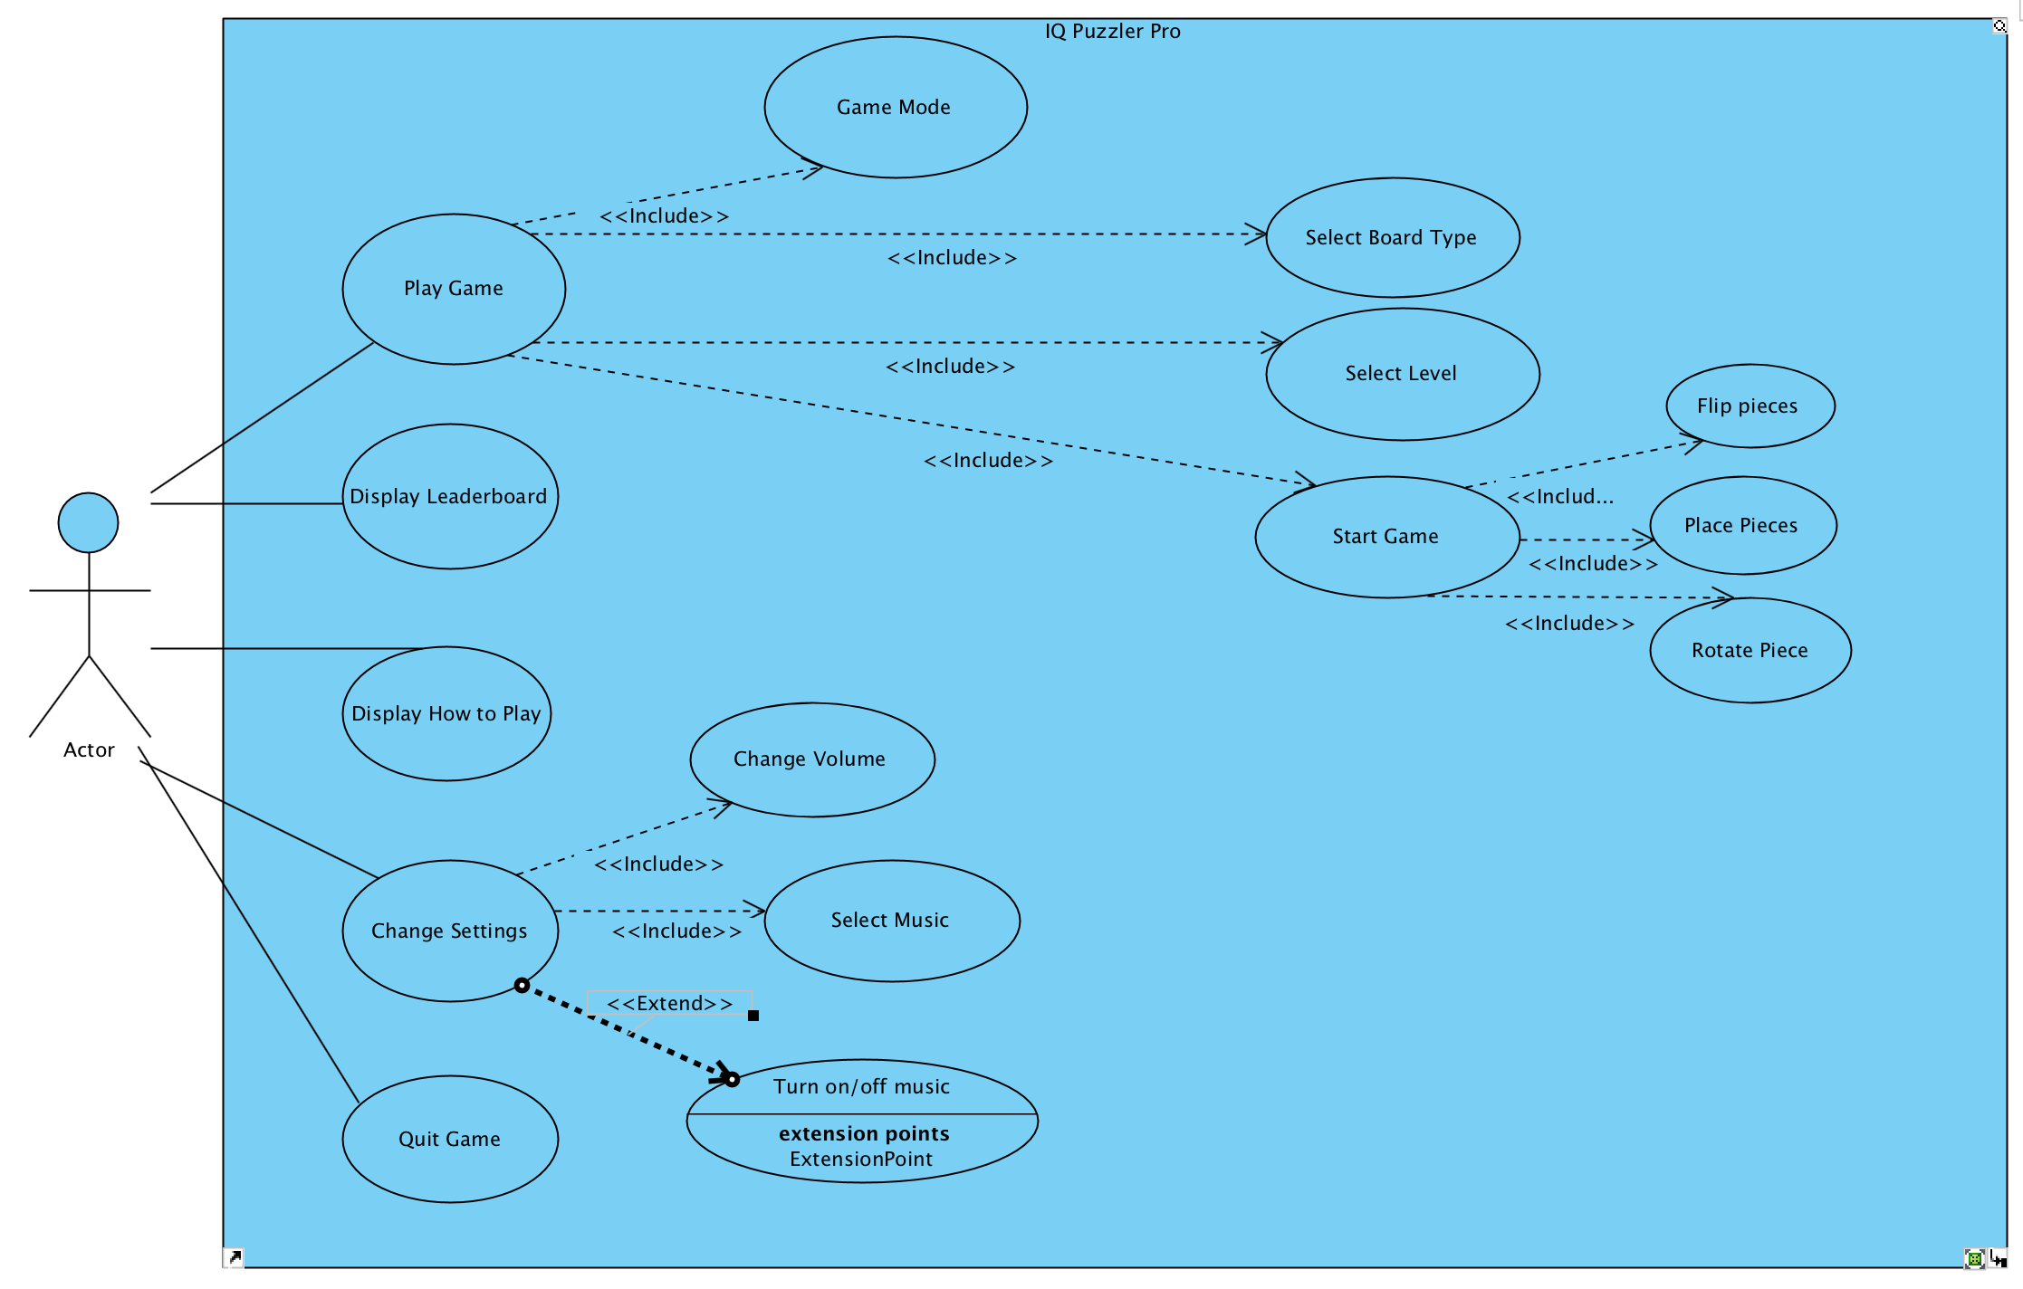

Actor can choose playing or investigating the leaderboard, settings or directly quit in game user interface. In playing selection game modes can be selected as single or multiplayer simultaneously, board type selection for 3d models black board or gray board. Also level selection is needed to be chosen by actor. To display leaderboard actor should tap its button, or other functions need to be tapped in user interface menu. In change settings actor could change volume level, turn it off or on and select the music itself.

**Use Case #1**

Use Case: Play Game

Primary Actor: User

Stakeholders and Interests:

* User wants to play IQ Puzzler Pro

Pre-Conditions

* User must be in the menu

Post-Conditions

* System requires to be chosen board, level selections to start

Entry Conditions

* Playing button should be tapped by actor

Exit Conditions

* Back button should be tapped
* Esc key should be tapped during the game from keyboard.

**Use Case #2**

Use Case: Display the Leaderboard

Primary Actor: User

Stakeholders and Interests:

* User wants to check leaderboard

Pre-Conditions

* User must be in the menu

Post-Conditions

* No post conditions

Entry Conditions

* Display Leaderboard button should be tapped by user

Exit Conditions

* Back button should be tapped
* Esc key should be tapped during the game from keyboard.

**Use Case #3**

Use Case: Display How To Play

Primary Actor: User

Stakeholders and Interests:

* User wants to learn how to play IQ Puzzler Pro

Pre-Conditions

* User must be in the menu

Post-Conditions

* No post conditions

Entry Conditions

* How to Play button should be tapped by user

Exit Conditions

* Back button should be tapped
* Esc key should be tapped during the game from keyboard.

**Use Case #4**

Use Case: Change Settings

Primary Actor: User

Stakeholders and Interests:

* User wants to change settings in IQ Puzzler Pro

Pre-Conditions

* User must be in the menu

Post-Conditions

* Changing volume, sound on off or choosing music should be chosen

Entry Conditions

* Playing button should be tapped by user

Exit Conditions

* Back button should be tapped
* Esc key should be tapped during the game from keyboard.

**Use Case#5**

Use Case: Quit Game

Primary Actor: User

Stakeholders and Interests:

* User wants to quit

Pre-Conditions

* User must be in the menu

Post-Conditions

* No post conditions

Entry Conditions

* Quit button should be tapped by user

Exit Conditions

No exit conditions

**5.2 Dynamic models**

**5.2.1 Sequence Diagram**

**5.2.1.1 Overall Sequence Diagram**

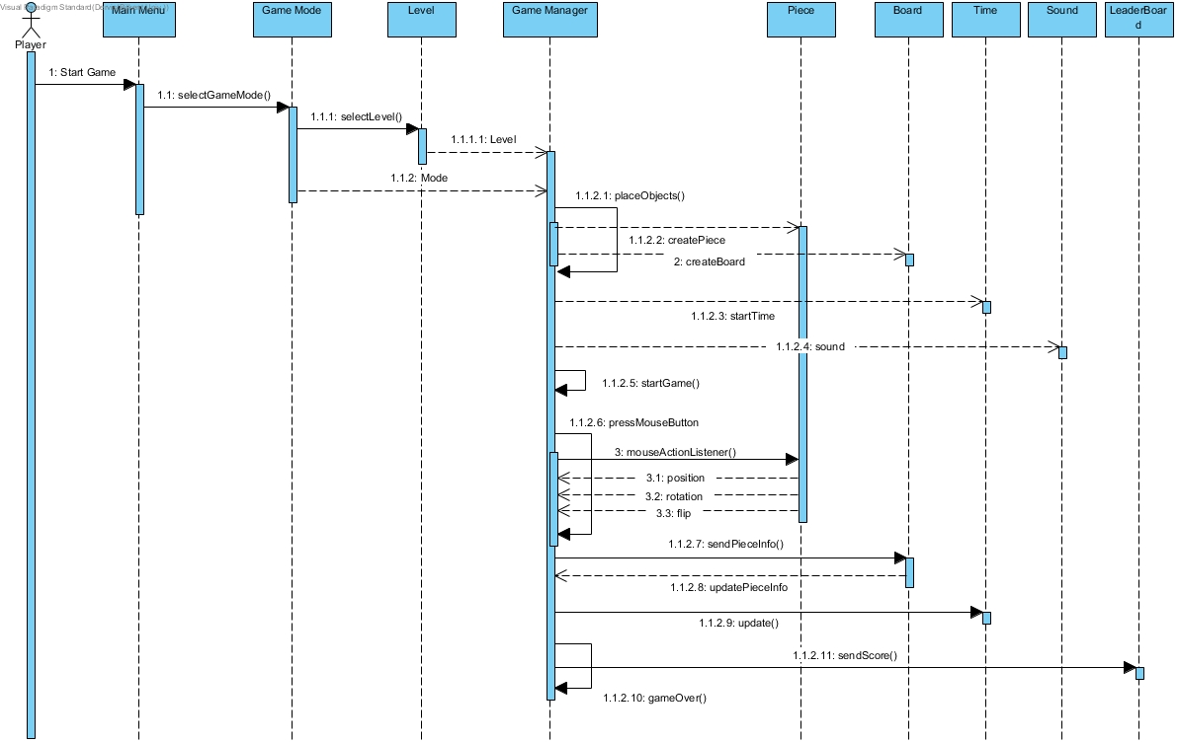

In this diagram, basically how the application works through classes and how they interact between them. First, actors interact with main menu when they start the game. Then, they select the game mode between single player and multiplayer options, after they determine how they play, they need to select which level they will play, and this decides how the interface will be created, namely board and pieces. All these processes are controlled by Game Manager and it will interact with the other classes when it is needed.

Game manager first creates the pieces and the board in terms of input information, level and mode, starts time of that level and lastly loads the sounds. Manager recursively takes the inputs from mouse and according to inputs it will interact with pieces. After putting pieces, board will be updated and when all empty spaces is filled by pieces, the game is finished and information will be sent to leaderboard.

**5.2.1.2 Setting Sequence Diagram**

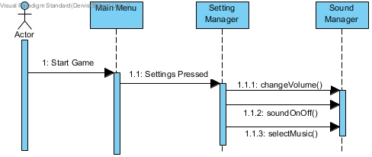

This diagram shows that how settings interacts with the classes. Players, actor, go to the setting from menu. What they can do in setting menu, is shown in diagram. They can change volume of the sound, change the status of these sound or they can select their music from computer and listen it while they can play the game.

**5.2.2 Activity Diagram**

When the game is opened, firstly the main menu is opened. In the main menu, several choices are offered to the user. These are settings, playing game, leaderboard, help and quit. If settings are clicked, settings will be shown to the user. If playing game will be clicked, two option will be shown, multiplayer and single player. One of them must be selected. After that, board selection will be done. In addition, level selection will be done between easy mode, medium mode and hard mode. After the game is started. Time started to count. In the game, if the pause is pressed, the game will stop and time count will stop. If resume will be pressed, the game continues and time count will continue. If a piece is selected, it can be flipped, rotated or moved. When the piece is placed in some place, and this place is full, the piece goes its previous place. If the place is empty, piece placed in this place. Until the board will become full, this movement repeats itself. If the board become full, the game ends and it is returned to the main menu. If leaderboard will be clicked, the leaderboard will be shown. If help will be opened, it will show help. If quit is clicked, the program will be closed.

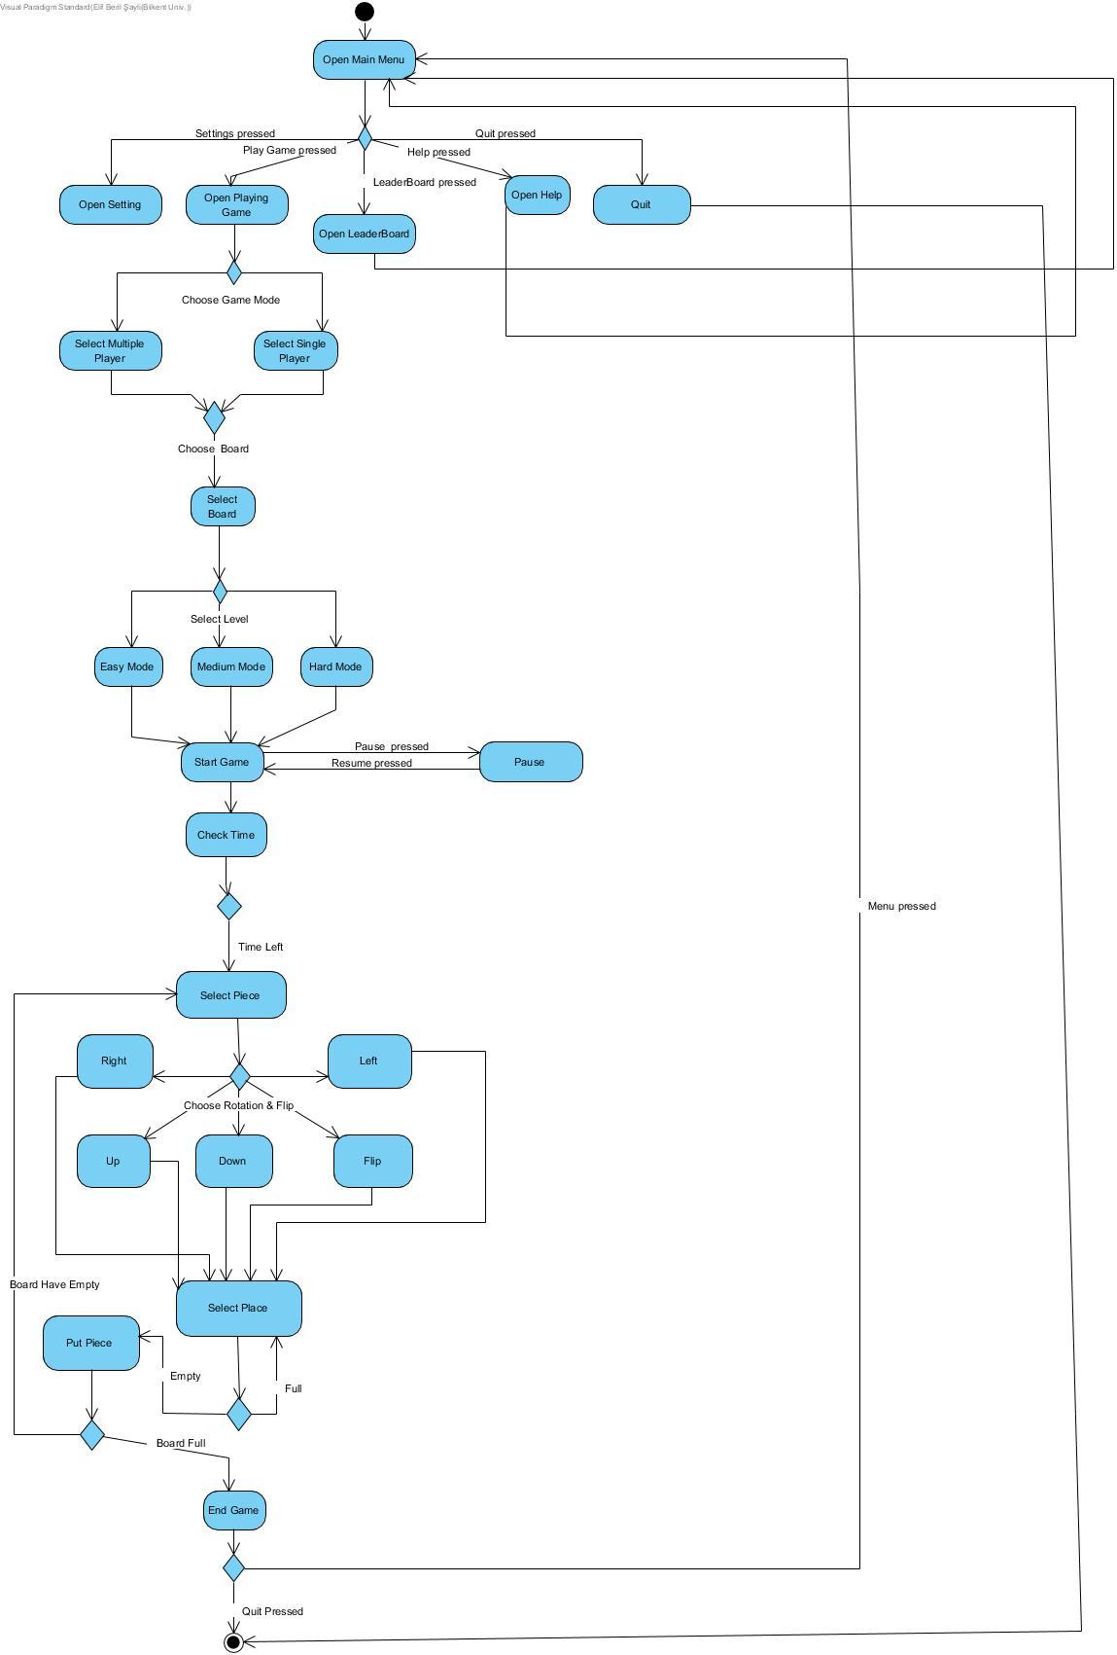

**5.3 Object and class model**

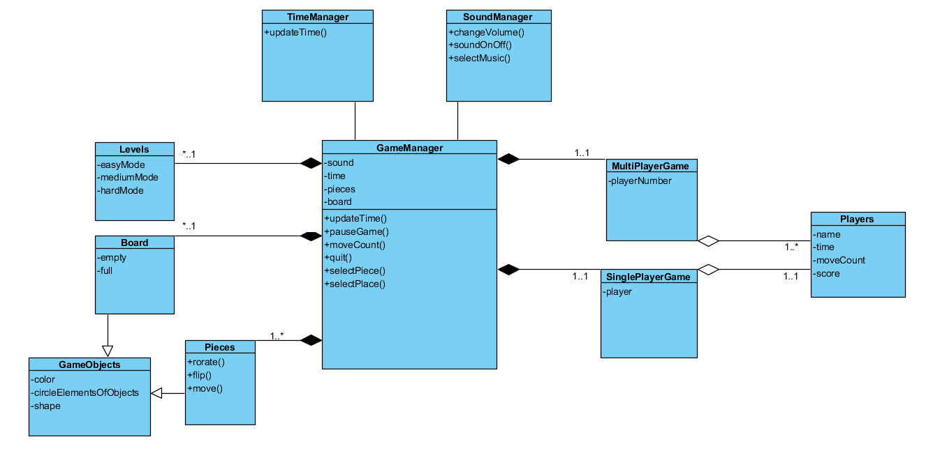

Currently, there are 10 classes on the project. The main class is the GameManager class. This class controls the game flow. The SoundManager class is the class which controls the music and sounds of the game. It has functions for change volume, close and open the sound and select the music of the game. Time manager class is held the time. It has a function for updating time. Board and pieces are the game objects of the game and have properties color, circle elements, and shape. Board can be full or empty. Pieces class has functions for rotate, flip and move the piece. Multiplayer and Singleplayer game classes are modes of the game. They both have the player object (while SinglePlayerGame has one player, MultiPlayerGame can have multiple players). Players class has properties name, time, moveCount and score which calculated from time and moveCount. Levels class has three main properties which have easy mode, medium mode, and hard mode levels.

**5.4. User Interface - Navigational Paths and Screen Mock-ups**

**5.4.1 Main Menu**

The main menu is our main screen. It has five buttons.

**Start Game:** By using this button, the user can access selections to start the game.

**Leaderboard:** With this button, the user can see the leaderboard.

**How to Play:** The user can see a video about how to play the game.

**Settings:** The user can change the settings of the game by using this button.

**Quit:** This button is to exit the game.

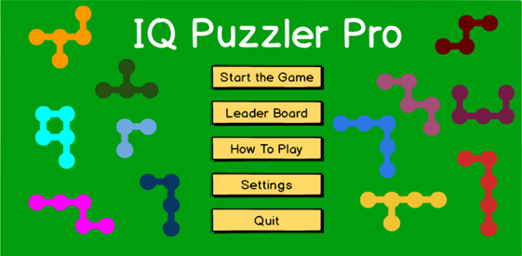

**5.4.2 Leaderboard Screen**

This screen shows the leaderboard which is a list player’s game scores. The list is created according to players' number of moves and their time to finish the episode. This screen has one button

**Back Button:** This button is to go back to the main menu.

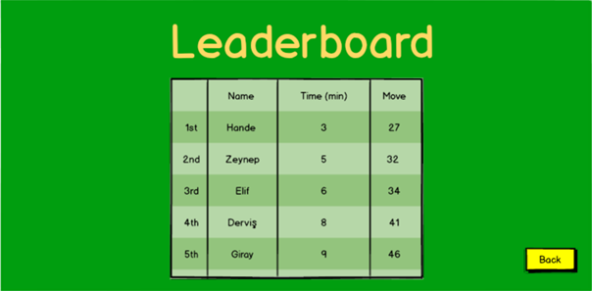

**5.4.3 Setting Screen**

This screen has four buttons. Three of them are to set the sound level (volume-off, volume-down, volume-up) and the last one is to go back to the main menu (Back button). 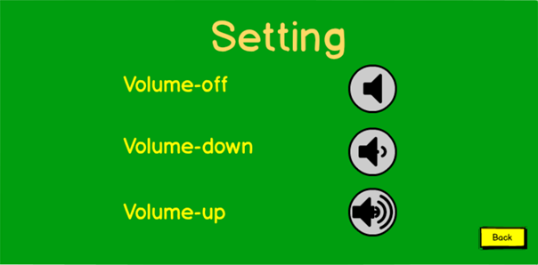

**5.4.4 Start Game Screen**

This screen is the first selection to start the game. In this screen, the player can select how many users play the game. It has two buttons and a bar.

**Name bar:** before start, the game user enters his name so when he wants his game score is saved to the leaderboard.

**Single Player:** If the user wants to play the game alone, he can click this button.

**Multiple Player:** If the user wants to play the game with one or more people, he can click this button.

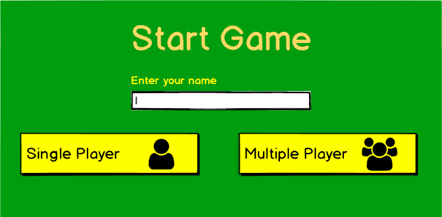

**5.4.5 Board Screen**

After the selection in the start game screen, the user gets board screen. In this screen, there are three buttons.

**Black Board:** With this button, the user can select the black board with size 11x5.

**Pyramid Board (3D):** the user can play the game as 3D by clicking this button. In this button, the player tries to build a pyramid.

**Grey Board:** By choosing this button the player play the game with this board.

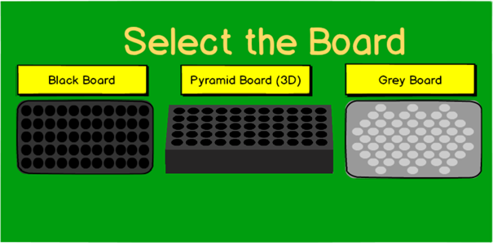

**5.4.6 Mode Selection Screen**

In this screen, the user can select the mode of the game. This screen has three buttons.

**Easy Mode Button**

**Medium Mode Button**

**Hard Mode Button** 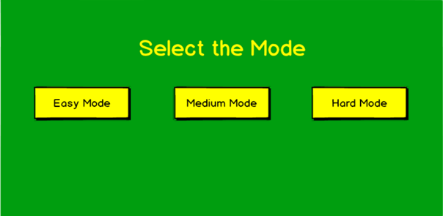

**5.4.7 Levels Screen**

After the mode selection screen, the user gets the levels screen. In this screen, the user choose the level to play. At first, in each mode just first levels are available. Every time when the player completes a level, the next level becomes unlocked. Otherwise, they are locked.

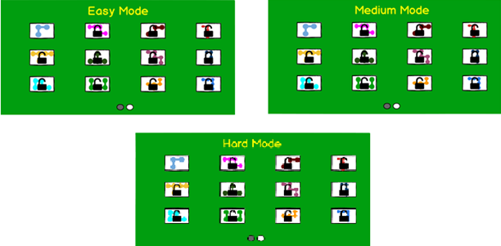

**5.4.8 Game Screen**

After all selections, the user can start to play the game. In the game, the player can see his number of moves and elapsed time. this scene has 3 buttons.

**Pause Button:** when the player click this button, the game and the time is stopped.

**Menu Button:** this button is to go back to main menu.

**Hint Button:** when the user couldn’t find the solution, he can get help with hint button.

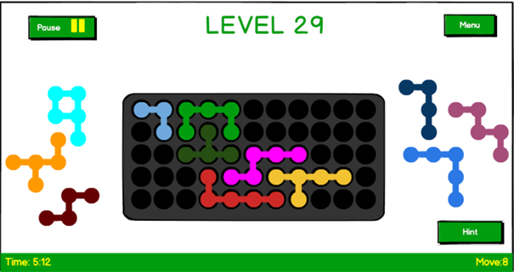

**(Black Board)**

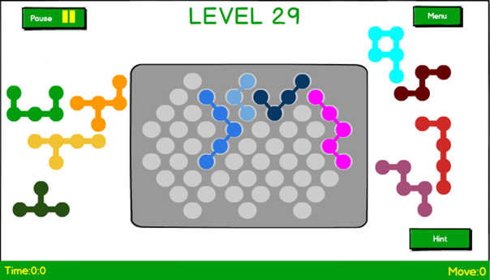

**(Grey Board)**

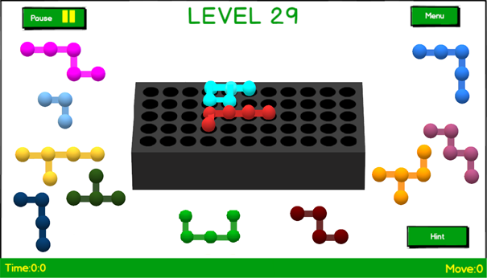

**(Pyramid (3D) Board)**

**5.4.9 Paused Screen**

When the player clicks the pause button in the game screen, he access paused screen. In this screen, there are two buttons.

**Continue Button:** when the player wants to continue to his game, click this button and the paused screen is closed. So the player can see the game screen and continue to play.

**Menu Button:** when the player clicked the pause button, he can go back to the main menu screen, if he wants.

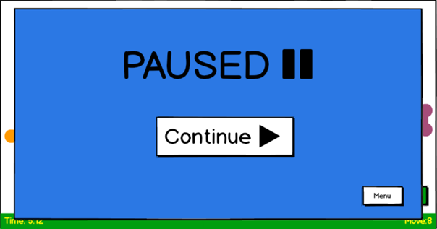

**5.4.10 Finish Screen**

When the player complete the level, reaches this screen. It has two buttons.

**Save Button:** If the player wants to save his level score, click this button. So his move number and time saved with the name the player enter at the beginning. And ıt's added to leaderboard considering the score.

**Next Level:** With this button user can start to play the next level.

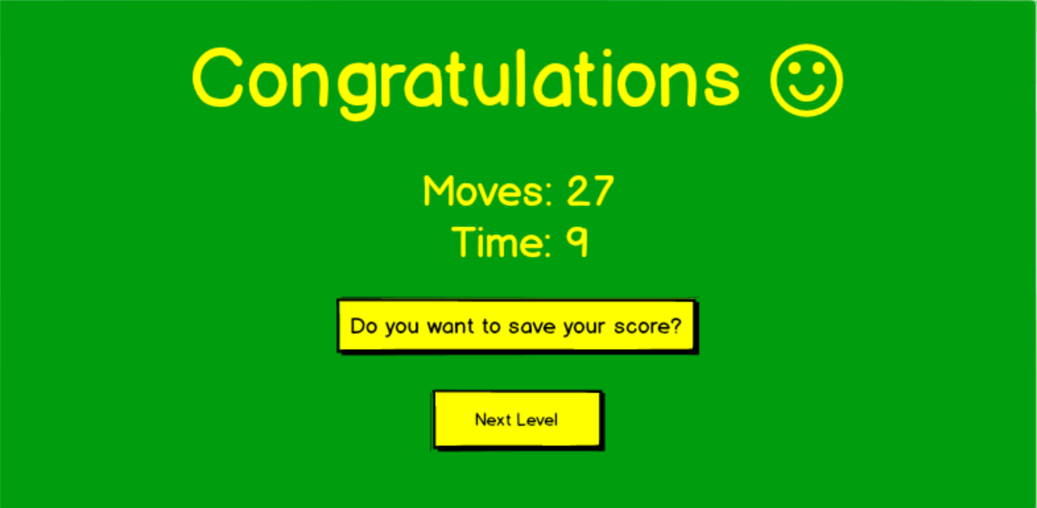

**5.4.11 Navigation Path**

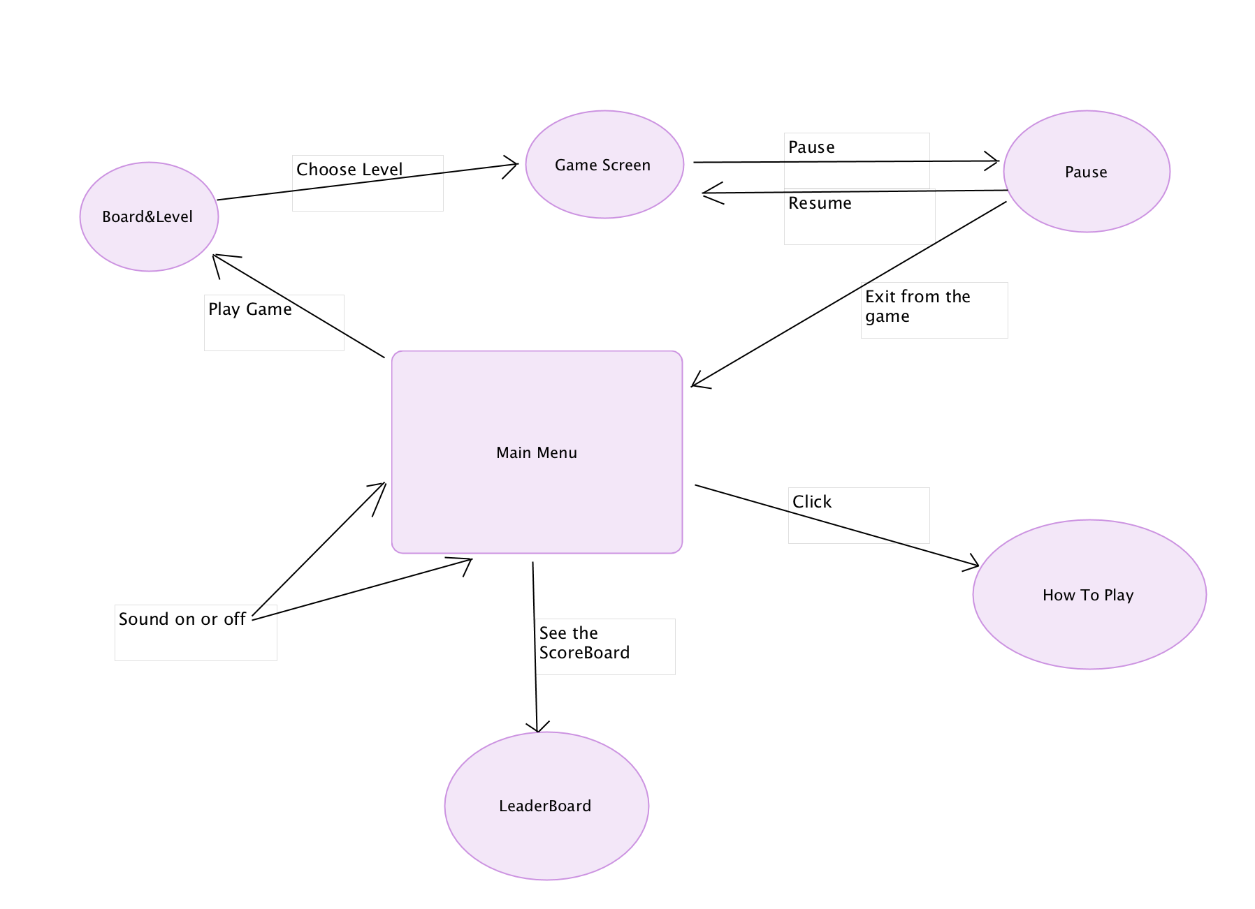

Navigation path diagram shows that how interfaces interacts between each other and how players go that screen and go back to specific screens.

**6. References**

* https://www.smartgames.eu/uk/one-player-games/iq-puzzler-pro