AMC1100
The AMC1100 is a precision isolation amplifier with an output separated from the input circuitry by a silicon dioxide (SiO2) barrier that is highly resistant to magnetic interference.

The AMC1100 input is optimized for direct connection to shunt resistors or other low voltage level signal sources. The excellent performance of the device enables accurate current and voltage measurement in energy-metering applications. The output signal common-mode voltage is automatically adjusted to either the 3-V or 5-V low-side supply.

Features:
±250-mV Input Voltage Range Optimized for Shunt Resistors
Very Low Nonlinearity: 0.075% max at 5 V
Low Offset Error: 1.5 mV max
Low Noise: 3.1 mVRMS typ
Low High-Side Supply Current:
8 mA max at 5 V
Input Bandwidth: 60 kHz min
Fixed Gain: 8 (0.5% Accuracy)
High Common-Mode Rejection Ratio: 108 dB
Low-Side Operation: 3.3 V
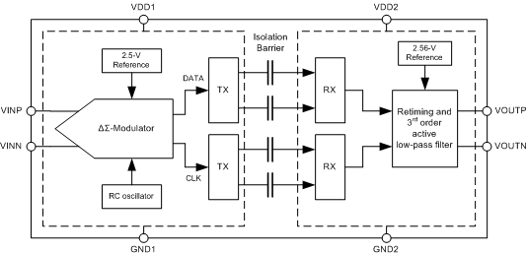

AMC1200
The input of the AMC1200 or AMC1200B is optimized for direct connection to shunt resistors or other low voltage level signal sources. The excellent performance of the device supports accurate current control resulting in system-level power saving and, especially in motor-control applications, lower torque ripple. The common mode voltage of the output signal is automatically adjusted to either the 3-V or 5-V low-side supply.

Features

±250-mV Input Voltage Range Optimized for
Shunt Resistors
Very Low Nonlinearity: 0.075% Maximum at 5 V
Low Offset Error: 1.5 mV Maximum
Low Noise: 3.1 mVRMS Typical
Low High-Side Supply Current:
8 mA Maximum at 5 V
Input Bandwidth: 60 kHz Minimum
Fixed Gain: 8 (0.5% accuracy)
High Common Mode Rejection Ratio: 108 dB
3.3-V Operation on Low-Side

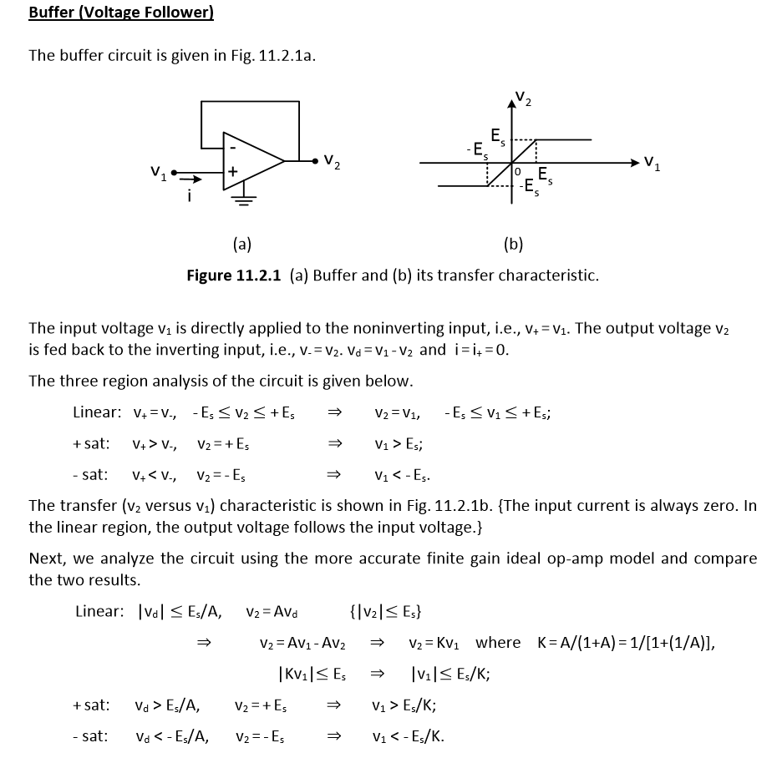
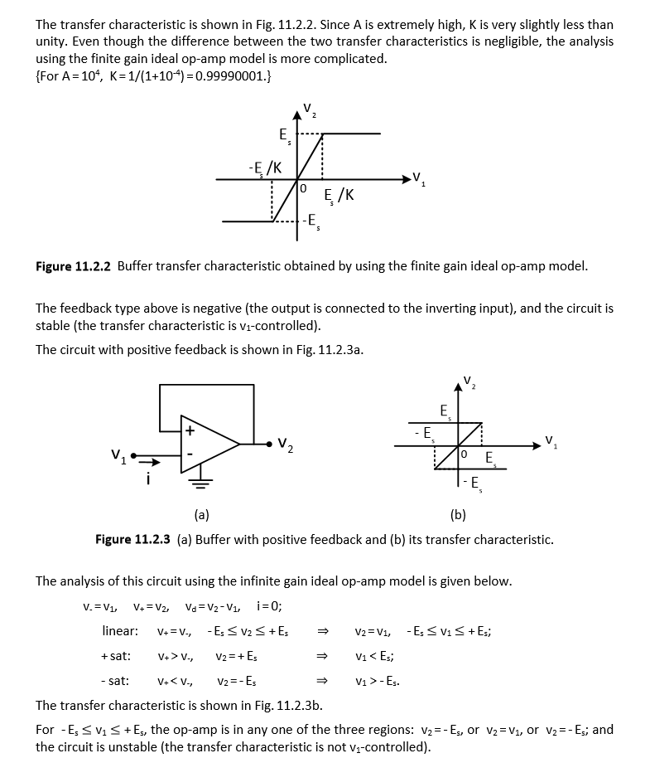
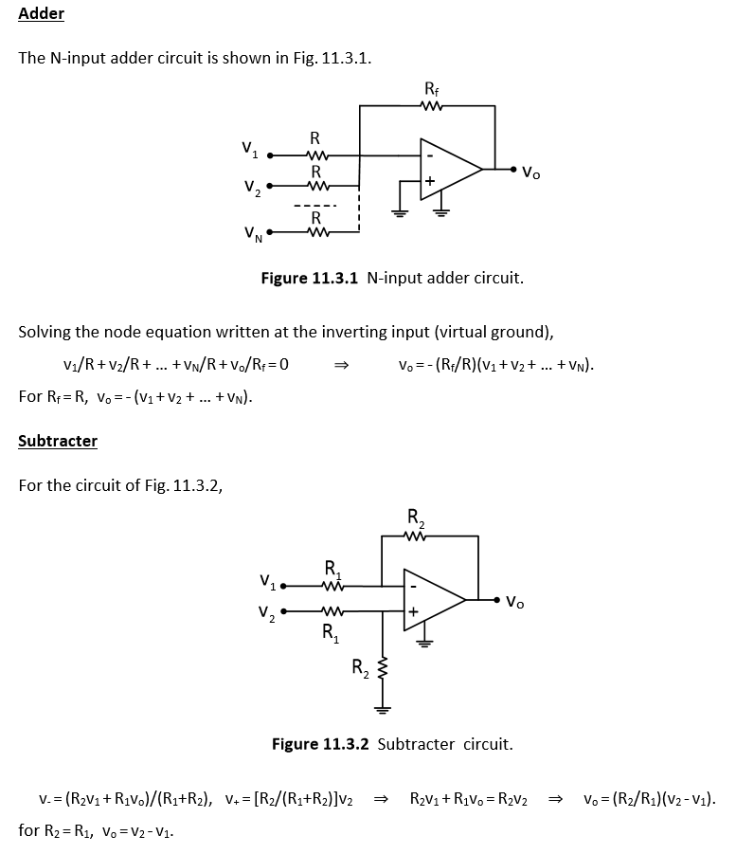

RC FILTERS

SIMPLE LOW PASS RC FILTER

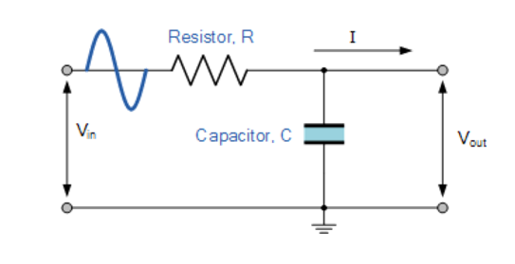(formulas are on the paper.)

Instead of resistor we can use ferrite bead.
A ferrite bead or ferrite choke is a passive electric component that suppresses high frequency noise in electronic circuits. It is a specific type of electronic choke. Ferrite beads employ high frequency current dissipation in a ferrite ceramic to build high frequency noise suppression devices. Ferrite beads may also be called blocks, cores, rings, EMI filters, or chokes.

BYPASS CAPACITOR
In order to eliminate the noise we connect it between Gnd and +Vcc due to AC ripple.

http://www.learningaboutelectronics.com/Articles/What-is-a-bypass-capacitor.html

What is a Bypass Capacitor?
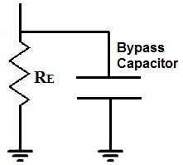
A bypass capacitor is a capacitor that shorts AC signals to ground, so that any AC noise that may be present on a DC signal is removed, producing a much cleaner and pure DC signal.
A bypass capacitor essentially bypasses AC noise that may be on a DC signal, filtering out the AC, so that a clean, pure DC signal goes through without any AC ripple.
For example, you may want a pure DC signal from a power source.
Below is a transistor circuit. A transistor is an active device, so in order to work, it needs DC power. This power source is VCC. In this case, VCC equals 15 volts.
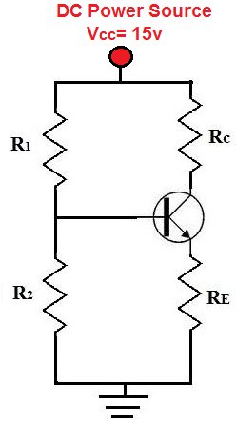
This 15 volts provides power to the transistor so that the transistor can amplify signals. We want this signal to be as purely DC as possible. Although we obtain our DC voltage, VCC, from a DC power source such as a power supply, the voltage isn't always purely DC. In fact, many times the voltage is very noisy and contains a lot of AC ripple on it, especially at the 60Hz frequency because this is the frequency at which AC signals run in many countries.
So although we want a pure DC signal, such as below:
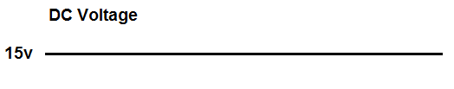
Many times, we get a noisy signal that looks like:
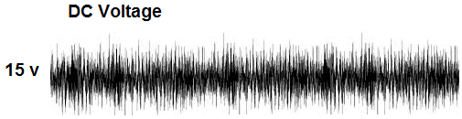
A DC signal such as this is actually very common. This is undesired because it adds noise to the transistor circuit. Therefore, this noisy DC signal will be imposed on the AC signal. So the AC signal which may have music or some type of recording will now have much more noise.
This noise which is on the signal is AC ripple. Many times when using a DC power supply connected to an AC power outlet, it will have some of the AC noise transfer to the DC power voltage. AC ripple can also appear from other sources, so even batteries can produce noise.
To eliminate this AC ripple, we use a bypass capacitor. So our transistor circuit above will have a bypass capacitor added to it:
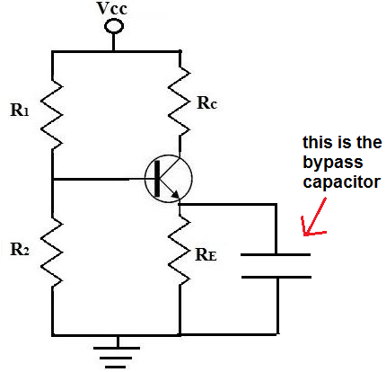
A capacitor is a device that offers a tremendously high resistance for signals of low frequencies. Therefore, signals at low frequencies will not go through them. This is because signals (current) always takes the path of least resistance. Therefore, they will instead go through the resistor, RE. Remember, again, this is for low frequency signals, which is basically DC signals.
However, capacitors offer much less resistance at higher frequencies (AC signals). So AC signals will go through the capacitor and then to gorund. Therefore, DC signals will go through the resistor, RE, while AC signals will go through the capacitor, getting shunted to ground. So AC signals get shunted to ground. This is how we have a clean DC signal across our circuit, while AC noise imposed on it is bypassed to ground.
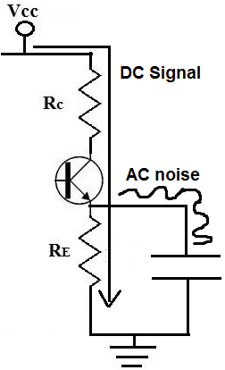
So a bypass capacitor blocks the DC from entering it by the great resistance it offers to the signal but accepts the AC noise that may be on the DC line and shunts or bypasses it to ground. This is how bypass capacitors work.
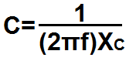

http://www.seattlerobotics.org/encoder/jun97/basics.html

