Carrotco
We produce two products: product 1 and product 2 on two machines (machine 1 and machine 2). The number of hours of machine time and labor depends on the machine and the product as shown in Table 64. The cost of producing a unit of each product is shown in Table 65. The number of labor hours and machine time available this month are in Table 66. This month, at least 200 units of product 1 and at least 240 units of product 2 must be produced. Also, at least half of product 1 must be made on machine 1, and at least half of product 2 must be made on machine 2. Determine how we can minimize the cost of meeting our monthly demands.
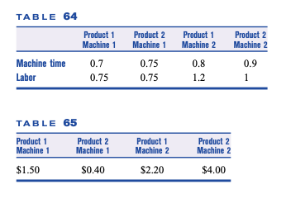

Airco
During the next three months Airco must meet (on time) the following demands for air conditioners: month 1, 300; month 2, 400; month 3, 500. Air conditioners can be produced in either New York or Los Angeles. It takes 1.5 hours of skilled labor to produce an air conditioner in Los Angeles, and 2 hours in New York. It costs $400 to produce an air conditioner in Los Angeles, and $350 in New York. During each month, each city has 420 hours of skilled labor available. It costs $100 to hold an air conditioner in inventory for a month. At the beginning of month 1, Airco has 200 air conditioners in stock. Formulate an LP whose solution will tell Airco how to minimize the cost of meeting air conditioner demands for the next three months.

Daisy drugs
Daisy Drugs manufactures two drugs: 1 and 2. The drugs are produced by blending two chemicals: 1 and 2. By weight, drug 1 must contain at least 65% chemical 1, and drug 2 must contain at least 55% chemical 1. Drug 1 sells for $6/oz, and drug 2 sells for $4/oz. Chemicals 1 and 2 can be produced by one of two production processes. Running process 1 for an hour requires 3 oz of raw material and 2 hours skilled labor and yields 3 oz of each chemical. Running process 2 for an hour requires 2 oz of raw material and 3 hours of skilled labor and yields 3 oz of chemical 1 and 1 oz of chemical 2. A total of 120 hours of skilled labor and 100 oz of raw material are available. Formulate an LP that can be used to maximize Daisy’s sales revenues.

