Akdeniz University

Department of Computer Engineering

Software Engineering Project

Project short-name: AdventureAlly

Software Requirements Specification

Elif Keskin (20210808062@ogr.akdeniz.edu.tr)

Leman Zakaryayeva (20200808504@ogr.akdeniz.edu.tr)

Inji Aliyeva(20200808505@ogr.akdeniz.edu.tr)

**Team Leader:** Elif Keskin

**Product Owner:** Group07

**Instructor:** Prof. Ümit Deniz ULUŞAR

<01.04.2024>

This report is submitted to the Department of Computer Engineering of Akdeniz University of the Software Engineering course CSE332.

|  |  |
| --- | --- |
| **Abbreviations** | |
| IP | Internet Protocol |
| SRS | Software Requirements Specification |
| URL | Uniform Resource Locator |
| API | Application Programming Interface |
| HTTP | Hypertext Transfer Protocol |
| JSON | JavaScript Object Notation |
| CI/CD | Continuous Integration/Continuous Delivery |
| GPS | Global Positioning System |
| GDPR | General Data Protection Regulation |
| ISO | International Organization for Standardization |
| iOS | iPhone Operating System |
| CRUD | Create, Read, Update, Delete operations |
| RESTful | Representational State Transfer |
| GUI | Graphical User Interface |
| OS | Operating Syste |
| UML | Unified Modeling Language |
|  |  |
|  |  |
|  |  |
|  |  |
|  |  |
|  |  |

Contents

1 Introduction 2

1.1 Purpose 2

1.2 Product Scope 2

1.3 References 2

2 Overall Description 3

2.1 Product Perspective 3

2.2 Product Functions 3

2.3 User Types and Characteristics 4

2.4 Operating Environment 4

2.5 Design and Implementation Constraints 4

2.6 User Documentation 5

2.7 Assumptions and Dependencies 5

3 External Interface Requirements 6

3.1 User Interfaces 6

3.2 Hardware Interfaces 10

3.3 Software Interfaces 10

3.4 Communications Interfaces 10

4 System Features / Requirements 10

4.1 User Class 1 <Administrator> 10

4.1.1 Download Mobile Application 10

4.1.1.1. Description and Priority 10

4.1.1.2. Stimulus/Response Sequences 10

4.1.1.3. Functional Requirements 10

5 Use Cases 12

5.1 Creating an new account 12

5.2 Deleting an account 13

6 Nonfunctional System Requirements 13

6.1 Performance Requirements 13

6.2 Safety Requirements 14

6.3 Security Requirements 14

6.4 Software Quality Attributes 15

6.5 Business Rules 15

7 Other Requirements 15

8 References 15

9 Appendix A: Glossary 16

# Introduction

## Purpose

This document outlines the comprehensive requirements for the software development of AdventureAlly. It aims to provide a detailed insight into the purpose, functionality, and specifications necessary for the creation of the application. Additionally, it defines system constraints, interfaces, and interactions. The primary audience for this document includes stakeholders, customers, and the development team. Its purpose is to gain approval from stakeholders and serve as a reference for the development team during the initial stages of system development.

## Product Scope

AdventureAlly is a an application designed to cater to the needs of tourists seeking unique experiences and cost-effective solutions during their travels. The application allows users to access exclusive deals and discounts from local businesses, thereby enhancing their travel experience while supporting local economies. AdventureAlly offers the following key features:

• Exclusive deals and integrated discounts for tourists.

• Personalized tour packages and event discounts.

• Recommendations for places to visit, restaurants, and shopping points.

• Integration with existing mobile applications for seamless user experience.

• Interaction with the AdventureAlly web portal for administrative purposes.

• Real-time access to information via an internet connection.

AdventureAlly operates within the realm of enhancing travel experiences while fostering collaboration between tourists and local businesses. By facilitating access to exclusive deals and personalized recommendations, AdventureAlly aims to become the go-to companion for travelers worldwide.

## References

AdventureAlly Vision and Scope Document

• Version: 1.0

• Date: March 31,2024

• Source: [Insert Source or Location]

AdventureAlly User Interface Style Guide

• Author: [Your Company Name]

• Version: 1.2

• Date: [Insert Date]

• Source: [Insert Source or Location]

AdventureAlly System Requirements Specification

• Author: [Your Company Name]

• Version: 2.0

• Date: [Insert Date]

• Source: [Insert Source or Location]

AdventureAlly Use Case Document

• Author: [Your Company Name]

• Version: 1.5

• Date: [Insert Date]

• Source: [Insert Source or Location]

# Overall Description

## Product Perspective

AdventureAlly is a comprehensive mobile application and web portal system designed to revolutionize the travel experience for tourists. The system comprises two primary components: a mobile application and a web portal.

The mobile application serves as the primary interface for users to engage with AdventureAlly, offering features such as accessing exclusive deals, personalized tour packages, event discounts, and recommendations for places to visit, restaurants, and shopping points. Additionally, users can view top scores and interact with the gaming aspect of AdventureAlly through the mobile application.

On the other hand, the web portal acts as the administrative interface for managing information about the game and the system as a whole. Administrators utilize the web portal to oversee player activities, administer the system, and monitor game-related data.

## Product Functions

**Mobile Application Functions:**

• Game Search: Users can search for games based on various criteria, with options managed by the system administrator.

• Game Result Viewing: Search results are displayed in a list view, showing relevant game information, allowing users to select a game to play or view top player scores.

• Game Information Access: Users can access detailed information about specific games, aiding in decision-making and game selection.

• Restaurant Search: Users can search for restaurants based on specified criteria, with options configurable by the system administrator.

• Restaurant Result Viewing: Search results can be viewed either in a list view or map view, displaying relevant restaurant information for user identification.

• Restaurant Location Display: In map view, restaurant locations are shown as pins on the map alongside the user's location, aiding in navigation.

• Restaurant Information Access: Users can access detailed information about specific restaurants, including directions and additional details.

**Web Portal Functions:**

• System Management: Administrators can manage system settings and game/restaurant information through the web portal.

• Information Provision: The web portal provides system information, such as notifications about updates, ensuring users stay informed about changes or enhancements.

## User Types and Characteristics

AdventureAlly serves three user classes: mobile application users, data providers, and administrators.

**Mobile Application Users:**

• Description: Tourists and travelers seeking exclusive deals and personalized recommendations.

• Requirements: Ability to search for deals and attractions, view detailed information, and make selections.

**Data Providers:**

• Description: Businesses and organizations contributing information about local offerings.

• Requirements: Access to submit and update business listings and promotional content.

**Administrators:**

• Description: Internal staff overseeing system management and user support.

• Requirements: Web portal access for system settings, content moderation, and performance monitoring.

AdventureAlly aims to deliver a seamless experience for users while facilitating efficient system management.

## Operating Environment

* Windows 7, Windows 8, and Windows 10
* Mac OS X
* iOS (iPhone and iPad)
* Android

## Design and Implementation Constraints

AdventureAlly is developed with a multi-platform approach, encompassing a web version, a mobile application, and an API, each adhering to specific design and implementation constraints for optimal performance and usability.

**Web Version:**

• AdventureAlly's web version is developed using modern web technologies such as HTML5, CSS3, and JavaScript.

• The web application is designed to be responsive, ensuring compatibility with a wide range of devices, including desktops, laptops, and tablets.

• It utilizes server-side technologies such as Node.js or Django to handle backend operations, database management, and API interactions.

• The web version features a modular architecture, allowing for scalability and easy integration of new features.

• AdventureAlly's web version is accessible through popular web browsers such as Google Chrome, Mozilla Firefox, and Safari.

**Mobile Application:**

• AdventureAlly's mobile application is developed natively for iOS and Android platforms using Swift and Kotlin respectively.

• The mobile application follows platform-specific design guidelines to provide a native and intuitive user experience.

• It leverages device capabilities such as GPS, camera, and push notifications to enhance functionality and user engagement.

• AdventureAlly's mobile application integrates seamlessly with the web version, enabling users to access the same features and data across different platforms.

• Continuous integration and delivery (CI/CD) pipelines are implemented to ensure timely updates and enhancements for both iOS and Android versions.

**API:**

• AdventureAlly provides a RESTful API to facilitate communication between the web version, mobile application, and external systems.

• The API is built using industry-standard protocols and conventions, ensuring interoperability and ease of integration.

• It offers endpoints for various functionalities such as user authentication, fetching deals and recommendations, and managing user preferences.

• AdventureAlly's API is well-documented with clear usage guidelines and examples, enabling developers to quickly integrate the platform into their applications.

• Security measures such as authentication tokens and HTTPS encryption are implemented to protect user data and ensure confidentiality.

## User Documentation

There is a quick start guide available on the website of AdventureAlly:

<https://adventureally.org/users/quick-start>

There are two other official tutorials, one for visualization:

<https://adventureally.org/users/tutorial-visualization/>

And one for layouts:

<https://adventureally.org/users/tutorial-layouts/>

In this page:

<https://adventureally.org/users/>

users can find every available tutorial including tutorials made by the community, video tutorials, the official tutorials mentioned above, non-English tutorials etc. Additional help and information can be found at AdventureAlly’s wiki:

<https://github.com/adventureally/adventureally/wiki/>

## Assumptions and Dependencies

**Assumptions:**

AdventureAlly assumes it will mainly operate on mobile devices with adequate performance. However, device limitations due to concurrent usage or other factors may affect the app's functionality.

**Dependencies:**

AdventureAlly relies on third-party APIs or services for features like location services or payment processing. Changes or disruptions to these services could affect app functionality.

The project depends on specific software libraries or frameworks for development, subjecting it to their maintenance and updates.

Availability of resources like development tools and expertise may influence AdventureAlly's development timeline.

# External Interface Requirements

## User Interfaces

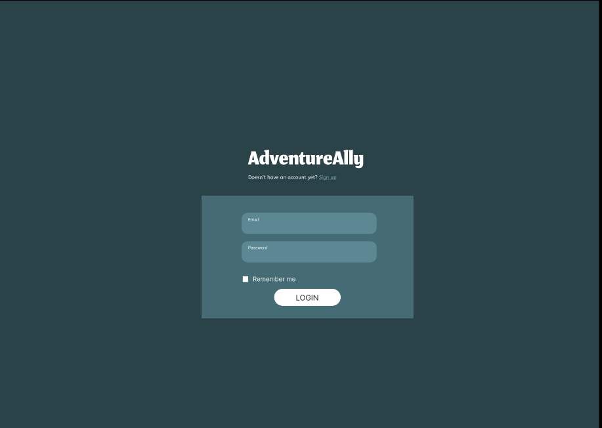 1.AdventureAlly Login Screen:

This is the first screen you see when you open the AdventureAlly app. On this screen, you can enter your email address and password to log in to the app. If you don't have an account yet, you can create one by clicking the "Sign Up" button.The "Remember me" checkbox allows the user to save their login information so that they do not have to enter it each time they open the application.

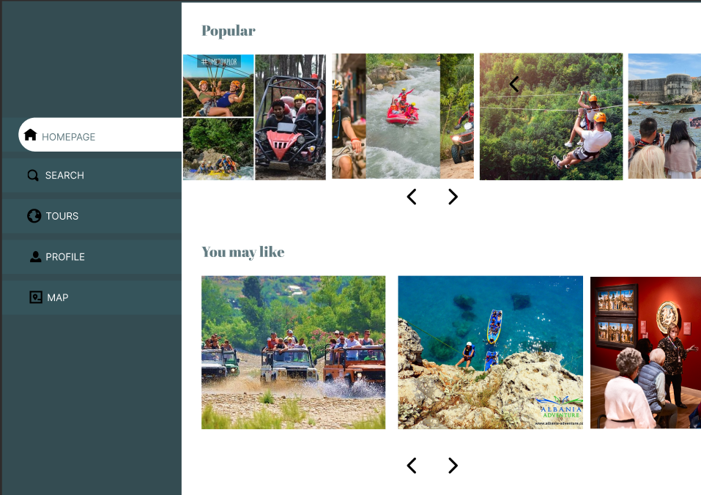2. AdventureAlly Home Page:

You see the home page of the AdventureAlly app. There is a slider for popular tours at the top of the page. There are various tours in the main part of the page under the heading "You May Like". The page generally has a minimalist design. The color palette and typography are pleasing to the eye. There are no unnecessary elements that will distract users. The user can easily access the information he is looking for. The design prioritizes functionality and offers an easy-to-use and enjoyable experience.

3. AdventureAlly Search Page:

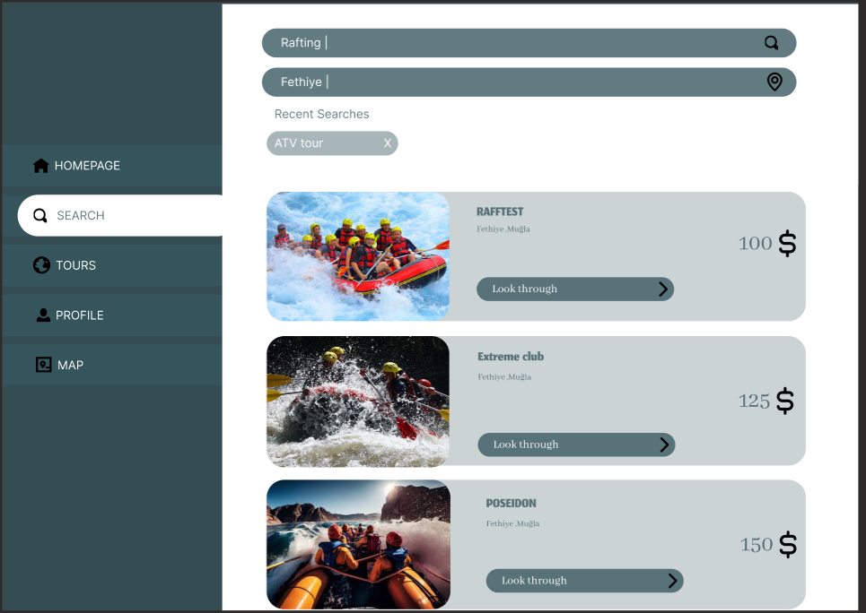

On this screen, you can choose the type of adventure you are looking for. You can choose from many different types of adventures such as hiking, cycling, camping, climbing, rafting and list your tours accordingly. You can also select a location to narrow your search.

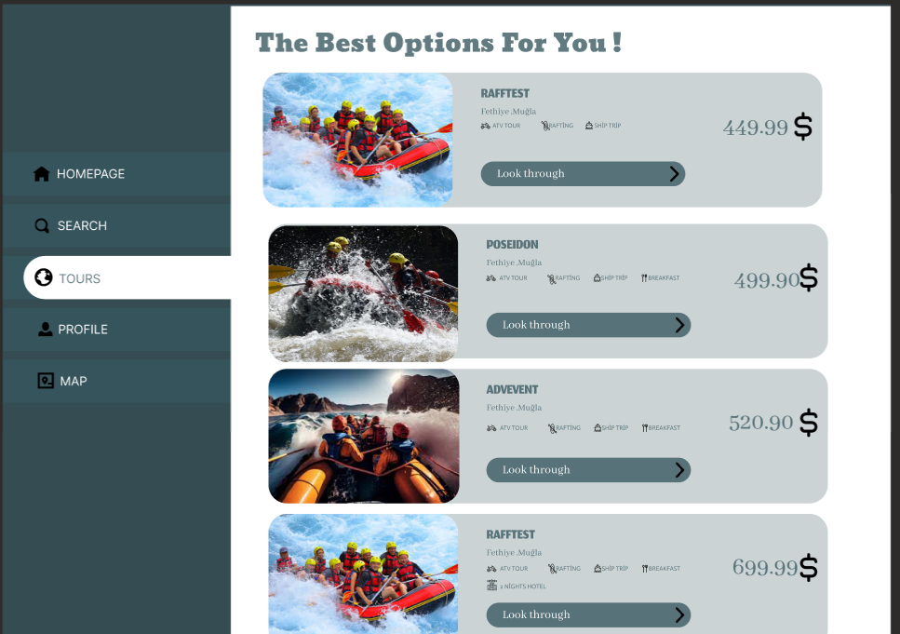4.AdventureAlly Tours Page:

The page shows tours organized by general companies. It lists all the tours currently available in a mixed order. High-quality visuals and an easy-to-use layout make it easy for potential customers to learn about and book rafting tours.

5. AdventureAlly Profile Page:

This page contains e-mail address, phone number, password, language selection, arrangements for the "Delete Account" button and contact information. Confirmation message (edits success or failure), account deletion confirmation. You can edit your profile information on this screen. You can change your e-mail address, phone number and password.

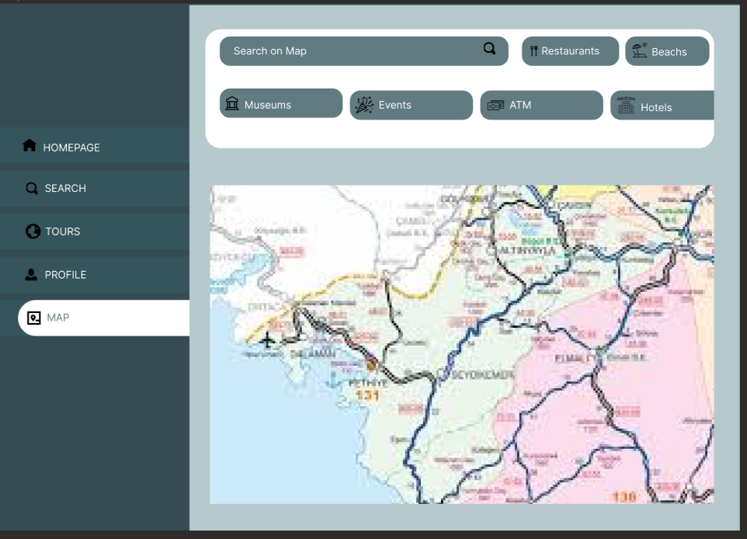6.AdventureAlly Map Page:

The map page is a page that details the user's planned adventure. The page shows nearby museums, restaurants and other activities according to the user's travel plan and location. In addition, sections such as route, accommodation, transportation and activities on the page help users plan and organize their travel plans in detail.

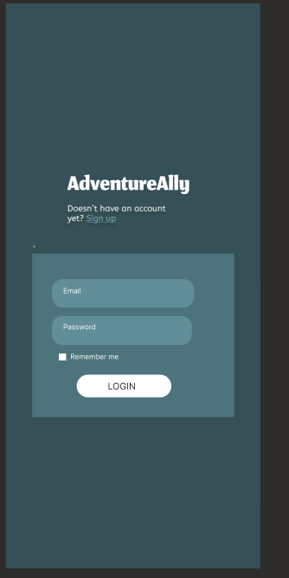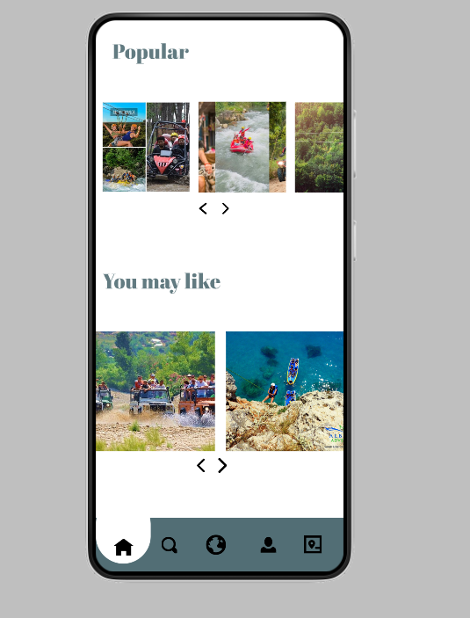

And these are the interfaces of some pages from the mobile application

## Hardware Interfaces

 AdventureAlly application does not have any designated hardware interfaces since neither the mobile application nor the web portal is hardware-dependent. The physical GPS functionality is managed by the GPS application running on the user's mobile device, while the connection to the database server is handled by the respective operating systems of the mobile device and the web server.

## Software Interfaces

The mobile application communicates with the GPS application to obtain location information and visual representation, and with the database to retrieve information about available deals. The web portal interacts with the database to provide users with information about available deals. Database operations involve both read and write operations, which are performed between the application and the web portal. Communication occurs using JSON or similar data exchange formats over the HTTP protocol.

## Communications Interfaces

Communication among different components of AdventureAlly occurs between the mobile application, the web portal, and the database. This communication is facilitated through the HTTP protocol and is achieved via RESTful APIs. Communication adheres to basic communication standards, ensuring data security and encryption protocols are implemented for data transfer. Data transfer rates are optimized to ensure minimal impact on user experience, and synchronization mechanisms are utilized to maintain data integrity.

# System Features / Requirements

<This template illustrates organizing the functional requirements for the product by system features, the major services provided by the product. You may prefer to organize this section by use case, mode of operation, user class, object class, functional hierarchy, or combinations of these, whatever makes the most logical sense for your product.>

## User Class 1 <Administrator>

### Download Mobile Application

#### Description and Priority

It is necessary for the user to be able to download the mobile application. Priority: High.

#### Stimulus/Response Sequences

Users receive notifications to check for new versions and download updates if necessary. Once the download is complete, the AdventureAlly icon appears on the user's device, indicating that the application is ready to use.

#### Functional Requirements

D: FR1

TITLE: Download mobile application

DESC: A user should be able to download the mobile application through either an application store or similar service on the mobile phone. The application should be free to download.

RAT: In order for a user to download the mobile application.

DEP: None

ID: FR2

TITLE: Download and notify users of new releases

DESC: When a new/updated version or release of the software is released, the user should check for these manually. The download of the new release should be done through the mobile phone in the same way as downloading the mobile application.

RAT: In order for a user to download a new/updated release.

DEP: FR1

ID: FR3

TITLE: User registration - Mobile application

DESC: Given that a user has downloaded the mobile application, then the user should be able to register through the mobile application. The user must provide user-name, password and e-mail address. The user can choose to provide a regularly used phone number.

RAT: In order for a user to register on the mobile application.

DEP: FR1

ID: FR4

TITLE: User log-in - Mobile application

DESC: Given that a user has registered, then the user should be able to log in to the mobile application. The log-in information will be stored on the phone and in the future the user should be logged in automatically.

RAT: In order for a user to register on the mobile application.

DEP: FR1, FR3

ID: FR5

TITLE: Retrieve password

DESC: Given that a user has registered, then the user should be able to retrieve his/her password by e-mail.

RAT: In order for a user to retrieve his/her password.

DEP: FR1

ID: FR6

TITLE: Mobile application - Search

DESC: Given that a user is logged in to the mobile application, then the first page that is shown should be the search page. The user should be able to search for a xxxx, according to several search options. The search options are xxx, xxxx, xxxxx and xxxx. There should also be a free-text search option. A user should be able to select multiple search options in one search.

RAT: In order for a user to search for a xxxxx.

DEP: FR4

ID: FR7

TITLE: Mobile application - Profile page

DESC: On the mobile application, a user should have a profile page. On the profile page a user can edit his/her information, which includes the password, e-mail address and phone number. A user should also be able to choose what language the mobile application should be set to. The different language choices are Turkish and English.

RAT: In order for a user to have a profile page on the mobile application.

DEP: FR1

ID: FR8

TITLE: Create an account

DESC: A user should be able to create an account on the mobile application. During the account creation process, the user should provide a username, password, email address, and optionally a frequently used phone number. The user should also be able to upload a profile picture during account creation.

RAT: To allow a user to create an account on the mobile application.

DEP: FR1, FR3

ID: FR9

TITLE: Delete an account

DESC: A user should be able to delete their account from the mobile application. Upon account deletion, all user information and data should be permanently removed.

RAT: To enable a user to delete their account from the mobile application.

DEP: FR4

ID: FR10

TITLE: Update an account

DESC: A user should be able to update their account information on the mobile application. This update process should allow the user to modify their username, password, email address, and phone number if necessary. Additionally, the user should be able to change their profile picture.

RAT: To allow a user to update their account information on the mobile application.

DEP: FR4, FR7

ID: FR11

TITLE: Manage information

DESC: Users should be able to manage their account information through the mobile application. This includes viewing, editing, and deleting account details. Additionally, users should be able to adjust certain preferences and customize the behavior of the mobile application according to their preferences.

RAT: To allow users to manage their account information through the mobile application.

DEP: FR4, FR7

# Use Cases

## Creating an new account

The purpose of this use case is to describe the procedure of creating an account in the system

**Pre-conditions:**

None

**Post-conditions:**

• An account is created for the user

**Basic Flow:**

1. The user is in the homepage

2. The user clicks on “new account” link and is taken to the account creation page

3. The user enters all their information and clicks “create” button

4. If the username already exits, an error message appears alerting the user and asking the user to choose another username. If the username does not exist, a confirmation appears letting the user know that the account has been created

## Deleting an account

**Purpose:** This use case outlines the process for a user to delete their account from the system.

**Preconditions:**

* The user must be logged in to their account.

**Post-conditions:**

* The user's account is successfully deleted from the system.

**Basic Flow:**

1. The user navigates to the account settings page.
2. The user selects the option to "Delete Account" or similar.
3. The system presents a notification to the user, asking them to confirm if they want to permanently delete their account.
4. Upon confirmation, the system permanently deletes the user's account and logs them out.

**Alternative Flows:**

* Step 3: If the user indicates that they do not want to delete their account, the process is canceled, and the user is redirected back to their account settings.

# Nonfunctional System Requirements

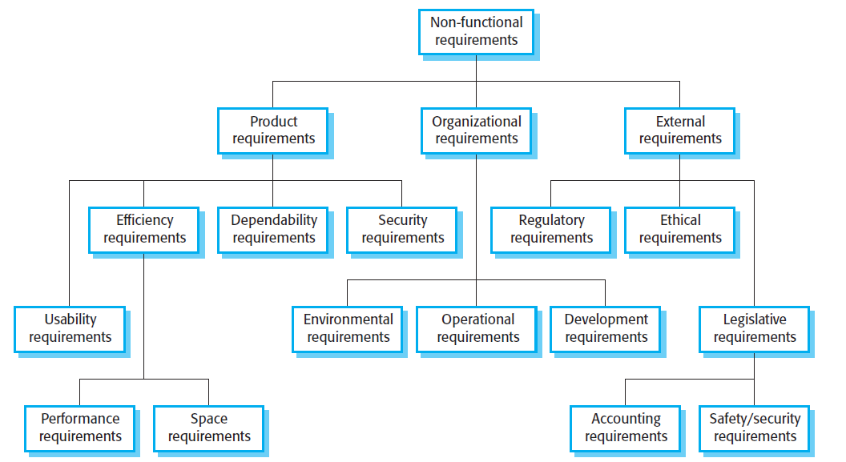

Figure 1

## Performance Requirements

This statement states that performance tests have not yet been conducted and specific performance metrics cannot be determined. Once performance testing is completed, appropriate performance requirements will be determined and documented.

ID: NF1

TAG: Response Time < ID: FR6 TITLE: Mobile application - Search >

GIST: The fastness of the search

SCALE: The response time of a search

METER: Measurements obtained from 1000 searches during testing.

MUST: No more than 2 seconds 100% of the time.

WISH: No more than 1 second 100% of the time.

ID: NF2

TAG: Response Time for < ID: FR4 TITLE: User log-in - Mobile application >

GIST: The fastness of the search

SCALE: The response time of a search

METER: Measurements obtained from 1000 searches during testing.

MUST: No more than 2 seconds 100% of the time.

WISH: No more than 1 second 100% of the time.

## Safety Requirements

1. Data Security: AdventureAlly must comply with industry-standard security protocols to protect users' personal data. All user data should be encrypted and stored on secure servers.
2. Application Stability: Regular updates should be made to ensure the stability of the application, and bug fixes should be provided promptly. Users should be able to report any errors or issues they encounter.
3. Internet Connection Requirements: AdventureAlly requires an internet connection for users to access real-time information. Therefore, the application should warn users when there is no internet connection and provide basic functionality.
4. User Data Backup: AdventureAlly should regularly backup user data. This ensures that user data is not lost in the event of any system failures.
5. User Education and Information: Users should be regularly informed about the safe and proper use of the application. User education plays a significant role in reducing potential risks.

## Security Requirements

1. Data Security: AdventureAlly must adhere to industry-standard security protocols to ensure the security of user data. This entails using encryption during data transmission and storing data on secure servers.
2. User Identity Authentication Requirements: Strong user identity authentication mechanisms should be employed to ensure user security. AdventureAlly should provide methods such as strong password policies and two-factor authentication to securely access user accounts.
3. External Policies and Regulations: AdventureAlly must comply with relevant legal regulations and external policies regarding the processing and storage of user data. Full compliance with data protection regulations such as GDPR is particularly important.
4. Security and Privacy Certifications**:** AdventureAlly may need to obtain specific security or privacy certifications. Compliance with security standards like ISO 27001 or privacy frameworks like Privacy Shield should be ensured.

## Software Quality Attributes

The fundamental software quality attributes of AdventureAlly include: Usability, reliability, flexibility, interoperability, and maintainability. Usability ensures an intuitive interface for easy use by all users. Reliability guarantees consistent performance without crashes. Flexibility allows customization to meet user preferences and needs. Interoperability ensures seamless integration with different platforms. Maintainability ensures easy upkeep and updates of the application's codebase. These attributes collectively ensure AdventureAlly provides a reliable, flexible, and user-friendly travel experience.

## Business Rules

1. **User Authentication**: Only registered users with valid accounts can access certain features such as personalized tour packages, event discounts, and exclusive deals from local businesses.
2. **User Roles**: Different user roles exist within AdventureAlly, including regular users, administrators, and business owners. Each role has specific permissions and functionalities tailored to their responsibilities.
3. **Deal Redemption**: Users can redeem exclusive deals and discounts offered by local businesses through AdventureAlly. The redemption process may involve presenting a digital voucher or code at the respective business establishment.
4. **Feedback and Reviews**: Users have the ability to leave feedback and reviews for tours, events, and businesses they interact with through AdventureAlly. This feedback contributes to the overall user experience and may influence future recommendations.
5. **Administrative Functions**: Administrators have the authority to manage user accounts, review feedback and reviews, and oversee the integration of new businesses into the platform. They ensure the smooth operation of AdventureAlly and adherence to its policies.
6. **Business Partnership Criteria**: AdventureAlly establishes criteria for businesses seeking to partner with the platform, ensuring that they align with the values and goals of the application. This may include criteria related to the quality of services offered, ethical practices, and willingness to provide exclusive deals for AdventureAlly users.

# Other Requirements

Privacy Policy and Terms of Use:

a. Privacy Policy Documentation: AdventureAlly must provide users with a documented privacy policy.

b. Terms of Use Documentation: Users should also be provided with terms of use documentation.

c. Clear Information: These documents should contain clear information about how users' personal data is processed and protected.

# References

[1] "Gephi Software Requirements Specification Document", Gephi.org, [Online]. Available: https://gephi.org/users/gephi_srs_document.pdf. [Accessed: 2 April 2024].

[2 ]Object-Oriented Software Engineering, Using UML, Patterns, and Java, 2nd Edition, by Bernd Bruegge and Allen H. Dutoit, Prentice-Hall, 2004, ISBN: 0-13-047110-0.

# Appendix A: Glossary

AdventureAlly: The name of the software application being developed, which aims to enhance the travel experience for tourists by providing exclusive deals and personalized recommendations from local businesses.

GPS: Global Positioning System. A satellite-based navigation system that provides location and time information anywhere on Earth.

JavaScript: A programming language commonly used to create interactive effects within web browsers.

Node.js: An open-source, cross-platform JavaScript runtime environment that executes JavaScript code outside a web browser.

Django: A high-level Python web framework that encourages rapid development and clean, pragmatic design.

API (Application Programming Interface): Application Programming Interface, a set of functions that allow access to specific functions of a software application.

CI/CD (Continuous Integration/Continuous Delivery): Continuous Integration/Continuous Delivery, the process of continuously integrating and delivering software components during the software development process.

CRUD (Create, Read, Update, Delete operations): Create, Read, Update, Delete operations, basic database operations that involve creating, reading, updating, and deleting data.

GDPR (General Data Protection Regulation): General Data Protection Regulation, a regulation by the European Union that addresses the processing and protection of personal data.

GUI (Graphical User Interface): Graphical User Interface, a graphical interface that allows users to interact with computers and other devices.

HTTP (Hypertext Transfer Protocol): Hypertext Transfer Protocol, a standard communication protocol used between web browsers and servers.

iOS (iPhone Operating System): iPhone Operating System, the mobile operating system used by Apple's iPhone, iPad, and other mobile devices.

Android: The operating system developed by Google for touchscreen mobile devices, such as smartphones and tablets.

IP (Internet Protocol): Internet Protocol, a communication protocol used for transmitting data between network devices.

Privacy Shield: A framework designed by the U.S. Department of Commerce and the European Commission to provide companies on both sides of the Atlantic with a mechanism to comply with data protection requirements when transferring personal data from the European Union and Switzerland to the United States

ISO (International Organization for Standardization): International Organization for Standardization, an organization that develops and publishes international standards.

JSON (JavaScript Object Notation): JavaScript Object Notation, a lightweight data interchange format used for transmitting data between a server and a web application.

OS (Operating System): Operating System, a system that manages computer hardware and software resources and provides common services for computer programs.

RESTful API: Representational State Transfer Application Programming Interface. A type of API that adheres to the principles of REST, allowing for stateless communication between client and server over HTTP.

SRS (Software Requirements Specification): Software Requirements Specification, a document that outlines the requirements, functions, and acceptance criteria of a software application.

UML (Unified Modeling Language): Unified Modeling Language, a standardized visual modeling language used to specify, visualize, construct, and document software systems.

URL (Uniform Resource Locator): Uniform Resource Locator, a standard address format used by web browsers to locate resources on the internet.

Typography: Design elements that specify the font, size, layout, and style of text in a document or design.