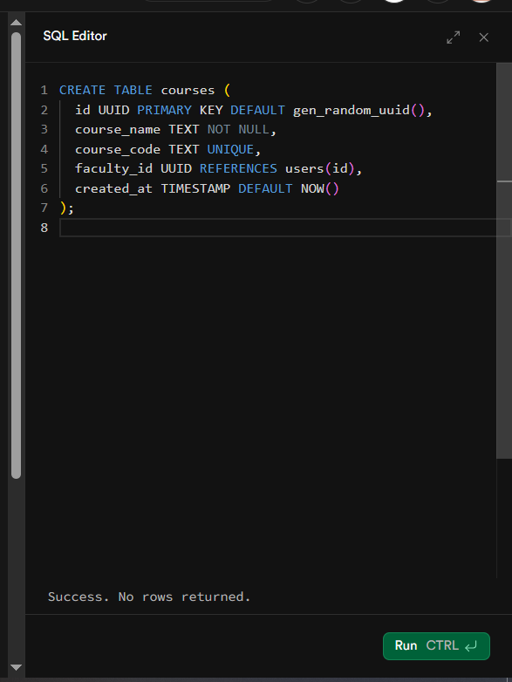
SQL table (courses) creation success
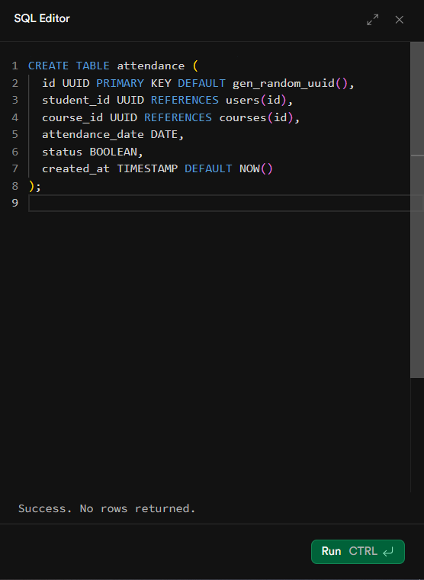
SQL table (attendance) creation success
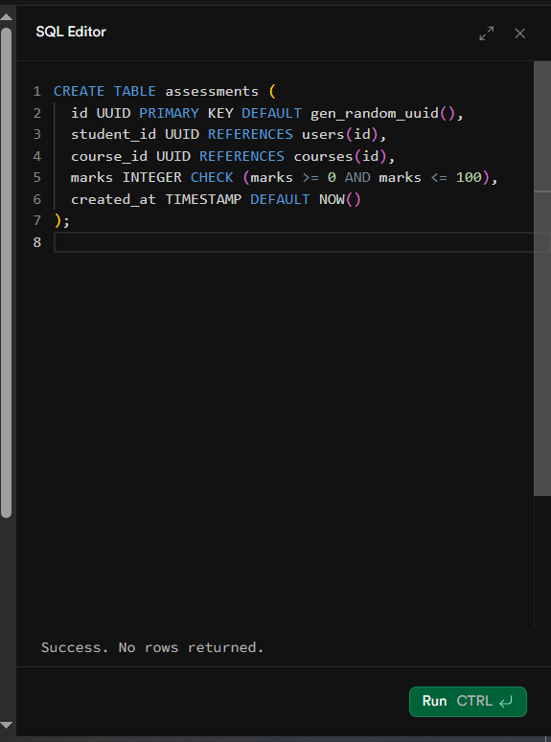
SQL table (assessments) creation success
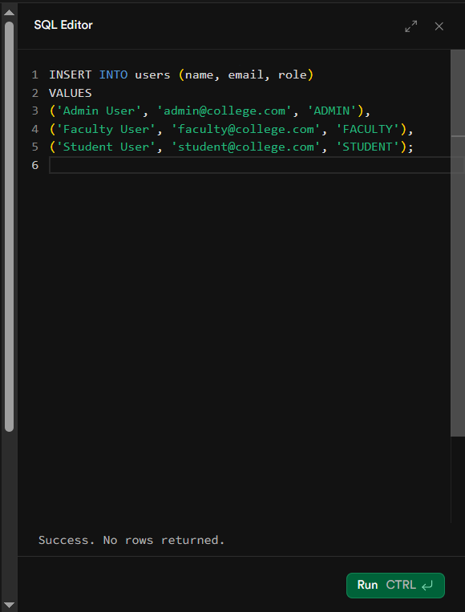
Figure 1SQL table (users) insertion success
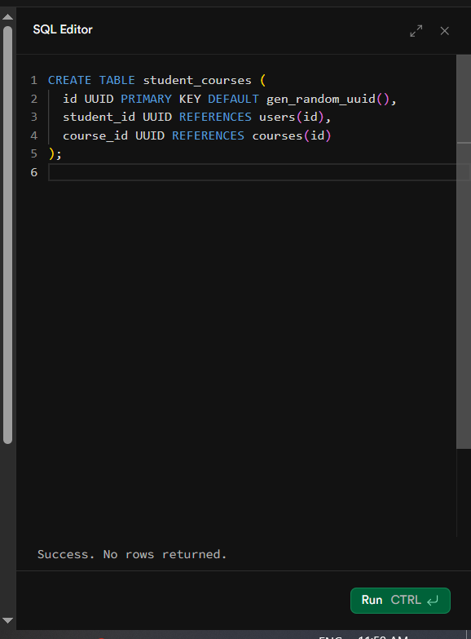
Figure 2SQL table (student_courses) creation success
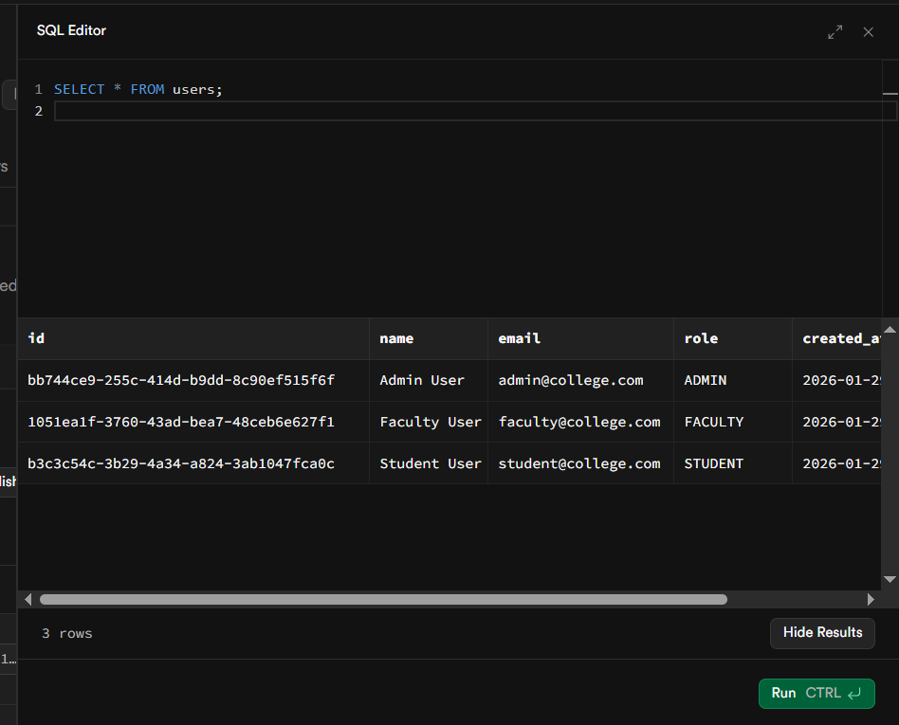
Users table data
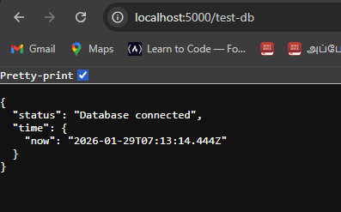
db-connection
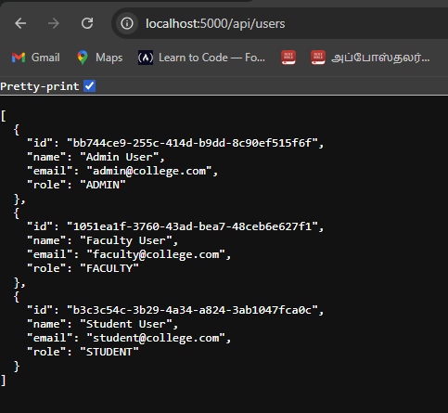
users-api-success.png

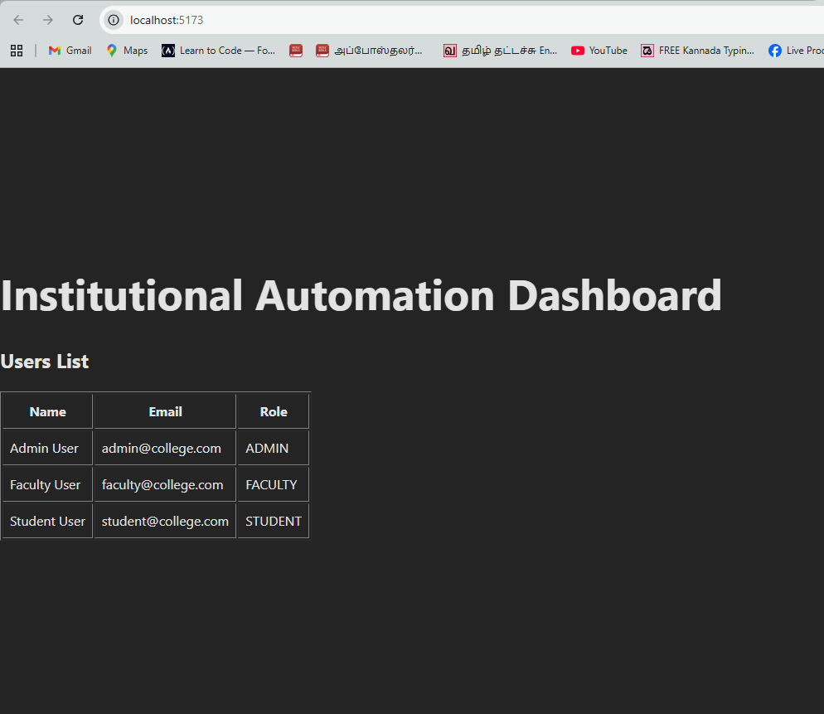
frontend-users.png
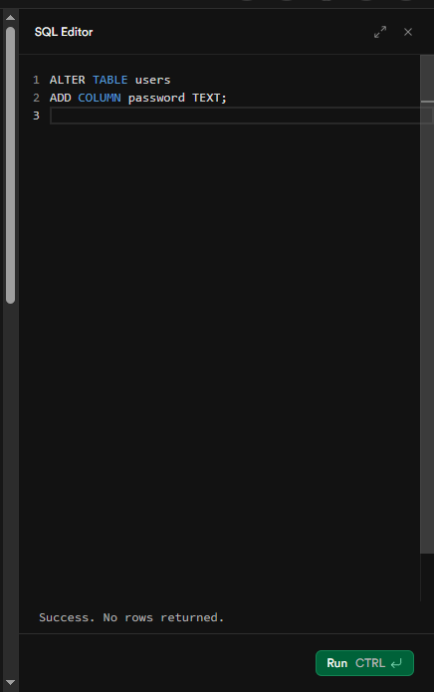
add column password to table users
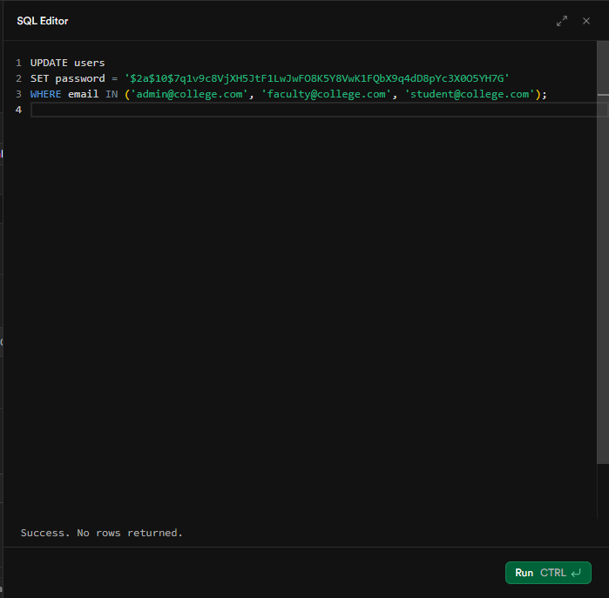

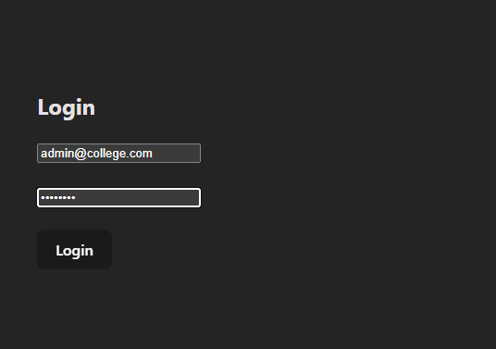
login-ui.png
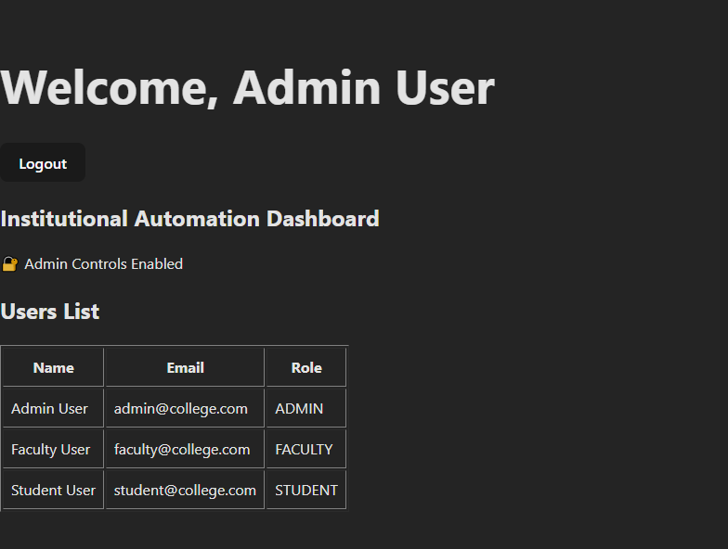
role-dashboard.png
The application uses JWT stored in browser localStorage. On logout, the token and role are removed, and the user is redirected to the login page, effectively terminating the session.
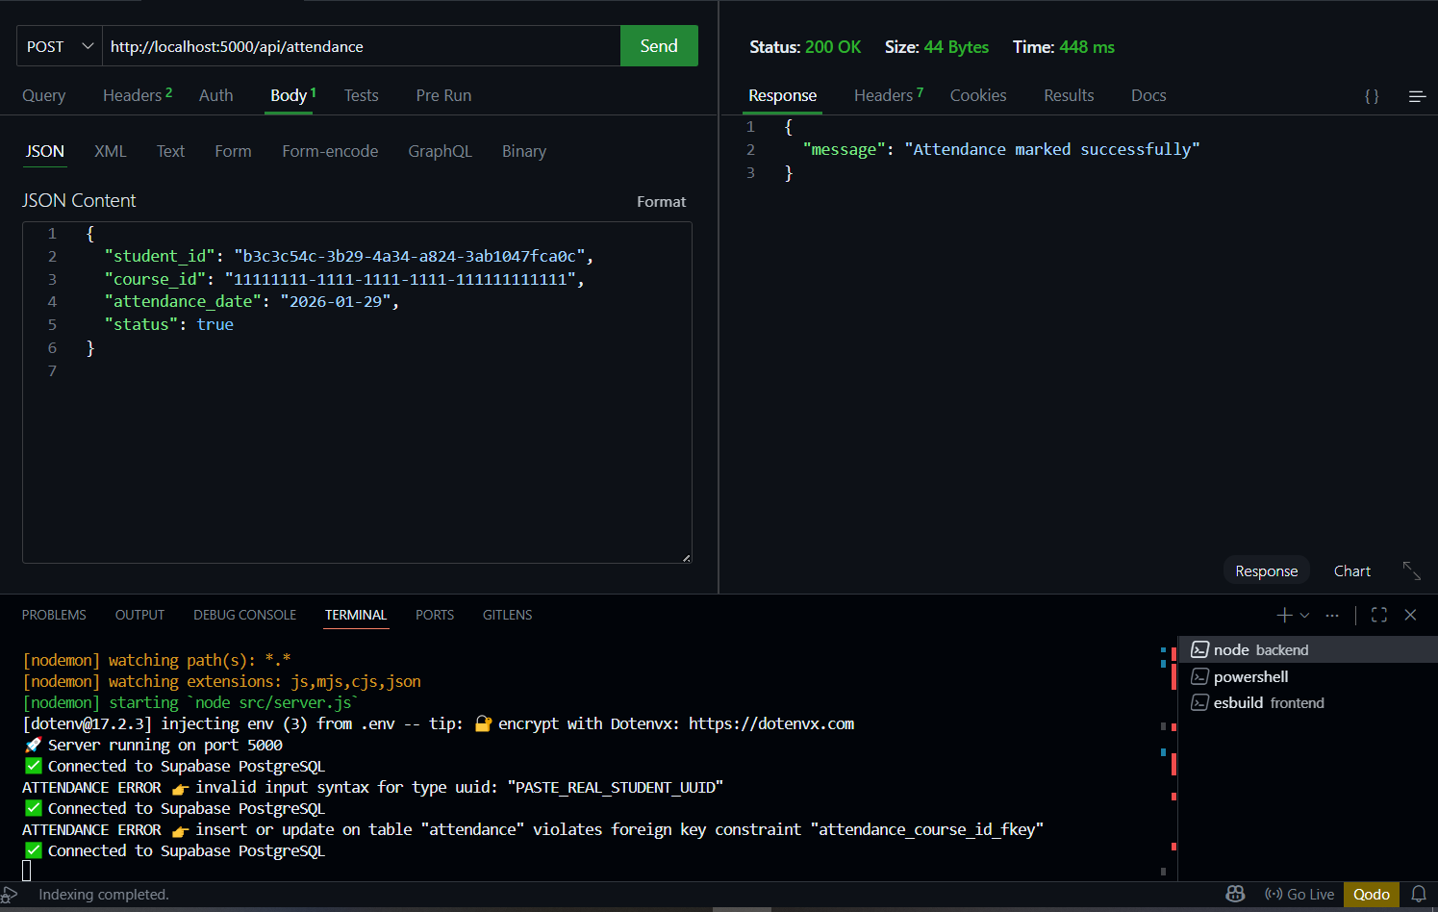
attendance-api-success.png
The attendance table initially enforced referential integrity with the courses table using foreign keys. During early prototyping, we relaxed this constraint to simplify attendance recording, and later we plan to re-enable it once the course management module is finalized.
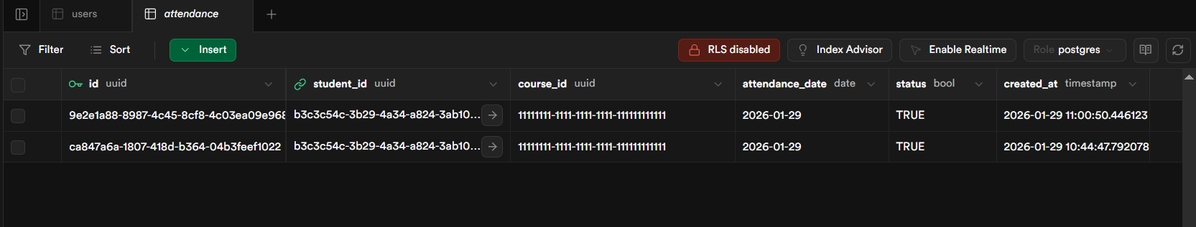
supabase-attendance-table.png
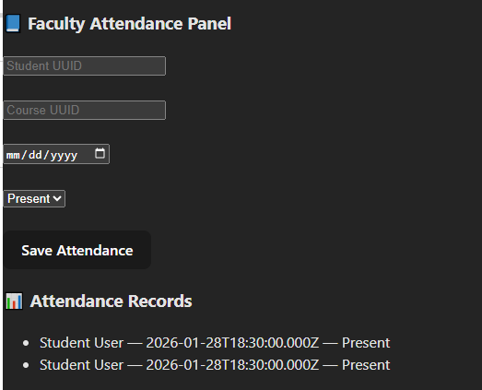
attendance-list-ui.png

The attendance module enables faculty to digitally record student presence, which is securely stored in a cloud-hosted database and later used as an input feature for AI-based academic risk prediction.

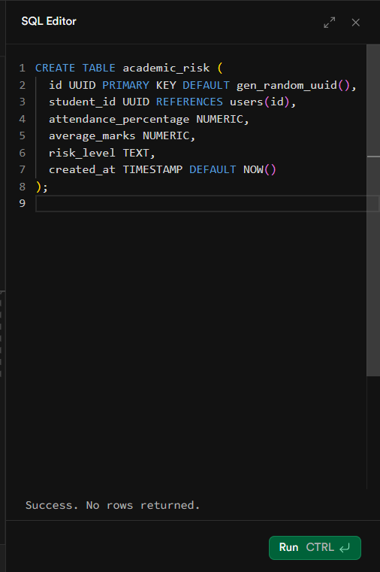
academic-risk-table.png
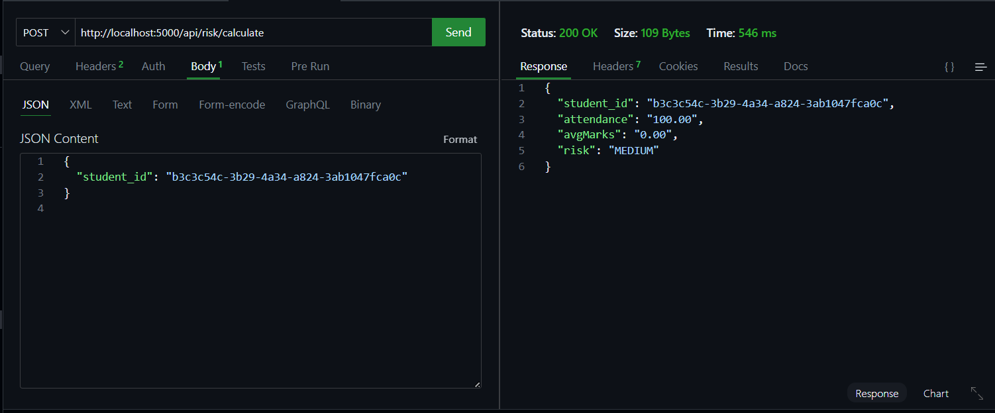
API response / Backend response
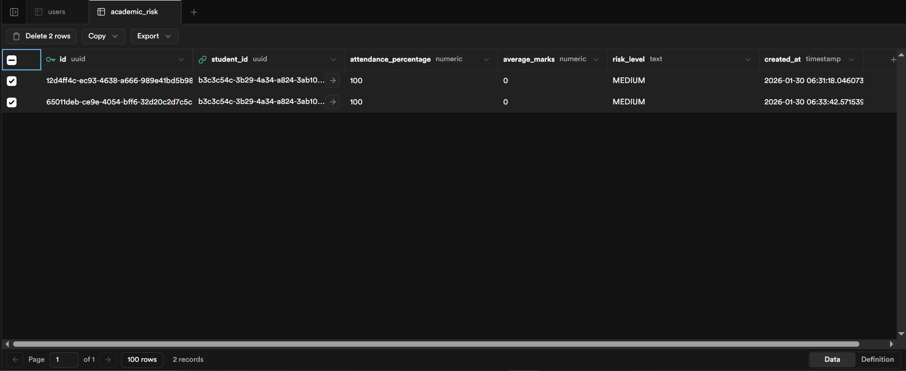
academic_risk table / Supabase academic_risk table

PostgreSQL aggregate functions return NUMERIC values, which are received as strings in Node.js. These values were explicitly cast to numbers before applying formatting and decision logic.
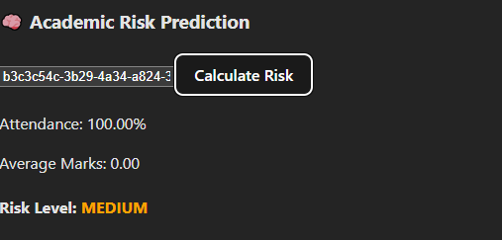
Risk calculation UI & Risk result

The system uses attendance and internal assessment data to compute a student’s academic risk level using a rule-based predictive model. This helps faculty identify at-risk students early and take corrective actions.

STEP 10: Notifications + Decision Support Module
“Don’t just predict risk — act on it.”
Risk Calculation
↓
Check Risk Level
↓
Generate Notification
↓
Store in DB
↓
Show on Admin / Faculty Dashboard
Decision Support System

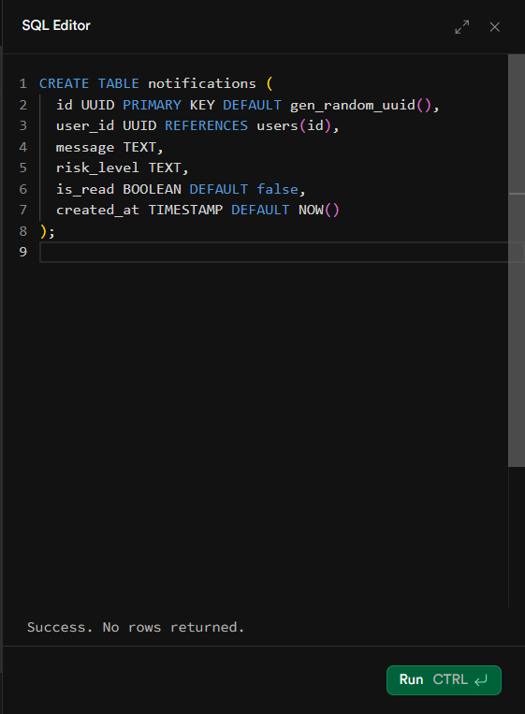
NOTIFICATIONS TABLE CREATED.png
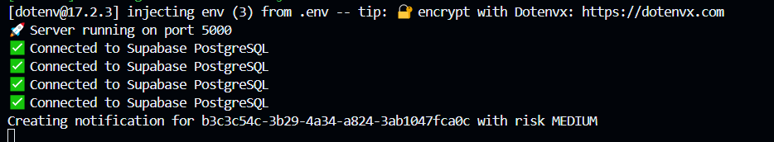
Backend Response to Notification Generation
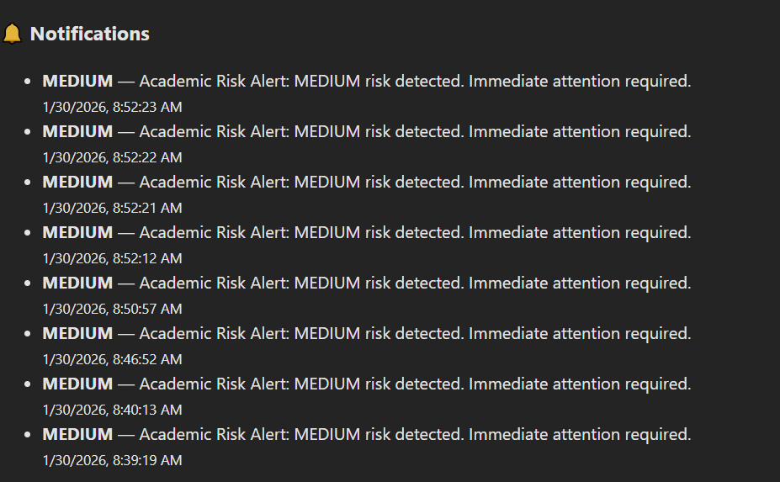

Risk alerts are generated for at-risk students and aggregated on the faculty and administrator dashboard to support institutional-level decision making.
Based on the academic risk prediction, the system automatically generates alerts for faculty and administrators, enabling early intervention and informed decision-making.

Next Step Desiging

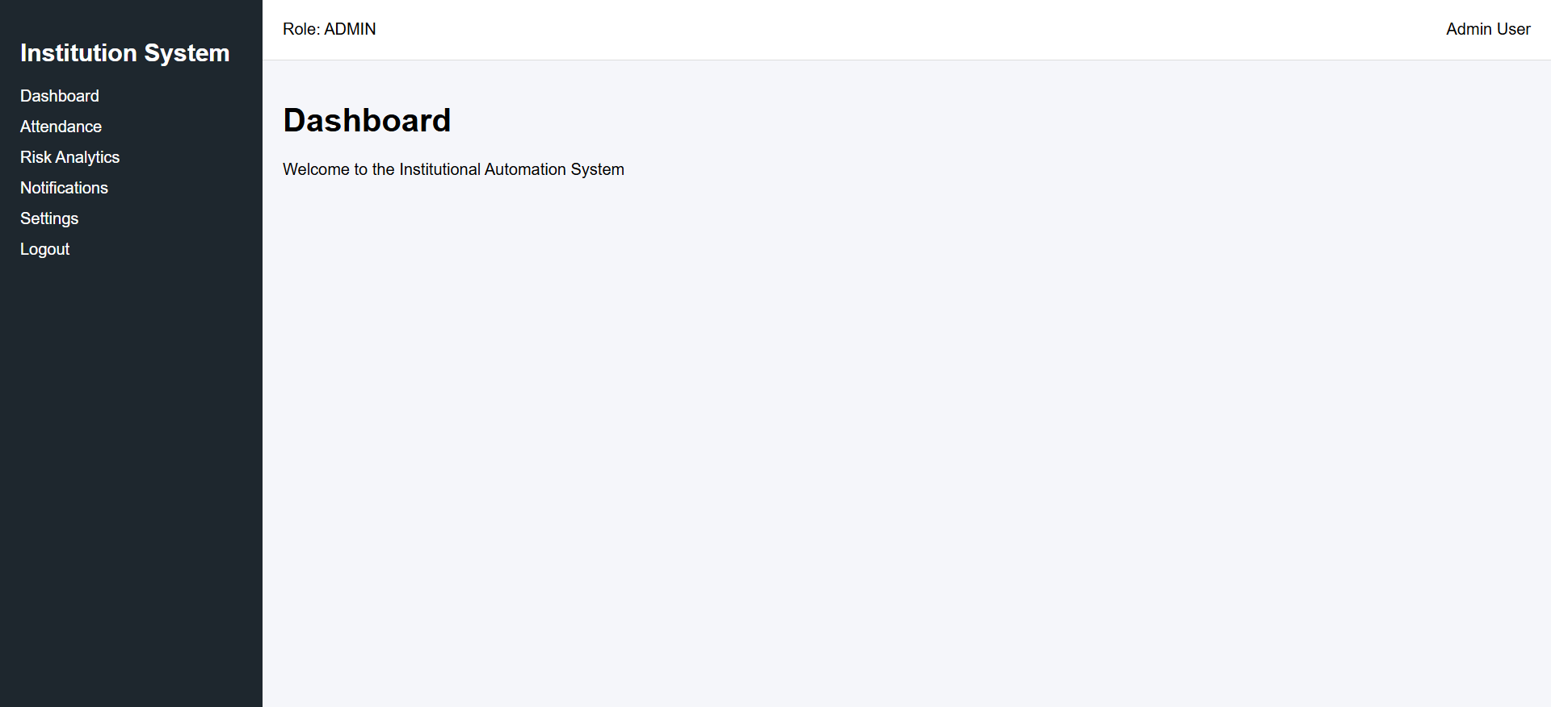

“The frontend interface follows a layout-based architecture consisting of a persistent sidebar and a top navigation bar. This structure ensures consistent navigation, role-based access visibility, and a scalable foundation for all academic and administrative modules.”

