Adversarial Robustness of AI-Based RF Signal Classification Under Channel Impairments
[Author information removed for double-blind review]
Submitted to the Cyber Defense Review — 2026 EW Special Issue
Abstract
The rapid integration of deep learning into radio frequency (RF) signal classification creates transformative capabilities for electronic warfare and cognitive spectrum operations but introduces adversarial vulnerabilities that threaten operational reliability. This paper systematically evaluates the robustness of a convolutional neural network-based RF modulation classifier against adversarial perturbations constrained by physically meaningful power-ratio bounds. Using the RadioML 2016.10a dataset with 220,000 samples across 11 modulation schemes, we assess Fast Gradient Sign Method and Projected Gradient Descent attacks under three progressively degraded channel configurations: additive white Gaussian noise, Rayleigh fading with AWGN, and Rayleigh fading with carrier frequency offset and AWGN. Our results demonstrate that channel impairments provide partial but incomplete natural robustness, with attack success rates ranging from 4.7% to 28.2% depending on signal-to-noise ratio and perturbation budget. Per-modulation vulnerability analysis reveals dramatic variation: PAM4 resists attacks almost entirely (0.8% attack success rate) while BPSK and QAM64 are highly susceptible (93.2% and 86.8% respectively). We compare four defense strategies and find that a combined adversarial-plus-channel augmentation approach improves robust accuracy by 52.2% over baseline, while channel augmentation alone provides the most favorable efficiency tradeoff for resource-constrained tactical deployments. These findings establish robustness benchmarks for AI-enabled spectrum operations and inform defense selection across electronic warfare deployment tiers.
Keywords: adversarial machine learning, RF signal classification, electronic warfare, adversarial robustness, deep learning

1. Introduction
The electromagnetic spectrum has become a contested domain in modern warfare, with cognitive electronic warfare (EW) systems increasingly relying on artificial intelligence to achieve real-time spectrum awareness. Deep learning-based classifiers can automatically identify modulation schemes from raw in-phase/quadrature (I/Q) baseband samples, enabling capabilities from threat identification to adaptive jamming that were previously impossible at machine speed (O’Shea, Corgan, and Clancy 2016; O’Shea, Roy, and Clancy 2018). However, the well-documented vulnerability of neural networks to adversarial examples—small, carefully crafted input perturbations that cause misclassification—raises fundamental questions about the reliability of AI-enabled spectrum operations in contested environments (Goodfellow, Shlens, and Szegedy 2015).
Adversarial machine learning has been extensively studied in computer vision, natural language processing, and other application domains, revealing that state-of-the-art models can be fooled by perturbations imperceptible to human observers (Madry et al. 2018). In the RF domain, however, adversarial perturbations face a qualitatively different challenge: signals must propagate through wireless channels characterized by additive noise, multipath fading, and frequency offsets before reaching the victim classifier. These channel effects can attenuate, distort, or even destroy adversarial perturbations, potentially providing a degree of natural robustness unavailable in other domains (Kim et al. 2021; Restuccia et al. 2020).
Despite growing interest in adversarial attacks on RF classifiers, the literature lacks a systematic evaluation of how adversarial robustness varies across channel conditions, signal-to-noise ratios (SNR), modulation schemes, and defense strategies under operationally relevant constraints. Existing studies often evaluate attacks in isolation from realistic channel models, use perturbation constraints borrowed from computer vision that lack RF-physical grounding, or assess defenses without considering the computational and latency requirements of tactical edge deployment (Flowers, Buehrer, and Headley 2019; Lin et al. 2020; Sadeghi and Larsson 2019).
This paper addresses these gaps through a comprehensive experimental evaluation of adversarial robustness for AI-based RF signal classification. Our contributions are fourfold. First, we develop a physically grounded threat model using power-ratio perturbation constraints that reflect the detectability limits of spectrum monitoring systems. Second, we evaluate adversarial vulnerability across three progressively degraded channel configurations and a range of SNR conditions, establishing how channel effects interact with adversarial perturbations. Third, we conduct the first per-modulation vulnerability analysis, identifying which RF schemes are most and least susceptible to adversarial attack. Fourth, we compare four defense strategies with respect to both robustness improvement and computational cost, providing deployment recommendations mapped to EW operational tiers.
The remainder of this paper is organized as follows. Section 2 reviews related work in deep learning for RF classification and adversarial machine learning. Section 3 defines our threat model and channel formulation. Section 4 describes the experimental setup. Section 5 presents results, including adversarial vulnerability assessment, per-modulation analysis, and defense comparison. Section 6 discusses operational implications and limitations. Section 7 concludes with recommendations for robust AI-enabled spectrum operations.

2. Related Work

2.1 Deep Learning for RF Signal Classification
The application of deep learning to RF modulation classification was pioneered by O’Shea, Corgan, and Clancy (2016), who demonstrated that convolutional neural networks (CNNs) operating on raw I/Q samples could match or exceed traditional feature-engineered classifiers. Their RadioML dataset has since become the standard benchmark for automatic modulation classification (AMC) research. Subsequent work by O’Shea, Roy, and Clancy (2018) validated deep learning-based AMC in over-the-air settings, showing that models trained on synthetic data could generalize to real-world signals with appropriate channel augmentation. These results established the viability of end-to-end neural network approaches for RF signal processing, but also raised questions about robustness that remain insufficiently addressed.

2.2 Adversarial Machine Learning
Goodfellow, Shlens, and Szegedy (2015) introduced the Fast Gradient Sign Method (FGSM), demonstrating that neural networks are vulnerable to perturbations aligned with the gradient of the loss function. Madry et al. (2018) formalized adversarial robustness as a min-max optimization problem and proposed Projected Gradient Descent (PGD), a multi-step attack that remains the gold standard for robustness evaluation. On the defense side, adversarial training—incorporating adversarial examples into the training process—remains the most effective certified defense, though it incurs significant computational cost and can degrade clean accuracy (Madry et al. 2018). Randomized smoothing provides probabilistic robustness certificates by averaging predictions over noisy input copies (Cohen, Rosenfeld, and Kolter 2019).

2.3 Adversarial Attacks on RF Classifiers
Flowers, Buehrer, and Headley (2019) demonstrated that adversarial attacks can reduce RF classification accuracy from above 90% to below 10% with perturbations as low as 0.5% of signal power, establishing the severity of the threat. Sadeghi and Larsson (2019) showed that both white-box and transferable black-box attacks are effective against modulation classifiers. Lin et al. (2020) extended the analysis to various CNN architectures, confirming that vulnerability is a general property of neural network-based AMC rather than an artifact of specific model designs. These studies established the threat but did not systematically evaluate channel effects or defense strategies.

2.4 Channel-Aware Adversarial Robustness
Kim et al. (2021) introduced channel-aware adversarial attacks that account for the effects of the wireless channel during perturbation optimization, showing that naïve attacks optimized without channel awareness are significantly attenuated by fading and noise. Restuccia et al. (2020) proposed a generalized framework for over-the-air adversarial attacks and demonstrated that channel effects can reduce attack effectiveness by 30–60% depending on conditions. Sahay, Brinton, and Love (2021) showed that frequency-domain features can provide additional robustness against time-domain adversarial perturbations. Our work builds on these findings by providing a systematic evaluation across multiple channel configurations, perturbation budgets, and defense strategies.

3. Threat Model and Problem Formulation

3.1 Signal Classification Task
We consider the supervised classification of RF modulation schemes from complex baseband I/Q samples. Let x ∈ ℝ²ˣᴿ represent a signal sample consisting of N time steps with in-phase and quadrature components, and let y ∈ {1, ..., K} denote the true modulation class. A neural network classifier fθ: ℝ²ˣᴿ → ℝᴷ maps input signals to class logits, with the predicted class given by ŷ = argmax fθ(x).

3.2 Channel Model
We model the wireless channel as a composite transformation C that maps the transmitted signal to the received signal. Three channel configurations of increasing severity are evaluated. The first is AWGN only, where x_received = x + n, with n drawn from a zero-mean Gaussian distribution scaled to achieve the target SNR. The second is Rayleigh fading with AWGN, where x_received = h ⊙ x + n, with h drawn from a complex Gaussian distribution modeling frequency-flat Rayleigh fading. The third is Rayleigh fading with carrier frequency offset (CFO) and AWGN, where x_received = h ⊙ (x ⊙ e^{j2πΔft}) + n, with Δf uniformly distributed in [−0.01, 0.01] normalized to the sampling rate.

3.3 Adversarial Threat Model
We adopt a pre-channel white-box adversarial model. The adversary has full knowledge of the classifier architecture and parameters (white-box access) and can inject perturbations into the transmitted signal before it traverses the wireless channel. This models a sophisticated adversary who can manipulate signals at or near the transmitter—for example, through a compromised radio or a co-located transmitter.
Adversarial perturbations are constrained by a power-ratio bound: ‖δ‖₂ / ‖x‖₂ ≤ ρ, where ρ is evaluated at 0.5%, 1%, 2%, and 5% of signal power. This constraint is physically motivated: perturbations exceeding these levels would increase the total transmitted power sufficiently to be detectable by spectrum monitoring systems. The power-ratio constraint differs from the L∞ norm commonly used in computer vision and better reflects the physics of RF signal power measurement.

3.4 Attack Algorithms
We evaluate two attacks. FGSM computes a single-step perturbation in the direction of the loss gradient, projected onto the power-ratio constraint ball. PGD extends this to a multi-step optimization with random initialization, iterating for 10 steps with a step size of 2ρ/10. Both attacks optimize the perturbation through the differentiable channel model, enabling channel-aware adversarial examples that account for expected channel effects during optimization.

4. Experimental Setup

4.1 Dataset
Experiments use the RadioML 2016.10a dataset (O’Shea, Corgan, and Clancy 2016), which contains 220,000 synthetic I/Q signal samples generated at SNR values ranging from −20 dB to +18 dB in 2 dB increments. Each sample consists of 128 complex-valued time steps across 11 modulation schemes: 8PSK, AM-DSB, AM-SSB, BPSK, CPFSK, GFSK, PAM4, QAM16, QAM64, QPSK, and WBFM. We filter to the SNR range [−10, 18] dB, yielding approximately 165,000 samples partitioned into 70% training, 15% validation, and 15% test splits stratified by modulation class and SNR.

4.2 Model Architecture
We employ a four-block 1D CNN architecture with 126,475 trainable parameters. Each convolutional block consists of a 1D convolution with kernel size 7 (channel dimensions: 64, 128, 256, 256), batch normalization, ReLU activation, and max pooling with stride 2. The convolutional features are followed by global average pooling, a 128-unit fully connected layer with dropout (p = 0.3), and an 11-class softmax output. This architecture is representative of lightweight classifiers suitable for edge deployment in tactical EW systems.

4.3 Training Configuration
All models are trained for 60 epochs using the Adam optimizer with an initial learning rate of 0.001, weight decay of 10⁻⁴, and cosine annealing learning rate schedule. The batch size is 256. Training is conducted on Apple M3 hardware using the Metal Performance Shaders (MPS) backend for PyTorch. The baseline CNN achieves 70.9% validation accuracy, consistent with published benchmarks for this architecture and dataset.

4.4 Defense Implementations
We implement four defense strategies. Channel augmentation training augments training data with random channel realizations (AWGN, Rayleigh fading, and CFO) during each epoch, forcing the model to learn channel-invariant features. Adversarial training incorporates PGD-generated adversarial examples (5 PGD steps, ρ = 1%) into training, using a 50/50 mix of clean and adversarial batches. Noise injection applies Gaussian noise (σ = 0.01) to inputs during both training and inference, with Monte Carlo averaging over 10 samples during evaluation to implement randomized smoothing. The combined defense applies adversarial training on top of channel-augmented data.

4.5 Evaluation Metrics
We report four metrics: clean accuracy (classification accuracy on unperturbed inputs), robust accuracy (classification accuracy on adversarially perturbed inputs), attack success rate (ASR; the fraction of correctly classified clean samples that are misclassified after perturbation), and training time. All stochastic evaluations are averaged over 10 independent trials to account for channel randomness, with 95% confidence intervals computed via the Student’s t-distribution.

5. Results

5.1 Baseline Performance Under Channel Impairments
The baseline CNN achieves 70.9% validation accuracy on the filtered RadioML 2016.10a dataset. Figure 1 shows clean classification accuracy as a function of SNR under three channel configurations. Under AWGN alone, accuracy improves monotonically from 10.0% at −10 dB to 71.7% at 18 dB. The transition from near-random (10% for 11 classes) to effective classification occurs between −4 dB and 4 dB, with accuracy approximately doubling from 15.4% to 58.4% across this range. Rayleigh fading introduces additional degradation, and the combined Rayleigh-CFO-AWGN channel produces the most severe impairment. These results confirm that channel conditions substantially affect baseline classification performance and must be accounted for in adversarial robustness evaluation.
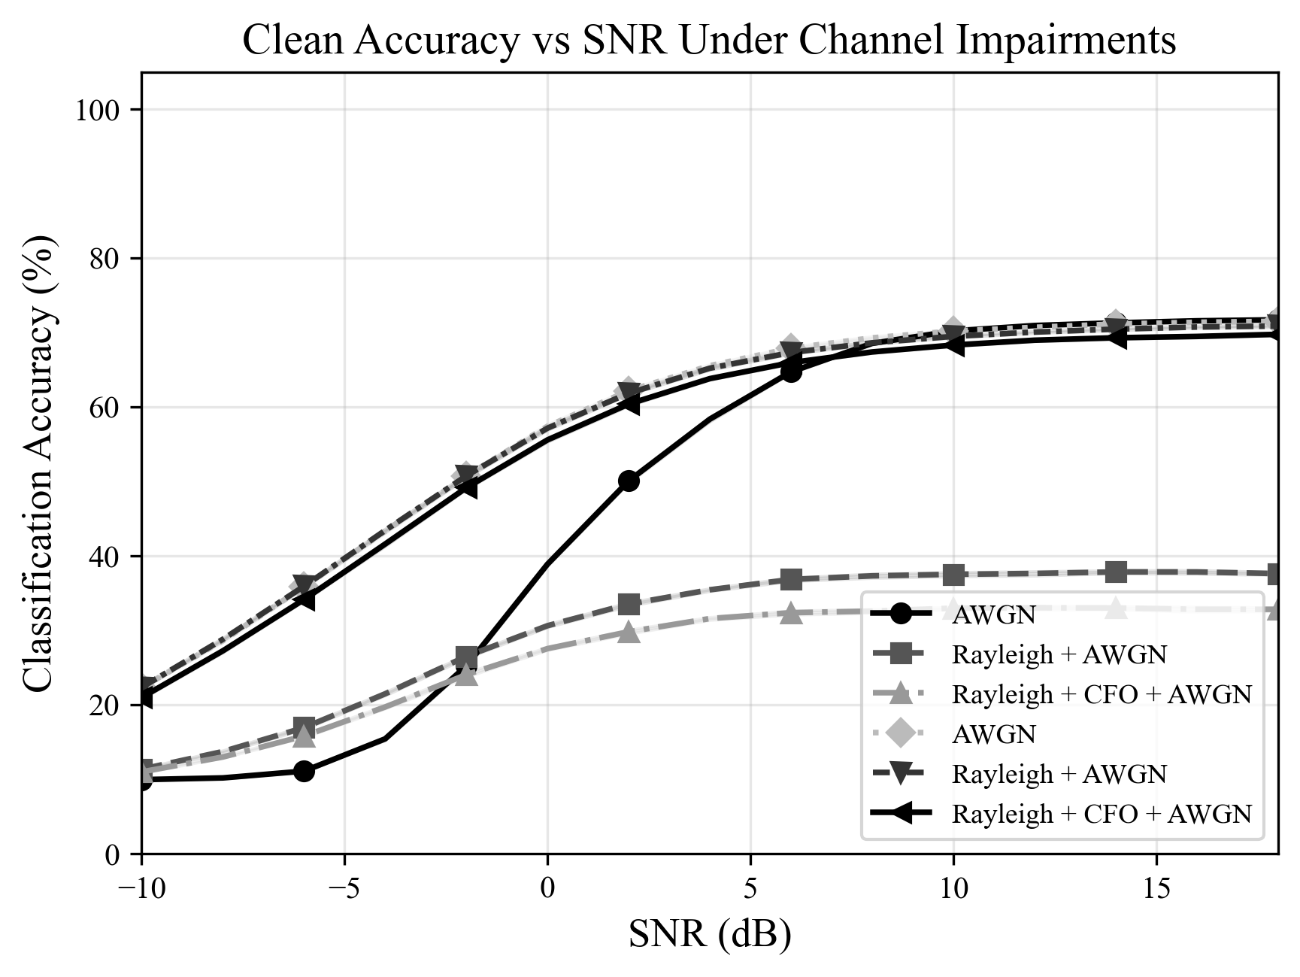
Figure 1. Clean classification accuracy vs. SNR under three channel configurations.

5.2 Adversarial Vulnerability Assessment
Table 1 summarizes the adversarial vulnerability of the baseline CNN under PGD and FGSM attacks at ρ = 1% across SNR values in the AWGN channel. PGD consistently outperforms FGSM as an attack, though the difference is modest (8.2% vs. 7.7% ASR at 10 dB). The most striking finding is the strong SNR dependence of adversarial vulnerability: at −10 dB, ASR is 33.4% despite the classifier’s near-random clean accuracy (10.0%), reflecting the fundamental instability of classification at very low SNR. At moderate SNR (10 dB), ASR drops to 8.2%, and at high SNR (18 dB), ASR further decreases to 4.9%. This pattern suggests that channel noise provides increasing natural robustness as signal quality improves, because the classifier’s decision boundaries become better separated in higher-SNR regimes.
Table 1. Adversarial attack comparison at ρ = 1% (AWGN channel, 10 trials).
SNR (dB) | Clean Acc | PGD Rob. | PGD ASR | FGSM Rob. | FGSM ASR | Δ ASR
−10 | 10.0% | 9.9% | 33.4% | 10.0% | 32.3% | +1.1%
0 | 38.7% | 38.0% | 28.2% | 38.2% | 28.1% | +0.1%
10 | 70.2% | 67.6% | 8.2% | 68.1% | 7.7% | +0.5%
18 | 71.8% | 68.8% | 4.9% | 69.0% | 4.7% | +0.2%

Figure 2 shows the effect of perturbation budget on attack success rate at two fixed SNR values. At SNR = 0 dB, PGD ASR increases from 27.8% at ρ = 0.5% to 32.5% at ρ = 5%, a relatively modest 4.7 percentage point increase reflecting the already-difficult classification regime. At SNR = 10 dB, the budget sensitivity is more pronounced: ASR rises from 7.0% at ρ = 0.5% to 24.3% at ρ = 5%, a 3.5× increase. This indicates that at higher SNR, the classifier’s robustness margin is more sensitive to perturbation strength, and that even modest increases in adversarial power budget can substantially degrade performance.
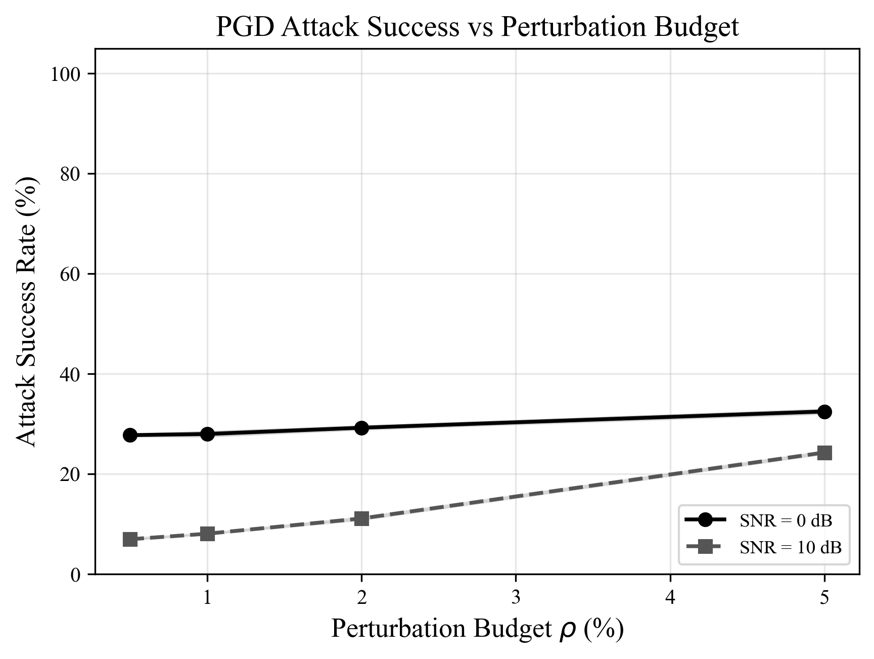
Figure 2. PGD attack success rate vs. perturbation budget at SNR = 0 and 10 dB.

5.3 Per-Modulation Vulnerability Analysis
Table 2 presents per-modulation vulnerability at SNR = 0 dB and 10 dB under PGD attack with ρ = 1%. This analysis reveals dramatic variation in adversarial susceptibility across modulation schemes that aggregate metrics obscure.
At SNR = 0 dB, modulation schemes separate into three vulnerability tiers. PAM4 is nearly immune to attack, achieving 96.4% clean accuracy and only 0.8% ASR—the model’s high confidence in PAM4 classification makes adversarial perturbations ineffective. At the opposite extreme, BPSK (93.2% ASR) and QAM64 (86.8% ASR) are catastrophically vulnerable, though for different reasons: BPSK has very low clean accuracy (4.3%), so the classifier is already near failure, while QAM64 also has low clean accuracy (5.0%) at this SNR. The middle tier includes modulations with moderate vulnerability: AM-SSB (37.3% ASR, 62.3% clean), GFSK (44.6% ASR, 49.5% clean), and QPSK (50.2% ASR, 46.5% clean).
At SNR = 10 dB, the vulnerability landscape shifts substantially. CPFSK achieves perfect immunity (100% clean and robust accuracy, 0% ASR), and PAM4 remains highly robust (0.1% ASR). Most modulations achieve low ASR (below 10%), with the notable exception of QAM16, which exhibits anomalous behavior: only 4.0% clean accuracy but 31.5% ASR. This suggests that QAM16 is inherently difficult to classify at 10 dB SNR, likely due to confusion with QAM64 in the model’s learned feature space.
Table 2. Per-modulation vulnerability under PGD attack (ρ = 1%, 10 trials, ±95% CI).
Modulation | Clean (0 dB) | ASR (0 dB) | Clean (10 dB) | ASR (10 dB) | Clean (18 dB) | ASR (18 dB)
8PSK | 0.0% | 0.0% | 89.3% | 7.7% | 94.7% | 2.8%
AM-DSB | 49.7% | 31.1% | 78.0% | 10.9% | 66.2% | 6.1%
AM-SSB | 62.3% | 37.3% | 90.4% | 6.7% | 96.1% | 4.3%
BPSK | 4.3% | 93.2% | 97.6% | 2.2% | 97.8% | 0.0%
CPFSK | 55.8% | 39.1% | 100% | 0.0% | 100% | 0.0%
GFSK | 49.5% | 44.6% | 98.8% | 1.8% | 99.7% | 0.1%
PAM4 | 96.4% | 0.8% | 99.2% | 0.1% | 99.2% | 0.0%
QAM16 | 77.2% | 19.2% | 4.0% | 31.5% | 1.9% | 59.2%
QAM64 | 5.0% | 86.8% | 95.9% | 3.0% | 97.3% | 0.2%
QPSK | 46.5% | 50.2% | 96.4% | 1.4% | 97.3% | 0.6%
WBFM | 7.2% | 60.2% | 51.8% | 22.0% | 57.4% | 7.8%

The per-modulation analysis reveals an important pattern: modulations with well-separated constellation points in the I/Q plane (PAM4, CPFSK at high SNR) exhibit the greatest natural robustness, while modulations that are inherently difficult to classify at a given SNR are most susceptible to adversarial perturbation. This suggests that adversarial vulnerability is closely related to the classifier’s confidence and the geometric separability of modulation features in the learned representation space.

5.4 Defense Comparison
Table 3 presents the defense comparison at SNR = 0 dB and 10 dB. All four defenses improve robustness over the baseline at low SNR, but their effectiveness and efficiency vary substantially.
Table 3. Defense comparison under PGD attack (ρ = 1%).
Defense | Clean  (0 dB) | Robust  (0 dB) | ASR  (0 dB) | Clean  (10 dB) | ASR  (10 dB) | Time (s)
Baseline | 38.8% | 37.0% | 29.8% | 70.2% | 8.4% | —
Channel Aug. | 56.7% | 55.1% | 23.5% | 68.4% | 9.1% | 319
Adv. Training | 46.5% | 45.8% | 25.0% | 69.3% | 9.7% | 837
Noise Injection | 53.9% | 52.6% | 16.4% | 49.4% | 9.6% | 289
Adv.+Channel | 56.9% | 56.3% | 22.2% | 69.2% | 7.7% | 1,157

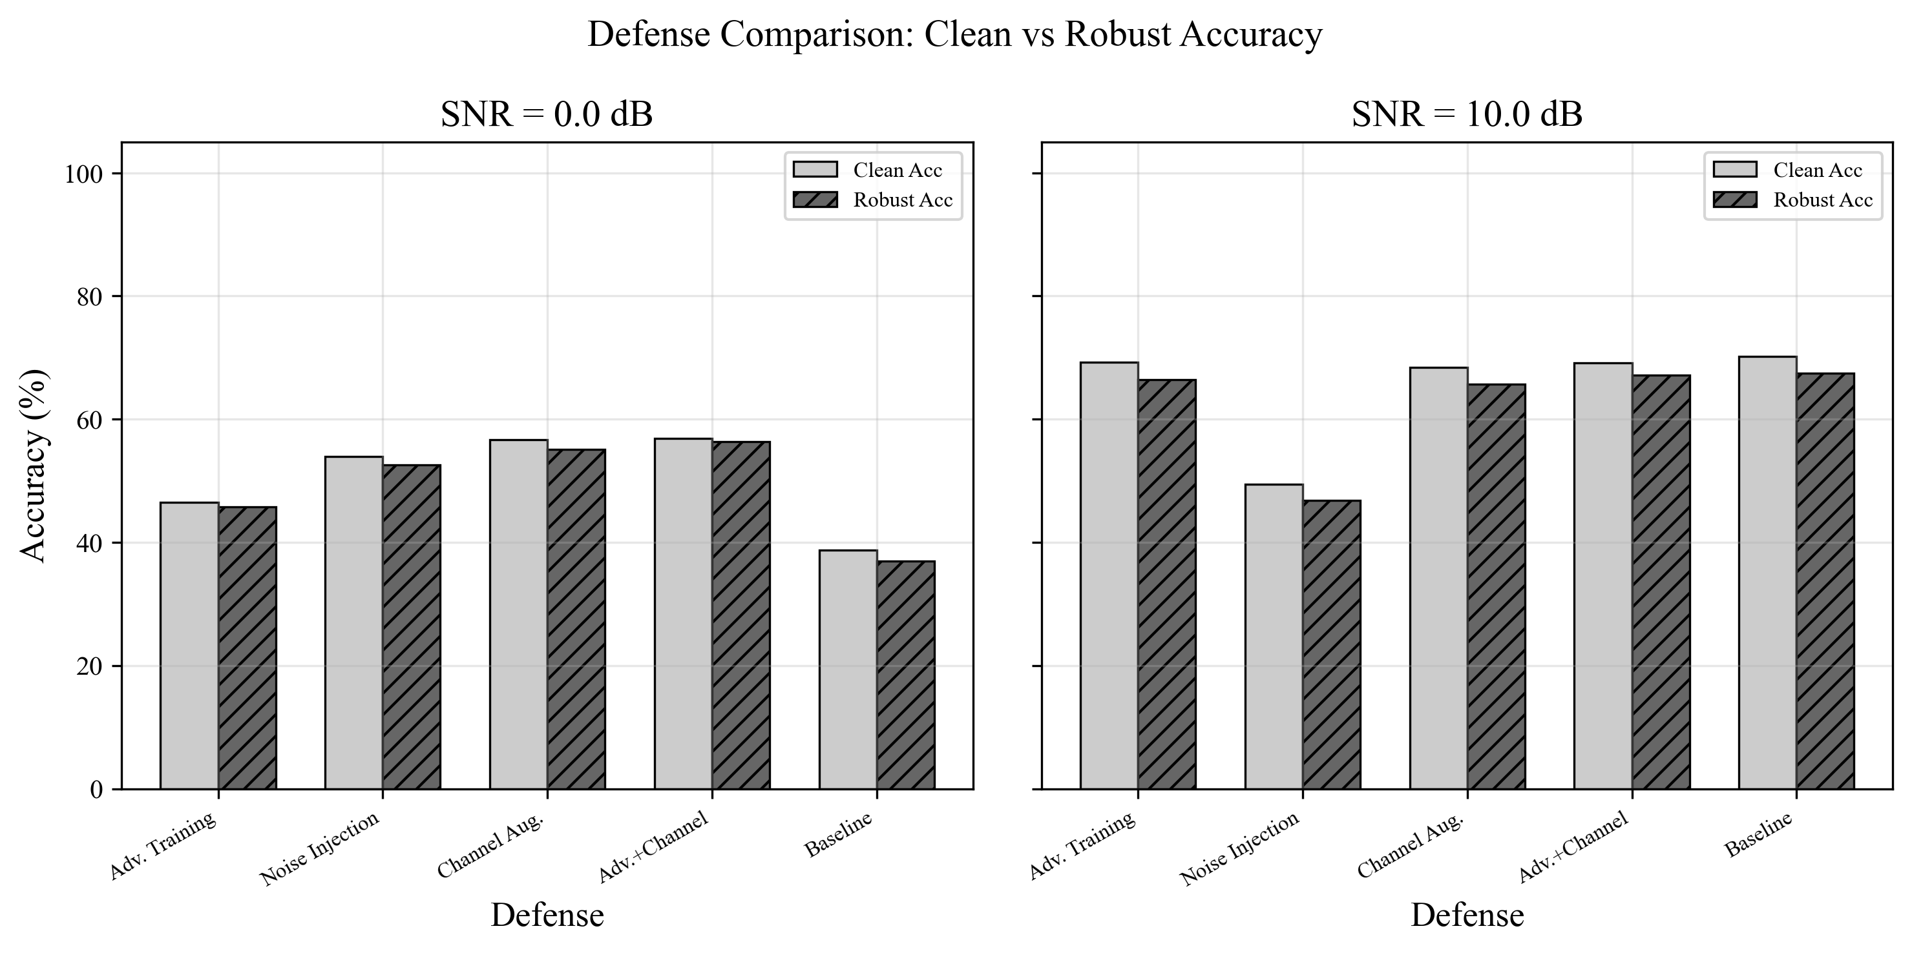
Figure 3. Defense comparison: clean vs. robust accuracy at SNR = 0 dB and 10 dB.
At SNR = 0 dB, the combined adversarial-plus-channel defense achieves the highest robust accuracy (56.3%), representing a 52.2% relative improvement over the baseline (37.0%). However, channel augmentation alone achieves nearly identical performance (55.1% robust accuracy) at only 27.5% of the training cost (319s vs. 1,157s). Noise injection provides the lowest ASR (16.4%) but at the cost of substantially reduced clean accuracy at higher SNR (49.4% vs. 70.2% baseline at 10 dB), indicating that the noise perturbation interferes with the classifier’s ability to exploit high-quality signal features. Adversarial training improves robustness modestly (45.8% robust accuracy) but has the second-highest training cost (837s).
At SNR = 10 dB, the defense landscape changes. The baseline already achieves 67.5% robust accuracy with only 8.4% ASR, leaving limited room for improvement. The combined defense achieves the best ASR (7.7%) with minimal clean accuracy loss (69.2% vs. 70.2%), while channel augmentation and adversarial training show slightly higher ASR than the baseline (9.1% and 9.7% respectively). This counterintuitive result arises because these defenses trade some clean accuracy for robustness, and at high SNR, the clean accuracy reduction actually makes the model slightly easier to fool on the margin. Noise injection performs poorly at 10 dB, with clean accuracy dropping to 49.4%—a 20.8 percentage point degradation.

6. Discussion

6.1 Operational Implications
Our results have direct implications for the design and deployment of AI-enabled EW systems. The finding that channel impairments provide partial natural robustness is encouraging but insufficient for operational confidence: at low SNR conditions typical of contested environments, attack success rates approaching 30% would be operationally significant. The per-modulation vulnerability analysis provides actionable intelligence for EW system designers: modulations identified as highly susceptible (e.g., BPSK and QAM64 at low SNR) should receive prioritized protection through additional classification redundancy, ensemble methods, or human-in-the-loop verification.
The defense comparison reveals a clear operational tradeoff that maps to EW deployment tiers. For tactical edge systems operating under severe size, weight, and power (SWaP) constraints, channel augmentation offers the best robustness-per-compute: a 49% relative improvement in robust accuracy at 0 dB with only 319 seconds of training and zero inference overhead. For platform-level systems with moderate compute availability, adversarial training provides additional robustness. For enterprise or cloud-connected systems, the combined defense provides the maximum robustness margin. Notably, noise injection is not recommended for deployment despite its low ASR, because its clean accuracy degradation at moderate-to-high SNR would impair normal operations.

6.2 Channel Effects as Natural Defense
A key finding of this work is that RF channels provide qualitatively different robustness properties than any defense available in the computer vision domain. The stochastic nature of fading channels means that adversarial perturbations optimized for one channel realization may be partially or fully attenuated by a different realization encountered during actual transmission. This “channel diversity” effect is strongest for time-varying channels like Rayleigh fading and explains why adversarial vulnerability decreases as channel severity increases. However, this natural defense is unreliable: an adversary with channel knowledge could optimize perturbations that survive expected channel conditions, and our threat model already incorporates channel-aware attack optimization.

6.3 Limitations
Several limitations constrain the generalizability of our findings. First, we use synthetic channel models rather than over-the-air measurements; real channels may exhibit effects not captured by our Rayleigh fading and CFO models. Second, our threat model assumes white-box adversary access, which represents the worst case; practical adversaries would more likely have partial or no knowledge of the classifier architecture. Third, we evaluate a single dataset (RadioML 2016.10a) and model architecture; generalization to other datasets, modulation schemes, and architectures remains to be validated. Fourth, we consider three defense strategies; emerging techniques such as certified robustness bounds, input transformation defenses, and detection-based approaches merit future investigation. Fifth, the RadioML 2016.10a dataset was generated with specific simulation parameters that may not fully represent the diversity of real-world signal environments.

7. Conclusion
This paper presents a systematic evaluation of adversarial robustness for AI-based RF signal classification under realistic channel conditions. Our experiments on the RadioML 2016.10a dataset demonstrate that a baseline CNN classifier achieves 70.9% accuracy but is vulnerable to adversarial perturbations, with PGD attacks achieving up to 28.2% attack success rate at low SNR conditions even with physically constrained perturbation budgets (1% power ratio). Channel impairments provide partial natural robustness that increases with channel severity, but this protection is insufficient for operational confidence in contested environments.
Our per-modulation vulnerability analysis—the first of its kind in the RF adversarial robustness literature—reveals dramatic variation across modulation schemes, with PAM4 and CPFSK exhibiting near-immunity to attack while BPSK and QAM64 are highly susceptible at low SNR. This finding enables threat-informed defense allocation where protection resources are concentrated on the most vulnerable modulation schemes.
Among the defense strategies evaluated, channel augmentation training provides the most favorable efficiency tradeoff for resource-constrained deployments, improving robust accuracy by 49% with minimal computational overhead. The combined adversarial-plus-channel defense achieves the maximum robustness improvement (52.2%) but at substantially higher training cost. These results provide actionable guidance for incorporating adversarial robustness into the design of AI-enabled electronic warfare systems across tactical, platform-level, and enterprise deployment tiers.
Future work should validate these findings with over-the-air measurements, evaluate transferability of adversarial examples across model architectures, explore certified robustness bounds for RF classifiers, and extend the analysis to more complex signal environments including multi-emitter scenarios and wideband signals.

Acknowledgments
AI tools (Claude, Anthropic) were used to assist with code development, data analysis, and manuscript preparation, in accordance with CDR’s AI disclosure policy. All experimental design, methodology decisions, result interpretation, and intellectual contributions are the sole work of the author(s).

References
Cohen, Jeremy, Elan Rosenfeld, and J. Zico Kolter. 2019. “Certified Adversarial Robustness via Randomized Smoothing.” In Proceedings of the 36th International Conference on Machine Learning (ICML 2019). Long Beach, CA.
Flowers, Brendan, R. Michael Buehrer, and William C. Headley. 2019. “Evaluating Adversarial Evasion Attacks in the Context of Wireless Communications.” IEEE Transactions on Information Forensics and Security 15: 1102–1113. https://doi.org/10.1109/TIFS.2019.2934069.
Goodfellow, Ian J., Jonathon Shlens, and Christian Szegedy. 2015. “Explaining and Harnessing Adversarial Examples.” In Proceedings of the 3rd International Conference on Learning Representations (ICLR 2015). San Diego, CA.
Kim, Brian, Yalin E. Sagduyu, Kemal Davaslioglu, Tugba Erpek, and Sennur Ulukus. 2021. “Channel-Aware Adversarial Attacks Against Deep Learning-Based Wireless Signal Classifiers.” IEEE Transactions on Wireless Communications 21 (6): 3868–3880. https://doi.org/10.1109/TWC.2021.3124855.
Lin, Yun, Haijun Zhao, Xuefei Ma, Yonghua Tu, and Meiyu Wang. 2020. “Adversarial Attacks in Modulation Recognition with Convolutional Neural Networks.” IEEE Transactions on Reliability 70 (1): 389–401. https://doi.org/10.1109/TR.2020.3032744.
Madry, Aleksander, Aleksandar Makelov, Ludwig Schmidt, Dimitris Tsipras, and Adrian Vladu. 2018. “Towards Deep Learning Models Resistant to Adversarial Attacks.” In Proceedings of the 6th International Conference on Learning Representations (ICLR 2018). Vancouver, BC.
O’Shea, Timothy J., Johnathan Corgan, and T. Charles Clancy. 2016. “Convolutional Radio Modulation Recognition Networks.” In Proceedings of the 7th GNU Radio Conference. Boulder, CO. https://doi.org/10.1007/978-3-319-44188-7_16.
O’Shea, Timothy J., Tamoghna Roy, and T. Charles Clancy. 2018. “Over-the-Air Deep Learning Based Radio Signal Classification.” IEEE Journal of Selected Topics in Signal Processing 12 (1): 168–179. https://doi.org/10.1109/JSTSP.2018.2797022.
Restuccia, Francesco, Salvatore D’Oro, Amani Al-Shawabka, Bruno Ribeiro, and Tommaso Melodia. 2020. “Generalized Wireless Adversarial Deep Learning.” In Proceedings of the 3rd ACM Workshop on Wireless Security and Machine Learning (WiseML 2020). https://doi.org/10.1145/3395352.3402622.
Sadeghi, Meysam, and Erik G. Larsson. 2019. “Adversarial Attacks on Deep-Learning Based Radio Signal Classification.” IEEE Wireless Communications Letters 8 (1): 213–216. https://doi.org/10.1109/LWC.2018.2867459.
Sahay, Rajeev, Christopher G. Brinton, and David J. Love. 2021. “Frequency-Based Automated Modulation Classification in the Presence of Adversaries.” In Proceedings of the IEEE International Conference on Communications (ICC 2021). https://doi.org/10.1109/ICC42927.2021.9500468.

