**JUNGLE ADVENTURE**

Software Requirements Specification

**Draft 1**

*September 7th, 2018*

**Team Avengers**

AJ: GREEN& AK: D. BLUE & MQ YELLOW & SN: RED

*Aaleyah Joseph, Adefemi Kolawole, Matteo Quintero, Scott Nguyen*

**Contents**

**1Introduction…………………………………………………………………………………………………………………………….2**

* 1. Problem Statement………………………………………………………………………………………………………………….2
  2. Scope………………………………………………………………………………………………………………………….…….2
  3. Setting……………………………………………………………………………………………………………………………….2
  4. General Overview…………………………………………………………………………………………………………………...3

1. **Overall description………………………………………………………………………………………………………………….3**
   1. Function Requirements……………………………………………………………………………………………………………...3
   2. Non-Functional Requirements………………………………………………………………………………………………………3
2. **Specific Requirements………………………………………………………………………………………………………………4**
   1. Game Map…………………………………………………………………………………………………………………………...4
   2. Table of Rooms……………………………………………………………………………………………………………………5-7
   3. Table of Monsters……………………………………………………………………………………………………………………8
   4. Table of Puzzles……………………………………………………………………………………………………………………...9
   5. Table of Artifacts………………………………………………...…………………………………………………………………10

**ITEC 3860- Software Development1: Game Narrative**

PROBLEM STATEMENT

*“A crime has just occurred, several people are injured, and some are dead. You (the player) are lucky to be alive, but your spouse has been captured and the assailants have escaped before the rescue team got to the scene. You are determined to rescue your spouse at all cost. To get to your spouse safely, you must make several choices, solve several puzzles, endure/sustain several injuries, use several weapons, and conquer several enemies. The choices you make can be for or against you on this mission to rescue your wife.”*

SCOPE

To ensure this system is created in a timely manner and according to class requirements, this game will comprise of 30 different rooms, 11 reusable artifacts, 8 reusable puzzles, and 8 reusable monsters. Each room has an entry and exit points which also serves as the linkage points to other rooms, every room must link to at least two others. There will be a short textual description for each room (graphics would be even better), and a hint or description of any monster, artifact, and puzzles available in each room by default will also be displayed.

The player will have the option to *call for/purchase available artifact*, *exit a current room*, *enter a room,* *pause the mission*, and *continue with a mission*.

Because player can lose or gain points as they proceed in the game, the page will display the current number of points the player has. Accumulated points can be used to purchase artifacts as needed. Also, by clicking a special appointed key, the player can see the artifacts and resources available for purchase in each room.

The last item for display is the state of player’s health score. The player must be warned when their health state / point is very poor. Player automatically dies when health is below 5 %.

SETTING

All events occurred in a rural setting. The criminals / kidnappers ran into a thick forest (jungle) with the player’s spouse. Unknown to them, they left a path that leads back to them. The jungle has several wild animals and other dangerous entities the player must confront. These creatures constitute monsters in this game.

GENERAL OVERVIEW OF THE RESCUE MISSION GAME

The game is a about a player who embarks on a rescue mission, his main task is to rescue his/her spouse who was captured and taken into in a thick forest by some criminals who invaded their village of residence. The player needs to locate the criminals/assailants/kidnappers as fast as possible to save his wife, needs to confront creatures that live in the jungle, needs to call / order artifacts as needed, needs to correctly solve puzzles to progress on this mission— all puzzles answered correctly gives the player points which can be later used to purchase artifacts.

Because the mission is set in a jungle, the player will encounter several wild creatures. The more the player defeats them, the more points gained. The more points accumulated, the more artifacts he/she can later purchase as needed for the mission.

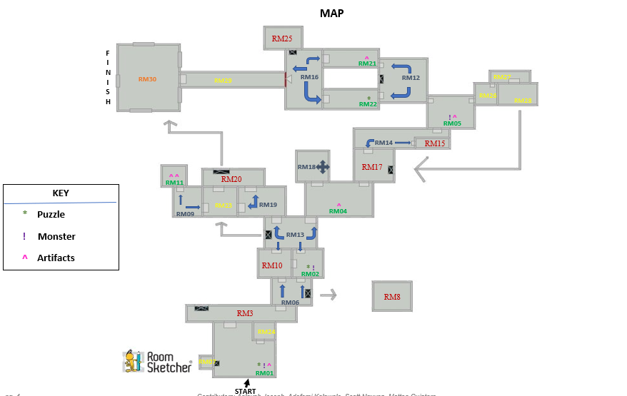

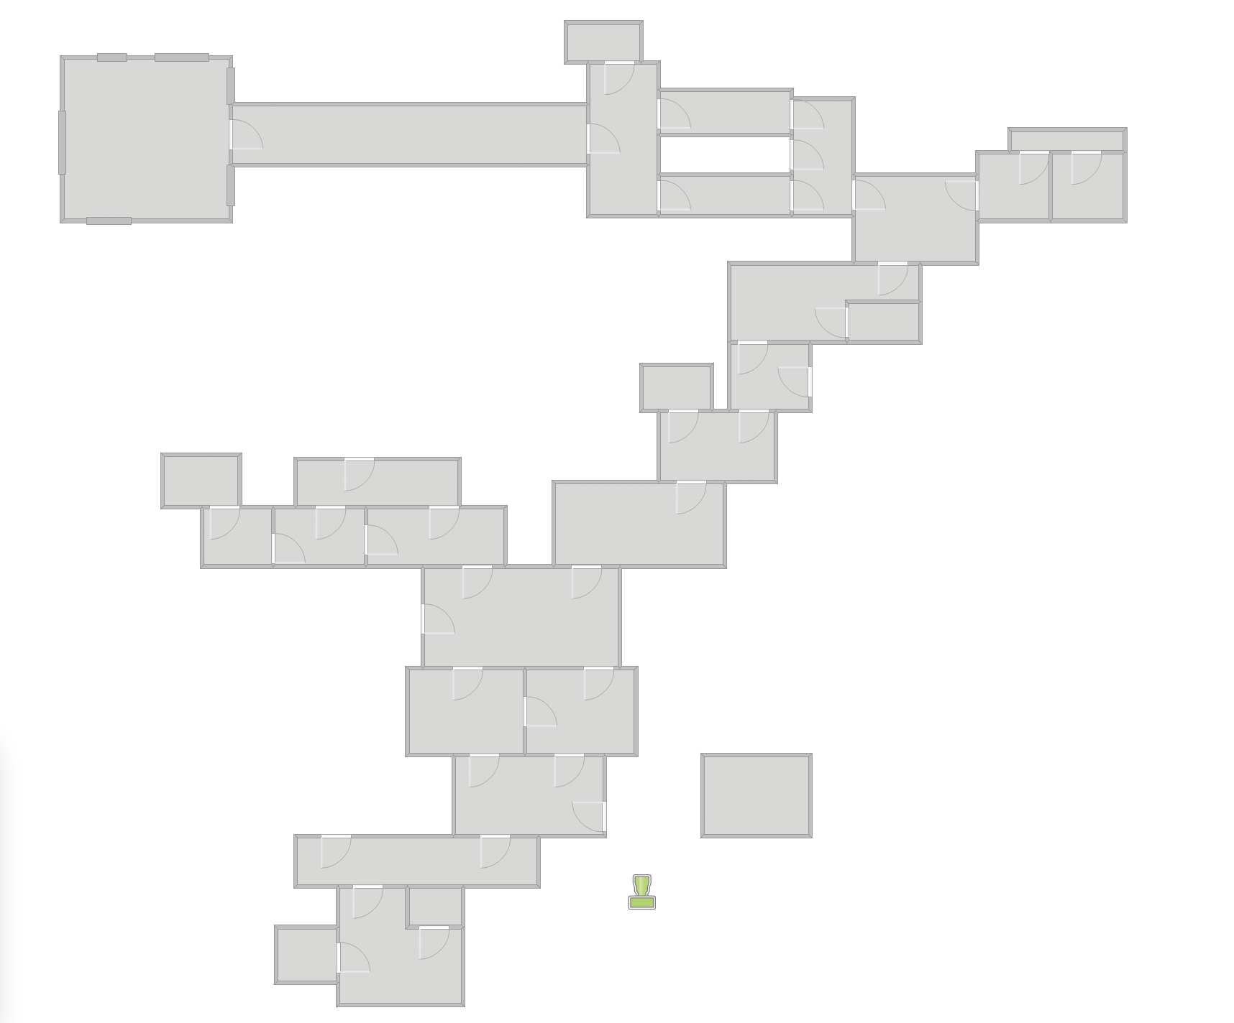

ROOMS

|  |  |  |  |  |  |  |
| --- | --- | --- | --- | --- | --- | --- |
| **Room Name** | **Room ID** | **Monsters**  **Included** | **Artifact**  **Included** | **Puzzle**  **Included** | **Description** | **Value / Worth** |
| Jungle Furry | RM01 | Homo habilis (HOM32) | BA448 | PZ02 | You have entered the Jungle to go after your spouse! There is a trail of blood that leads to a clue/puzzle that the kidnappers or your spouse seemed to have dropped (PZ02). There is another room to the left, slightly to the right and exit straight ahead. Player must fight and defeat Homo habilis (HOM32) to exit room. | Solving the puzzle and defeating the monster will fetch player 10 points each totaling to 20 points |
| The Snake Keeper | RM02 | Snake(SNK78) | N/A | PZ09 | Solve puzzle (PZ09) to enter room. As soon as you enter the room a snake (SNK78) has attacked you. Once you have defeated the snake you can exit straight ahead or to the left. | Solving the puzzle and defeating the monster will fetch player 10 points each totaling to 20 points |
| Lake Finder | RM03 | N/A | Water  (H2O82) | N/A | Contain clean water of life helping the player to keep them alive by drinking it to heal life points, store it for later to heal, or clean tools. | Heal Health |
| The Tree of Faith | RM04 | N/A | Wood/Log (WLG18) | N/A | Your health has decreased, and you are hungry. There is a tree with some unknown fruits; you will do anything for survival. You spotted a wood/log (WLG18) that will be able to help you get the fruit out of the tree. There is an exit to the left or right up ahead. | Getting the fruit out of the tree will increase the player health by 15. |
| Land of the Tiger | RM05 | Tiger (TIG01) | Band-Aid (BA448) | N/A | You see footprints that lead you to RM05 when you enter there is a monster (TIG01) with an exit to the left or right. | Defeating the monster will give the player 20 points. |
| Swampy ditch | RM06 | N/A | N/A | PZ01  PZ05 | A ditch is beside player’s pathway. Player must solve 2 puzzles to move ahead. You can also exit the room if the puzzle are too hard to answer. | Solving both puzzles will fetch player 20points in total towards other needed artifact. 10 point for each puzzle. |
| Treasure room | RM07 | none |  | PZ03 | An empty room with just a golden treasure chest |  |
| Trap Room | RM08 | N/A | N/A | PZ08 | Trap floor that will break down and fall to death. | GAME OVER |
| Bees Highland | RM09 | N/A | Blanket  (BLKT77) | N/A | This room houses a lot of bees. The player needs to take caution. He also needs to purchase blanket before going into the room, to avoid being bitten. The blanket is the only protection available. Hence, he must have enough points to purchase one. | Blanket requires 20 points to purchase |
| Marsh pit | RM10 | Scorpion  (SCR93) | Antidote Potion  (POR78) | PZ10 | A pit fall trap full of scorpion must solve the puzzle to get out or a given a chance to kill a scorpion it drop antidote potion. | The puzzle solve matching picture to open the door to escape. If stun player loses 5 health points. |
| The Path Less Traveled | RM11 | N/A | Stone (ST45)  Pistol (GUN78) | N/A | As you enter the room there are two artifacts (ST45 & GUN78). There is an exit to left and right. | ST45 has a value of 2 points and GUN78 has a value of 20 points if sold. |
| Stone Mountain | RM12 | N/A | Warrior  (WAR784) | N/A | This is a hill. Player in this room must climb to the top to be able to access the artifacts that lies at the top of the hill. One useful artifact lies at the top of the hill. However, player needs enough strength (***20 health points) to be able to climb the hill successfully. | Reaching the top of the hill fetches player a partner (WARRIOR).  WARRIOR is worth 50 points if player is not willing to climb the hill.  WARRIOR is worth 50 points if player avoids this room. |
| Distraction Highland. | RM13 | Cheetah  (CHE87)  Homo-Erectus  (ERE31) | Wood/Log  WLG18 | PZ5  PZ7  PZ9 | There are side attractions in this room, the player enjoys what is going on, and helpful hints are also in this room. Unaware to the player, there are monsters hidden in this room as well. Player must solve puzzles to get more hints, he also must fight monsters to get on in this room. Player can purchase more artifacts as needed. | Each puzzle solved, leads to more hints for the mission.  Every monster killed adds 10points each to players points. Otherwise, the player loses 10 points for not defeating a monster. |
| Treasure Storage | RM14 | Tiger  (TIG01) | N/A | N/A | This room houses the details of all kidnapped fellow in this jungle. Player sees the photo size image of the kidnapped spouse here. Also finds a small note saying “I am alive— keep looking…” There is only one monster to fight in this room. | Player can purchase artifacts as needed  Killing the tiger fetched 15 points |
| Spike Room | RM15 |  |  | PZ15 | Spike trap walls that will move closer and closer to crush the player with spike. | GAME OVER |
| Despondency Dungeon | RM16 | Scorpion  (SCR93) | N/A | PZ4  PZ6 | This room is very close to the boss man. Hence it is designed to discourage players from moving forward with the game, by having several monster attacks and difficult puzzles. No artifact is provided for player by default. If player exits, he/she must still come back to this room in order to reach the boss. | Players’ points increase by 10 for every puzzle and monster won.  Player purchases artifacts as needed so long as they have enough points to purchase. |
| The Ancient knife | RM17 | Snake  (SNK78) |  | PZ17 | A Room that contain ancient knife use by warrior from past era for hunting animals, fighting with honor, and tool to save them in harsh conations. | Unlock the area to go back to the area when the player left off. |
| Jungle Locomotive | RM18 | N/A | N/A | PZ10 | This room has a locomotive which moves people to their desired room in the game. The access pas is the attached puzzle. From this room, the player can jump to any desired room (RM19 – RM28) in the game, except for two which are the boss’ room (30) and the room right before it (29). | Solving the puzzle gives access to the locomotive. |
| Farmland of Plenty | RM19 | Tim King of the Jungle (TIM76) | N/A | N/A | This farmland produces and stores all food eaten in that jungle. The player needs food to have more strength and health point. He however must defeat the monster in charge of this room to be able to access the food. | Player gets 15 points after defeating monster. He has access to good food which increases health points as well. |
| Solider | RM20 |  |  |  | A man who fight for Jack the Over lord. | Player can fight Jack to obtain bullets for the gun once pick up in room 11. |
| Lala Land | RM21 | N/A | BLKT77 | N/A | This room only contains BLKT77 which you can use to increase your health at any time throughout the game. Exit can be found straight ahead. | Using this will increase the player health by 30. |
| Never Alone | RM22 | N/A | N/A | PZ12 | This room has a puzzle (PZ11) that your spouse has left behind that will give you a clue to their next location. Exit can be found straight ahead. | Solving the puzzle and defeating the monster will fetch player 10 points |
| Hidden falls | RM23 |  |  |  | This room is constantly wet from a hidden water fall above the room. Nothing in the room at all. |  |
| Little Furry | RM24 |  |  |  | This is the small room located in jungle furry. There's a monster in this room and defeating the monster drops you an knife |  |
| The Shop Owner | RM25 |  |  |  | Provide the things the hero such as the tools, the items need to fight on like bullets, but come with heavy price to pay. | A greedy shop owner wants your points for trade items he own. |
| No escape | RM26 |  |  |  | Once you enter in this room you have to keep moving forward and there's only one way out which is going forward |  |
| Unknown | RM27 | N/A |  | N/A | This is a follow up to No escape. Its really dark in the room, you cant see at all. You see a little bit of light, you choose to move forward. |  |
| escape | RM28 |  |  | POR78 | You make it to a room with no escape. Your stuck in here for a while. You are rooming around the room looking for an exit and end up pressing a secret button. A small door opens and you see a slide. |  |
| Bridge | RM29 |  |  |  | An old bridge on the verge of collapse, the fall nothing but darkness and all you see is the shining light coming from a room at the end of the bridge where you believe your wife is. | No checkpoints. Last time to turn back and collect items or explore rooms. Once you cross the bridge it collapses. |
| Boss Room Final Battle for your wife. | RM30 | Jack the Overlord  (JAC23) |  |  | Fight the boss in the most epic final battle to save your wife to end the game once and for all. | YOU WIN GAME OVER. |

MONSTERS

|  |  |  |  |  |
| --- | --- | --- | --- | --- |
| Monster Name | Monster ID | Monster Room ID | Items Dropped | Chance (Player will win or lose) |
| Tiger | TIG01 | RM05 | bullets | 25% chance to win vs 75% to lose. (Depend on the weapon chance may go up 55%-win vs 45% lost) |
| Scorpion | SCR93 |  | Antidote Potion | 25% of getting poison, 50% to win, and 25% to lose |
| Cheetah | CHE87 | RM 13 | Drop 7 Bullets | 40% chance to win vs 60% to lose. (Depend on the weapon chance may go up 52%-win vs 48% lost) |
| Snake | SNK78 | RM02 | Knife | 25% of getting poison, 50% to win, and 25% to lose |
| Homo habilis | HOM32 | RM01 | Band aid or Umbrella | 64% chance to win vs 36% to lose. |
| Homo erectus | ERE31 | RM 13 | Blanket | 41% chance to win vs 59% to lose. |
| Bees | BE755 | RM09 | Blanket | 65% chance of winning 35 % losing |
| Tim King of the Jungle | TIM76 |  | bullets | 46% chance to win vs 54% to lose. |
| Jack the Overlord | JAC23 |  | Wife/Spouse | [Boss of the Game] 25% chance to win vs 75% to lose (Depend on the weapon chance may go up 75% win vs 25% lost) YOU WIN THE GAME |
| Solider | SOD04 | RM20 | bullets | 25% chance to win vs 75% to lose. (Depend on the weapon chance may go up 55%-win vs 45% lost) |

PUZZLES

|  |  |  |
| --- | --- | --- |
| **Puzzle ID** | **Puzzle Details** | **Puzzle answer** |
| PZ01 | One is to three as three is to five and five is to four and four is the magic number.  What is the pattern? | **Four** |
| PZ02 | One of these is Cupid. But it doesn’t have a bow. Instead it pulls a sleigh. Through the air and lands on snow | Reindeer |
| PZ03 | How do you put a giraffe in the refrigerator? | Open it up and put it in. |
| PZ04 | Two scientists are trying to get across a crocodile infested river. There are no rocks or anything to get over, under, or around it. How do they get across? | Swim, because the alligators are at the funeral. |
| PZ05 | What 8 letter word can have a letter taken away and it still makes a word.  Take another letter away and it still makes a word. Keep on doing that until you have one letter left. What is the word? | The word is starting! starting, staring, string, sting, sing, sin, in, I.  Cool, huh? |
| PZ06 | The more you take, the more you leave behind. What am I? | Footsteps. |
| PZ07 | What comes once in a minute, twice in a moment, but never in a thousand years? | The letter "m". |
| PZ08 | I like to use my long tongue. To eat leaves from tops of trees I don’t have to climb up though With my long neck it’s a breeze | Giraffe |
| PZ09 | Some types slither on the ground. And some can live up in the trees. What kind of animals are these? | Snake |
| PZ10 | What becomes wetter the more it dries? | Towel |
| PZ11 | As I walked along the path, I saw something with four fingers and one thumb, but it was not flesh, fish, bone or fowl. What was it? | Glove |
| PZ12 | I am a yellow fruit that you might eat at lunch. When there’s a group of me we are known as a bunch | Banana |

**\**

ARTIFATCS TABLE

|  |  |  |  |  |
| --- | --- | --- | --- | --- |
| **Artifact Name** | **ID** | **Artifact Room ID** | **Description** | **Value / Worth** |
| Antidote Potion | POR78 |  | Uncommon. Players calls this whenever he gets bitten by a creature in the jungle (SCR93 or SNK78). | * 5 points every single call |
| Knife | CUT89 |  | Uncommon. Very sharp object to protect from creatures in the jungle and to cut items as needed | * 5points to use |
| Water | H2O82 |  | Very common | 3 point to use |
| Pistol | GUN78 |  | Very rare. Strongest weapon in the game. | * 20 points to use |
| Band aid | BA448 |  | Common. Player must use this at any point in the game if their health has decreased. | 10 point to use |
| Blanket | BLKT77 |  | Very rare. Player can uses this to take a nap. Gets full heath back | 20 point to use |
| Umbrella | UMB44 |  | Uncommon drop, attack and defensive item | 11 point to use |
| **Jungle tools  (Wooden Spear Bows and arrow) | JGTL99 |  | Crafting items | 11 point to use |
| Stone | ST45 |  | Very common. Very hard rock that can be thrown at monsters. | 2 points to use |
| Wood/Log | WLG18 |  | Very common | 3 point to use |
| Warrior | WAR784 |  | He is there to offer help to the player but can only be called ones throughout the game without points being deducted. | * Free only ones * 10 points every other time |

FIGHTING/ATTACK SYSTEM

|  |  |
| --- | --- |
| **Shop Owner** | Points for Items |
| Bullets | 10 points |
| Gun (if didn’t obtain) | 25 points |
| Band Aid | 4 points |
| Blanket | 25 points |
| Umbrella | 15 points |
| Antidote Potion | 10 points |
| Wooden container (water) | 11points |

|  |  |
| --- | --- |
| **Crafting System** |  |
| Stone axe | 3 stone and 2 wood |
| Spear | 2 wood |
| Band Aid | 1 water/restore small health |
| A wooden dagger | 1 wood |
| Bow | 3 wood |
| Arrows | 1 wood = 1 arrow |
| A wooden container | 5 woods |

|  |  |
| --- | --- |
| **KEY CODES** | |
| Attack Key | Space |
| Block | B |
| inventory/ Assets | Z |
| Movement-Right | Right Arrow Keys |
| Movement-Up | Up Arrow Keys |
| Movement-Left | Left Arrow Keys |
| Movement-Down | Down Arrow Keys |
| Lunch Available Artifacts | A |

**USECASE DIAGRAMS**

**Functional Requirements**

This section includes the requirements that specify all the fundamental actions of the software system.

**PUZZLE USECASE DIAGRAM**

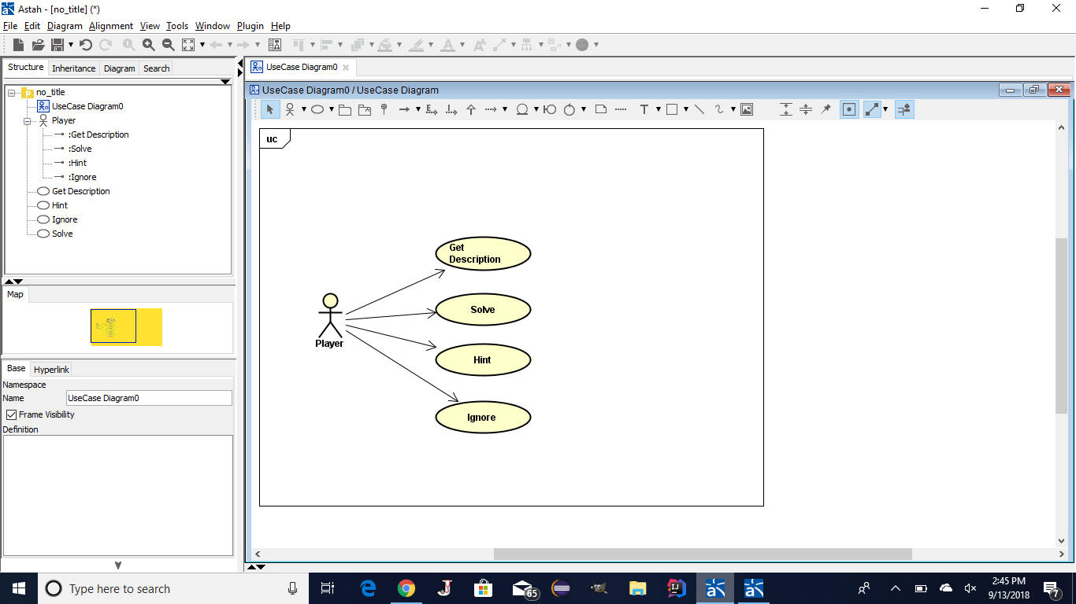

**ID: FRP01**

**Feature: Get Description**

The player must be able to get room description of puzzle.

**ID: FRP02**

**Feature: Solve Puzzle**

The player must be able to solve the puzzle.

If the player solves the puzzle correctly he/she will get all the points allocated.

Else the player may choose to ignore the puzzle or ask for a hint.

**ID: FRP03**

**Feature: Hint**

The player must be able to get a hint.

If the player chooses to use a hint, he/she will get half the points they would have gotten by solving the puzzle.

**ID: FRP04**

**Feature: Ignore Puzzle**

The player must be able to ignore the puzzle.

If the player chooses to ignore the puzzle he/she will not get any points.

**INVENTORY USECASE DIAGRAM**

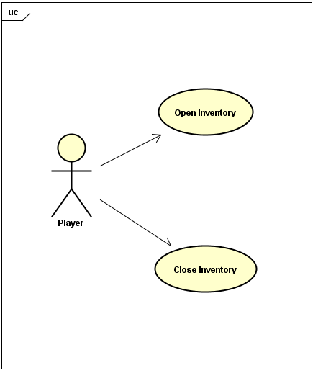s

**ID: FRIN 01**

**Feature: Open inventory**

The player must be able to open the inventory pack

If player chooses to open, a list of all items relevant to the room is shown.

**ID: FRIN 02**

**Feature: Close Inventory**

The player must be able to close the inventory pack

If player chooses to open, a list of all items relevant to the room is shown.

**ITEMS USECASE DIAGRAM**

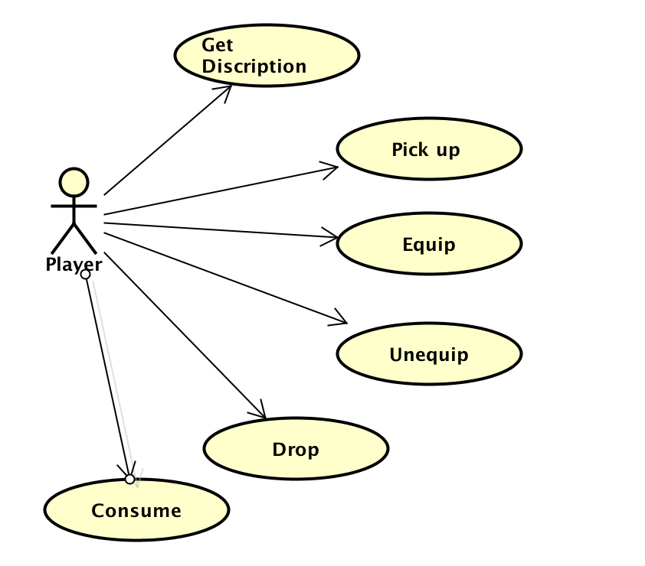

**ID: FRIT 01**

**Feature: Get description**

**The player can read the description of all items they come across**

**ID: FRIT 02**

**Feature: Select / Pick up**

The player can pick up the item and the item automatically goes to the inventory.

**ID: FRIT 03**

**Feature: Drop**

The player can drop items he or she does not find necessary or obsolete.

**ID: FRIT 04**

**Feature: Equip**

The player can choose to equip items they come across and items that are in the inventory.

**ID: FRIT 05**

**Feature: Unequip**

The player can choose to unequip items and the items automatically go to the inventory.

**ID: FRIT 05**

**Feature: Consume**

**The Player can choose to consume items that are consumable.**

**MONSTER USECASE DIAGRAM**

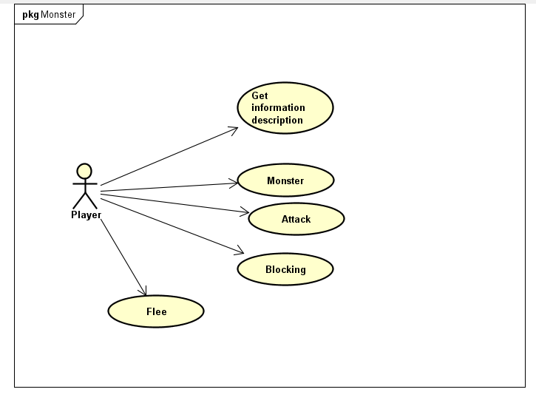

**ID: FRM 01**

**Feature: Get description**

The player will try to get the information about the next monster within the room making sure they don’t walk into a trap or don’t come into the room without being prepared.

**ID: FRM 02**

**Feature: Attack**

Equipping the item to attack and block the monster attack within the battle to save health.

**ID: FRM 03**

**Feature: Engage**

**Engaging the monster is by choice between the player don’t have to attack, the player can choose to take another path**

**ID: FRM 04**

**Feature: Flee**

**If the monster is to powerful the player have a chance to flee from the monster**

**ROOM USECASE DIAGRAM**

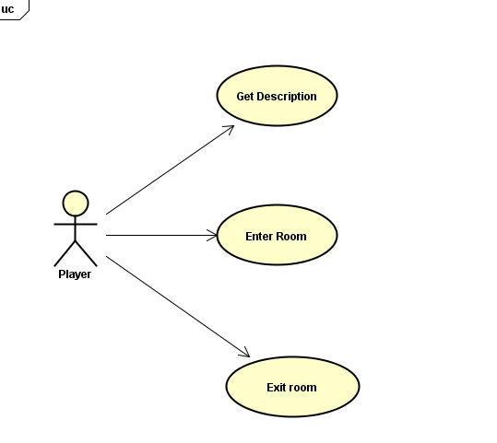

**ID: FRRM 01**

**Feature: Get description**

The player must be able to see the description of the room they currently are in.

**ID: FRRM 02**

**Feature: Enter Room**

The player must be able to enter the room by choice

**ID: FRRM 03**

**Feature: Exit Room**

The player must be able

Use this as description

|  |  |  |  |  |  |  |  |
| --- | --- | --- | --- | --- | --- | --- | --- |
| **S/N** | **Room Name** | **Room ID** | **Monsters**  **Included** | **Artifact**  **Included** | **Puzzle**  **Included** | **Attacker: Form** | **Attack: Details and Points.** |
| 1. | Jungle Furry | RM01 | Homo habilis (HOM32) | BA448 | PZ02 |  |  |
| 2. | The Snake Keeper | RM02 | Snake(SNK78) | N/A | PZ09 |  |  |
| 3. | Lake Finder | RM03 | N/A | Water  (H2O82) | N/A |  | No monster in this room the player have to craft a wood container to hold the water in place to obtain the clean water that will be use to heal the player health. |
| 4. | The Tree of Faith | RM04 | N/A | Wood/Log (WLG18) | N/A |  |  |
| 5. | Land of the Tiger | RM05 | Tiger (TIG01) | Band-Aid (BA448) | N/A |  |  |
| 6. | Swampy ditch | RM06 | N/A | N/A | PZ01  PZ05 | No monsters in this room. Player only has to answer available puzzles correctly.  Player must be able to tell if the y accumulated points or not whenever they decide to exit the room. | Upon entry, the room asks player if s/he wishes to answer the available puzzles for adventure point. If yes, PZ01 appears. If correctly answered, PZ05 appears also. Else, you have not answered one or all of the puzzles correctly, your current point is --- appears. Player gets 10 points for each puzzle answered correctly. |
| 7. | Treasure room | RM07 | none |  | PZ03 |  | The room contain points that start the player off once solve the puzzle or move on. |
| 8. | Trap Room | RM08 | N/A | N/A | N/A |  | Game Over Instinct Death fall into a hole and the player die thus causing the Game Over. |
| 9. | Bees Highland | RM09 | N/A | Blanket  (BLKT77) | N/A | No puzzle in this room. Bees are available to sting player. S/he need at least 20 points to purchase a blanket for protection | 1. Before player enters room: display, “BEWARE: Bees enclosed, You need 20 points for a protection-blanket ” 2. Condition: Do you wish to proceed,    1. Yes: display “Bees Sting… above” .Else, AND *Put blanket on*       1. *While blanket is on, display, “wipe out bees.” If clicked, displays*    2. No: display button *Exit room* AND Stay *in room.* |
| 10. | Marsh pit | RM10 | Scorpion  (SCR93) | Antidote Potion  (POR78) | PZ10 |  | Before the player enters, a warning message is displayed “BEWARE: Watch Your Step”, You need 11 points for a umbrella.”  A condition “Do you wish to proceed?” If yes, player enters, scorpion sting released is printed. Once the player kill the scorpion it drop antidote potion. |
| 11. | The Path Less Traveled | RM11 | N/A | Stone (ST45)  Pistol (GUN78) | N/A |  |  |
| 12. | Stone Mountain | RM12 | N/A | Warrior  (WAR784) | N/A |  |  |
| 13. | Distraction Highland. | RM13 | Cheetah  (CHE87)  Homo-Erectus  (ERE31) | Wood/Log  WLG18 | PZ5  PZ7  PZ9 | Upon entry, the room displays a prompt notifying he player that there are two monsters and 2 puzzles in this room  Player can choose to stay or exit the room. | If player stays,  A prompt shows “CHE87” is behind you  Player can click “enter button” to see what artifacts are available  Player can select an artifact |
| 14. | Treasure Storage | RM14 | Tiger  (TIG01) | N/A | N/A |  |  |
| 15. | Spike Room | RM15 |  | N/A | N/A |  | Open door room once enter the player fall into a spike trap room the door will close and spike will fall upon the player Game Over Instinct Death |
| 16. | Despondency Dungeon | RM16 | Scorpion  (SCR93)  Snake  (SNK78) | N/A | PZ4  PZ6 |  |  |
| 17. | The Ancient knife | RM17 |  |  | PZ17 | Protected by anaconda “snake” once the monster is killed must solve the puzzle to unlock the case to get the Ancient Knife. | Obtain 15 points for killing the snake unless player flee there is no point obtain. |
| 18. | Jungle Locomotive | RM18 | N/A | N/A | PZ10 |  |  |
| 19. | Farmland of Plenty | RM19 | Tim King of the Jungle (TIM76) | N/A | N/A |  |  |
| 20. | Solider | RM20 | N/A | N/A | N/A | Soldier Work for Jack the Over lord fight him or sneak pass him if choose to fight him due caution. | Drop 6 Bullets and Obtain 20 point. |
| 21. | Lala Land | RM21 | N/A | BLKT77 | N/A |  |  |
| 22. | Never Alone | RM22 | N/A | N/A | PZ12 |  |  |
| 23. | Hidden falls | RM23 | N/A | N/A | N/A |  | Hidden Water fall that restore player small health and items to craft. |
| 24. | Little Furry | RM24 | N/A | N/A | N/A | Captor by 2 soldier the warrior must be rescue before joining the player on a mission. | A Warrior will help player fight any time due to honor, but only be able to call once. |
| 25. | The Shop Owner | RM25 | N/A | N/A | N/A |  | The Greedy Shop Owner have items that player need that can be buy with point system or sell crafting items as points to gain items before fighting the final boss. Once cross the Bridge There no turning back. |
| 26. | No escape | RM26 |  |  |  |  | Death Room Game over |
| 27. | Unknown | RM27 | N/A |  | N/A |  |  |
| 28. | escape | RM28 |  |  | POR78 |  |  |
| 29. | Bridge | RM29 |  |  |  |  | The bridge lead to the Boss Room once cross it the there is no turning back the choice is to the player to cross it or go back to get items from room they miss. |
| 30. | Boss Room Final Battle for your wife. | RM30 | Jack the Overlord  (JAC23) | WIFE | PZ30 | Final battle must fight him with everything you have that is on the player and inventory. | You Win Game Over! |