**University Academic Performance Management System**

**(UAPMS)**

Njugi Elijah Muiru

146412

Karogo Joe Ndungu

167141

ICS 3 Group: B

**Supervisor Name**: Dr. Kennedy Ronoh

An Informatics Project Proposal Submitted to the School of Computing and Engineering Sciences (SCES) in partial fulfilment of the requirements for the award of a Degree in Informatics and Computer Sciences

School of Computing and Engineering Science

Strathmore University

Nairobi, Kenya

13 May 2025

# Declaration and Approval

We declare that this work has not been previously submitted and approved for the award of a degree by this university or any other university. To the best of our knowledge and belief, the research proposal contains no material previously published or written by another person except where due reference is made in the research proposal itself.

Student Name: Njugi Elijah Muiru

Admission Number: 146412

Student Signature: _________________________ Date: ________________________

Student Name: Karogo Joe Ndungu

Admission Number: 167141

Student Signature: _________________________ Date: ________________________

Supervisor Name: Dr. Kennedy Ronoh, who will provide guidance and oversight throughout the project.

Supervisor Signature: _________________________ Date: ________________________

# Abstract

The University Academic Performance Management System (UAPMS) is a web-based application that revolutionizes how university students monitor, evaluate, and manage their academic journey. It provides an interactive interface where students can log units, grades, and credit hours while receiving real-time feedback on GPA trends, unit status (pass/fail), and degree classification projections. Unlike traditional Academic Management Systems (AMS) that offer minimal interaction and feedback, UAPMS enhances student decision-making through visual charts, intelligent alerts for retake requirements, and tailored academic guidance. It also generates academic performance summary reports for the Dean and Examination Office and confirms a student's final degree classification based on institutional grading policies. The system built using React, PHP, and PostgreSQL, follows an Agile development methodology with sprint-based feedback cycles to ensure adaptability and user-centered improvement. The potential impact of UAPMS on students' academic journey is promising, offering a more insightful and actionable approach to educational management.

Table of Contents

Declaration and Approval ii

Abstract iii

List of Abbreviations vii

Chapter 1: Introduction 1

1.1 Background Information 1

1.2 Problem Statement 1

1.3 Aim/ Specific Objectives 2

1.3.1 Specific Objectives 2

1.3.2 Research Questions 3

1.4 Justification 3

1.5 Scope and Limitations 4

1.5.1 Scope 4

1.5.2 Limitations 5

1.5.3 Delimitations 5

Chapter 2: Literature Review 6

2.1 Introduction 6

2.2 Exploration of Current Academic Performance Tracking Practices 7

2.3 Challenges in Academic Tracking Tools 7

2.3.1 Challenge 1: Delays in Report Generation and Distribution 7

2.3.2 Challenge 2: Difficulty in Identifying and Addressing Missing Grades 8

2.3.3 Challenge 3: Shallow academic report insights 8

2.3.4 Challenge 4: Lack of Visual and Analytical Feedback 8

2.4 Review of Existing Systems 8

2.4.1 Ellucian Banner Student 8

2.4.2 Moodle LMS with Gradebook 9

2.4.3 Strathmore University Academic Management System (AMS) 10

2.5 Gaps in Current Approaches and Related Applications 11

2.6 Conceptual Framework 11

References 14

**List of Figures**

Figure 1 Example of Ellucian Banner Student system 9

Figure 2 Example of Strathmore AMS 10

Figure 3 Conceptual Framework diagram 13

# List of Abbreviations

| **Abbreviation** | **Full Meaning** |
| --- | --- |
| **AMS** | Academic Management System |
| **API** | Application Programming Interface |
| **CI/CD** | Continuous Integration / Continuous Deployment |
| **CRUD** | Create, Read, Update, Delete |
| **CSS** | Cascading Style Sheets |
| **DBMS** | Database Management System |
| **DFD** | Data Flow Diagram |
| **ERD** | Entity Relationship Diagram |
| **GPA** | Grade Point Average |
| **HTML** | HyperText Markup Language |
| **IDE** | Integrated Development Environment |
| **JS** | JavaScript |
| **JWT** | JSON Web Token (if token-based auth is used) |
| **LMS** | Learning Management System |
| **PDF** | Portable Document Format |
| **PHP** | Hypertext Preprocessor |
| **QA** | Quality Assurance |
| **SCES** | School of Computing and Engineering Sciences |
| **SQL** | Structured Query Language |
| **UAPMS** | University Academic Performance Management System |
| **UI** | User Interface |
| **UX** | User Experience |
| **UX/UI** | User Experience/User Interface |

# Introduction

## Background Information

In higher education, academic performance management is critical for ensuring students meet graduation requirements and thrive intellectually and professionally. However, many university students often face difficulties in effectively tracking and managing their academic progress due to the absence of accessible, insightful, and actionable performance data. While students are typically provided with raw grades at the end of each semester, these grades are often presented without context or analytical support. As a result, learners are left to interpret their academic standing without any system-generated guidance, projections, or intervention prompts.

Educational technology has grown significantly in recent years, yet most institutional systems remain limited to administrative functions such as grade posting and course registration. These systems rarely provide personalized academic feedback, longitudinal performance trends, or predictive analytics, all of which are essential for students to make informed educational decisions. This issue is particularly pressing in university environments where students must meet cumulative academic thresholds such as GPA minimums for graduation or core course completion requirements for program progression.

According to studies on academic advising (Tinto, 2012; Kuh et al., 2006), timely and meaningful feedback is essential for student success and retention. Without integrated systems to help interpret academic data, many students mismanage course selections, miss retake deadlines, or remain unaware of looming academic probation. In Kenya, where institutions like Strathmore University aim to provide holistic and tech-enabled education, this gap highlights a missed opportunity for leveraging data-driven technologies to enhance student outcomes.

## Problem Statement

Despite the growing integration of technology in education, the Academic Management System (AMS) and the eLearning portal currently deployed at Strathmore University and many similar institutions fall short in delivering intelligent, personalized academic management. These platforms primarily function as static repositories for grades, attendance, and course listings, offering little to no real-time interpretation or actionable feedback. Key functionalities such as GPA trajectory visualization, early alerts on failing units, or predictive degree classification are missing entirely.

This lack of interactivity and foresight in current systems results in significant pain points for students and academic staff. For instance, students often fail to identify that they have been unable to complete a core unit until it blocks their progression. They can also not estimate their current GPA trend or predict whether they are on track for a First Class or Second Upper degree classification. Additionally, the user interfaces of these systems are often unintuitive, and design inconsistencies between desktop and mobile platforms further degrade the user experience.

Consequently, students are disempowered in their academic planning and risk delayed graduation, unplanned retakes, and academic penalties—all of which could be mitigated with timely, data-driven insights. Furthermore, academic advisors, deans, and exam offices lack access to streamlined, synthesized reports that could help them offer timely student support or interventions. Addressing this problem through a modern, intelligent system can drastically improve academic engagement, decision-making, and overall institutional performance.

## Aim/ Specific Objectives

To develop a responsive, web-based University Academic Performance Management System (UAPMS) that enables students to track their academic performance, receive real-time feedback and projections, and obtain academic guidance and degree classification confirmation, thereby enhancing decision-making and reducing risks of educational failure.

### Specific Objectives

The following objectives will guide the development and implementation of the University Academic Performance Management System (UAPMS):

i. To investigate current practices and challenges in academic performance tracking among university students and staff.

ii. To analyse existing academic tracking systems and identify gaps in functionality, usability, and feedback.

iii. To design a user-focused system architecture that enables real-time academic tracking, feedback, and guidance.

iv. To develop a working prototype of the UAPMS using selected frontend, backend, and database technologies.

v. To conduct system testing and evaluation to assess functionality, usability, and overall effectiveness.

### Research Questions

The following research questions align with the project's specific objectives and will guide the investigation:

1. What are the current practices and challenges in tracking academic performance in universities?
2. What are the limitations of existing academic tracking systems in terms of functionality and user experience?
3. How can a user-centered system be designed to offer real-time feedback and academic guidance?
4. What technologies are suitable for developing a reliable and interactive academic performance tracking system?
5. How effective, usable, and reliable is the developed system in supporting students and academic staff?

## Justification

Effective academic performance tracking plays a critical role in helping students navigate their educational journey, make informed decisions, and achieve their academic goals. In most universities, however, students can access fragmented information—grades, GPA scores, and remarks—without a deeper analysis or prediction of their academic trajectory. This results in students being unaware of potential academic risks, failing to plan timely retakes, and misunderstanding their progression toward graduation. Institutions also struggle to offer timely interventions due to the lack of consolidated student performance insights.

The development of the University Academic Performance Management System (UAPMS) addresses this gap by offering a centralized, intelligent, and interactive platform that not only allows students to log and review their academic records but also gives them real-time feedback, retake alerts, degree classification projections, and semester-wise GPA visualizations. These features enable students to take a proactive role in their academic success.

Beyond individual student benefits, the system is also designed to support lecturers, academic advisors, and administrators. Academic staff can view summarized performance reports and identify students who may need educational support early enough. The Examination Office and Dean’s Office can utilize these reports for degree classification confirmation, academic progression checks, and quality assurance processes.

Moreover, this project supports the broader institutional goals of improving academic quality, reducing failure and repetition rates, and ensuring students graduate on time. It aligns with Kenya's higher education objectives and the digital transformation efforts promoted by the Commission for University Education (CUE). In the long term, such systems can contribute to national education policy development by providing analytics that inform curriculum improvement and institutional benchmarking.

By leveraging modern technologies (such as React, PostgreSQL, PHP, and Chart.js) and following user-centered design principles, UAPMS will offer a responsive and intuitive platform that addresses a pressing educational need and offers tangible, measurable benefits to all stakeholders, including students, faculty, and university administrators.

## Scope and Limitations

### Scope

The proposed study focuses on designing and developing a web-based academic performance management system tailored to university environments. The system will target key user groups: students, lecturers, deans, and examination officers. Its primary functionalities include logging academic records (units, grades, semesters), real-time GPA calculation, visual analytics, academic progress tracking, retake alerts, and degree classification projections. Additionally, the system will support administrative reporting for educational planning and decision-making.

The scope includes:

* Frontend development using **React.js** for interactivity and responsiveness.
* Backend logic using **PHP** to manage server-side processes.
* Academic data storage and management using **PostgreSQL**.
* Data visualization using **Chart.js** to generate intuitive, interactive charts.
* Authentication and role-based access for different users (students, lecturers, admins).
* Reporting tools to support academic offices.

The project will not cover:

* Integration with live university portals or databases (e.g., real AMS systems).
* Mobile application development (though the system will be mobile-responsive).
* Broader eLearning functionalities such as assignment uploads or discussion forums.
* Financial or fee tracking.

### Limitations

While the proposed system offers several innovations, it faces some inherent limitations. First, it relies heavily on the accuracy of user-entered data. If students input incorrect grades or course information, the system’s projections and reports may be misleading. Second, the GPA and classification projections will be based on fixed institutional grading rules subject to periodic change. Adapting the system to policy changes may require manual updates. Lastly, the system will not integrate with live institutional databases due to privacy concerns and restricted API access, which limits real-time syncing with official records.

### Delimitations

To manage these limitations, the project will include validation rules during data entry to reduce user errors and ensure that entries follow correct academic formats. The system will be designed to allow administrators to easily update grading rules, ensuring that institutional changes can be accommodated with minimal technical intervention. Moreover, users will be trained on how to use the system accurately through a built-in help guide, and the platform will be designed with scalability in mind for future integrations or extensions, such as mobile apps or API-based syncing.

# Literature Review

## Introduction

This chapter discusses how academic performance tracking was previously done in universities before modern systems were introduced. It also highlights some current academic tracking systems that were created to improve grade management and report generation. In addition, the gaps in these systems are identified, and a conceptual framework of the proposed improved system is presented.

## Exploration of Current Academic Performance Tracking Practices

Universities need a simple way to record and manage student grades from start to finish. Instructors enter marks into a central system, which then calculates each student’s average grade so far. The system creates reports of their performance and enables students to access them online. These functions of grade entry, average grade calculation, report creation, and student access of grades provides the necessary data for decisions on progression and graduation to students (DiplomaSafe, 2023)

So, lets focus on how academic reports are created. After lecturers enter grades and the system calculates average marks, the platform turns this data into performance reports. These usually include course names, credit hours, and overall averages, and are available as PDFs or online pages. Students and school staff can view them through the student portal, with options to check by semester or academic year (Ellucian, 2025)

Report creation must follow university grading rules e.g., A=70, B=60, C=50, D=40 and ensure reports are available and correct. (Wikipedia, 2024) Ideally, the system would automatically flag missing grades, create reports as soon as grades are entered, and notify students right away. In reality, many systems wait for manual checks by the exams office before releasing reports, causing delays. Students often aren't notified when their exam results are ready, which can affect their ability to plan ahead for their studies.

## Challenges in Academic Tracking Tools

### Challenge 1: Delays in Report Generation and Distribution

One major challenge in academic tracking is the delay in generating and sharing student performance reports. In many institutions, exam results must first be manually reviewed and approved by the exams office before being released to students (Collegis Education, 2021) This process slows things down and prevents students from accessing their results in a timely manner. As a result, important academic decisions, like applying for graduation, planning for supplementary exams, or tracking progress, can be delayed. Although some systems have introduced partial automation to speed things up, manual checks are still common and continue to cause bottlenecks.

### Challenge 2: Difficulty in Identifying and Addressing Missing Grades

Another major challenge is the difficulty in identifying and addressing missing or incorrect grades in a timely manner. In many cases, students are unaware that a grade is missing until they try to access their final report. This is often because the system does not automatically detect incomplete records or notify users when something is wrong. As a result, students may experience delays in graduation applications, scholarship processing, or enrolment for the next academic period. While some platforms have started to include basic alerts, most still rely on students or staff noticing these issues manually, which is unreliable and inefficient.

### Challenge 3: Shallow academic report insights

Finally, there is a problem with how academic progress is reported. Some systems only provide basic summaries, like final grades, without offering deeper insights such as performance trends over time or personalized feedback. This makes it harder for students to understand where they’re doing well or falling behind. Although a few solutions have started to include more advanced reporting features, many platforms still present data in a way that lacks depth and makes it hard to support meaningful academic improvement.

### Challenge 4: Lack of Visual and Analytical Feedback

Many academic platforms do not provide visual representations of student performance, such as charts or trend graphs. Instead, data is displayed using plain text or static tables, making it harder for users to interpret results over time. Without tools like GPA trend graphs, course performance comparisons, or semester-over-semester analytics, both students and administrators miss opportunities to spot patterns, identify strengths or weaknesses, and make informed academic decisions. This absence of analytical support can lead to delayed interventions, reduced student engagement, and limited insight into overall academic progress. While a few modern platforms have started integrating dashboards and visual analytics, these features are still missing in most systems.

## Review of Existing Systems

### Ellucian Banner Student

Ellucian Banner Student is a student information system designed specifically for higher education institutions. It helps solve the problem of manual grade management and administrative inefficiency by offering students self-service access to view grades, register for courses, and track academic standing. Built on Oracle-based architecture and integrated with cloud technology, it enables real-time access to academic records. However, most of the information is presented in static formats such as lists and tables. Students often struggle to interpret their performance over time due to the lack of graphical feedback and analytics. The proposed system improves on this by using visual tools such as GPA trend graphs, semester comparisons, and personalized feedback dashboards to enhance student understanding and academic planning.

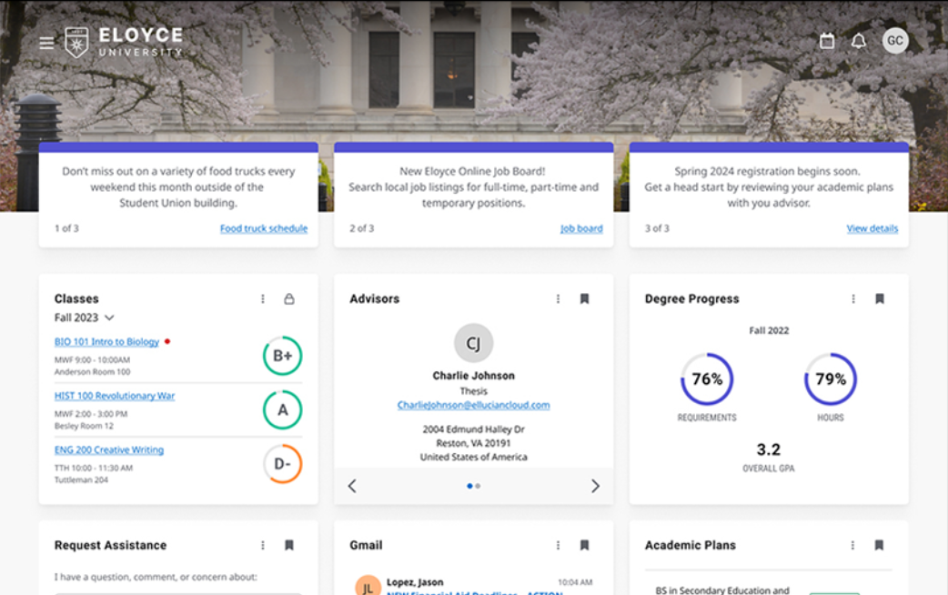

Figure Example of Ellucian Banner Student system

### Moodle LMS with Gradebook

Moodle is an open-source Learning Management System (LMS) widely used in universities to manage course content and assessments. The Moodle Gradebook feature allows lecturers to upload scores, calculate total grades, and display course performance to students. It solves the problem of disjointed academic tracking by centralizing grade reporting and allowing students to view their progress at any time. Built using PHP and supported by SQL databases, Moodle provides flexibility in integration with other systems. However, while it allows students to see grades per course, it lacks automated summaries such as GPA calculations, semester-based analytics, or early warnings for underperformance. The proposed system fills this gap by adding intelligent automation, performance visualization, and feedback features to support personalized academic growth.

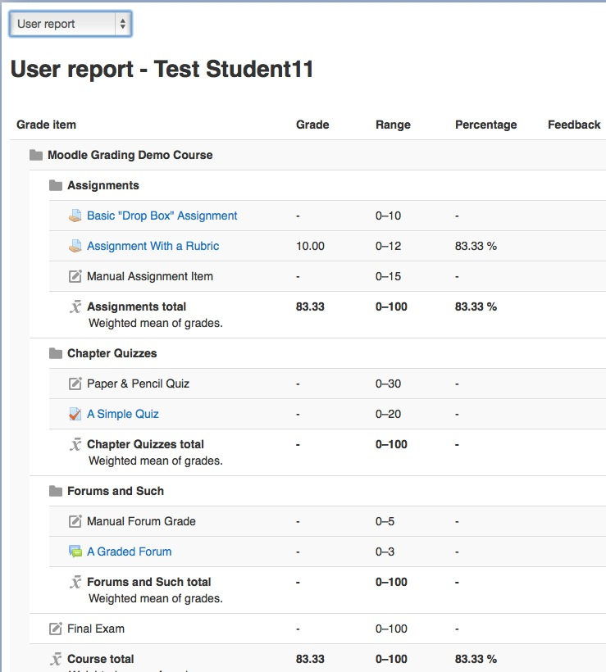

### Strathmore University Academic Management System (AMS)

Strathmore University’s Academic Management System (AMS) is a locally developed platform used by students and staff to manage academic records. It helps solve the issue of academic tracking by allowing students to register for units, view results, and access academic reports online. AMS reduces the burden of physical paperwork and manual distribution of results. The system is built on custom web technologies and supports secure login and role-based access. However, AMS presents academic performance data in plain tables and PDFs, with no graphical analysis or performance breakdowns. This limits students’ ability to interpret trends or identify areas needing improvement. Additionally, real-time alerts or intelligent feedback are not integrated into the system. The proposed solution addresses these gaps by introducing visual dashboards, real-time performance analytics, and tailored academic suggestions, making academic data more actionable for both students and advisors.

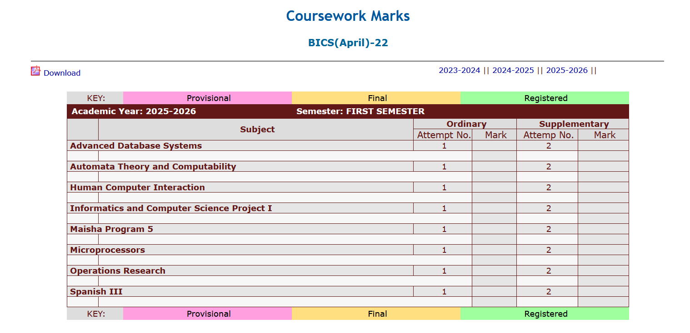

Figure Example of Strathmore AMS

## Gaps in Current Approaches and Related Applications

Many existing academic tracking systems such as Ellucian Banner, Moodle, and Strathmore AMS have helped institutions manage academic records, but they still face several key inadequacies. These include delays caused by manual verification of grades, which slow down the release of results and hinder timely decision-making for students. In addition, most systems lack advanced features like trend analysis or personalized feedback, offering only basic grade summaries that do not help students understand their academic strengths and weaknesses. The user interfaces in many platforms also present information in rigid tables without visual tools like graphs, making it harder for users to track progress or spot performance patterns. These inefficiencies show that while current systems serve essential functions, they fall short in delivering fast, insightful, and user-friendly academic tracking experiences.

## Conceptual Framework

The system will support three main types of users: Students, Lecturers, and Administrators. Each of them will interact with the system based on their role. Students will log in to request academic reports such as GPA summaries or performance overviews for specific semesters or academic years. They can also view alerts or receive messages related to their academic progress.

Lecturers will be able to submit student grades and corrections directly into the system. Their inputs go through a validation process that checks for missing or incorrect data. Administrators, on the other hand, have access to full system control. They will set academic rules such as grading scales and progression thresholds and monitor student performance trends using admin reports.

At the core of the system is the processing unit, which handles validation, GPA calculation, and rule-based alerts. It converts raw marks into GPA points, checks for failed core units, and identifies students who may be at academic risk. All this data is stored in a central academic records database.

From this database, the system can generate outputs like student dashboards, in-portal notifications, and performance reports for both students and administrators. By centralizing data and automating analytics, the system ensures accuracy, transparency, and faster decision-making, replacing traditional manual academic tracking methods.

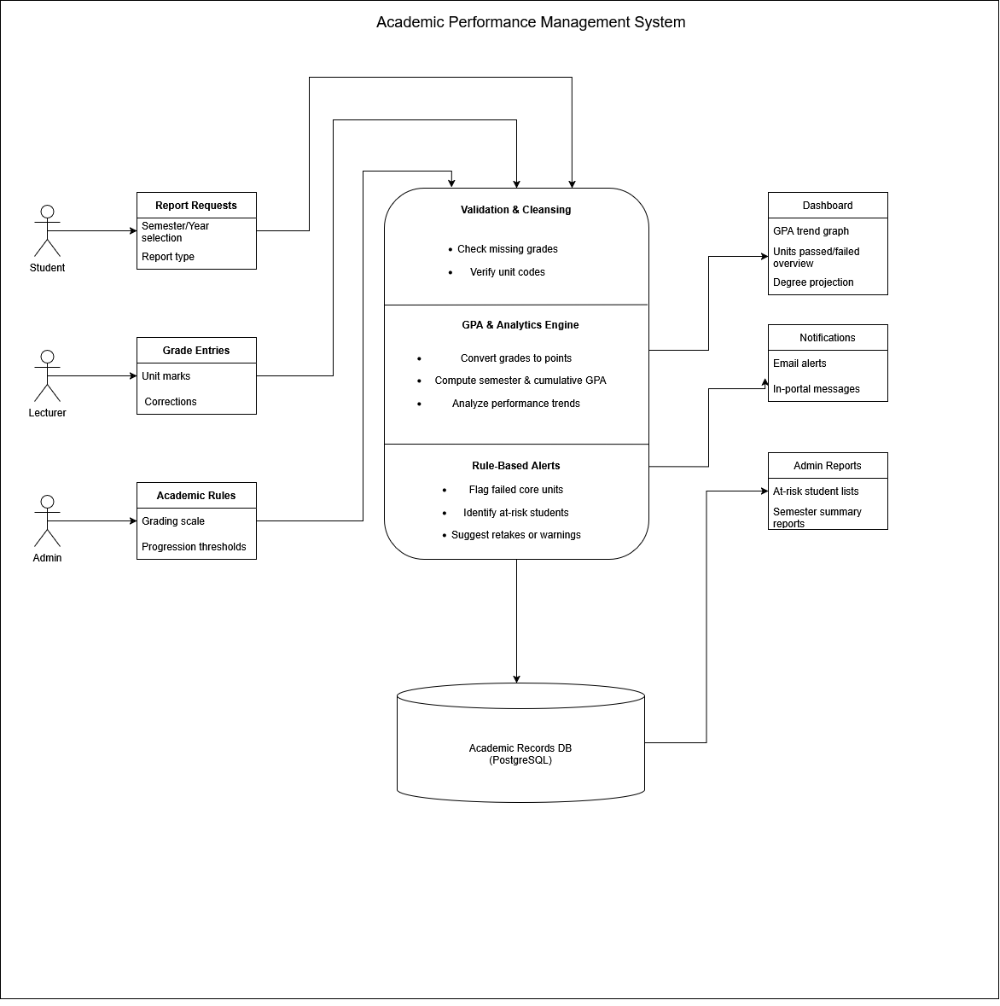

Figure Conceptual Framework diagram

# References

Collegis Education. (2021). *Level up your student information system (SIS): Moving processes from manual to automated*. Retrieved from Collegis Education: https://collegiseducation.com/insights/technology-management/level-up-student-information-system/

DiplomaSafe. (2023, n.d.). *Student Information Systems (SIS) Explained*. Retrieved from DiplomaSafe: https://diplomasafe.com/student-information-system/

Ellucian. (2025, nd). *What is a Student Information System in Higher Education?* Retrieved from Ellucian: https://www.ellucian.com/blog/what-student-information-system-higher-ed

Wikipedia. (2024). *Academic grading in Kenya*. Retrieved from Wikipedia: https://en.wikipedia.org/wiki/Academic_grading_in_Kenya