**Home Beam Analysis**

**Elijah Roberts**

**July 31st 2022**

**Finite Element Analysis (FEA)**

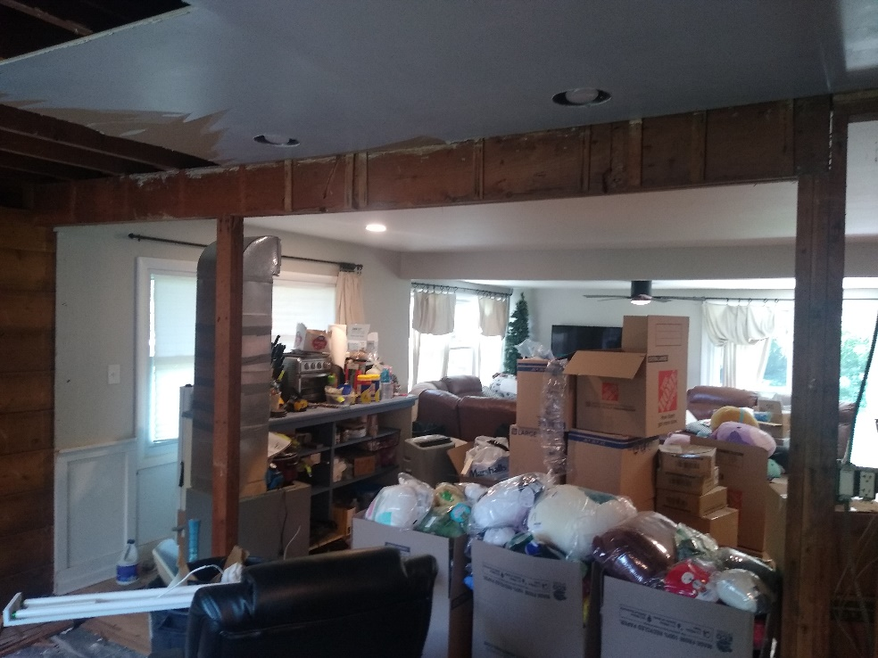

**Figure (1):** Photo of the homes support beam for reference.

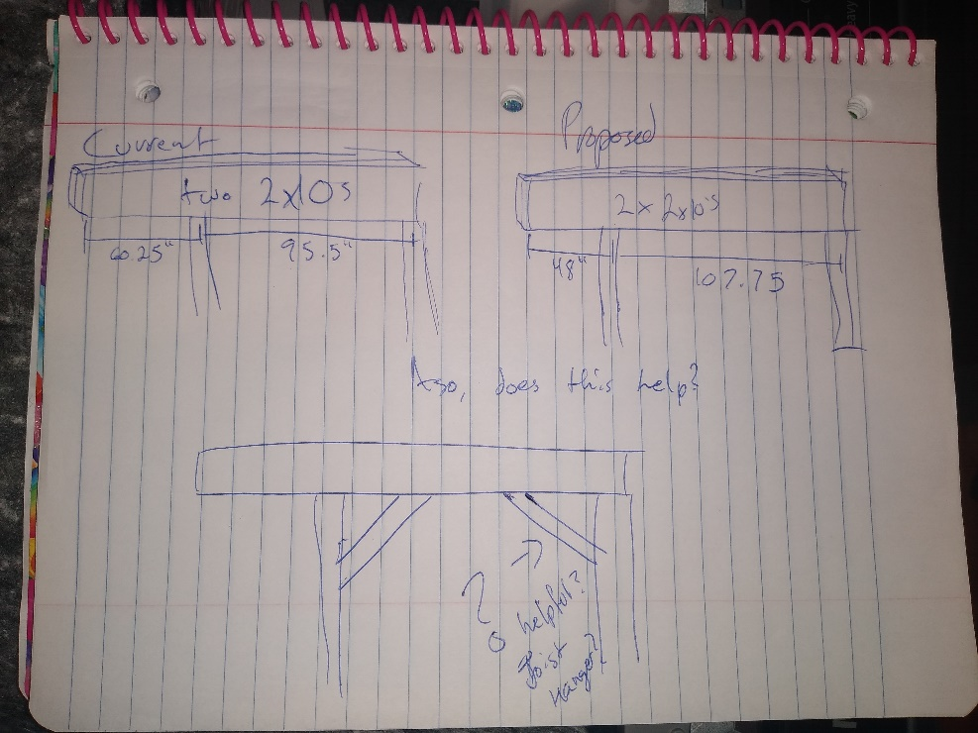

**Figure (2):** Diagram of beam with relevant measurements for analysis.

**Modeling**

Based off of Figure (2), the beam is seen to be composed of two 2x10 wooden beams. These beams are bound together with nails such that their larger faces are parallel and flush to one another. This pair is oriented so that the larger faces are perpendicular to the direction of loading. This indicates the beam is intended to be used to withhold vertical loading as a horizontal structural support. With these elements in mind for the purpose of analysis the beam will be modeled as a single “4x10” wooden piece under 2D static beam bending conditions.

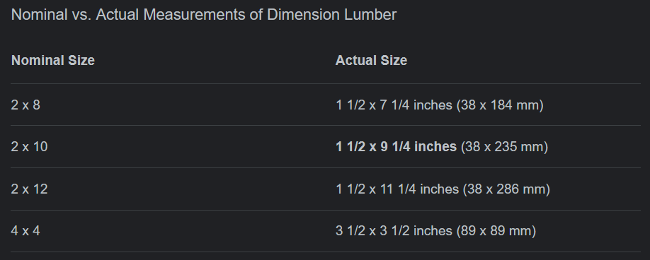

**Figure (3):** Nominal vs. actual measurements of dimension lumber referenced from Google.

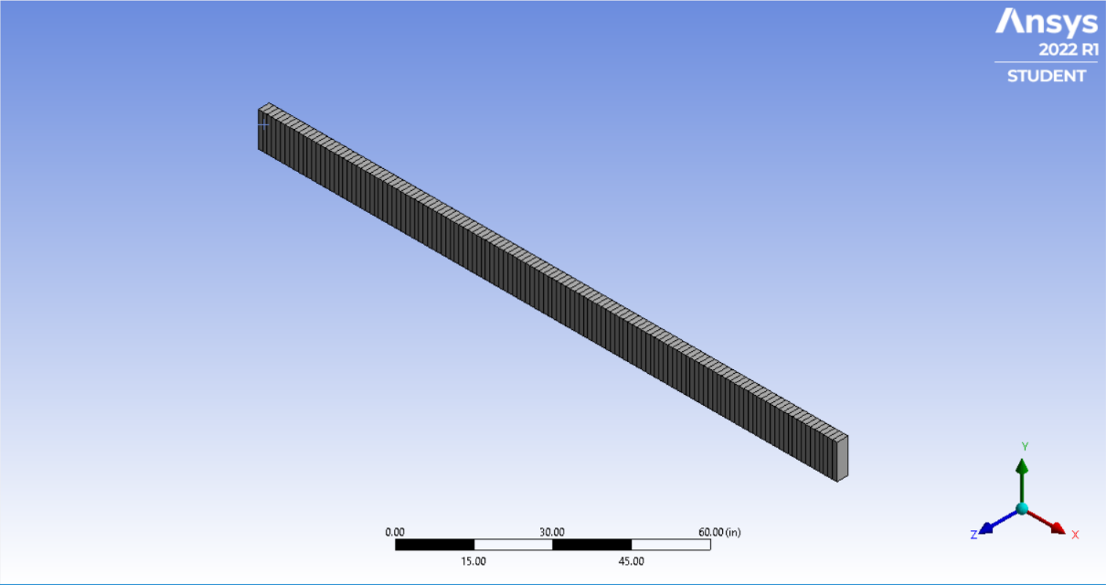To generate accurate cross-section geometry Figure (3) was used to convert the nominal dimensions of the lumber to actual size. This resulted in a composite beam with a cross-section of 3x9.25in.

**Figure (4):** Ansys beam geometry with FEA mesh.

As shown in Figure (4) the beam geometry was completed as a singular beam with a 3x9.25in cross-section and total length of 155.75in as written in the ‘Proposed’ portion of Figure (2). The segmentations across the length of the beam represent the FEA elements. The mesh settings are quadratic elements with the element size set to 0.1ft. Testing with various mesh resolutions showed these settings to be more than enough to give accurate results for the given loading situation.

Without exact material information being given two materials were used for analysis, The stock “Wood, Oak” material included with ANSYS and a generated “Pine Wood” material with properties taken from [material-properties.org](https://material-properties.org/pine-wood-properties-application-price/). These materials were selected to represent both ends of the wood spectrum from high density to low density. Oak has a larger Young’s Modulus of Elasticity (E) of 23GPa than Pine at 10GPa. This means Pine is more elastic than Oak as shown in Figure (5).

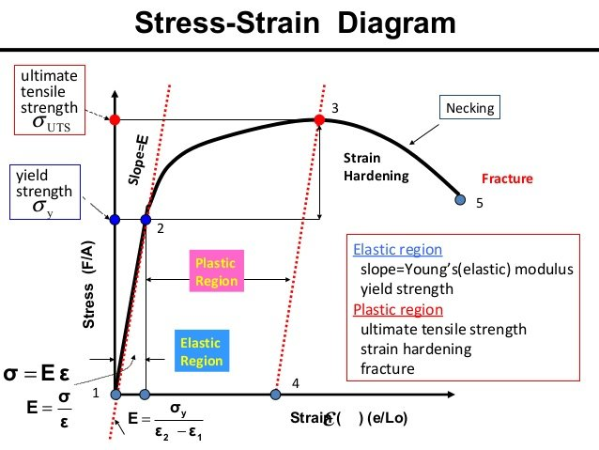

**Figure (5):** Stress-strain diagram of typical material behavior with annotations.

With this in mind if results show that Pine is suitable for the given loading it can be reasonably assumed to be suitable given higher density and quality structural woods.

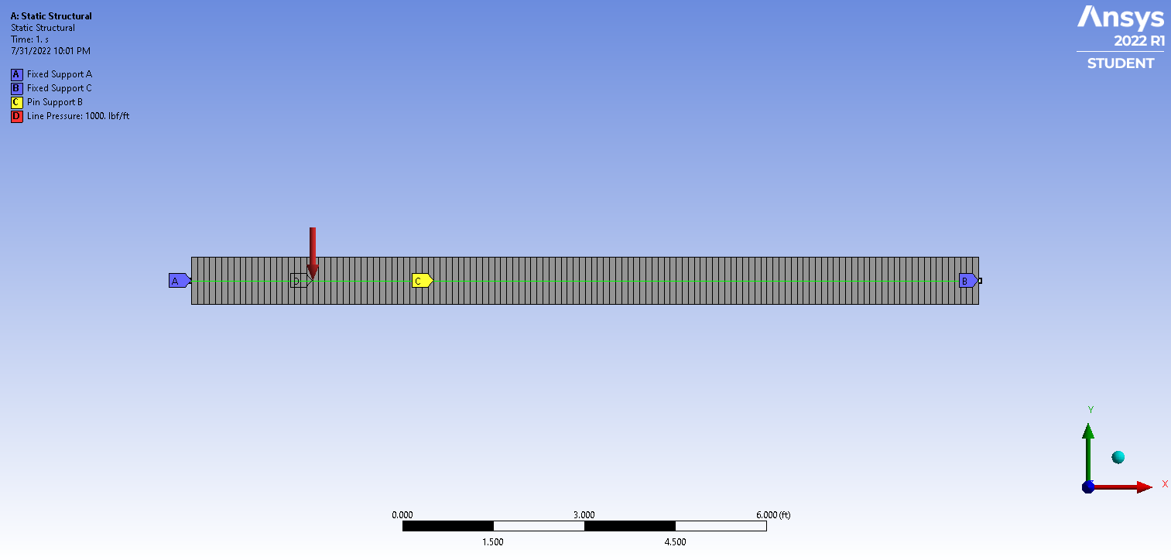

**Figure (6):** Ansys static structural beam loading conditions.

The model beam loading conditions can be seen in Figure (6). Based on Figure (1) fixed supports were used at either end of the beam. Fixed supports assume zero deformation (movement) and zero rotation at that point. For the center support that is being relocated a pin support was used. Pin supports assume zero deformation but do allow for rotation around the given point. Lastly the loading of the beam is generated by a distributed line pressure along the length of the beam.

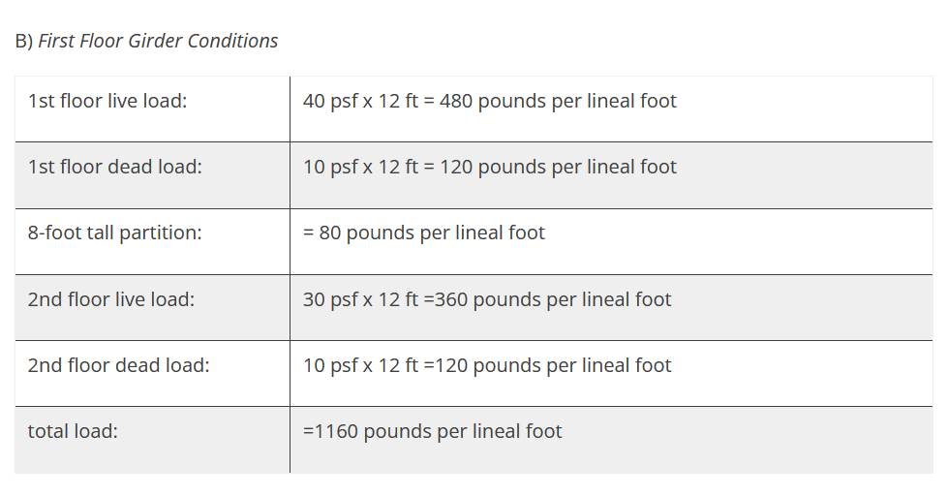

**Figure (7):** First floor girder conditions referenced from [umass.edu](https://bct.eco.umass.edu/publications/articles/calculating-loads-on-headers-and-beams/).

To determine the magnitude of the line pressure Figure (7) was used. By adding the values for the live and dead load of a 2nd floor home the loading for the beam is found to be 480lbs/ft. Since the actual loading conditions of the home are ultimately unknown a factor of safety of roughly 2 is used to determine the magnitude. This results in 1000lbs/ft being used as shown in Figure (6).

**Results and Discussion**

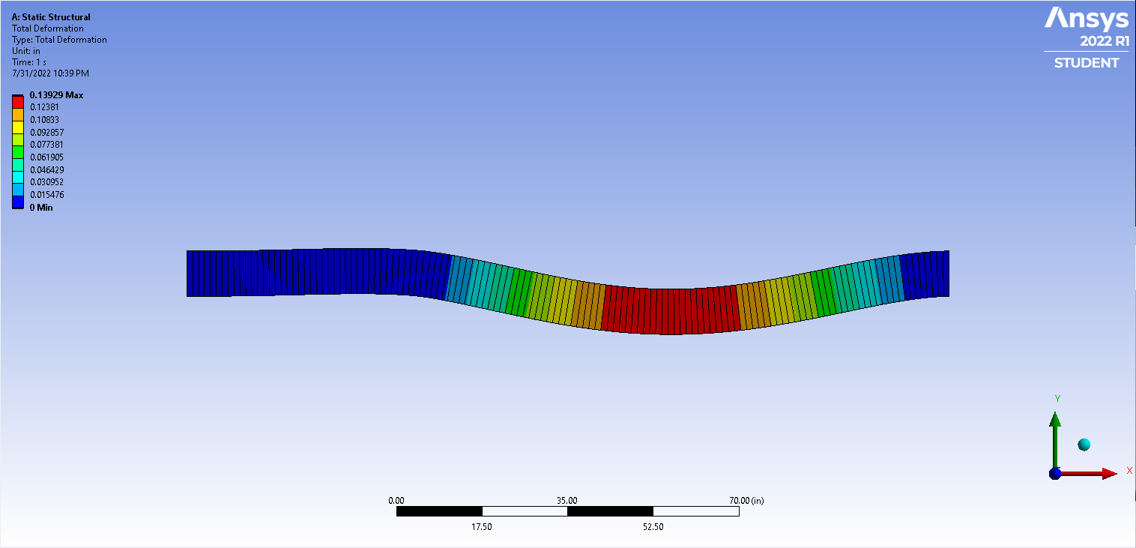

**Figure (8):** Ansys total deformation results window.

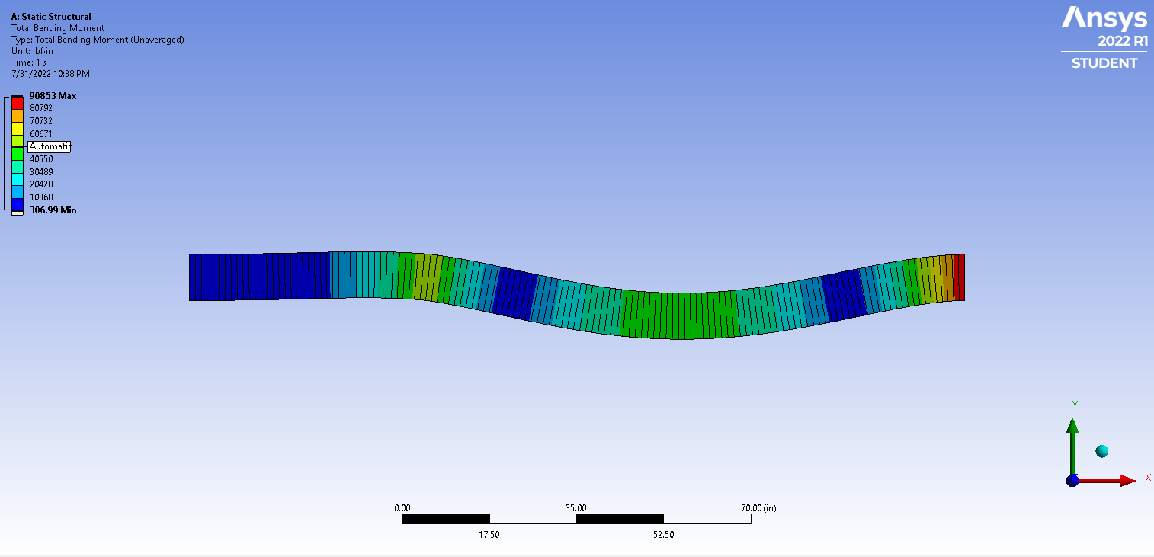

**Figure (9):** Ansys total bending moment results window.

**Figure (10):** Ansys total shear force results window.

Figures (8-10) show relevant results from the FEA solution of the beam model. The most important result is found in Figure (8) which shows the total deformation of the beam. It can be seen that the maximum deformation occurs at the center point of the longer section between the pin support and the right fixed support (as expected). This maximum deformation is 0.13in. A promising result considering the loading is double the theoretical amount. This deformation is low enough that plastic deformation can be assumed to not occur and as such fracture failure will not occur according to the model. Figure (9) shows the maximum bending moment occurs at the right fixed support. This magnitude can be converted to 7500lbs-ft. Intuitively this amount seems large and for the loading shown in Figure (1) being conscious of the how the beam is mounted there may be a large amount of torque twisting the beam out of doorframe. This issue is likely much less relevant though when considering that the beam is in actuality supported from the bottom by a stud. The fixed support does not fully capture how the beam will react to rotational moments. With this in mind the maximum shear force shown in Figure (10) can also be considered semi-irrelevant since it also occurs at the right fixed support.

In conclusion the beam modeled as pine under a factor of safety of 2 shows results well within functional deformation. One should be mindful of the bending moment occurring at the right support but given the actual support it seems likely to be a nonissue.

**Disclaimer**

For personal and legal reasons this report should not be considered structurally valid without the ok from a trained professional. It is important to understand that this model could be rendered invalid due to inaccurate information or assumptions used. Any use of information from this analysis should be applied at one’s own risk.