Johnathan Clayton: Functions for distance, physics loss node sums, mass loss, total loss, and moving averages. Also implemented trimming and changing alpha and beta over time. Wrote and presented on future improvements, project introduction, and also came up with the idea of the project.
Elijah Weddle: Spearheaded Latex integration, wrote code to do all of the visualization of the optimization results, wrote and presented data and results sections,.
Khushi Kapoor: Wrote the code to calculate diameter and weight using inputs like force, length, Youngs modulus. Helped implement and test mass and physics loss functions. Wrote and presented methods section, wrote abstract and conclusion.

Final Project Report
Your final write-up is required to be 8 pages using the provided LaTeX template. The report should be structured as a paper with the following sections.

Title, Author(s)

Abstract
Briefly describe your problem, approach, and key results. Should be no more than 300 words.

Introduction (10%)
Describe the problem you are working on, why it's important, and an overview of your results.
- Introduce the engineering problem
- Why is the problem interesting or important?
- Why do we need machine learning to tackle this problem?

Related Work (10%)
Discuss published work that relates to your project.
- Summarize current approaches and relevant literature
- Highlight limitations in existing research
- What is the gap in current solutions?

Data (10%)
Describe the data used in your project.
- Where did you obtain your data?
- What steps did you take to clean and prepare your data?
- How did you divide your data for training, validation, and testing?
- How is the dataset used to design and run your experiments?

Methods (30%)
Discuss your approach.
- Why is your approach the right choice?
- Did you consider alternative approaches?
- Demonstrate application of course concepts
- Include figures, diagrams, or tables if helpful

Experiments and Discussion (30%)
Discuss experiments and results.
- Present findings using graphs, figures, or tables
- Which metrics are used to evaluate performance?
- Evaluate whether the method solves the problem

Iterations / Refinements
- What changes did you make?
- How did these changes affect performance?

Analysis
- Discuss shortcomings or failure modes
- Describe challenges faced and lessons learned

Conclusion (5%)
- Summarize key results
- Suggest future extensions or applications

Writing / Formatting (5%)
Ensure the paper is clearly written and nicely formatted.

Supplementary Material (separate file)
- Source code
- Optional: videos, visualizations, demos

Additional Submission Requirements
- Include all authors in final report
- List contributions of each group member
- Cite relevant literature throughout
- Reference any external code or datasets used

- Spaceframe Topology Optimization using Machine Learning
- Khushi Kapoor, Johnathan Clayton, and Elijah Weddle

Abstract
The design of lightweight structural systems is a fundamental challenge and goal in engineering, particularly in applications where material choices directly impact performance, such as aerospace and mechanical systems. This project investigates a machine learning-based approach to optimizing the topology and geometry of two-dimensional spaceframe structures. The objective is to generate truss configurations that satisfy static equilibrium under loading while minimizing total structural mass. Traditional topology optimization methods often struggle in scenarios where applied loads are small relative to member weight, leading to poor convergence or impractical solutions. Using a physics-informed loss function and gradient-based optimization via the commonly used Adam optimizer, the model iteratively adjusts node positions to balance equilibrium constraints while minimizing mass. The results demonstrate that this approach can successfully generate physically consistent truss structures and reduce mass relative to initial random configurations. However, challenges remain in maintaining numerical stability and ensuring physically meaningful pruning of members. This work highlights the potential of machine learning as a framework for structural optimization and provides a foundation for extending these methods to more complex, real-world applications.

Introduction (10%)
In a fully optimized structure, all elements are sized to have the maximum safe stress to minimize weight. In a heavily loaded case where space is constrained, most of the volume will necessarily be taken up with material. But given a lightly loaded case, as the scale becomes larger and geometric constraints become less pressing, more efficient shapes can be achieved. In a simple compression beam, a square cross section becomes a cylinder, which becomes hollow, which then turns into a truss, each truss member of which is sometimes also a truss itself when the structure is large enough. As 3D printing matures, geometric constraints become less pressing as traditionally complex geometry has little penalty. Trusses have three distinct synergies with selective laser sintering (SLS) metal 3D printing. Due to the higher strength of 3D printed metal compared to polymer 3D printing, many loads will be small compared to the strength of the material. SLS naturally creates circular cross sections of truss members with the laser melt and is able to move rapidly to the next truss member. And finally, minimizing the weight of a SLS 3D printed component directly corresponds to its machine time, which likewise directly corresponds to its cost, meaning the lightest weight component is also the cheapest when metal 3D printed. As such, trusses are beneficial for use with 3D printing. Although 3D printed trusses don’t have true pin joints at the connections, their moment carrying capability is very small compared to their compressive and tensile strength, making the approximation appropriate.
Though a 3D truss solver would be more applicable to real use cases, this project is constrained to two dimensions. A network of fixed nodes, free nodes and loaded nodes were used to calculate force equilibrium with some residual. The forces from those equilibriums were used to size member diameters via Euler Buckling, which defined member mass. The equilibrium residual and combined member mass were combined as physics and mass loss to obtain the overall loss function. The member forces and node positions were then optimized to reach static equilibrium and low truss weight.
This optimization process benefits from the truss simplification, as strengthening relevant connections and deactivating less useful ones is exactly what these optimizers are built to do in neural networks. The truss takes the form of a fully connected graph network, with the exception that some nodes are also free to move position. The truss neural network that is trained through this optimization process yields the result in its network properties directly.

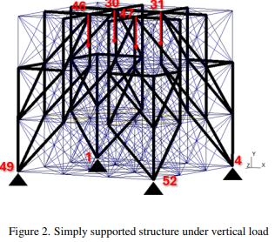
Related Work (10%)
Three papers focused on optimizing space frame trusses were analyzed. ‘Topology optimization of spatial frames’ by Schroeder and Cardoso (2024) used a 3D grid of points with various connections. Their method optimized the topology by trimming the less impactful nodes from the lattice. But the node positions were not allowed to move, limiting the flexibility of the solver.
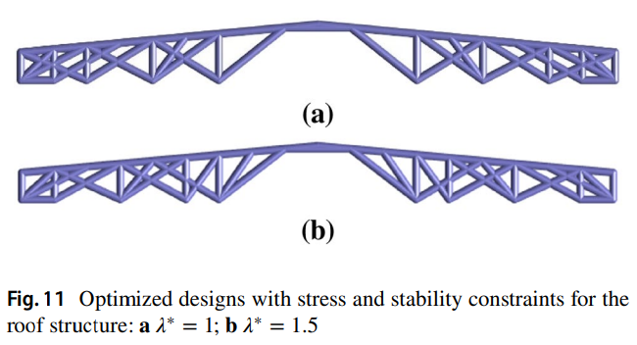
‘Topology optimization of frame structures with stress and stability constraints’ (2022) likewise used a 2D or 3D lattice of points, whose connections were gradually trimmed.
‘Ultralight Fractal Structures from Hollow Tubes’ (2012) deals with exclusively 1D compression members. It solves the buckling equation to size truss members, then replaces those members with smaller trusses. Replacing the 1D members in a truss solver like ours or the ones above with hierarchical trusses would likely lead to even lower structure weights.
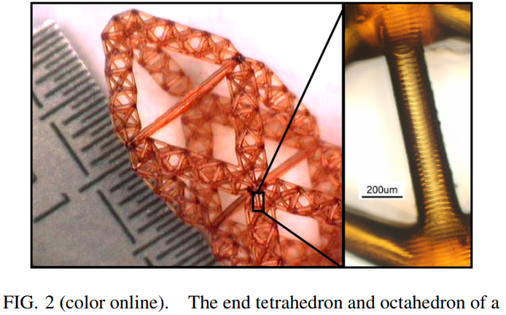

Data (10%)
There are multiple variables to account for in the data set. The problem does not have a traditional dataset to learn from. Instead, the input data consists of the locations and forces on the loaded and fixed nodes. Each of these individual load cases is trained till convergence. With the number of nodes we are working with, this is still reasonable. For larger and more complex systems, it may become beneficial to train a hyper model using the outputs of this model as training data to decrease compute time.

Methods (30%)
To optimize the topology, the structure must physically support the loads and minimize weight. These are quantified in the physics loss and mass loss respectively.
The 2D pin connected truss enabled faster computation times. A predefined number of free nodes, fixed nodes, and loaded nodes were initialized for a load case. Given the constraints, the force balance equations become simple balances in x and y directions (pin connections cannot carry moments). The physics loss is then the sum of the residual of these force balances.
$$Physics Loss_{node}=\sum_{x}{F_{node}}+F_{node_{external}}$$
$$Physics Loss_{node}=\sum_{y}{F_{node}}+F_{node_{external}}$$
Note that the fixed nodes are not included in the physics loss tally, to account for the real reaction loads they will experience. The loaded nodes have their forces applied as an inequality to the force balance.
The total mass of the structure is computed as the sum of the masses of individual members. Each member is a cylinder sized for Euler buckling given the member force and length.
$$F_{buckling}=\frac{π^{2}YI}{L^{2}}$$
This sizing should only apply to compression forces, but a current limitation of the model is that both tension and compression members are sized via buckling, which represents tension members as heavier than they actualy need to be. Unfortunately, when the difference is considered, the weight discontinuity around 0 force breaks the gradient optimizer.
In the implementation, member sizing is tied to force requirements. Meaning that larger internal forces lead to larger required cross-sectional areas and therefore higher mass.
These competing requirements are incorporated into a physics-informed loss function that balances equilibrium satisfaction with mass minimization. The loss function is defined as a weighted sum of two primary terms as defined: a physics loss and a mass loss. The relative importance of these two objectives is controlled by weighting parameters, denoted as alpha and beta. These parameters must be selected carefully, as placing too much emphasis on mass reduction can lead to unrealistic structures that do not satisfy equilibrium, while prioritizing physics too heavily can result in unnecessarily heavy designs. In practice, the physics term is weighted more strongly to ensure that all generated solutions remain physically valid.
To minimize the loss function, a gradient-based optimization approach is used. Specifically, the Adam optimizer is employed due to its ability to provide stable and efficient convergence with a learning step of 0.1. Adam, which stands for Adaptive Moments, improves upon standard gradient descent by incorporating both the average of past gradients and the variability of those gradients into the update step. This allows the optimization process to adaptively adjust step sizes for each variable, leading to faster convergence and improved numerical stability. In the context of this problem, the optimizer computes how small changes in node positions and connection properties affect the total loss and then updates these variables in a direction that reduces the loss.
During each iteration, the model calculates internal forces in each member, resolves those forces into their directional components, evaluates the equilibrium residual at each node, and computes the corresponding mass contribution of each member. Based on these calculations, gradients of the loss function are determined with respect to the design variables, and the optimizer updates the structure accordingly. Over successive iterations, this process leads to a gradual refinement of the truss configuration. The final result is a structure that effectively balances the competing objectives of minimizing mass and maintaining physical validity, demonstrating the effectiveness of combining physics-based modeling with machine learning optimization techniques.

Experiments and Discussion (30%)
Need to insert graphs here – GIFS and screenshots

To interpret the results quickly and visually, a plotting function was developed. The plotting function assigns a shape to fixed nodes, free nodes, and load points to distinguish the three types of nodes. To reduce the amount of plots analyzed and keep run times reasonable, the graphs plot at specific intervals ( 10,000 steps or 50,000 steps).
There are a few main features of the plotting functions that are worth noting to understand the results. The plotting function assigns a thickness based on the rods diameter. The advantage of seeing this visually not only shows what members bear more load, but additionally what member have the potential to be pruned; this became
The beginning of the optimization causes the most noticeable and significant changes. As seen in the GIF’s, the first 50,000 iterations cause the majority of movement in nearly every configuration of loads and supports – this follows in class teachings for a model of this kind. It is expected that an optimizing loop would cause more change at the beginning.

Refinements
We found that with a constant alpha, (physics loss weighting factor) the model tends to get stuck in a local maximum of disregarding physics entirely, or being too timid to move nodes substantially, since that will temporarily change the force balance. The physics loss and mass loss are balanced against each other, where the relative weighting changes over iterations. The physics loss weighting factor alpha decreases to the mid iteration, then ramps back up to its initial value. This enables the model to take larger geometry jumps in the middle, while still ensuring that it yields an accurate result.
To improve model performance and visual clarity, a trimming function was used to mask out any members who’s diameter averaged under a given threshold averaged over several model iterations.
Several future improvements could make this tool more useful in real life. Implementing a 3D instead of 2D solver, keep out zones where the model is penalized for putting members, a post processor to export to Open sCAD script to generate 3D models, a smoothing algorithm for the intersection points, and a way to physically accurately handle intersections between members.

Analysis
The loop gravitates towards traditional shapes that should be recognized by mechanical engineering and structural engineering students. The bridge loaded simulations clearly trend towards diamond shapes, built by obvious triangles, one of nature’s strongest shapes.
The structure does often end up symmetric above and below the loaded nodes. This is because in the current model iteration there is no advantage to members in tension rather than compression. So the model has no incentive to be on one side of the load vs the other.
The nodes do spread out rather than clustering together, which is a good sign that they are finding an optimum. Previously when the loss function wasn’t accurate, all the nodes were clustering together to minimize the weight of the members between them. But now they are spreading out to give a more even distribution for the distributed load cases.

Conclusion (5%)
In conclusion, the topology optimization framework developed in this project successfully demonstrated the ability to generate lightweight truss structures that satisfy static equilibrium while minimizing structural mass. By modeling the truss as a graph and applying a physics-informed loss function, the approach was able to balance competing objectives of physical validity and efficiency through gradient-based optimization. The use of the Adam optimizer allowed for stable convergence and enabled continuous updates to node positions and member properties, resulting in optimized structures that reflect recognizable and efficient engineering designs. The emergence of traditional truss geometries, such as triangular and diamond-shaped configurations, further supports the validity of the method, as these forms are known to be structurally efficient.
This work highlights the effectiveness of combining classical structural mechanics principles with modern machine learning techniques. The integration of equilibrium constraints, Euler buckling-based member sizing, and loss-based optimization provides a flexible framework that can adapt to different loading conditions and boundary configurations. Additionally, the ability of the model to start from random initial configurations and converge toward meaningful structural layouts demonstrates its potential as a generative design tool.
However, several limitations were identified throughout the project. The balance between physics loss and mass loss remains highly sensitive, and improper tuning can lead to either physically invalid structures or overly conservative designs. The use of a single sizing method for both tension and compression members introduces conservatism and limits physical realism. Furthermore, the current implementation is restricted to two-dimensional systems, which reduces its applicability to real-world engineering problems. Computational cost is also a significant challenge, as extending the model to more complex systems or higher node counts would require substantially more processing power.
Future work should focus on extending the framework to three-dimensional spaceframes, which would significantly increase its practical relevance. Incorporating more accurate material models, including separate treatment of tension and compression members, would improve physical fidelity. Additional constraints such as stress limits, buckling modes, and manufacturability considerations could also be integrated into the loss function. From a machine learning perspective, developing adaptive weighting strategies for the loss terms or training a higher-level model to predict optimized configurations could improve convergence speed and robustness. Improvements to pruning strategies and post-processing techniques would also help produce cleaner and more realistic final designs.
Overall, this project demonstrates that machine learning provides a promising and flexible approach to structural topology optimization. While further refinement is needed, the results establish a strong foundation for future development and highlight the potential for combining physics-based modeling with data-driven optimization techniques in engineering design.

Mis.
To limit the design space to a reasonable scope for this project, we undertook 2D cases with relatively few nodes. We focused on simple load cases like overhung loads and distributed loads such as bridges. We defined nodes that could not change position for loaded nodes and fixed anchor nodes. Then we randomly distributed a set number of free nodes around those loaded and fixed nodes. Finaly, we fully connected the nodes to obtain the truss’ initial condition.
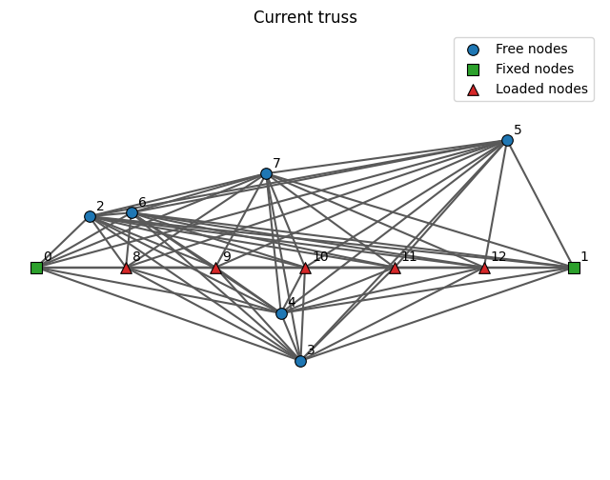

There are an infinitesimal number of configurations for lightweight structures and therefore limitations needed to be set from the beginning to conduct a meaningful optimization. To begin, the model focuses only on 2D cases with 2 fixed. All nodes

mass of the structure while keeping the load nodes supported. The driving equation determining the structure's mass is the buckling force equation given here:
Buckling force eq from text
Each force found from the equilibrium equations determines the minimum rod diameter (each truss member is assumed to be a round solid rod.

In addition to buckling forces, the following equations were used to determine equilibrium:
Sum of Y
Sum of X
Moment balance

- Spaceframe Topology Optimization using Machine Learning
- Khushi Kapoor, Johnathan Clayton, and Elijah Weddle

Abstract
The design of lightweight structural systems is a fundamental challenge and goal in engineering, particularly in applications where material choices directly impact performance, such as aerospace and mechanical systems. This project investigates a machine learning-based approach to optimizing the topology and geometry of two-dimensional spaceframe structures. The objective is to generate truss configurations that satisfy static equilibrium under loading while minimizing total structural mass. Traditional topology optimization methods often struggle in scenarios where applied loads are small relative to member weight, leading to poor convergence or impractical solutions. Using a physics-informed loss function and gradient-based optimization via the commonly used Adam optimizer, the model iteratively adjusts node positions to balance equilibrium constraints while minimizing mass. The results demonstrate that this approach can successfully generate physically consistent truss structures and reduce mass relative to initial random configurations. This work highlights the potential of machine learning as a framework for structural optimization and provides a foundation for extending these methods to more complex, real-world applications.

Introduction (10%)
In a fully optimized structure, all elements are sized to have the maximum safe stress to minimize weight. In a heavily loaded case where space is constrained, most of the volume will necessarily be taken up with material. But given a lightly loaded case, as the scale becomes larger and geometric constraints become less pressing, more efficient shapes can be achieved. As 3D printing matures, geometric constraints become less pressing as traditionally complex geometry has little penalty. Trusses have three distinct synergies with selective laser sintering (SLS) metal 3D printing. Due to the higher strength of 3D printed metal compared to polymer 3D printing, many loads will be small compared to the strength of the material. SLS naturally creates circular cross sections of truss members with the laser melt and can move rapidly between truss members. And finally, lowering the weight of a SLS 3D printed component lowers its machine time, which likewise lowers its cost. Although 3D printed trusses don’t have true pin joints at the connections, their moment carrying capability is very small compared to their compressive and tensile strength, making the approximation appropriate.
This project optimizes the topology of trusses in two dimensions. A network of fixed nodes, free nodes and loaded nodes were used to calculate force equilibrium with some residual. The forces from those equilibriums were used to size member diameters via Euler Buckling, which defined member mass. The equilibrium residual and combined member mass were combined as physics and mass loss to obtain the overall loss function. The member forces and node positions were then optimized to reach static equilibrium and low truss weight.
This optimization process benefits from the truss simplification, as strengthening relevant connections and deactivating less useful ones is exactly what these optimizers are built to do in neural networks. The truss takes the form of a fully connected graph network, with the exception that some nodes are also free to move position. The truss neural network that is trained through this optimization process yields the result in its network properties directly.


Related Work (10%)
Three papers focused on optimizing space frame trusses were analyzed. ‘Topology optimization of spatial frames’ by Schroeder and Cardoso (2024) used a 3D grid of points with various connections. Their method optimized the topology by trimming the less impactful nodes from the lattice. But the node positions were not allowed to move, limiting the flexibility of the solver.

‘Topology optimization of frame structures with stress and stability constraints’ (2022) likewise used a 2D or 3D lattice of points, whose connections were gradually trimmed.
‘Ultralight Fractal Structures from Hollow Tubes’ (2012) deals with exclusively 1D compression members. It solves the buckling equation to size truss members, then replaces those members with smaller trusses. Replacing the 1D members in a truss solver like ours or the ones above with hierarchical trusses would likely lead to even lower structure weights.


Data (10%)
There are multiple variables to account for in the data set. The problem does not have a traditional dataset to learn from. Instead, the input data consists of the locations and forces on the loaded and fixed nodes. Each of these individual load cases is trained till convergence. With the number of nodes we are working with, this is still reasonable. For larger and more complex systems, it may become beneficial to train a hyper model using the outputs of this model as training data to decrease compute time.

Methods (30%)
There are two methods to analyze – the structural method and the optimization method. Although these two play are interdependent, it is worth considering the two as distinct. The structural method ties in several concepts and principles taught throughout Washington University's Mechanical Engineering and Material Science (MEMS) courses. The optimization method is more specific to MEMS 5205 – Machine Learning Applications in Mechanical Engineering.
The structural method was intentionally kept simple. The model is limited to 2-D spaces, all pin connections, a predefined number of free nodes, and two fixed nodes. Given the constraints, the force balance equations become simple balances and no reaction moments need to be accounted for (pin connections cannot counter a moment). Not only does this approach simplify the physics and math for a simpler set up, the simplicity also drastically reduces runtimes, which is important to the ability to focus on optimization when working on personal computers.
To analyze the optimization, the main focus of MEMS 5205, the truss is modeled as a graph consisting of nodes and edges, where nodes represent joints and edges represent structural members; this representation allows the problem to be treated similarly to a neural network, where connections between nodes can be adjusted continuously during optimization. The goal of the optimization process is to identify a configuration that is both physically valid and efficient, meaning the structure must satisfy static equilibrium under applied loads while minimizing total structural mass. By framing the problem in this way, the model can evaluate how well given truss configuration has been designed through a defined loss function, which guides the optimization process.
The total mass of the structure is computed as the sum of the masses of individual members, with each member’s mass depending on both its geometry and the magnitude of the force it must carry. In the implementation, member sizing is implicitly tied to force requirements, meaning that larger internal forces lead to larger required cross-sectional areas and therefore higher mass. This relationship is derived using principles from structural mechanics, including Euler buckling equation, $F_{buckling}=\frac{π^{2}YI}{L^{2}}$ which ensure that members are sized sufficiently to avoid failure under compressive loads. A current limitation of the model is that both tension and compression members are sized via buckling, which is unrealistically conservative for tension members. Unfortunately, when the difference is taken into account, the weight discontinuity around 0 force breaks the gradient optimizer.
At the same time, the structure must satisfy static equilibrium, meaning that the net force at each node must be zero when accounting for both internal member forces and externally applied loads. To enforce this, the model computes force contributions from each connected member in both the x and y directions and compares the resulting sum to the external load vector at each node. The calculations designing the truss do not need to account for moments because each connection is assumed to be a pin which simplifies the calculations tremendously.
These competing requirements are incorporated into a physics-informed loss function that balances equilibrium satisfaction with mass minimization. The loss function is defined as a weighted sum of two primary terms: a physics loss and a mass loss. The physics loss measures how well the structure satisfies equilibrium by penalizing any imbalance in forces at each node. If the forces do not sum to zero, the residual increases, resulting in a higher loss value. The mass loss, on the other hand, estimates the total weight of the structure and encourages the optimizer to favor lighter designs. The relative importance of these two objectives is controlled by weighting parameters, typically denoted as alpha and beta. These parameters must be selected carefully, as placing too much emphasis on mass reduction can lead to unrealistic structures that do not satisfy equilibrium, while prioritizing physics too heavily can result in unnecessarily heavy designs. In practice, the physics term is weighted more strongly to ensure that all generated solutions remain physically valid.
To minimize the loss function, a gradient-based optimization approach is used. Specifically, the Adam optimizer is employed due to its ability to provide stable and efficient convergence. Adam, which stands for Adaptive Moments, improves upon standard gradient descent by incorporating both the average of past gradients and the variability of those gradients into the update step. This allows the optimization process to adaptively adjust step sizes for each variable, leading to faster convergence and improved numerical stability. In the context of this problem, the optimizer computes how small changes in node positions and connection properties affect the total loss and then updates these variables in a direction that reduces the loss.
During each iteration, the model calculates internal forces in each member, resolves those forces into their directional components, evaluates the equilibrium residual at each node, and computes the corresponding mass contribution of each member. Based on these calculations, gradients of the loss function are determined with respect to the design variables, and the optimizer updates the structure accordingly. Over successive iterations, this process leads to a gradual refinement of the truss configuration. The final result is a structure that effectively balances the competing objectives of minimizing mass and maintaining physical validity, demonstrating the effectiveness of combining physics-based modeling with machine learning optimization techniques.

Experiments and Discussion (30%)
Need to insert graphs here – GIFS and screenshots

To interpret the results quickly and visually, a plotting function was developed. The plotting function assigns a shape to fixed nodes, free nodes, and load points to distinguish the three types of nodes. To reduce the amount of plots analyzed and keep run times reasonable, the graphs plot at specific intervals ( 10,000 steps or 50,000 steps).
There are a few main features of the plotting functions that are worth noting to understand the results. The plotting function assigns a thickness based on the rods diameter. The advantage of seeing this visually not only shows what members bear more load, but additionally what member have the potential to be pruned; this became

The beginning of the optimization causes the most noticeable and significant changes. As seen in the GIF’s, the first 50,000 iterations cause the majority of movement in nearly every configuration of loads and supports – this follows in class teachings for a model of this kind. It is expected that an optimizing loop would cause more change at the beginning.

Iterations / Refinements
The physics loss and mass loss are balanced against each other, where the relative weighting changes over iterations. The physics loss weighting factor alpha decreases to the mid iteration, then ramps back up to its initial value. This enables the model to take larger geometry jumps in the middle, while still ensuring that it yields a accurate result in the end. Without this changing alpha, the model tends to get stuck in a local maximum of disregarding physics entirely, or being too timid to move nodes substantially, since that will temporarily change the force balance.
To improve model performance and visual clarity, a trimming function was used to mask out any members who’s diameter averaged under a given threshold averaged over several model iterations.
Several future improvements could make this tool more useful in real life. Implementing a 3D instead of 2D solver, keep out zones where the model is penalized for putting members, a post processor to export to Open sCAD script to generate 3D models, a smoothing algorithm for the intersection points, and a way to physically accurately handle intersections between members.

Analysis
The loop gravitates towards traditional shapes that should be recognized by mechanical engineering and structural engineering students. The bridge loaded simulations clearly trend towards diamond shapes, built by obvious triangles, one of nature’s strongest shapes.
The trend of the geometric configuration of the nodes is encouraging, but further analysis is required to determine effectiveness and success.

Conclusion (5%)
In conclusion, the topology optimization framework developed in this project successfully demonstrated the ability to generate lightweight truss structures that satisfy static equilibrium while minimizing structural mass. By modeling the truss as a graph and applying a physics-informed loss function, the approach was able to balance competing objectives of physical validity and efficiency through gradient-based optimization. The use of the Adam optimizer allowed for stable convergence and enabled continuous updates to node positions and member properties, resulting in optimized structures that reflect recognizable and efficient engineering designs. The emergence of traditional truss geometries, such as triangular and diamond-shaped configurations, further supports the validity of the method, as these forms are known to be structurally efficient.
This work highlights the effectiveness of combining classical structural mechanics principles with modern machine learning techniques. The integration of equilibrium constraints, Euler buckling-based member sizing, and loss-based optimization provides a flexible framework that can adapt to different loading conditions and boundary configurations. Additionally, the ability of the model to start from random initial configurations and converge toward meaningful structural layouts demonstrates its potential as a generative design tool.
However, several limitations were identified throughout the project. The balance between physics loss and mass loss remains highly sensitive, and improper tuning can lead to either physically invalid structures or overly conservative designs. The use of a single sizing method for both tension and compression members introduces conservatism and limits physical realism. Furthermore, the current implementation is restricted to two-dimensional systems, which reduces its applicability to real-world engineering problems. Computational cost is also a significant challenge, as extending the model to more complex systems or higher node counts would require substantially more processing power.
Future work should focus on extending the framework to three-dimensional spaceframes, which would significantly increase its practical relevance. Incorporating more accurate material models, including separate treatment of tension and compression members, would improve physical fidelity. Additional constraints such as stress limits, buckling modes, and manufacturability considerations could also be integrated into the loss function. From a machine learning perspective, developing adaptive weighting strategies for the loss terms or training a higher-level model to predict optimized configurations could improve convergence speed and robustness. Improvements to pruning strategies and post-processing techniques would also help produce cleaner and more realistic final designs.
Overall, this project demonstrates that machine learning provides a promising and flexible approach to structural topology optimization. While further refinement is needed, the results establish a strong foundation for future development and highlight the potential for combining physics-based modeling with data-driven optimization techniques in engineering design.

