Project Part2- Write a PSS in MatLab

I decided to go the cheaper and what I felt was more efficient way which involved downloading octave compared to MATLAB. Last time I did this project I went the same route as well but as some time has passed since the last time, I loaded up Octave and found myself needing a refresher. As you stated, in PowerPoint we should either go through a tutorial or go online whether that be YouTube and follow that tutorial. The video I decided to watch was labeled as Octave Tutorial #1: Getting Started for Absolute Beginners posted on YouTube by Mr. STEM EDU TV which I found to be very informative.

To start off this project I decided to keep the same formula as prior which was y = 2x + 1 and create the values from -10 to 10 using the : operator. I plotted the line using the plot() function and made sure to have it customizable. Keep in mind that this was just the original plot data and salting nor smoothing have been applied at this point. Essentially this was the start up or the set up for what to come later.

After creating that original line with the plot function we were then asked to salt the function which is basically just adding some noise to the data set. I generate random values between -1 and 1 using the rand() function and add that to the original y- values. Doing so distorted the graph or shall I say the line into a choppy kind of line is the best way I can put it. I use the rng (42) to seed the random number generator to reproduce my results. After doing so you can finally see the plotted original data vs the new salted data. The graph below shows two different lines the blue being the original and the distorted red being the salted data. Looking at the image it’s kind of hard to see the plotted blue line but if you look hard enough around 2.5, you’ll be able to see.

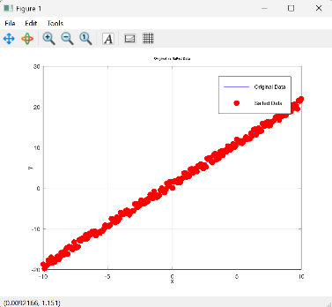

Naturally the next step is to smooth the now salted data which started off with using the built in function called movmean(). This method is used to average the y-values within a window around each possible point and I defaulted the windowSize to 3 if the user input was to collected. Essentially the goal is to reduce the fluctuations caused previously by salting and go back to prior which is my original data. All that was left to do was plot this smoothed data and as you can see in the image below we have our newly smoothed data against the salted data.

