**Cool Web Page Transitions using NodeJS**

**Requirements:**

You will need node to be installed on computer because it is the development platform for this project. With node, there comes npm (Node Package Manager) with it which you will use to install the project packages as listed below.

**Packages needed for this project**

1. Gsap
2. Dogstudio’s Highway
3. Parcel

**Procedure:**

**Installing NodeJS on your machine**

* Visit <https://www.nodejs.com>
* Download the version that suits your machine
* In the terminal or cmd enter the following
  + node -v
  + npm -v
* The above will display the versions you have installed if the installation was successful
* If no error message then you have successfully installed node on your machine

**Installing parcel globally on your machine**

Open the terminal or cmd

npm install -g parcel-bundler

This is to make sure you can use parcel for other projects without needing to download it again for every project you may need it for.

**Initiating the project**

Make the project folder with a name for example **pageTransitionProject**

In the terminal or cmd navigate to the project folder you created

mkdir pageTransitionProject

cd pageTransitionProject

npm init

**Note:** after npm init command, you can just press enter until it is done with all the prompts.

**Installing the project packages**

After navigating to the project folder, still in the terminal enter the following command.

npm install gsap @dogstudio/highway

Create *index.html* file in the root folder which is the **pageTransitionProject** folder

This is the folder structure below

Contains the image files

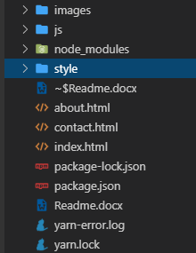

These are all generated automatically

This is the index.html file, note it is at the root of the project folder

Contains the JavaScript files

Contains the scss, sass, css files

**Note:** node_modules, package-lock.json, package.json, yarn-error.log, yarn.lock are generated automatically.

**Run the project**

With the above project folder structure, you can run the project in the terminal or cmd as follows

parcel index.html

Parcel will create for you server on which the page will run and you enter that link into your browser to view your page.