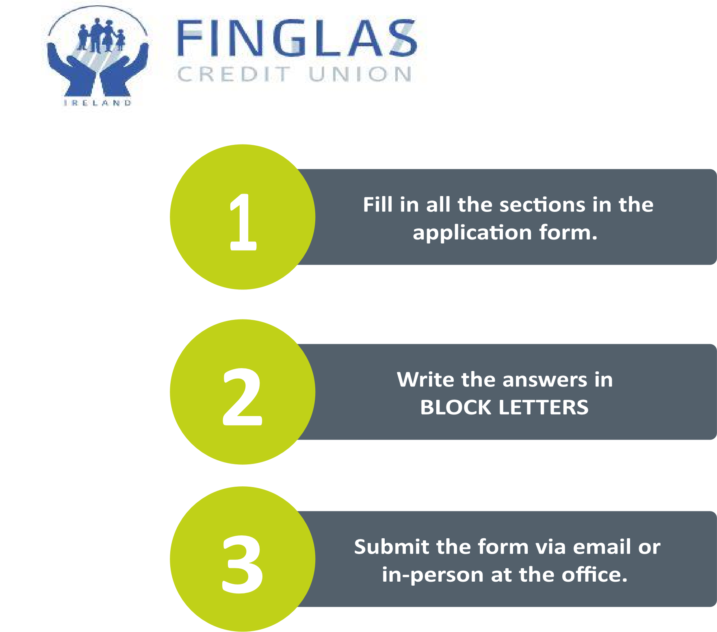
CONTACT DETAILS:
Name of Applicant: | Elijel Dela Cruz
Address: | [ADD YOUR ADDRESS — must be in Finglas CU common bond / Meakstown–Finglas–Charlestown area if possible]
Contact  Number (Tel): | [ADD YOUR PHONE NUMBER]
Email: | jackalsvolleyballclub@gmail.com
Name of Club / Organisation: | Jackals Volleyball Club
Role within organisation:  (if applicable) | Chairperson
Number of members:  (if applicable) | 45+ club members; 550+ social members
Website:  (If applicable) | https://jackalsvolleyball.com
Social Media Channels:  (if applicable) | Instagram @jackalsvolleyball · Facebook facebook.com/JackalsVC

Provide a brief description of your organisation/club?
Jackals Volleyball Club is a volunteer-run Irish National League club. We field 3 competitive teams (Division 3 winners 2024/25), with 45+ club members and 40+ league matches each season. We also run open social fun sessions and weekly trainings year-round — 150+ sessions for 550+ social members — so beginners and casual players can join and stay active. Our trainings include sessions in Meakstown (near Charlestown / Finglas), as well as other Dublin venues. Sponsorship goes straight into court hire, league fees, kits, and equipment.

Why do think your organisation/club should receive a donation from Finglas CU?
We deliver competitive and community volleyball in the Meakstown / Charlestown / Finglas area, including regular trainings that welcome local players of all levels. As a volunteer-run club, funding from Finglas Credit Union at Matchday & Kit Partner level (€1,000) would directly support court hire, league fees, kits, and equipment so sessions stay affordable and accessible for people living and working in your common bond. In return, Finglas CU would receive premium local visibility — including kit branding, matchday recognition, website and social coverage — seen by our National League squads and 550+ social members.
Have you received a donation from Finglas CU in the past?
YES
NO ✓
Not sure
*If you ticked “YES” please give a brief description of donations in the past.

How much funding is required & how does the organisation/club intend to use the funding (equipment, event, etc.)?


(if possible, please provide an approximate breakdown of project costs).

Amount sought: €1,000 (Matchday & Kit Partner level)
Use of funds (2026/27 season):
• Court hire for weekly trainings (including Meakstown sessions) and matchdays — approx. €500
• League / affiliation fees contribution — approx. €200
• Player kits / training kit branding and volleyball equipment — approx. €300
Total: €1,000
Quotes for court hire / kit / equipment can be attached on request / with this application.


How does the organisation/club intend to acknowledge Finglas CU?
Matchday & Kit Partner recognition for Finglas Credit Union (€1,000 level):
• Logo and link on https://jackalsvolleyball.com/sponsors/partners
• Logo placement on match/training kit
• Brand visibility during league matches and tournaments
• Matchday recognition and announcements
• Dedicated thank-you post on Instagram (@jackalsvolleyball) and Facebook (facebook.com/JackalsVC)
• Logo on Match Week & Match Results posts; multiple social mentions across the season
• Tag and credit Finglas Credit Union on posts (please confirm preferred handles)
• Photos and content featuring your brand; display Finglas CU logo/banner at a sponsored Meakstown/local event as requested
• Provide photos/posts for Finglas CU to reuse on website, social media, and newsletters
• Short partnership announcement / photo when funding is confirmed
Approx. 15K+ monthly digital reach; branding seen by competitive squads and 550+ social members year-round.

Do you have a Credit Union or Bank Account to which the payment will be made?
Yes — payment to Jackals Volleyball Club account. [ADD IBAN / account name / sort details]

Do you need any permission or approval for this project?
No special permissions required beyond standard venue hire for trainings. We agree to display the Finglas Credit Union logo/banner at a sponsored event and to Finglas CU publicising the partnership as set out in the terms.
Organisations/clubs that receive funding will be requested to display the Finglas Credit Union logo or banner during a sponsored event and agree that Finglas Credit Union can publicise material related to the sponsorship/event on social media pages, website, local newspaper or in email newsletters.
For full details, please see the terms & conditions.
If you have any questions, please send us an email, or give us a call.


Phone: 01-834 3193
Email: brian@finglascu.ie
Address: Seamus Ennis Road, Finglas, Dublin 11

Declaration:
- I declare that the information provided in this form is correct.
- I confirm that I have read & agree with the Terms & Conditions for the Community Fund outlined in this form.
- I permit to have my personal data processed for the purpose of applying for this funding.
Signature
[SIGN HERE — Elijel Dela Cruz]
Position held
Chairperson
Date
18/07/2026

Terms & Conditions of the Community Fund:
- All applications are to be made via a completed Application Form with any supporting documents which may be required.
- To be eligible, applicants must be located within our Common Bond.
- Only groups or organisations will be considered. (Finglas Credit Union does not sponsor individuals).
- All applicants for sponsorship will be notified in writing of the outcome of their application.
- Finglas Credit Union does not guarantee recurring sponsorship year-to-year. Each applicant can reapply for sponsorship, if required on an annual basis in each financial year.
- All applications must state how Finglas Credit Union will be represented through its sponsorship. The organisation must also demonstrate what benefits Finglas Credit Union and our community will get through the sponsorship of their organisation.
- Finglas Credit Union requests that any sponsored organisation publish on their website, social media pages or in the local papers a photograph/brief statement in recognition of the contribution made by Finglas Credit Union.
- All sponsorships are subject to agreement that Finglas Credit Union can publicise on the social media, internet and any publication Finglas Credit Union so chooses.
- Finglas Credit Union requests that any sponsored organisation display the credit union logo and Finglas Credit Union’s banner during a sponsored event. Finglas Credit Union will provide a credit union logo and banner where necessary.
- Finglas Credit Union requests that all sponsored organisations provide material showing how Finglas Credit Union was represented (photographs, copies of event brochures/adverts, printed items, copy of article in a newspaper etc).
- Finglas Credit Union reserves the right to use the name of a sponsored organisation and any material provided for promotional purposes on our website, social media, AGM booklet, and local papers.
- Failure to adhere to the terms and conditions could preclude the organisation from getting further sponsorship from Finglas Credit Union.
- The decision taken by the Board of Directors on all applications is final and no correspondence will be entered into.

