Restaurant Inventory Management System
Objective
To verify that all service-layer methods in the Restaurant Inventory Management System backend perform as expected, including CRUD operations, search, and report generation

Test Environment
- Spring Boot
- JUnit
- Mockito
- MySQL
- Java
Test Cases
Test Case ID | Test Description | Input Data | Expected Result | Actual Result | Status
TC-01 | Add Ingredient | name=Sugar, category=Baking | Ingredient saved | Ingredient returned | Pass
TC-02 | Get All Ingredients | – | Returns list of ingredients | List size > 0 | Pass
TC-03 | Update Ingredient | id=1, name=Brown Sugar | Updated name returned | Updated successfully | Pass
TC-04 | Search Ingredients | query=“Sug” | Returns Sugar | Correct record returned | Pass
TC-05 | Generate Report | – | Report JSON with title/timestamp | Matches expected | Pass

Test Results
All 5 test cases passed successfully.
- Add Ingredient
- Get All Ingredients
- Update Ingredient
- Search Ingredients
- Generate Report
No test failures or runtime exceptions occurred.
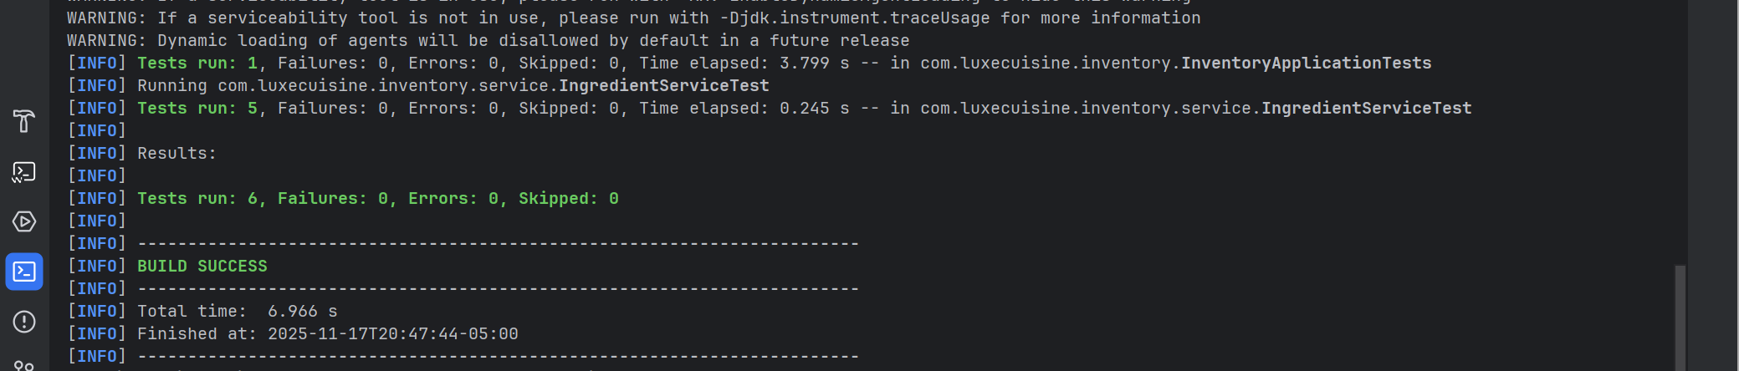
Testing Defects and Fixes
Issue Found | Resolution
The update method didn’t persist the updated record | Added save() call after modifying the entity
Validation is missing on numeric fields | Added @PositiveOrZero annotations

