The Cloud, AI and Machine Learning  
CST8912 Solutions Architecture, 10/6/2024



Group 2-CST8912  
Section: 13  
Caleb Watson-Danis- 041041241

Catherine Daigle- 41175118  
Farhana Mahmud- 041008887  
Elias Ngugi Kariuki- 41114696  
Yue Gao-040895157

Professor: Madaan, Ragini

Table of Contents

Abstract: 1

Introduction: 1

Literature Review 1

Use Cases: 1

Interviews and Surveys 1

Technology Analysis 1

Speech & Text services: 1

Chatbots: 1

Diagnostic services 1

Amazon Lookout for Metrics 1

Image services 1

Platform services 1

Azure Machine Learning 1

Using AI Tools with Machine Learning 1

Market Analysis 1

Growth Forecasts 1

Competitive Landscape 1

Key Providers: 1

Conclusion 1

References 1

# Abstract:

In this research, we discover how AI and Machine learning affect businesses using the cloud. We will review the challenges, Explore AI and ML (Machine Learning), look at business surveys and interviews, and observe the tools used and how AI/ML affected the business market.

# Introduction:

AI and Machine learning help enterprises scale, automate and grow with the Cloud. There are challenges and problems when managing a large enterprise by looking at Schneider Electric, Toyota, and BBC, we can see these companies apply cloud computing and machine learning to overcome these challenges. Numerous Tools in AI and Machine Learning are used in the cloud, and we will take an in-depth look into each tool and how they operate. The tools presented are Platform services, Imaging services, Speech & Text Services and Diagnostic services. Cloud and machine learning have already affected many businesses, and surveys conducted on machine learning reveal business production has increased significantly after adopting machine learning to their cloud. Finally, machine learning and AI technology have recently been integrated with the cloud. The future of machine learning, AI and the cloud is promising as storage options and monitoring services are growing, allowing cloud users to access big data anytime for deep learning.

# Literature Review

Artificial intelligence in cloud computing is developing quickly in different industries as more companies embrace the cloud platform. AI cloud computing is focused on building these intelligent applications, helping enterprises leverage big data, providing algorithms for advanced app functionality, and predicting future growth. (Soni & Kumar, 2023)

The synergy between AI, Machine Learning, and cloud services empowers IoT ecosystems to evolve beyond basic data collection, fostering intelligent automation and predictive analytics (Chen & Kumar, 2023). By integrating the cloud platform with artificial intelligence, companies can leverage the scalability of computational resources for complex Artificial intelligence algorithms.

Azure, Aws, and Google Cloud platforms are key providers, tailoring AI driven applications by providing an environment with dedicated tools and services. The evolution of artificial intelligence in the cloud is very promising and has brought about a new era of innovation, reshaping operations in the digital world

Use Cases:

  
[Microsoft Customer Story-Schneider Electric fast-tracks innovation with Azure OpenAI Service](https://customers.microsoft.com/en-us/story/1745242950134216820-schneider-electric-azure-machine-learning-discrete-manufacturing-en-france?culture=en-us&country=us)Schneider Electric

|  |  |  |
| --- | --- | --- |
| Challenges | Azure Services Used | Results |
| Schneider Electric faced the challenge of enhancing sustainability and efficiency while reducing carbon emissions. The complexity of managing energy resources and optimizing operations for global customers required advanced technology to process large amounts of data and automate decision-making. | To address these challenges, Schneider Electric partnered with Microsoft and integrated Azure OpenAI Service, Azure Machine Learning, and other tools from Microsoft Cloud for Manufacturing. These services helped automate tasks, optimize energy use, and improve internal efficiency. Solutions like EcoStruxure, which leverages IoT and AI, allowed Schneider to gather and analyze data for informed decision-making. | The use of Azure services led to increased productivity, faster innovation, and enhanced sustainability efforts at Schneider. Their AI-powered solutions, such as EcoStruxure Resource Advisor, enabled customers to manage energy efficiently across global portfolios, reducing emissions and driving smarter energy usage. These results allowed Schneider to accelerate its growth and have a positive impact on the environment. |

U,{933eecfa-46ad-416e-80c5-696076176ff0}{160},3.125,3.125  
[Microsoft Customer Story-Toyota Motor North America turns employee ideas into apps with Microsoft Power Platform](https://customers.microsoft.com/en-us/story/763052-toyota-motor-north-america-automotive-power-apps)

|  |  |  |
| --- | --- | --- |
| Challanges | Azure Services Used | Results |
| TMNA struggled to foster employee innovation and needed numerous applications for various functions, such as quality control and COVID-19 screenings, but lacked the technical expertise to develop them efficiently. | TMNA adopted Microsoft Azure's Power Platform, including Power Apps and Power Automate, allowing employees to create applications easily with no-code and low-code solutions. | The implementation led to the development of over 400 applications, significantly enhancing productivity and efficiency while fostering a collaborative culture of innovation, supported by a Center of Excellence for governance and training. |

  
[Microsoft Customer Story-BBC innovates how it delivers trusted news and entertainment with Azure AI](https://customers.microsoft.com/en-us/story/754836-bbc-media-entertainment-azure)

|  |  |  |
| --- | --- | --- |
| Challenges | Azure Services Used | Results |
| As one of the world's leading broadcasters, the BBC faced the challenge of creating a branded voice assistant that maintained full control over customer data and relationships. The BBC needed to provide a natural, inclusive experience for diverse audiences with various accents and dialects, making voice recognition a significant challenge. Additionally, developing a scalable AI platform for global audiences required resources and expertise beyond what the BBC could handle alone. | To meet these challenges, the BBC utilized Microsoft Azure Cognitive Services, Azure Bot Service, and Custom Neural Voice. These services provided the flexibility and control necessary for building a natural-sounding, customized voice assistant. Azure’s Language Understanding and Direct Line Speech further helped the BBC enhance speech recognition and integrate their systems seamlessly, ensuring the voice assistant could access a wide range of content, from podcasts to news updates. | With the help of Azure’s tools, the BBC successfully launched its Beeb voice assistant, delivering a personalized experience while maintaining privacy for users. The assistant allows audiences to discover content through voice commands, improving user engagement. The BBC is now planning to expand the assistant’s capabilities to global markets, ensuring it can interact with users across different regions and languages. This project also emphasized the BBC's commitment to responsible AI and protecting customer data. |

# Interviews and Surveys

The AI and Machine Learning survey report conducted by WCG CenterWatch in 2020 contains compelling information about the use of AI and machine learning within the medical sector, showing the interest level of the industry to it.  
  
The following figure shows the demographic of users that responded to the survey:

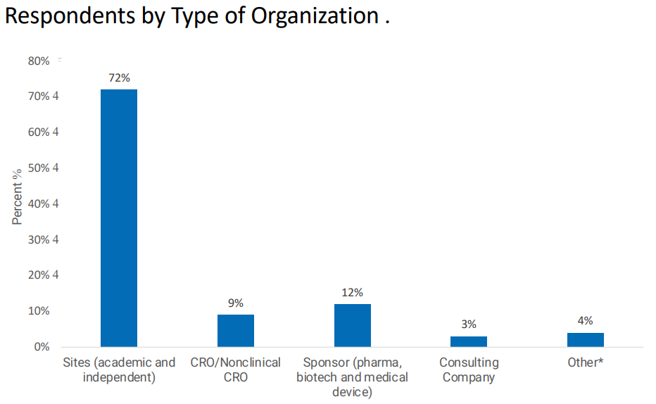To fully understand the demographic, This is a sample size of 311 respondents: 224 from sites, 28 from CRO/Nonclinical CRO, 36 from sponsors, 11 from consulting companies and 12 from other sources.  
  
The figure below shows the level of understanding with AI and machine learning from the respondents in the survey. It is noted in the survey that nearly half of the respondents (41%) have no experience with AI and machine learning. 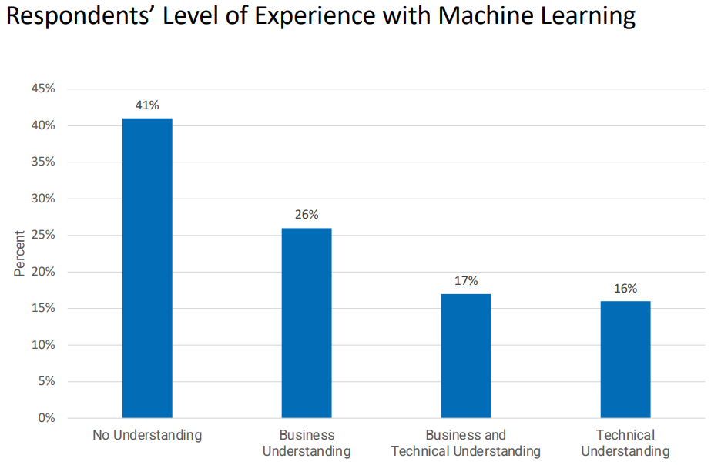We can see that some technology sectors have little need for knowledge on machine learning, given that most respondents have worked in this industry without any knowledge or just with business understanding of AI & ML.  
  
Now that we have the demographic of the respondents and their knowledge on ML, the following are pertinent questions and their results.  
  
One question that is intriguing is the benefits that the respondents thought that ML might have on clinical trials:  
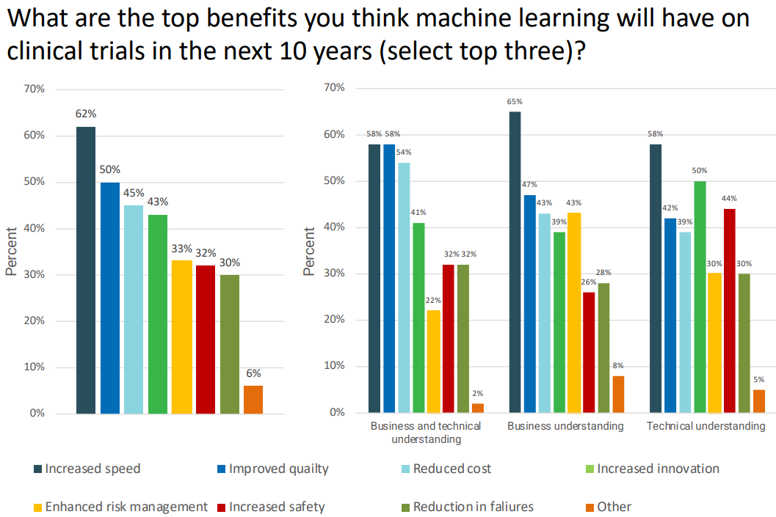There are some key observations to be made about this question’s results. We can notice that across the board, regardless of understanding, the respondents agree that increased speed is a benefit from ML. However, there is a massive difference of the Increased Innovation benefit between those with technical understanding versus business understanding. 50% of those with technical understanding have Increased Innovation in their top 3 benefits, whereas it drops to 39% for those with only business understanding. This can likely be attributed to those with technical understanding having a deeper knowledge of machine learning’s capabilities and understanding how it could evolve and help in their industry.   
  
Another key change that can be noted is Increased Safety. 44% of those with technical understanding chose it as a benefit, whereas only 26% of those with business understanding chose it. This makes sense because we want to believe that safety is within our legacy systems, and we grow accustomed to them. However, machine learning can greatly increase safety using ML algorithms to pinpoint malicious patterns or encrypted traffic (<https://www.cisco.com/c/en/us/products/security/machine-learning-security.html#~how-ml-helps-security>). This makes sense that those with technical understanding (44%) are more eager to believe in the increased security rather than those with business understanding (26%).

# Technology Analysis

The cloud offers a variety of tools and technologies to support the various aspects of machine learning and AI. Each tool may only differ slightly between cloud providers. The key providers of such tools are AWS, Azure, and GCP. Speech & Text services, Diagnostic services, Image services and Platform services are common tools created by public cloud providers. These tools can be adapted to machine-learning algorithms to speed up production, conserve costs, and automate applications.

This diagram shows the basic workflow for deploying common machine-learning tools such as Speech & Text, Diagnostic and image services. Each step is as follows: 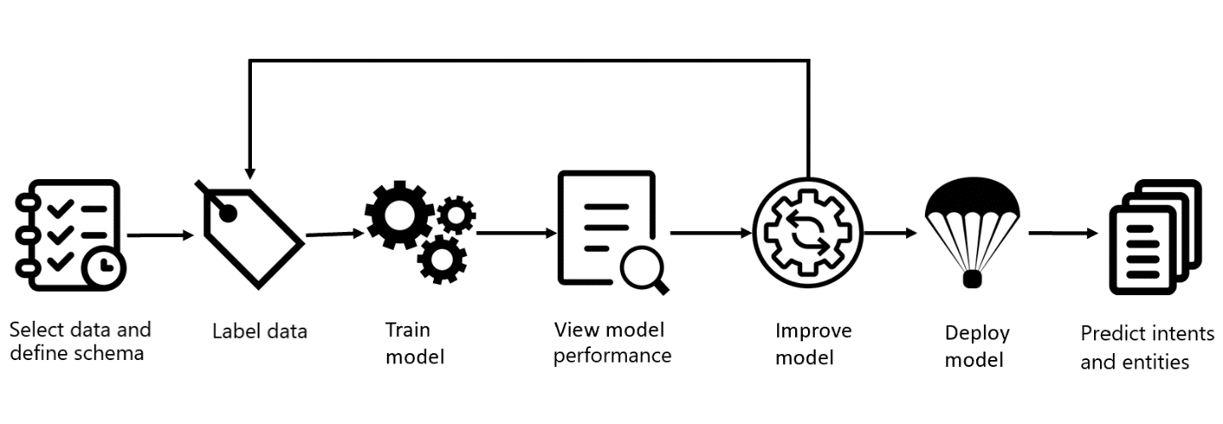(*What is conversational language understanding?* 2024)

**Define schema:** Define the information data needed for the machine learning and define what you want your machine learning model to predict.

**Label datasets:** Labelling is a key aspect of Machine learning; it defines what the AI looks for in a dataset. For example: a pet store may want to label images that contain dogs as “dog”.

**Training the model:** Training the A.I. algorithm allows the algorithm to learn “correct” patterns using the previous step’s labels. Training is the basis of how ML algorithms truly learn by recognizing patterns.

**View performance:** Assess the algorithm’s performance and confidence when testing the model with new, unlabeled data. If the model is not confident in its prediction, you may need to return to re-labelling the dataset. Confidence defines how accurate a model prediction is.

**Improving the model:** Optimize the model’s performance and confidence levels for better predictions of the meaning behind data. Improving confidence levels also gets rid of ML Bias. Being a giant survey machine, societal opinions can get in the way of retrieving the desired prediction.

**Deploying the model:** Prepare the model and its dependencies to be usable within the cloud. Here, you build the model and deploy it to production as “beta” for testing.

**Predict intent:** Use the algorithm to predict relevant information from user input. And test the product. The model should be operating efficiently for users at this step.   
(*What is conversational language understanding?* 2024)

## Speech & Text services:

Speech services allow cloud users to use or build AI language models to analyze and predict customer documents and text prompts. AI Speech services can include Speech-to-text, Text-to-speech, Chatbots, Translation and Document Analysis.

### Chatbots:

Chatbots are language models that can be trained on customer input in real-time. They can be used within product services or human assistance. Amazon named their chatbot services Amazon Lex and Microsoft Azure Conversational Language Understanding (CLU). A common example of a chatbot today is Amazon Alexa (which uses Amazon Lex). (*What is conversational language understanding?* 2024)

## Diagnostic services

The cloud can also provide diagnostic services for web applications such as Azure AI Metrics Advisor or Amazon Lookout. These services analyze data, detect anomalies, and diagnose web workspaces.

### Amazon Lookout for Metrics

Lookout for Metrics is Amazon’s version of diagnostic services. Within Lookout, you create and configure resources to identify changes in data within your business applications, called anomalies. You can set these resources to analyze your data within a timed schedule or specify a location. When a resource finds an anomaly, it can notify you and output a graph of what caused the anomaly and what it affects.

(*Amazon Lookout for Metrics - Developer Guide* 2024)

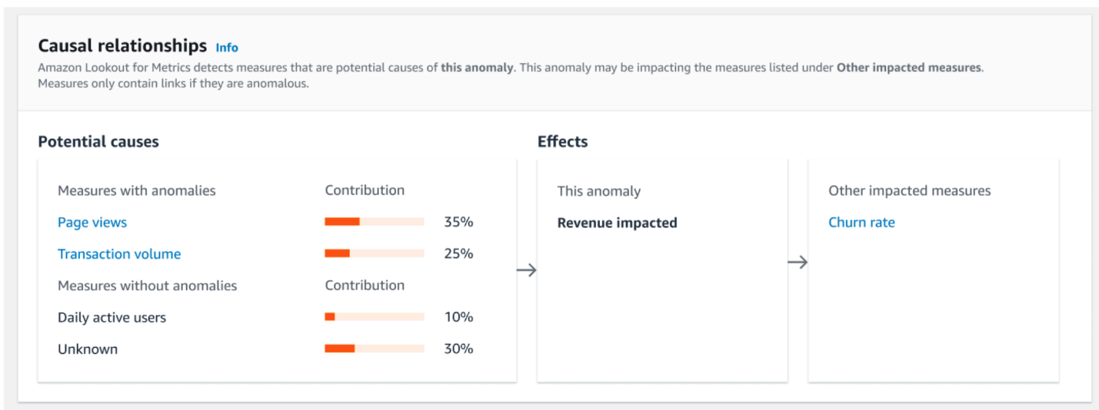(*Amazon Lookout for Metrics - Developer Guide* 2024)  
  
Microsoft Azure may also output similar graphs that show the relationship between what caused the anomalies and what data got impacted. Azure AI Metrics Advisor and Amazon Lookout use AI to diagnose Anomalies and determine what caused them with only slight differences. For example, the resources to detect anomalies have different names: Amazon calls them” detectors,” and Microsoft calls them” Measures”. (*How-to: Onboard your metric data to Metrics Advisor* 2024)

## Image services

The cloud provides AI imaging tools to deploy into larger-scale image recognition models. This tool uses computer vision to extract information from faces, texts, images and video for use in any application that requires image recognition. Azure calls this service Azure AI Vision, while Amazon’s is Image Rekognition.

## Platform services

Each cloud provider may integrate outside machine learning platform services into the cloud. For example, Amazon and Azure use ML frameworks like Py Torch, TensorFlow or scikit-learn. Platform services like Azure Machine Learning provide fully integrated workspaces to develop and manage machine learning projects.

### Azure Machine Learning

Azure Machine learning integrates everything you need for teams of developers, engineers and data scientists to build fully scalable ML models for production and automation. Azure ML implements Jupyter Notebook for writing ML code and uses Py Torch or TensorFlow for building training models. For security, Azure ML uses Azure virtual networks and Azure Key Vault to store sensitive information.

Below is a Cloud-based Machine Learning Image architecture using AI and Machine Learning Technology:

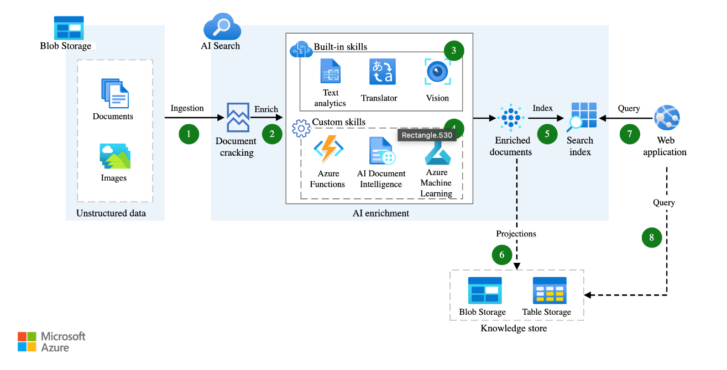

(Santos, *Use AI enrichment with image and text processing* 2023)

In this architecture diagram the cloud uses a combination of both AI and Machine learning to predict meaning behind images and text. The AI tools use Speech & Text as well as image services such as Azure Translator, Text analytics and Azure AI Vision. Here, Azure Machine learning is used to support specific use-cases and scenarios. The machine learning architecture is split into Built-in-skills, referring to pre-built AI tools and models and Custom skills for specific custom ML models. (*What is Azure Machine Learning?* 2024)

## Using AI Tools with Machine Learning

With pre-packaged AI tools such as Image services, diagnostic services and speech/text services, a business can combine these services with a Platform service such as Azure Machine Learning to create and deploy an expansive machine learning model that can account for specific use cases without the additional work to create these tools.

# Market Analysis

By combining cloud computing with artificial intelligence (AI) and machine learning (ML), we are driving growth across industries, intensifying competition, and creating new opportunities. This section is an in-depth assessment of market dynamics, including growth forecasts, competitive landscape and emerging opportunities.

## Growth Forecasts

The Global Cloud AI Market size is expected to reach $395.8 billion by 2029, rising at a market growth of 38.4% CAGR during the forecast period. (Marqual IT Solutions Pvt. Ltd,2023)

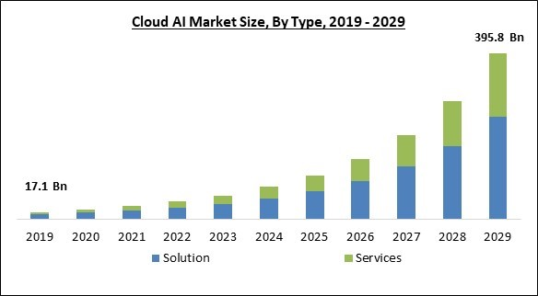

## Competitive Landscape

Innovation and strategic partnerships are the primary characteristics of the competitive landscape of the cloud AI market that helps to expand the reach of service offerings and markets. Leading cloud providers such as AWS, Azure, and GCP lead the market with their excellent and powerful AI capabilities. These companies are trying to enhance AI algorithms, improve data security, and optimize the underlying infrastructure of cloud AI. In addition, cloud providers and AI software developers are increasingly collaborating in different industries, such as healthcare, finance, and manufacturing to customize solutions based on specific needs.

### Key Providers:

This section introduces some of the major cloud vendors and their features and offerings.

#### Amazon Web Services

AWS offers a suite of artificial intelligence (AI) and machine learning (ML) services. For example, Amazon SageMaker is a powerful platform for building, training, and deploying large-scale machine learning models and it improves the productivity of ML projects.

#### Google Cloud

Google Cloud Platform (GCP) is a comprehensive set of cloud services that provide scalable compute and storage for data analysis, machine learning, and application development. Vertex AI is a unified machine learning platform on Google Cloud that allows users to train and deploy ML models and AI applications, and to customize large language models (LLMS) for AI-driven applications.

#### IBM

Watsonx is IBM's enterprise-focused AI and data platform that enables businesses to build, manage, and scale AI applications and workflows with an emphasis on advanced analytics, machine learning, and generating AI capabilities.

#### Microsoft Azure AI

Microsoft Azure AI provides a set of AI services and tools that enable developers and data scientists to build, train, deploy, and manage machine learning models and integrate advanced AI capabilities into intelligent applications.

#### Salesforce

Salesforce is a leading cloud-based customer relationship management (CRM) platform that helps businesses manage customer interactions, sales processes, and marketing efforts through a suite of integrated applications.

#### Oracle

Oracle Cloud's AI toolset provides a comprehensive suite of integrated artificial intelligence services and machine learning capabilities that enable businesses to automate processes, enhance decision-making, and gain insights from their data through pre-built models and customizable solutions.

Conclusion

We found the various ways AI or Machine learning can be applied to the cloud and affect businesses. AI or Machine learning can automate and provide encapsulated tools for enterprises to deploy quickly. We found from clinical trials that most enterprises do not understand machine learning but are interested in adopting it into their systems. Additionally, using AI and Machine Learning increased production speed and security significantly.   
  
Group Meeting Log

|  |  |  |  |  |  |  |  |  |
| --- | --- | --- | --- | --- | --- | --- | --- | --- |
| **Meeting** | **Date** | **Caleb Watson-Danis** | **Catherine Daigle** | **Farhana Mahmud** | **Elias Ngugi Kariuki** | **Yueying Li** | **Yue Gao** | **Attendnace Notes** |
| **Initial Zoom meeting** | Sept 23 | Present | Present | Present | Present | Present | Present | Everyone contributed, Work distribution completed |
| **In person meeting** | Sept 28 | Present | Present | Present | Present | Present | Present | On the track! |
| **Zoom meeting** | Sept 30 | Present | Present | Present | Present | Present | Present | Delivered work |
| **In person meeting** | Oct 1 | Present | Present | Present | Present | Present | Present | On the right track for the demo 1. |
| **Zoom meeting** | Oct 4 | Present | Present | Present | Present | Present | Present | Happily, contributed, everyone is ready for the presentation |

# References

Amazon Web Services. (2024). *Amazon Lookout for Metrics - Developer Guide*. What is Amazon Lookout for Metrics? <https://docs.aws.amazon.com/lookoutmetrics/latest/dev/lookoutmetrics-welcome.html>

Cisco. (n.d.). *How machine learning enhances security*. Cisco. <https://www.cisco.com/c/en/us/products/security/machine-learning-security.html#~how-ml-helps-security>

Marcus Law. (2023, December 1). *How AI is changing the cloud landscape*. Technology Magazine. <https://technologymagazine.com/articles/how-ai-is-changing-the-cloud-landscape>

Microsoft. (2024, September 19). *What is Azure Machine Learning?*. Azure Machine Learning documentation. <https://learn.microsoft.com/pdf?url=https%3A%2F%2Flearn.microsoft.com%2Fen-us%2Fazure%2Fmachine-learning%2Ftoc.json%3Fview%3Dazureml-api-2>

Microsoft. (2024, August 28). *What is Azure AI Vision?*. Azure AI Vision documentation. <https://learn.microsoft.com/pdf?url=https%3A%2F%2Flearn.microsoft.com%2Fen-us%2Fazure%2Fai-services%2Fcomputer-vision%2Ftoc.json>

Microsoft. (2024, August 28). *How-to: Onboard your metric data to Metrics Advisor*. Azure AI Metrics Advisor documentation. <https://learn.microsoft.com/pdf?url=https%3A%2F%2Flearn.microsoft.com%2Fen-us%2Fazure%2Fai-services%2Fmetrics-advisor%2Ftoc.json>

Microsoft. (2024, August 28). *What is conversational language understanding?*. Azure AI Language documentation. <https://learn.microsoft.com/pdf?url=https%3A%2F%2Flearn.microsoft.com%2Fen-us%2Fazure%2Fai-services%2Flanguage-service%2Ftoc.json>

Pavan Ogeti. (2024). Benefits and Challenges of Deploying Machine Learning Models in the Cloud. *International Journal of Intelligent Systems and Applications in Engineering*, *12*(22s), 194–209.

Research and Markets. (2023, April). Global cloud AI market size, Share & industry trends analysis report by type, by industry, by technology (solution deep learning, machine learning, Natural Language Processing), by regional outlook and forecast, 2023-2029. Research and Markets - Market Research Reports <https://www.researchandmarkets.com/reports/5806529/global-cloud-ai-market-size-share-and-industry>

Santos, C. A. (2023, August 21). *Use AI enrichment with image and text processing*. Artificial intelligence (AI) architecture design. <https://learn.microsoft.com/pdf?url=https%3A%2F%2Flearn.microsoft.com%2Fen-us%2Fazure%2Farchitecture%2Fai-ml%2Ftoc.json>

Soni, D., & Kumar, N. (2023). Artificial Intelligence in cloud computing. *Artificial Intelligence in Cyber-Physical Systems*, 51–73. https://doi.org/10.1201/9781003248750-4

WCG CenterWatch. (2021, February). *Artificial intelligence and machine learning in life sciences: Survey report*. Oracle. <https://www.oracle.com/a/ocom/docs/industries/life-sciences/ls-ai-machine-learning-survey-report.pdf>