

Career Path Decision Framework
A self-guided workbook for figuring out your next move — on your own timeline.

What's inside
01 Where you are now
02 What you actually want
03 What paths exist
04 What's in your way
05 Your 30-day action plan

A free resource from Elikonas | elikonas.com

00 How to use this workbook

This workbook has one purpose: to help you think clearly about your next career move. Not in the way a job board does — by showing you what exists — but the way a good conversation does: by helping you figure out what you actually want, what's in your way, and what to do first.
Work through it in one sitting or across a few days. There are no wrong answers.

A note on why this exists
Psychologist Abraham Maslow showed that people struggle to focus on growth when foundational needs — safety, stability, belonging, self-worth — aren't met. This workbook is built with that in mind. Section 4 asks you to name your real barriers honestly, without shame. That's not a soft exercise. It's the most practical thing in here.

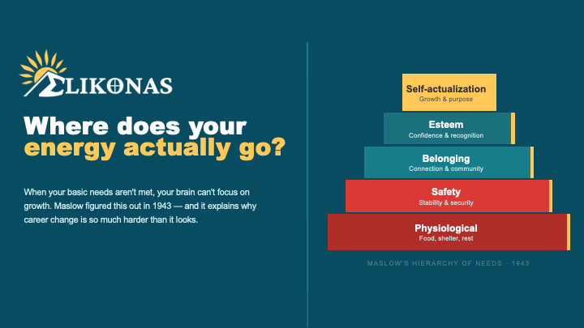

Three rules for getting the most out of this:
Print or type
We made this a Word doc so you can type directly in the fields. You can also print and fill by hand.

Be honest
The more truthful your answers, the more useful your plan will be.

No timeline pressure
There's no deadline. Work at whatever pace feels right.

01 Where you are now
Before planning where you're going, be honest about where you're starting. Answer as candidly as you can — no one is grading this.

1. What is your current work situation?
e.g. employed but unhappy, unemployed, underemployed, career-pausing
2. In one sentence, what is most frustrating about it?
3. What are you most proud of in your career or life so far?
4. How many hours per week could you realistically dedicate to learning or exploring something new?
Be realistic — this matters for planning
5. What financial constraints should your next step account for?
e.g. need income within 3 months, can't afford unpaid training, carrying debt

02 What you actually want
Not what sounds responsible, or what other people expect. What would genuinely feel like success to you — in work and in life.

What matters most to you in work?
Rank your top 3 by writing 1, 2, or 3 in the box on the right.
☐ Financial security / good income
☐ Flexible hours or remote work
☐ Feeling like my work matters
☐ Creative freedom
☐ Working with people I respect
☐ Physical / hands-on work
☐ Building something of my own
☐ Stability and predictability
☐ Continuous learning and challenge
☐ Recognition and status

Describe your ideal workday. Where are you, who are you with, what are you doing?
Five years from now, what would "I made it" look like to you?
Is there something you've always been good at — paid or unpaid — that you've never built a career around?

03 What paths exist
Most people know about two options: college or a job. There are many more. Here's a plain-language map of the most common alternatives.
Trades & apprenticeships  Electrician, plumber, HVAC, welder, carpenter, and more. Many apprenticeships pay while you learn. Median salaries often rival 4-year grad starting pay. mikeroweworks.org offers scholarships. |  | Certifications & licensing  Industry credentials in IT (CompTIA, AWS, Google), healthcare (CNA, medical coding), real estate, project management (PMP), and dozens more. Often 3–12 months.
Coding bootcamps  Intensive programs (12–24 weeks) in software development, data analytics, UX design, and cybersecurity. Many offer income share or deferred tuition. |  | Community college (2-year)  Lower cost than 4-year universities. Credits often transfer. Associates degrees, vocational programs, and continuing ed. A practical middle path.
Self-directed learning  Coursera, edX, LinkedIn Learning, YouTube, books, mentorship. Best for motivated self-starters — works well alongside a portfolio or freelance work. |  | Entrepreneurship / freelancing  Building your own thing or selling skills independently. Higher risk, higher autonomy. Works best combined with a proven skill base.
Which paths feel worth exploring? Check all that apply and add a note.
☐ Trades & apprenticeships
Any notes or questions about this path?

☐ Certifications & licensing
Any notes or questions about this path?

☐ Coding bootcamps
Any notes or questions about this path?

☐ Community college (2-year)
Any notes or questions about this path?

☐ Self-directed learning
Any notes or questions about this path?

☐ Entrepreneurship / freelancing
Any notes or questions about this path?

04 What's in your way
This is the most honest section in the workbook. Naming your real barriers is the first step to working around them.

Why this matters
Psychologist Abraham Maslow found that people struggle to learn and grow when foundational needs aren't met — financial security, stability, belonging, and self-worth. If any of the barriers below apply to you, that is not a character flaw. It is a real constraint worth acknowledging.

Check any barriers that apply to you right now:
☐ Financial pressure — I need income before I can invest time in learning
☐ Time — work, caregiving, or other commitments leave little bandwidth
☐ Confidence — I'm not sure I'm capable of making a real change
☐ Belonging — the spaces I'd need to enter don't feel like they're for me
☐ Stigma — I've internalized the message that without a degree, my ceiling is lower
☐ Information overload — I don't even know where to start
☐ Fear of failure — I've tried to change before and it didn't work out
☐ Support — I don't have people around me who understand what I'm trying to do

Of the barriers you checked, which one feels most within your control right now?
Which feels hardest to solve alone — and who or what might help?
What one small thing would make the biggest difference in the next 30 days?

How Elikonas is building a solution to help
We can't solve certain pressures directly — but we’re working to remove time pressure, build real community, take the thinking out of finding your path, and work to strip the stigma from non-college careers. Share you email with us at Elikonas.com to get updates leading up to our product release.

05 Your 30-day action plan
Everything in this workbook leads here. One clear, concrete direction. No big long-term plan — just your next 30 days.

Before writing your plan, pull together your thinking:
The path I'm most interested in exploring:
The one constraint I most need to work around:
How I want to feel 30 days from now:

My 30-day plan
Week 1  Research & reality-check | What will you learn this week? e.g. research 3 programs, talk to someone in the field, look up salary data.

Week 2  Take one concrete step | What is the one action you'll take? e.g. attend an info session, request a syllabus, make one phone call.

Week 3  Address your top barrier | What will you do about the biggest obstacle you named in Section 4? Even a small step counts.

Week 4  Decide & commit | Based on what you've learned: enroll, apply, start a free course, or consciously choose a different path.

Who will you tell about this plan?
Saying it out loud to one person dramatically increases follow-through.

ELIKONAS
Your path. Your terms.

What comes next
You've done the thinking. That matters more than most people realize. Most people never get this specific about what they want and what's standing in their way.
Elikonas is building a platform that does this thinking with you — an AI-guided process that takes your answers and helps you build a real, personalized path to the career you actually want. Where everything you learn counts toward a formal education. Where there’s no judgment about where you're starting from.

Get early access to the Elikonas platform
Share your email with us at elikonas.com

What's Your College Story?
Check our blog for links to video interviews with guest who share their stories about their education adventures — college or no college. We also share episode recaps. Check it out at elikonas.com/stories.

If you want to share your story, email us at story@elikonas.com. You can be a guest on the show or you can offer to share your story that we’ll write up as a post.

Read the blog
We offer insights and resources at elikonas.com/blog

Share this workbook freely with anyone who might need it.
© Elikonas · elikonas.com · Free to share with attribution

