GHANA COMMUNICATIONS AND TECHNOLOGY UNIVERSITY (GCTU)


FACULTY OF COMPUTING AND INFORMATION SYSTEMS DEGREE IN INFORMATION TECHNOLOGY
FINAL YEAR PROJECT DOCUMENTATION TITLE:
THE IMPACT OF AUTOMATED TELLER MACHINE (ATM) SERVICE QUALITY ON CUSTOMER SATISFACTION AND BANKING EFFICIENCY: A CASE STUDY OF GHANA COMMERCIAL BANK

BY:

CANDIDATES’ DECLERATION

This project is presented as part of the requirements for Degree in Information Technology awarded by Ghana Communications Technology University. This project is submitted in the partial fulfilment for the requirement for the award of the Degree in Information Technology.

CANDIDATES NAME AND INDEXES: SIGNATURES

() …………………

() ………………….

() ………………….

DATE: …………………………….

SUPERVISOR DECLARATION

We hereby certify that the work entitled “” was prepared by the students and was submitted to the Faculty of Information Technology and Communication as a partial fulfilment for the Degree in Information Technology. All sources of information have, however, been acknowledged with due respect.

SUPERVISOR: ………………………………….

SIGNATURE: …………………………………….

HOD: ……………………………………………......

DATE: ………………………………………………...

DEDICATION
[Insert your dedication here — for example, the family members, friends, or mentors you wish to dedicate this work to.]
ACKNOWLEDGEMENT
[Insert your acknowledgement here — thank your supervisor, lecturers, family, and anyone else who supported this project.]
ABSTRACT

The study examined the impact of Automated Teller Machine (ATM) service quality on customer satisfaction and banking efficiency using Ghana Commercial Bank as a case study. The introduction of ATM services has transformed banking operations in Ghana by providing customers with convenient access to banking services such as cash withdrawals, balance inquiries, fund transfers, and other financial transactions without visiting banking halls. Despite the benefits associated with ATM services, customers still experience challenges such as network failures, machine breakdowns, delayed transactions, cash shortages, and card capture, which may affect customer satisfaction and the operational efficiency of banks.

The main objective of the study was to examine how ATM service quality influences customer satisfaction and banking efficiency at GCB Bank PLC. The study specifically sought to assess the quality of ATM services provided by the bank, determine the level of customer satisfaction, identify challenges customers face when using ATM services, and recommend measures for improving ATM service delivery and banking efficiency.

A descriptive research design was adopted for the study. Data were collected from customers of GCB Bank PLC using questionnaires and interviews. The data collected were analysed using tables, percentages, and descriptive statistical methods to present the findings clearly and accurately.

The findings of the study revealed that ATM services have significantly improved convenience and accessibility to banking services for customers. However, the study also found that customers continue to face several challenges including poor network connectivity, machine downtime, delayed transaction reversals, and occasional cash shortages. The study further revealed that the quality of ATM services has a direct effect on customer satisfaction and banking efficiency. Customers who experienced reliable, secure, and fast ATM services were more satisfied with the bank, while poor service quality negatively affected customer confidence and trust.

The study concluded that ATM service quality plays an important role in improving customer satisfaction and enhancing banking efficiency within GCB Bank PLC. The study recommended that the bank should improve network stability, ensure regular maintenance of ATM machines, increase security measures, provide faster transaction reversal systems, and expand ATM accessibility to improve customer experiences and operational performance.

Keywords: Automated Teller Machine (ATM), Service Quality, Customer Satisfaction, Banking Efficiency, Electronic Banking, GCB Bank PLC.

TABLE OF CONTENTS
Right-click this paragraph and choose "Update Field" (or press F9) to generate the table of contents from the chapter and section headings.

CHAPTER ONE
INTRODUCTION
1.1 Background of the Study
Technological advancement and increasing demand for rapid, reliable and convenient financial services have brought about major changes in the banking industry all over the world. The old style of banking is giving way gradually to electronic banking systems where the customer had to go to the banking hall and spend many hours before a transaction could be carried out. The Automated Teller Machine (ATM) is one of the most important innovations introduced within the banking industry. The introduction of ATM services has revolutionized the conduct of banking activities by allowing customers to access banking services at any time without total reliance on bank tellers or normal banking hours.
Electronic banking has become an important characteristic of the financial sector in Ghana in recent years. Banks in Ghana continue to pour huge sums of money into technological systems to improve the delivery of customer service, reduce operational delays and remain competitive in the industry. The increasing number of bank customers, particularly in urban areas like Accra, Kumasi, Takoradi, Tamale and Cape Coast, has compelled banks to adopt more efficient service delivery channels. Consequently, some commercial banks in Ghana have increased their ATM networks to improve customers’ access to financial services.
This has made ATM services very common in Ghana and has become part of the daily lives of many individuals including workers, traders, students, business owners and public servants. The ATMs are used by customers for various transactions such as cash withdrawals, balance enquiries, fund transfers, mini statements, PIN changes and airtime purchases. Unlike the traditional banking system where customers must queue inside banking halls, ATM services provide convenience, speed and accessibility. This has helped in reducing the congestion in banks and improving the banking experience of the customers.
Even though the use of Automated Teller Machines (ATMs) is growing in Ghana, customers still face several challenges when they use these machines. Customers often encounter network failures, delays in transaction processing, machine breakdowns, cash shortages, card trapping, receipt errors, and occasional cases of debit without cash dispensation. In some cases, customers may not be able to access their money in an emergency due to ATMs being offline or out of service. These problems appear to lead to customer frustration and dissatisfaction particularly at weekends, public holidays and month end periods when ATM usage is normally high.
Ghana Commercial Bank, currently known as GCB Bank PLC, is one of the oldest and largest banks in Ghana. The bank was formed in 1953 and has been a significant player in Ghana’s financial sector offering banking services to individuals, business and government institutions across the country. GCB Bank has a wide branch network with numerous ATM points strategically located in cities, towns, campuses, shopping centers and business districts to make banking services easily accessible to customers.
GCB Bank PLC has invested heavily over the years in technological innovation and digital banking solutions in its quest to enhance customer satisfaction and operational efficiency. The bank’s ATM services form an important part of its electronic banking system. Its network of ATMs allows customers to access banking services twenty-four hours a day without visiting the banking hall. This has helped the bank to reduce congestion in branches and improve service delivery.
Nevertheless, many GCB Bank clients continue to face difficulties using ATMs despite this expenditure. Some users continue to frequently complain about sluggish transaction processing, transient machine malfunctions, unavailable funds, and bad network access. Customers' opinions of the bank's service quality may be impacted by these encounters. Customers' confidence and trust in the bank may decline if they frequently experience problems using ATM services. Customer loyalty and the bank's reputation may eventually suffer as a result.
In the banking sector, service quality is regarded as one of the primary determinants of client happiness. Consumers anticipate effective, safe, dependable, quick, and user-friendly ATM services. Customers are more likely to be happy and stick with a bank when it offers high-quality ATM services. However, inadequate ATM service can result in consumer complaints, discontent, and a decline in trust in electronic banking systems.
ATM service quality has an impact on banking efficiency in addition to customer happiness. Banks can minimize long lines in banking halls, save operating expenses, ease the strain on customer care employees, and speed up financial operations with the use of efficient ATM systems. Customers may use ATMs to do simple transactions on their own, freeing up bank staff to concentrate on more complicated banking tasks. As a result, the efficiency of ATM services has a big impact on banks' total operational performance.
Banks in Ghana are under pressure to offer better electronic banking services to draw in and keep consumers as the country's banking industry continues to become more competitive. Consumers today have greater expectations for service quality and are better educated. Because of this, banks who don't offer dependable ATM services risk losing clients to rival financial institutions that provide superior and more practical online banking.
Therefore, utilizing GCB Bank PLC as a case study, this study aims to investigate how ATM service quality affects customer satisfaction and banking efficiency. The research is to evaluate client experiences with ATM use; pinpoint issues related to ATM services and ascertain how ATM service quality affects the bank's operational effectiveness. It is anticipated that the study's conclusions would improve ATM service delivery and raise consumer satisfaction in Ghana's banking industry.

1.2 Statement of the Problem
The introduction of Automated Teller Machines (ATMs) was aimed at improving the quality of banking services by providing customers with faster, easier, and more convenient access to financial transactions. ATMs were expected to reduce the pressure on banking halls, minimize long queues, improve operational efficiency, and allow customers to perform basic banking activities at any time of the day. In Ghana, the increasing use of ATM services has become an important part of the banking sector as banks continue to promote electronic banking systems to meet the growing demands of customers.
Despite the advantages associated with ATM services, many bank customers in Ghana continue to experience several difficulties when using ATM facilities. Customers frequently encounter problems such as network failures, machine breakdowns, cash shortages, delayed transaction processing, poor connectivity, card trapping, and instances where accounts are debited without cash being dispensed. These problems are commonly experienced during peak periods such as month-end salary payments, weekends, and public holidays when ATM usage is usually high.
These ATM-related challenges have created concerns among customers regarding the reliability and quality of electronic banking services. In many cases, customers become frustrated when they are unable to access their money or complete transactions successfully. Some customers are forced to visit banking halls to report issues or reverse failed transactions, which defeats the purpose of convenience and accessibility associated with ATM banking. Such situations may lead to dissatisfaction, loss of confidence in the banking system, and negative perceptions about the quality of services provided by banks.
In addition, poor ATM service quality can also affect the operational efficiency of banks. Frequent machine failures and transaction errors often result in increased customer complaints and higher workloads for customer service staff who must deal with ATM-related issues. This can lead to delays in service delivery and reduce the effectiveness of banking operations. Banks may also incur additional operational and maintenance costs by resolving ATM-related problems. Therefore, the efficiency of ATM services is directly linked to both customer satisfaction and the overall performance of banking institutions.
Ghana Commercial Bank, now operating as GCB Bank PLC, has invested significantly in ATM infrastructure and electronic banking technologies to improve service delivery and maintain its position as one of the leading banks in Ghana. The bank has installed several ATM machines across major cities, towns, campuses, and commercial areas to make banking services more accessible to customers. However, despite these efforts, complaints relating to ATM service failures, transaction delays, and machine downtimes are still reported by some customers. These recurring issues raise concerns about whether the quality of ATM services provided by the bank is adequate to satisfy customers and improve banking efficiency.
Although several studies have been conducted on electronic banking and ATM usage, much of the focus has been on customer adoption of electronic banking services and general usage patterns. Limited attention has been given to how ATM service quality specifically affects customer satisfaction and banking efficiency within the Ghanaian banking sector, particularly in relation to GCB Bank PLC. This creates a gap in knowledge that requires further investigation.
It is therefore important to examine the quality of ATM services provided by GCB Bank PLC and determine how these services influence customer satisfaction and banking efficiency. This study seeks to investigate the impact of ATM service quality on customer satisfaction and banking efficiency using GCB Bank PLC as a case study. The study will also identify the major challenges associated with ATM service delivery and provide recommendations that may help improve ATM operations and customer experience within the bank.

1.3 Objectives of the Study
The objectives of this study provide a clear direction for the research and outline what the study seeks to achieve. The study focuses on examining how the quality of ATM services influences customer satisfaction and the efficiency of banking operations within GCB Bank PLC. The objectives are divided into the general objective and specific objectives.

1.3.1 General Objective
The general objective of this study is to examine the impact of Automated Teller Machine (ATM) service quality on customer satisfaction and banking efficiency using Ghana Commercial Bank as a case study.
1.3.2 Specific Objectives
The specific objectives of the study are to:
- Examine the quality and reliability of ATM services provided by GCB Bank PLC to its customers.
- Assess the level of customer satisfaction with the ATM services offered by GCB Bank PLC.
- Determine the effect of ATM service quality on the operational efficiency of banking activities within GCB Bank PLC.
- Identify the major challenges and difficulties customers encounter when using ATM services provided by the bank.
- Examine how factors such as network availability, machine functionality, transaction speed, security, and accessibility influence customer experiences with ATM services.
- Recommend practical strategies and measures that can help improve ATM service quality, customer satisfaction, and banking efficiency at GCB Bank PLC.

1.4 Research Questions
The study seeks to answer the following research questions to examine the relationship between ATM service quality, customer satisfaction, and banking efficiency at Ghana Commercial Bank:
- What is the quality level of ATM services provided by GCB Bank PLC?
- How satisfied are customers with the ATM services offered by GCB Bank PLC?
- What effect does ATM service quality have on banking efficiency at GCB Bank PLC?
- What major challenges do customers encounter when using ATM services provided by GCB Bank PLC?
- How reliable and accessible are ATM services provided by GCB Bank PLC?
- To what extent do network failures and machine breakdowns affect customer satisfaction with ATM services?
- How does transaction speed influence customers’ perception of ATM service quality?
- What impact does ATM service quality have on customers’ trust and confidence in the bank?
- How effective are the security features of GCB Bank PLC ATM services in protecting customers during transactions?
- What measures can be implemented to improve ATM service quality, customer satisfaction, and banking efficiency at GCB Bank PLC?

1.5 Significance of the Study
This study is important because it focuses on an area that has become a major part of modern banking operations in Ghana. As the use of Automated Teller Machines (ATMs) continues to increase, there is a growing need for banks to ensure that ATM services are reliable, efficient, secure, and capable of meeting customer expectations. The findings of this study will therefore be beneficial to several groups including banks, customers, researchers, students, and regulatory authorities within the financial sector.
Firstly, the study will be beneficial to Ghana Commercial Bank management and staff. The research will help the bank better understand customer opinions and experiences regarding the quality of ATM services provided. Through the findings, management will be able to identify the strengths and weaknesses associated with their ATM operations. This will help the bank make informed decisions on areas that require improvement, such as network reliability, machine maintenance, transaction speed, security, and cash availability. Improving these areas can help increase customer satisfaction, strengthen customer loyalty, and improve the overall image and reputation of the bank.
The study will also help GCB Bank PLC improve operational efficiency. Efficient ATM services can reduce congestion in banking halls, minimize customer complaints, and reduce the workload placed on customer service staff. When ATM systems function properly, customers can perform transactions independently without always relying on bank tellers. This allows employees to focus on more complex banking services while improving the speed and effectiveness of banking operations. The study will therefore provide useful information that can support better service delivery and operational performance within the bank.
Secondly, the study will benefit customers of GCB Bank PLC and the banking public in general. Customers depend heavily on ATM services for daily financial transactions, especially because of the convenience and accessibility they provide. However, frequent ATM failures and transaction challenges often create frustration and inconvenience for users. The findings of this study may contribute to improvements in ATM service quality by drawing attention to the common challenges faced by customers. Improved ATM services will help customers enjoy safer, faster, and more reliable banking experiences. It will also reduce the stress associated with failed transactions, long queues, and unnecessary visits to banking halls.
In addition, the study will contribute to academic knowledge in the field of electronic banking and customer service management. The research will provide valuable information for students, lecturers, and future researchers who may want to conduct studies related to ATM services, customer satisfaction, service quality, and banking efficiency. Since electronic banking continues to evolve rapidly in Ghana and other parts of the world, this study will serve as useful reference material for further academic work and discussions within the area of banking technology.
Furthermore, the study will be beneficial to policymakers and regulatory institutions within Ghana’s financial sector. Regulatory bodies such as the Bank of Ghana are responsible for ensuring that banks provide efficient and secure financial services to customers. The findings of this study may help such institutions understand some of the practical challenges associated with ATM service delivery in Ghana. This can assist them in developing policies, regulations, and standards aimed at improving electronic banking services and protecting the interests of bank customers.
The study is also important because it highlights the growing role of technology within the Ghanaian banking industry. As competition among banks continues to increase, financial institutions are expected to provide better and more convenient services to attract and retain customers. By examining the relationship between ATM service quality, customer satisfaction, and banking efficiency, the study will provide insights into how banks can use technology effectively to improve service delivery and remain competitive within the industry.
Overall, the study will contribute significantly to efforts aimed at improving ATM operations, enhancing customer experiences, and strengthening the quality of electronic banking services within Ghana’s banking sector.

1.6 Scope of the Study
The study focuses on how customer happiness and banking efficiency at GCB Bank PLC are affected by ATM service quality. In particular, the study will look at consumer opinions and experiences with the bank's ATM services.
Geographically, just a few GCB Bank PLC branches in Ghana would be included in the study. Cash withdrawals, balance enquiries, fund transfers, and other ATM transactions will all be included in the research.
Additionally, the study will look at how ATM services' dependability, responsiveness, accessibility, convenience, and security affect client satisfaction and banking effectiveness.

1.7 Limitations of the Study
The research process may be impacted by a few restrictions during the investigation. One potential drawback is the challenge of getting sufficient replies from clients because of their hectic schedules and reluctance to take part in the survey.
Restricted access to certain private financial data pertaining to ATM performance and operations might be another drawback. The scope of data collecting and analysis may also be impacted by budgetary and time restrictions.
Despite these drawbacks, every effort will be made to guarantee that accurate and trustworthy data is gathered to fulfil the study's goals.

1.8 Organization of the Study
The study is organized into five chapters.
Chapter One covers the introduction of the study, including the background, statement of the problem, objectives, research questions, significance, scope, limitations, and organization of the study.
Chapter Two focuses on the review of related literature and theoretical concepts relating to ATM service quality, customer satisfaction, and banking efficiency.
Chapter Three presents the research methodology, including research design, population, sampling techniques, data collection methods, and data analysis procedures.
Chapter Four deals with data presentation, analysis, and discussion of findings obtained from the study.
Chapter Five presents the summary of findings, conclusions, and recommendations of the study.

CHAPTER TWO

LITERATURE REVIEW

2.1 The Automated Teller Machine: Origins and Adoption
Self-service cash dispensing was pursued in several countries at roughly the same time during the 1960s, but the installation most widely credited as the first true walk-up cash machine was unveiled at a branch of Barclays Bank on Enfield High Street in north London on 27 June 1967. The machine was the work of the engineer John Shepherd-Barron; the Personal Identification Number that still underpins ATM security today is credited to his colleague James Goodfellow, who patented the concept (Barclays, 2017). Machines of this kind spread quickly to other banks in the United Kingdom and continental Europe before being adopted, through the 1970s and 1980s, across North America and eventually much of the world, evolving from single-purpose cash dispensers into the multi-function self-service terminals in use today.

2.2 Diffusion of ATM Technology in Ghana
The spread of ATM technology to sub-Saharan Africa followed a later trajectory than in North America and Europe, reaching Ghana in earnest from the late 1990s as part of a wider modernisation of the country's banking sector. Ghana Commercial Bank, as one of the country's oldest and largest indigenous banks, was among the institutions that extended ATM access most widely during this period, and continues to operate one of the more extensive branch and ATM networks among Ghana's indigenous banks (Ghana Commercial Bank PLC, 2023). Research into ATM banking in Ghana has repeatedly found the ATM to be among the most heavily used self-service channels among bank customers even where alternative digital channels exist (Narteh, 2013, 2015), and studies conducted at individual GCB branches have found customers rating the bank's ATM services as being of comparatively high quality relative to some of its other retail products (Adams, Bashiru and Abdulai, 2016). At the same time, research across the sector has identified transaction delays, card-replacement turnaround times, and customers' sense of personal safety while withdrawing cash as recurring concerns in Ghanaian ATM service delivery (Boateng, Amponsah and Serwaa-Adomako, 2014).

2.3 Theoretical Frameworks

2.3.1 Service Quality: The Grönroos and SERVQUAL Traditions
The academic study of service quality traces its roots to Grönroos (1984), who was among the first to distinguish between the technical quality of a service, what is delivered, and its functional quality, how it is delivered, arguing that a customer's overall quality perception is formed by comparing expected service against perceived service. This expectation-perception framing was formalised by Parasuraman, Zeithaml and Berry (1985, 1988) in the SERVQUAL model, which operationalised service quality across an initial ten dimensions later consolidated into five: tangibles, reliability, responsiveness, assurance, and empathy. SERVQUAL, validated through a twenty-two-item instrument published in the Journal of Retailing, remains among the most widely applied instruments for measuring service quality in banking research internationally. It has not gone unchallenged: Cronin and Taylor (1992) argued, on the basis of their own empirical testing, that a performance-only measure of service quality (which they termed SERVPERF) explained customer satisfaction at least as well as SERVQUAL's expectation-minus-performance formulation, a critique that has shaped how later researchers design service-quality instruments. Within Ghana, SERVQUAL has been applied directly to Ghana Commercial Bank: Cudjoe, Anim and Nyanyofio (2015) surveyed 120 GCB customers across three branches using the five SERVQUAL dimensions and found that all five contributed to customers' perceptions of service quality, identifying reliability, responsiveness, empathy, assurance, and tangibility, in that order, as the priority areas the bank needed to strengthen.

2.3.2 Expectation-Disconfirmation Theory
A closely related theoretical contribution is Oliver's (1980) Expectation-Disconfirmation Theory, which proposes that customer satisfaction results from the comparison between a customer's prior expectations of a service and their perception of its actual performance: when performance meets or exceeds expectation, positive disconfirmation produces satisfaction, and when it falls short, negative disconfirmation produces dissatisfaction. Where SERVQUAL is typically used to measure the structure of service quality, Oliver's framework is useful for explaining why satisfaction with an objectively similar service can vary between customers and change over time as expectations themselves shift, an insight of direct relevance to ATM services, where repeated exposure to a bank's machines steadily raises the baseline against which each new transaction is judged.

2.3.3 The Technology Acceptance Model
Because ATM interactions are technology-mediated rather than interpersonal, part of the literature draws instead, or in addition, on Davis's (1989) Technology Acceptance Model (TAM). TAM proposes that a user's acceptance and continued use of a technology is governed principally by two beliefs: perceived usefulness, the degree to which the technology is believed to improve the user's task performance, and perceived ease of use, the degree to which using it is believed to be free of effort. Davis validated both constructs empirically and found perceived usefulness the stronger predictor of reported usage, with ease of use exerting much of its influence indirectly, through usefulness. Applied to ATM services, TAM suggests that a machine perceived as difficult to operate will be judged less useful regardless of the range of transactions it supports, a proposition with particular relevance in a market such as Ghana's, where digital literacy and confidence with self-service technology vary considerably across the customer base.

2.4 The Behavioural Consequences of Service Quality
Beyond its direct link to satisfaction, service quality has been shown to carry through into customers' behavioural intentions toward the institution providing it. Zeithaml, Berry and Parasuraman (1996) proposed and empirically tested a model linking service quality perceptions to a spectrum of customer responses, from favourable behaviours such as loyalty, willingness to pay a premium, and positive word of mouth, to unfavourable behaviours such as complaining, reduced patronage, and outright defection to a competitor. For a bank such as GCB, operating in a Ghanaian market where customers can increasingly choose between traditional banks, mobile money providers, and fintech entrants, this behavioural dimension gives the study of ATM service quality practical stakes well beyond customer sentiment alone: poor ATM service quality, sustained over time, is a plausible driver of customer attrition.

2.5 Dimensions of ATM Service Quality
A number of studies have sought to identify the dimensions that specifically characterise ATM service quality, as distinct from branch service quality, where interpersonal interaction plays a larger role. The most extensive Ghanaian contribution to this literature is Narteh (2015), who surveyed 530 ATM customers across fifteen banks and, using confirmatory factor analysis, identified six dimensions of ATM service quality: convenience, reliability, ease of use, privacy and security, responsiveness, and fulfilment. Of these six, Narteh found that all except privacy and security were significantly related to overall customer satisfaction, a finding that suggests Ghanaian ATM users may treat baseline security as an expected feature of the service rather than as an active source of satisfaction, while reliability, convenience, ease of use, responsiveness and fulfilment behave as more direct drivers of how satisfied customers report being. An earlier study by the same author had already identified reliability-related concerns among the dimensions Ghanaian customers use to judge ATM quality (Narteh, 2013).

2.5.1 Reliability, Convenience and Ease of Use
Reliability, understood as a machine's capacity to function consistently and accurately across transactions, is treated across this literature as closely tied to customer satisfaction. Convenience, covering both the physical distribution of ATMs and the range of transactions a customer can complete without visiting a branch, is one of the most consistently cited motivators of ATM use; in markets with sparse branch networks, ATMs function as an important physical touchpoint between banks and customers outside major urban centres, which makes the geographic density of ATM deployment a strategic as well as an operational decision. Ease of use, which bridges the SERVQUAL and TAM traditions discussed above, captures how intuitive a customer finds a machine's on-screen instructions, menu navigation and keypad responsiveness; in a linguistically diverse market such as Ghana, where customers may be more comfortable transacting in English or in one of several Ghanaian languages, interface accessibility is a dimension banks can reasonably improve without new hardware investment.

2.5.2 Privacy and Security
Security concerns in ATM banking span both the physical safety of customers at ATM locations and the technical integrity of the transaction itself. Adeoti's (2011) study of ATM fraud in Nigeria documents the principal fraud mechanisms directed at ATM users, including card skimming, in which a device is fitted to the card reader to copy card data, and shoulder surfing, in which a bystander observes a customer entering their PIN, and argues that inadequate physical security at ATM sites and weak enforcement of basic security protocols were significant contributors to fraud losses in Nigerian banking at the time of the study, a caution that applies with similar force to other West African banking markets, including Ghana's.

2.5.3 Responsiveness and Fulfilment
Responsiveness concerns the speed with which transactions are processed and complaints resolved, while fulfilment concerns whether a transaction is completed as the customer intended, whether that be a specific withdrawal amount, a successful transfer, or an accurate balance enquiry. In their study of ATM customers in Kumasi, Boateng, Amponsah and Serwaa-Adomako (2014) found that the ATM-related factors most closely associated with customer satisfaction were the time customers spent completing a transaction, how promptly renewed or replacement ATM cards were issued, and how safe customers felt during cash withdrawals, findings that span the responsiveness, fulfilment and security dimensions discussed in this section.

2.6 ATM and Electronic Banking Service Quality in Ghana: Further Evidence
The relationship between ATM and wider electronic banking service quality and customer satisfaction has attracted sustained research attention in Ghana specifically. Addai, Ameyaw, Ashalley and Quaye (2015) surveyed customers of two banks operating in Ghana and found that customers of the non-GCB bank in their sample reported higher satisfaction with internet banking service quality than GCB customers did, with income level also found to influence customer satisfaction and web design quality identified as the factor most strongly associated with overall satisfaction with electronic banking. At GCB specifically, Adams, Bashiru and Abdulai (2016), surveying 155 customers of the bank's Wa Municipality branch, found that current accounts, savings accounts and ATM services were rated of at least high quality by the majority of respondents, but that more than forty percent of respondents were nonetheless dissatisfied overall with the bank's products and services, a gap between individual-service ratings and overall satisfaction that suggests the presence of dissatisfaction drivers not fully captured by service-specific quality scores alone.

2.7 Banking Efficiency and ATM Deployment
Beyond its effect on individual customer satisfaction, ATM deployment is widely understood in the banking literature as a lever for operational efficiency: transactions completed at an ATM are, in general, cheaper for a bank to process than the same transaction completed by a teller, and migrating routine transactions such as withdrawals and balance enquiries to self-service channels frees branch staff to handle more complex customer needs. For a bank with a wide branch network such as GCB, sustaining a reliable ATM estate therefore serves the dual purpose of protecting customer satisfaction, as reviewed above, and containing the operational cost of routine banking activity, which together provide the underlying rationale for treating ATM service quality as a matter of strategic rather than purely operational concern.

2.8 Financial Inclusion and the Wider Digital Banking Context
The role of ATMs in extending banking access sits within a broader pattern of growth in digital financial inclusion across sub-Saharan Africa. According to the World Bank's Global Findex Database, account ownership in sub-Saharan Africa has more than doubled since 2011, an increase driven substantially by mobile money and other digital financial channels, with roughly half of adults in the region now holding an account of some kind (World Bank, 2025). This growth in mobile money usage does not eliminate the role of ATMs: many customers, particularly those without smartphones, reliable data access, or comfort with app-based banking, continue to depend on ATMs as their primary means of accessing physical cash, so the complementarity between ATM banking and mobile money remains a live strategic question for Ghanaian banks rather than a settled one. The Bank of Ghana, as the sector's regulator, continues to update its guidelines for electronic banking and payment systems in response to this shifting channel mix (Bank of Ghana, 2023).

2.9 Summary and Gaps in the Literature
Taken together, the literature reviewed in this chapter establishes service quality, and specifically the SERVQUAL and technology-acceptance traditions discussed in Section 2.3, as a well-established lens for understanding customer satisfaction in banking generally and ATM banking in particular. The empirical evidence from Ghana, though smaller in volume than the international literature, consistently identifies reliability, convenience and ease of use as central to how Ghanaian customers judge ATM service quality, with security and privacy behaving more as a baseline expectation than as an active driver of satisfaction (Narteh, 2015). At the same time, the Ghana-specific studies reviewed here are, without exception, single-institution or small-sample studies conducted at a particular point in time, using convenience or purposive samples drawn from a handful of branches (for example, Cudjoe, Anim and Nyanyofio, 2015; Adams, Bashiru and Abdulai, 2016). None of the studies identified track ATM service quality at GCB continuously or compare performance across the bank's branch network in a systematic way. This gap, between periodic single-branch survey snapshots and the bank's actual, geographically distributed ATM estate, is the specific gap this study seeks to address, both through the survey reported in the chapters that follow and through the prototype continuous-monitoring system presented in Appendix A.

CHAPTER THREE

RESEARCH METHODOLOGY

3.1 Introduction

This chapter explains the methods and procedures that were used in carrying out the study on the impact of Automated Teller Machine (ATM) service quality on customer satisfaction and banking efficiency using Ghana Commercial Bank as a case study. The chapter provides a detailed explanation of the research processes that guided the collection, analysis, and interpretation of data used for the study. It also outlines the techniques and strategies adopted by the researcher to ensure that the information gathered was accurate, reliable, and relevant to the objectives of the research.
Research methodology plays a very important role in every academic study because it serves as the foundation upon which the entire research is built. It provides a systematic and organized procedure that helps the researcher gather facts and information in a logical and scientific manner. The choice of methodology is important because the quality of the findings obtained from a study largely depends on the methods used in conducting the research. In this study, the methodology was carefully selected to ensure that the researcher obtained dependable information capable of addressing the research problem and answering the research questions outlined in Chapter One.

This chapter therefore discusses the research design, study area, population of the study, sample size, sampling technique, sources of data, instruments used for data collection, methods of data collection, procedures for data analysis, validity and reliability of the research instrument, ethical considerations, and the limitations encountered during the study. The chapter provides a clear explanation of how the research was conducted and the processes involved in obtaining the findings of the study.

3.2 Research Design

The study adopted a descriptive research design to examine the impact of ATM service quality on customer satisfaction and banking efficiency at GCB Bank PLC. A descriptive research design is a type of research approach used to describe existing conditions, situations, opinions, attitudes, and behaviors within a particular study area. It focuses on collecting information that helps explain what currently exists without manipulating or changing any variables.
The descriptive research design was considered appropriate for this study because the research aimed at obtaining detailed information regarding customers’ experiences, perceptions, and opinions about ATM service quality. Since the study sought to examine how ATM services influence customer satisfaction and banking efficiency, the descriptive approach allowed the researcher to gather direct responses from customers who actively use ATM services.

Another reason for selecting the descriptive research design was because it enabled the researcher to study the phenomenon in its natural setting. The study did not involve any experimental procedures or controlled conditions. Instead, the researcher focused on understanding the real-life experiences of customers regarding ATM reliability, accessibility, convenience, responsiveness, transaction speed, security, and machine availability. This helped the researcher obtain practical and realistic information concerning ATM operations within the banking sector.
The descriptive research design also helped the researcher organize and present data in a meaningful and understandable manner. By using tables, frequencies, percentages, and descriptive explanations, the findings of the study were presented clearly and systematically. This design therefore made it easier to identify patterns, relationships, and trends relating to ATM service quality and customer satisfaction.
Furthermore, the descriptive approach was suitable because it allowed the researcher to interact directly with respondents and gather firsthand information concerning ATM-related challenges faced by customers. The design provided an opportunity for respondents to express their personal opinions and experiences, which contributed to the reliability and depth of the study findings.

3.3 Study Area

The study was conducted at selected branches of Ghana Commercial Bank within Ghana. GCB Bank PLC was selected for the study because it is one of the largest and most widely recognized commercial banks in the country. The bank has operated in Ghana for several decades and has established a strong reputation within the financial sector. The bank also has a large customer base and a wide branch network across different regions of the country, making it an appropriate institution for the study.
GCB Bank PLC offers several electronic banking services including Automated Teller Machine (ATM) services, internet banking, mobile banking, and digital payment solutions. Among these services, ATM banking remains one of the most used channels by customers due to the convenience and accessibility it provides. The widespread use of ATM facilities by customers made the bank a suitable case for examining the relationship between ATM service quality, customer satisfaction, and banking efficiency.

The selected branches for the study were branches with high customer activity and regular ATM usage. These branches were chosen because they provided the researcher with easy access to respondents who had practical experience using ATM services. The ATM centers around the selected branches also recorded high transaction volumes, especially during peak periods such as salary payment periods and weekends.
The study area was considered appropriate because it reflected the real operational environment within which customers interact with ATM services daily. Conducting the study within GCB Bank PLC also allowed the researcher to obtain relevant information concerning customer experiences, ATM challenges, and the effectiveness of electronic banking services within the Ghanaian banking sector.

In addition, the study area provided a diverse group of respondents from different educational, occupational, and social backgrounds. This diversity helped ensure that the data collected represented the opinions and experiences of different categories of ATM users within Ghana.

3.4 Population of the Study

The population of a study refers to the complete group of individuals, objects, or elements that the researcher intends to investigate. For this study, the target population consisted mainly of customers of GCB Bank PLC who regularly use ATM services provided by the bank.
The study population included both male and female customers from different age groups, occupations, educational levels, and income categories. The population covered students, business owners, public servants, workers in private organizations, traders, and other individuals who depend on ATM services for their daily financial transactions.

The researcher selected ATM users as the target population because they were in the best position to provide relevant information concerning ATM service quality. Since these individuals interact with ATM machines frequently, they were able to share their experiences regarding machine functionality, network reliability, accessibility, convenience, transaction speed, and security.
Employees of GCB Bank PLC who had knowledge concerning ATM operations and customer service were also considered during the data collection process. Their contributions helped provide additional insight into the operational challenges associated with ATM services and how ATM performance affects banking efficiency within the institution.

The population for the study was considered appropriate because it consisted of individuals who had direct experience with ATM services and could therefore provide reliable and accurate information relevant to the objectives of the study.
3.5 Sample Size

A sample refers to a smaller portion of a population selected by the researcher to represent the entire population in a study. Since it was not possible for the researcher to collect data from all customers of GCB Bank PLC due to limitations such as time, cost, and accessibility, a sample was selected for the purpose of the study.
For this research, a sample size of one hundred (100) respondents was selected. The respondents were mainly customers of GCB Bank PLC who actively use ATM services. The sample size was considered adequate because it provided sufficient data needed to analyze customer experiences and perceptions regarding ATM service quality.

The researcher selected respondents from different ATM locations and bank branches to ensure diversity in responses. The sample included individuals from different age groups, educational backgrounds, occupations, and levels of ATM usage. This helped ensure that the findings obtained represented different customer experiences and opinions concerning ATM services.
The selected sample size also helped the researcher manage the data collection process effectively within the available time and resources. Collecting information from one hundred respondents allowed the researcher to obtain enough data for meaningful analysis while ensuring that the study remained manageable and organized.

In addition, the sample size was appropriate because it enabled the researcher to identify common patterns and challenges associated with ATM services among customers of GCB Bank PLC. The use of a representative sample therefore contributed to the reliability and credibility of the findings obtained from the study.

3.6 Sampling Technique

The study employed convenience sampling techniques in selecting respondents for the research. Convenience sampling is a non-probability sampling method where respondents are selected based on their availability, accessibility, and willingness to participate in the study.
This sampling technique was considered suitable for the study because the researcher collected data from customers who were readily available at the selected branches and ATM centers during the period of data collection. Customers who visited the ATM locations and banking halls were approached and asked to participate voluntarily in the research.

The convenience sampling method enabled the researcher to gather information quickly and efficiently without going through complicated selection procedures. It also helped reduce the financial cost and time involved in the data collection process. Since the study focused specifically on ATM users, selecting respondents who were actively using ATM services provided the researcher with direct access to individuals who had practical experience with ATM operations.
Another reason for selecting convenience sampling was because it allowed the researcher to interact directly with respondents and clarify questions whenever necessary. This improved the quality of responses obtained from participants and reduced misunderstandings during questionnaire administration.

Although convenience sampling does not provide every member of the population with an equal opportunity of being selected, it was appropriate for this study because the primary objective was to obtain detailed opinions and experiences from active ATM users. The technique therefore provided the researcher with useful and relevant information needed to achieve the objectives of the study.

3.7 Sources of Data

The study made use of both primary and secondary sources of data to obtain comprehensive and reliable information concerning ATM service quality, customer satisfaction, and banking efficiency at Ghana Commercial Bank. The use of both sources of data helped the researcher gather firsthand information from respondents while also reviewing existing materials related to the study topic.
Using both primary and secondary data was important because it enabled the researcher to compare practical experiences from respondents with information obtained from previous studies and academic materials. This helped improve the quality, reliability, and credibility of the research findings.

3.7.1 Primary Data

Primary data refers to original information collected directly from respondents by the researcher for the specific purpose of the study. In this research, primary data was obtained mainly from customers of GCB Bank PLC through questionnaires and interviews conducted by the researcher.
The primary data collected focused on customers’ experiences and opinions regarding ATM service quality. Respondents provided information concerning ATM reliability, transaction speed, network availability, accessibility, security, convenience, and the challenges they encounter while using ATM services. The researchers also gathered information regarding customer satisfaction levels and the effect of ATM services on banking operations.

The use of primary data was very important because it provided firsthand information directly from individuals who actively use ATM services. This helped the researcher obtain realistic and current information relating to the operation and performance of ATM services within the banking sector.
In addition, primary data allowed the researcher to ask questions that were directly related to the objectives of the study. This improved the relevance of the information collected and ensured that the data obtained addressed the research questions effectively.

The researcher also interacted personally with respondents during the data collection process. This created an opportunity for respondents to provide explanations regarding their experiences with ATM services and suggest possible ways of improving service quality.

3.7.2 Secondary Data

Secondary data refers to information that has already been collected, published, or documented by other individuals, researchers, institutions, or organizations for purposes different from the current study. Secondary data for this research were obtained from textbooks, academic journals, newspapers, articles, published research works, online materials, banking reports, and other relevant documents related to electronic banking and ATM service quality.
The researcher reviewed several materials concerning ATM operations, customer satisfaction, service quality, banking efficiency, and electronic banking systems within Ghana and other countries. These materials helped provide background knowledge and theoretical understanding concerning the topic under study.

Secondary data also helped the researcher understand previous studies conducted in the area of ATM service quality and customer satisfaction. Through the review of existing literature, the researcher was able to identify research gaps and understand how other researchers approached similar studies.
In addition, secondary data contributed significantly to the development of the literature review section of the study. The information gathered from books, journals, and internet sources helped support discussions and arguments relating to ATM services and customer satisfaction within the banking sector.
The use of secondary data further improved the depth and quality of the study by providing additional evidence and academic support for the research findings.
3.8 Data Collection Instruments

Data collection instruments refer to the tools or methods used by the researcher to gather information from respondents for the purpose of the study. In this research, the main instruments used for data collection were questionnaires and interviews.
The selection of these instruments was based on their suitability for gathering detailed information concerning ATM service quality and customer satisfaction. The instruments enabled the researcher to obtain both quantitative and qualitative information from respondents.

The use of questionnaires and interviews also helped increase the reliability and completeness of the data collected because respondents were able to provide both direct answers and detailed explanations regarding their experiences with ATM services.

3.8.1 Questionnaire

The questionnaire was the main instrument used for collecting data from respondents. The questionnaire consisted of both closed-ended and open-ended questions designed to obtain information related to the objectives of the study.
Closed-ended questions provided respondents with specific answer options to choose from, making it easier for the researcher to analyze and compare responses. Open-ended questions, on the other hand, gave respondents the opportunity to express their opinions, experiences, and suggestions freely regarding ATM services provided by GCB Bank PLC.

The questionnaire was divided into different sections. One section focused on the demographic characteristics of respondents such as gender, age, occupation, and educational background. Other sections focused on ATM service quality, customer satisfaction, ATM-related challenges, and the impact of ATM services on banking efficiency.
The questionnaire method was selected because it enabled the researcher to collect information from a relatively large number of respondents within a short period of time. It also helped ensure uniformity in the questions asked, thereby making the responses easier to organize and analyze.

Another advantage of using questionnaires was that respondents were able to answer the questions at their convenience without pressure. This encouraged respondents to provide honest and unbiased responses regarding their experiences with ATM services.
Furthermore, questionnaires were cost-effective and easy to administer. The instrument therefore helped the researcher gather adequate information needed for the study in an organized and efficient manner.

3.8.2 Interview

Apart from questionnaires, the researcher also conducted interviews with selected respondents and some bank staff to obtain additional information regarding ATM operations and customer experiences.
The interview method provided the researcher with the opportunity to interact directly with respondents and ask follow-up questions where necessary. This helped the researcher obtain detailed explanations and deeper understanding regarding ATM service challenges and customer satisfaction.

During the interviews, respondents were asked questions concerning the reliability of ATM services, common problems experienced during transactions, the speed of transaction processing, customer support services, and suggestions for improving ATM operations.
The interview method was useful because it allowed respondents to explain issues in their own words instead of selecting answers from fixed options. This helped provide richer and more detailed information that could not easily be captured through questionnaires alone.
Interviews also helped the researcher clarify unclear responses and gather additional opinions concerning ATM service quality and banking efficiency. The information obtained through interviews therefore complemented the questionnaire responses and improved the quality of the research findings.

3.9 Data Collection Procedure

The data collection procedure refers to the steps and processes followed by the researcher in gathering information from respondents for the study. Before the actual data collection process began, the researcher first sought permission from the management of GCB Bank PLC to conduct the research within selected branches and ATM centers.
After obtaining permission, the researcher visited the selected branches and ATM locations to identify potential respondents who actively use ATM services. Customers who were willing to participate in the study were approached politely, and the purpose of the research was explained to them clearly before the questionnaires were administered.

The questionnaires were distributed personally by the researcher to respondents. This approach allowed the researcher to explain any questions that respondents found difficult to understand. Respondents were given adequate time to complete the questionnaires honestly and independently without interference.
The researcher also conducted interviews with selected respondents and some bank staff during the data collection process. Notes were taken during the interviews to ensure that important information provided by respondents was properly recorded.

After the completion of the questionnaires, the researcher collected and checked them carefully to ensure that all questions had been answered appropriately. Incomplete questionnaires were corrected where possible to improve the accuracy and reliability of the data collected.
The completed questionnaires and interview responses were then organized systematically for coding, analysis, and interpretation. The careful data collection procedure adopted by the researcher helped ensure that accurate and relevant information was obtained for the study.

3.10 Method of Data Analysis

Data analysis refers to the process of organizing, interpreting, and presenting collected information to draw meaningful conclusions from the study. The data collected from respondents were carefully organized, coded, and analyzed using descriptive statistical methods.
The researcher used tables, frequencies, percentages, and charts to present and summarize the data obtained from respondents. These methods helped simplify the information collected and made the findings easier to understand and interpret.

The analysis focused mainly on identifying relationships and patterns concerning ATM service quality, customer satisfaction, and banking efficiency. Responses from respondents were examined to determine how factors such as network reliability, machine functionality, accessibility, transaction speed, convenience, and security influence customer satisfaction.
The researcher also analyzed the common challenges faced by customers when using ATM services provided by GCB Bank PLC. The responses obtained through interviews were interpreted and discussed together with the questionnaire findings to provide a broader understanding of the issues identified during the study.
Descriptive analysis was considered appropriate because the study focused mainly on describing customer experiences and opinions rather than testing complex statistical relationships. The use of descriptive statistical tools therefore helped present the findings in a simple, clear, and organized manner.
The data analyzed were interpreted in relation to the objectives and research questions of the study. This enabled the researcher to draw conclusions and make recommendations based on the findings obtained from the research.

3.11 Validity of the Research Instrument

Validity refers to the extent to which a research instrument can measure exactly what it is intended to measure. In other words, validity determines whether the instrument used for data collection is appropriate and capable of obtaining accurate information related to the objectives of the study. Ensuring validity is very important in every research because the quality and accuracy of the findings depend greatly on the effectiveness of the data collection instrument.
To ensure the validity of this study, the questionnaire was carefully designed in relation to the research objectives and research questions outlined in Chapter One. The questions included in the questionnaire were structured in a simple and clear manner so that respondents could easily understand and provide appropriate responses. The researcher ensured that all questions focused directly on ATM service quality, customer satisfaction, banking efficiency, and the challenges associated with ATM usage.

The researcher also reviewed related literature and previous studies concerning ATM services and customer satisfaction before designing the questionnaire. This helped ensure that the questions reflected important issues that were relevant to the study topic. In addition, the researcher consulted the project supervisor for guidance and corrections regarding the suitability and clarity of the research instrument.
Furthermore, the questionnaire was examined carefully to remove ambiguous, confusing, and irrelevant questions that could affect the accuracy of responses provided by respondents. Corrections and adjustments were made where necessary before the final questionnaires were distributed to respondents.

The validity of the instrument was also improved through direct interaction with respondents during the data collection process. Whenever respondents encountered difficulties understanding certain questions, explanations were provided by the researcher to ensure that the intended meaning of the questions was not misunderstood.
Through these measures, the researcher was able to ensure that the research instrument collected information that was accurate, relevant, and capable of addressing the objectives of the study effectively.

3.12 Reliability of the Research Instrument

Reliability refers to the consistency and dependability of a research instrument in producing similar results when used repeatedly under similar conditions. A reliable research instrument should be capable of generating stable and dependable information that can be trusted for analysis and interpretation.
To ensure reliability in this study, the researcher conducted a pre-test of the questionnaire before the actual data collection process began. The pre-test involved administering the questionnaire to a small group of respondents who shared similar characteristics with the target population of the study.

The purpose of the pre-test was to identify errors, unclear questions, and weaknesses within the questionnaire. It also helped determine whether respondents clearly understood the questions and whether the questions could obtain the intended information.
During the pre-test process, some respondents pointed out questions that were difficult to understand or required further clarification. Based on the feedback received, necessary corrections and modifications were made to improve the structure and clarity of the questionnaire. Questions that appeared repetitive, confusing, or irrelevant were revised accordingly.
The researcher also ensured consistency in the administration of the questionnaires by personally distributing and explaining the questions to respondents where necessary. This helped reduce misunderstandings and ensured that respondents interpreted the questions in a similar manner.

In addition, the use of standardized questions for all respondents improved the consistency of responses obtained during the study. The reliability of the research instrument was therefore strengthened through careful preparation, pre-testing, correction, and proper administration of the questionnaires.
These measures helped ensure that the data collected during the study was dependable, consistent, and suitable for analysis and interpretation.

3.13 Ethical Considerations

Ethical considerations are very important in every research study because they help protect the rights, privacy, and well-being of respondents who participate in the research. In this study, the researcher ensured that ethical standards were observed throughout the entire research process.
Before the data collection process began, respondents were informed about the purpose and objectives of the study. The researcher explained clearly that the study was purely for academic purposes and that the information collected would be used strictly for educational research only.

Participation in the study was voluntary, and respondents were not forced or pressured to participate. Individuals who agreed to participate in the research did so willingly without any form of coercion. Respondents also had the freedom to withdraw from the study at any stage if they no longer wished to continue participating.
The researcher ensured that confidentiality was maintained throughout the study. Respondents were assured that the information they provided would not be disclosed to unauthorized people and that their identities would remain anonymous. Names and personal details of respondents were not included in the final report to protect their privacy.

In addition, the researcher treated all respondents with respect and fairness during the data collection process. Questions asked during the study were designed in a respectful and professional manner to avoid causing discomfort or emotional distress to participants.
The researcher also ensured honesty and transparency throughout the study by presenting information accurately without falsifying or manipulating data. All sources of secondary information used in the study were properly acknowledged to avoid plagiarism and maintain academic integrity.
By observing these ethical principles, the researcher was able to create trust and cooperation between the respondents and the research process, thereby improving the quality and reliability of the information collected.

3.14 Limitations of the Methodology

Despite the efforts made by the researcher to ensure a successful study, several limitations were encountered during the research process. These challenges affected certain aspects of the study but were carefully managed to reduce their impact on the overall findings.
One of the major limitations encountered was the unwillingness of some customers to participate in the study. Some respondents were reluctant to complete the questionnaires because of their busy schedules, lack of interest, or concerns regarding the confidentiality of their responses. This made the data collection process slower and more difficult at certain points.

Another limitation was time constraint. The researcher had limited time to conduct the study, administer questionnaires, conduct interviews, and analyze the data collected. Due to the limited time available, the researcher was unable to cover a larger number of branches and respondents across different regions of Ghana.
Financial constraint was also another challenge faced during the study. Costs associated with transportation, printing of questionnaires, internet access, and other research materials affected the scope of the data collection process. Limited financial resources made it difficult for the researcher to expand the study to more locations.

Furthermore, some respondents were unable to provide detailed information regarding their ATM experiences because they were in a hurry or lacked adequate knowledge about certain ATM operations. In some cases, respondents provided incomplete answers, which required additional clarification from the researcher.
Another limitation involved access to certain banking information. Some operational details relating to ATM management and banking efficiency were considered confidential by the bank and could not be disclosed fully to the researcher. This limited access to some internal information could have added further depth to the study.

Despite these limitations, the researcher made every effort to ensure that accurate, relevant, and reliable data were collected. Appropriate research procedures were followed carefully to ensure that the findings of the study remained credible and useful.

3.15 Summary

This chapter discussed the research methodology adopted for the study on the impact of ATM service quality on customer satisfaction and banking efficiency at Ghana Commercial Bank. The chapter provided detailed explanations of the research design, study area, population of the study, sample size, sampling technique, sources of data, data collection instruments, and procedures used in gathering information from respondents.
The chapter also explained the methods used for data analysis as well as the measures taken to ensure the validity and reliability of the research instrument. In addition, ethical considerations observed during the study and the limitations encountered during the research process were discussed.

The methodology adopted for the study enabled the researcher to collect relevant and dependable information needed to examine customer experiences regarding ATM service quality and its effect on customer satisfaction and banking efficiency. The next chapter presents the analysis, interpretation, and discussion of the data collected during the study.

References
Aaker, D. A., Kumar, V. and Day, G. S. (2011) Marketing Research. 10th edn. New York: John Wiley and Sons.
Aboagye-Debrah, K. (2007) Competition, Growth and Performance in the Banking Industry in Ghana. Accra: Ghana Universities Press.
Adams, A. M. and Lamptey, D. B. (2009) 'Customer satisfaction in the Ghanaian banking industry', International Journal of Business and Management, 4(5), pp. 81–90.
Adams, A.-M., Bashiru, M. and Abdulai, I. A. (2016) 'Customer satisfaction in the banking industry in Ghana: A case of GCB Bank Limited in Wa Municipality', Journal of Social Science Studies, 3(2), pp. 217–235.
Addai, B., Ameyaw, B., Ashalley, E. and Quaye, I. (2015) 'Electronic banking and customer satisfaction: Empirical evidence from Ghana', Journal of Economics, Management and Trade, 9(3), pp. 1–8.
Adeoti, J. O. (2011) 'Automated teller machine (ATM) frauds in Nigeria: The way out', Journal of Social Sciences, 27(1), pp. 53–58.
Bank of Ghana (2023) Annual Report and Financial Statement. Accra: Bank of Ghana.
Barclays (2017) From the Archives: The ATM is 50. London: Barclays Bank PLC.
Boateng, A., Amponsah, M. and Serwaa-Adomako, N. (2014) 'Impact assessment of ATM on customer satisfaction of banks in Ghana: A case study of Kumasi, Ghana', ADRRI Journal of Arts and Social Sciences, 7(1).
Burns, A. C. and Bush, R. F. (2014) Marketing Research. 7th edn. Harlow: Pearson Education.
Creswell, J. W. (2014) Research Design: Qualitative, Quantitative and Mixed Methods Approaches. 4th edn. Thousand Oaks: Sage Publications.
Cronin, J. J. and Taylor, S. A. (1992) 'Measuring service quality: A reexamination and extension', Journal of Marketing, 56(3), pp. 55–68.
Cudjoe, A. G., Anim, P. A. and Nyanyofio, J. G. N. T. (2015) 'Service quality and customer satisfaction in the Ghanaian banking industry: A case of Ghana Commercial Bank', European Journal of Business and Management, 7(3).
Davis, F. D. (1989) 'Perceived usefulness, perceived ease of use, and user acceptance of information technology', MIS Quarterly, 13(3), pp. 319–340.
Ghana Commercial Bank PLC (2023) Annual Report and Financial Statements. Accra: GCB Bank PLC.
Grönroos, C. (1984) 'A service quality model and its marketing implications', European Journal of Marketing, 18(4), pp. 36–44.
Hair, J. F., Black, W. C., Babin, B. J. and Anderson, R. E. (2014) Multivariate Data Analysis. 7th edn. Harlow: Pearson Education.
Kothari, C. R. (2004) Research Methodology: Methods and Techniques. 2nd edn. New Delhi: New Age International Publishers.
Kotler, P. and Keller, K. L. (2016) Marketing Management. 15th edn. Harlow: Pearson Education Limited.
Kumar, R. (2011) Research Methodology: A Step-by-Step Guide for Beginners. 3rd edn. London: Sage Publications.
Malhotra, N. K. and Dash, S. (2016) Marketing Research: An Applied Orientation. 7th edn. Harlow: Pearson Education.
Narteh, B. (2013) 'Service quality in automated teller machines: An empirical investigation', Managing Service Quality: An International Journal, 23(1), pp. 62–89.
Narteh, B. (2015) 'Perceived service quality and satisfaction of self-service technology: The case of automated teller machines', International Journal of Quality & Reliability Management, 32(4), pp. 361–380.
Oliver, R. L. (1980) 'A cognitive model of the antecedents and consequences of satisfaction decisions', Journal of Marketing Research, 17(4), pp. 460–469.
Parasuraman, A., Zeithaml, V. A. and Berry, L. L. (1985) 'A conceptual model of service quality and its implications for future research', Journal of Marketing, 49(4), pp. 41–50.
Parasuraman, A., Zeithaml, V. A. and Berry, L. L. (1988) 'SERVQUAL: A multiple-item scale for measuring consumer perceptions of service quality', Journal of Retailing, 64(1), pp. 12–40.
Saunders, M., Lewis, P. and Thornhill, A. (2016) Research Methods for Business Students. 7th edn. Harlow: Pearson Education Limited.
Sekaran, U. and Bougie, R. (2016) Research Methods for Business: A Skill Building Approach. 7th edn. Chichester: John Wiley and Sons.
World Bank (2025) The Global Findex Database 2025: Financial Inclusion, Digital Payments, and Resilience in the Age of AI. Washington, DC: World Bank Group.
Zeithaml, V. A., Berry, L. L. and Parasuraman, A. (1996) 'The behavioral consequences of service quality', Journal of Marketing, 60(2), pp. 31–46.

APPENDIX A

PROTOTYPE IMPLEMENTATION: THE ATM SERVICE QUALITY MONITORING SYSTEM

A.1 Introduction
The literature reviewed in Chapter Two and the objectives set out in Chapter One both point toward the same practical conclusion: a bank is better placed to protect customer satisfaction and operational efficiency when it can observe the reliability, convenience, and responsiveness of its ATM network on an ongoing basis, rather than relying only on periodic surveys or on customer complaints raised after the fact. In direct response to this conclusion, and specifically to address Objective Six of the study (Section 1.3.2), which calls for practical strategies and measures for improving ATM service quality, customer satisfaction, and banking efficiency at GCB Bank PLC, a working prototype system was developed alongside this research. This appendix presents that prototype, an ATM Service Quality Monitoring system that allows customers to report on their ATM experience immediately after a transaction, through whichever channel is most convenient to them, and allows bank management to view the resulting information as trends across branches and individual machines over time.
The prototype should be understood as a proof of concept rather than a finished production system. It was built to show, in a tangible and testable form, how the recommendations arising from this study concerning network reliability, machine maintenance, transaction speed, and ATM accessibility could be carried out as an actual piece of banking infrastructure rather than remaining only as suggestions on paper. A working copy of the system has been deployed and can be reached online at http://gcb-atm.vercel.app/.
A.2 Rationale for a Multi-Channel Feedback Approach
One point that came up repeatedly during the review of related literature in Chapter Two is that ATM users in Ghana differ widely in the level of access they have to smartphones and mobile data (Section 2.8.1). A feedback system built around a single mobile app or a data-heavy web page would, by its nature, exclude a large number of GCB Bank's ATM customers, particularly those in areas with weaker network coverage or those who rely on basic mobile handsets. The prototype was therefore designed to accept feedback through more than one channel rather than only one.
The first channel is a web feedback form, reached by scanning a QR code printed on the transaction receipt or displayed at the ATM. The form asks the customer to rate network reliability, transaction speed, cash availability, and security one at a time, so that it can realistically be completed in well under a minute while the customer is still at the machine or shortly after leaving it. The second channel is a USSD session, dialled as a short code such as *920#, intended for customers who do not own a smartphone or do not have an active data bundle. The USSD flow in the prototype follows the same request-and-response pattern used by real telecommunications USSD gateways in Ghana, so that connecting it to an actual aggregator would be a configuration change rather than a redesign. The third channel is a short message service option, for customers who would rather send a short text message in a fixed format than navigate a menu. A fourth option is an on-screen prompt shown directly on the ATM's own display immediately after a transaction is completed, giving the customer the chance to leave a quick rating before they even step away from the machine.
Asking the same four service-quality questions across all four channels keeps the resulting data consistent and directly comparable, no matter which channel a particular customer happened to use.
A.3 The Management Dashboard
Feedback submitted through any of the channels described above is stored in a shared database and made available to bank management through a password-protected dashboard. The dashboard presents summary figures for the number of responses received and the average rating recorded for each of the four service-quality dimensions, together with an overall satisfaction score, over a date range chosen by the user. It also presents a trend chart showing how each dimension has moved over time, which can be viewed daily, weekly, or monthly and narrowed down to a single branch or a single machine, a comparison of overall satisfaction across branches, and a list of machines whose recent average rating has fallen to or below a set threshold.
This last feature addresses the study's concern with banking efficiency most directly. Rather than management learning about a malfunctioning or poorly stocked ATM only once customers have already complained at the branch counter, the dashboard is intended to surface that same information earlier, and in one place, so that maintenance and cash-replenishment decisions can be made before a machine's poor performance accumulates into a large number of individual customer complaints.
A.4 How the Prototype Relates to the Study's Objectives
Table A.1 summarises how the main features of the prototype relate to the specific objectives of this study set out in Section 1.3.2.
Specific objective (Section 1.3.2) | How the prototype addresses it
Examine the quality and reliability of ATM services | Every submission records a network-reliability rating tied to a specific machine and time, building a continuous record rather than a single survey snapshot.
Assess the level of customer satisfaction | Overall satisfaction is captured alongside the four component ratings on every submission and summarised on the dashboard.
Determine the effect on operational efficiency | The alert list and branch comparison are intended to shorten the time between a service problem occurring and management becoming aware of it.
Identify major challenges customers encounter | An optional comment field and quick-tag options on the feedback form let customers describe specific problems, such as a slow network or a low-cash warning, alongside their numeric rating.
Examine how network availability, machine functionality, speed, security, and accessibility influence customer experience | The four rated dimensions were drawn directly from these factors, and four separate channels, two of which do not require a smartphone, were built to keep the system accessible.
Recommend practical strategies and measures for improvement | The system as a whole is the practical measure: a working implementation of continuous ATM service-quality monitoring rather than a proposal on paper.

A.5 Selected Screens from the Prototype
Figures A.1 to A.4 reproduce a number of screens from the deployed prototype referred to in Section A.1.
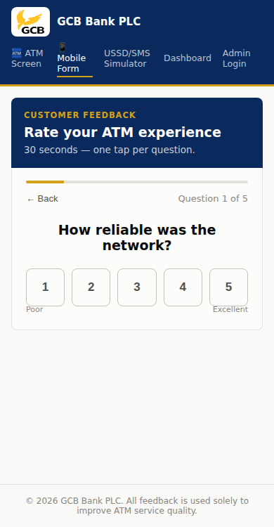
Figure A.1: The customer feedback form, reached by scanning the QR code linked to a specific ATM.
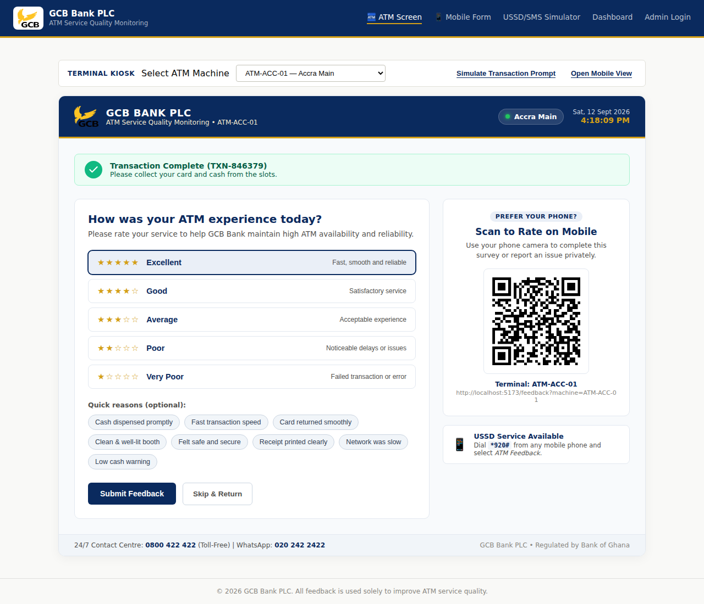
Figure A.2: The on-screen rating prompt as it would appear on the ATM's own display immediately after a transaction.
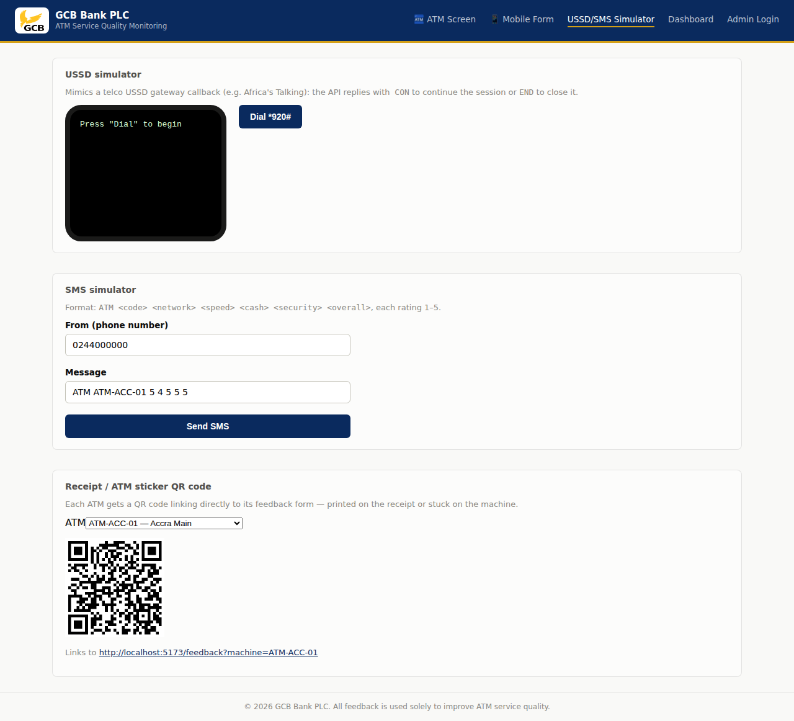
Figure A.3: The USSD session, SMS option, and QR code generator used to demonstrate the low-technology feedback channels.
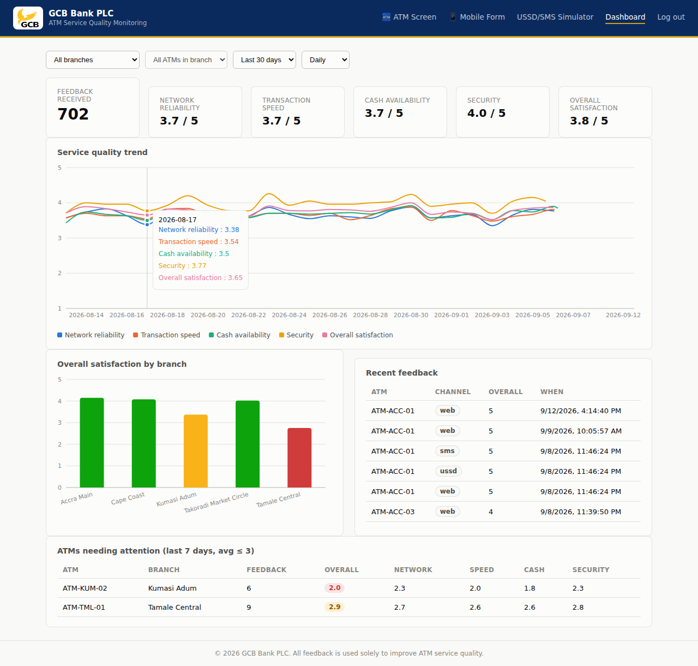
Figure A.4: The management dashboard, showing the service-quality trend, branch comparison, and the list of machines flagged for attention.
A.6 Limitations of the Prototype
Consistent with the limitations already acknowledged in Section 1.7, the prototype described in this appendix has a number of limitations that should be kept in mind when interpreting it. The USSD and SMS channels are simulated rather than connected to a live telecommunications aggregator, so in their present form they demonstrate the intended interaction rather than operating over an actual mobile network. Administrative access to the dashboard is presently limited to a single demonstration account rather than the tiered staff and branch-level accounts that a live deployment would require. The prototype has also not been tested with actual GCB Bank customers, nor has it been integrated with the bank's existing transaction-processing infrastructure, and doing either would raise additional considerations around data protection and system security that fall outside the scope of this project.
Notwithstanding these limitations, the prototype demonstrates that the practical measures recommended by this study, namely the continuous monitoring of network reliability, transaction speed, cash availability, and security at the level of the individual branch and machine, can be carried out as working software rather than remaining a purely conceptual recommendation.

