GHANA COMMUNICATION TECHNOLOGY UNIVERSITY
(GCTU)



FACULTY OF ENGINEERING
DEPARTMENT OF COMPUTER ENGINEERING
DESIGN AND DEVELOPMENT OF AN AUTONOMOUS ROVER FOR PRECISION SEED PLANTING AND SPOT WATERING ON SMALLHOLDER FARMS
A Project Work Submitted in Partial Fulfillment of the Requirements For
BSc Computer Engineering
BY:
ELIKPLIM KOFI NYAHE – 4121230028
AARON LORD ANNAN – 1706202763
SUPERVISOR:
DR. SAMUEL DANSO
JUNE, 2026

TABLE OF CONTENTS

TABLE OF CONTENTS i
TABLE OF TABLES ii
TABLE OF FIGURES iii
CHAPTER ONE 1
INTRODUCTION 1
1.1 Background to the Study 1
1.2 Statement of the Problem 8
1.3 Objectives of the Study 10
1.4 Significance of the Study 10
1.5 Scope of the Study 11
1.6 Research Questions 12
1.7 Methodology Overview 12
1.8 Operational Definitions 13
1.9 Organisation of the Report 13
CHAPTER TWO 15
LITERATURE REVIEW 15
2.1 Introduction 15
2.2 Precision Agriculture and Agricultural Robotics 15
2.3 Precision Seed Planting Mechanisms 17
2.4 Navigation Techniques for Agricultural Robots 19
2.5 Spot Watering and Precision Irrigation Systems 20
2.6 Soil Sensing in Autonomous Farming Systems 21
2.7 ROS and ROS 2-Based Agricultural Robotic Systems 21
2.8 Summary of Related Works and Research Gaps 22
REFERENCES 27

TABLE OF TABLES
Table 1. 1: Key Indicators of Ghana's Agricultural Sector 1
Table 1. 2 Estimated Food Losses in Sub-Saharan Africa 3
Table 1. 3: Comparison of Manual versus Automated Seed Sowing Performance 4

TABLE OF FIGURES
Figure 1. 1 Manual seed planting on a smallholder farm in Ghana 2
Figure 1. 2: Relationship between speed of emergence and corn yield (Heppner et al. [43]) 4

CHAPTER ONE

INTRODUCTION

1.1 Background to the Study
In Ghana and across much of sub-Saharan Africa, smallholder farmers form the backbone of food production. They cultivate relatively small plots of land, often relying on family labour and basic hand tools to carry out planting and watering tasks. Despite their central role in feeding the population, these farmers face persistent challenges that limit how much food they can produce from the land available to them. Two of the most significant of these challenges are the inconsistency of manual seed planting and the inefficiency of traditional irrigation methods [1], [2].
The scale of dependence on smallholder agriculture in Ghana is substantial, as summarised in Table 1.1. Agriculture accounts for approximately 23% of the national Gross Domestic Product (GDP) and employs over 52% of the labour force, while providing over 90% of the country’s food needs [31]. The vast majority of this production comes from smallholder farmers using traditional methods: about 60% of all farm holdings are less than 1.2 hectares in size, and small-to-medium farms of up to 10 hectares account for 95% of cultivated land [31], [32]. The predominant farming system remains traditional, involving the use of hoe and cutlass, with mechanised farming being minimal [32]. Perhaps most critically, less than 3% of cultivated land is under any form of irrigation, meaning that over 90% of food production is entirely rain-fed [33], [34].
Indicator | Value
Contribution of agriculture to GDP | ~23%
Share of labour force in agriculture | >52%
Proportion of food needs met domestically | >90%
Farm holdings under 2 hectares | ~60%
Small/medium farms (≤10 ha) share of cultivated land | 95%
Predominant farming system | Traditional (hoe and cutlass)
Irrigated area as share of cultivated land | <3%
Total area equipped for irrigation (est.) | ~59,000 ha
Table 1. 1: Key Indicators of Ghana's Agricultural Sector
Source: Compiled from FAO [31]; MoFA/SRID [32]; FAO AQUASTAT [33]; Dittoh [34].

Of all the stages involved in growing a crop, the planting stage has an outsized influence on the final harvest. How seeds are placed into the ground the distance between them, how deep they go, and how evenly they are spread shapes the entire trajectory of the crop from germination through to maturity. On most smallholder farms in Ghana, seeds are planted by hand, either through broadcasting (scattering seeds across the soil surface) or dibbling (poking holes individually and dropping seeds in). Both approaches introduce a high degree of variability. It is practically impossible for a person to maintain perfectly even spacing and consistent depth over hundreds or thousands of planting points across a field. What happens as a result is that some seeds end up too close together, forcing the emerging seedlings to compete intensely for sunlight, water, and soil nutrients. Meanwhile, gaps form in other parts of the field where seeds were missed or spaced too far apart, leaving productive land unused. Seeds placed too shallow may dry out before they can germinate, and those pushed too deep may struggle to reach the surface. The overall effect is an uneven crop stand some areas are overcrowded, other areas are bare, and plants mature at different rates, which complicates weeding, fertiliser application, and harvesting.
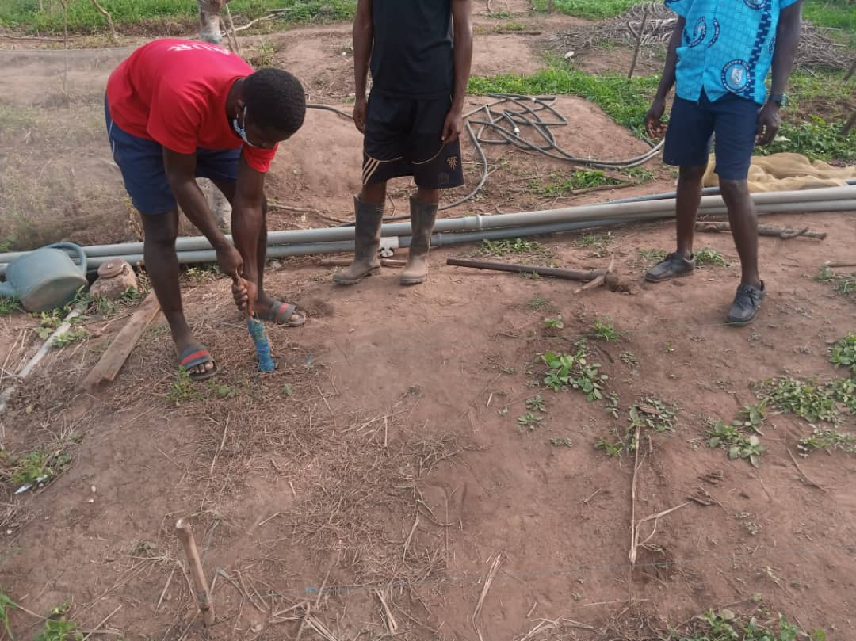
Figure 1. 1 Manual seed planting on a smallholder farm in Ghana
The consequences of these inefficiencies are compounded by losses throughout the food supply chain. According to the Food and Agriculture Organization (FAO), as much as 37% of all food produced in sub-Saharan Africa is lost between production and consumption [35]. For cereal crops specifically, the African Postharvest Losses Information System (APHLIS) estimates annual post-harvest losses in the range of 9–18%, while studies on maize the most important staple for resource-poor smallholders in Africa report grain losses of between 14% and 36% [36], [37]. The economic value of post-harvest grain losses alone in sub-Saharan Africa has been estimated at $4 billion per year, an amount sufficient to meet the annual food needs of over 40 million people [35], [38]. These figures are summarised in Table 1.2.
Loss Category | Estimated Range | Source
Total food lost (production to consumption), SSA | ~37% | FAO (2011)
Post-harvest cereal losses, SSA | 9–18% | APHLIS
Post-harvest maize grain losses, Africa | 14–36% | Tefera (2012)
Economic value of grain PHL in SSA | $4 billion/year | FAO (2011)
Post-harvest mango losses, Ghana | ~49% | Moneda Africa (2025)
Table 1. 2 Estimated Food Losses in Sub-Saharan Africa
Source: Compiled from FAO [35]; APHLIS; Tefera [36]; World Bank [37]; Moneda Africa [38].
While a substantial portion of these losses occurs after harvest (during storage and transport), the losses that begin at the planting stage through poor germination caused by inconsistent seed placement and inadequate initial watering are often overlooked. Improving the precision of planting and initial irrigation thus represents an upstream intervention that can reduce the cascade of losses that follows.
Precision seed dispensing tackles the planting problem directly. The idea is straightforward: instead of relying on a human hand to scatter or drop seeds, a mechanical or electromechanical dispensing system releases individual seeds at programmed intervals and at a controlled depth as it moves along the planting row. The result, at least in principle, is that every seed gets roughly the same amount of space and the same starting conditions, which gives every plant in the field a more equal chance of reaching its full yield potential. As Table 1.3 illustrates, the performance gap between manual and automated sowing approaches is significant across multiple parameters.

Parameter | Manual Sowing | Automated/Robotic
Seed spacing consistency | Highly variable | Uniform (±2 mm)
Planting depth control | Inconsistent | Programmable (e.g. 15 mm)
Seed wastage rate | High (broadcasting) | Minimal (metered)
Seeds planted per hour | 10–21 | 50–95
Labour intensity | Very high | Low (autonomous)
Watering integration | Separate manual task | Combined on same pass
Cost trend over 9 months | $18,000 cumulative | $9,000 cumulative
Table 1. 3: Comparison of Manual versus Automated Seed Sowing Performance
Source: Compiled from Nyahe and Annan (this study); Urkude et al. [22]; Srivastava et al. [23].
Research by Heppner et al. [43] provides further empirical evidence for the yield benefits of precise seed placement. In a field study comparing a precision planter to an air drill for corn, the planter achieved a 5.5% higher yield (11,032 kg/ha versus 10,458 kg/ha) due to shallower and more uniform seeding depth (44.8 mm versus 52.4 mm) and a 56% faster speed of emergence (2.5 versus 1.6 plants/day/m²). As shown in Figure 1.2, yield was found to have a positive linear relationship with speed of emergence (R² = 0.38), confirming that uniform and rapid seedling emergence which is a direct consequence of consistent seed placement translates into measurably higher crop output.
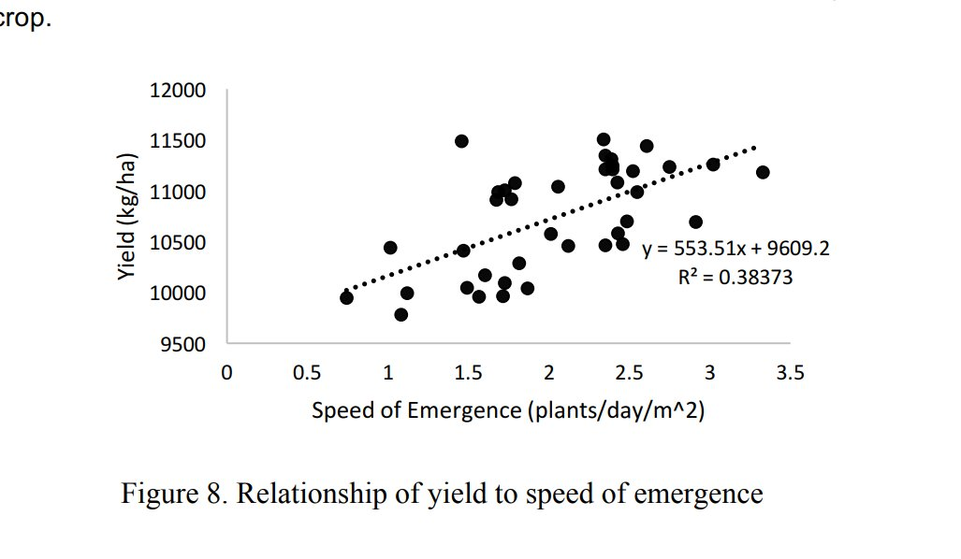
Figure 1. 2: Relationship between speed of emergence and corn yield (Heppner et al. [43])
But getting the seed into the ground properly is only half the equation. The other half is water. A seed needs adequate soil moisture to begin the germination process without it, the seed simply sits dormant or dies. In many parts of Ghana, rainfall patterns are seasonal and increasingly erratic due to climate variability, and most smallholder farmers do not have access to mechanised irrigation systems. Where irrigation does happen, it tends to be crude: buckets, hoses, or simple flood methods that apply water broadly across the field without much regard for where it is actually needed. This wastes water on areas that may already be sufficiently moist while leaving drier spots under-served. As noted by the FAO, water use efficiency at both conveyance and field levels in Ghana’s existing irrigation systems is low, since no concerted efforts have been made to address water losses [33]. Targeted spot watering offers a smarter alternative. Rather than flooding the whole field, a spot watering system delivers a controlled amount of water to each individual planting location. If this delivery is guided by an actual measurement of the soil moisture at that specific point, then water only goes where it is genuinely needed, and none is wasted on already-wet soil.
When precision seed dispensing and targeted spot watering are combined on a single platform, the benefits compound. Each seed is placed at the right spacing and depth, and then immediately receives the right amount of water for germination no more, no less. The result is a field of seedlings that emerge uniformly, grow at similar rates, and compete less with each other. This kind of uniformity does not just improve yield; it also makes every subsequent farming operation easier. Weeding is simpler when plants are in straight, evenly spaced rows. Fertiliser can be applied more efficiently. Harvesting is more predictable. For a smallholder farmer working with limited land, limited water, and limited labour, these are not marginal improvements they can make a real difference to household food security and income.
Precision agriculture is the broader field that encompasses these kinds of targeted, data-driven farming interventions. The fundamental idea behind precision agriculture is to apply the right input, in the right amount, at the right place, at the right time. Over the past two decades, research in this area has produced a wide range of technologies variable-rate applicators, remote sensing platforms, automated guidance systems that have proven effective in large-scale commercial farming. Ghalazman et al. [3] reviewed the state of autonomous robots and solar energy systems for precision agriculture and smart farming, noting that while commercially available precision farming tools have become quite advanced, most of them are designed for large operations with substantial budgets. Their analysis made clear that practical, affordable precision agriculture solutions for smallholder farmers are still lacking.
The global precision farming market underscores both the opportunity and the problem. As shown in Table 1.4, the market is projected to grow from approximately $11–15 billion in 2025 to $21–27 billion by 2030, with compound annual growth rates consistently above 9% [39], [40], [41], [42]. However, the vast majority of this market activity is concentrated in North America and Europe, where large-scale commercial farms can justify the cost of advanced GPS guidance systems, AI-enabled analytics, and variable-rate machinery. The Asia-Pacific region is the fastest-growing segment, driven by government modernisation initiatives, but sub-Saharan Africa remains largely absent from these projections. This gap is precisely what motivates the present study: the need for precision agriculture solutions that are designed from the outset for the scale, cost constraints, and infrastructure realities of smallholder farming in Ghana.
Source | 2025 (USD Bn) | 2030 (USD Bn) | CAGR
Grand View Research | $11.67 | $24.09 | 13.1%
MarketsandMarkets | $11.38 | $21.45* | 9.5%
BCC Research | $12.80 | $21.20 | 10.6%
Mordor Intelligence | $14.77 | $26.86 | 12.7%
Figure 1. 3: Global Precision Farming Market Projections (2025–2030)
Source: Compiled from Grand View Research [39]; MarketsandMarkets [40]; BCC Research [41]; Mordor Intelligence [42]. *MarketsandMarkets projects to 2032.
One of the most promising avenues for bringing precision agriculture down to the smallholder scale is through agricultural robotics, and specifically through autonomous ground rovers. A rover is a mobile robotic platform that can travel across a field and carry out tasks planting seeds, spraying water, collecting sensor data with a level of consistency that human hands simply cannot match over a full day of work. Xu and Li [4] built and demonstrated a system they called MARS (Modular Agricultural Robotic System), which used interchangeable hardware modules to perform different farming tasks including plant phenotyping and soil sensing. Their approach showed that a single robotic platform could serve multiple purposes if designed with modularity in mind. Iqbal et al. [5] took a similar path with their MARIA robot, an open-source differential-drive platform that could navigate autonomously both indoors and outdoors while conducting plant monitoring and soil measurements. Both systems proved that integrating multiple agricultural functions onto one robot is technically feasible. That said, neither MARS nor MARIA combined seed dispensing with irrigation on the same rover those remained separate concerns in their designs.
The problem with most of these research-grade agricultural robots is their cost. Systems like MARS and MARIA, while clever in their design, still rely on components and computing platforms that put them out of reach for a typical Ghanaian smallholder farmer. Many agricultural robots in the literature use LiDAR sensors for navigation, which alone can cost more than an entire smallholder farm earns in a year. Others run their software on powerful single-board computers or laptops, which add both cost and complexity. This gap between what is technically possible and what is practically affordable is not trivial [6], [7]. It is especially frustrating because the farmers who would benefit most from automated seed dispensing and spot watering those with the most inconsistent manual planting and the least access to irrigation are exactly the ones who cannot afford the existing systems.
Researchers have explored lower-cost approaches to seed planting automation. Pandey et al. [8] built an AgriBot aimed at small landholdings, using a simple mechanical cam-based seed dropping mechanism. It managed consistent spacing of about 15 cm during trials, but it had no electronic feedback for controlling planting depth and no ability to water the seeds after placement. Debnath et al. [9] developed a smart seed dispenser on a mobile vehicle that could plow, sow, and level the soil, but the vehicle had to be controlled via mobile phone rather than navigating on its own. Ha-mim et al. [10] took an IoT approach, combining Arduino-based seed dispensing with soil moisture sensors and cloud-based monitoring. Their system showed that cheap sensors could provide useful soil data alongside planting, but the robot still needed a human operator to guide it through the field. What all of these projects have in common is that they treat seed dispensing as a standalone task. None of them coupled the dispensing mechanism with autonomous navigation to systematically cover a field, and none of them delivered water to the planting location immediately after seed placement.
For a planting rover to operate without constant human guidance, it needs some form of autonomous navigation. The literature offers a range of approaches at different price points. At the high end, Rakun and Popič [11], [12] built and refined an autonomous navigation algorithm for a robot called FarmBeast, which used LiDAR and IMU sensors together with advanced filtering to generate 3D point clouds for navigating between maize rows. At the affordable end, Kanagasingham et al. [13] got a weeding robot to navigate rice paddies autonomously using a combination of a front-mounted camera for detecting crop rows and GPS plus a compass for handling turns between rows. Levoir et al. [14] looked specifically at making GPS more accurate for rovers without paying for expensive RTK corrections. These studies point toward GPS and IMU as a practical navigation foundation for a low-cost rover not as precise as LiDAR, but workable and dramatically cheaper.
On the software side, the Robot Operating System 2 (ROS 2) has established itself as a go-to framework for building modular robotic systems. Fang et al. [15] used ROS 2 alongside a distributed network of ESP32 microcontrollers for their irrigation robot. Sani et al. [16] worked on improving the ROS 2 navigation stack for outdoor agricultural use. Post et al. [18], [19] built affordable farm robots with off-the-shelf parts running ROS on budget hardware and documented some of the real-world headaches, like GPS drift under tree cover and the computational limits of cheap single-board computers.
A recurring issue in these ROS-based projects is that the framework assumes the computer running it will be available and stable throughout the robot’s operation. On a smallholder farm where power supply may be inconsistent, where the robot might be working in dusty or hot conditions, and where there is no IT support if the software crashes, that assumption becomes risky. This dual-mode architecture ROS 2 on the desktop for design work, a single Arduino-class microcontroller on the rover for actual field operation could offer the best of both worlds, but it remains underexplored in the context of agricultural robots.
This study aims to fill that gap. The rover being developed here is, at its core, a seed dispensing and spot watering machine. The seed dispensing mechanism places individual seeds at controlled spacing and depth as the rover moves along predefined planting rows. The spot watering subsystem delivers a measured amount of water to each planting location right after the seed goes in, but only if a soil moisture reading taken at that point indicates the soil is too dry. For navigation, the rover uses GPS and IMU to follow predefined paths. The software is developed and tested in ROS 2 on a computer, but the rover itself runs on embedded microcontroller firmware (a single Arduino Uno R4) so it does not need a laptop or ROS 2 running in the field.

1.2 Statement of the Problem
The fundamental problem addressed by this study is the gap between the precision that smallholder crop production demands and the precision that manual methods can deliver. On Ghanaian smallholder farms, seeds are planted by hand through broadcasting or dibbling, methods that produce wide variations in seed spacing, planting depth, and field coverage. These variations directly reduce germination rates and lead to uneven crop stands, ultimately resulting in a harvest that falls short of what the land and the crop variety could have produced [1], [2].
The water situation compounds the problem. Where farmers rely on bucket irrigation, hosepipes, or simple flood methods, water is distributed unevenly. Some planting locations get soaked while others especially on slightly raised ground or at field edges get too little. Since water is often the most limiting resource for smallholder crop production in Ghana, this inefficiency has real consequences. Seeds in under-watered spots fail to germinate. Water applied to already-moist areas is effectively wasted through runoff or deep percolation.
The core issue is not that farmers lack good seed varieties or suitable land. It is that the manual methods used to place seeds and deliver water introduce too much variability at the most critical stage of crop development. Mechanised precision seed dispensing and soil moisture-informed spot watering could address this variability directly, improving germination rates and water use efficiency without requiring additional land, new crop varieties, or expensive chemical inputs.
Precision agriculture technologies and agricultural robotics have shown they can deliver this kind of consistency [3], [4], [5]. The problem is that most existing systems are built for large-scale farms and come with price tags to match. They tend to rely on LiDAR sensors, powerful computing platforms, and complex software stacks [11], [12], [16] none of which are realistic for a Ghanaian smallholder context. There is also the issue of fragmentation. Most robotic systems in the literature treat seed planting, irrigation, and soil sensing as separate problems to be solved by separate machines [8], [9], [10], [15]. The potential gains from doing both on the same platform, in the same pass over the field, remain largely untapped. On top of this, while the ROS 2 framework is excellent for robot development and simulation, its reliance on continuous middleware availability makes it risky as a runtime system for rovers operating in field conditions where power and computing reliability are uncertain [18], [19].
What is needed, then, is an affordable autonomous rover that brings precision seed dispensing and soil moisture-informed spot watering together on a single platform. It should use low-cost GPS and IMU for navigation, embedded microcontrollers for reliable field operation, and benefit from ROS 2 during the design and testing phase without depending on it in the field.

1.3 Objectives of the Study
General Objective
The overall aim of this study is to design and build an autonomous rover for precision seed planting and spot watering on smallholder farms in Ghana, using GPS and IMU-based navigation, embedded microcontroller control, and a ROS 2-supported development process.
Specific Objectives
The specific objectives are to:
1. Design and build a low-cost rover platform that integrates mechanisms for precision seed dispensing of 3 seeds per hole and targeted spot watering.
2. Develop a GPS and IMU-based navigation system that enables the rover to follow predefined planting rows autonomously.
3. Incorporate soil moisture sensing so that spot watering decisions at each planting point are based on actual soil conditions rather than a fixed schedule.
4. Implement a dual-mode software approach where ROS 2 is used for development, simulation, and testing, while embedded microcontroller firmware handles standalone field operation.
5. Test and evaluate the rover through simulation and controlled field trials, measuring navigation accuracy, seed placement consistency, watering precision, and overall system reliability.

1.4 Significance of the Study
On the practical side, this project addresses a real need. Smallholder farmers in Ghana and similar contexts would benefit from a machine that can plant seeds evenly and deliver water precisely, because these are exactly the tasks where manual methods fall short and where small improvements can lead to meaningful gains in yield and water efficiency. The rover is designed to be affordable enough that it could realistically be used at the community level, even if individual ownership might remain out of reach for most farmers initially. By prioritising low-cost components and embedded control, the design avoids the trap of building a technically impressive system that no one in the target context can actually afford or maintain. Ghalazman et al. [3] made a strong case that solar-powered autonomous robots represent a sustainable direction for precision agriculture in resource-limited settings, and this project aligns with that direction by keeping energy consumption and component costs low.
From an academic perspective, the project makes a contribution by showing how a functional agricultural robot can be designed under tight cost and resource constraints. The dual-mode architecture using ROS 2 for development but embedded firmware for field deployment is a practical pattern that other student projects and research groups could adopt. It offers the modelling and simulation benefits of a modern robotic framework without the reliability headaches of running that framework on a rover in the field. The integration of seed dispensing, spot watering, and soil moisture sensing on a single low-cost platform also addresses a gap that runs through the literature, where these functions are almost always implemented on separate systems [4], [5], [8], [9], [10].

1.5 Scope of the Study
This study covers the design, construction, and initial evaluation of an autonomous rover for precision seed planting and spot watering in smallholder farm settings. The work includes mechanical design (the chassis, drive system, seed dispensing mechanism, and water delivery system), electronics integration (microcontrollers, motor drivers, sensors, and power supply), and software development for navigation and task control.
The rover’s navigation relies on GPS and IMU data for position and heading. LiDAR, SLAM, and advanced obstacle avoidance are not part of the current design due to their cost. An ESP32-CAM module may be explored for basic visual assistance, but camera-based navigation is not a core design requirement.
ROS 2 is used for simulation, algorithm testing, and system integration on a desktop or laptop computer. The rover itself runs on embedded firmware (a single Arduino Uno R4) and does not require ROS 2 to be running during field operation.
Testing takes place in controlled environments with relatively flat, uniform terrain. The project assesses baseline functionality and reliability, not full commercial readiness. The seed dispensing mechanism is designed for small to medium seed types like maize, beans or groundnuts, and the water delivery system is sized for the modest volumes appropriate to smallholder plot sizes.

1.6 Research Questions
This study seeks to answer the following questions:
1. How accurately can GPS and IMU-based navigation guide the rover along predefined planting paths in conditions typical of Ghanaian smallholder fields?
2. How consistently can the rover achieve target seed spacing and water delivery volumes using its low-cost dispensing and pumping mechanisms? Planting depth control was descoped from this study because of time constraints and is treated as future work in Chapter Five.
3. Does integrating real-time soil moisture sensing improve spot watering efficiency compared to applying a fixed amount of water at every planting point?
4. How does the reliability of the embedded microcontroller-based field operation compare to what is achieved in the ROS 2 simulation and testing environment?

1.7 Methodology Overview
The project follows a modular development methodology. The rover's hardware and software are organised into six functional modules, Core Processing and Communication, Power Management and Failsafe, Locomotion and Motor Protection, Sensor and Navigation, Actuators and Payload, and Telemetry and Visualisation, each specified, built, and bench-tested largely on its own before being integrated into the complete system. Splitting the work this way kept faults easier to isolate during assembly, since a problem could usually be traced to a single module rather than the system as a whole. Within that structure, individual modules still went through their own rounds of revision as components were swapped or issues were found during integration, as described in the relevant sections of Chapter Three. The key metrics for evaluation include navigation path deviation, seed spacing accuracy, water delivery precision, and system reliability across the two operating modes. Full design details, implementation steps, and test protocols are presented in Chapter Three.
Figure 1.3 illustrates the generic form of a modular development methodology, before it is applied to this specific project: a system is decomposed into independent modules, each of which is designed, built, and tested largely on its own, before the modules are integrated and the complete system is tested against its requirements.
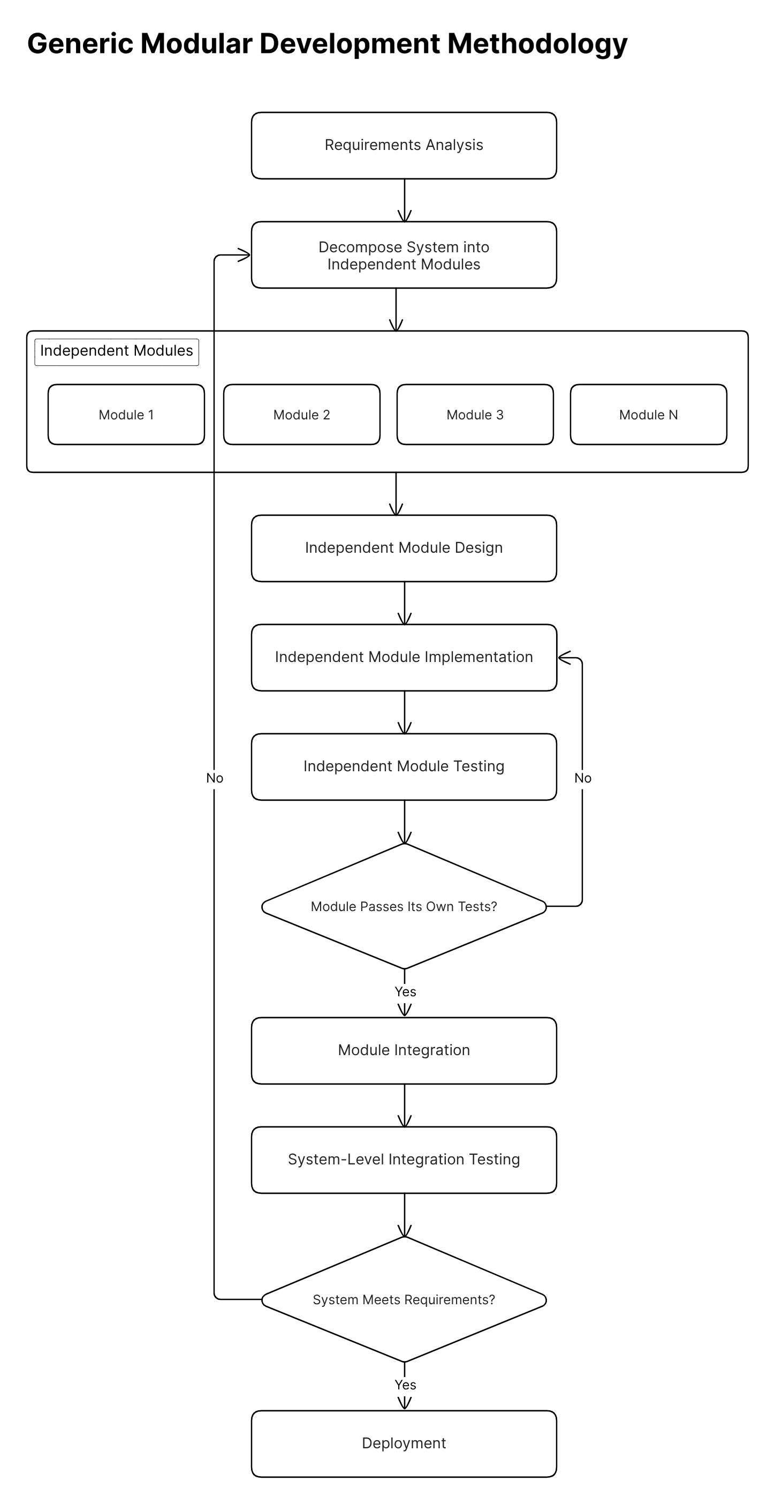
Figure 1. 1 Generic modular development methodology
Figure 1.4 shows this same methodology applied to the present project, with the six functional modules named in place of the generic "Module 1" through "Module N" placeholders, and the design-build-bench test loop applied independently to each one before integration onto the rover chassis.
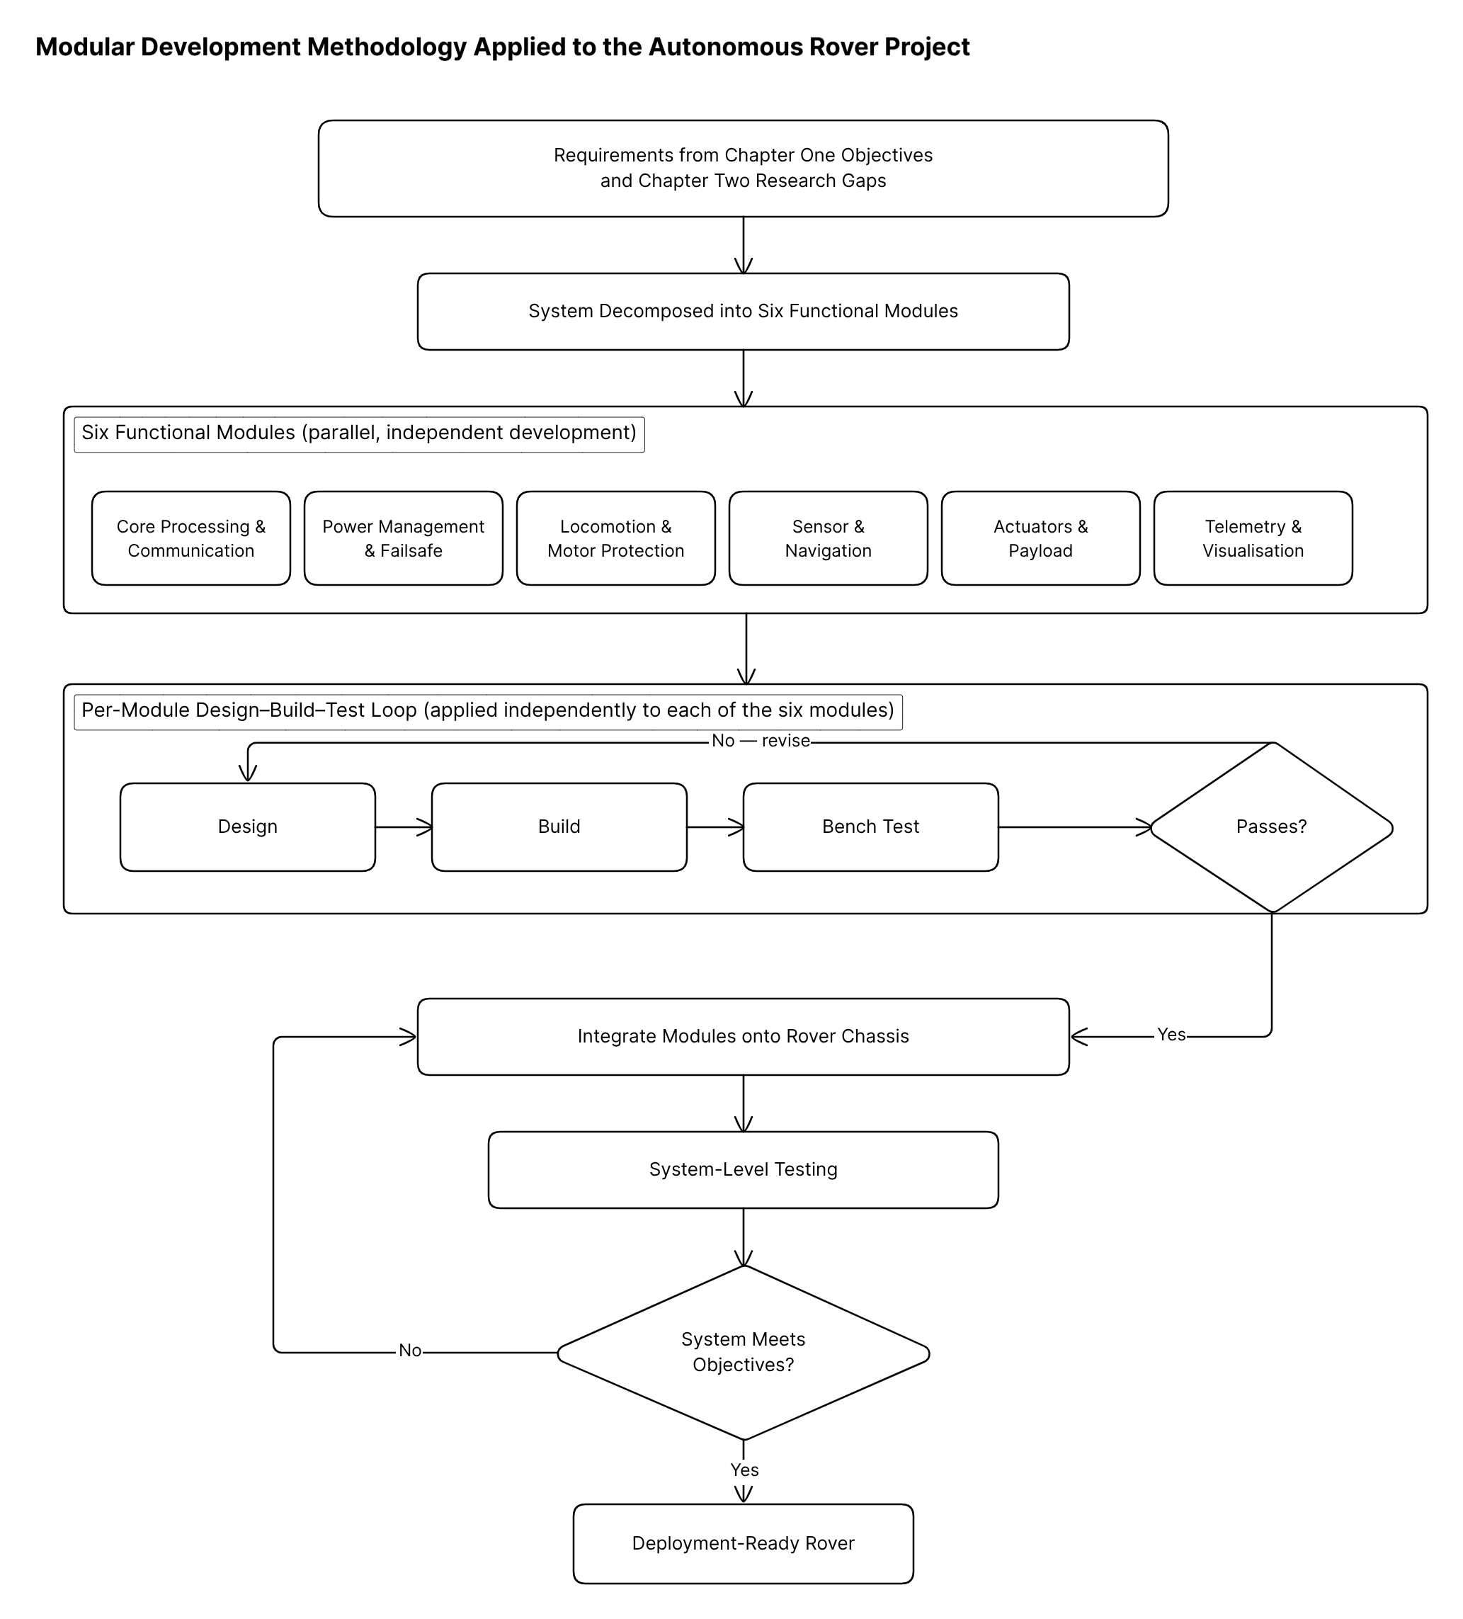
Figure 1. 1 Modular development methodology as applied to this project

1.8 Operational Definitions
Autonomous rover: A mobile robotic platform that can move across a field and carry out specified tasks (in this case, seed planting and spot watering) without needing continuous human control during operation.
Precision seed dispensing: Placing individual seeds at set spacing intervals to promote even germination and crop emergence across the field. Depth control was not implemented in this study and is treated as future work.
Spot watering: Delivering a measured quantity of water to a specific planting location rather than irrigating the whole field uniformly. In this study, spot watering decisions are guided by soil moisture readings at each planting point.
ROS 2-enabled development: Using the Robot Operating System 2 framework for writing, simulating, and testing the rover’s software, without requiring ROS 2 to run on the rover during actual field deployment.
Standalone (embedded) mode: The rover running its navigation and task-execution functions on microcontroller firmware (a single Arduino Uno R4) independently of ROS 2.
Differential drive: A drive configuration with two independently powered wheels, allowing the rover to move forward, turn, and rotate in place by varying the speed of each wheel.

1.9 Organisation of the Report
This report is organised into five chapters. Chapter One introduces the study with its background, problem statement, objectives, significance, scope, and research questions. Chapter Two reviews the relevant literature on agricultural robotics, precision seed planting, navigation techniques, spot watering and irrigation, soil sensing, and ROS/ROS 2-based systems. Chapter Three covers the system design, hardware selection, circuit design, software architecture, and implementation details. Chapter Four presents and discusses the results from simulation and field testing. Chapter Five concludes with a summary of findings, limitations of the study, and recommendations for future work.

CHAPTER TWO

LITERATURE REVIEW

2.1 Introduction
This chapter reviews existing research related to the design and development of autonomous agricultural robots, focusing on five key areas: precision seed planting mechanisms, autonomous navigation techniques, spot watering and precision irrigation, soil sensing in farming robots, and ROS/ROS 2-based robotic systems. The literature drawn upon consists mainly of peer-reviewed journal papers, conference proceedings, and technical reports published between 2017 and 2026, chosen to capture both established foundations and the most recent work in the field.
The review has three purposes. The first is to establish what has already been achieved in agricultural robotics and precision farming technology what kinds of systems exist, what approaches they use, and how well they perform. The second is to critically examine the strengths and weaknesses of these existing systems, paying particular attention to cost, complexity, the degree to which different functions are integrated on a single platform, and suitability for smallholder farming environments in developing countries. The third purpose is to identify the specific research gaps that justify the design choices made in this study.
The chapter is divided into six thematic sections. After this introduction, Section 2.2 covers the broader landscape of precision agriculture and agricultural robotics. Sections 2.3 through 2.6 address the four main technical areas seed planting, navigation, irrigation, and soil sensing in turn. Section 2.7 discusses ROS and ROS 2-based systems. The chapter concludes with a comparative summary table (Table 2.1) and a discussion of the identified research gaps.

2.2 Precision Agriculture and Agricultural Robotics
Precision agriculture, broadly defined, is about applying the right farming inputs in the right amounts at the right locations and times. Instead of treating an entire field uniformly, precision agriculture uses data from sensors, GPS, cameras, or other sources to tailor operations to the actual conditions at each point in the field. When applied to planting and irrigation, this means placing each seed where it will grow best and delivering water only where it is actually needed. The integration of robotic systems into this approach offers the possibility of carrying out these tasks with a consistency and accuracy that manual labour cannot sustain over a full working day.
Ghalazman et al. [3] carried out a wide-ranging review of autonomous robots and solar energy applications in precision agriculture. Their paper examined the current state of robotic platforms for farming, their energy needs, and the potential for solar power to make these systems more sustainable. A key takeaway from their analysis was that while agricultural robots have become quite sophisticated in research and commercial settings, the vast majority of them are designed for large-scale operations. The cost of entry, both in terms of hardware and the technical knowledge required to operate these systems, puts them out of reach for most smallholder farmers.
Xu and Li [4] took a different approach with their Modular Agricultural Robotic System, or MARS. The central idea behind MARS was modularity: the robot was built from five core hardware modules and three optional ones. By swapping and combining modules, a single platform could be reconfigured for different tasks, from plant phenotyping to soil sensing. The limitation, from the perspective of this study, is that MARS was developed and tested at the University of Georgia a well-resourced research environment quite different from the conditions on a Ghanaian smallholder farm.
Iqbal et al. [5] developed MARIA, short for Multipurpose Autonomous Robot of Intelligent Agriculture. MARIA was an open-source differential-drive robot that navigated outdoors using GPS waypoints and indoors using LiDAR. The open-source approach was commendable and made the design accessible to other researchers, but MARIA required a laptop running ROS to function, which raised concerns about field reliability and power consumption.
Zinzani et al. [20] introduced Rockerbot, a compact rover built for navigating maize crop rows during early growth stages. The rover used a rocker-bogie suspension borrowed from planetary rover designs, which helped it maintain stability on uneven agricultural terrain. It was designed for monitoring rather than planting or watering, so it did not address the specific tasks this study targets.
Menon and Prabhakar [21] developed a Smart Agriculture Monitoring Rover aimed at small-scale farms in rural areas. Built around an Arduino Mega, their system monitored weather and soil conditions using IoT sensors and included a sprinkler mechanism for water delivery and pest treatment. The rover was not autonomous it required manual or remote control and the sprinkler applied water broadly rather than to specific planting points.
Taken together, these studies paint a picture of a field that has made substantial technical progress but still has a significant gap when it comes to affordable, multi-function autonomous rovers for smallholder farming. Systems that are sophisticated enough to combine seed dispensing, spot watering, and autonomous navigation tend to be too expensive. Systems that are cheap enough for smallholder contexts tend to sacrifice either autonomy, precision, or the integration of multiple functions. Bridging this gap is the central motivation for the present study.

2.3 Precision Seed Planting Mechanisms
Getting seeds into the ground at consistent spacing and depth is one of the most impactful things a farmer can do to improve crop performance. When spacing and depth are controlled, plants emerge more uniformly, compete less with each other, and ultimately yield more.
Pandey et al. [8] built an AgriBot specifically for farmers with small landholdings who could not afford commercial planting equipment. The AgriBot used a mechanical cam mechanism driven by the rotation of the wheels to drop seeds at regular intervals, achieving roughly 15 cm spacing. The simplicity of the cam-based approach meant it was cheap and mechanically robust, but it also meant there was no electronic control over planting depth and no way to adjust spacing on the fly.
Debnath et al. [9] designed a smart seed dispenser, mounted on a small vehicle that could plow, sow, and level the soil in a single pass. The dispensing mechanism used a servo motor to release seeds at programmed intervals. The main limitation was that the vehicle required a human operator controlling it via a mobile phone.
Ha-mim et al. [10] integrated seed dispensing with IoT-based soil monitoring in an Arduino-controlled system. The IoT aspect was a genuine step forward in terms of making soil data available alongside planting. However, the system was manually guided and did not have any path planning or autonomous navigation capability.
Urkude et al. [22] built a simpler seed dispenser around an Arduino Uno with a servo-controlled mechanism and a soil sensor. They tested it on different soil types and reported consistent performance. However, the device was a standalone dispenser it was not mounted on an autonomous mobile platform.
Manimekalai et al. [23] developed an Arduino-based seed sowing robot that combined a robotic arm with a conveyor belt and dispensing mechanism. Their system could also cover seeds with soil and apply water after planting, making it one of the more integrated low-cost designs. The catch was that it navigated using simple line-following, which required black lines to be physically marked on the field beforehand.
Liu et al. [24] conducted a detailed mechanical study of seed dispensers with eye-type metering mechanisms, using discrete element method (DEM) simulation. This kind of engineering analysis is valuable for predicting performance before building a physical prototype, but the study was purely analytical.
Vakiti and Subhadra [25] built a Smart Seed Sower that combined solar power, IoT-based soil monitoring, and a seed dispensing mechanism. It was one of the few low-cost systems that addressed energy sustainability alongside planting. But like several others, it lacked autonomous mobility and did not include an irrigation function.
One project that came closest to the concept pursued in this study was an autonomous farming robot for precision seed sowing and targeted irrigation using wireless control [26]. This system automated hole drilling, seed dispensing, and immediate watering on a single wirelessly controlled platform. The limitation was that it operated under wireless remote control rather than autonomous navigation.
Three observations emerge from this body of literature. First, low-cost seed dispensing systems based on microcontrollers and simple mechanical designs can achieve acceptable planting consistency. Second, almost all existing systems treat seed dispensing in isolation. Third, the step from manually guided or remote-controlled planting to fully autonomous operation on a budget remains an open challenge. This study addresses all three points.

2.4 Navigation Techniques for Agricultural Robots
For a planting rover to work without a human steering it, it needs to know where it is and where it is going. The quality of navigation directly affects the quality of the planting.
At the expensive end, Rakun and Popič [11], [12] developed an autonomous navigation system for the FarmBeast robot using LiDAR combined with an IMU and advanced data filtering. Their improved algorithm reduced traversal time by up to 33% and crop damage by 25%, but at the cost of expensive LiDAR hardware.
Sperti et al. [27] went in a different direction with a non-linear model predictive control (NMPC) system for GPS-free navigation in vineyards. The approach was clever and cost-effective on the sensor side, but NMPC is computationally demanding and the system depended on visible crop rows for guidance.
Sani et al. [16] tackled a specific problem with the ROS 2 Nav2 navigation stack: in agricultural settings, the standard obstacle detection treats tall grass and weeds as impassable barriers. Their solution used a depth camera with pixel-level classification to update the navigation costmap in real time.
Vu et al. [17] built a ROS 2-based navigation system for orchard robots using RTK-GNSS, stereo cameras, visual odometry, and IMU fusion. However, the sensor suite puts the total cost well above what this study is targeting.
On the more affordable side, Kanagasingham et al. [13] achieved fully autonomous navigation for a rice field weeding robot by combining camera-based crop row detection with GPS and compass data. Levoir et al. [14] focused specifically on making GPS more accurate without paying for RTK equipment. Their results showed that with the right signal processing, cheap GPS can be good enough for many precision agriculture tasks.
Shi et al. [28] published a thorough review of row detection-based navigation methods for agricultural robots. Their conclusion was practical: the right navigation method depends on the specific application, the crop, the growth stage, and the budget available. Lim and Phang [29] worked on obstacle detection for rovers in plantation settings, training a YOLOv5 model to classify obstacles.
Post et al. [18], [19] are perhaps the most directly relevant to this study. They built autonomous agricultural robots using ROS and inexpensive hardware, and they were honest about the problems they encountered: GPS drifting under tree canopy, single-board computers struggling with computational load, and wireless communication dropping out in the field. These practical lessons strongly influenced the decision in this study to use embedded microcontrollers for field operation.
The navigation literature supports three conclusions for this project. GPS and IMU provide a workable navigation foundation for a low-cost rover operating in open fields. The ROS 2 navigation tools are valuable for development and simulation but need customisation for agricultural use and are risky to depend on in the field. And the choice of navigation method should be driven by practical constraints rather than by chasing maximum accuracy.

2.5 Spot Watering and Precision Irrigation Systems
Water is often the most limiting factor for crop production on smallholder farms, particularly in areas with seasonal or erratic rainfall. Delivering water efficiently can make the difference between a successful germination and a failed one.
Fang et al. [15] built one of the more technically advanced irrigation robots in the recent literature. Their system ran on ROS 2 and used a YOLOv8 vision model to detect and locate individual plants, then navigated to each one using LiDAR-based SLAM to deliver water. It was an elegant design, but it was built for indoor houseplants, and its reliance on LiDAR and trained AI models puts it in a different cost bracket.
The autonomous farming robot described in [26] came closer to the concept of this study by integrating seed dispensing with immediate watering on the same platform. The drawback was that the robot was wirelessly remote-controlled and did not use soil moisture data to decide how much water to deliver.
Menon and Prabhakar [21] included a sprinkler system on their monitoring rover, capable of spraying water over a general area. This is useful for broad-area treatment but lacks the precision needed for spot watering.
Sathya et al. [30] built an Intelligent Agritech Rover that collected soil data and applied machine learning to predict crop suitability and irrigation requirements. The concept of using rover-collected soil data to inform watering decisions is directly relevant to this study’s approach.
Two trends stand out from the irrigation literature. First, the most effective precision irrigation systems base their water delivery decisions on actual measured conditions rather than on fixed schedules. Second, the integration of irrigation with planting on a single autonomous platform is still rare. This study addresses both points.

2.6 Soil Sensing in Autonomous Farming Systems
Soil moisture measurement is the sensing function most directly relevant to this study, because it provides the data that determines whether and how much water the rover delivers at each planting point.
Iqbal et al. [5] included soil sensing on the MARIA platform, using penetrometer measurements alongside plant phenotyping sensors. Ha-mim et al. [10] used soil sensors in their IoT-based seed sowing system for monitoring and cloud upload. They demonstrated that inexpensive capacitive soil moisture sensors provide readings that are reliable enough for practical irrigation decisions when properly calibrated. Vakiti and Subhadra [25] put IoT-enabled soil sensors on their Smart Seed Sower, measuring humidity, pH, temperature, and nutrients. Sathya et al. [30] used their rover to collect soil moisture, potassium, phosphorus, and nitrogen data, feeding it into machine learning models.
The pattern across these studies is clear: researchers have demonstrated that low-cost soil sensors mounted on rovers can collect useful data, and that this data can inform irrigation decisions. What has not been widely demonstrated is the closing of the control loop on the rover itself using a soil moisture reading taken at a specific planting location to immediately decide, on the spot, whether to pump water to that location. This is what the present study implements: a closed-loop system where the soil moisture sensor feeds directly into the rover’s watering control logic.

2.7 ROS and ROS 2-Based Agricultural Robotic Systems
ROS (Robot Operating System) and its successor ROS 2 have become standard tools in robotics research. They provide a publisher-subscriber communication system, a library of ready-made packages for navigation and perception, and simulation environments like Gazebo.
Post et al. [18], [19] used ROS to build affordable farm robots and were candid about what worked and what did not. On the positive side, ROS allowed them to integrate GPS, IMU, and odometry data into a coherent navigation system quickly. On the negative side, they ran into GPS drift, limited processing power on budget single-board computers, and flaky wireless connections during field tests.
Fang et al. [15] used ROS 2 alongside a distributed network of ESP32 microcontrollers. The central computer ran ROS 2 for SLAM, navigation, and high-level decision-making, while the ESP32 nodes handled lower-level tasks. This hybrid architecture is relevant because it shows one way to distribute the workload. The present study takes this idea a step further by having the microcontrollers handle everything in the field.
Sani et al. [16] showed that the ROS 2 Nav2 stack needs custom extensions for agricultural environments. Vu et al. [17] demonstrated the capabilities of a full ROS 2-based navigation system in orchards, but with hardware that costs significantly more than what this project can afford.
The takeaway from the ROS/ROS 2 literature is that ROS 2 is an excellent development tool but a risky field runtime for budget agricultural robots. This dual-mode approach (ROS 2 for design, embedded firmware for deployment) is what the present study adopts.

2.8 Summary of Related Works and Research Gaps
Table 2.1 summarises the key works reviewed in this chapter, listing their focus areas, technologies, main contributions, and limitations

Ref. | Author(s) & Year | Focus | Key Technologies | Contributions | Limitations
[3] | Ghalazman et al. (2023) | Autonomous robots and solar energy for precision agriculture | Survey: robotics, solar energy | Comprehensive review of robotic platforms and energy solutions | Review paper; no system built
[4] | Xu and Li (2022) | MARS: Modular Agricultural Robotic System | Modular hardware, ROS, GPS | Multi-purpose platform for phenotyping and farming | Designed for US research context; not smallholder-oriented
[5] | Iqbal et al. (2020) | MARIA: Multi-purpose autonomous robot | ROS, GPS, LiDAR, differential drive | Open-source platform for plant phenotyping and soil sensing | Needs a laptop running ROS; field reliability concerns
[8] | Pandey et al. (2023) | AgriBot for seed sowing automation | Mechanical cam dispenser, DC motors | Low-cost planting for small farms | No depth control; no irrigation or sensing
[9] | Debnath et al. (2024) | Smart seed dispenser | Servo dispenser, mobile phone control | Integrated plowing, sowing, and levelling | Not autonomous; no irrigation
[10] | Ha-mim et al. (2023) | IoT-based seed sowing and nutrition | Arduino, soil sensors, IoT | Seed sowing with soil monitoring | Manually guided; no autonomous navigation
[11],[12] | Rakun and Popič (2025, 2026) | Autonomous navigation for FarmBeast | LiDAR, IMU, sensor fusion, ROS | 33% faster traversal, 25% less crop damage | Requires LiDAR; expensive
[13] | Kanagasingham et al. (2019) | Vision + GPS/compass navigation | Camera, GPS, compass | Fully autonomous weeding robot | Needs visible crop rows; unsuitable for bare-field planting
[14] | Levoir et al. (2020) | Low-cost GPS accuracy improvement | Adaptive GPS, sensor fusion | Better GPS accuracy without RTK | Localisation only; no task integration
[15] | Fang et al. (2024) | ROS 2 irrigation robot | ROS 2, YOLOv8, LiDAR, ESP32 WMN | Vision-based plant detection with irrigation | Indoor application; high sensor costs
[16] | Sani et al. (2024) | ROS 2 Nav2 for agriculture | ROS 2, depth camera, costmap layers | Real-time costmap updates for farm navigation | Requires custom extensions; adds complexity
[17] | Vu et al. (2024) | Orchard navigation with ROS 2 | ROS 2, RTK-GNSS, stereo cameras | Hybrid controller for row following | Expensive hardware (RTK, stereo cameras)
[18],[19] | Post et al. (2017, 2018) | Affordable farm rover with ROS | ROS, GPS, IMU, odometry | Autonomous navigation on a budget | GPS drift under canopy; limited computing
[20] | Zinzani et al. (2024) | Rockerbot for maize farming | GPS, IMU, rocker-bogie suspension | Cost-effective rover for crop row traversal | Monitoring only; no planting or irrigation
[21] | Menon and Prabhakar (2023) | Smart agriculture monitoring rover | Arduino, IoT sensors, sprinkler | IoT monitoring with basic sprinkler | Manual/remote control; broad-area watering
[22] | Urkude et al. (2025) | Arduino-based seed dispenser | Arduino Uno, servo, soil sensor | Uniform seed spacing across soil types | Standalone device; not on a mobile platform
[23] | Manimekalai et al. (2023) | Arduino seed sowing robot | ATmega, conveyor, line following | Combined planting, covering, and watering | Line-following navigation; not GPS-based
[24] | Liu et al. (2024) | Seed dispenser mechanical analysis | DEM simulation, ANSYS | Validated dispensing consistency | Mechanical analysis only; no field test
[25] | Vakiti and Subhadra (2023) | Smart Seed Sower: IoT + solar | Solar panels, IoT soil sensors | Solar-powered dispensing with soil monitoring | No autonomous mobility
[26] | Autonomous Farming Robot (2024) | Seed sowing + targeted irrigation | Wireless control, drill, pump | Integrated drilling, dispensing, and watering | Remote-controlled; no autonomous navigation
[27] | Sperti et al. (2024) | GPS-free vineyard navigation | RGB-D camera, NMPC | Cost-effective row navigation without GPS | Needs existing crop rows; computationally heavy
[28] | Shi et al. (2023) | Row detection navigation review | Survey: cameras, LiDAR, DL | Taxonomy of navigation approaches | Review paper; no implementation
[29] | Lim and Phang (2023) | Obstacle detection for rovers | YOLOv5, camera | Obstacle classification in plantations | Detection only; no task integration
[30] | Sathya et al. (2024) | Intelligent Agritech Rover | ML, soil sensors, rover | Soil quality prediction with machine learning | Monitoring and prediction only; no irrigation
Table 2. 1: Comparative Summary of Related Works
Based on this review, five research gaps stand out:
Gap 1 No affordable multi-function rovers for smallholders. The systems that combine navigation, planting, and irrigation tend to be expensive. The ones that are cheap tend to do only one thing, or require human control. An affordable rover that does all three autonomously does not currently exist in the literature for smallholder contexts.
Gap 2 Seed dispensing and irrigation are not integrated. Planting robots [8], [9], [10], [22], [23] and irrigation systems [15], [21], [26] are developed separately. The efficiency gain from dispensing a seed and immediately watering that exact spot based on measured soil moisture has not been exploited on a single autonomous platform.
Gap 3 GPS/IMU navigation has not been applied to low-cost planting rovers. While GPS and IMU have been used for monitoring and general field traversal [14], [18], [19], [20], their specific application to guiding an autonomous seed dispensing and spot watering rover on a smallholder farm has not been demonstrated.
Gap 4 Soil moisture sensors are used for monitoring, not real-time control. Most systems that include soil sensors use them for data logging and cloud monitoring [10], [21], [25], [30]. Closing the loop using the reading to decide on the spot whether to pump water has not been widely implemented on mobile agricultural platforms.
Gap 5 Dual-mode ROS 2 development with embedded deployment is unexplored. ROS 2 is common in agricultural robotics research [15], [16], [17], and budget rovers have used ROS with acknowledged reliability issues [18], [19]. But systematically using ROS 2 for development and simulation while deploying standalone embedded firmware for field operation has not been explored for smallholder agricultural robots.
This study addresses all five gaps. It develops a low-cost autonomous rover that integrates GPS/IMU navigation, precision seed dispensing, soil moisture sensing, and targeted spot watering on a single platform, using a dual-mode software approach (ROS 2 for development, embedded microcontroller firmware for field deployment), specifically targeting smallholder farming conditions in Ghana.

CHAPTER THREE

DESIGN AND SPECIFICATION

3.1 Introduction
This chapter presents the design and specification of the autonomous rover developed for this study. It translates the objectives set out in Chapter One and the research gaps identified in Chapter Two into a concrete system architecture, hardware configuration, and software design. The chapter opens with the overall design philosophy and system overview, then works through the mechanical structure, the electronic hardware organised by functional module, the circuit design and pin assignment, the bill of materials, the power budget, and the software and control architecture that ties the whole system together. Design constraints and the trade-offs they forced are discussed at the end of the chapter.

3.2 Design Philosophy and System Overview
The overriding design constraint for this project is cost. A rover that performs well but that no smallholder farmer or farmer cooperative in Ghana could realistically afford or repair would not address the problem set out in Chapter One. Every hardware decision in this chapter was therefore made with three questions in mind: can the part be sourced locally or through channels already available to Ghanaian students and technicians, can it be repaired or replaced without specialised tools, and does it add enough capability to justify its cost and complexity. This is the same reasoning that ruled out LiDAR-based navigation and single-board computer control in Chapter Two, and it carries through every subsystem described below.
The rover's hardware and software are organised into six functional modules: Core Processing and Communication, Power Management and Failsafe, Locomotion and Motor Protection, Sensor and Navigation, Actuators and Payload, and Telemetry and Visualisation. Organising the system this way keeps each concern separable during development and testing, and it maps cleanly onto the six subsections used later in this chapter to describe the electronic hardware. Figure 3.1 shows how the modules relate to one another and to the rover's two operating modes, autonomous mission mode and manual teleoperation. Figure 3.9, at the end of this chapter, gives the complementary deployment view of the same system once the cloud and companion application tiers are included.
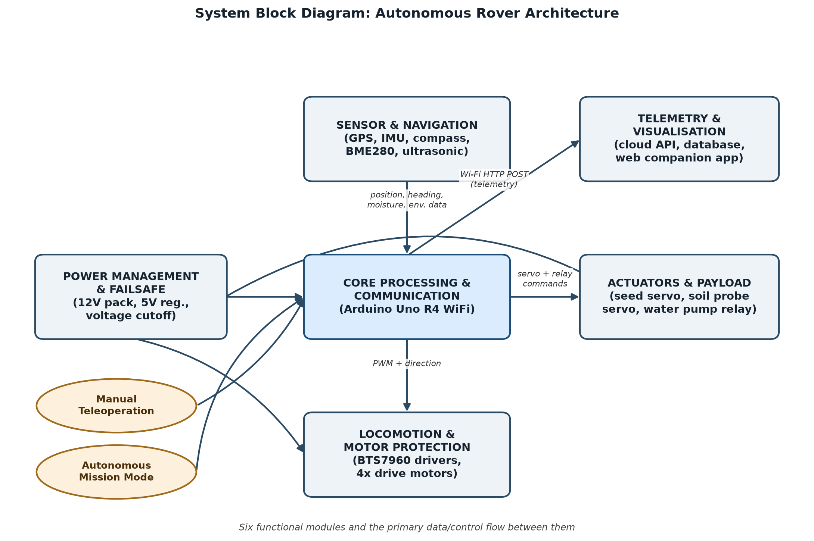
Figure 3. 1 System block diagram of the rover architecture
The design went through several rounds of revision before settling on the architecture described in this chapter. Earlier iterations explored a flight-controller-based approach using a Matek F405 board running iNav firmware, with a separate microcontroller handling actuator control and a companion mobile application communicating over the MultiWii Serial Protocol. That approach was abandoned after the project's chosen motor drivers proved incompatible with the PWM signal conventions expected by the alternative ArduRover firmware that was tried first, and after it became clear that a single general-purpose microcontroller could handle the full control loop, sensor fusion, and actuator logic directly, without the added complexity of a flight-controller stack designed primarily for aerial vehicles. The final architecture consolidates control on one Arduino-class microcontroller, which simplifies wiring, debugging, and the bill of materials considerably.

3.3 Mechanical Design
The rover uses a four-wheel-drive, skid-steer chassis designed as a set of parametric OpenSCAD models so that dimensions could be adjusted quickly as component choices changed during the build. The chassis is built from modular corner units, side rails, and a deck plate, all 3D printed locally, with a cutout in the deck plate for the seed dispensing mechanism. Each of the four drive motors sits in a custom two-piece motor cradle, printed in ABS for its higher heat tolerance next to the motor windings, with gusset fillets for rigidity and ventilation slots to help the motors shed heat during extended runs. An earlier version of the motor cradle was analysed with mesh-processing tools and reduced in volume by roughly 36 to 40 percent through triangular gusset reinforcement, cutting print time and material cost without sacrificing structural strength.
[Placeholder: Photograph or rendered CAD view of the assembled rover chassis, showing the four-wheel-drive layout, motor cradles, and deck plate with the seed dispenser cutout.]
Figure 3. 1 Rover chassis, motor mounts, and deck plate layout
Two mechanical subsystems sit on top of the chassis in addition to the drivetrain. The first is the seed dispensing mechanism, a servo-actuated metering gate mounted over the deck plate cutout that releases a measured number of seeds through a drop tube as the rover pauses at each planting point, in line with the target of three seeds per hole set out in the study's objectives. This mechanism controls seed count and release timing, which sets the spacing between holes as the rover advances; it does not control the depth at which seeds settle once they leave the drop tube. Adding depth control was outside what the project's timeline allowed and is identified as future work in Chapter Five. The second is a soil moisture probe arm, a small linkage driven by its own servo that plunges a capacitive soil moisture sensor into the ground at each stop and retracts it before the rover moves on, so that a moisture reading is available at every planting location without dragging a fixed probe through the soil continuously.

3.4 Electronic Hardware Design
This section describes the electronic hardware module by module. Each subsection covers the components chosen for that module, how they connect to the central microcontroller, and the reasoning behind the choice where it is not already obvious from the cost and availability constraints discussed in Section 3.2.

3.4.1 Core Processing and Communication
The rover is controlled by a single Arduino Uno R4 (available in both Minima and WiFi variants), chosen primarily because it operates natively at 5V logic. This allows it to interface directly with the BTS7960 motor driver modules and the analogue sensors used elsewhere in the design without the level shifting circuitry that a 3.3V-logic board such as an ESP32 would require. Where the WiFi variant is used, the board's built-in wireless networking also removes the need for a second microcontroller dedicated purely to connectivity, which was a feature of an earlier iteration of the design. Consolidating processing and communication onto one board reduces the bill of materials, removes a serial link that would otherwise be a possible point of failure, and keeps the firmware simpler to reason about.

3.4.2 Power Management and Failsafe
Power is supplied by a 12V battery pack (LiPo or sealed lead-acid, depending on availability), feeding the motor drivers directly and a regulated 5V rail for the microcontroller and logic-level sensors. Battery voltage is monitored through a 5:1 resistive voltage divider feeding an analogue input, and the firmware halts all motor and pump activity automatically if the reading falls below 10.5V, protecting the battery from deep discharge. A bulk capacitor of 100 to 220 microfarads sits across VIN and ground to absorb transient current draw from the motors, and additional decoupling (0.1 microfarad ceramic plus 10 to 47 microfarad electrolytic) is placed on the 5V rail close to the sensor ICs. All grounds are tied back to a single point at the battery terminal in a star configuration rather than daisy-chained, which reduces ground-loop noise on the analogue and I2C lines.
Failsafe behaviour is treated as a design principle rather than an afterthought. The motor driver enable pins are gated in software from dedicated Arduino output pins, each with a pull-down resistor, rather than being tied directly to the 5V rail. Hardwiring the enable pins high was tried in an earlier iteration and allowed the PWM control lines to float during the microcontroller's boot sequence, which could briefly drive a motor before the firmware had taken control. Gating the enable pins in software and holding them low by default with the pull-down resistors removed that failure mode. The same philosophy extends to the communication layer: any loss of the wireless link or a crash in the companion application is designed to cascade into the motors stopping, rather than the rover continuing to move with no supervision.

3.4.3 Locomotion and Motor Protection
The four drive motors are paired left and right and driven through two BTS7960 H-bridge modules, one per side, giving differential (skid-steer) control. The left motor pair is driven from PWM-capable pins 3 and 5, and the right pair from pins 6 and 9, with the enable pins for each module on pins 4 and 8 as described above. Series resistors of 330 ohms to 1 kilohm are placed on the PWM and enable control lines to limit inrush current into the driver's logic inputs, and bulk capacitors of 220 microfarads or larger are placed across the B+ and B- motor supply terminals of each driver to absorb back-EMF generated when the motors change speed or direction. Direction reversal is handled in firmware with a 100-millisecond coast period, during which both motor leads are driven low before the new direction is applied, which avoids the abrupt current spike and mechanical shock of an instantaneous reversal.

3.4.4 Sensor and Navigation Subsystem
Positioning and heading are derived from a combination of a u-blox NEO-M8N GPS module, connected over a dedicated hardware UART, and an inertial and magnetic sensor pair, an MPU6050 six-axis accelerometer-gyroscope and an HMC5883L magnetometer, both on the I2C bus. A BME280 sensor on the same bus provides ambient temperature, humidity, and pressure readings for the environmental logging described in Section 3.4.6. The I2C bus clock was reduced to 10kHz after early testing showed signal integrity problems over the roughly 64cm cable run to the sensor mast at the standard 100kHz clock rate. An earlier version of this subsystem used a BME680 for environmental sensing, but that part requires a 3.3V supply; powering it from the 5V rail caused I2C bus failures across all three connected devices, and it was replaced with the BME280, which is commonly available on breakout boards that regulate a wider input voltage range.
Forward speed is estimated from the GPS module's Doppler-derived speed output, parsed using the TinyGPSPlus library, rather than by double-integrating accelerometer readings. Integrating a low-cost accelerometer twice to obtain distance accumulates drift very quickly, and this approach was tested and rejected during development for exactly that reason. Heading is derived from a complementary filter that fuses the MPU6050 gyroscope's short-term rotation rate with the HMC5883L compass's long-term absolute bearing, giving a heading estimate that responds quickly to turns without drifting the way a gyroscope-only estimate would. This heading estimate feeds a PID controller that adjusts the relative speed of the left and right motor pairs to hold the rover on a target bearing.
For path following, the rover uses a corridor-following strategy rather than chasing exact GPS coordinates. A standard GPS module of the type used here has an accuracy of roughly 1.5 to 3 metres, which is not precise enough to guarantee the rover crosses a specific waypoint, but is precise enough to confirm that the rover is within a defined latitude and longitude corridor representing a planting row. Combining this corridor check with dead-reckoning for forward distance travelled between planting points was identified, in view of the navigation literature reviewed in Chapter Two, as a more robust strategy for low-cost hardware than exact waypoint chasing, since it tolerates the GPS module's inherent position uncertainty rather than fighting it. Obstacle detection is planned using an ultrasonic distance sensor, with the trigger and echo lines wired to two analogue pins configured as digital input and output, since no dedicated digital pins remained free at the time of writing.

3.4.5 Actuators and Payload
The seed dispensing servo is driven from pin 10, and the soil probe servo from pin 12. The water pump is switched through a 5V relay on pin 7, which the firmware energises whenever the soil moisture reading on analogue pin A0 falls below a calibrated threshold, currently set at an ADC value of 400, indicating soil dry enough to warrant watering at that point. A buzzer on pin 11 and an addressable WS2812B RGB LED strip on pin 13 are planned additions for local status indication, for example distinguishing autonomous operation, manual teleoperation, and fault states without the operator needing to check the companion application. The LED strip requires more current than the Arduino's 5V rail can safely supply, so it is powered separately through a 12V-to-5V buck converter fed from the main battery.

3.4.6 Telemetry and Companion Application
Telemetry follows a cloud-first design rather than logging to an onboard SD card or streaming over a wired serial connection to a laptop. An SD card module was considered but ruled out because of pin contention with the sensors and actuators already occupying most of the Arduino's available pins. Instead, the rover posts location, orientation, environmental, and actuator-state data over WiFi to a cloud-hosted API and database at regular intervals during a run. A browser-based companion application then pulls this data from the API and renders it using Plotly.js, giving the operator a way to review a run's telemetry from any device with a browser, without needing the rover physically connected or a specific desktop application installed. A browser-based Mission Planner has since been added to the companion application. It lets an operator set the row count, drop spacing, and PID gains for a planting run and draws the resulting boustrophedon path before a mission is sent to the rover. A separate Mission Hub page pulls completed runs from the cloud database and renders each one as an interactive three-dimensional terrain model, reconstructed from the barometric elevation readings, alongside the Plotly charts described above. Figures 3.5 to 3.8 show these screens as implemented, using a sample run generated by the application's own demo feature to illustrate the interface rather than field data collected from the physical rover.

3.5 Circuit Design and Pin Assignment
Table 3.1 summarises the complete pin assignment for the Arduino Uno R4, covering every sensor, actuator, and protection component described in Section 3.4. Figure 3.3 shows the corresponding circuit schematic.
Pin | Function | Notes
3, 5 | Left motor pair PWM | To BTS7960 (left) via 330 ohm-1k series resistors
6, 9 | Right motor pair PWM | To BTS7960 (right) via 330 ohm-1k series resistors
4 | Left motor driver enable | Software-gated, 10k ohm pull-down
8 | Right motor driver enable | Software-gated, 10k ohm pull-down
Serial1 (UART) | GPS module (NEO-M8N) | Hardware serial, parsed with TinyGPSPlus
SDA/SCL (I2C) | IMU (MPU6050), compass (HMC5883L), BME280 | Bus clock reduced to 10kHz
A0 | Soil moisture sensor | Analogue input, pump threshold at ADC 400
A1 | Battery voltage sense | Via 5:1 resistive divider, 25V range
A2 | Ultrasonic sensor trigger | Analogue pin used as digital output
A3 | Ultrasonic sensor echo | Analogue pin used as digital input
7 | Water pump relay | 5V relay module, active on low moisture
10 | Seed dispenser servo | Metering gate actuation
12 | Soil probe servo | Plunges/retracts moisture probe
11 | Buzzer | Planned, status alerts
13 | WS2812B RGB strip data | Planned, externally powered via buck converter

Table 3. 1 Pin assignment for the Arduino Uno R4 controller
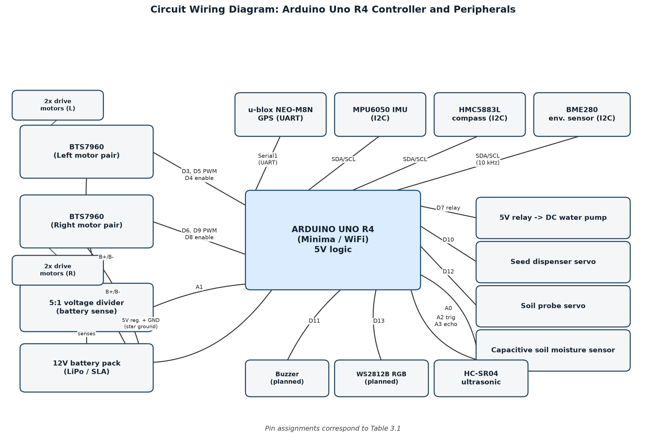
Figure 3. 1 Circuit schematic of the rover's electronics

3.6 Bill of Materials
Table 3.2 lists the major components used in the build. It excludes small consumables such as wire, solder, heat-shrink tubing, and fasteners, and the 3D-printing filament used for the chassis and mounts, which were sourced locally in Accra and are not itemised individually here.
Component | Specification | Qty | Function
Microcontroller | Arduino Uno R4 (Minima/WiFi) | 1 | Central processing and control
GPS module | u-blox NEO-M8N | 1 | Position and Doppler speed
IMU | MPU6050 | 1 | Gyroscope and accelerometer for heading
Compass | HMC5883L | 1 | Absolute heading reference
Environment sensor | BME280 | 1 | Temperature, humidity, pressure logging
Motor driver | BTS7960 H-bridge module | 2 | Left/right differential drive control
Drive motor | JGA25-370 DC gear motor | 4 | Wheel propulsion
Soil moisture sensor | Capacitive soil moisture probe | 1 | Watering trigger input
Servo motor | Standard hobby servo | 2 | Seed dispenser gate and soil probe arm
Relay module | 5V single-channel relay | 1 | Water pump switching
Water pump | Low-voltage DC diaphragm/submersible pump | 1 | Spot watering delivery
Ultrasonic sensor | HC-SR04 type | 1 | Planned obstacle detection
RGB LED strip | WS2812B addressable strip | 1 | Planned status indication
Buck converter | 12V-to-5V DC-DC converter | 1 | LED strip power
Battery | 12V LiPo or sealed lead-acid pack | 1 | Main power supply
Voltage sensor module | B25, 0-25V range | 1 | Battery voltage divider feeding analogue pin A1
Power switch | Illuminated rocker switch, panel-mount | 1 | Master on/off for the battery circuit
Chassis and mounts | 3D-printed PLA/ABS (custom OpenSCAD design) | 1 set | Structural frame and motor cradles

Table 3. 1 Bill of materials for the rover

3.7 Power Budget
Table 3.3 gives an estimated current draw for each major electrical load, based on typical values from component datasheets rather than direct measurement on the assembled rover. These figures are intended as a design-stage sizing check for the battery and wiring; Chapter Four discusses the plan for validating them against measured current draw once the fully assembled rover is available for bench testing.
Component | Typical Current Draw | Notes
Arduino Uno R4 (WiFi active) | ~50-80 mA | Higher during WiFi transmission bursts
GPS module | ~45 mA | Continuous during operation
IMU + compass + BME280 | ~5 mA combined | I2C sensors, low draw
Each BTS7960 driver (logic only) | ~15 mA | Excludes motor current, which is separate
Drive motors (4x, combined, cruising) | ~1.0-2.0 A | Stall current substantially higher
Servo (each, active) | ~200-500 mA | Brief peaks during actuation
Water pump | ~300-700 mA | Depends on pump model selected
Relay module | ~70 mA | While energised
WS2812B strip (planned, per meter) | ~1.0 A max | Powered separately via buck converter

Table 3. 1 Estimated power budget (datasheet-typical values, to be validated by measurement)
Table 3.4 gives a photographic reference for the electronics components listed in Table 3.2, taken from the parts as purchased for the build. Two components, an illuminated rocker switch used as the master power switch and a B25 voltage sensor module used for the battery-sensing divider described in Section 3.4.2, are included here even though they were not itemised separately in Table 3.2; both are added to that table below for completeness.
Photograph | Component | Notes
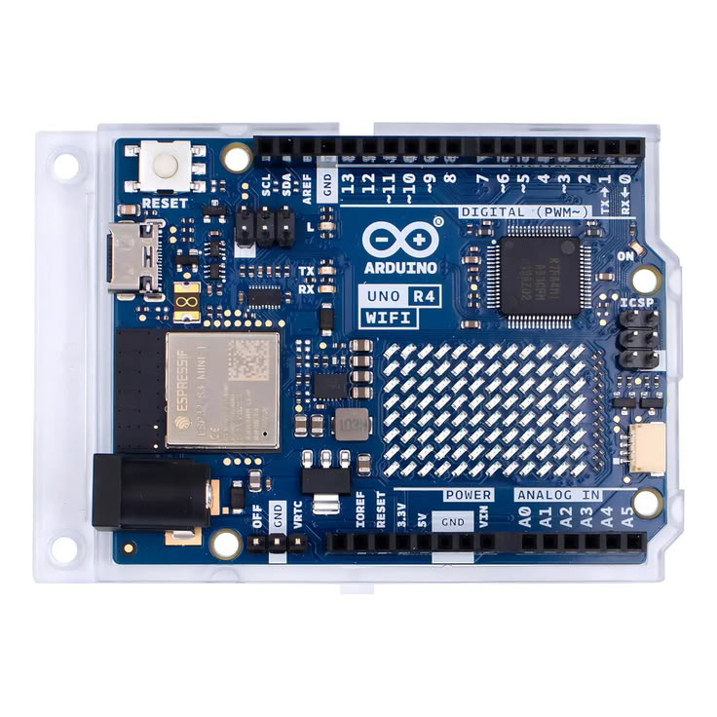 | Arduino Uno R4 (Minima/WiFi) | Central microcontroller. Runs the navigation, dispensing, and watering control loop and posts telemetry over Wi-Fi.
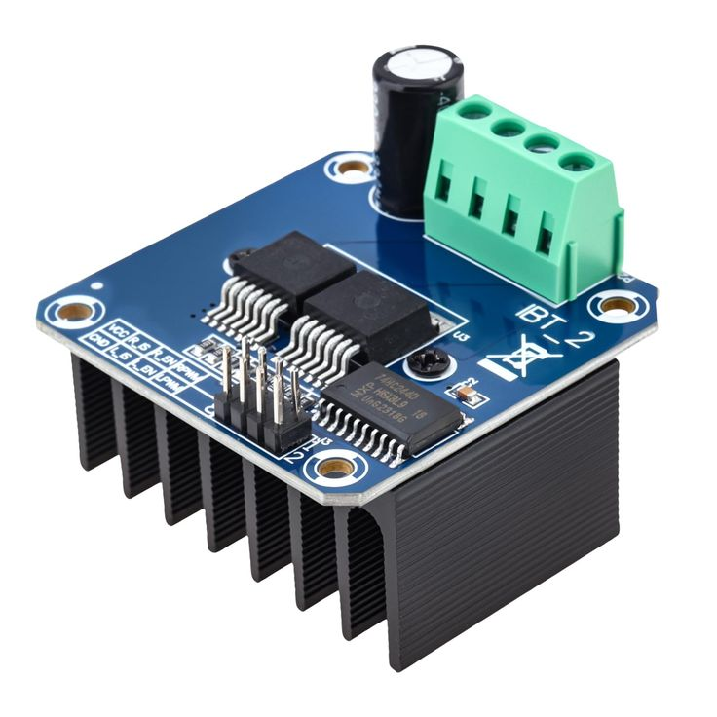 | BTS7960 H-bridge motor driver | One per side (left and right). Converts the PWM and direction signals from the Arduino into motor drive current.
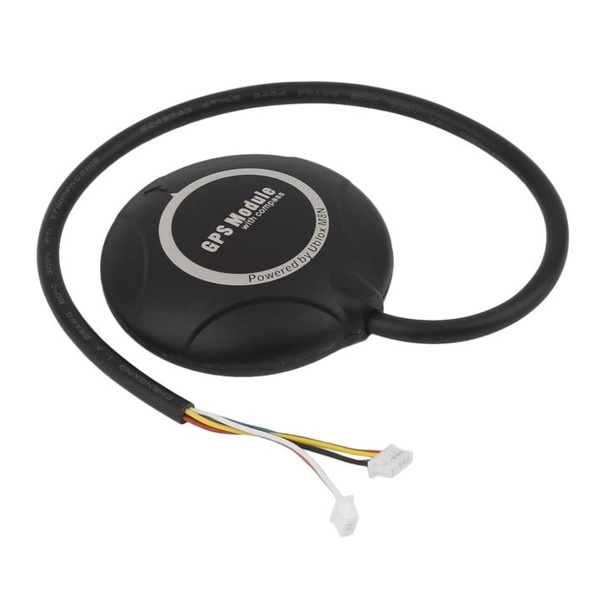 | u-blox NEO-M8N GPS module (onboard compass) | Provides position and Doppler speed over UART. The onboard compass supplies the absolute heading reference on the I2C bus, so no separate HMC5883L breakout was fitted.
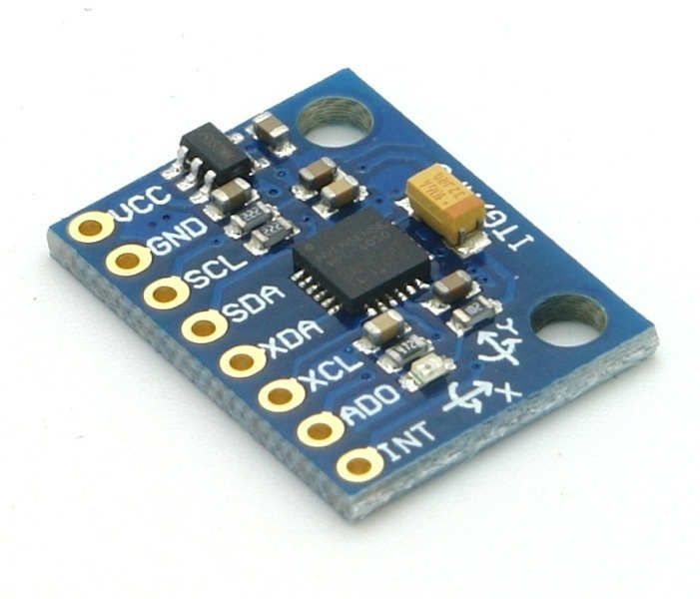 | MPU6050 IMU | Six-axis accelerometer and gyroscope. Its short-term rotation rate feeds the complementary heading filter and the pitch/roll estimate.
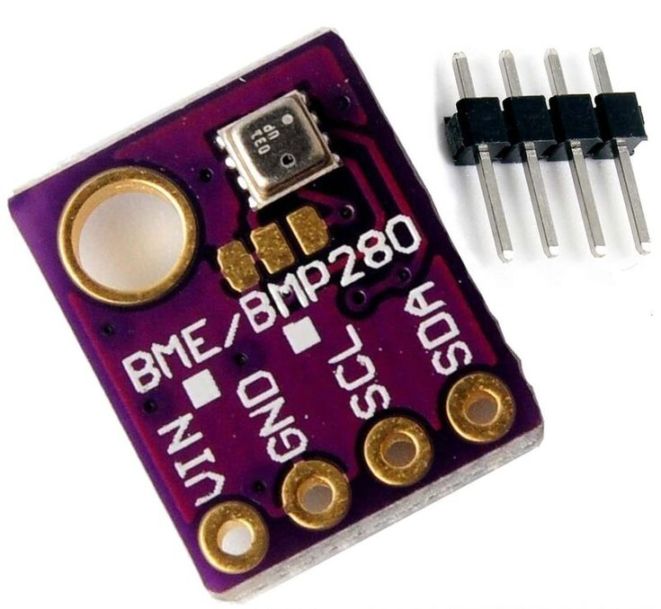 | BME280 environmental sensor | Temperature, humidity, and pressure. The barometric reading is tared at boot and used for relative elevation logging.
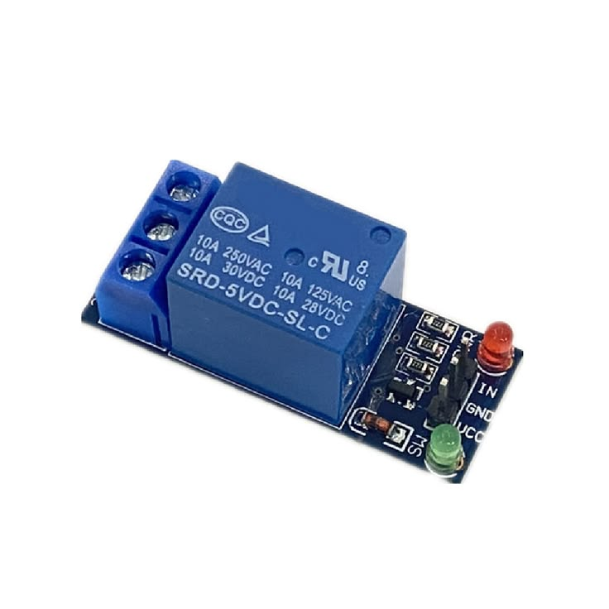 | 5V single-channel relay module | Switches the water pump on and off under firmware control whenever a planting point is found to be dry.
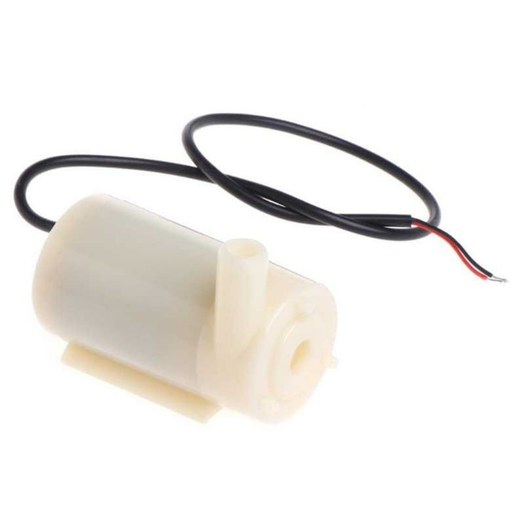 | Low-voltage DC submersible/diaphragm pump | Delivers the metered water dose to a planting point once the relay energises.
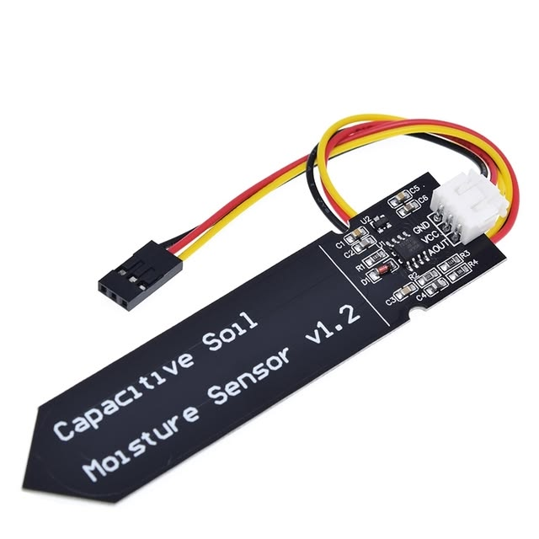 | Capacitive soil moisture sensor | Read on analogue pin A0. Its reading decides whether the pump fires at a given planting point.
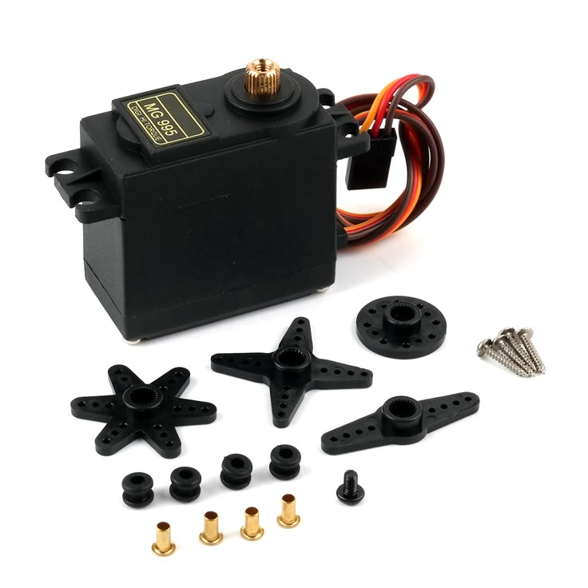 | Standard hobby servo (MG995 or equivalent) | Used twice on the rover, actuating the seed dispenser gate and driving the soil probe arm.
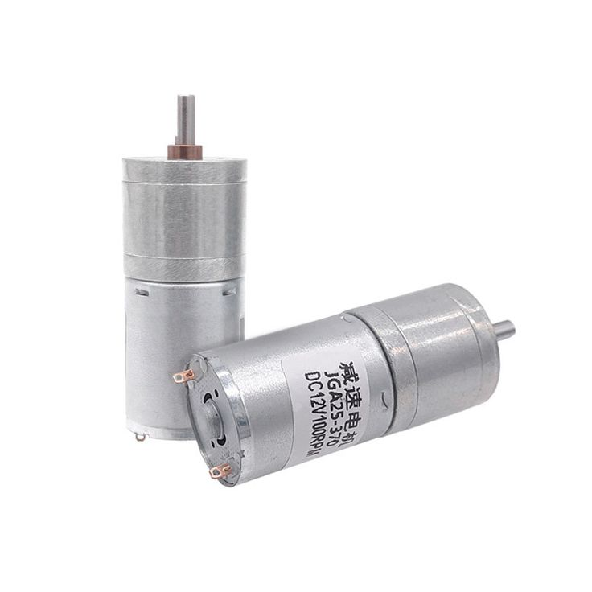 | JGA25-370 DC gear motor | Four fitted, paired left and right, and driven through the BTS7960 modules for skid-steer locomotion.
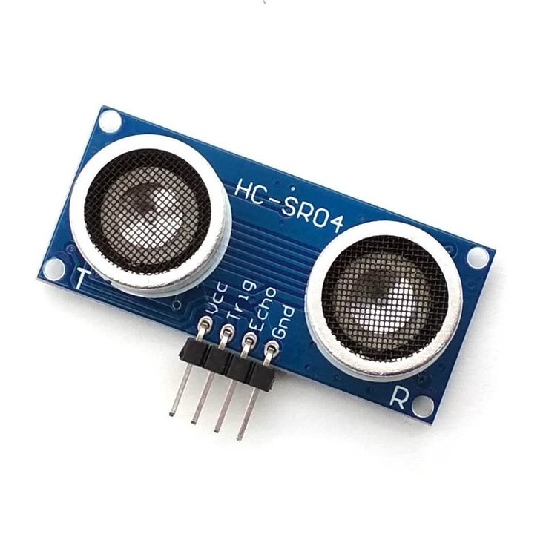 | HC-SR04 ultrasonic sensor | Planned forward obstacle detection. Trigger and echo lines run on two analogue pins used as digital I/O.
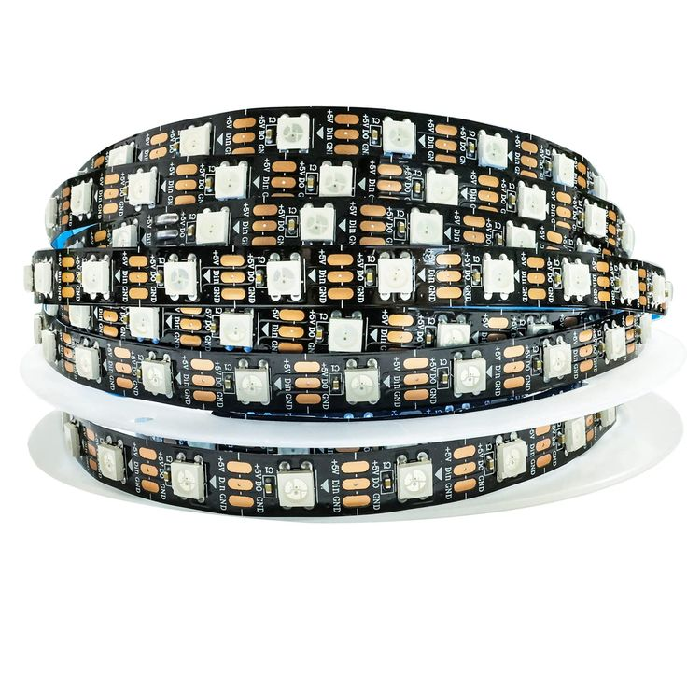 | WS2812B addressable RGB LED strip | Planned status indicator, powered separately through a buck converter rather than from the Arduino's 5V rail.
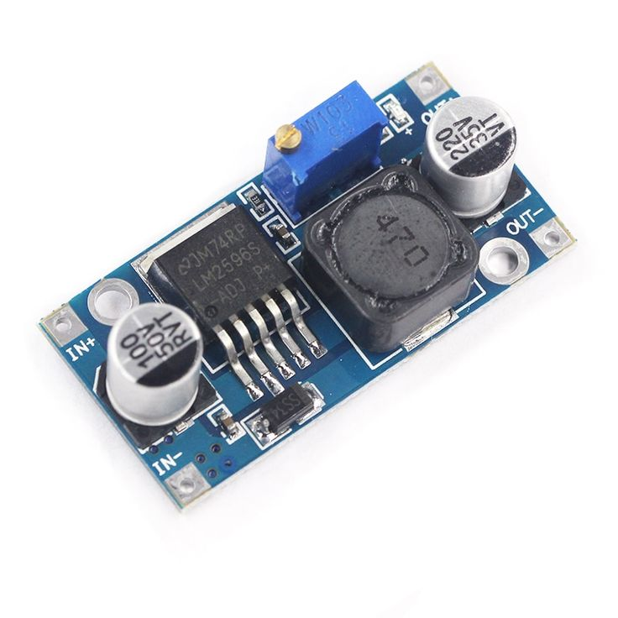 | LM2596 buck converter | Steps the 12V battery rail down to power the WS2812B strip independently of the Arduino's 5V regulator.
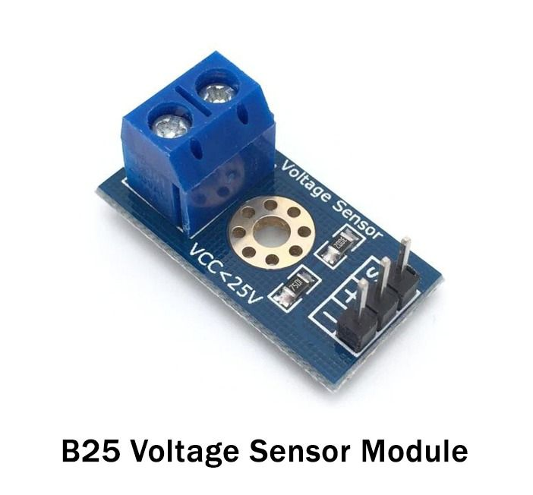 | B25 voltage sensor module (0-25V) | Provides the resistive divider used for battery voltage sensing on analogue pin A1.
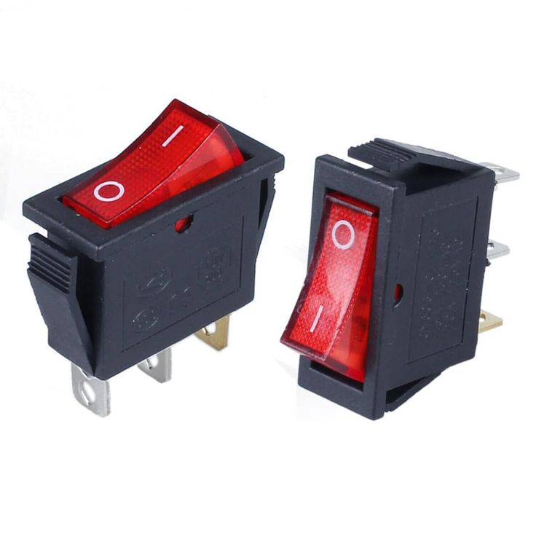 | Illuminated rocker switch | Panel-mounted master power switch for the battery circuit, added during assembly.
Table 3. 1Photographic reference of key electronics components

3.8 Software Architecture
Figure 3.4 gives an overview of the software architecture described in this section, showing how the ROS 2 development and simulation tier, the standalone Arduino firmware, and the cloud and companion application tier connect to one another. The sections that follow describe each tier in turn.
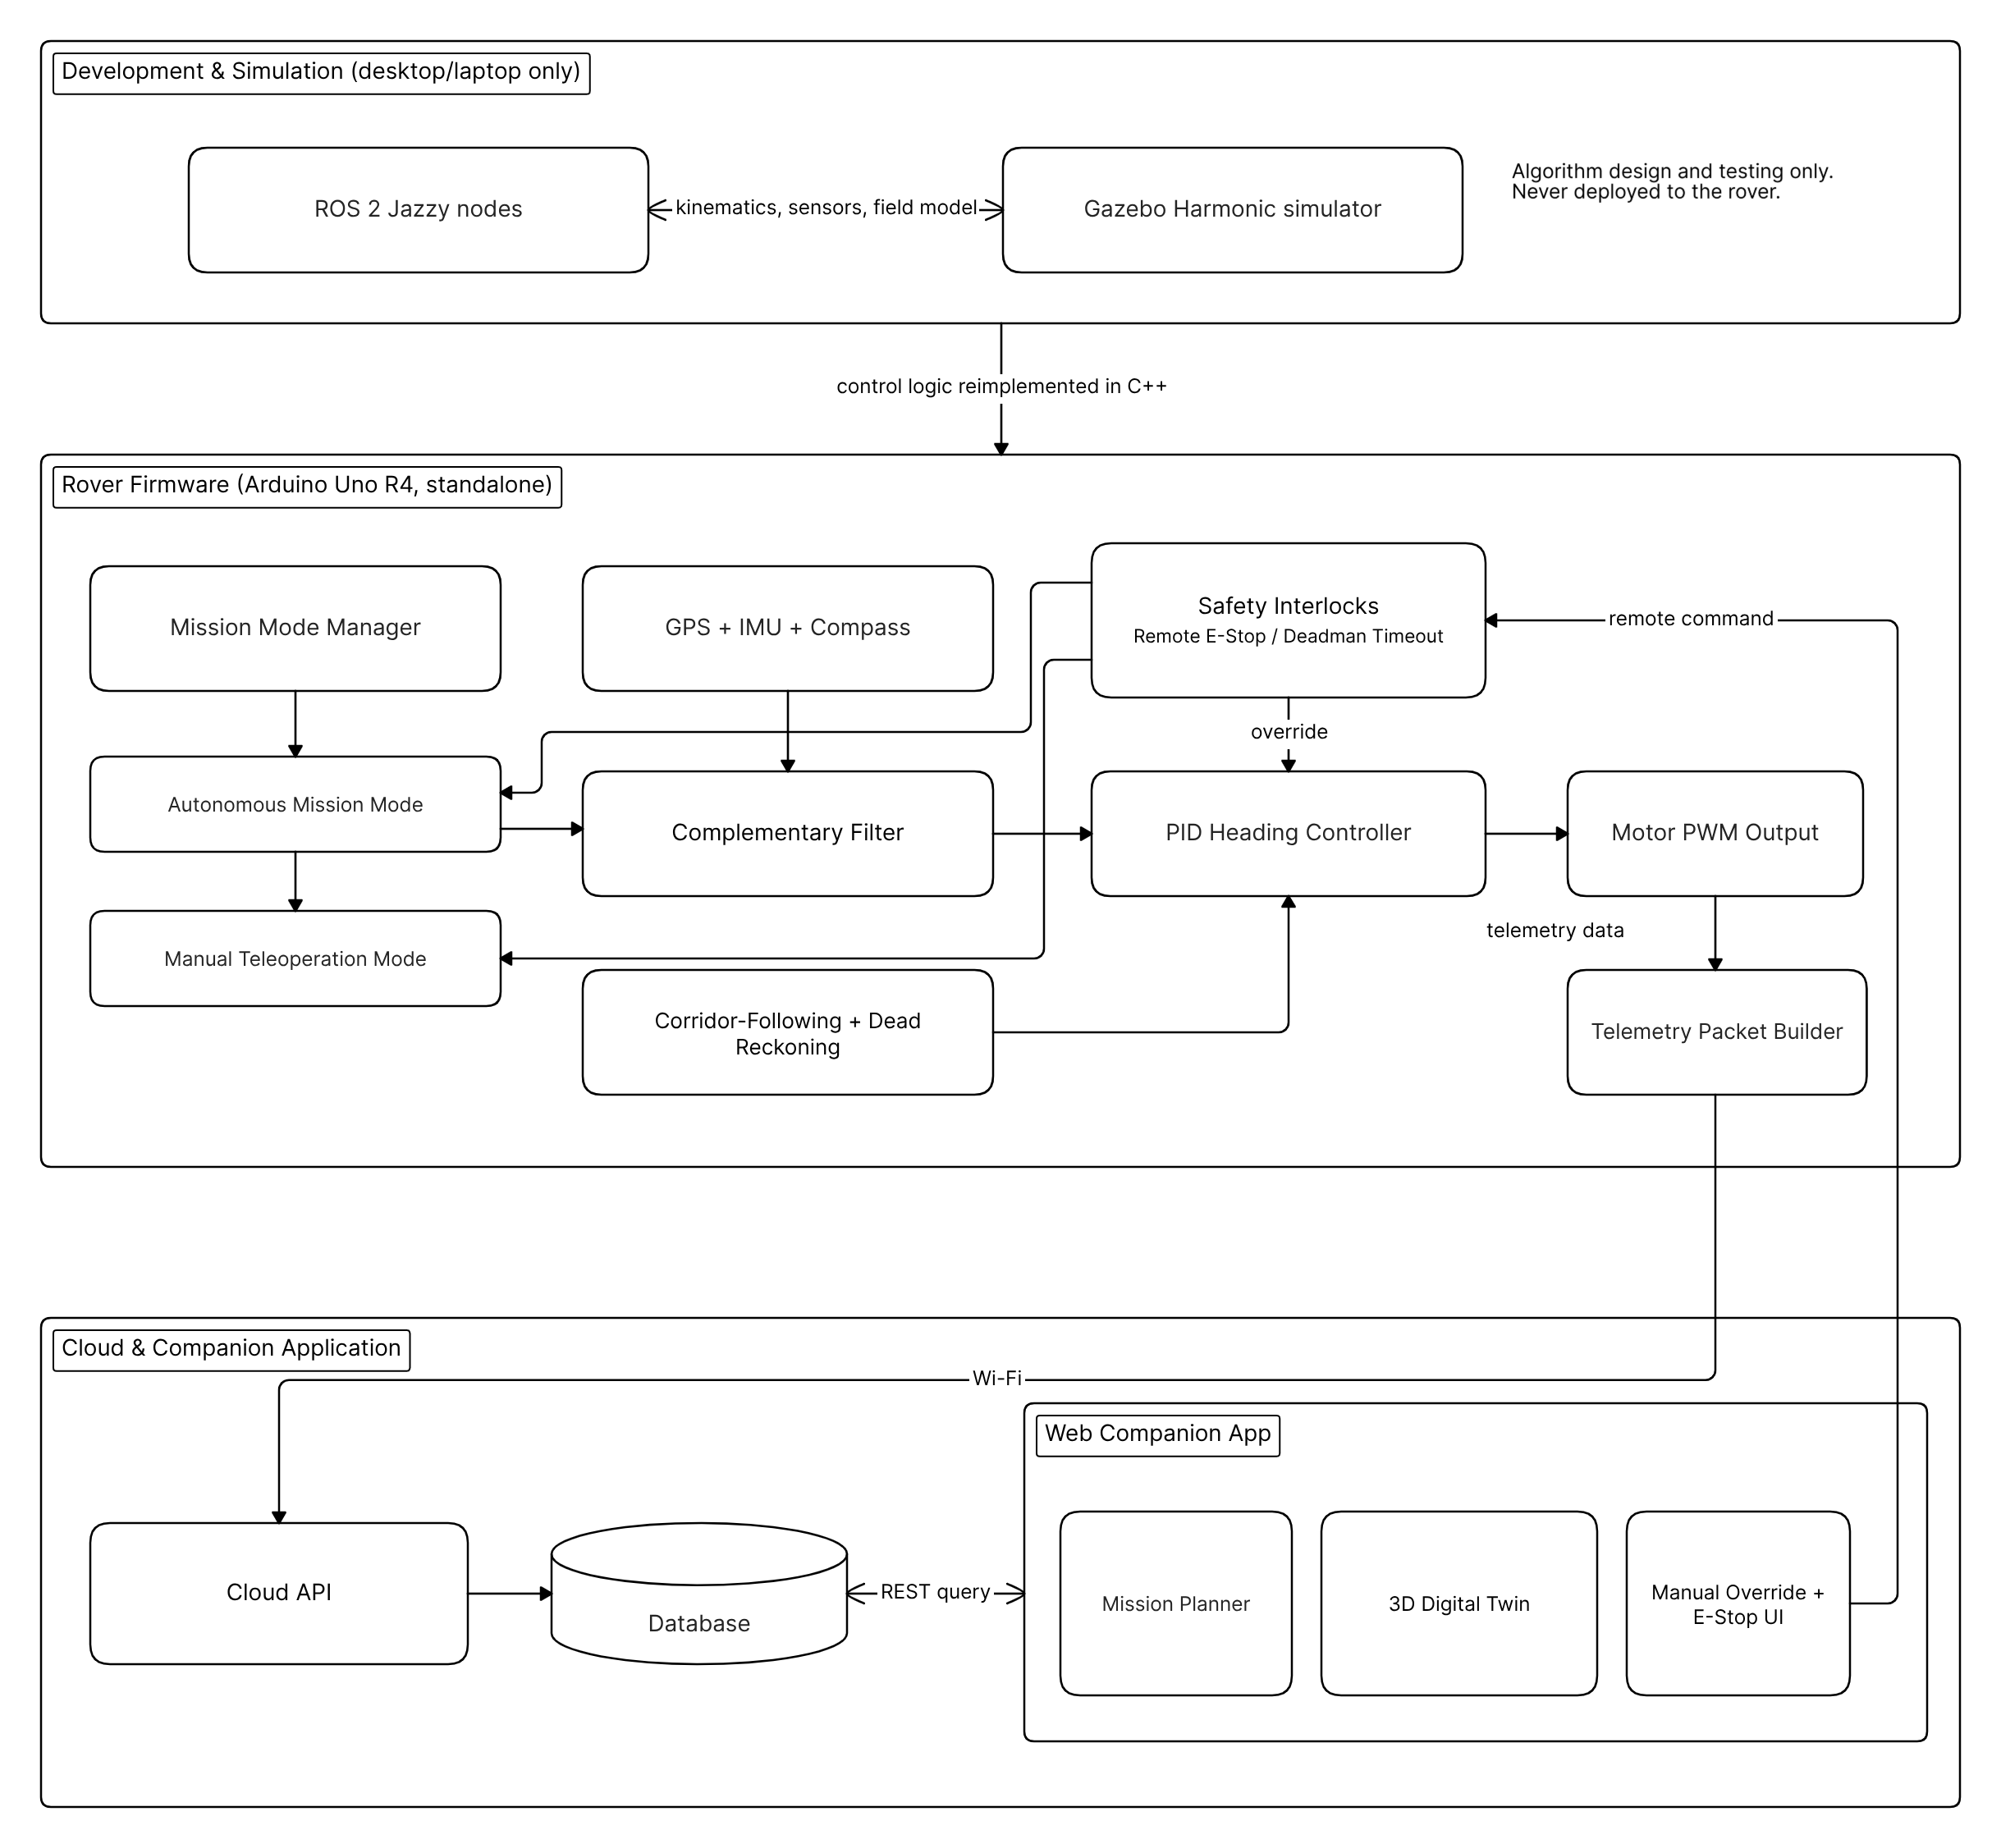
Figure 3. 1 Dual-mode software architecture, from ROS 2 simulation through to embedded firmware and the cloud-connected companion application

3.8.1 Dual-Mode Development Approach
As identified in Chapter Two, ROS 2 offers strong simulation and development tooling but is not well suited to running directly on a low-cost rover operating in the field, where a software crash or a lost connection to a supervising computer should not be able to strand the machine. This project resolves that tension with a dual-mode approach. Navigation and control algorithms are first designed and tested as ROS 2 nodes, using ROS 2 Jazzy with the Gazebo Harmonic simulator to model the rover's kinematics, sensors, and the field environment before any hardware is involved. Once an algorithm behaves correctly in simulation, its logic is reimplemented in C++ as embedded firmware for the Arduino Uno R4. ROS 2 is therefore a development and simulation tool only; it is never deployed on the rover itself, and the rover does not require a laptop, a stable WiFi connection to a supervising computer, or ROS 2 running anywhere to complete an autonomous mission in the field.

3.8.2 Navigation and Control Algorithm
The control loop reads the GPS, IMU, and compass at a fixed interval, updates the complementary-filter heading estimate, and feeds the difference between the current and target heading into a PID controller that adjusts the left and right motor PWM duty cycles to steer the rover back onto its target bearing. Forward progress along a row is tracked by combining the GPS-derived speed with elapsed time, since position fixes alone are not precise enough to reliably confirm short-distance progress between adjacent planting points. When the rover's estimated position falls within the latitude and longitude corridor defined for the current row and the dead-reckoned distance indicates it has reached the next planting interval, the rover stops, actuates the soil probe and seed dispenser in sequence, checks the moisture reading, waters if required, and then resumes travel.

3.8.3 Mission Modes and Safety Interlocks
The rover supports two modes of operation. In autonomous mission mode, it executes the row-following and planting sequence described above without operator intervention. In manual teleoperation mode, an operator can drive the rover directly and trigger individual actuators, such as a single seed drop or a single watering pulse, without starting a full mission, which is useful for testing and calibration. Both modes share the same underlying safety interlocks: a remote emergency stop that immediately cuts motor power regardless of mode, and a deadman timeout that halts the rover automatically if it stops receiving supervisory input for longer than a set interval during teleoperation.

3.8.4 Telemetry Data Flow
During a run, the rover periodically packages its current location, orientation, environmental readings, and actuator states and sends them over WiFi as an HTTP POST request to a cloud-hosted API, which writes the data to a database. The companion web application queries this API and renders the run's data with Plotly.js, allowing the operator to review a completed or in-progress run's path, moisture readings, and actuator activity from a browser. This design keeps the rover's own firmware simple, since it only needs to send data outward and does not need to store or manage a full run history locally.

3.8.5 Mathematical Formulation of Key Algorithms
Three of the algorithms described above are implemented as explicit formulas in the firmware and are stated here for reference.
Boustrophedon grid position. Each planting point's local coordinates are computed as:
SynY = (Row − 1) × RowGap
SynX = (Drop − 1) × DropDist, for odd-numbered rows
SynX = (TotalDrops − Drop) × DropDist, for even-numbered rows
where Row and Drop are the current furrow and planting-point indices, and RowGap and DropDist are the row spacing and drop spacing set in the Mission Planner. Alternating the direction of SynX between odd and even rows produces the boustrophedon (serpentine) traversal pattern described in Section 3.4.4.
Relative terrain elevation. The rover tares its barometric altitude reading at boot:
Alt₀ = (1/12) × Σ Altᵢ, for i = 1 to 12
ΔElev = Altⱼ − Alt₀
where Alt₀ is the baseline altitude averaged from twelve BME280 readings taken during setup, and Altⱼ is the current reading at planting point j. Taring the sensor this way removes the day-to-day offset caused by changing atmospheric pressure, leaving ΔElev as a measure of terrain height relative to the rover's starting point rather than true altitude.
Battery voltage sensing. The battery voltage is recovered from the divider's analogue reading as:
V = (V_ADC × 5.0 / 1023) × k
where V_ADC is the raw analogue-to-digital reading on the sense pin and k is the divider's scaling factor. The firmware currently uses k = 2, which matches a 1:1 divider rather than the 5:1 divider described in Section 3.4.2 and Table 3.1; this discrepancy should be resolved by re-checking the installed divider (or the B25 module's actual ratio, see Table 3.4) against the firmware constant before the voltage readings in Chapter Four are taken as reliable.
Heading control law. The steering correction is designed around the standard PID form, using the Kp, Ki, and Kd gains exposed in the Mission Planner (Section 3.4.4):
Correction = Kp·e(t) + Ki·Σe(t)Δt + Kd·[e(t) − e(t−Δt)]/Δt
where e(t) is the heading error (the difference between the target furrow bearing and the compass heading, normalised to the range −180 to 180 degrees). The correction is clamped to ±MaxCorrection and used to bias the left and right motor PWM duty cycles in opposite directions around BaseSpeed. At the time of writing, the committed firmware computes the heading error e(t) as telemetry but drives forward and turning motion at fixed BaseSpeed and TurnSpeed values rather than closing this loop automatically; applying the correction term above to produce continuous closed-loop steering, and fusing the MPU6050 gyroscope with the compass into a complementary-filter heading estimate as originally intended, remain open implementation work rather than a measured result.
Figures 3.5 to 3.8 show four screens from the companion web application referred to above, as implemented at the time of writing. The mission and telemetry data shown were produced by the application's own built-in demonstration generator, used here to illustrate the interface; they are not measurements from the physical rover, which are reported separately in Chapter Four.
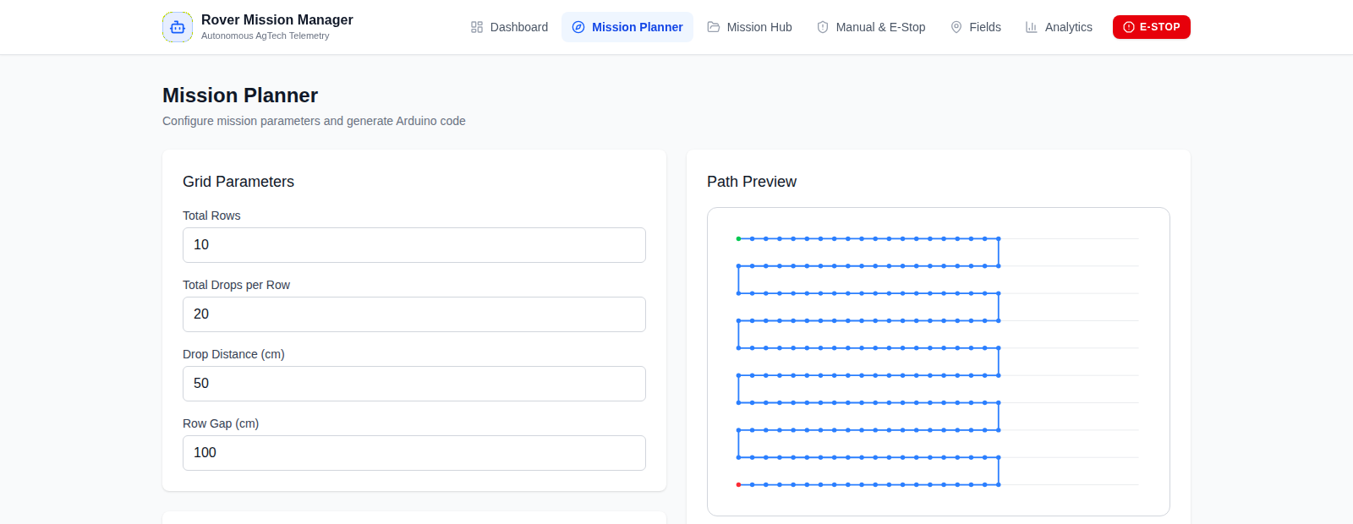
Figure 3. 1The Mission Planner screen, showing configurable grid parameters (row count, drop spacing, row gap) and PID gains on the left, with the generated boustrophedon path preview on the right
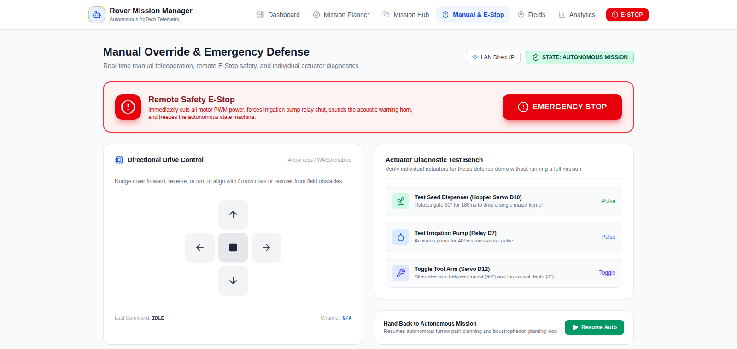
Figure 3. 1The manual override and emergency-stop screen, including the directional drive pad and the actuator diagnostic test bench used to pulse the seed dispenser, pump, and probe arm independently
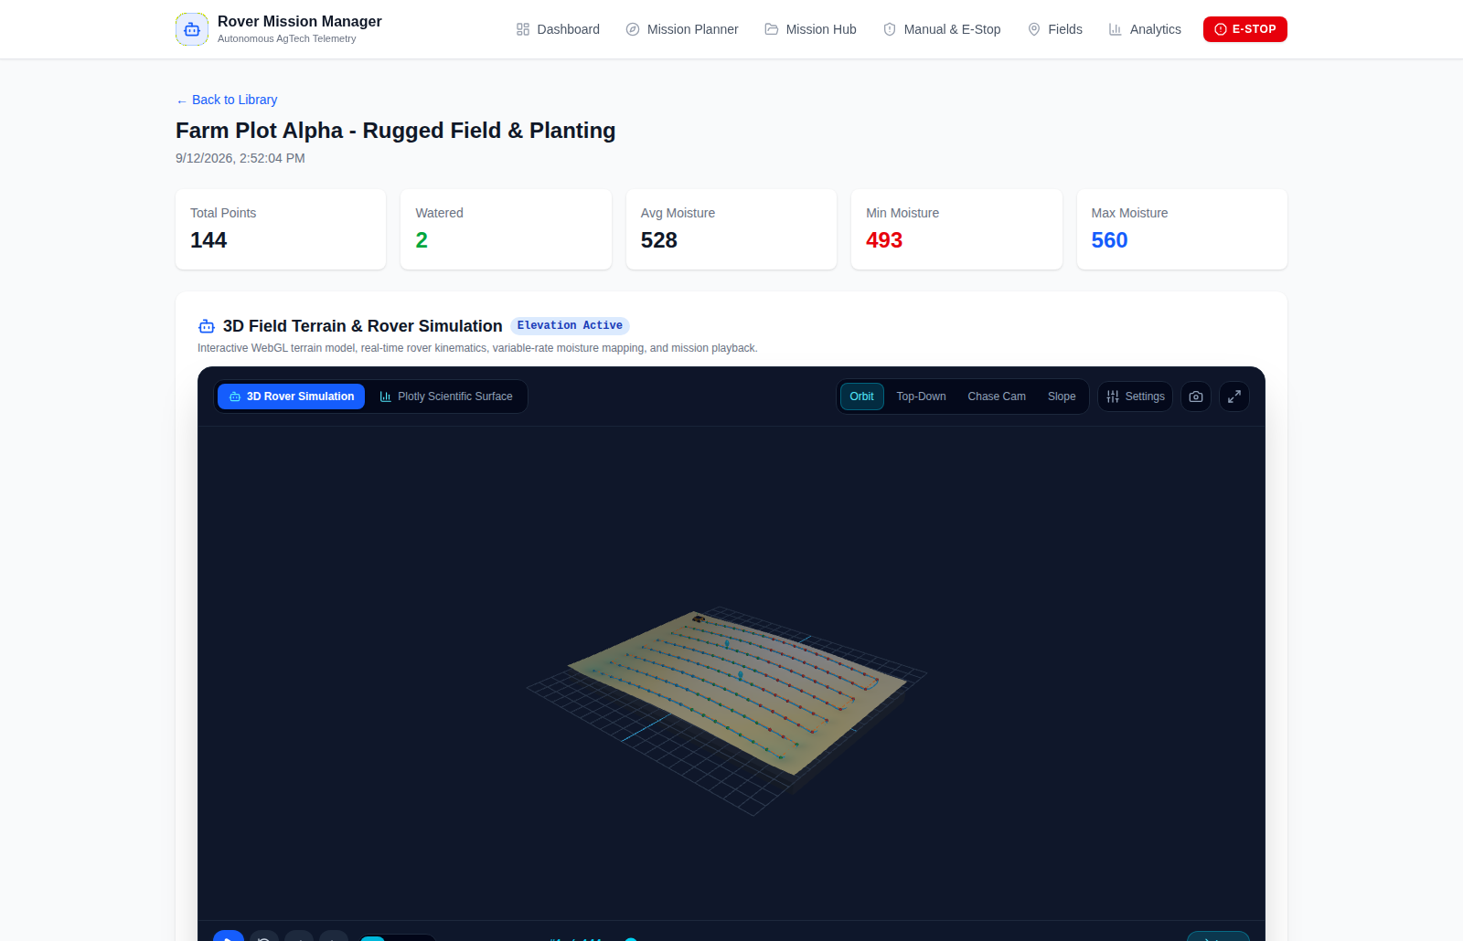
Figure 3. 1The three-dimensional digital twin, reconstructing field terrain from barometric elevation readings and replaying the rover's path over a sample run
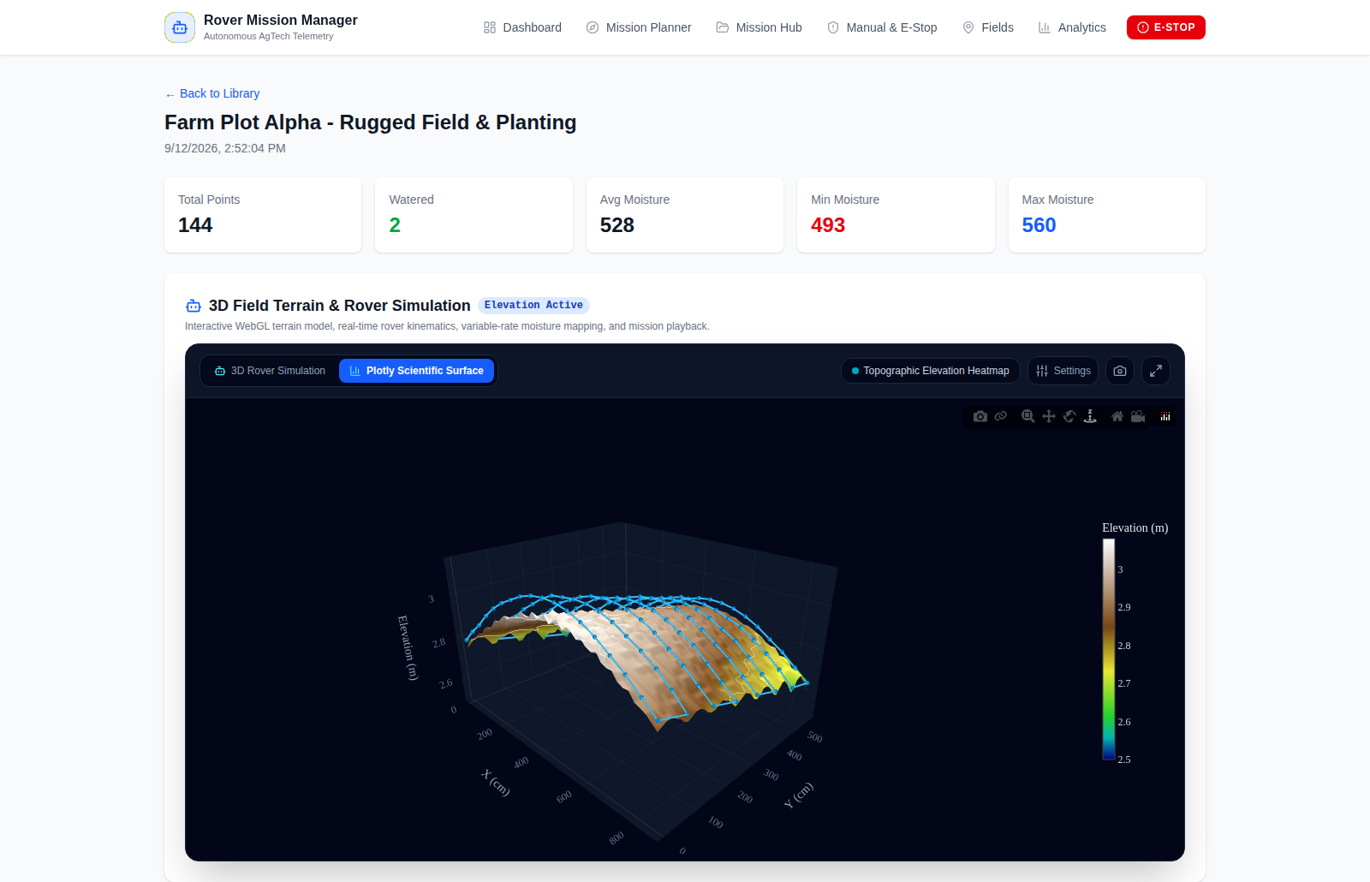
Figure 3. 1The same run rendered as a Plotly elevation surface, with the rover's track overlaid on the interpolated terrain
Figure 3.9 draws the same system together from a deployment perspective, showing the rover, the Dokploy cloud stack, and the web companion application as three connected tiers, and distinguishing the direct local-network teleoperation path from the cloud-relayed telemetry and mission data path described in Section 3.8.4.
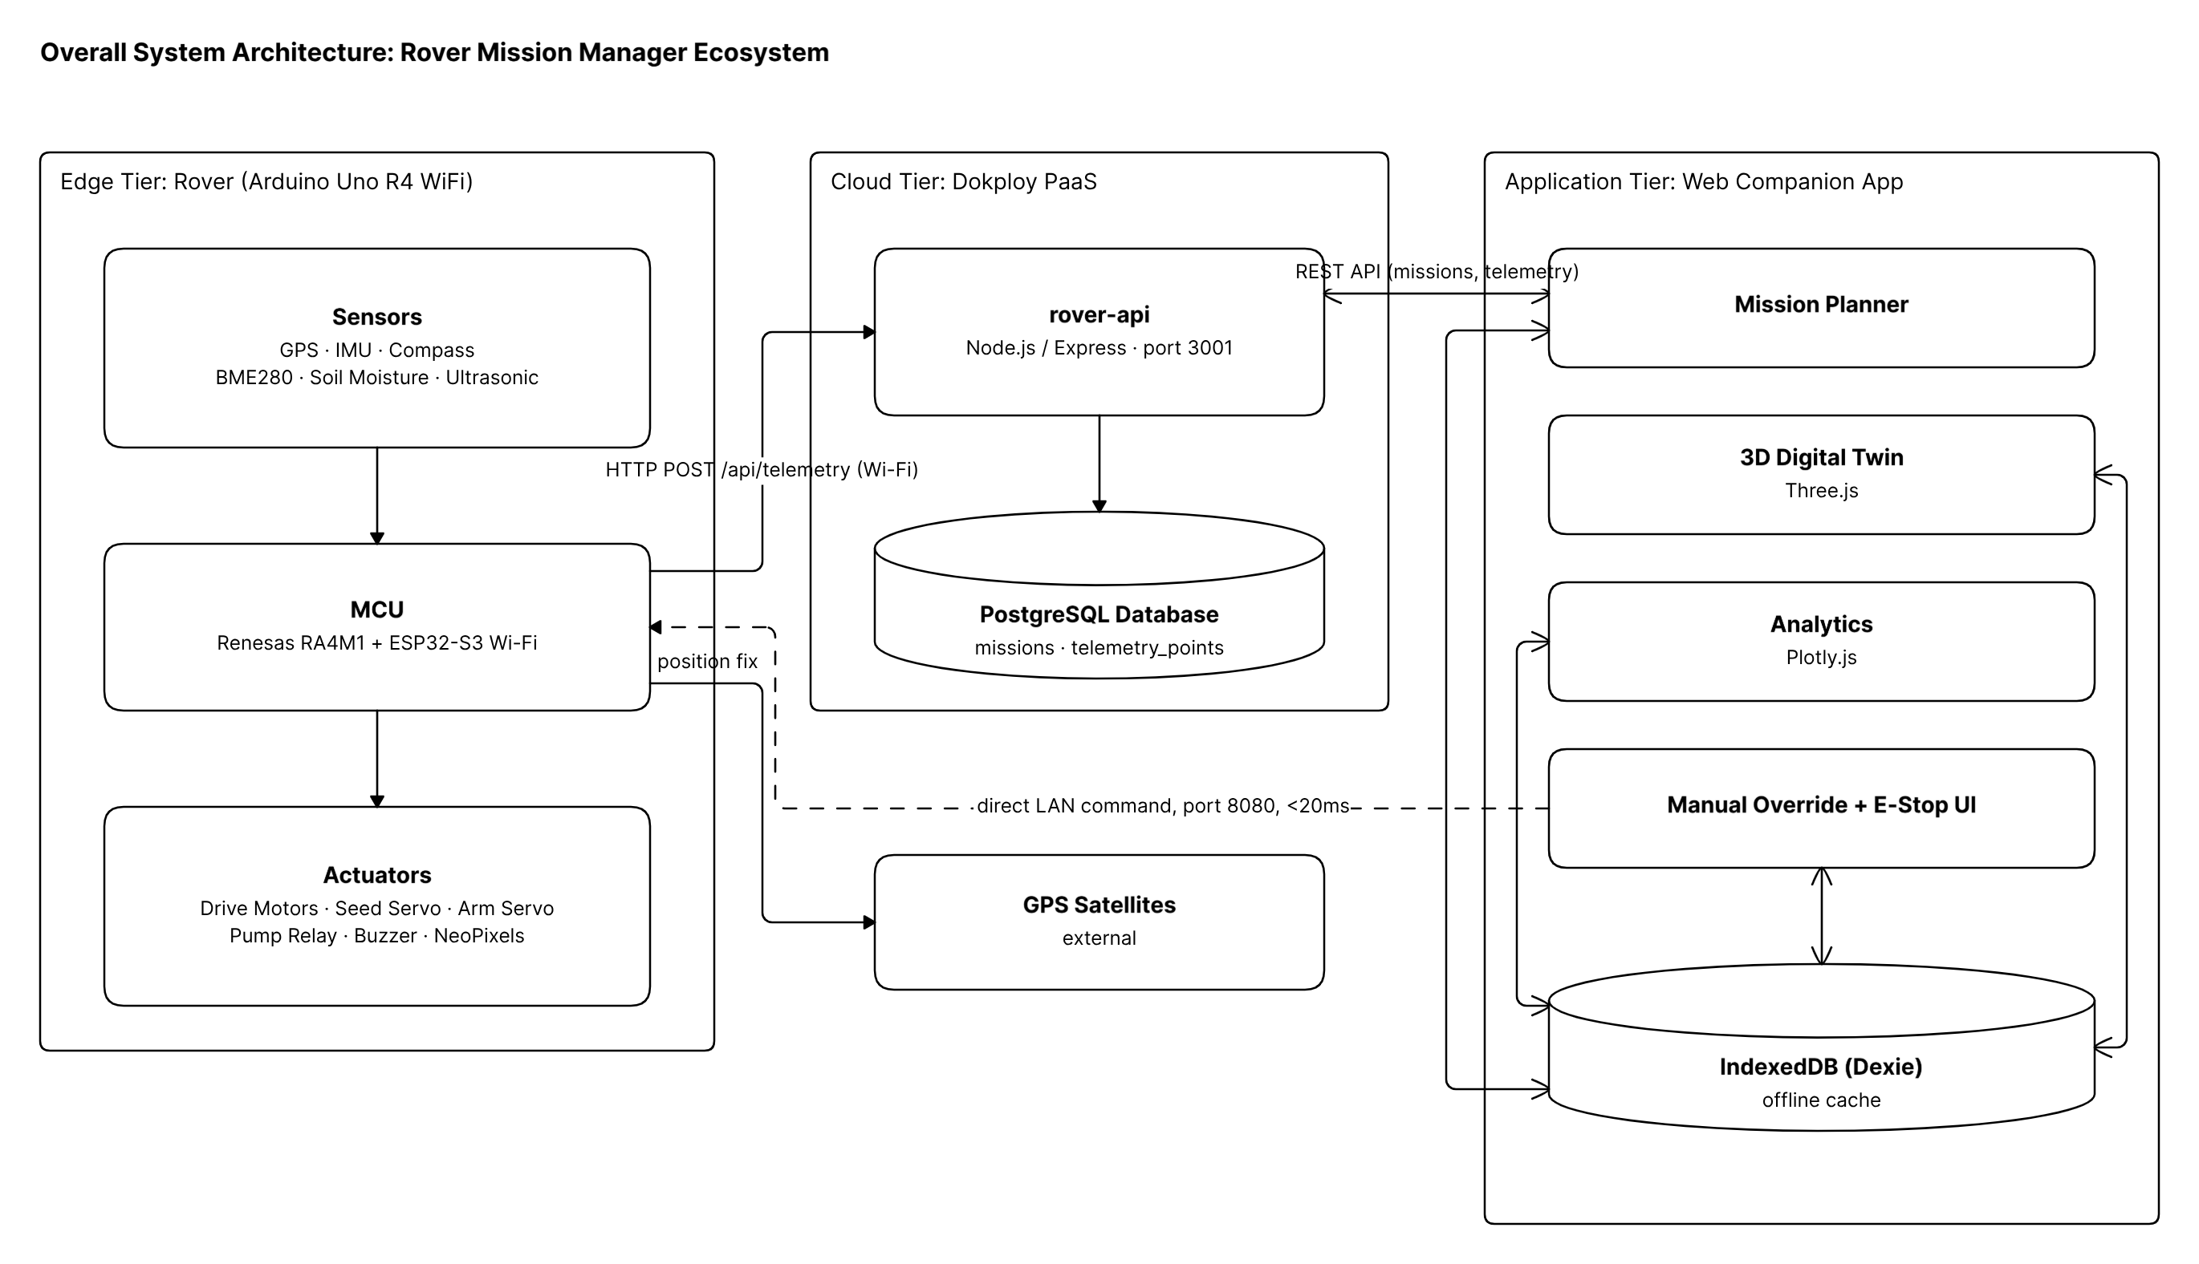
Figure 3. 1 Overall system architecture, showing the edge, cloud, and application tiers and how they connect
Figure 3.10 sets out the system's main use cases from the operator's side (configuring and launching a mission, driving manually, monitoring telemetry, and triggering an emergency stop) and from the rover's side (executing the planting cycle autonomously), along with where each one touches the rover hardware or the cloud database.
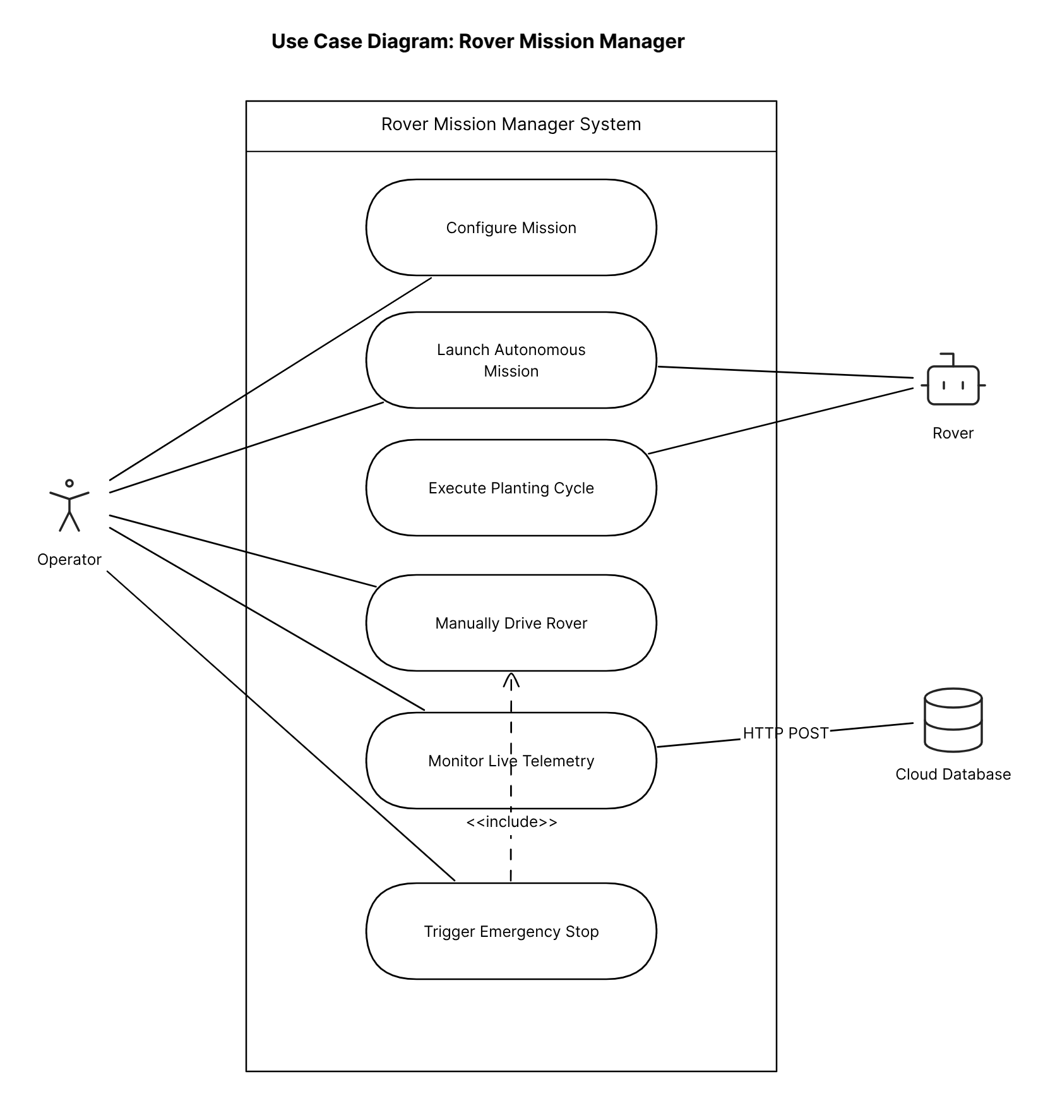
Figure 3. 1 Use case diagram for the Rover Mission Manager system, showing the operator- and rover-initiated use cases
Figure 3.11 shows the two tables that make up the cloud-hosted PostgreSQL database introduced in Section 3.8.4: a missions table holding one row per run, and a telemetry_points table holding one row per recorded planting point, linked by mission_id with cascading delete. The config_id and field_id columns on the missions table are plain text fields rather than enforced foreign keys, since mission configurations and field boundaries are managed client-side in the browser's IndexedDB cache.
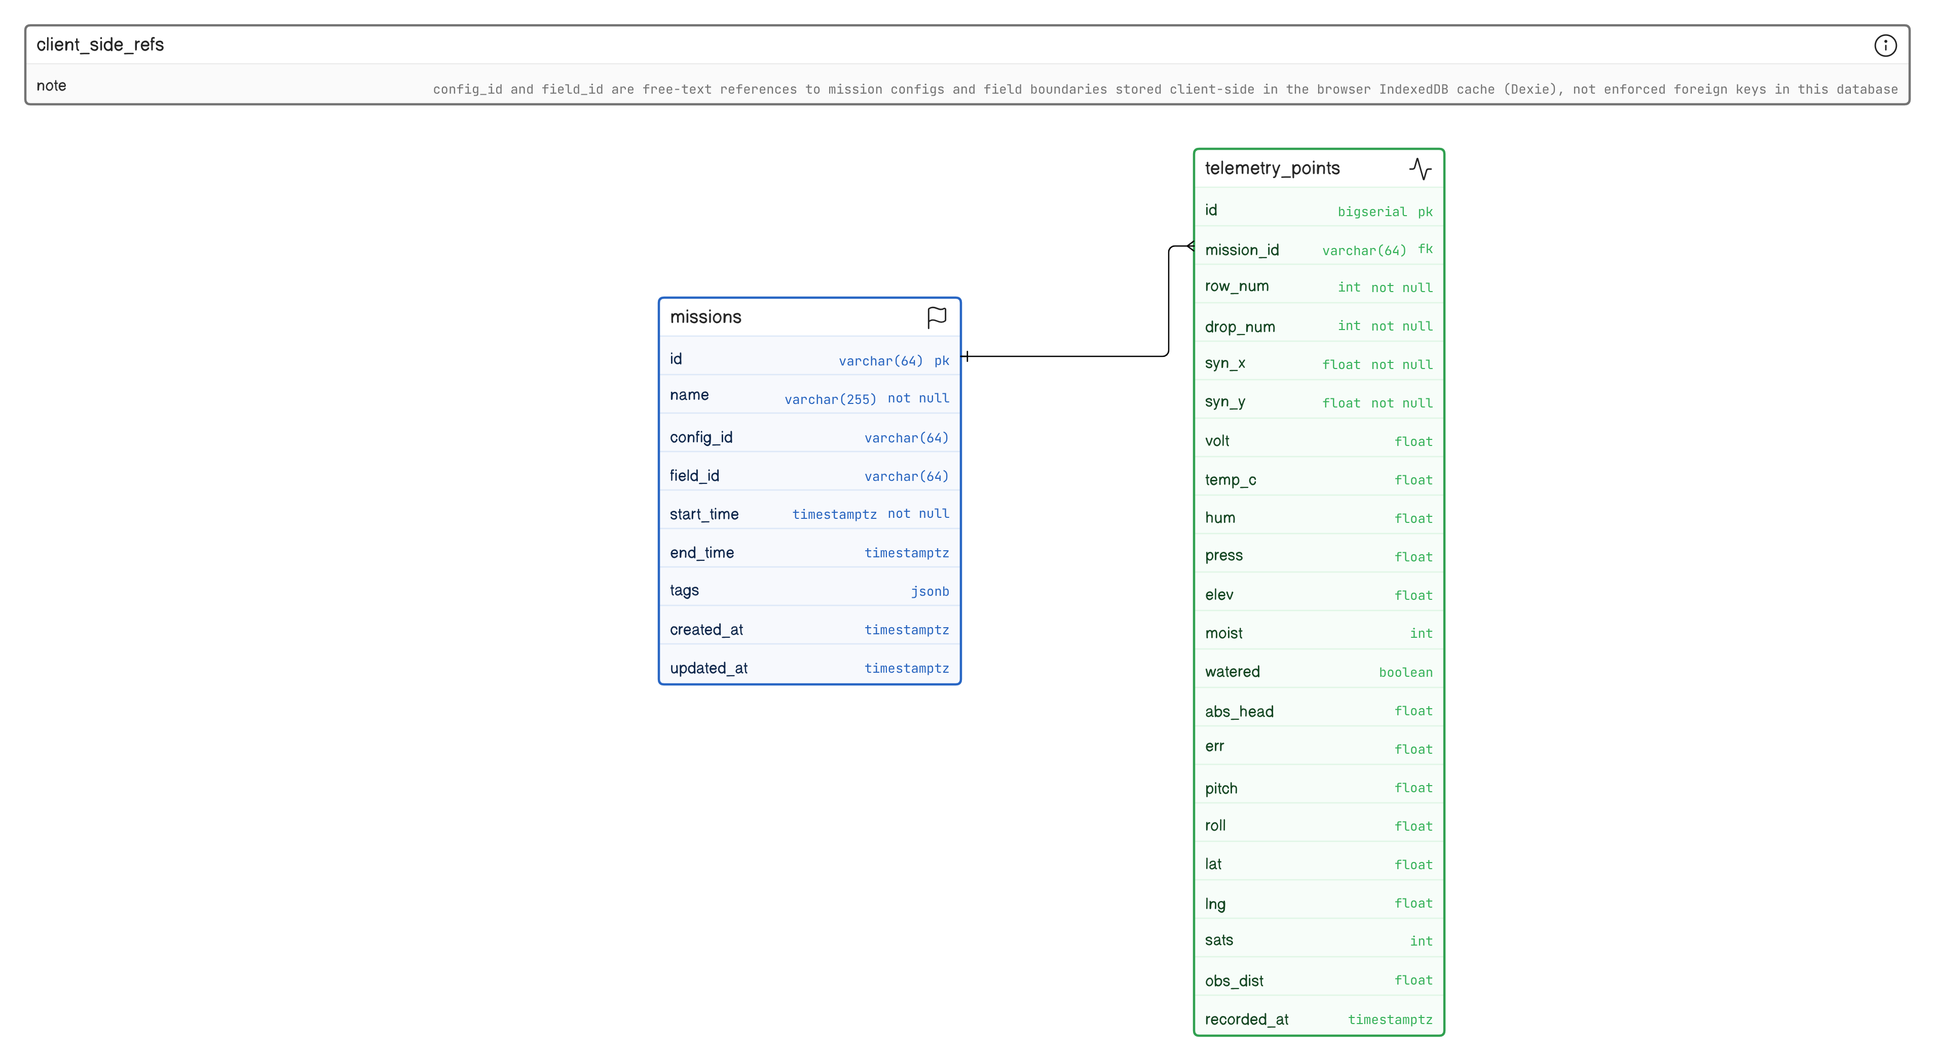
Figure 3. 1 Entity relationship diagram of the PostgreSQL telemetry database, showing the missions and telemetry_points tables
Figure 3.12 gives a second, hardware-grouped view of the same architecture shown in Figure 3.1, organising the electronics into power, locomotion, sensing, and actuator groups around the central Arduino Uno R4. It is complementary to the pin-level circuit schematic in Figure 3.3 rather than a replacement for it.
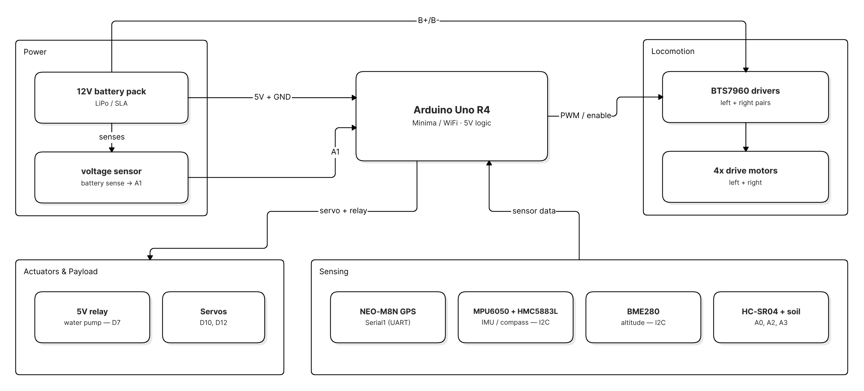
Figure 3. 1 Hardware architecture overview, grouped by power, locomotion, sensing, and actuator subsystems
Figure 3.13 traces the rover's operating logic at runtime, from power-on through the autonomous planting and watering cycle described in Section 3.8.2, including the safety interrupt path and the handoff between autonomous and manual teleoperation modes described in Section 3.8.3.
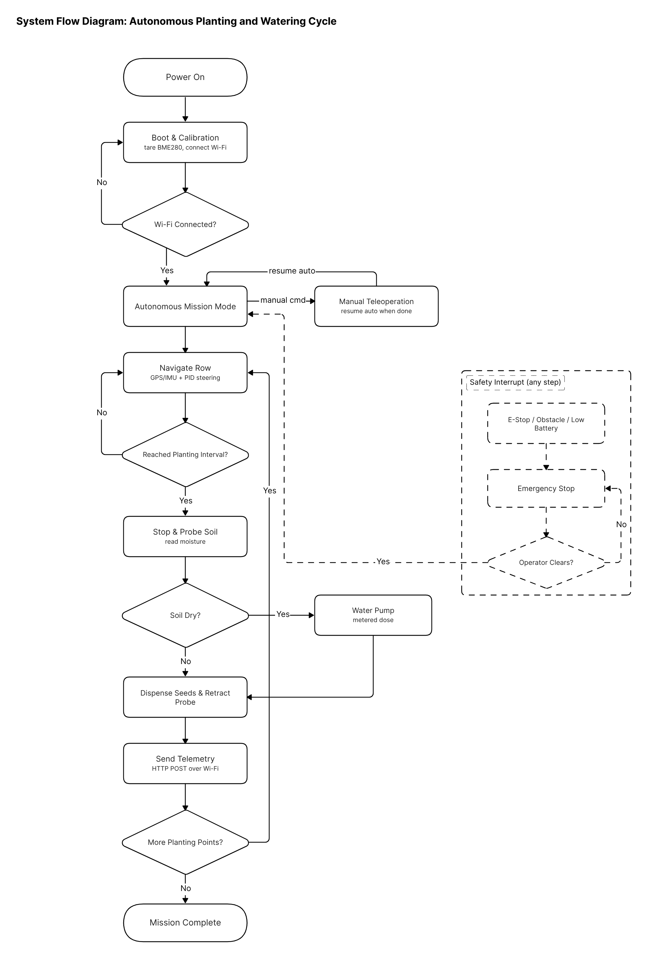
Figure 3. 1 System flow diagram of the autonomous planting and watering cycle

3.9 Design Constraints and Trade-offs
Several constraints shaped the final design and are worth stating explicitly, since they define the boundaries within which the results in Chapter Four should be interpreted. Standard GPS accuracy of roughly 1.5 to 3 metres is not sufficient for crop-row-level precision on its own; the corridor-following strategy described in Section 3.4.4 works around this limitation rather than eliminating it, and real-time kinematic (RTK) GPS correction is flagged as a future consideration if strict row-level accuracy becomes a hard requirement. Cost constraints ruled out LiDAR-based obstacle detection and single-board-computer-based control, as discussed in Chapter Two, in favour of an ultrasonic sensor and a single Arduino-class microcontroller. Finally, the current design and the testing described in Chapter Four assume relatively flat, uniform terrain typical of a controlled test plot, rather than the full range of slopes, obstructions, and soil conditions a rover might encounter across every smallholder farm in Ghana; extending validation to more varied terrain is identified as future work in Chapter Five.

3.10 Chapter Summary
This chapter has described the rover's mechanical structure, its electronic hardware organised into six functional modules, the pin assignment and bill of materials that realise that hardware, an estimated power budget, and the dual-mode software architecture that separates ROS 2-based simulation and development from embedded firmware deployed on the rover itself. Chapter Four presents the results of testing this design, beginning with the ROS 2 and Gazebo simulation environment and moving through subsystem-level bench validation and the planned field trial protocol.

CHAPTER FOUR

RESULTS AND ANALYSIS

4.1 Introduction
This chapter presents the results of evaluating the design described in Chapter Three. Evaluation follows the two-track approach set out in the methodology overview in Chapter One: a ROS 2 and Gazebo simulation track used to validate navigation and control logic ahead of hardware deployment, and a physical track combining subsystem-level bench validation with controlled field trials of the fully assembled rover. The chapter reports what has been completed at the time of writing and is explicit about which results are drawn from actual testing and which are presented as a template awaiting data from trials still to be run, consistent with the honest reporting of GPS accuracy and other limitations called for in Chapter Three.

4.2 Simulation Environment and Methodology
The simulation environment was built using ROS 2 Jazzy with the Gazebo Harmonic physics simulator, running on Ubuntu. A model of the rover's four-wheel differential drive kinematics was constructed together with simulated GPS and IMU sensors, into which position noise and heading drift were injected to approximate the accuracy limitations of the real NEO-M8N GPS and MPU6050/HMC5883L sensor pair discussed in Chapter Three. The simulated environment represents a rectangular test plot with defined planting rows, allowing the corridor-following and dead-reckoning navigation logic to be exercised under repeatable conditions before committing it to embedded firmware. Simulation trials were used primarily to check three things: whether the PID heading controller settles on a target bearing without excessive overshoot, whether the corridor-following logic correctly identifies when the rover has left its intended row, and whether the planting stop-and-go sequence executes at the expected intervals along a simulated row.

4.3 Simulation Results
Consistent with the design principle set out in Chapter Two that simulation results should be reported with their limitations rather than omitted, this section presents the format in which simulation results are being collected. At the time of writing, simulation trials were in progress rather than complete, so the figures and table below present the intended structure of the analysis with placeholders where measured values are to be inserted once the full set of simulation runs is complete.
[Placeholder: Plot of the rover's simulated path against the target row corridor over a representative Gazebo trial run, showing cross-track deviation over distance travelled.]
Figure 4. 1 Simulated path-following performance in Gazebo Harmonic
Metric | Target | Simulated Result
Mean cross-track deviation | < 0.3 m | TBD
Maximum cross-track deviation | < 0.6 m | TBD
Heading settling time after a turn | < 3 s | TBD
Corridor-exit detection accuracy | 100% of induced exits detected | TBD
Planting-interval timing error | < 5% of target spacing | TBD

Table 4. 1 Simulation evaluation metrics (to be completed following full simulation trials)

4.4 Subsystem-Level Bench Validation
Ahead of full integration, individual subsystems were validated on the bench where practical. GPS fix acquisition, compass heading readout, and sequential waypoint recognition were confirmed on an earlier hardware iteration by walking a handheld GPS/compass unit to a series of marked waypoints and checking that the system correctly registered arrival at each one, which validated the underlying navigation approach ahead of it being ported to the final Arduino Uno R4 architecture described in Chapter Three. The substitution of the BME280 for the originally specified BME680 environmental sensor, discussed in Section 3.4.4, was itself a validated finding from bench testing: powering the BME680 from the 5V rail caused I2C bus failures across every connected sensor, a fault that was diagnosed and resolved before the sensor cluster was finalised. Table 4.1 summarises the state of subsystem validation at the time of writing.
Subsystem | Validation Status | Notes
GPS fix and waypoint recognition | Validated (earlier hardware iteration) | To be reconfirmed on final Arduino Uno R4 build
I2C sensor cluster (IMU, compass, BME280) | Validated | 10kHz bus clock resolved signal integrity issue
Motor driver enable gating and dead-time reversal | Pending | Bench test scheduled after final assembly
Seed dispensing accuracy (3 seeds per hole) | Pending | Requires assembled dispenser mechanism
Soil-moisture-triggered watering logic | Pending | Requires assembled probe arm and pump
WiFi telemetry uplink to cloud API | Pending | Requires companion API endpoint deployment
Battery low-voltage cutoff | Pending | To be tested under controlled discharge

Table 4. 1 Subsystem-level validation status

4.5 Field Trial Protocol and Results
Controlled field trials of the fully assembled rover had not yet been conducted at the time of writing. This section sets out the evaluation protocol and the metrics that will be measured, so that the results can be recorded directly into Table 4.2 once trials are carried out. Each trial run is intended to involve the rover completing a defined planting row on a flat, cleared test plot, with seed placement, planting depth, and water delivery checked manually after each run against the targets stated in Chapter One's objectives.
[Placeholder: Photograph of the test plot used for field trials, and/or a photograph of the assembled rover during a trial run.]
Figure 4. 1 Field trial test plot and rover during a trial run
Metric | Target | Measured Result
Seed spacing consistency | Even spacing, minimal variance | TBD
Seeds dispensed per hole | 3 | TBD
Planting depth consistency | Descoped (see Section 5.5) | Not evaluated in this study
Water delivered per dry planting point | Measured volume within target range | TBD
Path deviation from intended row | < 0.5 m typical | TBD
Mission completion rate (no manual intervention) | As high as achievable | TBD
Battery life per full mission | Sufficient for a defined plot size | TBD

Table 4. 1 Field trial results (to be completed following controlled field trials)

4.6 Discussion of Results Relative to Objectives and Research Questions
At the design and simulation stage reached at the time of writing, the study has produced a complete, documented hardware and software design that integrates precision seed dispensing, moisture-triggered spot watering, and GPS/IMU-based navigation on a single low-cost platform, directly addressing specific objectives one through four set out in Chapter One. The dual-mode ROS 2 and embedded firmware architecture called for in objective four has been implemented and is in active use for developing and checking the navigation logic before it is committed to the rover. What remains open, corresponding to objective five and to research questions one through four, is the quantitative evidence from simulation trials and, more importantly, from physical field trials of the completed rover. The GPS accuracy limitation discussed in Chapter Three means research question one in particular can only be properly answered once real path-deviation data is collected under field conditions, and questions two, three, and four depend similarly on the field trial data that Table 4.2 is structured to receive. The honest position at this stage of the project is that the design has been shown to be internally consistent and buildable, while its real-world performance against the stated targets is the next piece of evidence to be gathered.

4.7 Chapter Summary
This chapter has described the simulation methodology used to validate the rover's navigation and control logic, reported the subsystems that have already been validated on the bench, and set out the field trial protocol and metrics that will be used to evaluate the completed rover. The results presented are, by design, a mixture of confirmed findings and a structured template awaiting further data, reflecting the stage the project had reached at the time of writing. Chapter Five draws conclusions from the work completed so far, states the study's limitations plainly, and sets out recommendations for the remaining work.

CHAPTER FIVE

CONCLUSION, LIMITATIONS AND RECOMMENDATIONS

5.1 Introduction
This final chapter draws the study to a close. It summarises what the project set out to do and what has been accomplished, states conclusions against each of the specific objectives listed in Chapter One, acknowledges the limitations of the work honestly, and sets out recommendations for the work that should follow, both for the continuation of this project and for related future studies.

5.2 Summary of the Study
This study set out to design and build a low-cost autonomous rover for precision seed planting and spot watering on smallholder farms in Ghana, motivated by the inconsistency of manual seed placement and the inefficiency of untargeted irrigation described in Chapter One. Chapter Two reviewed the existing literature on precision agriculture, seed dispensing mechanisms, and low-cost agricultural robot navigation, and identified a set of gaps that this study aimed to close, chiefly the lack of a single affordable platform integrating seed dispensing, moisture-based spot watering, and GPS/IMU navigation, and the absence of a dual-mode ROS 2 and embedded firmware development pattern in the smallholder agricultural robotics literature. Chapter Three presented the resulting design in full: a four-wheel differential-drive rover built around a single Arduino Uno R4 microcontroller, with a mechanical seed dispenser and soil probe arm, a moisture-triggered watering system, and a corridor-following navigation strategy built on GPS Doppler speed and complementary-filter heading estimation. Chapter Four reported the results of evaluating that design, including a ROS 2 and Gazebo simulation environment, a set of subsystem-level bench validations already completed, and a field trial protocol prepared for the physical rover.

5.3 Conclusions
Against the general objective of designing and building an autonomous rover for precision seed planting and spot watering using GPS and IMU-based navigation, embedded microcontroller control, and a ROS 2-supported development process, the study concludes that such a design is achievable within the cost and component constraints typical of a Ghanaian smallholder context, and that the resulting architecture has been fully specified and partially validated at the time of writing. The following conclusions can be drawn against each specific objective:
1. A low-cost rover platform integrating a mechanical seed dispenser targeting three seeds per hole and a moisture-triggered spot watering mechanism has been designed and specified in full, meeting the first objective at the design level; bench validation of dispensing accuracy on the assembled mechanism remains to be completed.
2. A GPS and IMU-based navigation system using corridor-following and complementary-filter heading estimation has been designed, implemented as ROS 2 simulation nodes, and partially validated through earlier bench testing of GPS and compass behaviour, meeting the second objective at the design and simulation level; full autonomous row-following on the final hardware has not yet been demonstrated in the field.
3. Soil moisture sensing has been integrated directly into the spot watering decision logic, so that watering at each planting point depends on an actual moisture reading rather than a fixed schedule, meeting the third objective at the design level.
4. A dual-mode software architecture has been implemented, with ROS 2 and Gazebo used for development, simulation, and testing, and standalone embedded firmware on the Arduino Uno R4 used for field deployment, fully meeting the fourth objective.
5. Evaluation through simulation and controlled field trials has begun but was not complete at the time of writing; the simulation environment and field trial protocol required to meet the fifth objective have been built and are ready to generate the navigation accuracy, seed placement, watering precision, and reliability data called for, but that data collection remains outstanding.

5.4 Limitations of the Study
Several limitations should be kept in mind when interpreting the design and results presented in this report. The rover's navigation relies on a standard GPS module without real-time kinematic correction, giving a position accuracy of roughly 1.5 to 3 metres that is not sufficient for crop-row-level precision on its own; the corridor-following strategy adopted works around this limitation rather than removing it. At the time of writing, the physical rover had not yet completed a full controlled field trial, so the navigation accuracy, seed placement consistency, and watering precision results presented in Chapter Four are structured as a protocol and template rather than as final measured outcomes. Planting depth control was also descoped from the seed dispensing mechanism because of time constraints; the finalised mechanism controls seed count and spacing only, and depth control is left for future work. The power budget in Chapter Three is based on typical datasheet values rather than direct current measurement on the assembled rover. The design and its intended testing assume relatively flat, uniform terrain typical of a controlled test plot, and does not address the fuller range of slopes, obstructions, and soil conditions found across smallholder farms in Ghana generally. Cost constraints also ruled out LiDAR-based obstacle avoidance and single-board-computer-based control in favour of a single ultrasonic sensor and a single Arduino-class microcontroller, which limits the rover's ability to handle complex or cluttered field layouts. Finally, the study evaluates a single prototype rather than multiple units, so the results, once collected, will describe the behaviour of one build rather than a statistically validated population.

5.5 Recommendations for Future Work
1. Complete the controlled field trials set out in Chapter Four and use the resulting data to refine the PID heading controller and corridor-following parameters.
2. Investigate real-time kinematic (RTK) GPS correction as an upgrade path if future work requires row-level positioning accuracy beyond what the standard GPS module can provide.
3. Explore camera-based row guidance using the ESP32-CAM module mentioned as a scope consideration in Chapter One, to give the rover a second, independent means of confirming row alignment alongside GPS.
4. Add solar charging to extend the rover's operating time between charges, following the direction suggested by Ghalazman et al. in the literature reviewed in Chapter Two for sustainable precision agriculture in resource-limited settings.
5. Complete the browser-based Mission Planner companion application described in Chapter Three, extending it beyond the current telemetry-review functionality to full mission configuration and live monitoring.
6. Test the passive tire-cover seed-covering concept considered during the mechanical design against different soil types and moisture conditions, since its performance is expected to vary with soil texture and was not validated within the scope of this study.
7. Extend field testing across a wider range of terrain, soil types, and seasons than the controlled test plot used in this study, to build confidence in the rover's reliability under the fuller range of conditions found on Ghanaian smallholder farms.
8. Add depth control to the seed dispensing mechanism, for example through a depth-gauging drop tube or a linear actuator on the probe arm, and validate planting depth consistency against a defined tolerance. This was descoped from the current study because of time constraints and was not implemented or tested.

5.6 Concluding Remarks
The gap this study set out to address, the lack of an affordable rover integrating precision seed dispensing, moisture-based spot watering, and GPS/IMU navigation for smallholder farming, remains a real and largely unaddressed one in the literature reviewed in Chapter Two. The design presented in this report offers one concrete, fully specified answer to that gap, built from components and methods chosen deliberately for their cost and availability in a Ghanaian context. What is left is the disciplined work of building, testing, and iterating on the physical rover until the field trial results in Chapter Four are filled in with real measurements, at which point the design can be judged not just on its specification but on how well it actually performs the task it was built for.

REFERENCES
[1] Food and Agriculture Organization of the United Nations, The Future of Food and Agriculture: Trends and Challenges. Rome: FAO, 2017. [Online]. Available: https://www.fao.org
[2] Food and Agriculture Organization of the United Nations, "Smallholder mechanization review," FAO Agricultural Review, 2021.
[3] A. Ghalazman E. et al., "Autonomous robots and solar energy for precision agriculture and smart farming," Lincoln Institute for Agri-Food Technology, University of Lincoln, 2023.
[4] R. Xu and C. Li, "A modular agricultural robotic system (MARS) for precision farming: concept and implementation," J. Field Robot., University of Georgia, 2022.
[5] J. Iqbal, R. Xu, H. Halloran, and C. Li, "Development of a multi-purpose autonomous differential drive mobile robot for plant phenotyping and soil sensing," Electronics, vol. 9, no. 9, p. 1550, 2020.
[6] "Agricultural automation survey," Agri-Tech Review, 2021.
[7] "Agricultural robotics: trends and challenges," Robotics, 2020. [Online]. Available: https://www.mdpi.com
[8] V. K. Pandey, V. K. Gupta, and T. Sheorey, "Development of Agri-Bot for seed sowing automation," in Proc. 23rd Int. Conf. Control, Automation and Systems (ICCAS), Yeosu, Korea, Oct. 2023, pp. 1–6.
[9] S. Debnath et al., "Design and development of smart seed dispenser for efficient cultivation," in 2024 IEEE Flagship Int. BIT Conf. (BITCON-24), 2024.
[10] F. Z. Ha-mim et al., "IoT-based automatic seed sowing and plant nutrition system," in 2023 5th Int. Conf. Sustainable Technologies for Industry 5.0 (STI), Dhaka, Dec. 2023.
[11] J. Rakun and G. Popič, "Optimizing autonomous navigation algorithm – a comparative study of new and legacy approach," in Precision Agriculture ’25, Wageningen Academic Publishers, 2025, pp. 956–962.
[12] J. Rakun and G. Popič, "Optimized autonomous navigation for field robots: extended results and practical deployment," Precision Agriculture, vol. 27, no. 5, 2026.
[13] S. Kanagasingham, M. Ekpanyapong, and R. Chaihan, "Integrating machine vision-based row guidance with GPS and compass-based routing to achieve autonomous navigation for a rice field weeding robot," Precision Agriculture, 2019.
[14] S. J. Levoir et al., "High-accuracy adaptive low-cost location sensing subsystems for autonomous rover in precision agriculture," IEEE Open J. Ind. Appl., vol. 1, pp. 74–94, 2020.
[15] Y. Fang, H. Hafizh, and M. Ateeq, "An autonomous irrigation robot based on ROS2, YOLOv8 and distributed ESP32 WMN architecture," 2024.
[16] E. Sani, A. Sgorbissa, and S. Carpin, "Improving the ROS 2 navigation stack with real-time local costmap updates for agricultural applications," 2024.
[17] C.-T. Vu, H.-C. Chen, and Y.-C. Liu, "Toward autonomous navigation for agriculture robots in orchard farming," 2024.
[18] M. A. Post, A. Bianco, and X. T. Yan, "Autonomous navigation with ROS for a mobile robot in agricultural fields," in Proc. 14th Int. Conf. Informatics in Control, Automation and Robotics (ICINCO), Madrid, 2017, pp. 388–395.
[19] M. A. Post, A. Bianco, and X. T. Yan, "Autonomous navigation with open software platform for field robots," in Lecture Notes in Electrical Engineering, vol. 430, Springer, 2018, pp. 33–50.
[20] M. Zinzani et al., "Rockerbot: Rover kinematics for maize farming," Agricultura Scientia, vol. 21, no. 1, pp. 1–10, 2024.
[21] A. G. Menon and M. Prabhakar, "Smart agriculture monitoring rover for small-scale farms in rural areas using IoT," REVA University, Bengaluru, India, 2023.
[22] V. R. Urkude et al., "Seed dispenser," Int. J. Data Science and IoT Management System (IJDIM), vol. 4, no. 4(1), pp. 91–95, 2025.
[23] S. Manimekalai et al., "Arduino based automatic seed sowing agri-robot," Industrial Engineering Journal, ISSN: 0970-2555.
[24] Z. Liu et al., "Design and analysis of seed dispensers with eye type," Dalian Polytechnic University, 2024.
[25] S. R. Vakiti and H. Subhadra, "Smart seed sower: Design and implementation of an IoT-based solar-powered automatic seed dispenser," CVR College of Engineering, 2023.
[26] "Autonomous farming robot for precision seed sowing and targeted irrigation using wireless control," 2024.
[27] M. Sperti et al., "Non-linear model predictive control for multi-task GPS-free autonomous navigation in vineyards," 2024.
[28] J. Shi et al., "Row detection based navigation and guidance for agricultural robots and autonomous vehicles in row-crop fields: Methods and applications," Agronomy, vol. 13, no. 7, p. 1780, 2023.
[29] J. H. X. Lim and S. K. Phang, "Classification and detection of obstacles for rover navigation," J. Phys.: Conf. Ser., vol. 2523, p. 012030, 2023.
[30] V. Sathya et al., "Intelligent Agritech Rover: Real-time data logging and machine learning for optimal crop management," Sri Sairam Engineering College, Chennai, 2024.
[31] FAO, "Ghana at a glance," FAO in Ghana, 2023. [Online]. Available: https://www.fao.org/ghana/fao-in-ghana/ghana-at-a-glance/en/
[32] Ministry of Food and Agriculture (MoFA), "Facts and figures: Agriculture in Ghana 2020," Statistics Research and Information Directorate (SRID), Accra, 2021.
[33] FAO, "AQUASTAT Country Profile – Ghana," FAO, Rome, 2005. [Online]. Available: https://www.fao.org/aquastat/
[34] S. Dittoh, "Assessment of farmer-led irrigation development in Ghana," World Bank Water Global Practice Case Study, Washington DC, 2021.
[35] FAO, "Global food losses and food waste," Rome, 2011.
[36] T. Tefera, "Post-harvest losses in African maize in the face of increasing food shortage," Food Security, vol. 4, pp. 267–277, 2012.
[37] World Bank, "Missing food: The case of postharvest grain losses in Sub-Saharan Africa," Report No. 60371-AFR, Washington DC, 2011.
[38] Moneda Investment, "The African perspective: Post-harvest losses," 2025. [Online]. Available: https://www.moneda.africa/news/the-african-perspective-post-harvest-losses
[39] Grand View Research, "Precision farming market size, share and trends analysis report," 2025.
[40] MarketsandMarkets, "Precision farming market – global forecast to 2032," 2025.
[41] BCC Research, "Global markets for precision farming," Dec. 2025.
[42] Mordor Intelligence, "Precision farming market size, trends and growth analysis 2030," Jan. 2026.
[43] C. M. Heppner, Y. Chen, and C. Yang, "Effect of different row spacings and seeders on yield and speed of emergence for corn," Paper No. CSBE17033, presented at CSBE/SCGAB 2017 Annual Conference, Winnipeg, MB, Aug. 2017.

