Restaurants Data Analysis

**Billy Kalman Bondi, Shira Deshet & Shira Fogler**

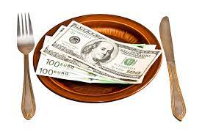

# 

# **Introduction**

In this report, we will review data that is collected from various restaurants, which includes different restaurants’ policies and ratings, in order to find effective patterns for restaurants and gain profitable insights on all the discussed issues.

## Data and Methodology

The given data named ‘restaurant Database.sql’ includes the following tables:

* consumer preferences
* consumers
* data dictionary
* ratings
* restaurant cuisines
* restaurants

The aim of the analysis is to bring insights about policies that could maximize the rating of the restaurant.

The main rating criteria in this work is ‘overall rating’ because it sums the overall satisfaction, and always has a high correlation with any other score.

(Apart from the alcohol issue where we also addressed the price and service rating in addition to the overall rating,

And we did an average of all three).

In particular, we have examined the policies regarding the following issues and asked some related questions:

* **The price of the restaurant and its food**How does the price affect its rating?  
  Which type of restaurant is preferred by the different kinds of consumers?
* **The available parking for the consumers**How does the parking options affect its rating?  
  Is there any difference between car owners and non car owners?
* **The smoking policy of the restaurant**  
  How does the available smoking area affect its rating?  
  Is there any difference between smokers and non-smokers?
* **The alcohol availability in the restaurant**  
  How does the alcohol service affect the rating?

Is there a different trend for consumers with different drink-levels?

In the four issues we present the data, visualize and discuss it from different perspectives and phrase a concluding suggestion that the restaurant is advised to take in order to optimize its rating.

# **Prices**

In this section we perform an analysis of the restaurant's price policy and its influence on the rating of the restaurant.

Distribution of Prices

First, we checked the price distribution by type of restaurant, restaurant at a high price, restaurant at a medium price and low price.

The following chart shows that 46% of all restaurants are medium priced, 35% low priced and only 19% considered as high priced restaurants.

In other words, almost half of the restaurants are considered as medium priced, so it can be considered as a “mainstream” and solid policy.

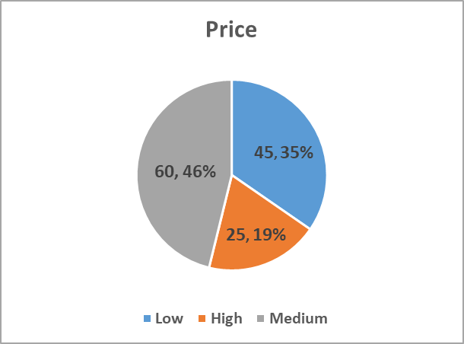

# 

Next, we chose to examine the effect of the price on the overall rating.

It can be concluded from the data that the rating is almost similar for the two pricing categories, restaurants with high prices (1.256) and restaurants with medium prices (1.253).

The lowest rating is obtained, despite the money saving, when the restaurant’s price is low.

Speaking of the food rating, somehow surprising, the medium priced restaurants get the highest score (1.256), even more than the expensive restaurants (1.235).

The service rating is significantly lower for the restaurants with low prices (0.92) than the score of the medium or expensive restaurants that have almost the same rating.

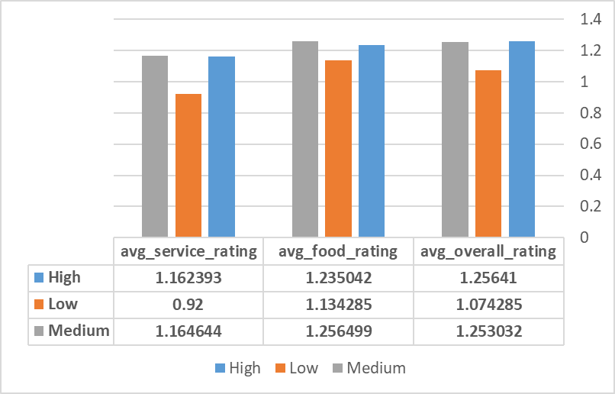

It can be concluded from these analyses that both expensive or medium-priced restaurants invest and operate according to their expectations and thus get almost the same, and high rating.

In contrast, cheap restaurants do not invest in the areas of services that people expect, and this is why their service and overall ratings are very low.

Indeed, in the manner of ​​food, the score is not particularly low, which perhaps shows that people are relatively satisfied with the food they receive in exchange for the low price.

Distribution of consumer budget

We examined all consumers regarding their budget.

69% of consumers have a medium budget (91)

27% of consumers have a lower budget (35)

4% of consumers have a high budget(5)

It can be concluded that consumers with a medium budget allow themselves to spend more money on spending time in a restaurant than consumers on a low budget, only 4 consumers on a high budget allow themselves to spend money on spending time in restaurants.

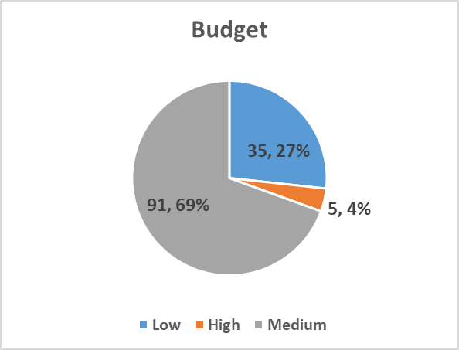

## Influence on rating

The next thing we examined is the effect of budget on the consumer in relation to their satisfaction from the restaurant with high, medium and low price.

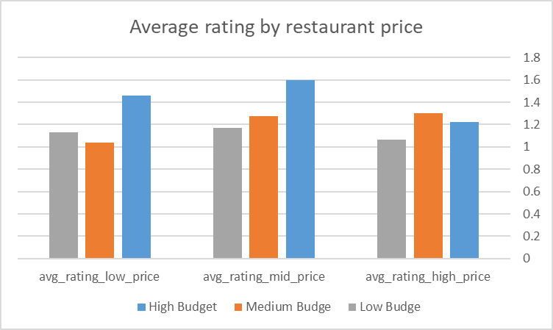

It can be clearly seen that consumers with a high budget prefer to go to restaurants at a medium price(1.6).

Medium-budget consumers will prefer to go to high-priced restaurants (1.3).

And low-budget consumers will prefer to go to medium-priced restaurants(1.166).

## Conclusion

Most restaurants with medium price

The service and food rating in a medium-sized restaurant is particularly high.

The level of service in the restaurant at a low price is significantly lower than the level of service in the high and medium restaurants, which significantly lowers the restaurant's rating.

It can be concluded that restaurants at high and medium prices invest more in providing good and courteous service to consumers.

High-budget consumers do not exactly prefer high-priced restaurants while medium-budget consumers prefer high-priced restaurants, the interesting thing is that low-budget consumers prefer medium-priced restaurants.

The consumer budget does not seem to affect the type of restaurant they prefer.

Low cost restaurants with the lowest rating Most consumers will not visit this restaurant.

# **Transportation**

In this section we perform an analysis of the restaurant's parking and its influence on the rating of the restaurant.

## 

# 561 restaurants without parking (48%) 389 restaurants have parking (34%) 182 restaurants have public parking (16%) 29 restaurants with valet (2%).

It can be concluded that about half of the restaurants have parking (of the restaurant or public) and about half do not.

Valet's service is provided in only 2 percent of restaurants and is numerically negligible.

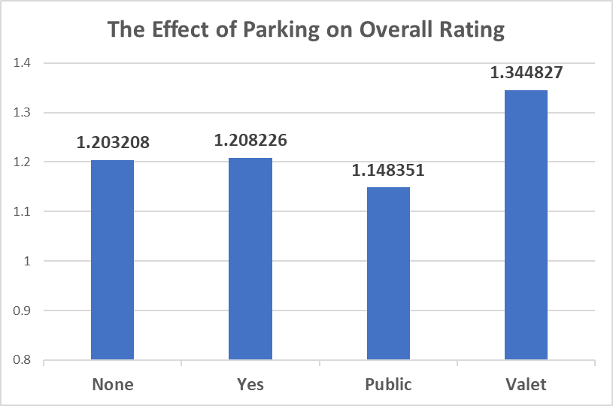

We chose to examine the effect of parking on the overall rating, because we assumed that parking would not affect the rating that the consumer would give to food or service in the restaurant

It can be concluded that the rating is similar when there is parking (1.208) or when there is no parking (1.203).

Surprisingly the lowest rating is obtained when parking in a restaurant is public (1.148) - lower than when there is no parking at all in the restaurant.

The highest rating is for Valet (1.344) - It seems that the personal help with the parking gives people a good feeling of an upscale restaurant. It should be taken with limited guarantee as there are very few restaurants offering this service.

# 

# 27% of consumers come to a restaurant by car (313 consumers), 68% arrive without a car (794 consumers) - they are divided into 57% who arrive at the restaurant by public transport (660 consumers) and 11% who arrive at the restaurant on foot (134 consumers), 5% unknown (54 consumers).

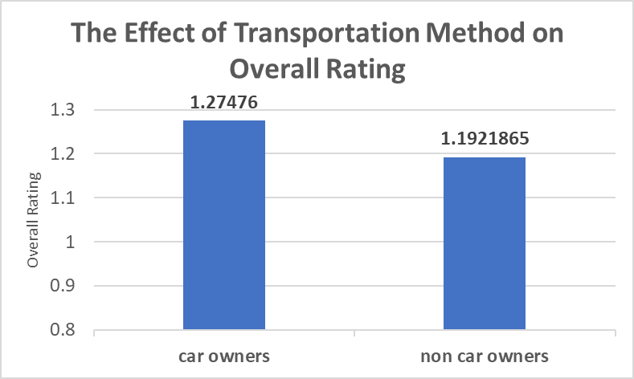

It can be deduced from the graph that car owners tend to rate the restaurant higher than people without cars, although the gap is not very large.

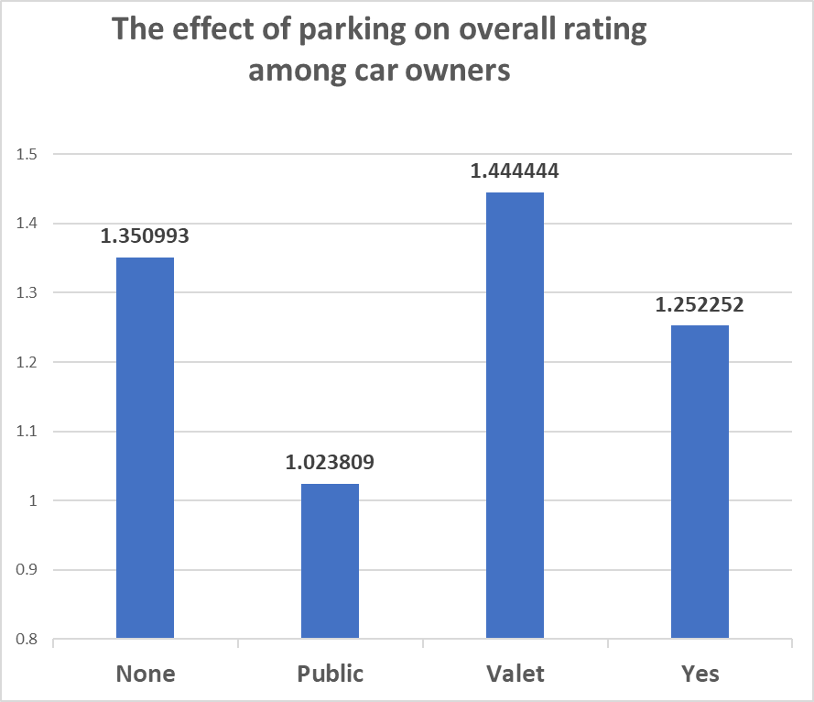

We examined among car owners how parking affects the ranking of the overall rating - since only for them parking is relevant.

# The trend we saw is similar to the general trend -

# You can clearly see that the valet service has a very positive effect on the ratings and raises it

# Here, too, public parking received the lowest rating.

**Conclusions -**

Most consumers do not come to the restaurant by car, but car owners tend to rate the restaurant higher.

A restaurant with public parking seems to have received the lowest rating so this is the least preferred option.

Parking with valet has received the highest rating so if there is an option it is highly recommended to add this service.

# **Smoking**

In this section we perform an analysis of the restaurant's smoking policy and its influence on the rating of the restaurant.

## Distribution of smokers

First, we have examined the distribution of the smokers and non-smokers in the population, assuming that it also reflects the general distribution of the smokers and non smokers of future diners

In the following chart it can be seen that there are more than 80% non smokers against less than 20% smoking diners.

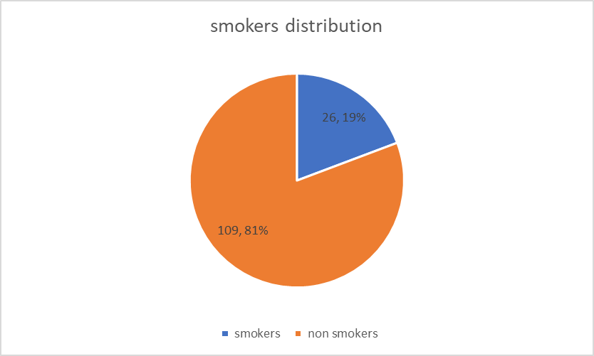

From this figure it seems better to try to please non-smokers, as they are the vast majority of the diners.

## Distribution of restaurant policy

We have examined the policies of the restaurants in the data in order to understand what are the possible smoking policies that the restaurants have, and what are their frequencies

The results are summarized in the following chart.

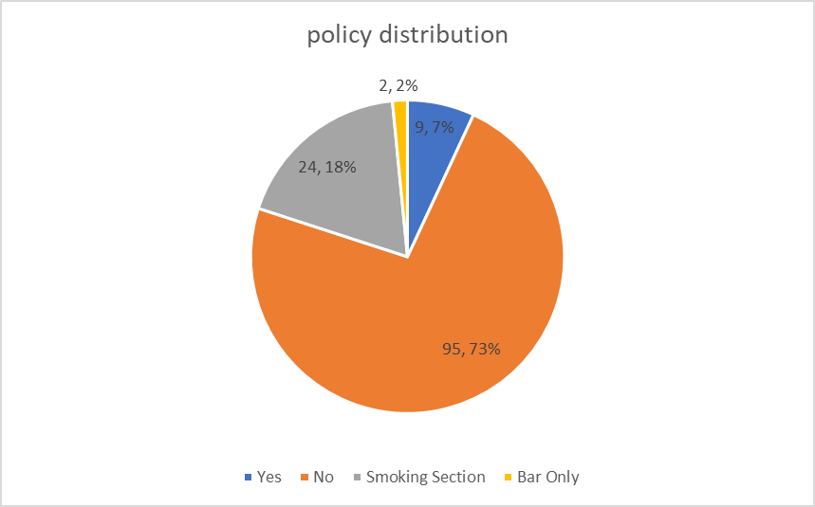

The figure shows that more than 70% of the restaurants do not allow smoking at all.

Moreover, an additional 20% allow smoking only in special and defined places.

That is, a total of 90 percent of the restaurants please mostly the non-smoking public.

## Influence on rating

The next thing we examined is the effect of the smoking policy and the identity of the diner as a smoker or non-smoker in relation to their satisfaction from the restaurant.

It should be noted that we relate to the overall rating and not the food rating because we assume that the smoking policy significantly affects this score, and also since the overall score is the important one.

The following bars show the average overall rating per restaurant’s policy and the question if the diner is smoking (we relate to the ‘bar only’ policy as a ‘section’ policy).

# 

The graph clearly shows that the overall average score for restaurants where a smoking section is defined is the highest (1.27 against 1.18 for the other policies).

Surprisingly, non-smokers give a higher score in a place where there is a smoking section than in a place where smoking is strictly forbidden.

In addition, smokers give the highest score where smoking is allowed, but give the lowest score in places with designated smoking areas, even less than where smoking is not allowed at all.

Overall, the highest score appears to be obtained where a special place for smoking is defined, and despite the dissatisfaction of people who smoke, their relatively small share in the population has less of an effect on the overall score.

## Conclusion

In conclusion, the majority of the guest population in restaurants, as the data reflect, does not smoke. Most restaurants, accordingly, are more considerate of non-smoker.

A comparison of the general satisfaction data shows that in places where smoking areas have been defined, the rating is highest (even among non-smokers) and this seems to be the most recommended policy for a restaurant.

# Alcohol

# 

We checked the policies of the various restaurants in relation to alcohol:

In 66% (762 restaurants) no alcohol is served at all,

In 27% (319 restaurants) only wine and beer are served

And 7% (80 restaurants) have a full bar.

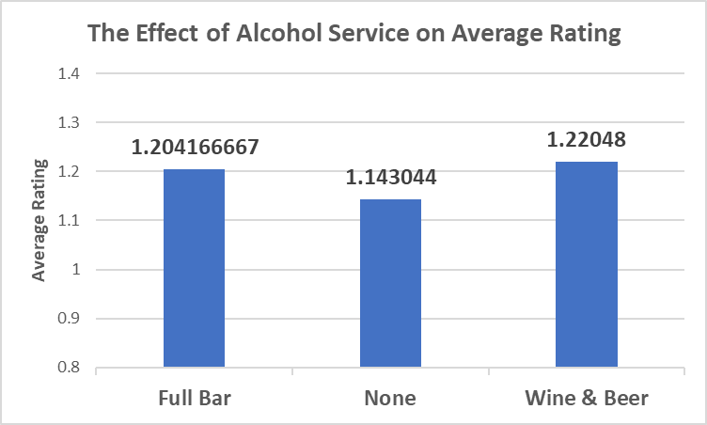

We examined how the restaurant's policy regarding alcohol affects restaurant ratings.

We chose to examine the average of the three types of ratings - the overall rating, the food rating and the service rating, since serving alcohol can be relevant to any of them.

It can be seen from the graph that when no alcohol is served at all the restaurant rating is the lowest (1.143)

When there is a full bar the rating is higher (1.204)

And the highest rating is when serving wine and beer (1.220).

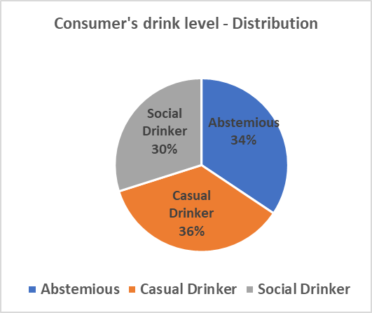

We examined the distribution of consumers' drink level -

34% (399 consumers)are abstemious

36% (415 consumers) are casual drinker

And 30% (347 consumers) are social drinker

It can be seen that most consumers (66%) drink alcohol occasionally or regularly so it is worth considering them.

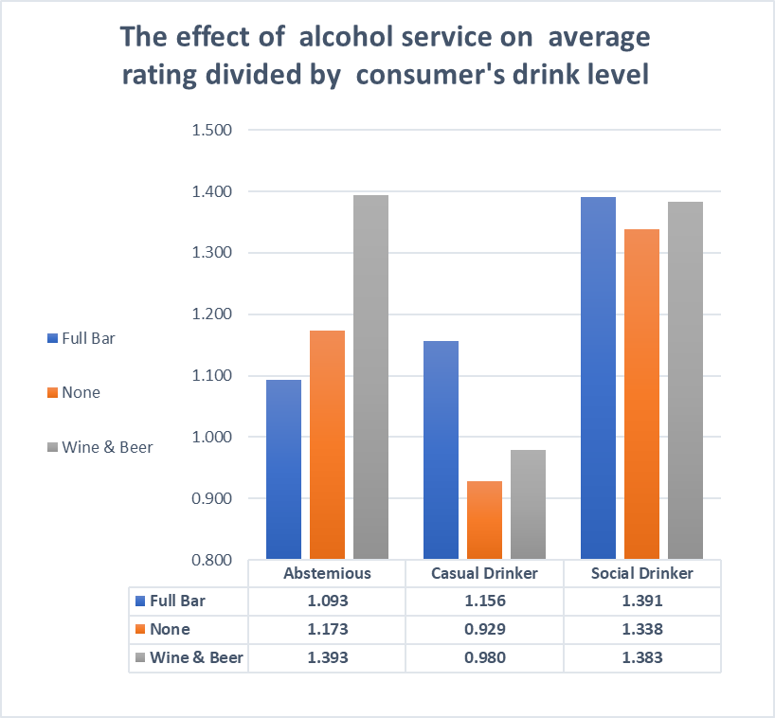

We examined the effect of the type of restaurant on the average rating (average of the three types of ratings - service, food and overall), we divided according to the consumer's drink level.

It’s noticeable in the graph that social drinkers give the highest rating to the restaurants. They prefer a full bar (1.391), then wine and beer (1.383) and then restaurants that do not serve alcohol (1.338) - but the differences in the rating level between the three types of restaurants are very small.

In contrast among casual drinkers their rating for restaurants was the lowest of the three types of consumers. They gave the highest rating to restaurants with a full bar (1.156) and a lower rating to restaurants that serve only wine and beer (0.98) and restaurants that have no alcohol (0.929)

The abstemious also surprisingly gave the highest rating to restaurants that serve wine and beer (1.393), then to restaurants that do not serve any alcohol at all (1.173) and the lowest rating to restaurants with a full bar (1.093).

**Conclusions** -

When setting up a restaurant, it seems worthwhile to serve wine and beer - these are the restaurants that received the highest ratings.

Most consumers drink alcohol occasionally or regularly so it is worth considering them, and even the abstemious preferred restaurants that serve wine and beer.

In addition the consumers who drink alcohol regularly are the ones who give the highest rating to the restaurant.

# 

# **Summary and Conclusions**

In the project we examined how different parameters affect the rating of the restaurant : prices, parking, smoking policy and alcohol servings.

The diagram shows in each of the parameters what is recommended for the restaurant in order to get the highest rating.

And then we will detail the conclusions we reached in the project.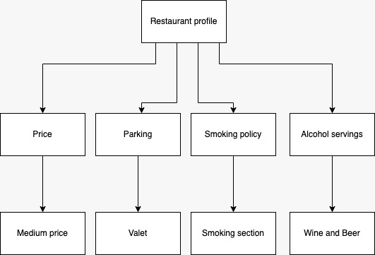

**Price**

* The most common restaurants are medium-priced restaurants, followed by low-priced restaurants and the least common are high-priced restaurants.
* medium-priced restaurants received the highest rating, high-priced restaurants received a slightly lower rating, and low-priced restaurants received the lowest rating by a significant margin.
* Most consumers have a medium budget, about a third have a low budget and a small minority have a high budget.
* The consumer's budget does not affect the price of the restaurant he prefers. Both high-budget and low-budget consumers gave the highest ratings to medium-priced restaurants.

**Parking**

* About half of the restaurants have no parking, about a third have parking, the seventh has public parking, and very few restaurants have valet parking.
* The lowest rating is given to restaurants with public parking
* The highest rating is given to restaurants with valet parking.
* Only a third of the consumers arrive at the restaurant by car, the majority arrive by public transport and a few arrive on foot.
* Car owners tend to rank restaurants higher

**Smoking policy**

* A large majority of the consumers in the restaurant do not smoke
* In most restaurants smoking is completely forbidden, in a fifth of them there is a smoking section and only in a small part smoking is allowed
* Restaurants with a smoking section received the highest ratings. Non-smoking consumers gave higher ratings to restaurants that have a smoking section

**Alcohol servings**

* Most restaurants do not serve alcohol, about a third serve wine and beer and few restaurants have a full bar.
* Restaurants that serve wine and beer received the highest ratings
* Most consumers drink alcohol occasionally or regularly, about a third of consumers do not drink at all
* Social drinkers give restaurants the highest rating, casual drinkers give the lowest rating.
* Restaurants that serve wine and beer received the highest ratings, also abstemious rated higher Restaurants that serve wine and beer more than restaurants that do not serve any alcohol