ECVP2026 Quarto demo with knitr engine
Eline Van Geert and Lisa Koßmann
2026-08-13

Add a heading in your document
This is a sentence with some bold text, italic text, code, and a link.

Figure 1: The Quarto logo
See Figure 1 for the Quarto logo.
Equation 1 gives the formula for the population mean:
$$μ=\frac{∑x}{N} \left(1\right)$$
Section 1 shows how to add R or Python code chunks.
The palmerpenguins package was developed by Horst, Hill, and Gorman (2020). We will create a document using Quarto (Allaire et al. 2025) and R (R Core Team 2024) or Python (Van Rossum and Drake 2009).
This sentence ends with a footnote.

Add R/Python code chunks

Add R code
library(palmerpenguins) # for data
library(tidyverse) # for data wrangling and visualization
library(knitr) # for tables
ggplot(data = penguins,
aes(x = flipper_length_mm,
y = bill_length_mm)) +
geom_point(aes(color = species,
shape = species))
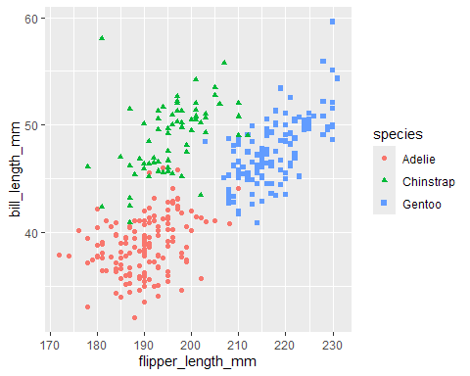
Figure 2: Scatterplot of flipper and bill lengths in R

Add Python code
import numpy as np
import matplotlib.pyplot as plt
from palmerpenguins import load_penguins
penguins = load_penguins()
penguins['species_color'] = penguins['species']
penguins['species_color'].replace(['Adelie', 'Chinstrap', 'Gentoo'],
['red', 'green', 'blue'], inplace=True)
penguins.plot.scatter(x='flipper_length_mm',
y='bill_length_mm',
c='species_color')
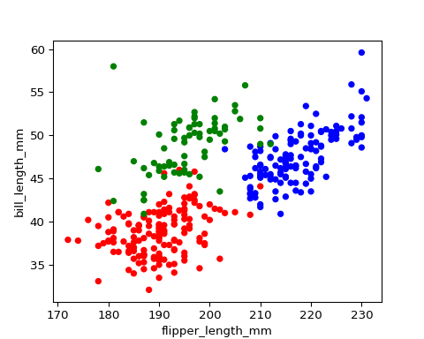
Figure 3: Scatterplot of flipper and bill lengths in Python

Add inline code
The palmerpenguins package contains data for 344 penguins.

Add tables
Table 1, Table 2, and Table 3 show different table options in Quarto.

Markdown
| fruit | price |
|--------|-------|
| apple | 2.05 |
| pear | 1.37 |
| orange | 3.09 |
: Fruit prices {#tbl-md .striped .hover}
Table 1: Fruit prices
fruit | price
apple | 2.05
pear | 1.37
orange | 3.09

R
penguins %>%
group_by(species) %>%
summarise(
`Mean bill length` = mean(bill_length_mm, na.rm = T),
`Min bill length` = min(bill_length_mm, na.rm = T),
`Max bill length` = max(bill_length_mm, na.rm = T),
`Mean flipper length` = mean(flipper_length_mm, na.rm = T),
`Min flipper length` = min(flipper_length_mm, na.rm = T),
`Max flipper length` = max(flipper_length_mm, na.rm = T),
`Correlation, r` = cor(flipper_length_mm, bill_length_mm, use = "complete")
) %>%
kable(digits = c(2, 2, 2, 2, 2))
Table 2: Summary statistics for flipper and bill lengths
species | Mean bill length | Min bill length | Max bill length | Mean flipper length | Min flipper length | Max flipper length | Correlation, r
Adelie | 38.79 | 32.1 | 46.0 | 189.95 | 172 | 210 | 0.33
Chinstrap | 48.83 | 40.9 | 58.0 | 195.82 | 178 | 212 | 0.47
Gentoo | 47.50 | 40.9 | 59.6 | 217.19 | 203 | 231 | 0.66

Python
from tabulate import tabulate
from IPython.display import Markdown
# Convert to markdown table
Markdown(tabulate(penguins[["species", "island",
"bill_length_mm",
"flipper_length_mm"]].head(),
headers='keys', tablefmt='github'))
Table 3: First rows of penguins dataframe
 | species | island | bill_length_mm | flipper_length_mm
0 | Adelie | Torgersen | 39.1 | 181
1 | Adelie | Torgersen | 39.5 | 186
2 | Adelie | Torgersen | 40.3 | 195
3 | Adelie | Torgersen | nan | nan
4 | Adelie | Torgersen | 36.7 | 193

References
Allaire, J. J., Charles Teague, Carlos Scheidegger, Yihui Xie, Christophe Dervieux, and Gordon Woodhull. 2025. “Quarto.” https://doi.org/10.5281/zenodo.5960048.
Horst, Allison M, Alison Presmanes Hill, and Kristen B Gorman. 2020. Allisonhorst/Palmerpenguins: V0.1.0. Zenodo. https://doi.org/10.5281/ZENODO.3960218.
R Core Team. 2024. R: A Language and Environment for Statistical Computing. Vienna, Austria: R Foundation for Statistical Computing. https://www.R-project.org/.
Van Rossum, Guido, and Fred L. Drake. 2009. Python 3 Reference Manual. Scotts Valley, CA: CreateSpace.

This is an example footnote.

