ECVP2026 Quarto demo with knitr engine
Eline Van Geert and Lisa Koßmann
2026-08-13

Add a heading in your document
This is a sentence with some bold text, italic text, code, and a link.

Figure 1: The Quarto logo
See Figure 1 for the Quarto logo. Equation 1 gives the formula for the population mean:
$$μ=\frac{∑x}{N} \left(1\right)$$
Section 1 shows how to add R or Python code chunks.
The palmerpenguins package was developed by Horst, Hill, and Gorman (2020). We will create a document using Quarto (Allaire et al. 2025) and R (R Core Team 2024) or Python (Van Rossum and Drake 2009).
This sentence ends with a footnote.

Add R/Python code chunks

Add R code
library(palmerpenguins) # for data
library(tidyverse) # for data wrangling and visualization
library(knitr) # for tables
library(IRdisplay)
#install.packages("palmerpenguins", repos = "http://cran.us.r-project.org")
ggplot(data = penguins,
aes(x = flipper_length_mm, y = bill_length_mm)) +
geom_point(aes(color = species, shape = species))
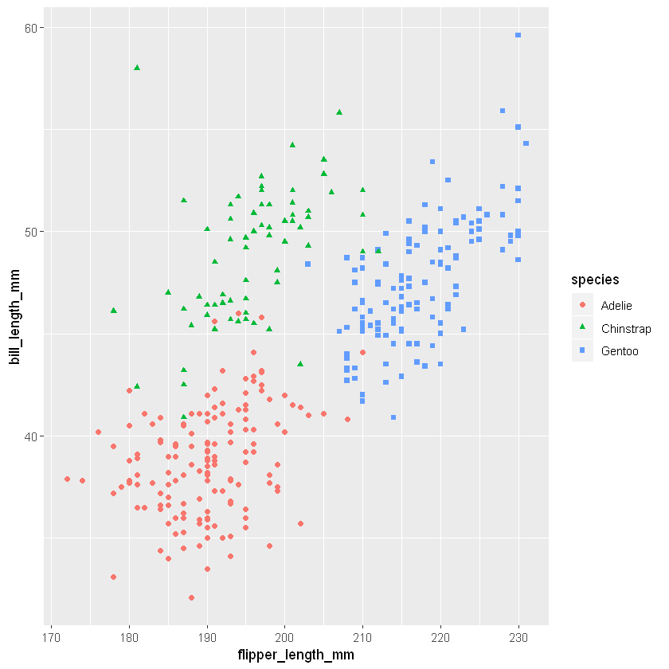
Figure 2: Scatterplot of flipper and bill lengths in R

Add inline code
The palmerpenguins package contains data for {r} nrow(penguins) penguins.

Add tables
Table 1 and Table 2, show different table options in Quarto.

Markdown
| fruit | price |
|--------|-------|
| apple | 2.05 |
| pear | 1.37 |
| orange | 3.09 |
: Fruit prices {#tbl-md .striped .hover}
Table 1: Fruit prices
fruit | price
apple | 2.05
pear | 1.37
orange | 3.09

R
Table 2: Summary statistics for flipper and bill lengths
penguins %>%
group_by(species) %>%
summarise(
`Mean bill length` = mean(bill_length_mm, na.rm = T) %>% round(2),
`Min bill length` = min(bill_length_mm, na.rm = T) %>% round(2),
`Max bill length` = max(bill_length_mm, na.rm = T) %>% round(2),
`Mean flipper length` = mean(flipper_length_mm, na.rm = T) %>% round(2),
`Min flipper length` = min(flipper_length_mm, na.rm = T) %>% round(2),
`Max flipper length` = max(flipper_length_mm, na.rm = T) %>% round(2),
`Correlation, r` = cor(flipper_length_mm, bill_length_mm, use = "complete") %>% round(2)
)
species | Mean bill length | Min bill length | Max bill length | Mean flipper length | Min flipper length | Max flipper length | Correlation, r
Adelie | 38.79 | 32.1 | 46.0 | 189.95 | 172 | 210 | 0.33
Chinstrap | 48.83 | 40.9 | 58.0 | 195.82 | 178 | 212 | 0.47
Gentoo | 47.50 | 40.9 | 59.6 | 217.19 | 203 | 231 | 0.66

References
Allaire, J. J., Charles Teague, Carlos Scheidegger, Yihui Xie, Christophe Dervieux, and Gordon Woodhull. 2025. “Quarto.” https://doi.org/10.5281/zenodo.5960048.
Horst, Allison M, Alison Presmanes Hill, and Kristen B Gorman. 2020. Allisonhorst/Palmerpenguins: V0.1.0. Zenodo. https://doi.org/10.5281/ZENODO.3960218.
R Core Team. 2024. R: A Language and Environment for Statistical Computing. Vienna, Austria: R Foundation for Statistical Computing. https://www.R-project.org/.
Van Rossum, Guido, and Fred L. Drake. 2009. Python 3 Reference Manual. Scotts Valley, CA: CreateSpace.

This is an example footnote.

