**Characterising novel lipoteichoic acid synthase inhibitors as potential antibiotics**

Elinor Macnab

Selwyn College

**Supervisor:** Xavier Chee Wezen, Department of Pharmacology, University of Cambridge

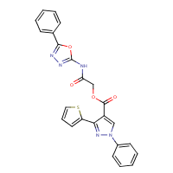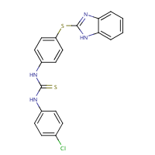

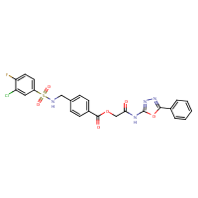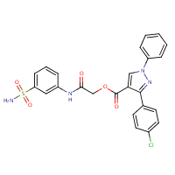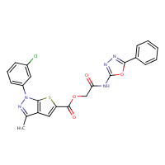

**Summary**

Lipoteichoic acid (LTA) is an important part of the cell walls of some bacteria, including MRSA and other disease-causing species. LTA has functions ranging from keeping magnesium concentrations constant through cell division to avoiding destruction by the host immune system. It would therefore be a good idea to develop new antibiotics to prevent it from being made by blocking one of the main enzymes involved in the process, lipoteichoic acid synthase (LtaS). Accordingly, we have tested a series of compounds similar to one known to block LtaS to see whether they could stop bacterial growth and at what concentrations. The three that did best were tested to check that they did indeed bind to LtaS. One of them certainly does, and the other two probably do but we cannot be certain from that experiment. We tried to find out whether a similar drug could prevent bacteria from entering human cells (yet another function of LTA), but there was not enough time available, the supply of that drug was limited and we may have been using the wrong kind of cell, so we had to stop before we could get good results.

**Abstract**

**Background and Purpose**

Lipoteichoic acid synthase (LtaS) is an enzyme critical to the synthesis of the Gram-positive bacterial virulence factor lipoteichoic acid (LTA). LtaS inhibitors have been shown to be effective antibiotics *in vitro* and to some extent *in vivo*, but existing inhibitors are limited by their metabolic instability *in vivo*. Accordingly, a series of analogues of a known LtaS inhibitor were assayed for antibacterial activity and binding to LtaS as part of the search for effective, stable antibiotics in this class.

**Experimental Approach**

Forty analogues of a known LtaS inhibitor were tested for their ability to inhibit bacterial growth *in vitro*. Antimicrobial dose-response curves were obtained for the three most promising candidates and the binding affinity with respect to LtaS measured by DSF for one of them. An attempt was made to measure the effect of another LtaS inhibitor on cell invasion using a gentamicin protection assay.

**Key Results**

Candidates **5**, **7** and **21** had good antibacterial activity *in vitro*, with IC50 values of 63.11±3.139 μM, 4.840±0.1790 μM and 2.376±0.07519 μM respectively. Candidate **7** bound to LtaS with an IC50 of 9.879±4.243 μM, which is not significantly different from its IC50 value for growth inhibition. A lack of time and resources and the choice of cell line prevented good results from being obtained from the cell invasion assay.

**Conclusion and Implications**

Three LtaS inhibitors with high antimicrobial potency *in vitro* have been identified and could be used as lead compounds in the search for antibiotics effective against multidrug-resistant bacteria.

**Non-approved Abbreviations**

eLtaS extracellular domain of lipoteichoic acid synthase

LTA lipoteichoic acid

LtaS lipoteichoic acid synthase

MOI multiplicity of infection

OD600 optical density at 600nm

**Introduction**

Lipoteichoic acid (LTA) forms an essential part of the cell walls of Gram-positive bacteria. LTA plays a role in magnesium ion absorption, autolysin trafficking, cell division and virulence (Neuhaus and Baddiley, 2003; Reichmann and Gründling, 2011). It is synthesised principally by an enzyme called lipoteichoic acid synthase (LtaS). LtaS is a druggable enzyme on the pathway owing to its lack of mammalian homologues and its accessibility (Pasquina et al., 2013). It is embedded in the cell membrane and its substrates are located in the outer leaflet (Gründling and Schneewind, 2007), so its active site should be relatively exposed. It is therefore a logical target for the development of future antibiotics.

An inhibitor of LtaS, compound **1771**, has already been shown to delay (but not halt) the progress of sepsis caused by the sometimes dangerous and often multidrug-resistant bacterium *Staphylococcus aureus* in mice. Unfortunately, the compound is unsuitable for clinical use owing to its short half-life, a consequence of its rapid cleavage via an unknown pathway (Richter et al., 2013). A number of other LtaS inhibitors have been developed from this lead compound and shown to have antibacterial activity. Two of these, compounds **19** and **A14-4**, have also been shown not to be cytotoxic to cultured mammalian cells (Figure 1). Compound **19** binds to LtaS in a concentration-dependent manner (Figure 2), and both drugs cause thickening of the bacterial cell wall and disordered septa formation (Figure 3). These are characteristic of LtaS knockout (Gründling and Schneewind, 2007) or inhibition (Richter et al., 2013). The purpose of this project is to characterise a series of potential LtaS inhibitors, analogues of compound **19**, and to a lesser extent **A14-4** with respect to their antibacterial activity and binding to LtaS. This will be done by standard antibacterial assays, differential scanning fluorimetry and gentamicin protection assays for cell invasion.

**

***Figure 1:*** *Cytotoxicity of a number of LtaS inhibitors as determined by the LDH activity of cell culture supernatants after incubation of HEK-293 cells with each drug. DMSO and water were used as negative controls and lysed cells as a positive control. Compounds* ***1771****,* ***19*** *and* ***A14-4*** *are not cytotoxic, but* ***NCI-14*** *and to a lesser extent* ***A14-14*** *are. These results were collected entirely by XCW. The protocol for this experiment may be found in the supporting information.*

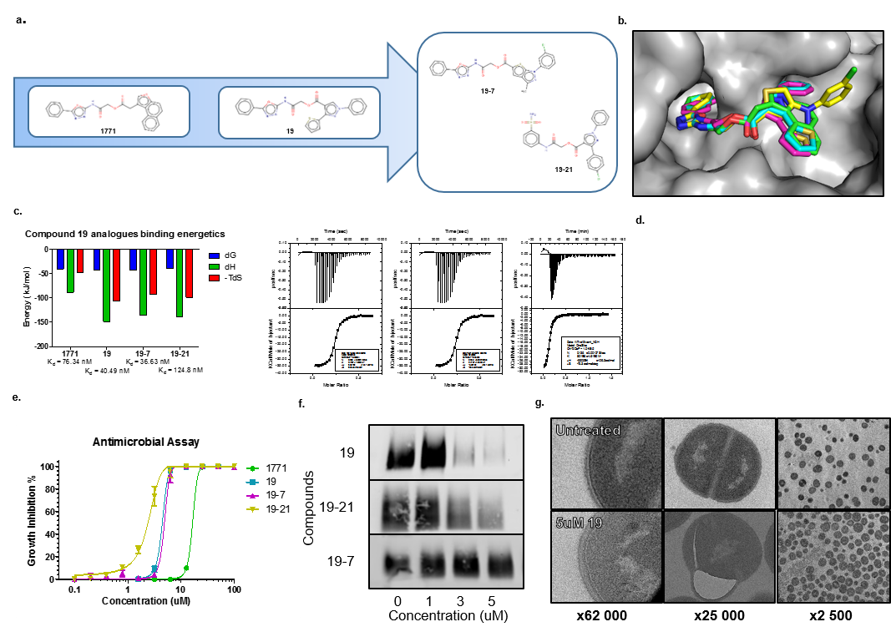

***Figure 2:*** *Western blot showing LTA levels after treatment with compound* ***19*** *and two of its analogues. Concentration-dependent LtaS inhibition is clearly visible for compound* ***19*** *and analogue* ***19-21****. These results were collected entirely by XCW.*

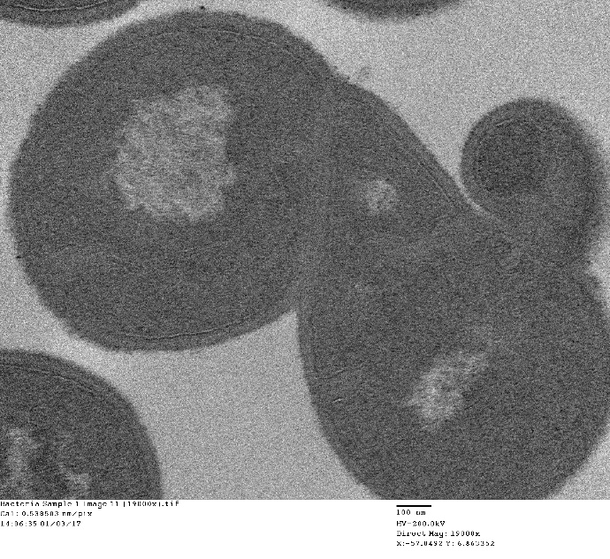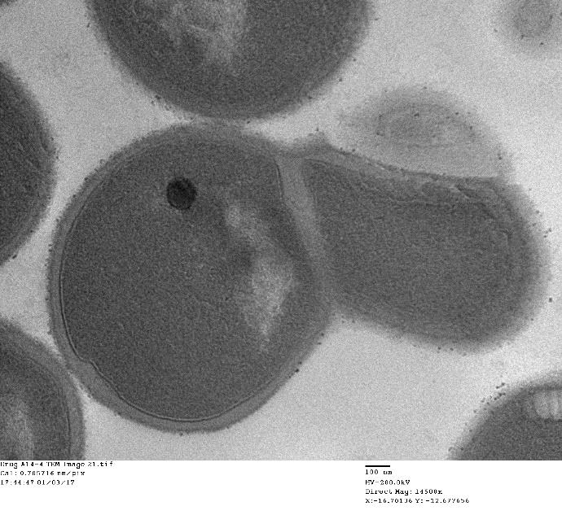

**B**

**A**

***Figure 3:*** *Thin-section transmission electron micrographs of* S. aureus *treated with compound* ***19*** *(A) or compound* ***A14-4*** *(B), showing thickened cell wall envelopes, disordered division septa and aberrant cell division. 100nm scale bars are shown at the bottom left of each picture. These results were collected by XCW with a very small amount of input from EMKM.*

**Methods**

**Bacterial and mammalian cell cultures**

Overnight cultures of *Staphylococcus aureus* Newman (a clinical isolate routinely used to test therapeutic antibiotics) were obtained by inoculation of a single colony into 10ml of autoclaved Mueller-Hinton broth (cation adjusted) and incubated overnight at 37°C with shaking. For the cell invasion assays, HEK-293 cells from the lab stock were grown in Dulbecco’s Modified Eagle Medium F12 supplemented with 10% foetal bovine serum and 1% penicillin and streptomycin at 37°C and 5% CO2.

**Antibacterial assays**

Forty analogues of compound **19** were identified (by XCW using computational screening) and purchased from EnamineStore ([www.enaminestore.com](http://www.enaminestore.com)). The candidate drugs were then diluted in DMSO to a concentration of 400µM. An overnight culture of *S. aureus* was normalised by the addition of growth medium such that its optical density at 600nm (OD­­600) was about 0.6 and then diluted by adding 5μl of culture to 10ml of growth medium. Sufficient volumes of this medium for a final volume of 100μl per well were dispensed into a 96-well plate. Each candidate was then added to a well to the desired final concentration (20μM, 50μM or 25μM). This was done with two or four replicates depending on the number of candidates being tested. The OD600 of each incubation was then determined at the beginning and end of the growth period and the drugs with greatest apparent antibacterial activity selected.

Each such candidate drug was used to make a serial dilution (successive twofold dilutions in DMSO from 20mM to 9.8μM, 50μl of all solutions except the most dilute, of which there was 100μl) and these were incubated with *S. aureus* as previously described (100μl of culture and 1μl of drug in each well). The plates were inspected and the change in OD600 on the more satisfactory plates determined. Dose-response curves were plotted as described below.

**Differential scanning fluorimetry (thermal shift)**

Solutions of the three selected candidate drugs at 20µM were diluted in dialysis buffer to concentrations of 600, 360, 200, 120, 60, 40, 20, 10, 4, 2, 1 and 0.5µM. LtaS in solution at 300µM was likewise diluted to 10µM in dialysis buffer and labelled with Sypro Orange (final volume 1400µl, 11.20µl Sypro Orange). 30µl of each drug solution was added to an equal volume of labelled LtaS and the solutions transferred to 96-well plates (two replicates per concentration, 20µl per replicate). This procedure was repeated with DMSO in place of the drugs. On the second attempt, only candidate **7** was tested, using initial concentrations of 600, 200, 60, 20, 4 and 1µM. The master mixes were made using 45µl of each solution and 45µl of LtaS apiece and four replicates were performed for each concentration. The plate was read on a fluorimeter while the temperature was raised from 25°C to 65°C in increments of 0.5°C. The data were analysed as detailed below and the melting points at each concentration used to plot a dose-response curve.

**Cell invasion assay**

This was performed as described previously (Edwards and Massey, 2011), with appropriate modifications. In particular, HEK-293 cells were used in place of endothelial cells and were grown in the 24-well plate rather than on coverslips, with the medium being changed as appropriate. The bacterial cultures were all incubated overnight. All volumes of cell cultures and media were doubled, halving the initial incubation time to 24 hours. The cells in two wells of each plate were counted using trypan blue and the OD600 of the bacterial cultures and the volume added to each well adjusted to give a multiplicity of invasion (MOI, the ratio of the number of bacteria to the number of host cells) of 20. The experiment was repeated three times, twice with only untreated bacteria to optimise the assay and once with five wells inoculated with untreated bacteria and five inoculated with bacteria that had been incubated overnight with 100µM **A14-4**. Three successive tenfold dilutions were performed on the lysates in each well and 100µl of each diluted lysate (or, in the final assay, the hundredfold and thousandfold dilutions, owing to a lack of agar) spread on agar plates. After a twenty-hour incubation at 37°C, the number of colonies on each plate was counted. XCW prepared the bacterial cultures and performed the cell counts, EMKM prepared the HEK-293 cells and made the final adjustments to the bacterial cultures and both collaborated on the remaining steps (on the final repeat, six replicates were provided by EMKM and four by XCW).

**Statistical analysis**

All results are reported as value±standard error. For the antimicrobial assays, OD600 values were normalised by subtracting the initial values from the final values to account for any variability in the number of bacteria inoculated in each well and percentage inhibition (taking the highest OD600 value or the control wells for the initial assays and the lowest drug concentration for the dose-response curves as zero inhibition) calculated to enable easier comparisons between replicates. Where appropriate, these figures were fitted to a variable-slope log(inhibitor) vs normalised response dose-response curve. Where negative values occurred, they were reset to zero on the grounds that negative growth or inhibition is highly unlikely under the circumstances. Compound **21** showed a tendency to precipitate out at the highest concentrations used, reducing the apparent inhibition, so the relevant data points were reset to 100% inhibition in the cases where this was clearly the true value. For the thermal shift assays, the raw data were normalised to account for non-uniform volumes in the plate wells according to the equation below and fitted to sloppy Boltzmann curves, from which V50 values were taken and used to plot a variable-slope log(agonist) vs response dose-response curve. For the cell invasion assays, the colonies on each plate were counted and the number of bacteria in each well after lysis calculated. Comparison between IC50 values for inhibition and binding was performed using a two-tailed unpaired Student’s t-test with Welch’s correction for unequal variances (an F-test having previously shown this to be necessary). The cell invasion assay results were analysed using a one-way ANOVA. A p-value of 0.05 was considered significant. All analyses were carried out in GraphPad Prism version 5 for Windows. The equations used were as follows:

Growth inhibition dose-response curve:

Normalisation of thermal shift data: where Y is the raw value and Ymin ­and Ymax are the minimum and maximum values at that concentration.

Sloppy Boltzmann:

Binding dose-response curve:

The initial parameter values for the sloppy Boltzmann curve were:

|  |  |  |  |
| --- | --- | --- | --- |
| Parameter | Initial value | Parameter | Initial value |
| Bottom | 1.0 | **Slope** | 0.8 |
| Top | 1.0 | **m1** | 0.01 |
| V50 | 45.0 | **m2** | 0.01 |

**Materials**

All the drugs used were obtained from EnamineStore ([www.enaminestore.com](http://www.enaminestore.com), Vestienas iela 2 B, LV-1035 Riga, Latvia). All product IDs may be found in the supporting information. The LDH assays were carried out using a Pierce LDH Cytotoxicity Assay Kit (product ID 88953 or 88954) from Thermo Fisher Scientific ([www.thermofisher.com](http://www.thermofisher.com), 168 Third Avenue, Waltham, MA USA 02451).

**Safety precautions**

Gloves were worn at all times while carrying out experimental work. Designated lab coats were worn for tissue culture experiments, which were done in a sterile fume hood. When plating out bacteria for the cell invasion assay, flame retardant lab coats were worn.

**Results**

**Antibacterial assays**

Forty analogues of compound **19**, a known LtaS inhibitor, were purchased and tested for efficacy against *Staphylococcus aureus* Newman (a strain frequently used, and therefore well characterised, for testing novel antimicrobial drugs) at a concentration of 50μM as detailed above (Table 1). Seven of these compounds (candidates **5**, **7**, **10**, **13**, **18**, **19** and **21**) were found to have good antibacterial activity and were selected for further investigation. (The most effective drug, candidate **16**, had previously been discovered to be the parent compound **19** and eliminated from further investigations. This set of candidates overlapped with, but was not identical to, the set identified on a previous screen at 20µM (see supporting information). Subsequent investigation highlighted candidate **21** as having the lowest IC50 despite not seeming to have the highest activity in the initial assay, indicating that that screen was likely to have been imperfectly performed and should be repeated.) A second antibacterial assay at both 50µM and 25µM highlighted candidates **5**, **7** and **21** as having the greatest efficacy *in vitro* (Table 2), and these compounds were therefore selected for further investigation. Serial dilutions were made from these drugs and incubated with bacterial cultures in order to produce dose-response curves (Figure 4). Candidate **21** had the lowest IC50 (2.376±0.07519µM), closely followed by candidate **7** (4.840±0.1790µM). Candidate **5**’s IC50 was an order of magnitude higher than those of the others (63.11±3.139µM), but was still relatively low.

***Table 1:*** *Percentage inhibition of the growth of* Staphylococcus aureus *by forty analogues of compound* ***19*** *at 50µM*

|  |  |  |  |  |  |  |  |  |  |  |
| --- | --- | --- | --- | --- | --- | --- | --- | --- | --- | --- |
|  | **% Inhibition** | | | | | | | | | |
|  | **1** | **2** | **3** | **4** | **5** | **6** | **7** | **8** | **9** | **10** |
| **A** | 25.94 | 36.35 | 26.62 | 70.10 | 92.78 | 53.66 | 100.00 | 17.67 | 13.04 | 85.87 |
| **B** | 14.18 | 23.90 | 32.94 | 0.00 | 28.85 | 100.00 | 42.25 | 82.96 | 77.87 | 22.13 |
| **C** | 98.91 | 22.67 | 43.66 | 27.62 | 30.80 | 20.40 | 15.22 | 25.44 | 28.26 | 59.93 |
| **D** | 33.71 | 44.25 | 7.95 | 39.07 | 10.54 | 16.22 | 42.53 | 21.85 | 47.98 | 18.17 |
|  | | | | | | | | | | |
| **E** | 15.88 | 33.28 | 8.52 | 64.16 | 91.17 | 34.64 | 98.01 | 4.60 | 18.86 | 93.57 |
| **F** | 10.24 | 18.55 | 75.29 | 11.60 | 16.98 | 100.00 | 27.27 | 84.90 | 11.13 | 0.00 |
| **G** | 88.51 | 10.92 | 28.74 | 26.65 | 19.91 | 10.24 | 12.02 | 15.20 | 6.64 | 12.64 |
| **H** | 19.64 | 11.18 | 0.16 | 8.93 | 1.25 | 8.10 | 72.88 | 27.22 | 50.63 | 7.84 |

*Each analogue was tested twice (replicate 1 in rows A-D and replicate 2 in rows E-H). Growth inhibition was calculated as the percentage decrease in the increase in optical density at 600nm (OD600), which is proportional to the concentration of bacteria, over a 20-hour incubation period relative to the least potent drug. Green cells indicate more than 75% growth inhibition by that drug. The corresponding drugs were selected for further investigation, with the exception of candidate 16, which was already known to be the parent compound. XCW performed this experiment and EMKM re-analysed the data.*

***Table 2:*** *Percentage inhibition of the growth of* Staphylococcus aureus *by seven analogues of compound* ***19*** *at 50µM and 25µM*

|  |  |  |  |  |  |  |  |  |
| --- | --- | --- | --- | --- | --- | --- | --- | --- |
|  | **% Inhibition** | | | | | | | |
|  | **5** | **7** | **10** | **13** | **18** | **19** | **21** | **Control** |
| **A** | 43.65 | 85.06 | 28.18 | 18.19 | 82.39 | 0.00 | 88.31 | 0.00 |
| **B** | 23.38 | 76.34 | 1.37 | 5.57 | 6.65 | 0.00 | 100.00 | 0.00 |
| **C** | 49.75 | 77.00 | 0.00 | 10.84 | 18.27 | 34.23 | 100.00 | 0.00 |
| **D** | 81.90 | 79.11 | 0.00 | 20.60 | 14.23 | 7.17 | 100.00 | 0.00 |
|  |  |  |  |  |  |  |  |  |
| **E** | 22.79 | 73.49 | 4.13 | 9.82 | 7.39 | 1.76 | 76.02 | 0.00 |
| **F** | 31.51 | 83.30 | 2.21 | 8.56 | 10.14 | 0.00 | 73.58 | 0.00 |
| **G** | 14.42 | 83.15 | 8.72 | 6.89 | 5.92 | 8.02 | 83.75 | 0.00 |
| **H** | 26.68 | 80.90 | 11.58 | 15.31 | 9.28 | 0.00 | 41.73 | 0.00 |

*The data from the replicates at 50µM are in rows A-D and those at 25µM in rows E-H. Growth inhibition was calculated as above (Table 1), but relative to an untreated control.*



Concentration/uM

***Figure 4:*** *Dose-response curves for inhibition of the growth of* S. aureus *by candidates* ***5****,* ***7*** *and* ***21****. Growth inhibition was calculated as above (Table 1). For each drug, XCW and EMKM each provided two replicates, and EMKM later carried out two further replicates with candidate* ***5****. The data were analysed by XCW and the analysis repeated and verified by EMKM. The graphs above are from EMKM’s analysis.*

**Differential scanning fluorimetry (thermal shift)**

Having selected the most potent compounds from the original set and measured their efficacy *in vitro*, it was considered advisable to verify their mechanism of action. A series of dilutions of each candidate was obtained as detailed above and used to perform a differential scanning fluorimetry assay for binding to LtaS. This technique relies on a fluorescent dye, Sypro Orange, which increases in fluorescence when in a hydrophobic environment, and can therefore be used as a reporter for protein denaturation. No clear dose-response curve could be obtained for any of the drugs, but the results (see supporting information) seemed to indicate that drug-protein binding may have been occurring, albeit largely masked by procedural errors. The experiment was therefore repeated more carefully with candidate **7**, which unlike candidate **21** had not been shown to bind to LtaS in a previous Western blot (Figure 2). (Candidate **5** was significantly less potent than the other two lead compounds, so was of less interest.) The binding and dose-response curves are shown in Figures 5 and 6. The IC50 for binding was 9.879±4.243µM, which is not significantly different (p=0.3208) from the IC50 obtained for growth inhibition by this compound.



***Figure 5:*** *Melting curves for LtaS at varying concentrations of candidate* ***7****. The degree of denaturation is being reported by the fluorescence of Sypro Orange, which increases when the dye is in a hydrophobic environment such as in the vicinity of an unfolded protein. The figure legend indicates the concentrations of drug used in µM. A representative melting curve obtained with DMSO in place of drug is also shown as a control. EMKM carried out the experiment and collected the results and XCW performed the analysis.*

**

[19-7]/uM

***Figure 6:*** *Dose-response curve for binding between candidate* ***7*** *and LtaS. V50 is the midpoint of the melting curve, also known as the melting point. The value at 300µM was clearly anomalous and therefore omitted. EMKM performed this analysis from XCW’s analysis of EMKM’s results.*

**Cell invasion assays**

After verifying the mode of action of at least one of the candidates, the next logical step was to test their effects in a slightly more physiologically relevant system. LTA has previously been implicated in cell invasion (Doran et al., 2005), so gentamicin protection assays were set up to try to determine whether LtaS inhibitors could block this process. Instead of the compound **19** analogues, **A14-4** was used owing to its high IC50 value, which enabled a bacterial culture to be incubated with a relatively high drug concentration without killing all the bacteria, which was not possible with the more potent drug candidates. **A14-4** is also known not to be cytotoxic, at least with respect to HEK-293 cells (Figure 1), whereas the compound **19** analogues have not been tested for cytotoxicity at the time of writing. Unfortunately, before good results could be obtained constraints on time and resources (especially the investigative drug) halted the experiment. Representative results from the second optimisation assay are shown in Figure 7. (Owing to time pressures, only six wells from the 24-well plate were inoculated and only four lysates were diluted and plated out.) Once the clearly anomalous well was omitted, there was no significant difference between the remaining three wells (p=0.2721). The results from the assay performed with **A14-4** were not recorded, as no conclusion other than the presence of at least one imperfection in the procedure (see discussion below) could be drawn.



***Figure 7:*** *Results from the second optimisation run of a gentamicin protection assay to determine the extent of invasion of HEK-293 cells by* S. aureus*. The error bars represent the standard error in the mean number of bacteria. Well 1 is clearly anomalous and was excluded from the subsequent ANOVA. XCW and EMKM collaborated on this experiment.*

**Discussion**

We have shown that three of the drug candidates under consideration are capable of inhibiting the growth of *Staphylococcus aureus* *in vitro* at micromolar concentrations. Two of them, candidates **7** and **21**, have IC50 values below that of the original compound (14.0µM for compound **1771** in *S. aureus* USA300, which is similar in sensitivity to compound **1771** to Newman (Richter et al., 2013) versus 4.840±0.1790µM and 2.376±0.07519µM respectively), although the immediate parent drug, compound **19** (candidate 16 in this project) was more effective with respect to growth inhibition (Table 1). At least one of them, candidate **7**, also binds to its theoretical target, LtaS, with an IC50 value close to that for its inhibition of bacterial growth, indicating that it is quite likely to be acting through this pathway. (A Western blot for LTA levels after treatment with candidate **21** (Figure 2) seems to confirm that this drug, too, acts through inhibition of LtaS.)

The lack of clear dose-response relationships in the initial DSF assay is likely to be caused by errors in making the drug and protein solutions. Discrepancies between theoretical and actual volumes were certainly observed during the procedure. The inconsistency in the results from the second cell invasion assay are probably largely due to uneven cell distributions across the culture plate, possibly exacerbated by the difficulty of counting large numbers of bacterial colonies accurately. Post-hoc literature searches showed that HEK-293 cells, owing to their low expression of fibronectin binding protein, may also not be readily invaded by *S. aureus*, which might account for the poor overall quality of the results from this assay. Indeed, in one study (Surmann et al., 2014) at a multiplicity of infection (MOI, the ratio of the number of bacteria to the number of host cells) of 25, only 10-20% of HEK-293 cells were infected, and the MOI used in most of our experiments was below this. For future studies, another, more susceptible cell line may give better results, such as the EA.hy926 endothelial cell line used by Edwards and Massey (Edwards and Massey, 2011).

Despite these problems, the overall results are encouraging, given the rapid rise of antimicrobial resistance among many species of pathogenic bacteria, among them *S. aureus.* New drugs effective against this and other pathogens are urgently needed, but progress is slow. As of November 2015, nine small molecule antibiotics, four phage therapies and six monoclonal antibodies were in Phase I or II development with respect to *S. aureus* infections and one monoclonal antibody had reached Phase III with disappointing results (Vuong et al., 2016). According to the AdisInsight database (adisinsight.springer.com), at the time of writing two of these drugs, lascufloxacin and MRX-I, have since reached phase III, but the results are unknown. Some of the others have been suspended or discontinued. Much work therefore remains to be done to defeat even this one pathogen, and LtaS inhibitors may prove to be part of the undoubtedly complex solution to this deadly problem.

(As a variation on this theme, a monoclonal antibody against the extracellular domain of LtaS (eLtaS) has been shown to protect against *S. aureus* infection. When cleaved from the transmembrane domain by the signal peptidase SpsB, eLtaS mediates immune evasion by binding to C3b, a key component of the complement pathway that forms part of the immune response, and thereby inhibits its deposition on bacterial surfaces, which would normally target them for phagocytosis (Liu et al., 2015). This approach may become clinically useful in the future, but small molecule inhibitors tend to be more attractive on the grounds of cost-effectiveness and ease of production and administration.)

As with any drug target, there are multiple possible routes to effective inhibitors of LtaS, chief among which are structure-based, fragment-based and random high-throughput screening techniques. Unfortunately, LtaS’s partial transmembrane character makes the native protein hard to crystallise, precluding effective structure-based drug design and complicating any fragment-based screen. The extracellular domain has been crystallised and its structure determined (Lu et al., 2009), allowing for the development of lead compounds that can be optimised against native LtaS, but it is not active by itself (Wörmann et al., 2011). Random screening approaches, such as that used to identify compound **1771** (Richter et al., 2013), followed by lead optimisation – possibly with a structure-based component - may therefore be the most logical routes to effective antibiotics that operate on this basis. Even this low-throughput screen of just forty compounds identified two or three reasonably good hits, so there is a good chance that further screens of analogues of known inhibitors and/or rational optimisation of those already identified will yield clinically useful drugs in the not too distant future.

However, much more work remains to be done to establish the efficacy and safety of these drugs *in vivo*. Their stability in mammals is a particular cause for concern, as their “grandparent compound” **1771** has been shown to be rapidly metabolised when administered to mice (Richter et al., 2013), a vulnerability likely to be shared by any analogous compounds that contain the same readily hydrolysed ester group, as all the compounds identified in this project do (Figure 8). It is therefore highly desirable to design or identify a drug that has the same pharmacological properties but a different, more stable skeleton, such as **A14-4** (Figure 8).

It has been demonstrated (see supporting information) that some members of this class can resensitise MRSA to other antibiotics, opening up the possibility of combination therapies containing, for example, a β-lactam (which is likely to be well tolerated) with potentially quite a low dose of an LtaS inhibitor. This strategy could reduce both the risk of any adverse effects from the LtaS inhibitor (which may well not occur, given that LtaS is only found in bacteria and that two of our most promising leads have been shown to be non-cytotoxic *in vitro*) and the rate of development of antibiotic resistance, as two targets are being affected simultaneously.

In conclusion, this project has identified two or three possible lead compounds in a relatively new class of antibiotics and verified their ability to inhibit the growth of one of the most problematic pathogens currently on this planet, as well as their likely mechanism of action. Other studies that need to be done before these compounds or their derivatives can even approach the clinic include tests of their efficacy against other species of bacteria (some other Gram-positive bacteria possess enzymes homologous to LtaS (Gründling and Schneewind, 2007), which these inhibitors may also block), *in vitro* cytotoxicity and metabolic assays, improved cell invasion assays, pharmacokinetic studies in cell culture and in animals and tests of efficacy in animal models of infection – quite formidable barriers, considering the established track record of LtaS inhibitors, but if they can be breached clinicians will have another weapon in their arsenal in the war on MRSA and other pathogenic bacteria. If not, at least researchers will have another tool with which to dissect a rather interesting and under-investigated set of pathways and mechanisms, which may yet provide further ways to strike at these microscopic invaders.



**A14-4**

**19-21**

**19-7**

**19-5**

**19**

***Figure 8:*** *Structures of compound* ***19****, its most effective analogues and compound* ***A14-4****. All structures were taken from the supplier’s website (*[www.enaminestore.com](http://www.enaminestore.com)*). The relevant product ID numbers may be found in the supporting information. The hydrolysable ester groups are circled.*

**Author Contributions**

XCW’s and EMKM’s contributions to the experimental work and analysis are noted above. EMKM wrote the report with some general guidance from XCW and Dr Taufiq Rahman.

**Acknowledgements**

The author would like to thank Xavier Chee Wezen for invaluable experimental assistance and guidance including providing bacterial and HEK-293 cultures and manuscript guidance, Rory Triniman and Saifur Rahman for technical advice, Kenneth Macnab for assistance with the summary and Dr Taufiq Rahman for general manuscript guidance.

**Supporting Information**

All the original data, analyses and figures as far as possible are accessible at <https://github.com/ElinorMacnab/LtaS-inhibitor-project>. This includes the unsuccessful attempts at antibacterial assays and differential shift fluorimetry, the raw data corresponding to the figures shown in this report, the product IDs for the compounds used, the protocol for the LDH assay and XCW’s data showing that compound **A14-4** resensitises MRSA to β-lactams, as well as the figures and tables shown here.

**References**

Doran, K.S., Engelson, E.J., Khosravi, A., Maisey, H.C., Fedtke, I., Equils, O., Michelsen, K.S., Arditi, M., Peschel, A., Nizet, V., 2005. Blood-brain barrier invasion by group B Streptococcus depends upon proper cell-surface anchoring of lipoteichoic acid. J. Clin. Invest. 115, 2499–2507. doi:10.1172/JCI23829

Edwards, A.M., Massey, R.C., 2011. Invasion of Human Cells by a Bacterial Pathogen. J. Vis. Exp. JoVE. doi:10.3791/2693

Gründling, A., Schneewind, O., 2007. Synthesis of glycerol phosphate lipoteichoic acid in Staphylococcus aureus. Proc. Natl. Acad. Sci. U. S. A. 104, 8478–8483. doi:10.1073/pnas.0701821104

Liu, Y., Feng, J., Lu, Q., Zhang, X., Gao, Y., Yan, J., Mu, C., Hei, Y., Lv, M., Han, G., Chen, G., Jin, P., Hu, W., Shen, B., Yang, G., 2015. MAE4, an eLtaS monoclonal antibody, blocks Staphylococcus aureus virulence. Sci. Rep. 5, 17215. doi:10.1038/srep17215

Lu, D., Wörmann, M.E., Zhang, X., Schneewind, O., Gründling, A., Freemont, P.S., 2009. Structure-based mechanism of lipoteichoic acid synthesis by Staphylococcus aureus LtaS. Proc. Natl. Acad. Sci. U. S. A. 106, 1584–1589. doi:10.1073/pnas.0809020106

Neuhaus, F.C., Baddiley, J., 2003. A continuum of anionic charge: structures and functions of D-alanyl-teichoic acids in gram-positive bacteria. Microbiol. Mol. Biol. Rev. MMBR 67, 686–723.

Pasquina, L.W., Santa Maria, J.P., Walker, S., 2013. Teichoic acid biosynthesis as an antibiotic target. Curr. Opin. Microbiol. 16, 531–537. doi:10.1016/j.mib.2013.06.014

Reichmann, N.T., Gründling, A., 2011. Location, synthesis and function of glycolipids and polyglycerolphosphate lipoteichoic acid in Gram-positive bacteria of the phylum Firmicutes. Fems Microbiol. Lett. 319, 97–105. doi:10.1111/j.1574-6968.2011.02260.x

Richter, S.G., Elli, D., Kim, H.K., Hendrickx, A.P.A., Sorg, J.A., Schneewind, O., Missiakas, D., 2013. Small molecule inhibitor of lipoteichoic acid synthesis is an antibiotic for Gram-positive bacteria. Proc. Natl. Acad. Sci. U. S. A. 110, 3531–3536. doi:10.1073/pnas.1217337110

Surmann, K., Michalik, S., Hildebrandt, P., Gierok, P., Depke, M., Brinkmann, L., Bernhardt, J., Salazar, M.G., Sun, Z., Shteynberg, D., Kusebauch, U., Moritz, R.L., Wollscheid, B., Lalk, M., Völker, U., Schmidt, F., 2014. Comparative proteome analysis reveals conserved and specific adaptation patterns of Staphylococcus aureus after internalization by different types of human non-professional phagocytic host cells. Front. Microbiol. 5. doi:10.3389/fmicb.2014.00392

Vuong, C., Yeh, A.J., Cheung, G.Y.C., Otto, M., 2016. Investigational drugs to treat methicillin-resistant Staphylococcus aureus. Expert Opin. Investig. Drugs 25, 73–93. doi:10.1517/13543784.2016.1109077

Wörmann, M.E., Reichmann, N.T., Malone, C.L., Horswill, A.R., Gründling, A., 2011. Proteolytic Cleavage Inactivates the Staphylococcus aureus Lipoteichoic Acid Synthase. J. Bacteriol. 193, 5279–5291. doi:10.1128/JB.00369-11