10.

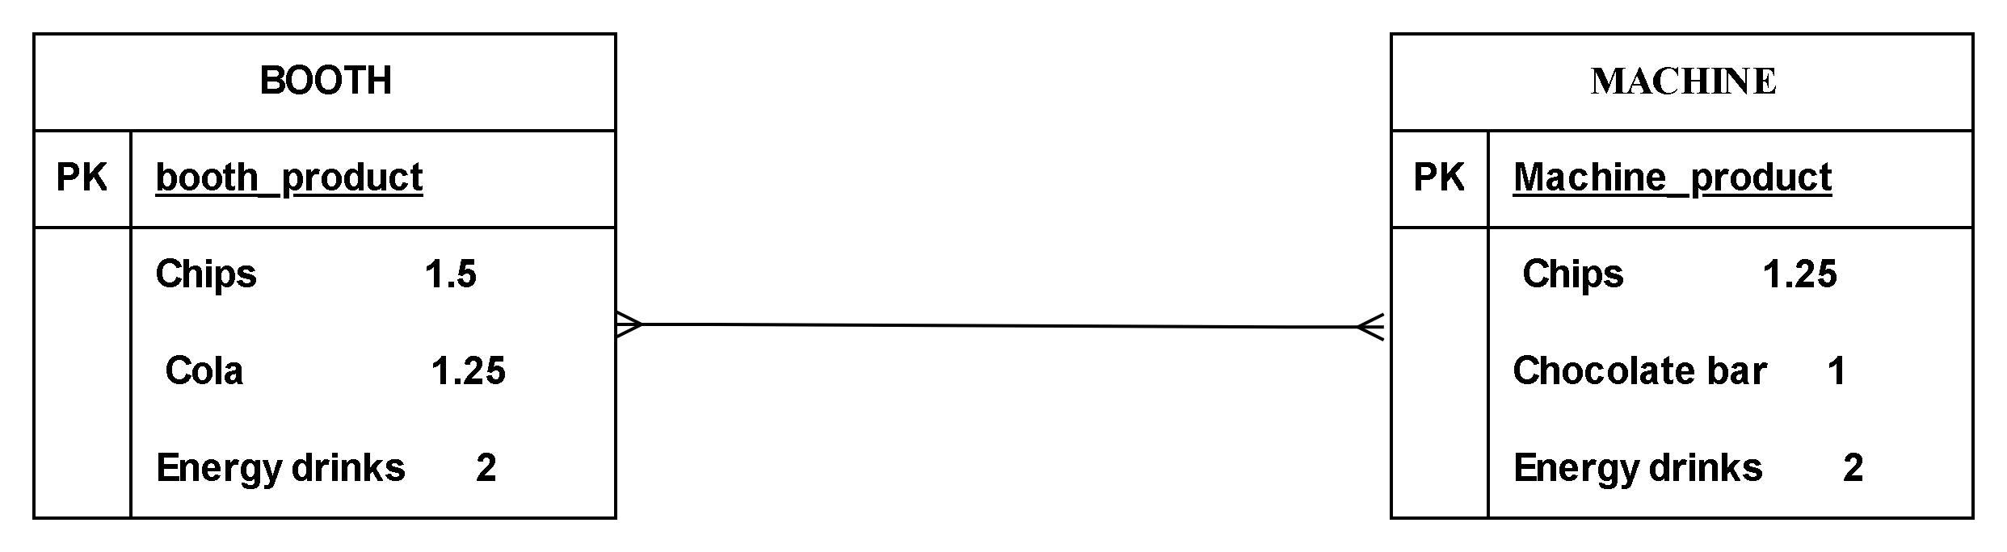

11. Table of (Booth ∪ Machine )
PRODUCT | PRICE
Chips | 1.5
cola | 1.25
Energy drinks | 2
chips | 1.25
Chocolate bar | 1

- Table of (Booth ∩ Machine)
This means that all products that both match
PRODUCT | PRICE
Energy drinks | 2

- Table of machine difference booth
This means that the rows that are in machine and not in booth
PRODUCT | PRICE
Chips | 1.25
Chocolate bar | 1

- Based on the ERD description we have a many-to-many (M:N) relationship between DRIVER and TRUCK. To convert this to only 1:M relationships, we need to introduce an associative entity so as to convert it to 1:M relationship.

From the figure the model is M:N relationship to convert it to the 1:M relationship we need to add an associative entity which is assignment that would help break it from M:N to 1:M.
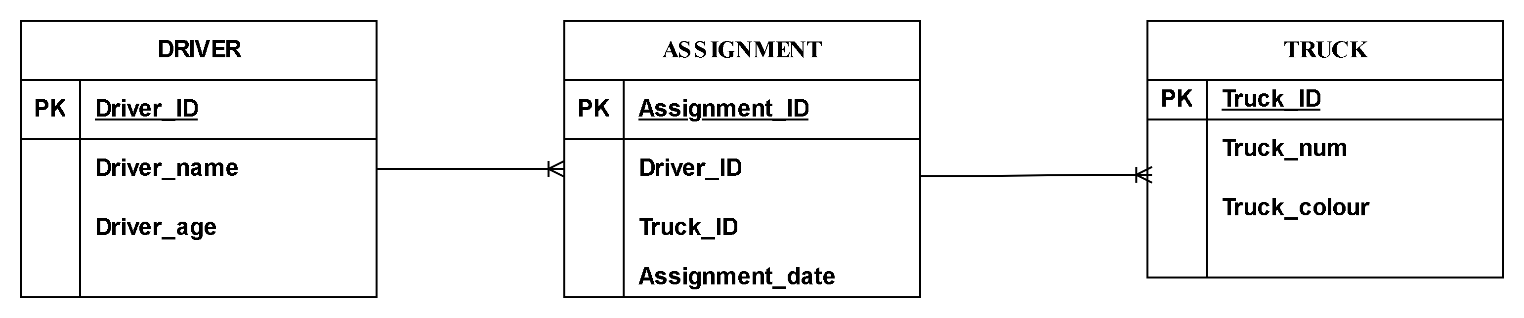

15.Homonyms these are entities with the same name but different meanings.
Synonym in database is a database object that provides another name for an existing object

Reasons to avoid homonyms and synonyms
- Cause confusion
- Lead to data redundancy
- Make queries and maintenance harder
- A 1:M (one-to-many) relationship is implemented by placing the primary key of the "one" side table as a foreign key in the "many" side table.
Implementation Step:Create the first table with its own primary key then create the second table with its own primary key and a foreign key column with reference to the primary key of the first table
Example; A database with the table of parent the parent_name is given as the primary key then the second table of child it will have its own primary key which is the child_name and with the foreign key that references to the table of parent which is parent_name in which it is the primary key in the parent ta ble
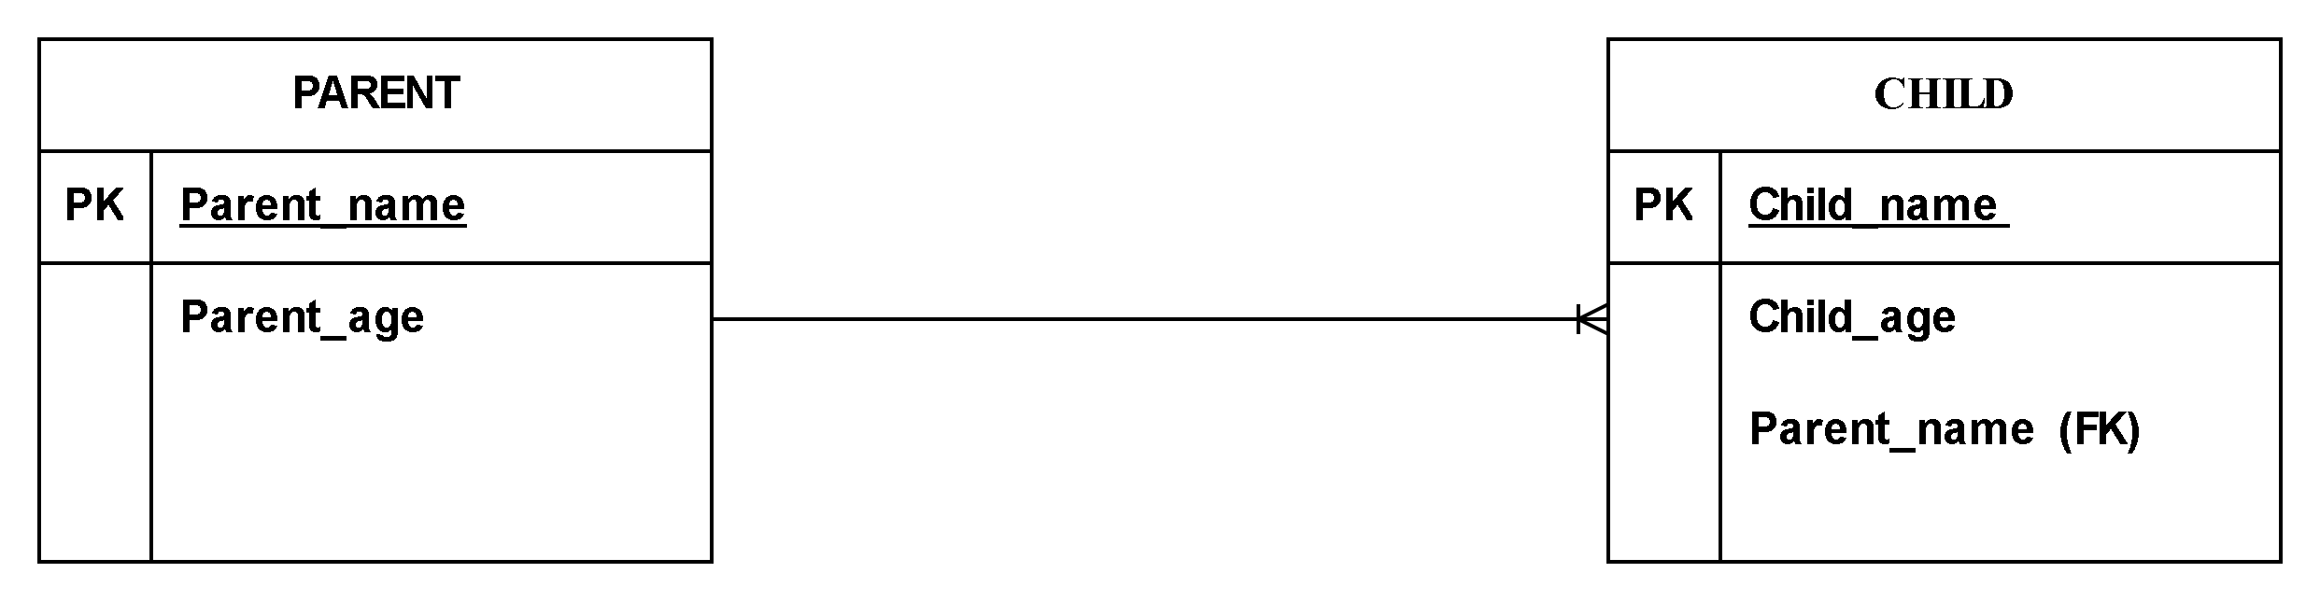
- 17.
Table Name: Identifies the entity being represented. Example in the figure the table name is Table of Employees.
Attributes:Each represents a characteristic of the entity has a name and data type. Example in the figure the attributes are EMP_NUM, EMP_LNAME , EMP_INITIAL, EMP_FNAME ,DEPT_CODE and JOB_CODE.
Tuples: Individual records/instances of the entity .
Primary Key:Uniquely identifies each row cannot contain NULL values must be unique for each row. Example in the table of employee the primary key is the EMP_NUM
Foreign Keys:Columns that reference primary keys in other tables establish relationships between tables. Example if there was a table of payment the reference key would become EMP_NUM.
Data Types: Defines the kind of data stored in each column
Constraints: Rules for data integrity (NOT NULL, UNIQUE, CHECK, etc.)

- The primary keys are DIR_NUM and PLAY_CODE
- The foreign key is DIR_NUM

- 