MARACOOS: MID-ATLANTIC OCEAN INTELLIGENCE
The ocean information system that helps protect lives, commerce, and coastal communities
A concise case for sustaining the regional delivery system of the U.S. Integrated Ocean Observing System (IOOS)
MARACOOS makes federal ocean data operational. It connects observing assets, models, and data systems to Coast Guard searches, port decisions, flood response, beach safety, and marine operations across the Mid-Atlantic.
 | UP TO 66%  smaller search area in a documented Mid-Atlantic HF-radar test | SINCE 2009  surface-current data delivered for Coast Guard search planning | 10%  coverage lost from the regional current map during one station outage

What IOOS is — and why MARACOOS is essential
IOOS is the nation’s network of ocean sensors, buoys, high-frequency radar, gliders, models, and data systems. MARACOOS is the regional layer that turns those pieces into a dependable service for the Mid-Atlantic.  The important distinction: the federal investment does not end at a sensor. MARACOOS maintains the chain from observation → reliable data → forecast → local decision.  - Observe — HF radar, buoys, water-level sensors, cameras, and partner systems.  - Connect — quality control and data delivery into federal and regional tools.  - Translate — models, maps, forecasts, and direct support for local users. |  |  |  | 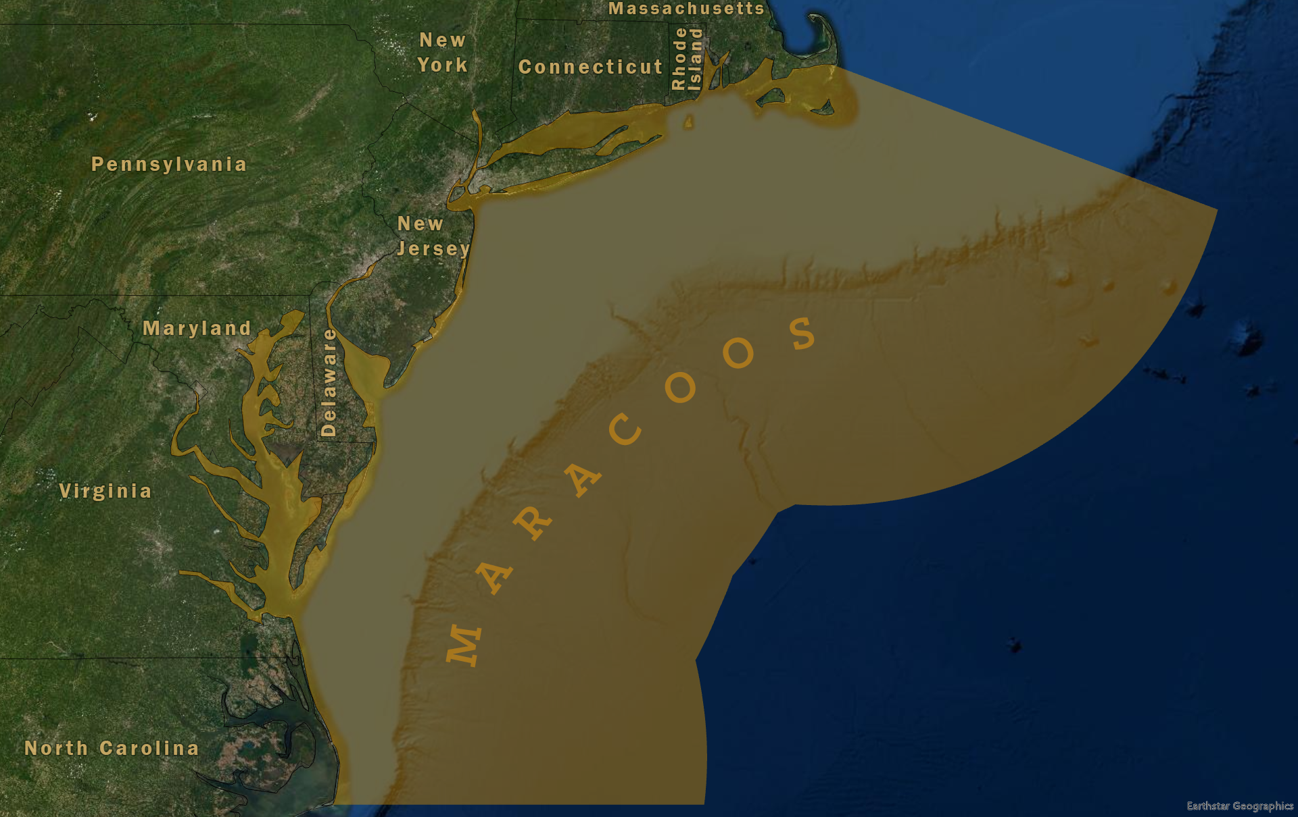  MARACOOS regional observing coverage
OBSERVE  radar • buoys • sensors | → | CONNECT  quality-controlled data | → | PREDICT  models • forecasts | → | DECIDE  search • navigate • prepare • operate

Three documented decision pathways
1 SEARCH AND RESCUE
The decision: Define where to search for a person or vessel in the water.
MARACOOS role: HF-radar currents and regional predictions support Coast Guard SAROPS drift planning.
Documented evidence: A test case reduced the modeled search area from 36,000 to 12,000 km²; results vary by incident.
2 PORTS AND NAVIGATION
The decision: Judge transit timing, under-keel clearance, bridge clearance, and safe vessel movement.
MARACOOS role: Real-time water-level, current, and air-gap observations support harbor pilots and vessel operators.
Documented evidence: Delaware River and Bay PORTS includes 11 water-level stations and 3 bridge air-gap sensors.
3 COASTAL HAZARDS
The decision: Understand flooding and water conditions as an event unfolds and decide when to act.
MARACOOS role: Forecasts are paired with observations and flood-view cameras for local situational awareness.
Documented evidence: MARACOOS provides a flood-watch view combining New York City and Hoboken cameras with observed and forecast water levels.
WHY THIS MATTERS: These are shared public capabilities. One maintained regional system supports many agencies and industries without each user building a separate observing network.
WHY THE REGIONAL LAYER HAS NO SUBSTITUTE
Federal infrastructure, translated into decisions close to home
1 FEDERAL SYSTEMS USE THE DATA  MARACOOS observations and models flow into Coast Guard search planning, NOAA navigation services, and regional hazard tools. A gap in the observing or data chain can weaken products funded elsewhere in the federal budget. | 2 THE REGIONAL WORK HAS NO EASY REPLACEMENT  MARACOOS operates regional assets, integrates partner data, maintains specialized products, and works directly with users. Downstream agencies consume the information; they are not structured to recreate the full regional network.

The economy and public missions this system serves
MARACOOS is shared infrastructure—an input to economic activity and public safety, not the sole producer of those outcomes. The strongest case is practical: high-value decisions already rely on the system, and the cost of losing continuity can be far larger than the cost of maintaining it.
EMERGENCY RESPONSE  During Sandy, NOAA reported IOOS-supported warnings informed a $10 million Navy sortie of 80 ships, and 23,000+ containers were diverted to alternate ports. The $500 million damage figure is a historical counterfactual, not measured savings. | MARITIME COMMERCE  Water levels, currents, and clearance observations reduce uncertainty for commercial navigation and port operations. | COASTAL COMMUNITIES  Flood views, water-level forecasts, and beach-condition information support emergency managers and public-safety decisions.
FISHERIES & BAY USERS  Short-term Chesapeake Bay forecasts help watermen, boaters, and environmental managers plan on-the-water activity. | OFFSHORE OPERATIONS  MARACOOS tools combine wave and wind conditions to identify potential marine work windows. | PUBLIC DATA ACCESS  Shared maps, forecasts, APIs, and expertise let many users benefit from one interoperable observing system.

What sustained federal funding protects
FUNDING KEEPS THE CHAIN WORKING  - Coverage — operating sensors and redundancy across high-risk areas  - Reliability — quality control, data delivery, archives, models, and forecasts  - Local value — tools and staff that adapt national information to regional users |  | FLAT OR REDUCED FUNDING CREATES COMPOUND RISK  - Gaps — less coverage and confidence when conditions change quickly  - Delays — slower replacement of aging sensors and data systems  - Fragmentation — less capacity to translate federal data into usable local services
THE ASSET  One interoperable regional system serving many missions. | THE RISK  Breaks anywhere in the chain reduce the value of every downstream product. |  | THE CHOICE  Maintain continuity now or pay more to rebuild capability after it is lost.
CLAIM DISCIPLINE
The 66% search-area result is one documented test case, not an average for all incidents. The Sandy damage figure is a historical counterfactual, not measured MARACOOS savings. PORTS valuations describe NOAA systems and should not be presented as MARACOOS return on investment. These limits strengthen—not weaken—the central argument: MARACOOS is operational infrastructure with a traceable role in consequential decisions.
THE CONGRESSIONAL TAKEAWAY
Sustain and strengthen MARACOOS / IOOS funding so the Mid-Atlantic keeps one reliable ocean-intelligence system—not a patchwork that fails when lives, cargo, and communities depend on it.
Request a state- or district-specific briefing on the ports, beaches, fisheries, emergency managers, and marine industries served by the network.
Selected sources: NOAA National Ocean Service 2013 Annual Report; IOOS/USCG HF Radar SAR project; IOOS Association maritime safety summary; Rutgers Center for Ocean Observing Leadership; NOAA Delaware PORTS report; MARACOOS Insights; Virginia Institute of Marine Science CBEFS. Claims and limitations are drawn from the IOOS Economic Impact Evidence Matrix.

