**NEAR EAST UNIVERSITY**

**FACULTY OF ENGINEERING**

**DEPARTMENT OF COMPUTER ENGINEERING**

**WEB-BASED STUDENT ATTENDANCE SYSTEM**

**GRADUATION PROJECT COM-490**

**JERUMEH EMMANUELLA AFUOBUE**

**ASSIST. PROF. DR. JOHN BUSH IDOKO**

**NICOSIA – 2000**

**ACKNOWLEDGEMENTS**

First, I would like to thank my supervisor Assist. Prof. Dr. John Bush Idoko for his invaluable advice and belief in my work and myself over the course of this Graduation Project.

Second, I would like to express my gratitude to Near East University for the scholarship that made the work possible.

Third, I thank my family for their constant encouragement and support during the preparation of this project.

Finally, I would also like to thank all my friends for their advice and support.

**ABSTRACT**

A **Student Attendance System** as the name implies is a digital solution designed to efficiently record and manage students' daily attendance in educational institutions. This attendance system is a very important aspect of academic institutions to monitor participation, ensure compliance, and maintain accurate records of students.

Traditional methods, such as the manual attendance registers, are prone to errors, inefficiency, as well as they can be very time consuming. This project presents a Student Attendance System that automates the process, making it more reliable, efficient, and accessible.

The system is designed to be implemented in educational institutions, applying technology to improve attendance management. By utilizing a database driven approach integrated with web or mobile applications, the system helps to minimize human error, enhances real-time tracking, and provides comprehensive attendance analytics. This project aims to improve the accuracy of attendance records, reduce administrative workload, and offer a seamless experience for students and faculty.

**INTRODUCTION**

Attendance tracking is an important administrative task in ***educational institutions***. However, many schools and universities still rely on the traditional/outdated, paper-based attendance systems that involve manual record-keeping. These traditional methods are time-consuming, prone to inaccuracies, susceptible to manipulation and majority of the time they get lost especially when they’re recorded in papers that can be easily be lost. They often lead to errors, loss of data, and difficulties in generating reports. Additionally, manual tracking consumes valuable classroom time that could otherwise be used for learning.

With the advancement of technology, there is a growing need for an automated solution that simplifies attendance management while maintaining accuracy and efficiency. A more efficient and automated system is required to address these issues and ensure a reliable and transparent attendance process.

**A student attendance system is very crucial and as a result of this it has its purpose** ***(Aim as to why this is important):***

* To develop an automated Student Attendance System that replaces manual record-keeping.
* To enhance accuracy and reliability in attendance tracking.
* To minimize the burden on teachers, staff as well as students.
* To provide real-time data access for faculty and students.
* Provides insights into student participation patterns.

**WHEN DISCUSSING THE PURPOSE OF THE STUDENT ATTENDANCE SYSTEM, WE ALSO ADDRESS THE “WHY,” WHICH HIGHLIGHTS THE SIGNIFICANCE OF THE PROJECT:**

The implementation of a Student Attendance System will bring lots of benefits, including improved efficiency, reduced paperwork, and enhanced accuracy in maintaining student records. It will also facilitate better decision-making for educators by providing insights into attendance patterns, helping in identifying students who may require additional support.

By combining technology into attendance tracking, this project aims to modernize academic administration and create a more organized and effective learning environment.

**Where is this project applicable?**

* Schools, Colleges, and Universities – To monitor class attendance and student participation.
* Training Institutes & Workshops – To track attendance for certification and participation records.
* Corporate Training Programs – For tracking employee training sessions.
* Online Learning Platforms – To ensure student engagement in virtual classrooms.

And many more.

In conclusion, the Student Attendance System simplifies attendance management by automating the process, reducing errors, and saving time. With real-time tracking and easy access to records, it improves accuracy and efficiency for students and faculty. This system enhances organization, promotes accountability, and modernizes attendance tracking in educational institutions.

**ABOUT PROJECT**

The Student Attendance System is an important part of academic institutions. The traditional attendance systems, such as manual roll calls and paper based registers, are often time consuming and most definitely open to errors in most cases. In response, new and modern technological solutions have surfaced, making use of things like *biometric authentication, QR codes, and facial recognition*.

My literature review will delve into existing student attendance systems and compare their effectiveness, reliability, and scalability.

**EXISTING ATTENDANCE SYSTEMS**

1. **The Manual and Paper based systems:** Right from time (back in the days even till now), educational institutions have always been known to use the manual or paper based method to take attendance of students. While this method is simple and easy to use as well, it has its downside which is the fact that it’s open to all sort of errors, inaccuracy and sometimes maybe loss of records.
2. **Biometric based attendance systems:** Biometric attendance systems, especially fingerprint, ensure a higher accuracy in identifying students. This system helps to reduce the possibility of proxy attendance as well as unauthorized access. However the downside is that it requires significant hardware investment and may also face hygiene concerns, especially post pandemic.
3. **Facial recognition attendance systems:** This system automates attendance tracking using AI-driven image processing. It removes physical contact and reduces fraudulent or multiple attendance attempts. However, the downside is that challenges include high implementation costs, privacy concerns, and potential biases in recognition algorithms.
4. **QR code based attendance systems:** Some academic institutions use QR codes that students scan using their smartphones to mark their attendance. This system is cost effective and easy to use but it may suffer from issues like QR code duplication and negligence of student.

**COMPARISON WITH THE STUDENT ATTENDANCE SYSTEM**

The Student Attendance System makes us of the modern technologies to improve accuracy, efficiency, and security. Unlike the manual methods, it automates attendance tracking, reducing administrative workload. Compared to QR-based systems, it minimizes misuse risks. Also, it ensures data security, offers real time reporting, and is scalable for institutional needs.

**COMPARISON TABLE**

|  |  |  |  |  |  |
| --- | --- | --- | --- | --- | --- |
| **Feature** | **Manual or Paper based systems** | **Biometric based systems** | **Facial recognition based systems** | **QR-code based systems** | **Student attendance systems** |
| **Accuracy** | Low | High | Moderate | High | High |
| **Cost** | Low | High | Low | High | Moderate |
| **Setup** | Low | High | Low | High | Moderate |
| **Data security** | Low | High | Moderate | High | High |
| **Real-time reporting** | No | Yes | Yes | Yes | Yes |
| **Scalability** | Low | Moderate | High | High | High |

**CONCLUSION**

My review shows the limitations of traditional attendance methods and the advancements offered by the modern systems. While biometrics, and facial recognition have all proven to be effective, each has their downsides in terms of cost, security, and few other things too.

The Student Attendance System thrives to optimize accuracy, reduce students’ trickery, and provide real time insights while maintaining affordability and ease of implementation.

**METHODOLOGIES USED IN MY STUDENT ATTENDANCE SYSTEM PROJECT**

**RESEARCH DESIGN**

My project is a **Web-based Student Attendance Management System** designed to streamline and track the recording, viewing, and reporting of student attendance in a classroom setting. **Students and administrators (admins)** are the two main user roles that this attendance system is intended to support. While the administrator looks after and manages all attendance data, student records, and report generation, the students will be able to use the system to mark their attendance and even view their reports.

The main goal of this project is to create something that is a functional, easy-to-use, and secure attendance system that reduces manual work and paperwork, minimizes errors in record-keeping, and provides accurate statistics through reports. Unlike the traditional (old) attendance registers, this system collects data digitally and makes it more accessible.

This project is **a full system development project** that involves planning, database design, backend logic implementation, frontend interface design, and integration of features like export to **EXCEL/PDF**, attendance percentage calculation, and **dark/light** mode preference tracking. The system is built as a **real world application** using web technologies to solve a specific problem faced in many educational institutions.

**DATA COLLECTION**

In gathering information for the development of this Student Attendance Management System, I depended primarily on **online research** and **review of similar systems**. I researched various open-source student attendance systems and their features to understand how they function, what tools that were used for them, and which common features are included.

One of the key references was a system hosted on Sourcecodester.com, which helped me understand traditional (old) attendance systems. However, I picked out areas for improvement in terms of user experience and role specific functionality. This research of mine informed my decision to build a more role based system where students and administrators (admins) have clearly defined tasks.

Additionally, I did study a few **developer forums**, **documentation**, and **tutorials** on platforms like W3Schools, Stack Overflow, and also GitHub to find best practices for implementing functionalities like session management, data export, PDF generation, and login-based access control.

Although I did not conduct any interviews or surveys whatsoever, I based many of my decisions on **user interface patterns** commonly seen in educational systems, with a focus on simplicity, clarity, and accessibility for both students and administrators (admins).

**TOOLS AND TECHNOLOGIES**

In the developing of this Web-based Student Attendance System, I used the following tools and technologies;

1. **HTML** and **CSS**: I used this to create the structure and design of the web pages, including both the student and administrator (admin) dashboards. CSS was used to style the interface and implement features like light/dark mode.
2. **JavaScript**: I used interactive features such as switching between light and dark themes and enhancing user experience on the frontend.
3. **PHP**: This served as the backend language for processing forms, handling authentication, interacting with the database, and generating vital content like reports and tables.
4. **MySQL** (via **phpMyAdmin**): I used this as the database system to store student information, attendance records, and other important data. The phpMyAdmin was implemented for database management and testing queries. 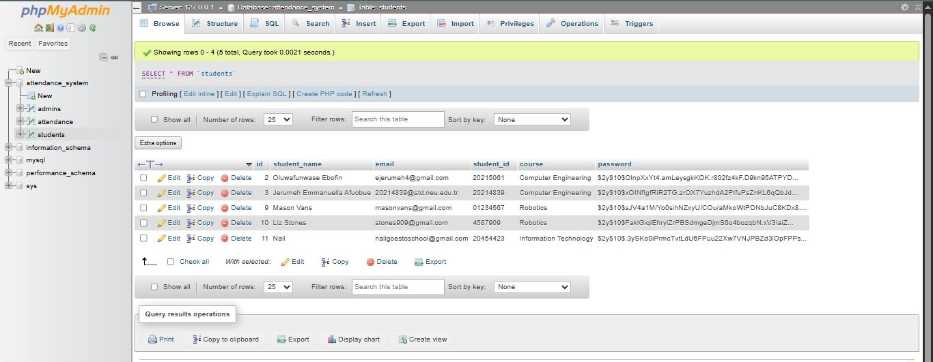

1. **Fpdf**: This is a  PHP library I used to generate PDF reports of attendance records.
2. **PHPExcel**: I used this so as to allow exporting reports in Excel format for easy sharing or record-keeping.
3. **Localhost (XAMPP)**: The entire system used for this project was developed and tested locally using XAMPP, which provided the necessary Apache and MySQL services.

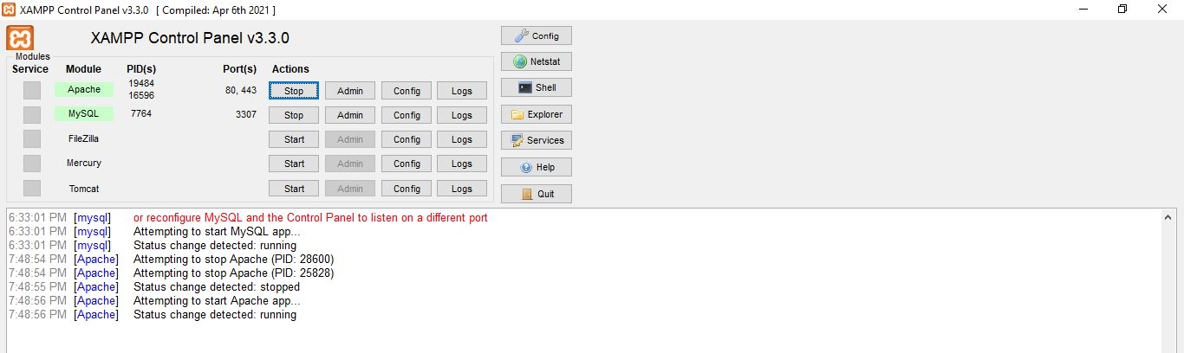

**STEP-BY-STEP PROCESS**

**Project Planning and Research:**

1. I began by pinpointing the need for a simple and efficient student attendance management system that could be used by both students and administrators (admins).
2. I also made sure to study some existing systems to understand their structure, features, and shortcomings, and compared it to the features I planned to implement for mine.

**Requirement Gathering**

I made a list of the key functions I wanted to include in this system, which are:

* + Student features: Mark attendance, view report, export to Excel/PDF.
  + Admin features: Manage students, manage attendance dates, generate reports, view attendance.

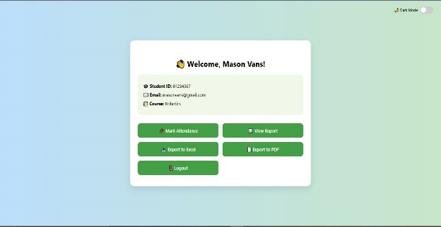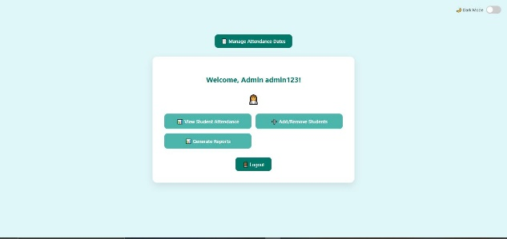

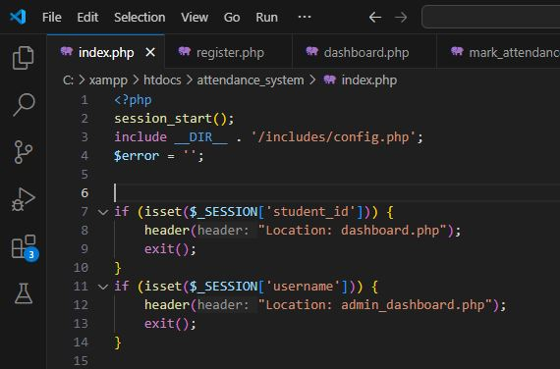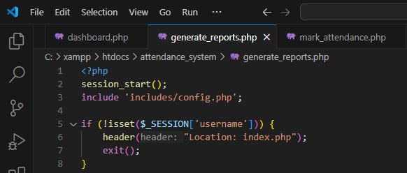

**Database Design and Setup**

* Using **phpMyAdmin**, I created a MySQL database with tables such as:
  + **students**
  + **attendance**
  + **admins**
* I placed primary/foreign keys for data relationships and enabled session control for user access.

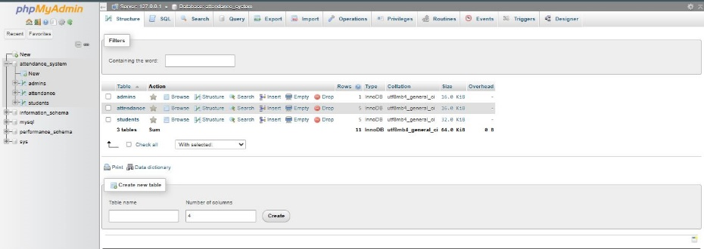

**Frontend Development**

* I designed the user interface using **HTML** and styled it with **CSS** to go with so as to create a clean and responsive layout for both dashboards (admin and student).
* I also put in a toggle for light and dark mode using **JavaScript**, ensuring user experience preferences were considered.  
  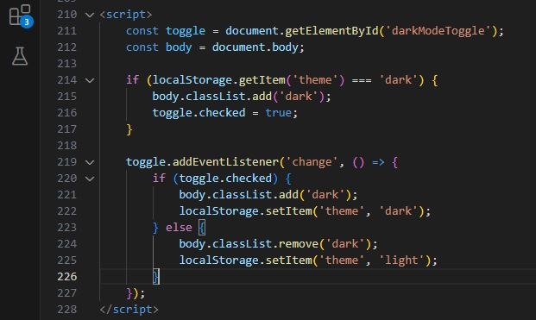

**Backend Development**

* While using **PHP**, I connected the frontend to the database to handle the login, session management, and dynamic data display.
* I also implemented functionality for students to mark attendance with checks in place (e.g., by date).
* I created admin pages to add/edit/delete students, manage attendance dates, and view records.

**Report Generation**

* I did add features for both students and admins to **view attendance reports**.
* I used **Fpdf** to generate downloadable PDF reports.
* I also used **PhpSpreadsheet** for Excel export.

**Security and Validation**

* I included session checks to restrict page access to only logged-in users.
* Form validations and input sanitization were added to prevent SQL injection and invalid data entry.

**Testing and Debugging**

* I tested the system thoroughly by creating test student accounts, marking attendance on different dates, and checking if reports were generated accurately.
* I made sure to test the export features and verified the content of PDF and Excel files.  
  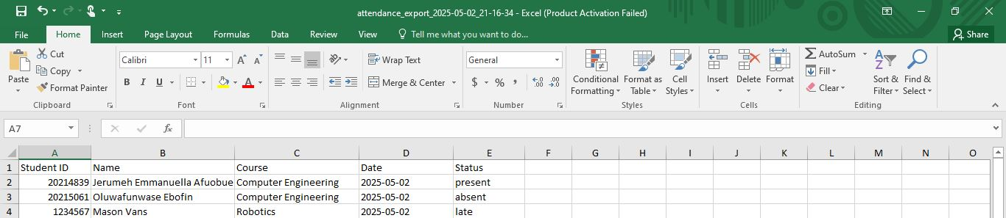

**Additional Features & Enhancements**

Taking an overall look at my project, I decided last minute to add a few several features/enhancements to improve its usability, functionality, and reliability. Below are a few added features that were introduced last minute to give my project a more unique, useful but yet simple look:

* 1. **Semester/Term Feature:**
* *About:*

The Semester feature allows the system to organize attendance records based on academic periods, such as Spring or Fall semesters. This allows the administrators (admins) to filter, review, and export records within specific timeframes.

* *How It Works*
* **Admin Panel:**

Admins can by themselves create new semesters from the database. The semesters available for now includes:

Semester name (2024/2025 Spring Semester) **with Start date and an End date**

Semester name (2024/2025 Fall Semester) **with Start date and an End date**

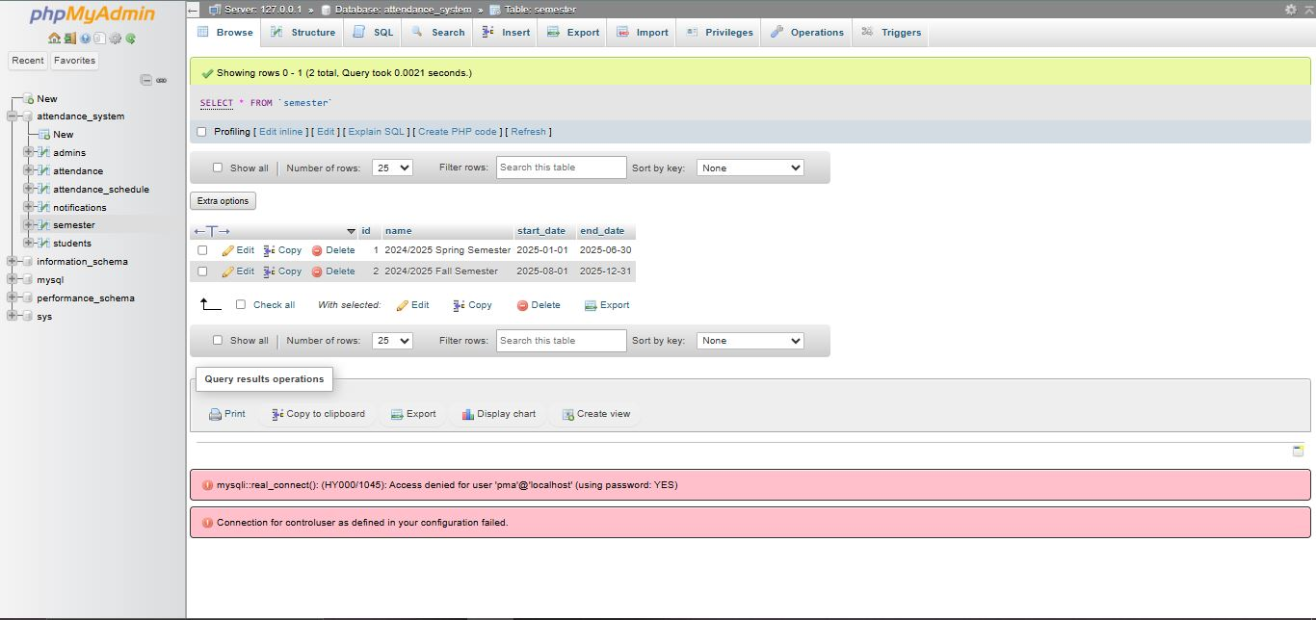

* **Attendance Scheduling:**

A dropdown is made available when scheduling a new attendance session, there the admin is able to select a semester.

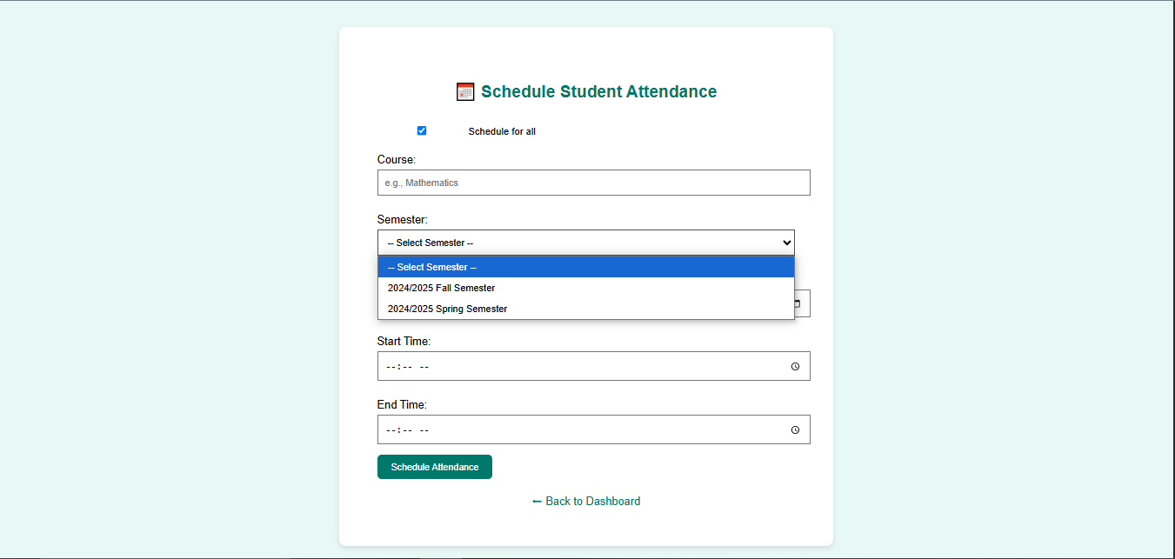

* **Attendance Tying:**

Each attendance schedule and student marking is associated with the selected semester, ensuring easy filtering and reporting.

* *Benefits*
* Detailed reporting per academic term
* Makes analysis very easy
* Helps schools follow their academic calendar

2) **Schedule for All Students (Bulk Scheduling):**

*- About:*

To make the scheduling process very easy and understandable, a "Schedule for All Students" option was added. This allows the admin to be able to schedule a session once for every student in the database. This helps to avoid repetitive manual entries as well as time wastage on scheduling one by one.

* *How It Works*

A checkbox labeled “Schedule for all students” is set to appear on the attendance scheduling form when an admin is about to schedule an attendance. And when the box is checked, the student dropdown is then hidden. When unchecked, admins can manually pick a student to schedule attendance *(but this takes time, if students are a lot but can be used for just a few students)*.

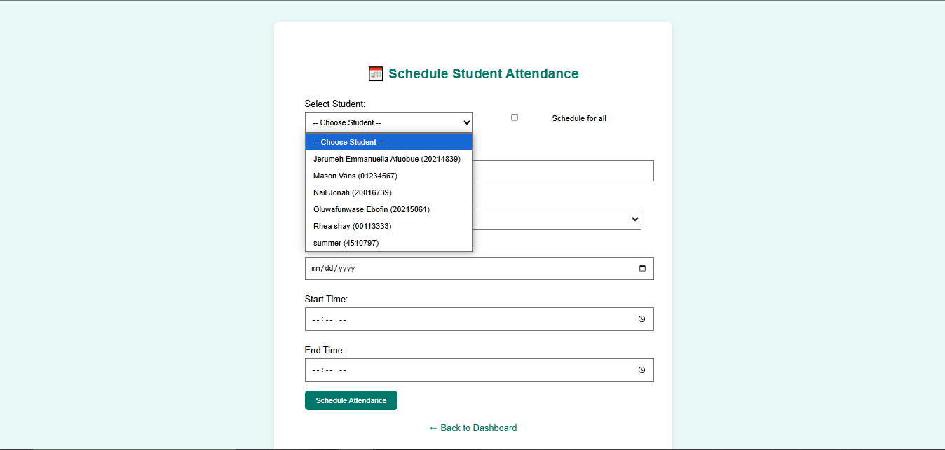

3) **Refined Time-Based Logic for Present, Late, Absent:**

*- About:*

The system categorizes each attendance mark as Present, Late, or Absent based on how close the student marks it to the scheduled time.

* *How It Works:*

The Start and End Time defines the attendance window.

* 75% rule logic: Within the first 75% of the session, the **present box** is made available to the student to mark themselves present for that course.
* Late: Within the last 25% of the session, the present box disappears and now shows the **late box** for students to mark themselves late for that course.
* Absent: The **absent box** is made available when the session scheduled is over or no attendance was marked at all.
* If no attendance date has been scheduled by the admin, the student mark attendance page will show**“No active attendance session found for you right now.”**
* *Example:*

Scheduled time for Course A: 8:00 AM – 9:00 AM

* Present: 8:00 – 8:44 AM
* Late: 8:45 – 8:59 AM
* Absent: After 9:00 AM

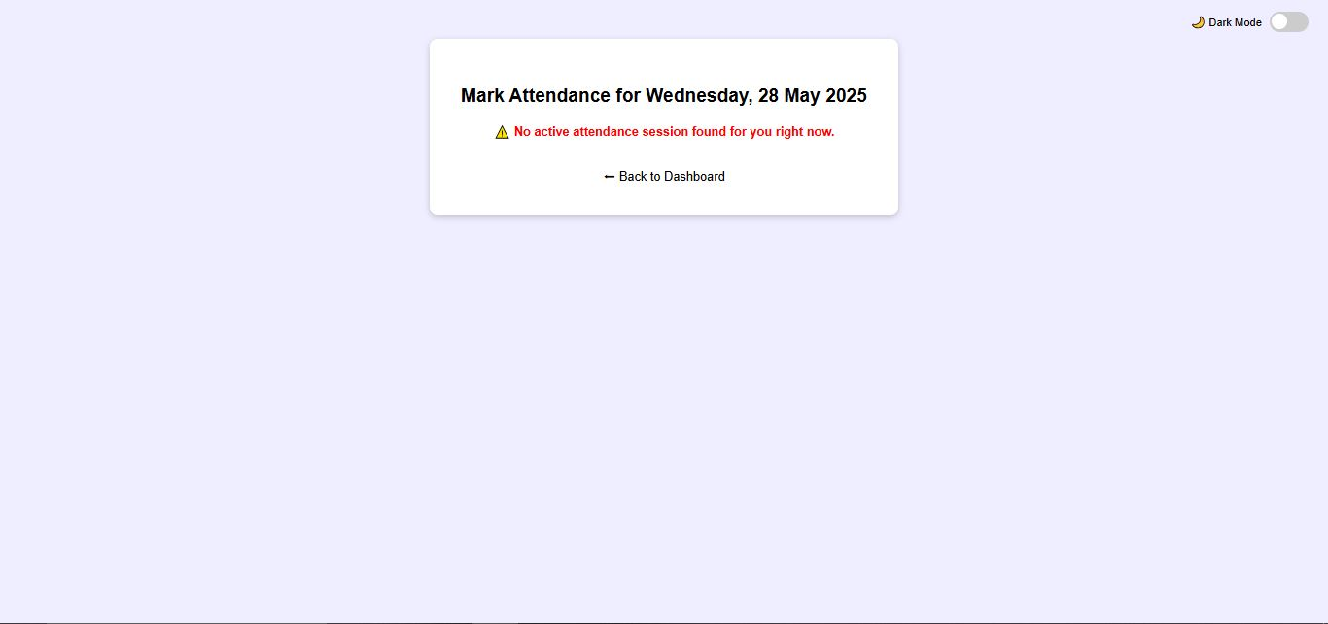

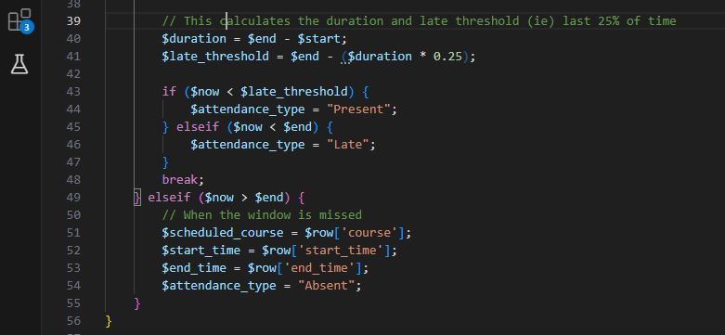

* 1. **One Attendance per Student per Course per Day:**
* *About:*

To prevent misuse or confusion, my web-based system prevents students from marking multiple attendances for the same course on the same day.

* *Functional Details:*
* When a student logs in and a course is scheduled for the day, if already marked, they get a **“You already marked attendance for (course)”.** message.
* *Benefits of this one attendance per student per course per day feature:*
* Eliminates duplicate data entry.
* Ensures system reliability and fairness.
* Prevents “back-and-forth” cheating or late-night marking.

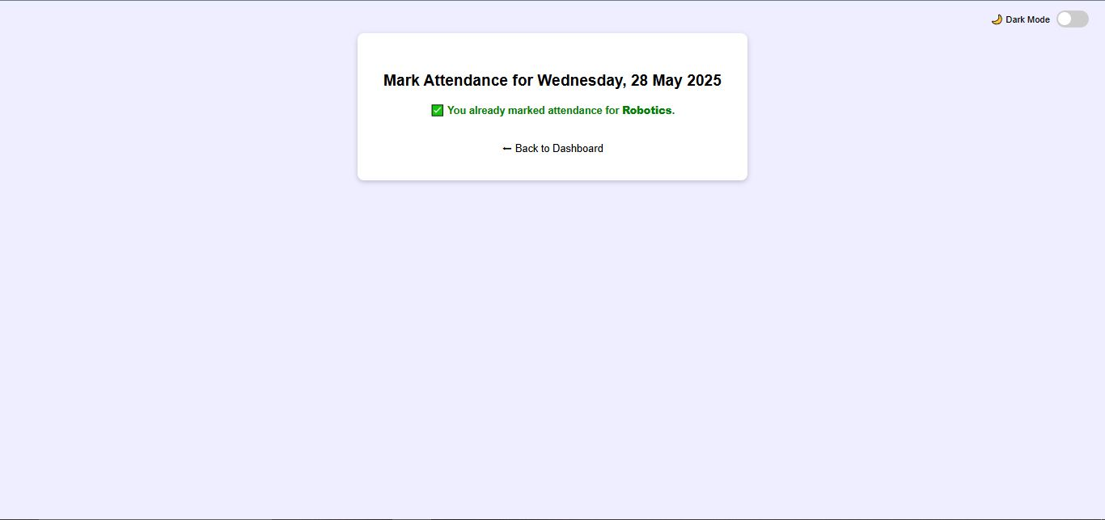

1. **Admin Notifications:**

* *About:*

Admins are now able to view a log of all student attendance actions which can be found in a notifications section.

* *Functional Details:*

When a student marks attendance, a row is inserted into the notifications table. Admin views it from the “View Notifications” section in the admin dashboard.

* *Fields displayed in the view notification page includes:*
* Student ID
* Course
* Status (Present, Late, Absent)
* Message (displays what course was marked and who marked it)
* Time (displays what time was marked for that attendance)
* *Benefits:*
* Real-time monitoring of attendance actions.
* Helps identify patterns or suspicious activities.

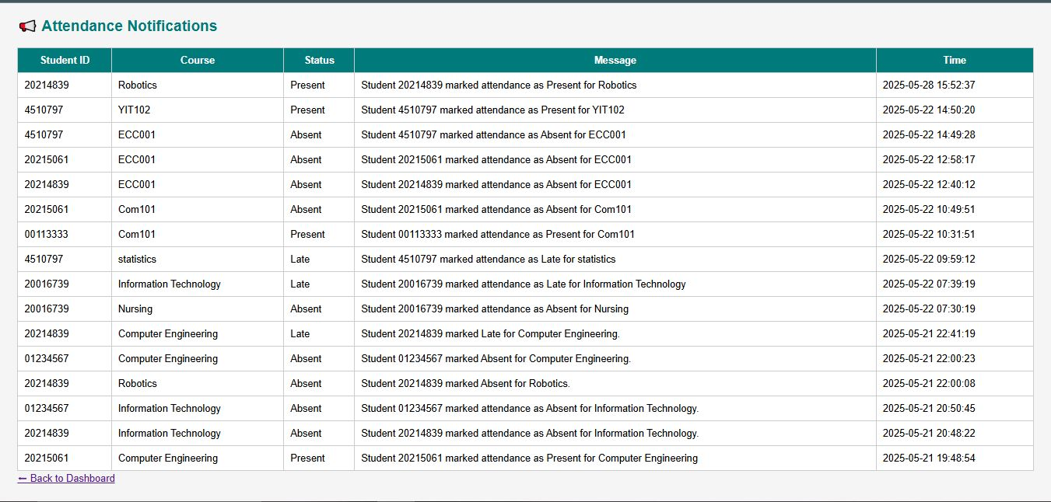

**JUSTIFICATION**

While developing this web-based student attendance management system, I thoroughly selected tools, technologies, and development methods that fit with the project’s goals of being user-friendly, practical, and efficient for both students and admins.

**Why did I choose PHP, MySQL, HTML, CSS, and JavaScript?**

1. **PHP:** I chose PHP as the server-side scripting language because it is widely supported, works easily with MySQL databases, and is very appropriate for web application development which clearly is what this project is.
2. **MySQL:** This was selected as the database system because of its reliability, ease of use, and seamless compatibility with PHP.
3. **HTML and CSS:** These were used to structure and style the interface, ensuring a clean and user-friendly design. I wanted users to easily navigate between marking attendance, viewing reports, and generating data, etc.
4. **JavaScript:** This was used because it is very important for interactivity, especially for features like the dark/light mode toggle, dynamic elements, and enhancing user experience without page reloads.
5. **LocalStorage:** I used this to persist user preferences, like dark mode, across different pages, improving usability.

* **Why I Used a Web-Based System:**

I chose to create a **web-based system** instead of a mobile app or desktop software so that it could be accessed from any internet-enabled device with no installation required. This increases accessibility for both students and admins, and also makes future updates easier to deploy.

* **Why I Included Features Like Mark Attendance and Report Export:**

The main idea of this project is to **reduce manual workload** and provide **real-time access to attendance data**. The ability for students to mark attendance themselves (with added security layers in development) and for admins to **generate reports**, **export data**, and **track attendance history** is essential in modern educational systems.

* **Why I Structured the Project into Dashboards:**

Dividing the functionalities into **Student** and **Admin** dashboards enables for there to be clarity as well as security. Each user (**Student** and **Admin)** has access only to features relevant to their role, preventing unauthorized actions and for simplicity.

* **Why I Collected Data from Online Sources:**

For research and planning, I depended on **online resources** and sample systems to understand standard practices, UI designs, and security concerns in attendance systems. This helped me avoid copying the same pattern and adopt best practices.

To conclude, the making of this web-based student attendance management system was guided by careful research, practical design decisions, and a focus on functionality and user experience.

**RESULT OF DISCUSSION**

The development of this project (Web-Based Student Attendance System) brought about very important improvements over traditional (old) manual methods. The system’s key objective to streamline the attendance process was met effectively through the integration of user-friendly interfaces, real-time functionality as well as automated reporting tools.

The result of the discussion of my Web-based Student Attendance System project talks about the conclusions and sole outcomes reached during the planning, development, and review phases. Below are the points that I summarized on what was decided and discovered.

#### **Decisions That I Made**

* I made a decision to implement a web-based student system using PHP, MySQL, JavaScript, HTML, and CSS.
* A login system with role-based access (Admin and Student) was finalized for managing system security and features which was unique compared to other types of this student system.
* The design was to incorporate options for marking attendance, exporting reports (PDF/Excel), and toggling dark/light mode.
* The system would also carry out one attendance entry per student per day to ensure data integrity.

#### **Work Items**

* Admin: Their job is to manage student records, set attendance dates, view and export reports.
* Students: Their job is to log in and mark attendance only once a day.
* I was the one involved in the developing and testing of this project. I Implemented session timeout, export functionality, and theme toggle (dark/light mode), and ensured the interface is mobile-friendly. I also perform testing to validate that the system meets all outlined requirements.

**TECHNICAL IMPLEMENTATION AND CODE STRUCTURE**

* The use of PHP and MySQL was a decision I made due to their ease of integration and wide support within the web development community.
* JavaScript was used to enhance interactivity, while HTML and CSS formed the foundation of the frontend.

#### **Problems That were Identified**

* There were issues including users being able to mark attendance multiple times a day; this was resolved with backend validation.
* There were a few challenges in session handling that were addressed by adding auto-logout for inactive users.

Also, some minor layout inconsistencies in different browsers were corrected through responsive design tweaks.

#### **Updates**

* Export functionalities were added successfully, allowing for smooth report downloads.
* Toggle between dark/light modes is functioning with LOCALSTORAGE to remember user preference.

Also, system testing showed positive results, with most features working as should be.

#### **Clarifications**

* The system is not intended for mobile app use at this stage but is fully responsive for mobile web browsers.
* The admin has full control over student data and attendance logs; students have limited access.

**DISCUSSION AND INSIGHTS:**

To test the project, the following things were carried out:

* I logged into a student’s account to mark attendance on a specific date.
* Then to the admin dashboard so as to confirm if the entry appeared immediately.
* I then exported the attendance record as Excel and PDF to ensure file generation worked.
* The system was refreshed and tested with dark mode enabled to confirm theme persistence.
* All forms were also tested for input validation (e.g., empty fields, duplicate entries).

#### **Testing Observations:**

* I made sure the attendance could only be marked once per day so as to prevent duplicates.
* Only registered students could access the dashboard and their attendance.
* Data consistency was observed with foreign key constraints in the database.

### **What Makes My Project Better?**

Compared to traditional (old) and existing systems;

* It offers real-time record access, unlike offline methods.
* Has both student and admin panels, making it suitable for shared usage.
* Exporting reports in both Excel and PDF is uncommon in basic systems.
* Dark mode UI, simple yet clean interface with session-based navigation.
* Attendance includes not just **“Present”**, but also support for **“Absent”** and **“Late”** statuses.
* Admin has control over the data and can generate summaries.

### **Comparison with Similar Projects**

Compared to other similar projects I found on SourceCodester, GitHub, and other platforms:

* I saw that many projects allow only admin control, while mine includes student access and self-marking.
* Some of these projects do not include the PDF/Excel export, dark mode, or have a more complex user interface.
* This project’s simplicity, clarity of navigation, and well-organized code make it easier to deploy and extend.

This project reveals how web technologies can address everyday institutional problems like attendance monitoring. By digitizing the process, the system reduces human error, saves time, and provides useful logic. Although this current version I made does not include any biometric or QR code scanning, it's been developed to take any form of future expansion.

On top of that, the project particularly talked about the importance of session control and user experience design in application development. Features like real-time feedback, theme toggling (dark/light mode), and data export significantly improved usability and gave the system a professional side.

**REFERENCES**

* W3Schools, “PHP MySQL Database,” 2023. [Online]. Available: <https://www.w3schools.com/php/php_mysql_intro.asp>
* Sourcecodester, “Student Attendance Management System in PHP and MySQL,” 2021. [Online]. Available: <https://www.sourcecodester.com/php/14623/student-attendance-management-system-using-php-and-mysql.html>
* Stack Overflow, “Handling Foreign Key Deletion in PHP MySQL,” 2024. [Online]. Available: <https://stackoverflow.com/questions/foreign-key-error-php-mysql>
* GitHub, “Attendance System Project Example,” [Online]. Available: <https://github.com/rickxy/Student-Attendance-Management-System>
* J. Smith, *Building Web Applications with PHP & MySQL*, 3rd ed., New York, NY: TechPress, 2020.
* PHP Manual, “Sessions in PHP,” 2023. [Online]. Available: <https://www.php.net/manual/en/book.session.php>
* GeeksforGeeks, “How to Export Data to Excel using PHP,” 2022. [Online]. Available: <https://www.geeksforgeeks.org/how-to-export-data-to-excel-using-php>
* TCPDF Documentation, “Generate PDF in PHP,” 2023. [Online]. Available: <https://tcpdf.org/docs/>