**Abstract:** This article is written to analyse the relationship between today’s smart education systems and their relationship with artificial intelligence. Firstly breaking down how AI is, or made suitable to understand education and learning patterns to be able to be used in educational platforms or by educational organizations, then through examples and further studies it is explained how the AI-powered smart education systems work overall.

For this regard many articles and papers upon artificial intelligence, smart education, AI applications and AI-powered platforms were deeply analysed and their fundamentals are briefly discussed upon to help the readers better understand whether if AI is important, or becoming an essential part of smart education or not.

**Introduction**

Artificial Intelligence (AI) is evidently becoming a bigger and bigger part of our lives. Starting from the weaker methods, called the Narrow AI (History of AI, Maryville University) in 1950s, AI has been developing in various methods, and lastly coming down to what we know as Generative AI; such as ChatGPT, MidJourney, DALL-E and more. Now, these AIs can generate images on command, can give entire class syllabuses just by the information provided on a written piece of paper, and can schedule an entire vacation for you within mere seconds. This fast and rapid development surely piqued a lot of potential methods for the AI systems to be used, and one of them, which is surely an important topic, was education.

Education is already switching to technology. Students in colleges and even in some high schools in some regions are seen with laptops and tablets instead of the old-schooled notebooks and pencils. Some elementary classrooms have smart boards to be able to easily access class materials and additional content. Blackboards and chalks are becoming rarer and rarer. However, that is not the only change that is happening in education.

Since the emergence of ChatGPT, even between the years of 2023 and 2024, the reported usage of it for schoolwork between the ages of 13 to 17 has been doubled (The Editors of ProCon Article History, Britannica). While this raises major concerns regarding unsolicited AI usage for students, another question that could be pitched would be how to use this enriched AI technology for smart education? In this article, we will look through the basics of smart education and how it is implemented or planned to to today’s AI systems, and the potential future appliances of this and how it may or may not work.

**AI In Education**

“Artificial Intelligence (AI) has the potential to address some of the biggest challenges in education today, innovate teaching and learning practices, and accelerate progress towards SDG 4.” This is the initial sentence by UNESCO regarding controlled AI usage in education. UNESCO’s vision regarding AI is to use it for equality in terms of access to research, to knowledge, and use this sort of AI within the boundaries of existing policies or regulatory frameworks. Moreover, they also claim that because AI is currently potentially violating a lot of laws, rules and regulations it is unusable in a formal way, however, they seem to be keen on changing that by 2030.

While UNESCO’s vision is one of many, it can be arguably stated that AI is here to stay. There seems to be no way from blocking AI from developing, or not allowing individuals from using it. Therefore, many sources and platforms, including educational organizations and institutions, are trying to develop ways to implement AI accordingly into their system, which we will delve deeper into later on. Since “smart” systems tend to render new technology and advancements into their own, AI is more likely bound to be a part of smart educational systems in the future.

With that said, briefly, what is a smart educational system and what are some examples of it?

**Smart Educational Systems**

“The requirement to develop a smart education system is critical in the era of ubiquitous technology (Nguyen, Tomy, Pardede).” Smart educational systems are systematic designs that focus on the learners and try to make it easier for them to access knowledge and, basically, learn. Smart education systems, while developing, consider the “hard” and the “soft” skills, such as analytical precision and emotional intelligence, respectively, and creates an environment to be creative and motivative. Thus, unlike the common misconception, a smart educational system does not focus on elements like regular entry to the system or the amount of tests that are solved by the student. It tries to be innovative and engaging for the learner.

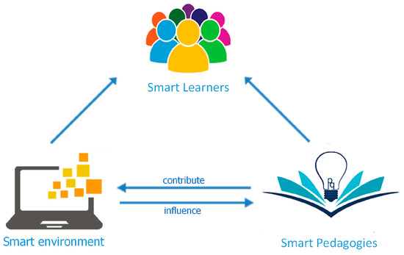  
Fig. 1, Smart Education.

Very briefly, as it can be seen from the figure above, smart education has three essential elements that coexist altogether. Smart environment, which will be exemplified later on in the article, constitutes the platform the learners are in. Smart learners represent the people using this system and being the students in it, while smart pedagogies are the ideas behind creating the innovative elements such as engaging and inspirational activities.

More related to our topic is the implementation of artificial intelligence into this equation. As it may be somewhat apparent, AI will most likely be used in the environment with the guidance and specifications of the bodies behind smart pedagogies. As it is also evident that for the sake of modern education smart systems are must have.

**AI Models**

There is a variety of AI models from very simple to complex designs, varying from generative AIs such as ChatGPT or DeepSeek, to video game mechanics-oriented AIs that regulate the response of the video game according to the player’s actions. With that said, AI Models vary.

Machine Learning (ML), being a subset of AI, is focused on “teaching” the machine. Learning from data and to make predictions based upon it, ML can be applied in applications such as identifying images, processing natural language, anomaly detection and so forth. For the process of learning to take place, however, an ML system needs labeled training data. They mostly rely on statistical models and algorithms, and this specifications tend to make an ML system faster than an average AI. ML is able to mostly conduct all of the appliances that made by AI, provided that its primary focus is data-driven learning.

A specialized subset of ML, Deep Learning (DL) may arguably be considered to take it to the next level and actually mimic human brain functions by conducting and using artificial neural networks. For instance, if a system recognizes images and speeches, it is most likely a DL system that is working to solve and identify it. As it might be guessed, to be able to train deep neural networks, DL needs an exponential amount of volumes of data to be trained. Moreover, because of their complex design and several layers of neurons, DL models are also sometimes referred to as “black boxes” (HPE Glossary). Since these networks are trained both by specialized hardware and parallel computing, it is considered to be the fastest form of AI out of all of them and has the potential to be used by the masses. DL systems can also be the most scalable because of their complex and multi-layered processing.

This is why, when we give examples of AI models specifically for smart education in this article, we will be referring to systems that are also created as a DL system.

According to a paper published at the International Conference on Computer Intelligence and Data Science (ICCIDS), there are four respective models that could be used in smart education. However, before delving deeper into that, the paper analyzes human understanding of learning and being educated, since the advanced AI models tend to mimic human brain, as mentioned before. First of these methods of learning is *Kolb’s learning theory model*. This model has four learning styles that are primarily Concrete Experience (CE), Reflective Observation (RO), Abstract Conceptualization (AC), and Active Experimentation (AE). These four elements are a mixture of two cycle states. Diverging (CE/RO) learners, according to the paper, tend to watch and gather information instead of any other method more, and rely on their imaginative excellency to overcome issues. Assimilating (RO/AC) learners, on the other hand, prefer more logical and sensible approaches to problems. Converging (AC/AE) learners solve issues, learn from them and use those learnings in other problems. Accommodating learners (AE/CE) are mostly hands-on, and they rely on their “guys” rather than findings. Second theory that is mentioned is the *Honey and Mumford learning theory model*. In this style, found by Peter Honey and Alan Mumford, also inspired from the previous model mentioned, learning is divided into four: activists, theorists, pragmatists and reflectors. Activists learn by action, brainstorming, group discussions and other “active” activities. Theorists tend more on models, ideas, theories to help with their learning processes. Pragmatists can put their learning into practice and learn better by seeing them in appliance. Reflectors, lastly, learn by watching, thinking, and reflecting on the events. Next to discuss briefly is the *VARK learning theory model*. VARK is the short for Visual, Aural, Read/write, and Kinesthetic styles that compose the model altogether. Visual side includes items or visuals such as maps, diagrams and charts, while the aural learning describes a preference for information, which is either heard or spoken. Read/write-ers learn the best from discussions and note taking, while Kinesthetic learners tend to include demonstrations, simulations, videos, movies, and other similar elements.

The reason why the paper talked about these models rather deeply is because a comparative analysis of them was much needed for the sake of understanding AI in smart education. In very essence, through these learning models 5 different AI models were introduced.

**Artificial Neural Networks (ANNs)**

Neurons, being interconnected with each other “mimicing” the human brain, and mostly used for classification tasks. In the context of the paper and the smart education AI model, it is suggested to be used for classifying learners by their learning style. Like briefly elaborated on above, if it is identified that X amount of learners learn better by images, while Y amount of them learn more effectively by demonstration and Z amount of people stick to theories, classification of these patterns and preferred learning models could help in any smart or non-smart education system to better evaluate and develop educational programs.

**Decision Trees**

These are tree-structured models that give possible outcomes of decisions. It is primarily thought to be used for personalized learning patterns based on the learners’ identified preferences. For instance, if, by answering certain questions or through prior data collected about a learner, now known that the learner prefers practice over theory, when putting an input about learning a specific subject on a Decision Tree, the tree would offer multiple paths and potential activities to complete for the learner to quickly gather the information in their own specialized way in the most effective way possible, making it another reliable AI product for smart education.

**Bayesian Networks**

Working on probabilities, Bayesian networks use direction-taken acrylic graphs and represent variables with what they depend on, thus, a graphical model in its essence. As it may be self-explanatory, these can be used to give any sort of probabilities or data that needs to be graphicized either during the education or to help improving that specific education with the data provided by the AI. When used appropriately, it can be arguably stated that it can be involved in a lot of complex educationary AI programs.

**Hidden Markov Models (HMMs)**

There are, undoubtedly, behavior of learners (or students) that are “hidden” by the lecturers at first. Not everyone is a blank sheet of paper. In this context, statistical models are most likely thought to be a Markov processing that is with unobserved (hidden) states. Thus, HMMs are, according to the paper, extremely helpful and at advantage while predicting behavior patterns of students and determining the differences and similarities between them.

**Genetic Algorithms**

Perhaps somewhat similar to HMMs, genetic algorithms are suggested to be good for constructing individualized paths and patterns for students through being inspired from natural selection. These evolutionary algorithms are role-modeling natural evolution and evolve their solutions, for lack of a better term.

Even though these are essential AI models that can be or are used in complex education based AI models today, they are not complete, real-life examples. Therefore, now we will explore a few in real life options of AI being used for smart education.

**Coursera**

One of the most commonly known examples of smart educational AI systems is Coursera platform. Some renowned universities such as Georgia Tech, Dartmouth College and Yale being a participant in their programs, classes that are in Coursera are taught by over 350 companies and universities (Korzekwinski, 2025). Coursera is powered by AI in more ways than one. First, after getting to know an account, or a student, more likely, through past activity, courses taken, what you are browsing and what you are actively interested in, it offers very specific courses and specifies them further over time, much like some of the specifications we previously mentioned. Next, Coursera is known to grade assignments and quizzes through AI-powered grading systems, allowing the learner to receive immediate feedback and showing what they did perfectly and what they were lacking in. Moreover, the platform also offers virtual tutors and chatbots to help further understand and engagingly learn and also to browse through the platform more easily. Auto translations of course materials, generating subtitles, transcribing full lectures, customizing learning paths through putting on more practices for the weak areas of a learner, assessing a user’s skills accordingly, summarizing courses, all are a part of the complex smart education platform of 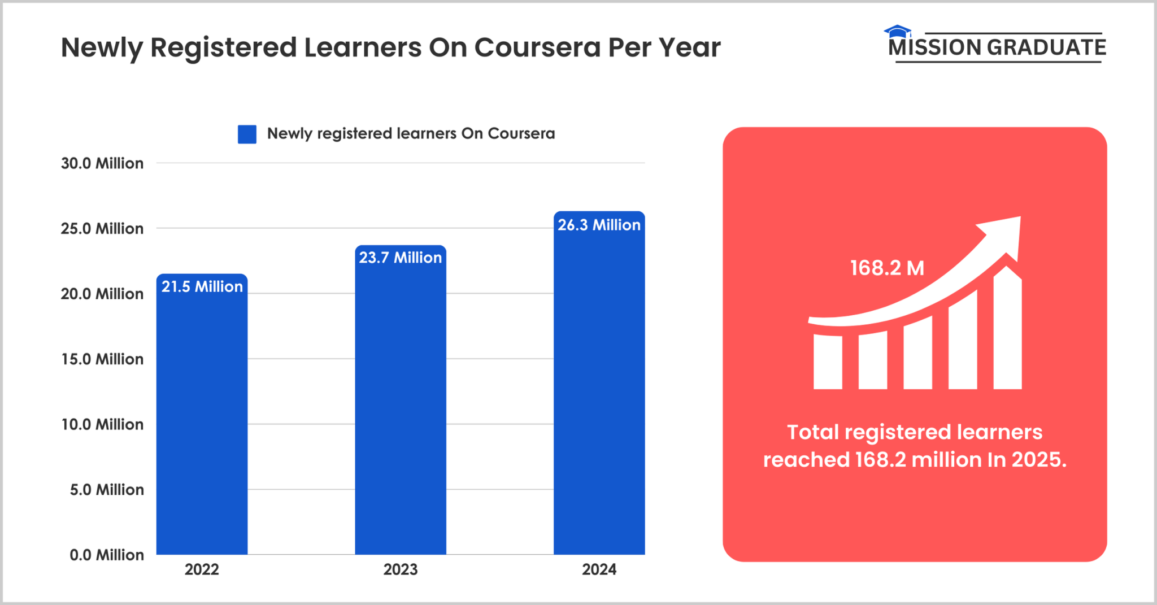Coursera being strongly AI-powered.

Fig. 2, Newly Registered Learners On Coursera Per Year Graph.

As it can be seen in the graph above, the number of users are on constant increase on Coursera. This alone shows the interest of students overall for AI-powered education hubs, and roughly 170 million people worldwide in 2025 have an account on Coursera, with the percentile of increase has been 29% in Q3 2024, and 22% on Q4 2024 (Winograd, 2025). This is also a strong indicator that these platforms are being status quo by each day passing.

**DreamBox**

Another popular platform in education to teach mathematics, DreamBox is yet another example of a smart education system that is powered by complex structures of artificial intelligence. The system the platform uses, Intelligent Adaptive Learning (IAL), is specifically designed for learning optimization by keeping students within their optimal “learning zone”, constantly checking what the student needs behind an AI-powered framework. Unlike a regular educational platform, giving every student the same template and the same materials to consume, this system specializes the materials according to each student’s needs. Furthermore, Extensive Data Collection and Analysis feature of DreamBox is rooted in a data driven approach, and gathers up to 50,000 data points per hour for each student (Fuel Your Digital, 2024). These data points include response times, problem solving skills and strategies, mistakes made, and so forth. Therefore, with these collected data real-time, they ensure that students are always within their Zone of Proximal Development (ZPD), where the learning period is challenging for the consumer but yet achievable. On top of all of that, DreamBox also uses virtual manipulatives to offer and change different shapes and designs according to the student’s learning behavior so they can visually comprehend the topics more clearly. Being able to do such sudden changes in real-time, adapting to the student while the student is actively learning is one of the key factors that suggests AI being incredibly helpful for the development of smart education.

Now that we explored not only the capabilities of artificial intelligence and what sorts of specifications are made for the AI to work properly enough to be used in education, we also delved deep into how those specialized AI formats made their ways into modern AI-powered smart education with a few examples, it is time to ask a question perhaps once again, and then follow up on the possible educational future that might be expecting us.

**How Important is Smart Education?**

Smart education is, as we mentioned in the beginning of this article, the version of education that technology has seeped its way into. Now we should ask how necessary smart education is and brainstorm upon it.

Traditional education arguably asks teachers and specific officers of specific departments or organizations to do everything manually. A teacher must keep track which questions they solved in the class, which topics they covered so far; an officer must follow up on the changes of the syllabus that was done that year, perhaps give warnings to the lecturers who are falling behind and do all of these by hand, one by one. However, with “smart” education, which could be traced all the way back to when computers made their way into educational institutions, educational life became easier. Right now, very simply put, every document can be written in minutes, printed in seconds. An electronic signature might spare one the bother to climb stairs and wait in the offices to get some specific person to sign a specific document. Thus, essentially, it would not be wrong to indicate that “smartness” in education saves time. On top of that, these days it does so much more. Smart boards in classes completely eradicated the need for teachers to write long descriptions or problems on the board, and just directly open the ready material, again, within seconds. Not to mention how virtual classes and online exams and assignments have practically “saved” education during COVID-19 pandemic back in 2020. In today’s world, it is so much more than that.

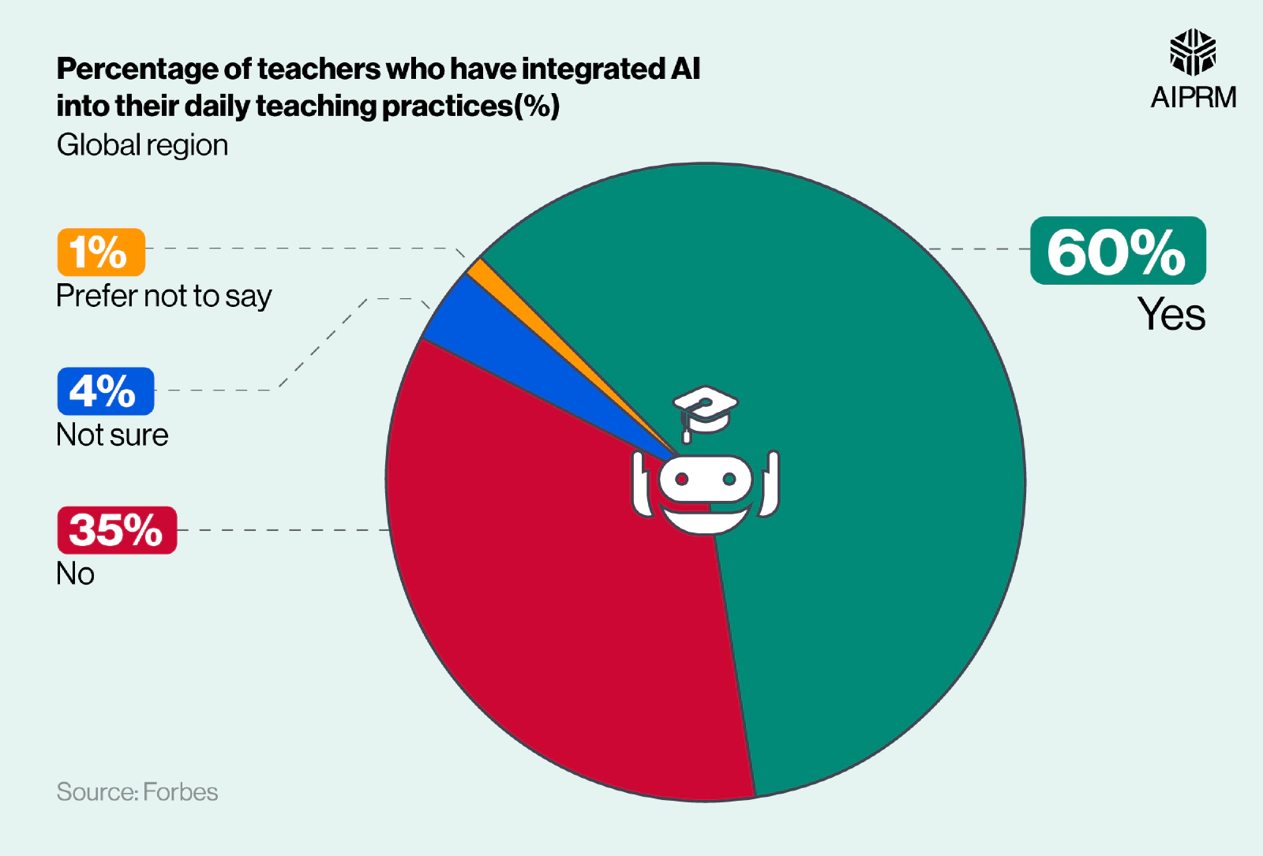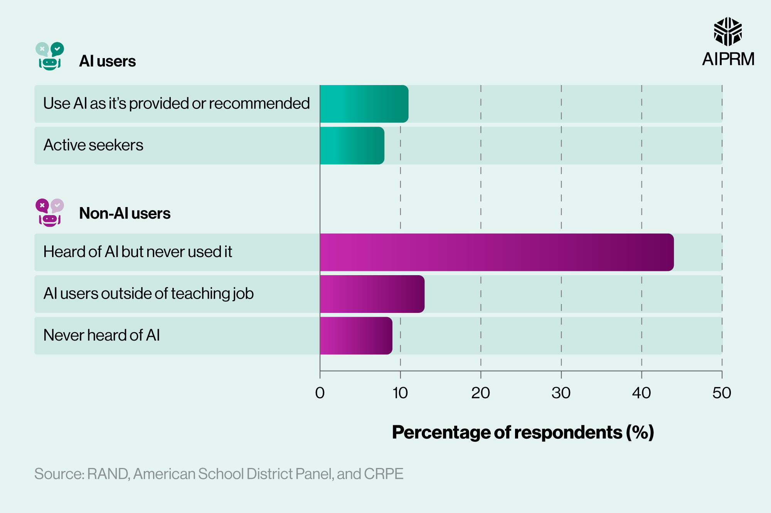

Fig. 3, Teachers of AI integration chart.

Fig. 4, K-12 lecturers AI usage chart.

According to statistics from a survey in Forbes, approximately three in five (60%) teachers interviewed claimed to be integrating AI into their daily lectures, and more than a third (35%) have replied positively to Generative AI technologies. This rate changes a little for teachers of primary education (K-12), but the numbers are still promising. Around 44% of the interviewed lecturers have heard of AI technologies, but did not use it in class, and just a bit above 10% of lecturers are already using it. On the other hand, the same article suggested that, in terms of AI market, North America held the greatest share of AI market globally in 2022, by owning around two-fifths of it. It is predicted that their share will increase almost another half (+48%) between 2023-2032.

According to another statistics, 49% of students worldwide have completed some sort of online learning (Peck, 2025). 70% of them are saying online learning is more beneficial than classrooms, and the expected number of online learners is 57 million by 2027 (Peck, 2025). By these statistics alone, it is apparent that the world of education is already in the process of a major change. It could be far-fetched to say that classrooms will disappear, but no doubt everyone is learning many things online that otherwise they might have not. Therefore, it would be appropriate to say that smart education is extremely important, and its importance is increasing by the minute. Even without artificial intelligence, smart education has came a long way, and now it is getting even wider with AI usage improving the education systems even more. But what really waits us in the future in the field of education? How will AI affect smart education and what are the possible outcomes we should expect?

**Future of AI-powered Smart Education**

This could be considered a hot topic, since the masses are talking about the rapid development of AI, surely these arguments are also apparent in educational world. As it is apparent with examples such as Coursera, DreamBox and much more that artificial intelligence is almost an inseparable part of today’s understanding of smart education, AI seems to be only developing more and more and covering a bigger and bigger part in our lives. It is apparent that ITS systems will develop more and more, and these sorts of virtual classes and their credentials will be recognized by more parties all across the world. One paper in particular, for instance, from the academicians in the Indian Institute of Technology Kharagpur, suggest that Generative AI will soon make its way into personalized intelligent tutoring systems more and more. Basically combining a personal assistant with educational help, a study tutor that is completely a Generative AI does not seem so far for this team, which, when its considered that chatbots are already in use in most of the smart education systems today, it might be pretty much possible. Furthermore, it is also thought that all of the personalized elements, such as ITS’, student specific syllabus makings and active real-time education tracking will develop, and it could be figured that they can make their way into traditional classrooms, as well. In conclusion, it is evident that the future of smart education and its relationship with artificial intelligence seems to develop even more and the world of education is rapidly changing with more people choosing to learn new topics or cover the parts they are weak in through online and mostly AI-powered platforms. It seems like AI, much like in almost any of the fields it made its way into, is here to stay regarding educational affairs.

**BIBLIOGRAPHY**

* **Sidoti, O., Park, E., Gottfried, J., About a Quarter of U.S. Teens Have Used ChatGPT for Schoolwork—Double the Share in 2023, January 15, 2025 (**[**https://www.pewresearch.org/short-reads/2025/01/15/about-a-quarter-of-us-teens-have-used-chatgpt-for-schoolwork-double-the-share-in-2023/**](https://www.pewresearch.org/short-reads/2025/01/15/about-a-quarter-of-us-teens-have-used-chatgpt-for-schoolwork-double-the-share-in-2023/)**)**
* **University of San Diego, 39 Examples of Artificial Intelligence in Education (**[**https://onlinedegrees.sandiego.edu/artificial-intelligence-education/**](https://onlinedegrees.sandiego.edu/artificial-intelligence-education/)**)**
* **Maryville University, History of AI: Timeline and the Future, May 19, 2023 (**[**https://online.maryville.edu/blog/history-of-ai/**](https://online.maryville.edu/blog/history-of-ai/)**)**
* **HPE Glossary, What are AI models? (**[**https://www.hpe.com/tr/en/what-is/ai-models.html**](https://www.hpe.com/tr/en/what-is/ai-models.html)**)**
* **Artificial intelligence in education, UNESCO (**[**https://www.unesco.org/en/digital-education/artificial-intelligence**](https://www.unesco.org/en/digital-education/artificial-intelligence)**)**
* **Smart education [description], Report on National Smart Education Framework, UNESCO Institute for lnformation Technologies in Education, 2022**
* **Walther, C. C., The Future of Education: Will AI Be The Great Equalizer?, Forbes, March 16, 2025 (**[**https://www.forbes.com/sites/corneliawalther/2025/03/16/the-future-of-education-will-ai-be-the-great-equalizer/**](https://www.forbes.com/sites/corneliawalther/2025/03/16/the-future-of-education-will-ai-be-the-great-equalizer/)**)**
* **Korzekwinski, K., What is Coursera? Everything You Need to Know, Scholarships360, May 29, 2025 (**[**https://scholarships360.org/college-admissions/what-is-coursera/**](https://scholarships360.org/college-admissions/what-is-coursera/)**)**
* **Does DreamBox Learning Use AI? Exploring Its Educational Technology, TheDataScientist (**[**https://thedatascientist.com/does-dreambox-learning-use-ai/**](https://thedatascientist.com/does-dreambox-learning-use-ai/)**)**
* **Does DreamBox Learning Use AI? Fuel Your Digital, December 10, 2024 (**[**https://fuelyourdigital.com/post/does-dreambox-learning-use-ai/**](https://fuelyourdigital.com/post/does-dreambox-learning-use-ai/)**)**
* **Tan, W., M., AI Education in 2025: Predictions and Preparations, The AI Playroom, December 15, 2024 (**[**https://www.theaiplayroom.com/blog/ai-education-2025**](https://www.theaiplayroom.com/blog/ai-education-2025)**)**
* **Winograd, G., Coursera Statistics 2025 - Revenue, Users & Courses Data, Mission Graduate, March 12, 2025 (**[**https://missiongraduatenm.org/coursera-statistics/#:~:text=Coursera%20Users%20%26%20Growth,and%2021.5%20million%20in%202022**](https://missiongraduatenm.org/coursera-statistics/#:~:text=Coursera%20Users%20%26%20Growth,and%2021.5%20million%20in%202022)**.)**
* **AI in Education Statistics, AIPRM (**[**https://www.aiprm.com/ai-in-education-statistics/**](https://www.aiprm.com/ai-in-education-statistics/)**)**
* **Bajaj, R. Sharma, V. Smart Education with artificial intelligence based determination of learning styles, International Conference on Computational Intelligence and Data Science (ICCIDS), Elsevier Ltd., 2018**
* **Maity, S., Deroy, A., Generative AI and Its Impact on Personalized Intelligent Tutoring Systems, Indian Institute of Technology Kharagpur, October 14, 2024**
* **Nguyen, L., Tomy, S., Pardede, E., Enhancing Collaborative Learning and E-Mentoring in a Smart Education System in Higher Education, Recent Advances in Computer-Assisted Learning, January 18, 2024**
* **Cardona, M. A., Rodríguez, R. J., Ishmael, K., Artificial Intelligence and the Future of Teaching and Learning: Insights and Recommendations, United States of America Department of Education Office of Educational Technology, May, 2023**