Aim : Get the behaviour of Pyrazine S2 state decay by TSSH (werner et al. 2008)
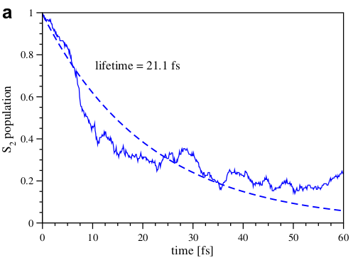
This week’s task :
1) Check how the code runs
2) Write a small function to print all output details in a file or in intervals.
3) Run the trajectories (one at a time) and check the density matrices.
4) If all the above goes fine:
1) Start testing for more trajectories
2) Try implementing the parallel version over trajectories

