1. כן
2. כן

נימוק: הildasm פותח את הקובץ בהצלחה ולכן ניתן להסיק שזהו .NET PE - זאת לפי הדוקומנטציה באתר מיקרוספוט. כמו כן ניסינו לפתוח exe שאינו PE (cpp שקומפל בmsbuild ופעולה זו נכשלה ).

1. תיאור הassembly
   1. שם: B23_Ex01
   2. גרסתו: 23:2:1:3494
   3. MANIFEST

|  |  |  |
| --- | --- | --- |
| **Type** | **Name** | **Members** |
| |  | | --- | | class | |  | | program | 1. public void Main() 2. public ctor() |
| |  |  | | --- | --- | | class | | |  |  | | demosexecuter | 1. public ctor() 2. public static void RunDemoApp() 3. private static bool authenticateUser() 4. private static eChoice getUserChoice() 5. private static void showMenu() |
| |  | | --- | | class | |  | | demoprograms | 1. public ctor() 2. public static void RunBinaryCheck 3. public static void RunSandClockProgram() 4. private static int buildLine(StringBuilder, int32,int32) 5. private static bool checkIfAscendingSeries(string) 6. private static bool checkIfDescendingSeries(string) 7. private static void drawAstrixClock(int32) 8. private static string getInputFromUser(int32&) |
| |  | | --- | | enum | |  | | eChoice | 1. public static int32 Abort 2. public static int32 BinaryCheck 3. public static int32 StarClock |

|  |  |
| --- | --- |
| OTHER ASSEMBLY REFERENCED NAME | VERSION |
| mscorlib | 2:0:0:0 |
| System.Xml | 2:0:0:0 |

ניתוח האסמלבי:

Ex01_01 –

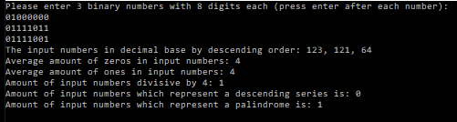

Ex01_02 –

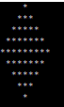

Ex01_03 (Incrementation in case of even input) -

Ex01_04 –

Ex01_05 –

