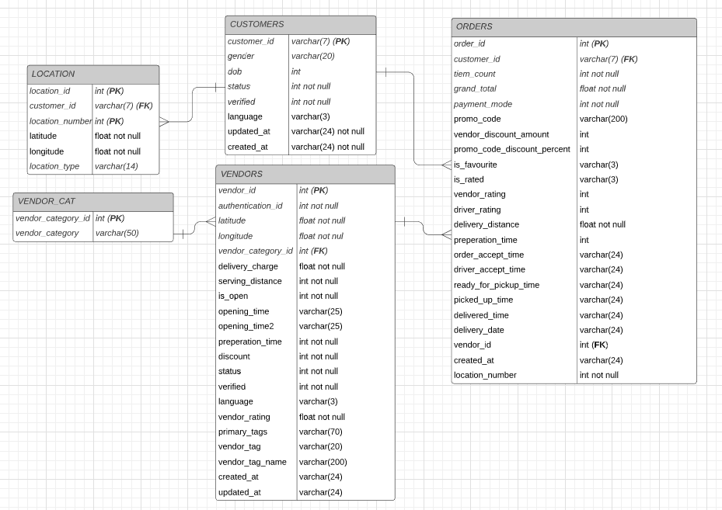**COMP5000**

**Student Ref:** 10557474

**ERDs**

Due to SQLite not having a date datatype, all of the date types of data were saved at a varchar for convenience

LOCATION table

A new primary key was generated for this table so each location entry would be unique, there is a foreign key for the customer_id that linked to the CUSTOMERS table. There is also a primary key for the location number so each customer can only have unique location numbers. The rest of the attributes are unchanged from the location csv.

CUSTOMERS table

The primary key is taken from the akeed_user_id supplied in the csv, there are no foreign key in this table as there was no need. The rest of the attributed for this table are taken from the customers csv and none of which have changed or been dropped

ORDERS table

The primary key is taken from the akeed_order_id from the orders csv, there are two foreign keys in this table, user_id and vendor_id which link to the USERS and VENDORS table respectively. . A few columns were dropped from the order csv due to the data not being of any use un this database due to all the values and being redundant or the same or have no impact on the rest of the data. The columns dropped were cityid, countryid, one_click, device_type, display_orders,commission, rank.

VENDOR table

The primary key in this table is vendor_id which was obtained from the vendor csv. The vendor category id was also originally found in the csv but was split into its own table to reduce redundancies and increase modularity. The category id is used here as a foreign key to link to the VENDOR_CAT table.

VENDOR_CAT table

The primary key in this table is vendor_category_id, this table was developed out of the vendor csv.

**GUI**

Home Page

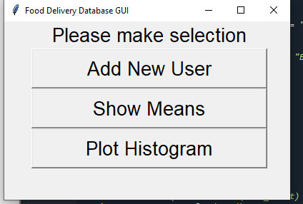

Add New User

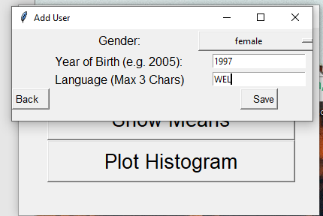

Save Button

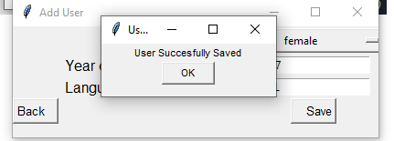

New User in the database



Show means page

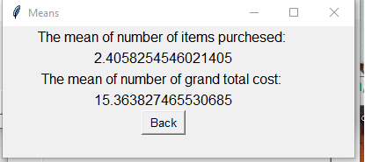

Plot Histogram Page

