The basics

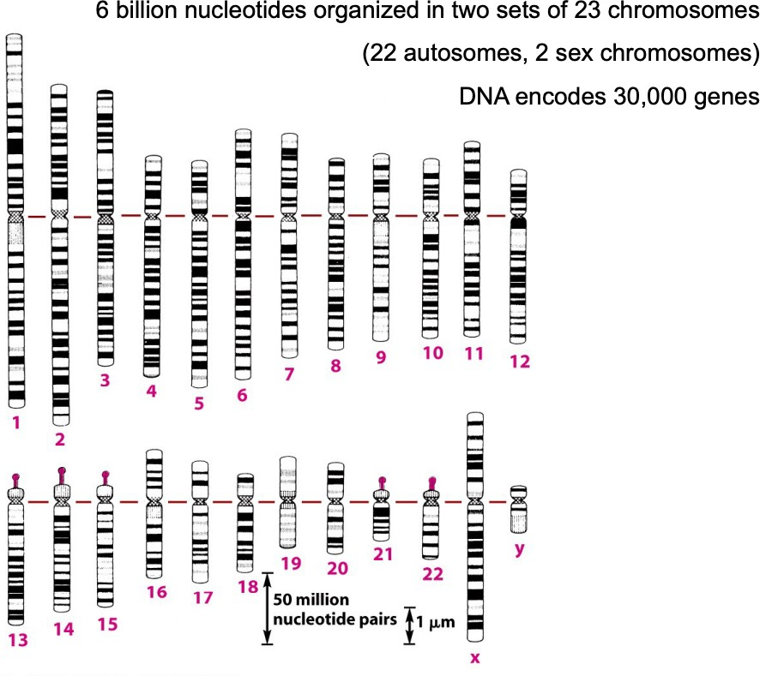

The words variations, aberrations and lesions are often interchanged. Aberrations and lesions are mainly used for acquired lesions, instead variations are mainly use for the inherited ones.

## Genetic Make-Up

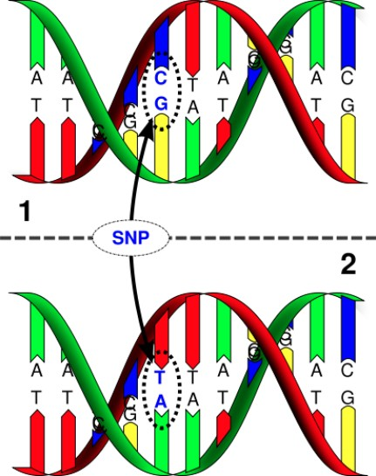A **Single Nucleotide Polymorphism** (SNP) is a sequence variation affecting single amino acid → point mutation

The genomes of two unrelated individuals have about 1% of different bases → that percentage corresponds to the SNPs

But looking at the **Copy Number**

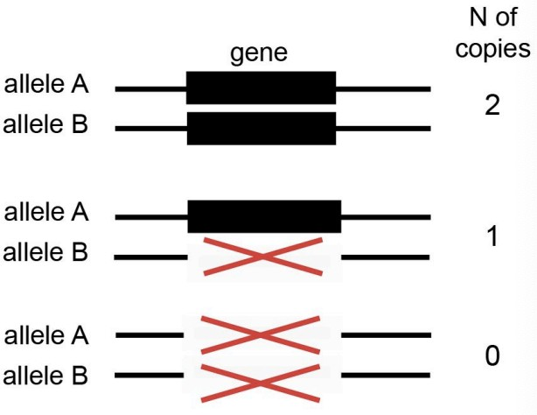**Variants** (CNV), that difference will be way higher than only 1%

DNA not present in only two copies, but in multiple, single or even zero copies (hemizygous loss, homozygous loss)

They are less known as inherited type of variants because they are harder to detect and identify, but they provide a lot of uniqueness in each of us.

Why are SNPs and CNVs so important?

They are responsible of human diversity → genetic changes

Hundreds of CNVs per individual and 20% of them potentially affect protein- coding genes

**Differences** in Genetic Make-up:

Very common variants are variants that are distributed in the population in a very specific way, so that 1/2 of the population has an heterozygous genotype at that position, 1/4 has an homozygous genotype for one allele and 1/4 has an homozygous genotype for the other allele.

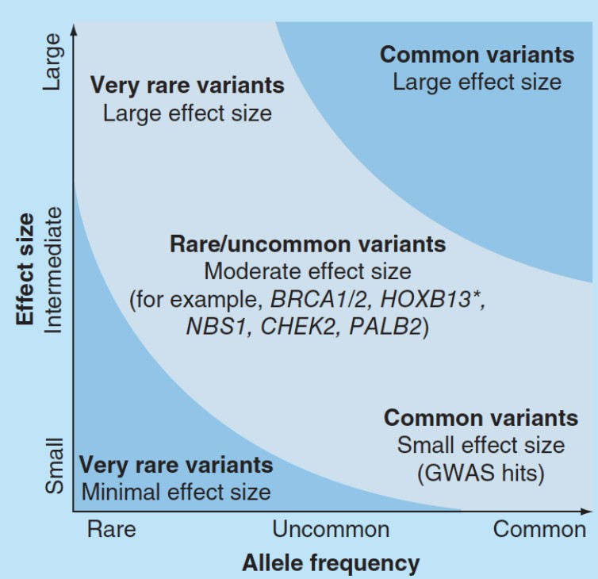

The **penetrance** is the proportion of individuals carrying an allele (or a genotype) that also expresses the trait (phenotype) associated with it

The penetrance is very high if the variant is very rare (at the same time if the variant is quite “common”, the penetrance will not be so high). It’s very unlikely that a SNPs related to a disease is common in the population and at the same time, very rare SNPs can have important influences in penetrance

The **allele frequency** is calculated by dividing the number of times the allele of interest is observed in a population by the total number of copies of all the alleles at that particular genetic locus in the population

The allele frequency is low with very rare variants

Well known variants: BRCA1/2, HOXB13, NBS1, PALB2, CHEK2 → they have moderate size effects, meaning that all the people who have the variants, have the disease

### Differences in genetic Make-Up, example

Absorption, distribution, metabolism and elimination (ADME) genetic variants determine pharmacokinetic variability of certain compounds, influencing the patients’ treatment response. Both common and rare variants are involved

The study of genetic variants is important also in the way we respond to treatments.

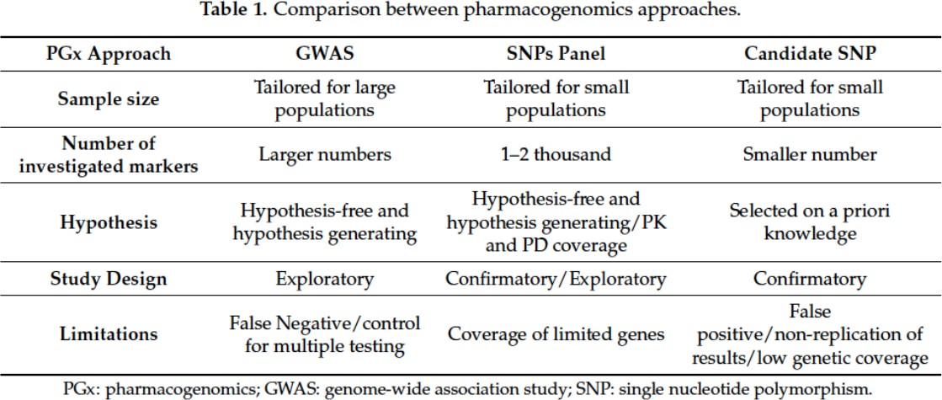

Three main ways to study genetic variants: GWAS

SNPs panel Candidate SNP

For example, in terms of hypothesis, if I study all the variants in the human genome and I query them in a large population, I generate data without a specific hypothesis. I just mine this whole amount of data to generate the hypothesis and observe observations that I not necessarily did expect to see.

Instead, if I have a very specific hypothesis, for example I want to query if a SNPs in the CYP gene relates to the conversion of androgens to estrogens, I don’t need to run an GWAS or a wide SNPs panel. I can query those SNPs because I have a priori hypothesis and I want to test them.

This type of differential design dsds ds for an experiment it is not only true for inherited variants and ADME genes, but also to predisposition to diseases and to study human tumors.

Precision medicine → treatment (or dosage) of a patient based on their individual traits: takes into consideration genetic and genomic of the individual and tumor/disease cells

Starch rich diet → CNV in the genome Drink beer and turn red → ADME gene

Athletes with a deletion of a gene, the steroids were not found in the anti-doping tests

## Acquired DNA aberrations

Somatic variants are the variants NOT inherited from parents and not transmitted to offspring. They are:

**Single Nucleotide Variants** (SNV) are somatic changes of single nucleotides present in only certain cells, instead of SNPs that are present in all cells of our body

**Indels** are changes that involve few nucleotides by INsertion and DEletion

**Rearrangements** are mutations that can involve events like translocations, inversion, chromothripsis,.. usually these events are caused by breakage in the DNA double helices a two different locations, followed by a rejoining of the broken ends to produce a new chromosomal arrangement of genes, different from the beginning

**Somatic copy number aberrations** (SCNA) are somatic changes similar to CNVs. They can be every change related to the number of copies like loss of a portion of a genome, loss of both alleles, extra copies,..

**Examples** of acquired DNA aberrations:

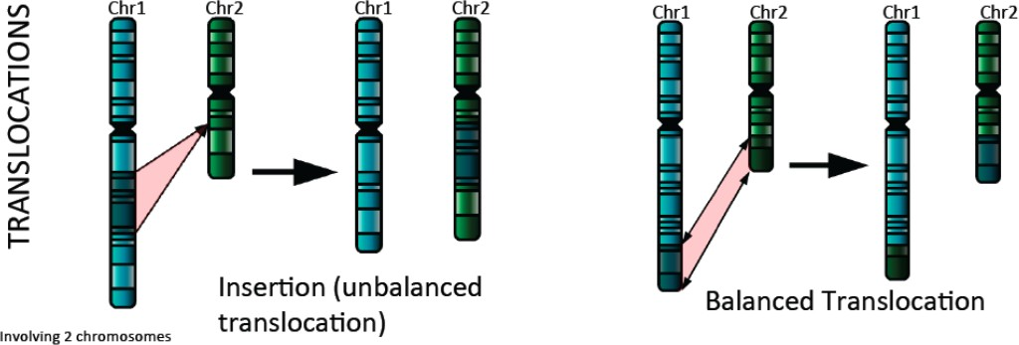

**Balanced translocation**: you conserve the quantity of DNA, there isn’t any loss or gain

**Unbalanced translocation**: you can (or not) conserve the quantity of DNA, you don’t have any viceversa

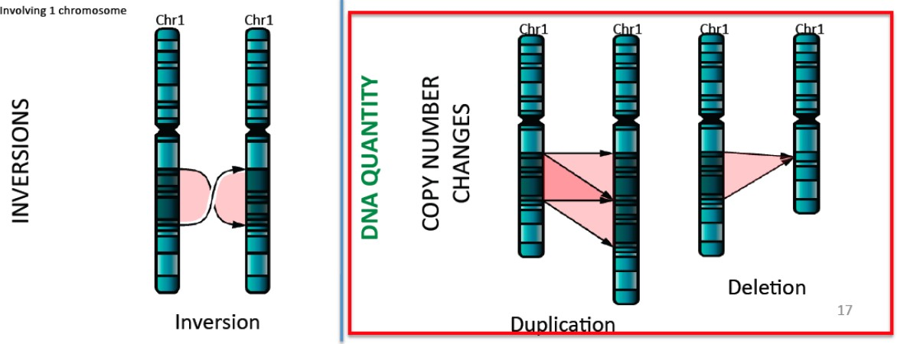

**Inversions** in only ONE chromosome: everything is normal instead in the break points

**Copy number changes:** duplication or deletion

It could happen in the same chromosome but also in different chromosomes

See on the break points to understand where the extra copies are in the

genome!

Other types of complex somatic events include:

**Chromoplexy**: a class of complex somatic DNA rearrangements whereby abundant DNA deletions and intra- and inter-chromosomal translocations that have originated in an interdependent way occur within a single cell cycle

**Chromothripsis**: a clustered chromosomal rearrangement in confined genomic regions that results from a single catastrophic event, usually limited to one chromosome

**Kataegis**: a phenomenon that is characterized by large cluster of mutations (hypermutation) in the genome of cancer cells. An APOBEC family enzyme might be responsible fo the kataegis process

Some basic concepts:

when an aberration (clonal) occurs, all the cells will harbour the aberration and at some point another aberration (subclonal of the other) could appear in just one cell line. The **clonal** aberration is present in all the cells, the **subclonal** aberration is inherited in just one cell line. They are important information that allow us to study evolution

[https://s3-us-west-2.amazonaws.com/secure.notion-static.com/705c1529-95b 2-45c5-9047-d67b6a1fd069/Nature_Genetics_Reviews_2016_Khurana_et_al](https://www.notion.so/signed/https%3A%2F%2Fs3-us-west-2.amazonaws.com%2Fsecure.notion-static.com%2F705c1529-95b2-45c5-9047-d67b6a1fd069%2FNature_Genetics_Reviews_2016_Khurana_et_al_.pdf?table=block&id=8af112bc-cb59-4b31-94fe-a34e45a28047&spaceId=7bd1d238-65cd-4d60-89ef-bc454392942f&userId=bd1407c0-1d16-4cc0-b61a-214dc1297e6a&cache=v2)

[_.pdf](https://www.notion.so/signed/https%3A%2F%2Fs3-us-west-2.amazonaws.com%2Fsecure.notion-static.com%2F705c1529-95b2-45c5-9047-d67b6a1fd069%2FNature_Genetics_Reviews_2016_Khurana_et_al_.pdf?table=block&id=8af112bc-cb59-4b31-94fe-a34e45a28047&spaceId=7bd1d238-65cd-4d60-89ef-bc454392942f&userId=bd1407c0-1d16-4cc0-b61a-214dc1297e6a&cache=v2)

# Experimental approaches

Experimental techniques to detect variants/aberrations **prior to NGS**: a failure because it was very hard to determine the starting points of the aberrations

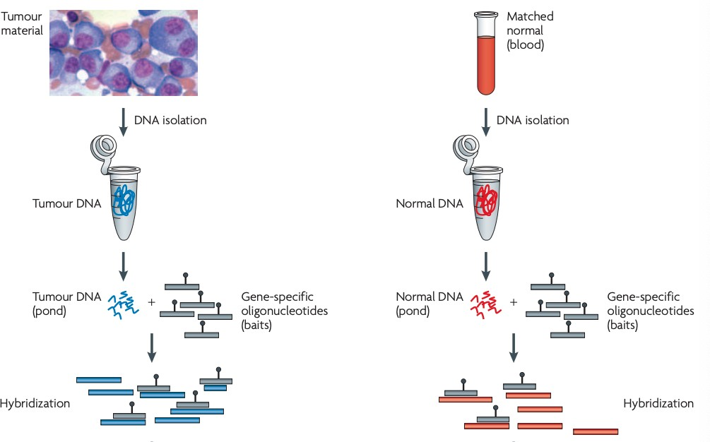

[https://s3-us-west-2.amazonaws.com/secure.notion-static.com/d5caee70-c53 b-4739-9948-d67af56552fc/Nature_2010_Reviews_advances_understanding](https://www.notion.so/signed/https%3A%2F%2Fs3-us-west-2.amazonaws.com%2Fsecure.notion-static.com%2Fd5caee70-c53b-4739-9948-d67af56552fc%2FNature_2010_Reviews_advances_understanding_cancer_genomes_Meyerson.pdf?table=block&id=a7ab15fe-38f9-4f77-b4fd-e31a3c29e7ce&spaceId=7bd1d238-65cd-4d60-89ef-bc454392942f&userId=bd1407c0-1d16-4cc0-b61a-214dc1297e6a&cache=v2)

[_cancer_genomes_Meyerson.pdf](https://www.notion.so/signed/https%3A%2F%2Fs3-us-west-2.amazonaws.com%2Fsecure.notion-static.com%2Fd5caee70-c53b-4739-9948-d67af56552fc%2FNature_2010_Reviews_advances_understanding_cancer_genomes_Meyerson.pdf?table=block&id=a7ab15fe-38f9-4f77-b4fd-e31a3c29e7ce&spaceId=7bd1d238-65cd-4d60-89ef-bc454392942f&userId=bd1407c0-1d16-4cc0-b61a-214dc1297e6a&cache=v2)

Bulk of tumor tissue/cells from the blood:

1. DNA isolation
2. Gene-specific oligonucleotides (**baits**) that get hybridized onto the tumor DNA → the baits have a tag that allows them to be isolated
3. The DNA does get fragmented
4. The captured DNA is eluted and prepared into sequencing libraries
5. Sequenced
6. Aligned to the bait sequences

We repeat the procedure for healthy cells of the same individual in order to **detect somatic mutations** and distinguish them from the germline (= match normal)

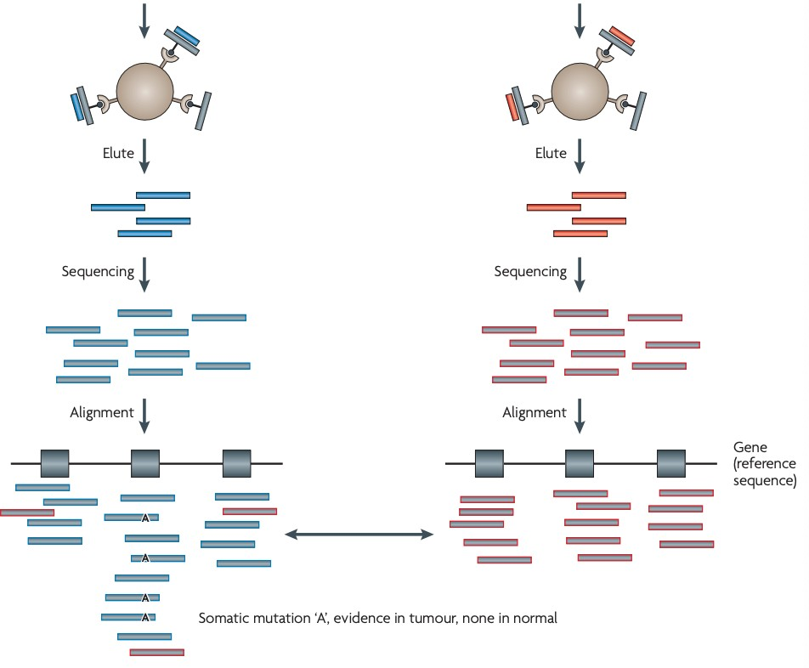

We sequence baits because is way cheaper (exons of 50 bases instead the whole genome)

After fragmentation procedure, before adding the adapters, we can choose between two different sequencing approaches:

### Single End (SE) sequencing



You will sequence only one part of a molecule (length of 150 bp → based on the power of the sequencing machine we are using). You will know exactly 150 bp for every molecule you sequence, but you lose information (the second end of the pair)

### Paired End (PE) sequencing

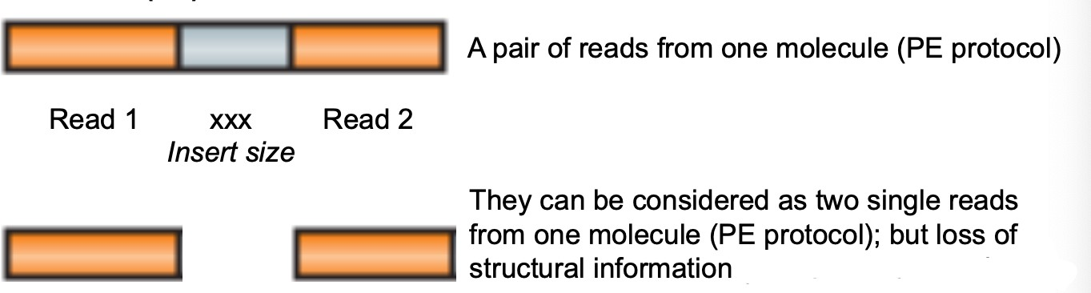

This method lose only the information between the two ends (= insert size) but you will know the exact length of the entire molecule. You can compare the **expected** insert size with what it has been generated.

It’s more expensive, but:

* it gives information about the localization of the molecule
* you can treat each end as single read

In the following picture: a view of reads that are mapped against reference genome and what we would look if we have any of the variations that we mentioned

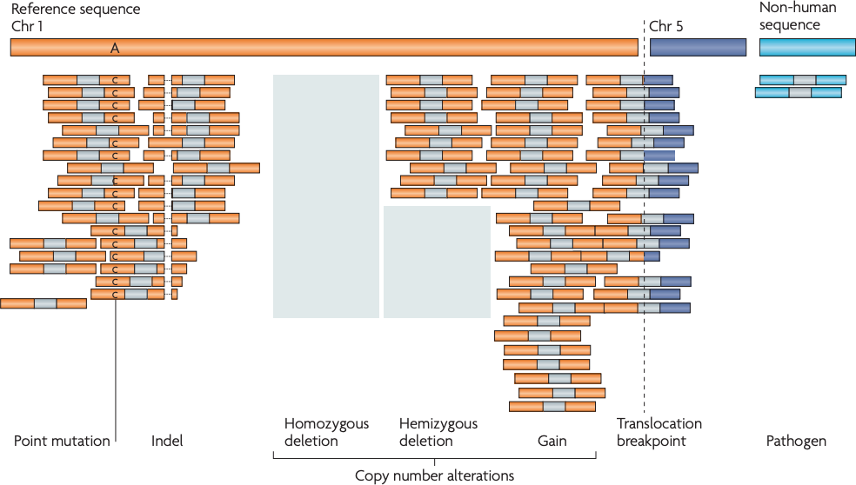

Different types of genomic alteration can be detected:

You can clearly identify **point mutations**. If a point mutation is present in the molecule that you sequenced and present on both alleles of the genome, it can be seen in all the reads very clearly

You might see **indels** (shown here by a dashed line). You will see a little space because the reference genome has more nucleotides than the sequenced molecule

If you have **homozygous deletion**, you don’t see anything mapped in that portion: there’s no DNA. Doesn’t matter if SE or PE.

If you have **hemizygous deletion**, you see the see the read mapped to that portion where the hemizygous deletion is sitting, that is more or less proportional to half of the reads that you have in regions where you don’t have a copy number change. Doesn’t matter if SE or PE

If you have **gain**, what you get is higher number of reads aligned against that part of DNA, underlying the fact that the molecule you sequenced has extra DNA for that portion of reference genome. Doesn’t matter if SE or PE

**Translocation breakpoint** are very important!! You will have one end mapping the chr1 and the other end mapping the chr5. Those two ends come from the same molecule of the *target cell* (the cell we sequenced), it means the cell has a translocation between chr1 and chr5. Without the PE protocol you cannot have this result

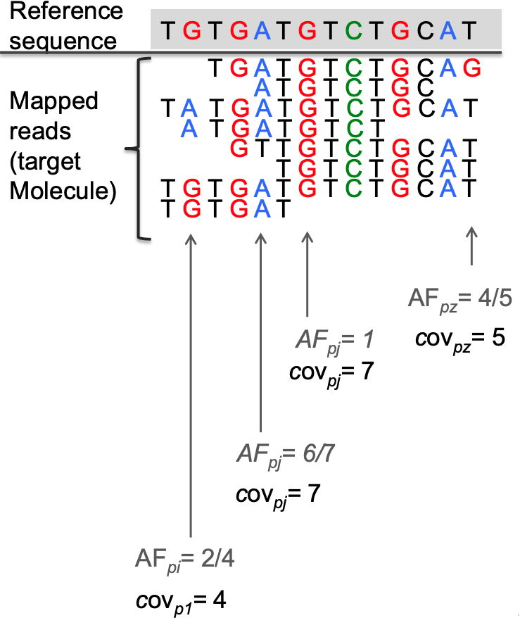

The **local coverage** (cov) at position *i* is the number of reads that span *pi*

The **allelic fraction** (AF) at position *i* is the proportion of reads that supports the reference base in *pi* (= the reference or the alternative allele)

**Whole Genome Sequencing Coverage**

*L* ⋅ *N*

*cov* =

*G*

where:

* L is the read length
* N is the number of mapped reads
* G is the haploid human genome length

This is super important because it saves us time and money when we design an experiment. When you design an NGS experiment, you should know up front what is the type of coverage you need to answer the question you wanna ask with your experiment. For example, if you want to look at the genotype of SNPs (inherited polymorphisms at single side), you don’t really need a coverage which is above 10 or 15. So you can design your experiment in order to have an average coverage equal to 10 or 15. To do that, you reverse the equation and count how many reads you need to generate to achieve that goal.

N.B. The number of mapped reads will be always lower of the number of reads generated by the machine (than the expected). There might be duplicates that you might not be able to use because there might be reads that have a quality below the threshold you intend to use

### Difference between sequence coverage and physical coverage

A graphic view of how SE or PE can be used:

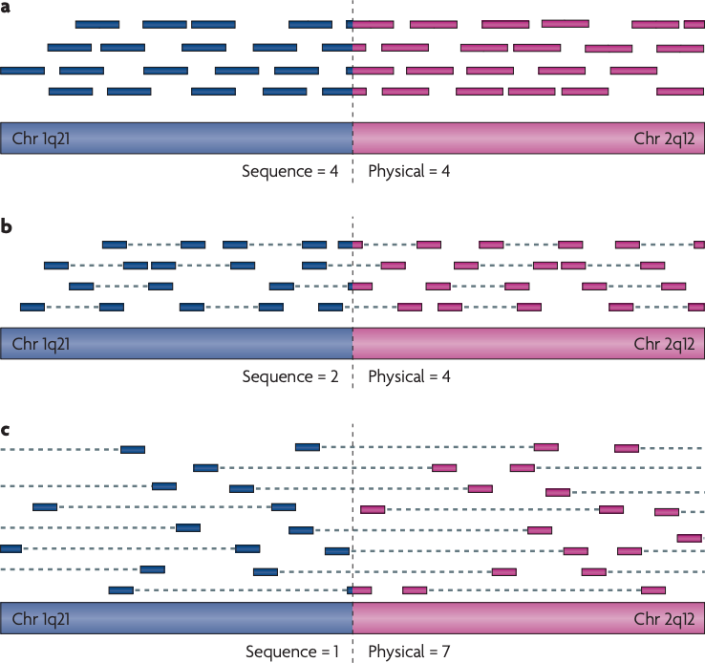

Panel A - SE protocol Panel B - PE protocol Panel C - PE protocol

Three different scenario are depicted that vary in the length of the DNA fragments that are sequenced. **Sequence coverage** represents the number of sequenced reads that cover the site; this affects the ability to detect point mutations. **Physical coverage** measures the number of fragments that span the site; this affects the ability to detect the rearrangement, based on paired reads that map to different chromosomes. It is a way informative type of coverage: for instance for translocations, deletions,..

In Paired End sequencing protocols, the physical coverage is always higher than the sequence coverage because it takes into consideration also the insert sizes

In NGS experiments, the power relates to the depth of coverage. Higher coverage → more power to detect anything

Sometimes you don’t need high coverage, but redundancy

Making estimation of intended coverage and observed coverage is very important. Here are few examples:

In these panels were designed to sequence a set of 10 genes that the researchers were interested in for prostate cancer. They designed this panel, sequenced cell lines on this panel and observed the following points

On x-axis: the genomic location

On y-axis: the local coverage (amplicon median coverage = each bar represents the local coverage of about 30 bp)

The different colors represent the different genes

### 1st panel - LNCaP sample (cell line)

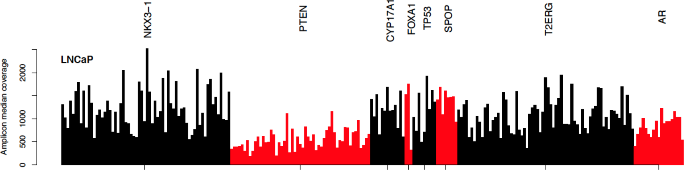

Local coverage (pile-up) of selected areas (targeted sequencing assay): 7 genes

+ 1 multi-gene region (T2ERG). Alternate colors indicate targeted areas The barplot show a single sample (LnCaP cell line; cancer cell line) data.

Apparent **deletion** of PTEN (monoallelic deletion) because the local coverage of PTEN is significantly lower than the one from other genes.

### 2nd panel - PC3 sample (cell line)

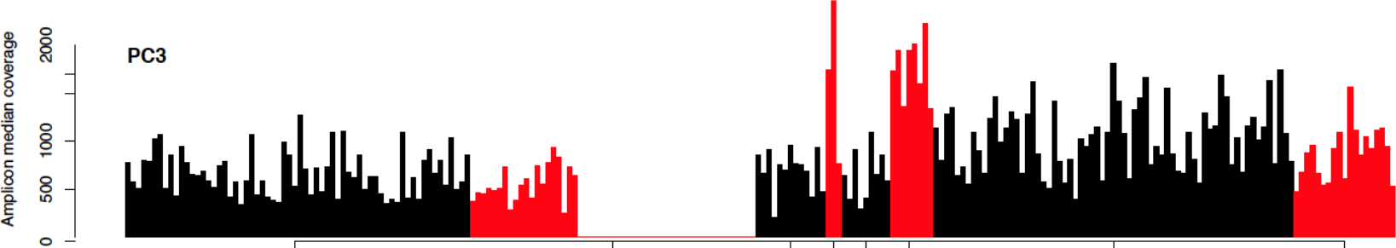

Local coverage (pile-up) of selected areas (targeted sequencing assay): 7 genes

+ 1 multi-gene region.

Monoallelic deletion and partial biallelic deletion of PTEN because one portion is deleted and one not. PTEN has a **partial homozygous deletion**.

The PC3 cell line shows a little bit of gain in the gene SPOP and FOXA1.

The average coverage for the PC3 cells is approximately the same as the previous sample.

### 3rd panel - VCaP sample (cell line)

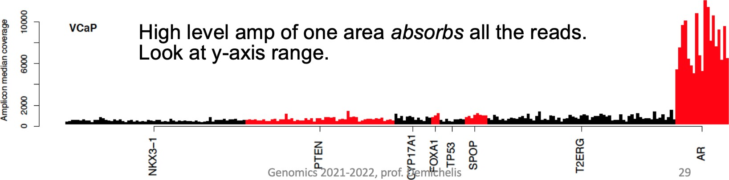

There’s no homozygous deletion but has a high level amplification of one area *absorbs* all the reads. Massive amplification of the Androgen Receptor (AR) → error: because it inhibits the sensitivity of detecting copy number changes in any other gene.

When designing a panel we must pay attention and make sure that we don’t have potential aberration that basically will draw all the attention of your experiment and leave you without information or sensitivity in all other regions.

It’s easy to increase the experimental coverage (i.e. the sequence depth) at later point. Provided tour original sample/library is still available, you can perform another run of sequencing and then combine the output from different runs

### Note that this isn’t possible with array-based technologies.

What are the limiting factors of NGS DNA-seq experiment, in any?

Repeated regions due to **short reads**

What is the problem of short sequencing on long genome?

Complexity regions CG content

# The reference sequence of the human genome

Many years ago, some people claimed that the entire human genome was sequenced but it wasn’t true at all. There were still unknown or missing regions. In 2022 we finally have the complete human reference genome sequence.

But we need to consider the polymorphisms, there is no **unique** genome. How to integrate them into a single reference genome? There is a consortium that deals with these problems. They assemble a reference genome that reflects the more common (in the whole population) sequences at each position of the human genome, but also tracks information of everything that is polymorphic. So that we can use the latest release of what they built as reference genome and then use databases to learn about all the polymorphic sites and all the features of every polymorphic variants

Genome Reference Consortium: <https://www.ncbi.nlm.nih.gov/grc/human> where you can find different versions of human reference genome

UCSC Genome Browser on Human: <http://genome-euro.ucsc.edu/>

where you can upload different versions of the reference

## Interpreting pair orientation

Using IGV (Integrative Genomics Viewer)

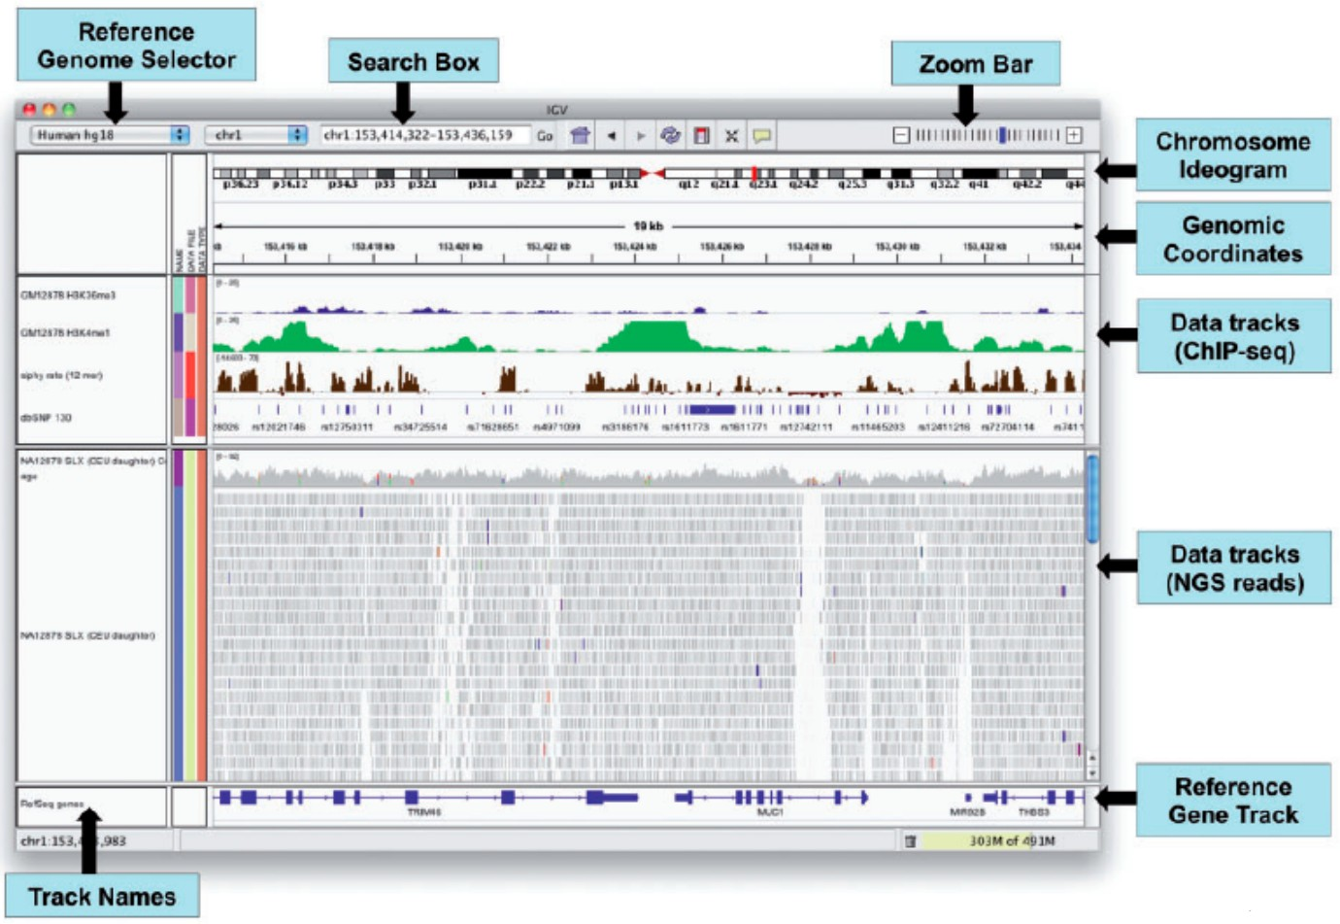

The main characteristic of IGV is that it is a main view viewer: all the information are in one window

Every vertical bar is a read

On the x-axis there’s the genome coordinates at the top, the reference genome at the bottom (we can select the reference genome we prefer)

Along with the data tracks there is the local coverage of the kb shown in the window (of the sample we are looking at)

You can get any information you want of any single read that you are uploading, very useful to see difference from the reference genome because every aberration or whatsoever is highlighted by a different color in the local coverage of a nucleotide base. Moreover, it gives information about the quality of the read and the bases, if you have a PE protocol, it tells you also information about the PE for each of them

The **orientation** of paired end can be used to detect structural events, including: inversions

duplications translocations

According to the Illumina protocol, the two ends are LR oriented, but we could also obtain other orientations, like LL RR RL, if we come up against the events mentioned above.

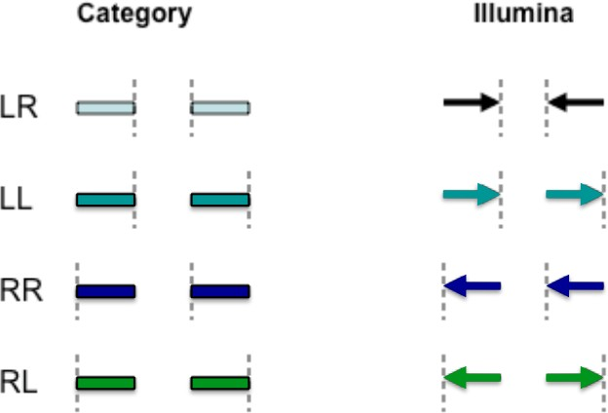

LR normal reads. They are left and right (respectively) of the unsequenced part of the sequenced DNA fragment when aligned back to the reference genome

LL, RR implies inversion in sequenced DNA with respect to reference RL implies duplication or translocation with respect to reference

## Inversion

A segment of DNA is inverted

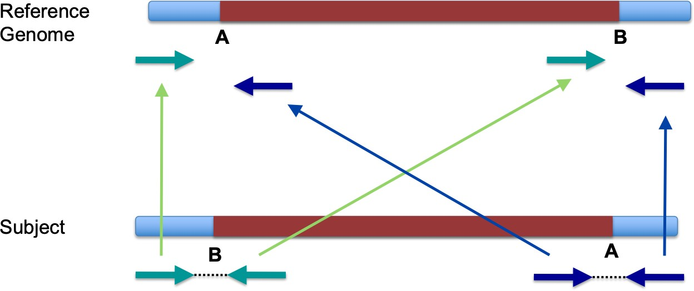

The most important pairs are the ones that stand between junctions because they are the most informative ones.

Here one end mapped where it was on the reference genome while the other end reversed its orientation

In IGV:

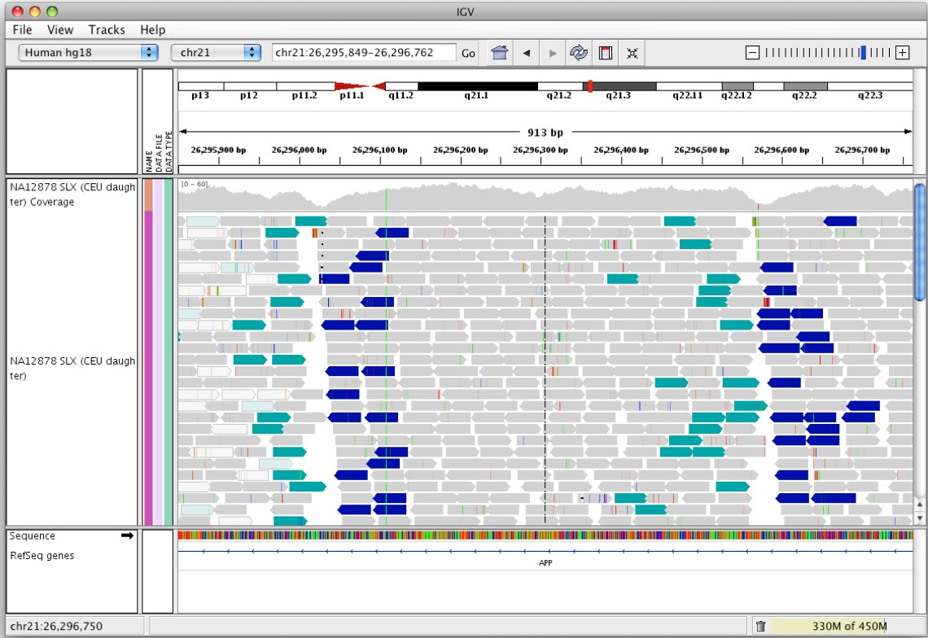

Information that help us:

The insert size from the target molecule (= the subject) is way longer. For all the pairs that are at the breakpoint, the insert size is different from the expected

The orientation is different

If you look at the local coverage, you can see a **drop** in two points: at the breakpoints. The reads that are mapping the junctions cannot map the reference genome because the breakpoint sequence does not exist in the reference genome. So, if we have an inversion in only one of the two alleles, then the reads coming from the allele with the inversion will not contribute to the local coverage at the breakpoint. The sequence in your target molecule exists only in one allele, so at the breakpoints you will only have reads contributing to the local coverage coming from one allele. The allele with the inversion will not have the

AB sequence, but only the BA sequence. That’s the why of the drop in the local coverage.

Moreover, we can notice that the coverage on the middle part does not change significantly from the coverage on the sides. That suggest this is not either a gain or a deletion, the only thing that might have happened is an inversion. Therefore, the inversion is not biallelic (because we see DNA, the drop doesn’t go to 0)

When you align reads against a genome, you can allow for a certain mismatches or partial alignment. So, if you impose certain thresholds to your aligner, you can also say that if there are reads that align for 80% and have 20% of sequences misaligned, you align them in any case. So you will have reads that are correct up to the breakpoints and the browser will shows the mismatches beyond the breakpoint. So, you can have a partial drop of coverage because you allow mismatches in your alignment.

## Tandem duplication

A segment of DNA is duplicated and inserted in the target molecule adjacent to the original one

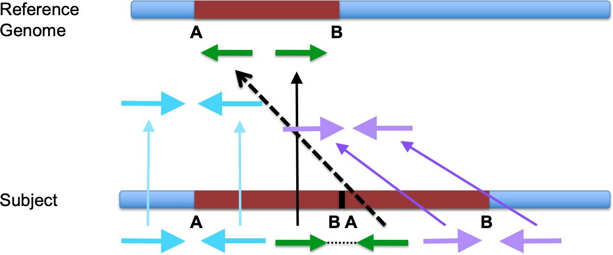

So, as result, the orientation instead of going inward goes outward.

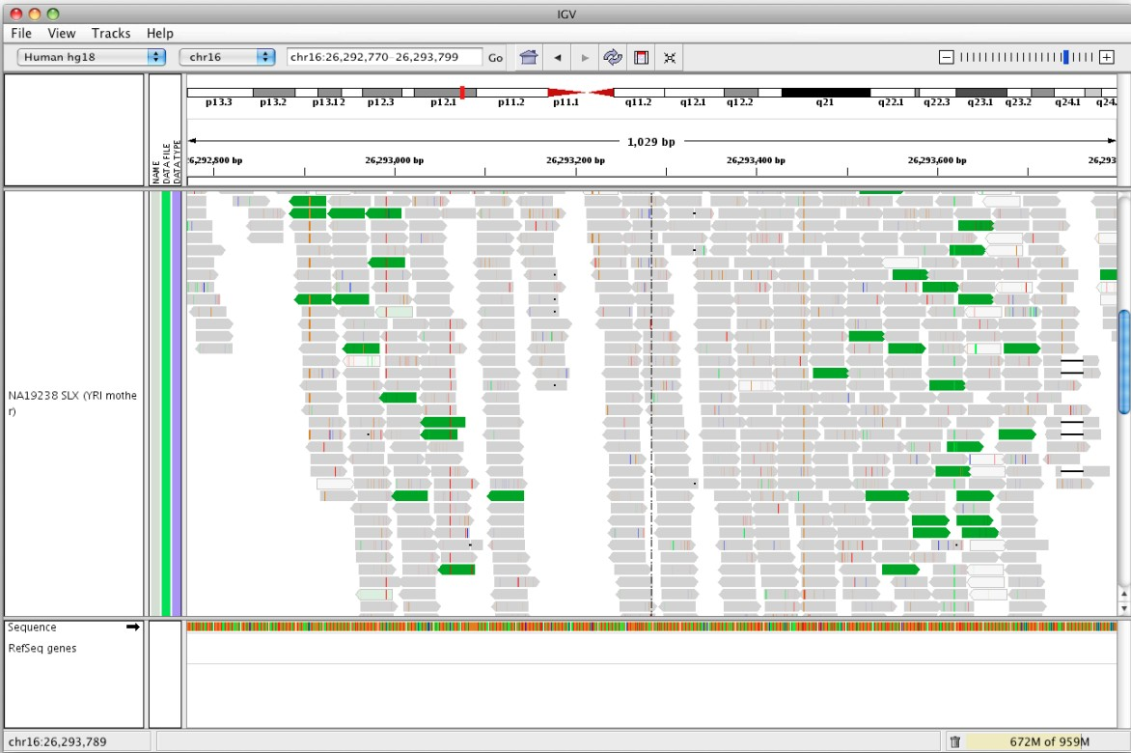

*What do you expect to see from coverage?* We will have a gain in coverage that is proportional to the extra copy. We need to pay attention to the double because it is a double contribution of that allele, but if a tandem duplication happens only in one allele and the other allele has his own one copy, then the local coverage corresponding to the tandem duplication will be 3/2 of the expected coverage.

If you have a read that maps BA, do you expect to see it in the mapped reads? Partial mapping. As we said before, if you allow your mapper to have some mismatches of a certain percentage of bases from your reads, you can still see some coverage contributed on one end of the segment and mismatches on the other side.

For what concern the junctions, you shouldn’t see any difference of coverage because that sequence exists only once in the target molecule. The local coverage increases only in correspondence of the segment AB.

## Inverted duplication

The duplication is inverted but it’s not located near the original fragment, but somewhere else

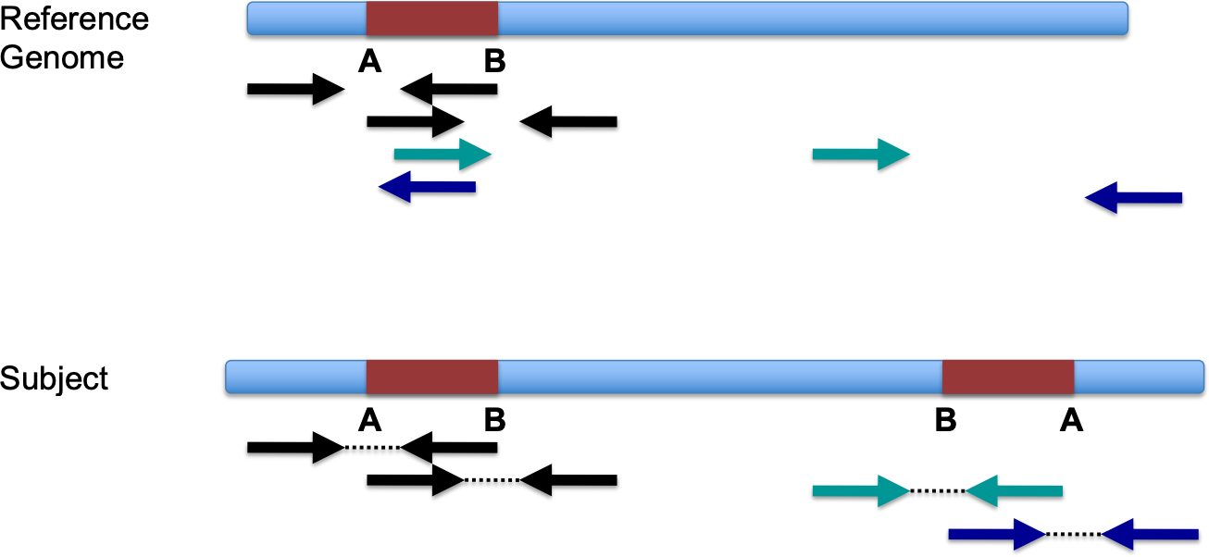

Take into consideration:

* overlapping of “left” and “right” reads on the reference genome
* coverage depth (copy number)

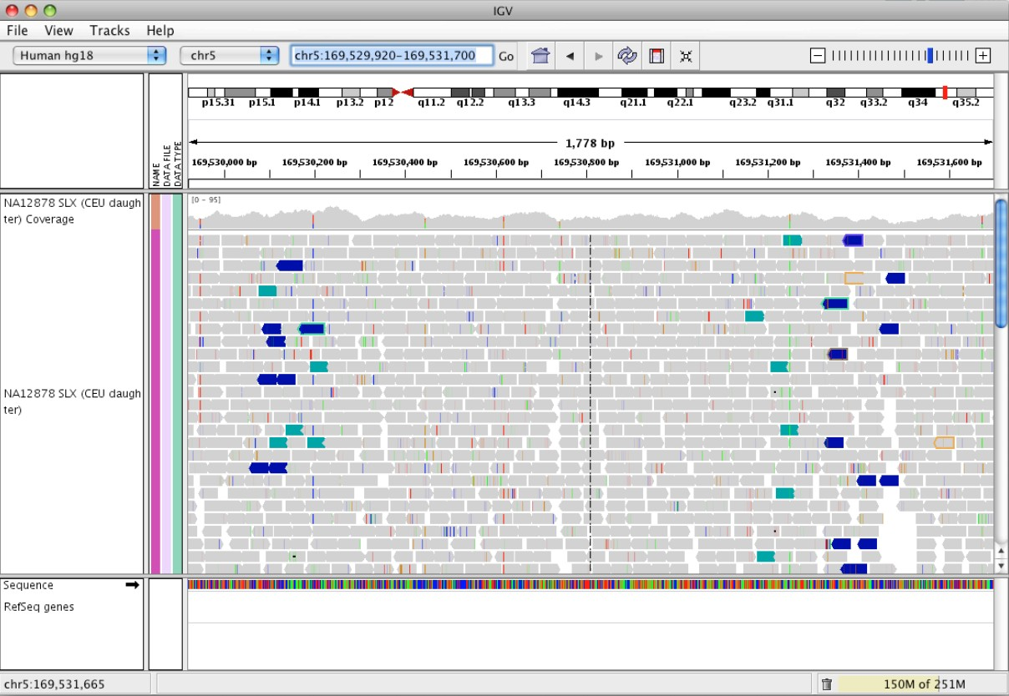

There is a gain of coverage in the duplicated region and a tiny drop in the break points where the sequence exists in only one allele

## Deletion

Deletion of a segment of DNA

If the deletion is larger than the size of the reads, we should see half of the coverage in the deleted regions

If the deletion is larger that the size of the reads, we should see a tiny little space corresponding to the missing nucleotides

Elements to consider:

Pair ends relative orientation Insert size length

Coverage within the aberrant region

Coverage outside of the aberrant region (flanking genomic segments) Coverage at the breakpoints

Ask yourself if the sequence exists and where it is