Treebank Annotation Guidelines

VALICO

Universal Dependencies

Release 2.8

Overview:

1. Introduction
2. Tokenization, lemmatization, morphology, PoS tagging
3. Dependency annotation

**1. Introduction**

These guidelines are meant to briefly outline how the annotation is applied to the learner part (LS) of the subcorpus of VALICO released within the framework of Universal Dependencies (UD) for the first time in version 2.8. We will use the parallel corrected sentences (TH) to highlight annotation difference.

Since the LS part of VALICO-UD contains texts written by non-native speakers, it is necessary to make some choices to deal with non-canonical forms. In these guidelines, we are going to illustrate how we performed tokenization, lemmatization, morphology and dependency annotation in the LS part, especially focusing on what differs from the UD scheme.

**2. Tokenization, lemmatization, morphology, PoS tagging**

**Tokenization**

If words are mistakenly tokenized, we follow the UD scheme[1], since this kind of error is sporadic.

Wrongly split word:

EXAMPLE (1a)

Ieri al parco ha suceso un distrasto per che una donna è andata al parco […]

9 per perche SCONJ CS _ 14 mark _ _

10 che _ X _ _ **9** **goeswith** _ _

Wrongly merged word:

EXAMPLE (1b)

Nell parco non c'era nessunosolo io.

7 nessuno nessuno PRON PI Gender=Masc|Number=Sing|PronType=Ind 6 nsubj _ **SpaceAfter=No|CorrectSpaceAfter=Yes**

8 solo solo ADV B _ 9 advmod _ _

We do not mark misspelled words[2] because they are highly frequent errors, and the correct spelling can be retrieved either in the err field of the LS CoNLL-U file or in the TH file.

**Lemmatization**

Lemmatization follows standard rules but maintains spelling errors, if present.

For example, in (1a), *perche* is lemmatized without the graphic accent. In example (2a) *perchè* maintains the wrong accent in the lemma, while *cominzava* and *sapiava*, although they do not exist in Italian[3], are lemmatized following the Italian rules for verb lemmatization.

EXAMPLE (2a)

Ma la donna cominzava a gridare e Io non sapiava perchè.

1 Ma ma CCONJ […]

2 la la DET […]

3 donna donna NOUN […]

4 cominzava **cominzare** VERB […]

5 a a ADP […]

6 gridare gridare VERB […]

7 e e CCONJ […]

8 Io io PRON […]

9 non non ADV […]

10 sapiava **sapiare** VERB […]

11 perchè **perchè** NOUN […]

12 . . PUNCT […]

When a foreign word occurs, if it is contextually plausible, we lemmatize it with its foreign lemma and add ‘Foreign=Yes’ in the feature column, as shown in (2b).

EXAMPLE (2b)

Il uomo era alto, forte e molto musculuso, ma Io può derribarle salvare a la donna.

14 derribar **derribar** VERB […] VerbForm=Inf|**Foreign=Yes** […]

If it is contextually implausible, we lemmatize it accordingly to the PoS and we do not add ‘Foreign=Yes’ in the feature column, as shown in (2c).

Example (2c)

Mi h'offerto du chiamare la polizia […]

4 du **du** ADP E _ 5 mark _ _

5 chiamare chiamare VERB V […]

**Morphology**

As specified in UD annotation scheme, if some tokens’ morphological features are invariant, we do not mark these features in the dedicated column. So, for example, in (2a) *perchè* is a masculine noun, which is number invariant, hence we mark only the gender in the dedicated column, as shown in (3).

EXAMPLE (3a)

Ma la donna cominzava a gridare e Io non sapiava perchè.

11 perchè perchè NOUN S Gender=Masc 10 obj […]

Conversely, if an invariant token displays a non-canonical suffix (3b), we annotate it literally maintaining the features that the learner gave to it.

EXAMPLE (3b)

Ieri al parco, un uomo con dei grossi muscoli avevano una fragila donna sulla spalla.

14 fragila **fragilo** ADJ A **Gender=Fem**|Number=Sing 15 amod […]

As a general rule, if the orthographical and morphological form of the word respect its canonical form, then we mark its features in a standard way. This applies to nouns, verbs, and other parts of speech (PoS) which are not context dependent. In (3c) we show a sentence in which we literally annotated the morphological features of a verb and a noun, without taking into account their distributional features, because we interpret this error as an agreement error involving the article and the noun.

EXAMPLE (3c)

La dona ringraziava suo salvatore con un braccio e chiusa le occhi.

2 dona dona NOUN […] Gender=Fem|Number=Sing […]

10 chiusa […] **Gender=Fem**|**Number=Sing**|**Tense=Past**|**VerbForm=Part** […]

11 le […] Definite=Def|**Gender=Fem**|**Number=Plur**|PronType=Art […]

12 occhi occhio NOUN S **Gender=Masc**|**Number=Plur** 10 obj _ SpaceAfter=No

We break this rule when we have overextension errors, such as in (3d), in which we have a gender invariant adjective which is likely used as a feminine plural (overextension of feminine plural suffix -e).

EXAMPLE (3d)

Avevo sentito delle parole forte, una donna sta gridando […]

5 forte forto ADJ A **Gender=Fem**|**Number=Plur** 4 amod […]

In the same text, we find also another error involving the same suffix, reported in (3e). In this case, it is likely an agreement error due to distraction. In fact, *fiore* in French is a feminine noun, so the adjective’s feminine suffix could be due to a negative interference of the L1. However, another interpretation could be that the learner uses the suffix -e as a marker of plural with no gender distinction, but the occurrences of this suffix in the text made us reject this hypothesis (e.g., *le ore piccole* [3-05_fr-3]). Note also the lemmatization of *uccele*, which not only maintains the spelling errors but also the feminine gender (even though *uccele* likely refers to *uccelli*, noun masculine and plural).

EXAMPLE (3e)

La natura del parco mi sembra piu verde, i fiori piu aperte, le uccele cantarono.

14 aperte aperto ADJ A **Gender=Fem**|**Number=Plur** 12 […]

17 uccele uccela NOUN S Gender=Fem|Number=Plur 18 […]

**PoS tagging**

As shown in the previous examples, we try to annotate always token’s distributional PoS tags. We annotate the distributional tag for spelling errors, also those resulting in real words, as in (3c).

In cases of wrongly split words, we tag the first part with the distributional tag, the second with X, as shown in example (1a).

We annotate literally (morphologically, not distributional-based) if the word belongs to the closed-class set and the original PoS is inconsistent with the distributional one, as in (4a) in which a preposition is used instead of a conjunction.

EXAMPLE (4a)

Durante un ragazzo è passato.

1 Durante durante **ADP** E […]

2 un un DET RI […]

3 ragazzo ragazzo NOUN S […]

4 è essere AUX VA […]

5 passato passare VERB V […]

Since our PoS tags are distributional based, we label cancelled words (marked with X in the text) with their distributional PoS tags[4], as in (4b).

EXAMPLE (4b)

L'uomo era brutto e ha la ragazza sull X.

6 ha avere VERB V […]

7 la la DET RD […]

8 ragazza ragazza NOUN S […]

9-10 sull _ _ _ _ _ _ _ _

9 su su ADP E […]

10 l lo DET RD […]

11 X _ **NOUN** S […]

12 . . PUNCT FS […]

**3. Dependency annotation**

For this level of annotation too, when a non-canonical form appears, we annotate it according to the co-text (considering the distributional slot) but keeping in consideration the morphological features and the annotation possibilities offered by the standard language.

Reusing the example 2b, in Figure 3.1a, we show its dependency tree, and the attributes of the node *le*. *Derribar* is a Spanish transitive verb, which is semantically appropriate in the sentence context, then we annotate *le* as direct object of *derribar*, but since *le* in Italian, when direct object refers to feminine plural nouns, we mark these features in the appropriate column as shown in **feats,** on the left of Figure 3.1a. If compared with its correspondent TH tree, shown in figure 3.1b, it is possible to infer the provided sentence interpretation, in which *lo* correspond to *le* and the antecedent of *lo* can be easily identified with *uomo*.

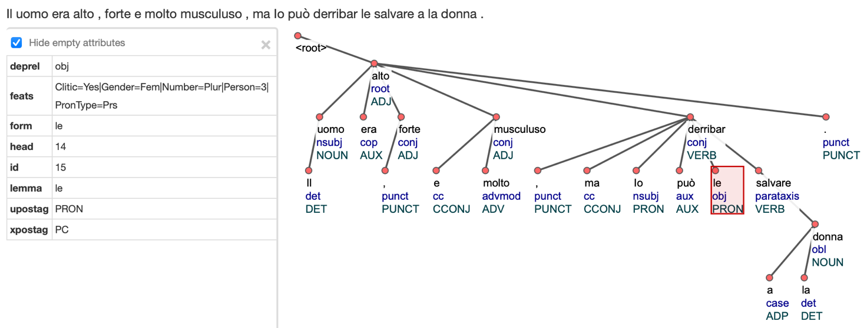

Figure 3.1a: Dependency tree of Example (2b).

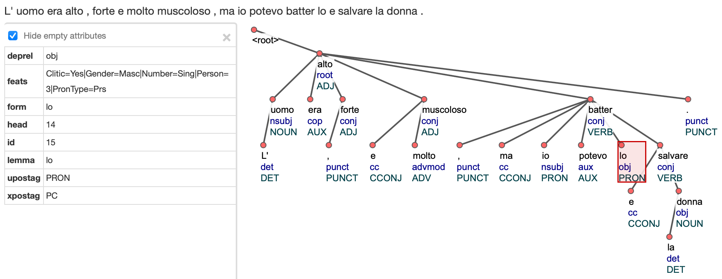

Figure 3.1b: TH version of dependency tree 3.1a.

Sometimes, learners modify verb argument structures adding or omitting some elements which can change the tree. For example, in Figure 3.2a, we show a sentence in which a noun is used as an indirect object, while in in the TH it is replaced by an oblique (Figure 3.2b).

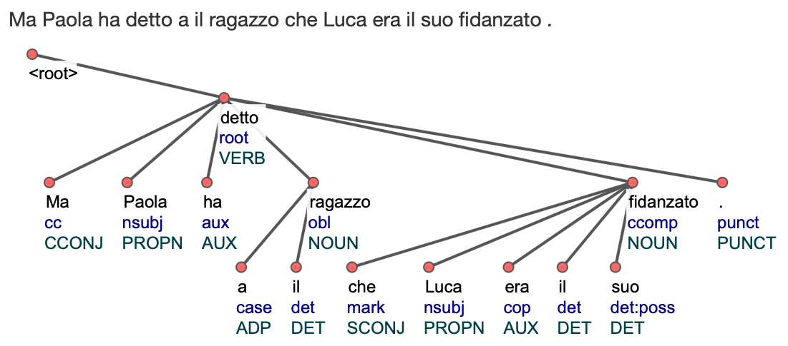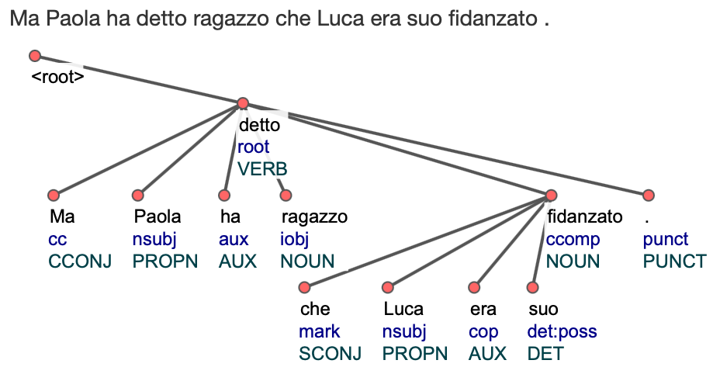

Figure 3.2a: Dependency tree *iobj* Figure 3.2b: TH version of dependency tree 3.2a.

In Figure 3.3a-b, we show an example of an oblique which corresponds to a direct object (TH).

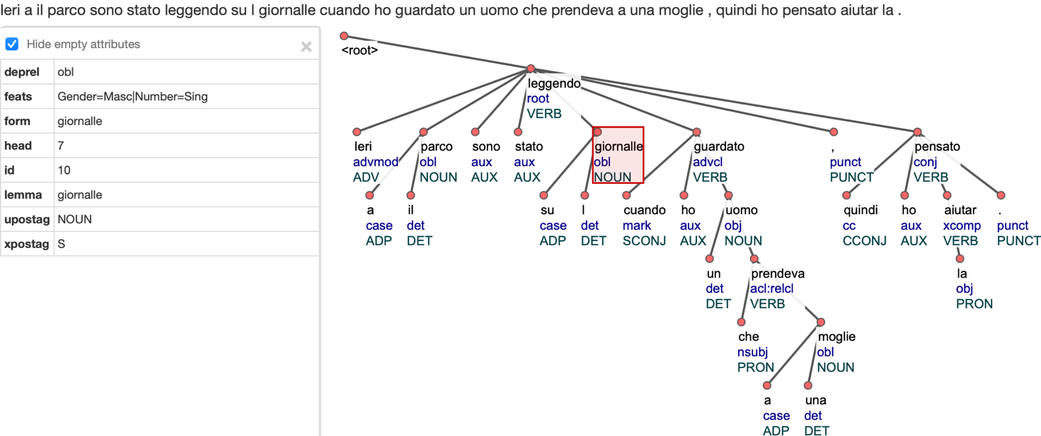

Figure 3.3a: Dependency tree *obl*.

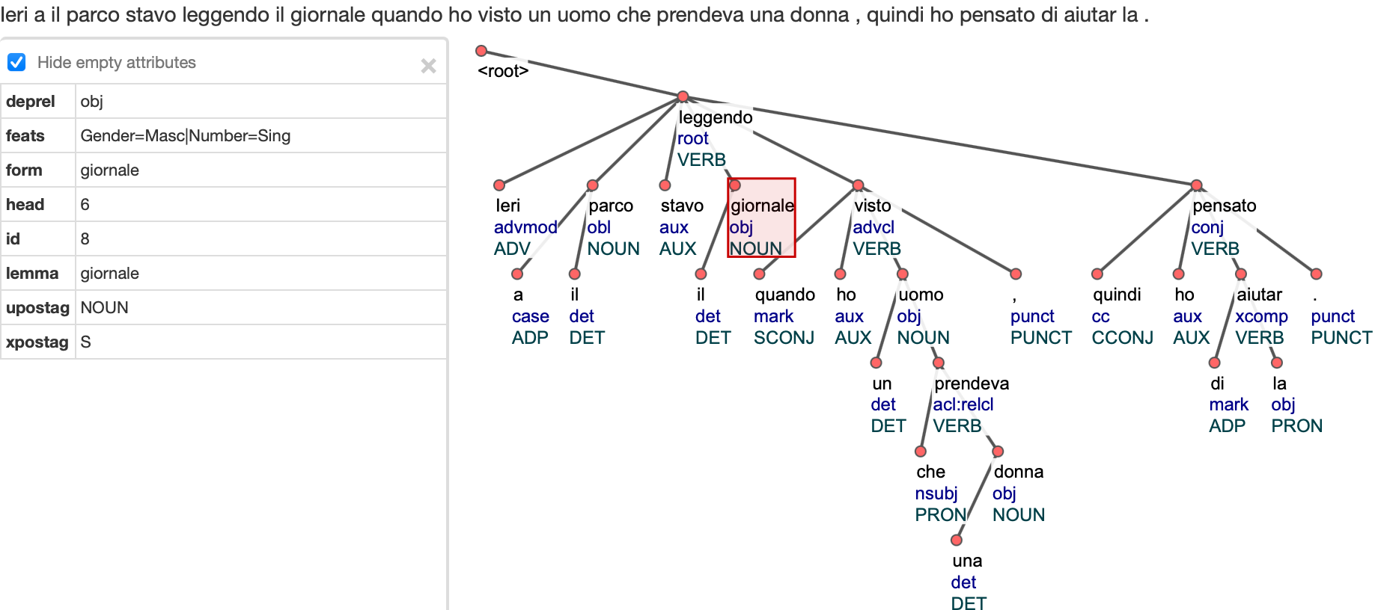Figure 3.3b: TH version of dependency tree 3.3a.

We always try to annotate the sentence as we can read it literally without interpreting. So, in Figure 3.4a-b we show an example in which a different final vowel changes the resulting tree. It is worth noticing that adverbs are invariant, so *molte* in 3.4a is annotated as a pronoun, despite it is substituted by an adverb in the TH (3.4b).

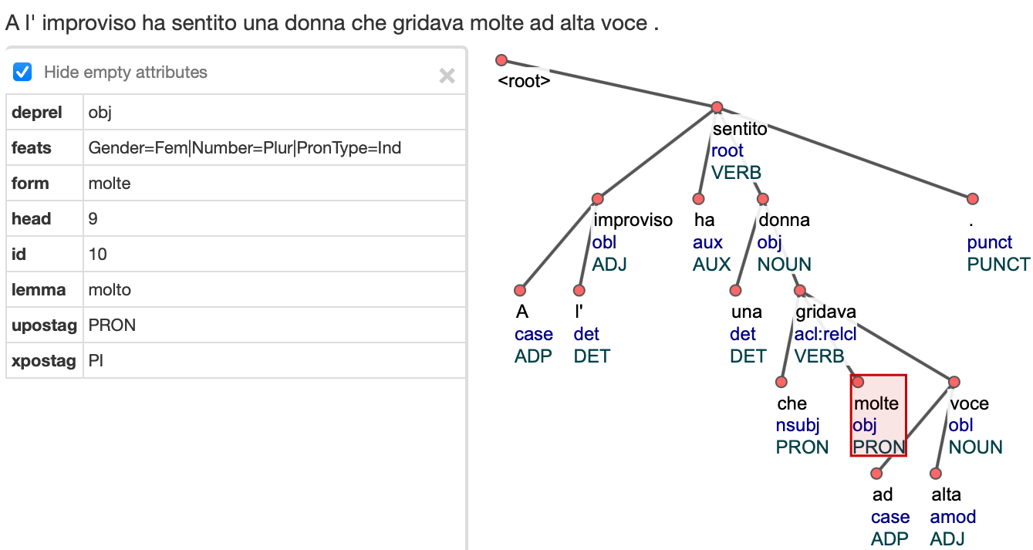

Figure 3.4a: Dependency tree of *molte*.

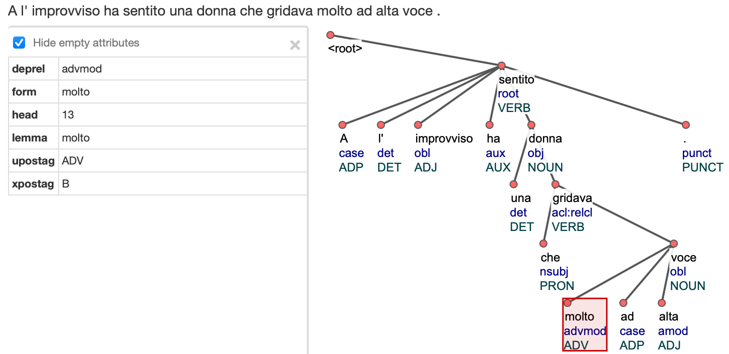

Figure 3.4b: TH version of dependency tree 3.4a.

If it is not clear the (logical) syntactical function of an element, we annotate it with the generic dependency relation label *dep*, as shown in Figure 3.5a-b.

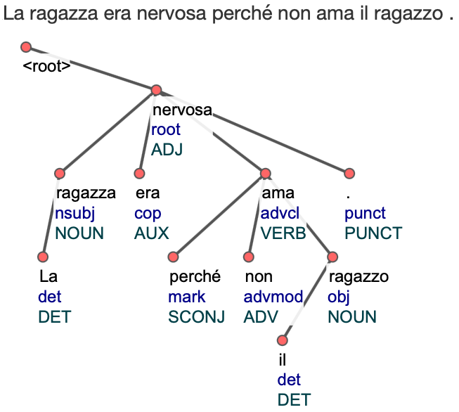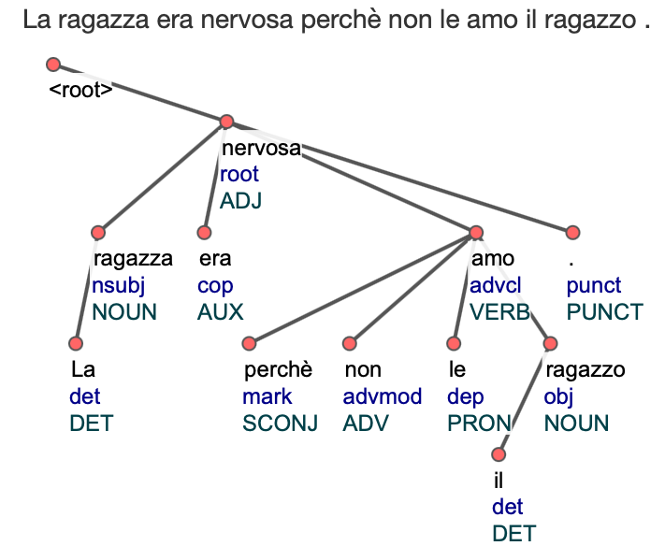

Figure 3.5a: Dependency tree of *dep.* Figure 3.5b: TH version of dependency tree 3.5a.

1. https://universaldependencies.org/u/overview/typos.html#wrongly-split-word

   https://universaldependencies.org/u/overview/typos.html#wrongly-merged-words
2. https://universaldependencies.org/u/overview/typos.html#misspelled-word
3. In the correspondent TH, we provide one of the possible interpretations, which in this case is *cominciare* and *sapere*, respectively.
4. Currently, we have only one occurrence of this phenomenon.