Macas, Edzra C. GEED 007 Science, Technology, and Society
BSIT 4-1 Activity 1

My Personal Gravity
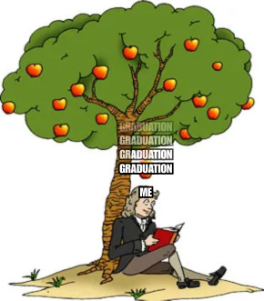
This meme titled “My Personal Gravity” shows Isaac Newton sitting under an apple tree labeled “Me,” while the apple is labeled “Graduation.” It reimagines the story of Newton’s discovery of gravity, which marked the beginning of an intellectual revolution that changed how people understood the world. In reality, Newton was never hit by the apple but simply saw it fall, which made him question why it always went downward. In this meme, the falling apple represents the realization that hits me as a graduating student. The approaching graduation becomes the turning point that awakens me from complacency, making me aware of my responsibilities and the weight of reality. Like Newton’s awakening to the laws of nature, this moment pushes me to reflect, grow, and take action. This represents my own intellectual evolution, as the fear of doing nothing and the drive to prepare for life after school transform how I see myself and my future.

