Part 4 System Design, Development, and Implementation
4.1 Requirements Engineering
Stakeholder Analysis
Stakeholder analysis serves as a critical component in the development of the MAP Active Philippines Asset Management System (MAP-AMS), facilitating the systematic identification of individuals and groups with either direct or indirect interests in the project. This analytical process seeks to delineate stakeholder roles, responsibilities, degrees of influence, and their relational dynamics within the project framework. Through this mapping, the analysis supports the alignment of the system’s design and implementation with both technical requirements and academic standards, while also addressing the operational needs of the client. Stakeholders are generally classified into two main categories, with internal stakeholders referring to the project development team, and external stakeholders including the client organization and academic advisers.
Table #
Stakeholder Analysis
Stakeholder | Role | Type | Interest in System | Level of Influence | Responsibility
Mr. Elvin Punzalan | IT Department Head, MAP Active Philippines | External | High | High | Serves as the Product Owner representing the client organization. Provides workflow details, identifies process inefficiencies, and defines the required functionalities of the Asset Management System. Validates deliverables and ensures that the system aligns with the IT department’s operational needs.
Mrs. Rosicar Escober | Capstone Adviser | External (Academic) | Medium | High | Provides academic guidance by setting deliverables, defining timelines, and assessing sprint progress. Reviews documentation and ensures that outputs comply with institutional standards and capstone requirements.
Ms. Keziah Monzon | Capstone Adviser | External (Academic) | Medium | High | Collaborates with the project team during consultations and documentation reviews. Offers insights on technical modeling, report writing, and presentation structure to ensure academic quality.
Mr. Estong Odpaga | System Consultant Adviser | External (Technical) | Medium | Medium | Provides technical consultation and validation of development decisions. Advises the team on best practices in software design, system architecture, and implementation strategies.
Ms. Ma. Elisa Johanna Garrote | Project Manager / Scrum Master / Business Analyst | Internal | High | High | Leads project planning and coordination. Oversees sprint schedules, assigns tasks, and ensures communication between the client, advisers, and development team. Manages progress tracking and sprint retrospectives.
Ms. Edzra Macas | Lead Backend and Frontend Developer | Internal | High | High | Handles backend system architecture and supports frontend integration. Ensures proper implementation of business logic, database integrity, and API performance. Provides technical recommendations during sprint reviews.
Ms. Johanna Mae Sillano | Lead Frontend and Backend Developer | Internal | High | Medium | Focuses on frontend user interface and user experience. Ensures design consistency and usability, while also contributing to backend development and API integration.
Mr. Bengie Villesco | Quality Assurance / Full Stack Developer | Internal | High | Medium | Conducts quality assurance testing based on established acceptance criteria. Identifies bugs and validates that each feature performs according to user stories and requirements.
End Users (IT Staff) | System Users | External | High | Medium | Represent the operational users of the system. Responsible for utilizing the AMS in asset registration, tracking, and auditing. Provide feedback during system demonstrations and user acceptance testing.
The table shows the classification and involvement of both internal and external stakeholders who play vital roles in the development of the Map Active Asset Management System (MAP-AMS). As presented, the external stakeholders include representatives from the client organization, academic advisers, and technical consultants, while the internal stakeholders comprise the project development team. This distribution ensures that both the academic and industrial aspects of the system are addressed throughout the project lifecycle. The inclusion of the client organization, MAP Active Philippines, represented by Mr. Elvin Punzalan, reflects the project’s real-world application and operational purpose. His active participation as the Product Owner provides the development team with essential insights regarding workflow inefficiencies, required functionalities, and feature prioritization. Through continuous validation and feedback, he influences the project’s direction to ensure that the resulting system aligns with the IT Department’s operational needs and long-term objectives.
The table also outlines the contributions of academic advisers who serve as guiding authorities throughout the project’s execution. Both Ms. Rosicar Escober and Ms. Keziah Monzon act as Capstone Advisers responsible for monitoring deliverables, reviewing documentation, and ensuring adherence to institutional guidelines. Their influence extends beyond administrative oversight, as they also assist the team in refining technical documentation, system models, and sprint outputs. Likewise, the System Consultant Adviser, Mr. Estong Odpaga, provides technical supervision to maintain the system’s alignment with current industry standards and software engineering practices. His role supports the team in addressing architectural and implementation challenges, bridging theoretical frameworks with practical development strategies. The inclusion of these advisers strengthens the project’s academic foundation and ensures that all technical and methodological standards are achieved.
Lastly, the table highlights the participation of the internal stakeholders, composed of the project’s development team and the end users. The internal stakeholders; namely Ms. Ma. Elisa Johanna Garrote, Ms. Edzra Macas, Ms. Johanna Mae Sillano, and Mr. Bengie Villesco—play distinct but interconnected roles throughout the development cycle. Elisa functions as the Project Manager and Scrum Master, overseeing sprint planning, communication, and task coordination. Edzra and Johanna serve as the lead developers for the backend and frontend, respectively, ensuring the technical accuracy and efficiency of each module. Bengie, on the other hand, focuses on quality assurance and validation of features according to the acceptance criteria and also contributed a huge part in development as a full stack developer. In addition, the MAP Active IT staff, as the intended end users, are identified as key participants during the User Acceptance Testing (UAT) phase, where they will provide practical feedback on the system’s usability and performance. Their input will be instrumental in refining the final output, ensuring that the AMS effectively supports asset registration, maintenance, and auditing functions. Overall, the table demonstrates how each stakeholder contributes to the project’s collaborative and iterative development approach, ensuring balance between academic rigor and real-world applicability.

Elicitation Techniques
The requirement-gathering process for the Asset Management System (AMS) involved the application of both survey and interview methods to ensure a comprehensive understanding of the client’s needs. The survey served as the preliminary phase of data collection and was administered to the IT Department Head of MAP Active Philippines during the early stage of development in March. It consisted of a structured set of questions designed to identify existing challenges in asset and inventory management, inefficiencies in workflow, and expectations for system functionality. This technique enabled the team to collect organized and objective responses, which provided a foundational perspective on the operational environment of the IT department.
Following the survey, an in-depth interview was conducted with the IT Department Head to obtain more detailed insights and clarify the responses provided in the initial survey. All four members of the project team participated in this session, which was carried out face-to-face at the client’s premises. The interview focused on exploring pain points, validation of workflow processes, and identification of features that could enhance efficiency in asset monitoring. Through open-ended questions and discussion, the team was able to understand the daily challenges experienced by IT personnel in managing asset information, maintenance schedules, and accountability procedures. This approach allowed the team to gather qualitative data that complemented the structured information from the survey, resulting in a more holistic view of the client’s operational needs.
Furthermore, the combination of survey and interview techniques proved effective in establishing an accurate representation of the client’s requirements. The survey provided an initial framework that allowed the stakeholder to reflect on the organization’s processes, while the interview encouraged interactive discussion and deeper exploration of issues. This sequence of methods was particularly appropriate for the stakeholder, as it facilitated both reflection and collaboration before technical development began. The general insight derived from these elicitation activities revealed that the organization required a comprehensive system to manage its assets and inventory more efficiently, promoting proper monitoring, accountability, and transparency. The information obtained from these techniques served as the foundation for identifying the system’s functional and non-functional requirements, which guided the design and development of the Asset Management System.
Functional Requirements
The functional requirements of the MAP Active Asset Management System (MAP-AMS) were derived from the results of the requirements elicitation activities, specifically the survey and interview conducted with the IT Department of MAP Active Philippines. These requirements represent the key functionalities necessary to address the identified workflow pain points and operational inefficiencies. To ensure systematic prioritization, the team utilized the MoSCoW method, which categorizes each function into four levels: Must Have, Should Have, Could Have (Nice to Have), and Won’t Have. This prioritization strategy allowed the project team to manage development resources efficiently and ensure that the most essential features were implemented first.
The prioritization process was guided by the feedback of the IT Department Head, technical feasibility, and the project’s timeline. The Must Have requirements were considered critical to the operation of the system and were therefore prioritized during the early development sprints. These include modules such as authentication, context management, asset registration, repair, and audit core functionalities that form the backbone of the MAP-AMS. The Should Have requirements were identified as secondary but valuable enhancements that improve usability and system performance, such as dashboard and reporting capabilities. Meanwhile, the Nice to Have requirements, including the forecasting feature and QR code scanning for asset information viewing, were recognized as innovative additions that could be developed if time and resources permit. The Won’t Have requirements, such as accessories and consumables management, were excluded from the current scope due to time and resource limitations but may be considered for future iterations.
Table 3
MoSCoW Prioritization of Functional Requirements
ID | Priority | Module/Feature | Description
FR-01 | Must Have | Authentication (Integrated) | Enables secure user login and role-based access control.
FR-02 | Must Have | Profile Management | Allows users to manage personal and account information.
FR-03 | Must Have | Assets Module (Includes Asset Model/Product Registration) | Handles asset registration, tracking, and detailed product data management.
FR-04 | Must Have | Asset Repair (Maintenance) | Records and manages repair or maintenance activities for assets.
FR-05 | Must Have | Asset Audit | Supports auditing processes and asset verification.
FR-06 | Must Have | Context (Category, Supplier, Manufacturer, Depreciation, Status, Recycle Bin) | Manages contextual data required across modules for efficient asset tracking.
FR-07 | Should Have | Dashboard | Displays summarized system analytics and key performance indicators.
FR-08 | Should Have | Reports | Generates detailed reports such as asset depreciation, end-of-life, warranty, and audit results.
FR-09 | Should Have | Components | Manages the relationship of asset parts and their configurations.
FR-10 | Nice to Have | Notification | Sends system alerts or reminders regarding asset activities or maintenance schedules.
FR-11 | Nice to Have | Forecasting | Provides predictive analytics for asset utilization and replacement cycles.
FR-12 | Nice to Have | QR Scanned (for asset info viewing only) | Allows quick retrieval of asset information through QR code scanning.
FR-13 | Won’t Have | Accessories and Consumables | Excluded from current scope but may be considered for future development.
The functional requirements presented in this section are aligned with both the Product Backlog and the Requirements Traceability Matrix (RTM). In the Product Backlog, the development process follows the MoSCoW prioritization approach, where must-have functionalities are implemented in the early and refinement sprints to establish the system’s core operations. Meanwhile, should-have and nice-to-have features are integrated in later stages to enhance usability and innovation. In the RTM, this alignment is reflected by documenting the version and completion status of each module. The initial iterations of the RTM primarily included the must-have and should-have requirements, which correspond to completed and tested modules. Subsequent refinements introduced minor features and enhancements. This structured approach ensures that every functional requirement identified during the elicitation process is traceable, implemented, and validated throughout the system’s development lifecycle.
Non-Functional Requirements
Table <#>
Non-Functional Requirements

ID | Category | Requirement Description | MoSCoW Priority
NFR-1 | Maintainability | Supplier updates must preserve historical data through versioning or logs, ensuring traceability and compliance with data retention policies. | Must
NFR-2 | Performance | Category list pages must load within 2 seconds for up to 1000 records, utilizing pagination with responsive list numbers and scrollable pages to handle large datasets efficiently. | Must
NFR-3 | Performance | Manufacturer updates must trigger real-time notifications to linked assets if changes affect depreciation or status, maintaining system responsiveness under 1 second. | Must
NFR-4 | Performance | Status pages must load with filters applied by default (e.g., alphabetical), supporting up to 5000 records with efficient querying for performance. | Must
NFR-5 | Performance | Depreciation calculations must be accurate to two decimal places for currency fields, with formulas executed in under 100ms per record. | Must
NFR-6 | Performance | Asset Model view pages must load details and tabs (Details/About, Assets) in under 1 second, with responsive design for mobile views. | Must
NFR-7 | Performance | Advanced search for Asset Models must handle multiple filters (e.g., category, manufacturer) efficiently, returning results in under 500ms. | Should
NFR-8 | Performance | Asset list views must support pagination and sorting, handling up to 5000 assets with load times under 3 seconds. | Must
NFR-9 | Performance | Advanced asset searches must support multi-field filtering, optimized for quick responses even with large datasets. | Should
NFR-10 | Performance | Asset check-out processes must integrate with tickets securely, completing in under 2 seconds with real-time status updates. | Must
NFR-11 | Performance | Component views and operations must be performant, with tables supporting filtering and pagination for scalability. | Should
NFR-12 | Performance | Status operations must be efficient, with updates propagating to linked entities in real-time. | Must
NFR-13 | Performance | Depreciation operations must maintain numerical precision and support batch processing for performance. | Must
NFR-14 | Reliability | Updates to categories must be processed atomically to maintain data consistency, with the system handling concurrent edits gracefully and logging changes for audit purposes. | Must
NFR-15 | Reliability | Deletion of categories must check for dependencies (e.g., linked assets or components) and prevent removal if in use, returning error messages within 1 second to ensure system reliability. | Must
NFR-16 | Reliability | Deletion of suppliers must be reversible via recycle bin within 30 days, maintaining data availability and recoverability. | Should
NFR-17 | Reliability | Status updates must be backward-compatible, ensuring no disruption to existing asset linkages. | Should
NFR-18 | Reliability | Deletion of statuses must include dependency checks and soft-delete mechanisms for recoverability. | Should
NFR-19 | Reliability | Deletion of depreciations must prevent removal if linked to assets, with error responses in JSON format for API integrations. | Should
NFR-20 | Reliability | Asset Model updates must maintain referential integrity with linked assets, logging changes for audit trails. | Must
NFR-21 | Reliability | Deletion of Asset Models must be restricted if in use, with soft-delete and recycle bin integration for data recovery. | Should
NFR-22 | Reliability | Asset updates must be atomic and trigger recalculations for depreciation or EoL, ensuring data consistency. | Must
NFR-23 | Reliability | Asset check-in must validate against existing requests, ensuring reliability and preventing unauthorized actions. | Must
NFR-24 | Reliability | Recycle bin recovery must be reliable, with operations logged and limited to admins for security. | Should
NFR-25 | Reliability | The system must handle errors gracefully, displaying user-friendly messages and preventing exposure of sensitive data. | Must
NFR-26 | Scalability | Manufacturer registration must handle high concurrency (up to 10 simultaneous users) without data loss, ensuring scalability. | Should
NFR-27 | Scalability | Depreciation updates must recalculate affected asset values automatically, ensuring computational efficiency for batches up to 1000 assets. | Should
NFR-28 | Scalability | Recycle bin must retain deleted items for at least 90 days, with storage optimized to handle up to 10,000 items without performance degradation. | Should
NFR-29 | Scalability | The system must be scalable to support up to 100 concurrent users without exceeding 80% CPU utilization on standard hardware. | Must
NFR-30 | Security | The system must ensure that access to the context module (category, supplier, manufacturer, status, depreciation, recycle bin) is restricted to IT Head/Admin roles only, with role-based authentication enforced at all times. | Must
NFR-31 | Security | Supplier registration must enforce security by validating file uploads against malware and limiting to .xlsx for imports, with all operations completing in under 3 seconds. | Must
NFR-32 | Security | Deletion of manufacturers must log events for security auditing, with operations restricted to admins and completed securely. | Must
NFR-33 | Security | Status registration must validate alphanumeric inputs and enforce uniqueness, with error handling that prevents system crashes. | Must
NFR-34 | Security | Depreciation registration must support integer months and float currencies, with input sanitization to prevent injection attacks. | Must
NFR-35 | Security | Asset registration must enforce admin-only access and validate inputs (e.g., dates not in future), with secure file handling. | Must
NFR-36 | Security | Asset deletions must use soft-delete for recoverability, with admin confirmation and logging. | Must
NFR-37 | Security | Asset view pages must display full details securely, with tabs loading asynchronously for better performance. | Must
NFR-38 | Security | Manufacturer operations must ensure data security through input sanitization and access controls. | Must
NFR-39 | Security | API requests (e.g., for assets, models) must be secure with HTTPS, rate-limited to 100 requests/minute per user to prevent abuse. | Must
NFR-40 | Security | Authentication must use secure protocols (e.g., JWT), with sessions expiring after 30 minutes of inactivity for security. | Must
NFR-41 | Security | Ticket, repair, and audit modules must ensure data privacy, with operations audited and retained for 1 year. | Must
NFR-42 | Usability | Category registration forms must validate inputs in real-time, supporting maximum input lengths (e.g., 100 characters for names), file uploads limited to JPEG/PNG under 5MB, and provide immediate feedback for duplicates or missing required fields, ensuring data integrity and usability. | Must
NFR-43 | Usability | Supplier list pages must support alphabetical sorting and filtering by type, with search bars responding in under 500ms for improved usability. | Should
NFR-44 | Usability | Manufacturer pages must be responsive across devices, with hover effects and clickable elements providing intuitive navigation and accessibility compliance (e.g., WCAG 2.1 Level AA). | Must
NFR-45 | Usability | Recycle bin pages must be searchable and filterable across tabs (assets, components), with pagination supporting 50 items per page for usability. | Should
NFR-46 | Usability | Asset Model creation must validate all fields (e.g., positive integers for life months, doubles for costs) and support file uploads under 5MB, with the process completing in under 2 seconds. | Must
NFR-47 | Usability | Reports generation (e.g., asset, depreciation) must export in multiple formats (Excel, PDF, CSV) within 5 seconds for up to 1000 records, with toast notifications for usability. | Should
NFR-48 | Usability | Supplier operations must validate alphanumeric inputs (up to 100 chars for names, 500 for notes) and handle concurrency without errors. | Should
NFR-49 | Usability | All pages must include a consistent MAP AMS Footer and be scrollable, ensuring cross-browser compatibility (Chrome, Firefox, Edge) and accessibility features like keyboard navigation. | Must

The table represents a set of non-functional requirements (NFRs) for the MAP Asset Management System (AMS), designed to ensure the system's performance, security, usability, and reliability across its operational context. Each NFR defines a specific quality attribute or constraint from the perspective of the IT Admin and the system's overall architecture. These requirements are intended to support the IT Admin in maintaining a robust and efficient asset management process by establishing standards such as load times under two seconds for category lists, secure authentication with JWT and session expiry, and malware-checked file uploads limited to 5MB. For instance, several NFRs focus on performance metrics, including computations completing in under 100ms for depreciation calculations and report exports finishing within five seconds for 1000 records, ensuring smooth operation with large datasets. Other NFRs emphasize security and compliance, such as admin-only access with role-based authentication, data privacy through auditing of tickets and repairs, and WCAG 2.1 Level AA accessibility for manufacturer pages, alongside requirements for atomic updates and real-time notifications. Additionally, the table addresses scalability and recovery, with provisions for handling 10,000 items in the recycle bin for 90 days and supporting 10 concurrent users without data loss, all aimed at delivering a dependable and user-friendly system for asset management tasks.
User Stories and Use Cases
Table <#>
User Stories and Use Cases
User Story Number | User Story
US-001 | As an IT Admin, I want to create, update, and delete categories with validation and dependency checks so that I can maintain an organized asset categorization system.
US-002 | As an IT Admin, I want to view category lists with pagination and quick load times so that I can manage large datasets easily.
US-003 | As an IT Admin, I want to register suppliers with malware-checked .xlsx uploads so that I can ensure data security and integrity.
US-004 | As an IT Admin, I want to update supplier details and track changes so that I can maintain accurate supplier records.
US-005 | As an IT Admin, I want to delete suppliers and recover them within 30 days so that I can manage supplier data with flexibility.
US-006 | As an IT Admin, I want to manage manufacturer data with real-time notifications so that I can keep asset-related manufacturer info current.
US-007 | As an IT Admin, I want to view manufacturer pages across devices so that I can manage data on any device.
US-008 | As an IT Admin, I want to manage status records with uniqueness checks so that I can track asset statuses accurately.
US-009 | As an IT Admin, I want to calculate depreciation with precision so that I can assess asset financial value correctly.
US-010 | As an IT Admin, I want to manage asset models with validation and file uploads so that I can define asset templates effectively.
US-011 | As an IT Admin, I want to view asset model details with tabs so that I can review all relevant model data.
US-012 | As an IT Admin, I want to manage assets with secure access and recalculations so that I can maintain an accurate asset inventory.
US-013 | As an IT Admin, I want to view asset details securely so that I can monitor asset status and history.
US-014 | As an IT Admin, I want to check out assets with ticket integration so that I can assign assets to users efficiently.
US-015 | As an IT Admin, I want to check in assets with validation so that I can ensure proper asset return.
US-016 | As an IT Admin, I want to generate reports in multiple formats so that I can analyze asset and depreciation data.
US-017 | As an IT Admin, I want to manage recycle bin items for 90 days so that I can recover deleted data as needed.
US-018 | As an IT Admin, I want to create tickets for asset-related issues so that I can track and resolve problems.
US-019 | As an IT Admin, I want to manage repair workflows so that I can restore asset functionality.
US-020 | As an IT Admin, I want to conduct audits with data retention so that I can ensure compliance and accuracy.
The table provides a list of user stories for the MAP Asset Management System (AMS), which captures asset based processes in an organizational context. Each user story describes a feature or functionality through the perspective of an IT Admin who will interact with the system. User stories have been designed for the IT Admin to manage a wide range of activities including aggregating areas defined as categories, registering and updating suppliers, managing manufacturers, defining status for assets, calculating depreciations, create and view asset models, registering assets and tracking them, to managing check outs and check ins, generating reports, and recovering deleted records from the recycle bin, creating tickets, conducting repairs, and performing audits. For example, user stories focus on creating and managing structured data forms, like categories and asset models, which identify required fields being validated, and various file upload and attachments to efficiently manage asset name data. User stories also consider functionality like the ability to securely update details of suppliers with history tracking, the ability to view paginated lists of asset data with reasonable load times, and description of a ticket system to check out an asset, and the ability to export a detailed report to analyze aspects of reported and defined events, all of which adheres to varying security and performance demands. There is additionally an emphasis on monitoring the status of assets, receiving alerts immediately, and controlling workflows, which will include capability of soft-deletes or recovery during a 90-day recycle bin period, all developed to ensure the integrity and compliance of asset inventory.

Figure <#>. User Use Case Diagram
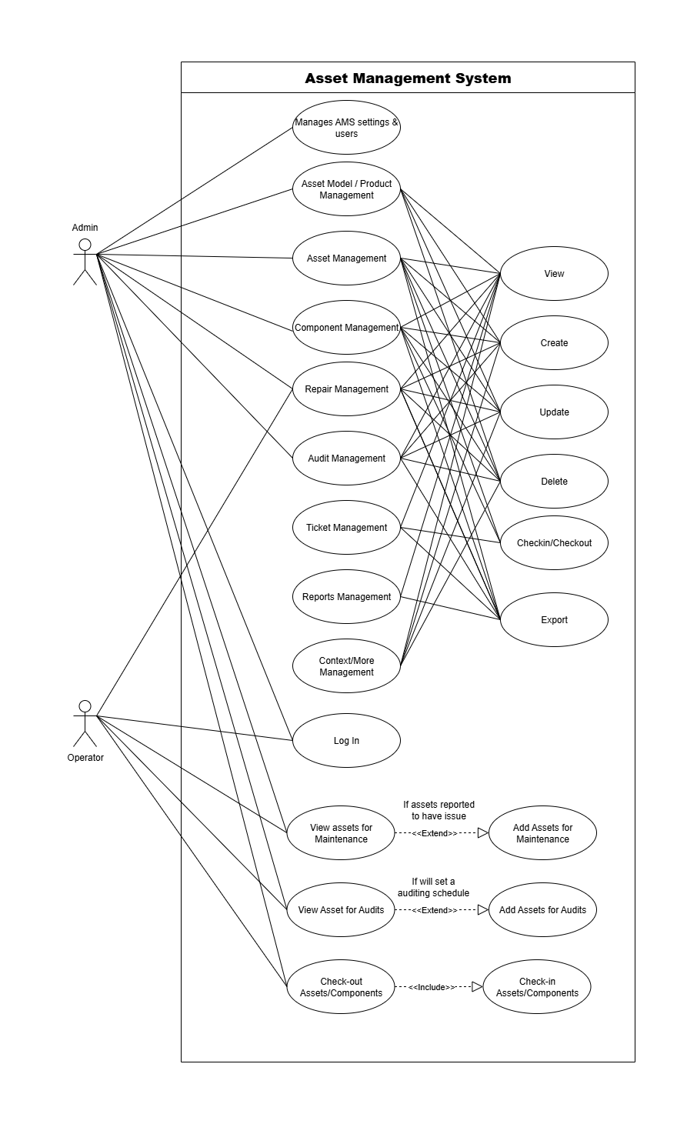
Figure <number> illustrates the use case from the user perspective in the Asset Management System (AMS). It describes a user’s ability to perform any of the asset specific use cases available to them based on their roles. The AMS defines two different kinds of users, Admin and Operator, with each role having specific access rights and duties to effectively and securely manage the assets of the organization.
The Admin has full access to all modules and functionalities within the system. This includes the ability to view, create, update, delete, check in and check out, and export data across multiple management modules such as Asset Model/Product Management, Asset Management, Component Management, Repair Management, Audit Management, Ticket Management, Reports Management, and Context/More Management. In addition, the Admin exclusively manages the “Manages AMS Settings & Users” module, which allows configuration of system settings, user account management, and overall administrative control. Through these permissions, the Admin can maintain data consistency, oversee asset operations, and ensure that all records within the system are accurate and up to date.
Meanwhile, the Operator has limited access focused primarily on operational and monitoring tasks. Operators can view records and perform check-in and check-out activities for assets and components. They have access to modules such as Asset Model/Product Management, Asset Management, Component Management, Repair Management, Audit Management, Ticket Management, and Reports Management for viewing purposes. Additionally, Operators can view assets for maintenance and audits and are able to add assets for these processes when issues are reported or when audit schedules are created. However, they do not have access to the “Manages AMS Settings & Users” and “Context/More Management” modules to maintain system security and prevent unauthorized configuration changes.
Acceptance Criteria
Table <#>
Acceptance Criteria
User Story ID | Acceptance Criteria
US-001 | - Category creation validates inputs (e.g., 100 char limit) and prevents duplicates  - Updates are atomic with change logging  - Deletion checks dependencies and prevents removal if in use
US-002 | - Category list loads in < 2 seconds for 1000 records  - Pagination with responsive numbers and scrollable pages works
US-003 | - Supplier registration completes in < 3 seconds  - .xlsx uploads are malware-checked and limited to 5MB
US-004 | - Supplier updates preserve historical data via versioning  - Concurrent edits are handled gracefully
US-005 | - Supplier deletion is reversible via recycle bin for 30 days  - Error message returns in < 1 second if dependencies exist
US-006 | - Manufacturer registration handles 10 concurrent users without data loss  - Updates trigger real-time notifications in < 1 second
US-007 | - Manufacturer pages are responsive with hover effects  - Meets WCAG 2.1 Level AA accessibility
US-008 | - Status registration enforces alphanumeric uniqueness  - Updates are backward-compatible with existing links  - Deletion includes dependency checks and soft-delete
US-009 | - Depreciation calculations are accurate to 2 decimal places  - Computations complete in < 100ms per record  - Updates recalculate affected assets for batches up to 1000
US-010 | - Asset Model creation validates fields (e.g., positive integers) and limits file uploads to 5MB  - Process completes in < 2 seconds  - Updates maintain referential integrity
US-011 | - Asset Model view loads tabs in < 1 second  - Responsive design works on mobile  - Advanced search handles multiple filters in < 500ms
US-012 | - Asset registration is admin-only with date validation (no future dates)  - Updates trigger depreciation recalculations atomically  - Deletions use soft-delete with recycle bin
US-013 | - Asset view displays details securely with async tab loading  - No sensitive data exposure  - Advanced search supports multi-field filtering
US-014 | - Asset check-out integrates with tickets and completes in < 2 seconds  - Real-time status updates provided
US-015 | - Asset check-in validates against existing requests  - Prevents unauthorized actions
US-016 | - Reports export in Excel, PDF, CSV within 5 seconds for 1000 records  - Toast notifications appear  - Asset and depreciation reports generated
US-017 | - Recycle bin retains items for 90 days, handling 10,000 items  - Search and filter across tabs with 50 items/page
US-018 | - Tickets are created with secure access  - Linked to assets and audited for 1 year
US-019 | - Repairs are managed with workflow tracking  - Data privacy ensured with auditing
US-020 | - Audits are conducted with data retention  - Ensures compliance with security protocols

The table represents a set of acceptance criteria for the MAP Asset Management System (AMS), designed to validate the system's functionality, performance, and compliance with specified requirements. Each criterion is associated with a unique "User Story ID" such as US-001 to US-020 and defines specific conditions that must be satisfied to confirm the successful implementation of corresponding user stories from the IT Admin's perspective. These criteria ensure that key processes, such as category creation with input validation like 100-character limit and duplicate prevention, supplier registration completing in under three seconds with malware-checked 5MB uploads, and depreciation calculations achieving accuracy to two decimal places within 100ms, meet defined standards. For instance, several criteria focus on performance, including category lists loading in less than two seconds for 1000 records with responsive pagination, asset model views loading tabs in under one second, and reports exporting in Excel, PDF, or CSV within five seconds for 1000 records with toast notifications. Other criteria emphasize security and data integrity, such as admin-only asset registration with no future date validation, supplier updates preserving historical data via versioning, and recycle bin retention handling 10,000 items for 90 days with searchable filters. Additionally, the table addresses usability and compliance, with requirements like WCAG 2.1 Level AA accessibility for manufacturer pages, real-time notifications for manufacturer updates, and audit data retention to ensure security protocols, providing a robust framework for system validation and quality assurance.
High-Level System Design
Figure <#>. System Context Diagram
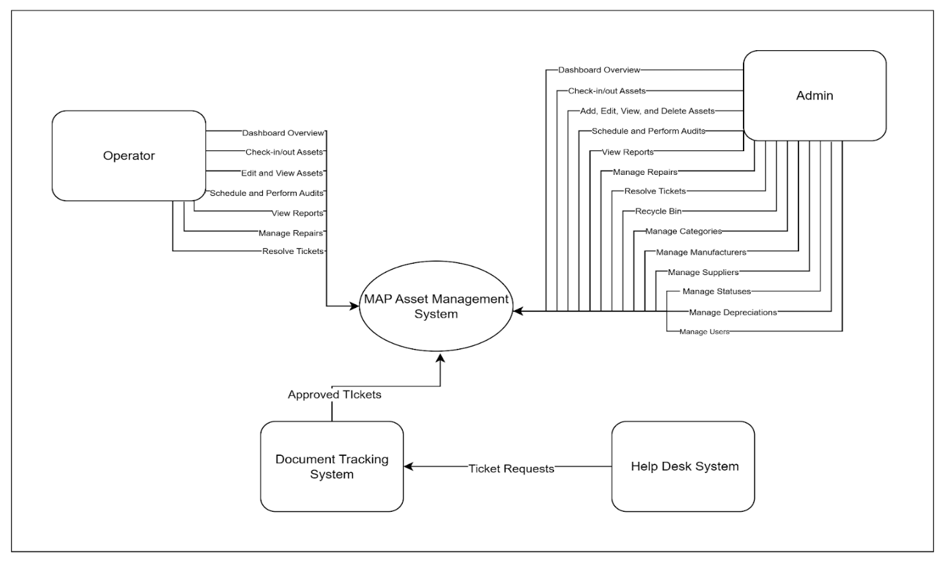
The System Context Diagram illustrates the MAP Asset Management System as the central platform that interacts with both human users and external systems. The Admin and Operator users perform core asset management functions such as check-in/check-out, auditing, and repair tracking, with the Admin having additional privileges to manage users, categories, and depreciation settings. The system also communicates with the Help Desk System to receive ticket requests and with the Document Tracking System to send approved tickets. This diagram provides an overview of all external interactions that define the system’s operational boundaries.

Figure <#>. Overview of the Integrated System
The figure above illustrates the integrated architecture of the MAP Asset Management System with other organizational systems. All systems, including the Asset Management, Budget Management, Document Tracking, and Help Desk systems, use a single centralized Authentication Service that manages user authorization and access control. The Asset Management System serves as the core platform that handles asset tracking, repairs, audits, and check-in and check-out operations. It communicates with the Budget Management System, which retrieves asset cost information and displays this data in its financial dashboard. The Help Desk System provides location data and sends asset-related ticket requests to the Document Tracking System for review and approval. Once approved, the Document Tracking System forwards the validated tickets to the Asset Management System. The Asset Management System then resolves or updates the ticket status based on the actions required by the Budget Management System. This integration ensures that asset, budget, and document processes remain synchronized across departments, enabling efficient tracking, accountability, and workflow automation.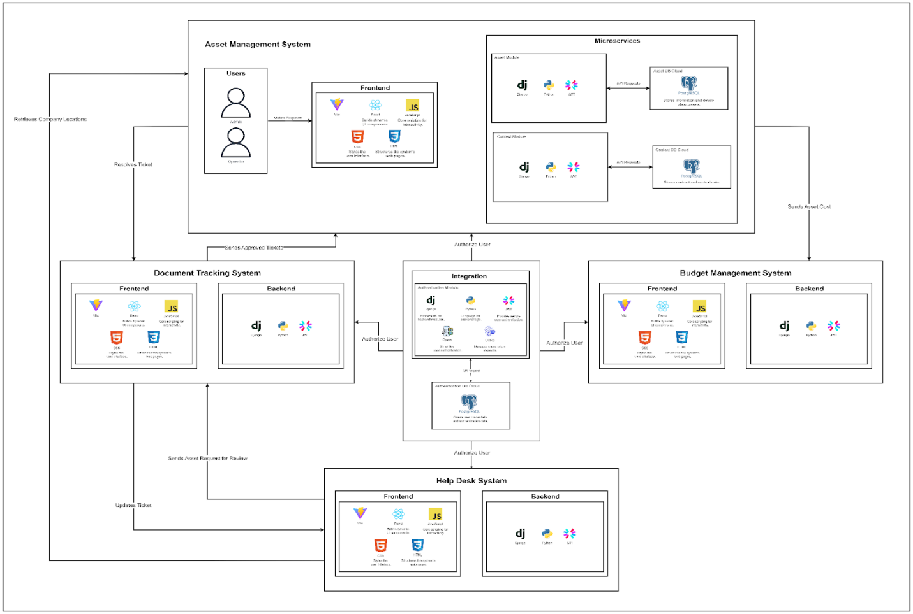

Business Process Architecture
Figure <#>. As-Is Business Process Model of MAP Asset Management System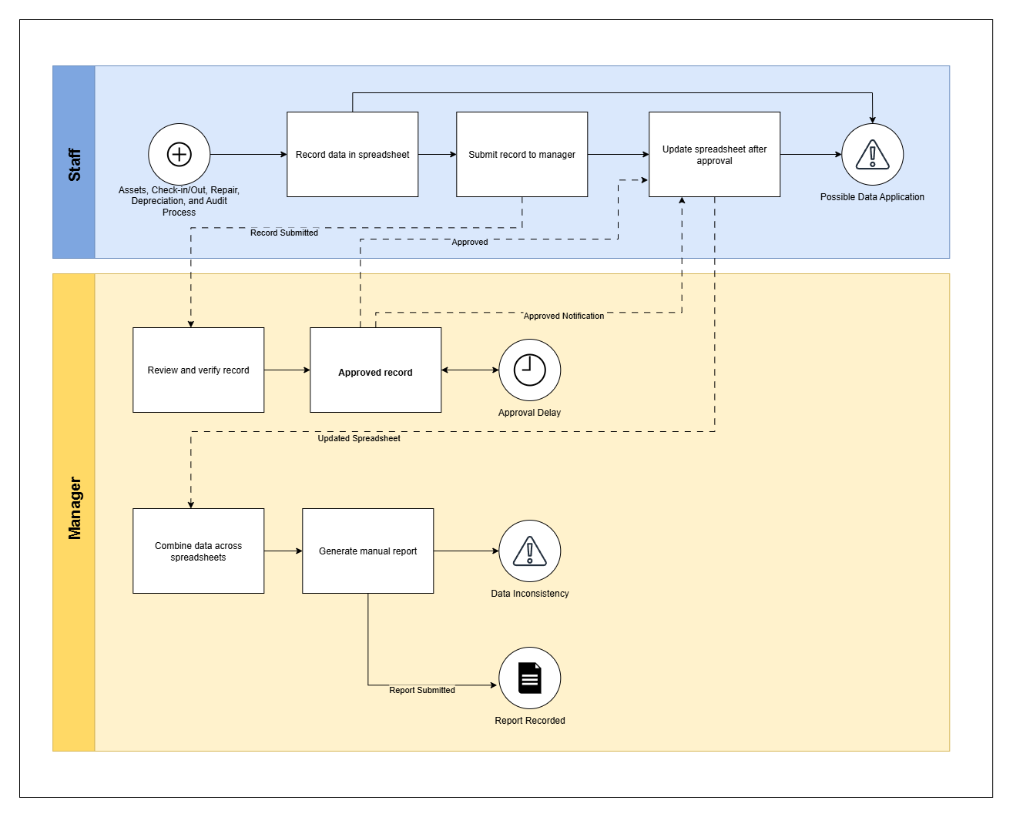
The As-Is Business Process Model shows the current manual process used by MAP Active Philippines in managing its IT assets. It includes activities such as asset recording, check-in/check-out, repair, depreciation, and audit. The diagram also shows how staff and managers handle records using spreadsheets and how the process often leads to delays and data problems.
Roles and Responsibilities
Staff
- Record asset data in spreadsheets.
- Submit the record to the manager for checking and approval.
- Update the spreadsheet after the manager’s approval.
- Handle any errors found in the data.
Manager
- Review and verify the asset record.
- Approve or return records for correction.
- Combine all spreadsheets into one file.
- Generate manual reports.
- Submit the final report for recording.
Table #
Process Flow and Identified Pain Points
Process Description | Pain Point / Observation
Staff record asset information in a spreadsheet. | Manual data entry can lead to errors and incomplete information.
The record is submitted to the manager for checking and approval. | Submitting through email or shared files may cause version errors or lost files.
The manager reviews it for accuracy. | Checking each record takes time and often causes approval delays.
After approval, staff update the spreadsheet. | Repeated changes can cause confusion or overwritten data.
Manager consolidates all approved data from various spreadsheets. | Manual consolidation increases the risk of duplication and inconsistencies.
A manual report is then generated from the consolidated data. | Report preparation is time-consuming and may not always reflect the most recent updates.
Finally, the report is submitted and recorded, marking the end of the process. | The process is fully manual and takes a long time to complete.
The As-Is Business Process Model presents the existing manual process used by MAP Active Philippines in managing its IT assets. The process mainly depends on spreadsheets for recording, checking, and reporting asset information. Staff members are responsible for encoding and updating asset data, while managers review, approve, and combine these records to prepare reports. However, this manual process often results in several issues such as data errors, missing files, and slow approval. The use of multiple spreadsheets makes it difficult to track changes and maintain accurate records. Preparing reports also takes time and may not reflect the latest information. Overall, the current process is time-consuming, prone to human error, and lacks efficiency, which affects the company’s ability to manage its IT assets properly.

Figure #. To-Be Business Process Model of MAP Asset Management System
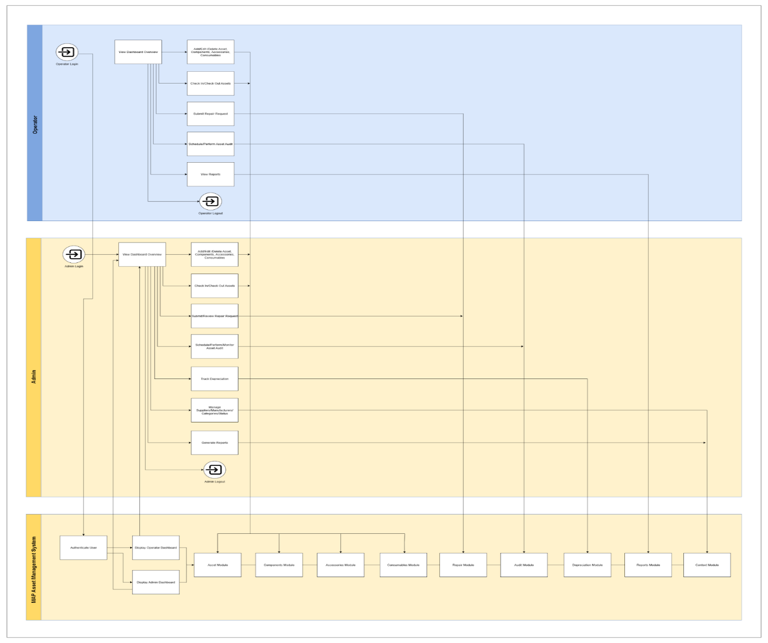
The To-Be Business Process Model shows the improved process of managing IT assets using the MAP Asset Management System. This new system replaces the manual and paper-based process with a computerized one. It allows both the Admin and Operator to perform tasks such as adding assets, checking in and checking out items, sending repair requests, tracking depreciation, and creating reports. With this system, data is stored in one place, making asset management faster, more accurate, and easier to monitor.
Roles and Responsibilities
Figure #. Operator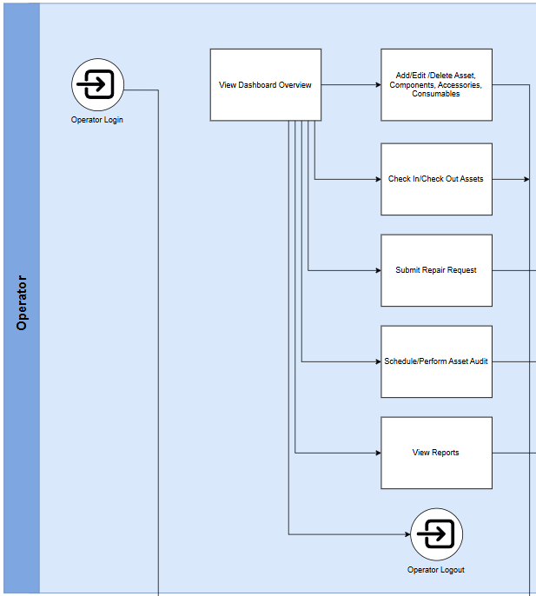
- Log in to the system through the Operator Dashboard.
- Add, edit, or delete asset information, including components, accessories, and consumables.
- Check in and check out assets when they are borrowed or returned.
- Submit repair requests for damaged or faulty equipment.
- Schedule and perform asset audits.
- View reports to check the status and condition of assets.
- Log out securely after finishing all tasks.
Figure #. Admin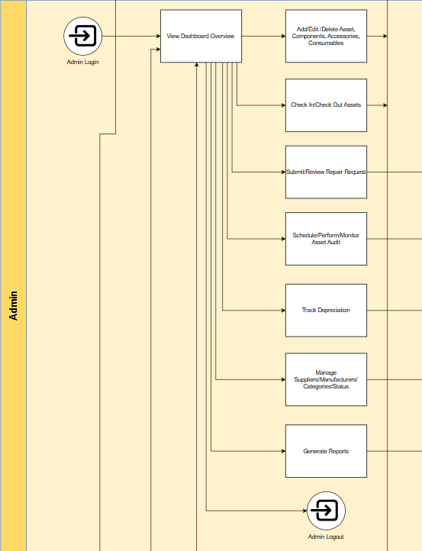
- Log in to the system through the Admin Dashboard.
- Add, edit, or delete asset records, components, accessories, and consumables.
- Review and approve repair requests from operators.
- Schedule, perform, and monitor asset audits.
- Track the depreciation or value decrease of assets.
- Manage suppliers, categories, and asset statuses.
- Generate reports for monitoring and documentation.
- Log out securely after finishing system activities.
Figure #. MAP Asset Management System
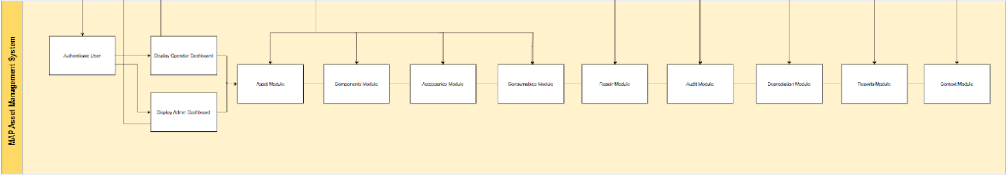

Table #
Process Flow and Improvements
Process Description | System Improvement / Benefit
User authentication through the login page | Provides secure access and separates admin and operator functions
Asset information is recorded and stored in the database | Data is managed through connected microservices for accurate and consistent records.
Asset movement (check-in/check-out) is monitored automatically | Updates records in real time and ensures accurate asset tracking.
Repair requests are created and reviewed within the system | Keeps a clear record of maintenance history and status.
Audit schedules and results are managed through the system | Makes audits easier to organize and follow up.
Depreciation values are computed by the system | Ensures consistent and reliable calculation of asset value.
Supplier, category, and status information are maintained | Keeps all records organized and up to date.
Reports are generated from stored data | Produces accurate summaries for decision-making.
Users log out after completing their activities | Protects data and maintains system security.
The To-Be Business Process Model presents the improved process of managing IT assets through the MAP Asset Management System. It replaces the manual and spreadsheet-based process with a computerized system that allows the Admin and Operator to perform their tasks more efficiently. These include adding and updating asset information, checking in and checking out items, sending repair requests, monitoring depreciation, and generating reports.
The system uses microservices to support automation, data accuracy, and real-time updates. It ensures that all records are well-organized, accessible, and secure. Overall, the To-Be Business Process Model provides a faster, safer, and more reliable way of managing the company’s IT assets.

Analysis of Improvements
The MAP Asset Management System shows clear improvements compared to the old manual process that relied on spreadsheets and emails. The new system helps reduce the time needed for asset recording, checking, and report preparation. In the previous setup, the process usually took around five days to complete because all data were entered and reviewed using spreadsheets. With the new system, these tasks can now be done within a shorter time depending on the availability of the Admin.
The system also helps reduce human error since all data are stored and updated in one place. This prevents missing, repeated, or incorrect information that often occurred when using spreadsheets. The automatic calculation of depreciation and real-time tracking of assets also make the records more accurate and reliable. In addition, the audit and report features can now be completed in just a few minutes instead of several hours.
Overall, the new system makes the work of both the Admin and Operator more organized and efficient. It helps them save time, lessen errors, and maintain updated records. The MAP Asset Management System also supports faster decision-making and smoother operations in managing the company’s IT assets.

Application Architecture
The Application Architecture of the MAP Asset Management System (MAP-AMS) explains how the system is organized and how its parts work together. It provides a safe, stable, and flexible structure that supports managing and keeping track of assets. The design keeps the system running smoothly, protects data, and makes it easy to maintain and update.

Components of Application Architecture
Figure #. Components Application Diagram

This component diagram shows the structure of the system and how each part connects and interacts with the others. At the bottom part is the Infrastructure Layer, which includes the web server hosted inside Docker containers. These containers are linked through a Docker network, allowing the system to be deployed in a stable and flexible environment. This layer ensures that the system runs smoothly and can easily be configured or updated when needed. It serves as the foundation that supports all the other layers above it, making sure the application is properly hosted and accessible.
Above it is the Core Application, which serves as the central part of the entire system. The main.jsx file acts as the entry point where the application starts, while the App.jsx file functions as the main router that connects all pages and handles navigation between them. The ProtectedRoute.jsx file plays an important role in maintaining security by allowing only authorized users to access certain parts of the system. Together, these components make sure that users can move around the system easily and securely, while keeping the structure organized and efficient.
The Pages Layer contains all the main sections that users interact with. It includes pages such as Dashboard, Assets, Products, Repairs, Tickets, Reports, and User Management. Each page has its own specific function, helping users view, manage, and update different kinds of information. These pages are connected to the UI Components Package, which contains reusable interface elements like tables, buttons, forms, loading indicators, and navigation bars. This setup allows the system to maintain a consistent design and makes it easier to manage or update user interface parts without changing the whole system.
The Services Layer Package acts as the bridge between the frontend and the backend. It manages data communication and processing by using files such as auth-service.js, assets-service.js, contact-service.js, and accessories-service.js. These services handle the requests and responses between the user interface and the backend, ensuring that the system’s operations run correctly. Below it is the Backend Layer, which performs the main logic and processing for different features such as authentication, asset management, contact management, and accessory tracking.
At the lowest level is the Database Layer, which is responsible for storing all data used by the system. Each database handles a specific area of information, such as ams_authentication for user accounts, ams_assets for asset records, ams_contacts for contact details, and ams_accessories for accessory data. By organizing the data into separate databases, the system can easily retrieve and update information without affecting other parts.
Overall, this diagram shows the structure of the system where every layer has a clear and specific role. The infrastructure provides the environment, the core application handles routing and security, the pages present the interface, the services manage communication, and the backend and database handle processing and storage. This layered design helps the system stay organized, efficient, and easy to maintain while ensuring all components work together smoothly.
Detailed UML Diagrams for Key Services

Use Case
Figure #. Use Case Diagram
The diagram presents the Use Case Diagram of the MAP Asset Management System, which shows how the two main users, the Admin and the Operator, interact with the system and its different functions. Both users are required to log in to access the system and can log out after completing their tasks. They can also use the dashboard to view important information and perform asset management activities. These include adding, updating, or removing asset details to maintain accurate records. The system ensures that both users can perform their roles efficiently within a controlled and organized environment.
The Admin has wider access to the system and is responsible for managing most of its core functions. These include handling products, components, consumables, accessories, and conducting asset audits. The Admin can also process tickets, manage repair requests, send notifications, and generate reports for monitoring and documentation. Another important role of the Admin is user management, which involves adding, editing, or removing users who have access to the system. The “More” section of the system allows the Admin to manage categories, manufacturers, suppliers, statuses, depreciations, and the recycle bin, which help in keeping asset data organized and updated.
The Operator, on the other hand, has a more specific role focused on daily operations involving assets. The Operator can check in and check out assets, which are connected to the asset management and dashboard functions. This feature helps track the movement and availability of assets in real time. By providing these functions, the MAP Asset Management System supports accurate record keeping and efficient asset monitoring.

Sequence Diagram

Figure #. Sequence Diagram

Figure #. Sequence Diagram
Figure #. Sequence Diagram
The System Sequence Diagrams above explain how the system handles each user process from start to finish. They focus on the flow of actions and the interaction between the user, frontend, backend services, and databases for key operations such as logging in, viewing assets, creating new assets, checking assets in and out, deleting assets, and logging out. Each step is illustrated in order, making it easier to understand how the system responds to user actions and how multiple processes occur behind the scenes. User requests can result in data retrieval, updates, or the creation of new records, and all of these steps are clearly represented to show the logical sequence of operations.
These diagrams also provide a detailed view of how data moves through the system, including the addition, updating, retrieval, and soft deletion of information. The system keeps track of asset status, checkouts, and check-ins over time, ensuring that records remain accurate and up to date. Connections between different components show how one action can affect multiple parts of the system, such as updating an asset’s record while recording a checkout history and generating logs. This detailed representation helps in understanding the full flow of operations, how data integrity is maintained, and how internal processes are organized.
Security and access control are included in the flow. The system checks JWT tokens, confirms user roles, and makes sure that only authorized users can perform certain actions. Session management is represented to show how secure access is kept throughout each process. Error handling is included to illustrate how the system responds to invalid inputs or failed operations, keeping data safe and guiding users properly when issues occur.
Interactions between different microservices, API calls, and database operations are also illustrated. Each service’s role is shown, including how data dependencies are managed and how tasks are separated between components. External integrations, such as DTS help desk tickets, are included to show how requests from other systems are handled and tracked. These representations make the system structure clear, showing how complex operations are managed efficiently.
Class Diagrams
Figure #. Class Diagram

The figure above shows the class diagram, which presents the overall structure and connections of the system’s main parts. It explains how different components work together to manage, track, and maintain assets. The diagram includes sections for important tasks such as recording assets, organizing them into categories, managing supplier information, tracking repairs, handling help desk tickets (DTS tickets), and managing inventory.
At the center of the diagram is the Asset class, which is linked to Asset Category, Supplier, Manufacturer, and Product to describe the type and source of each asset. The Asset class is also connected to records like Asset Checkout, Asset Check-in, Asset Repair, and DTS Tickets. DTS tickets represent help desk requests for maintenance or problem solving. These links allow the system to keep complete and up-to-date information about each asset and any help desk requests related to it.
Other items such as Components, Accessories, and Consumables are included to manage smaller items used with the main assets. Each has its own check-in and checkout records for proper monitoring. Reference classes such as Supplier, Manufacturer, and Location help keep records accurate and consistent. The diagram shows different types of relationships, including one-to-many and many-to-one, meaning one asset can have many repair, movement, or ticket records while still being linked to a single category or supplier.
The diagram also shows how the backend and frontend parts interact through API calls, allowing data to flow between them. Relationships such as inheritance, composition, aggregation, and association are used to organize the information. Rules like soft deletion, unique IDs, role-based access, and integration with DTS tickets are included to keep the system secure and organized.

Data Architecture and Design
Logical Data Model (ERD)
The Logical Data Model represents the conceptual structure of the system’s data. It identifies the main entities, their attributes, and the relationships between them. In this system, each microservice maintains its own logical model to ensure data separation, modularity, and independent scalability. The following subsections describe the Entity Relationship Diagrams (ERDs) and key relationships for each microservice.
Authentication Service
The Authentication Service manages user accounts, login credentials, group memberships, and permissions. It follows Django’s built-in authentication structure, extended with a custom user model for additional fields. This service ensures secure access, role-based authorization, and session tracking.
Figure #. Authentication Service

Key Relationships in the Service
In the context of this database model, the primary entities include Custom Users, Groups, Permissions, Sessions, and related Django system tables. The following relationships define how these entities interact:
- Custom Users and Groups (M:M Relationship)
A Custom User can belong to multiple Groups, and each Group can include multiple Users. This relationship is managed through the auth_service_customuser_groups junction table.
- Custom Users and Permissions (M:M Relationship)
A Custom User can be assigned multiple Permissions directly, while a Permission can be granted to several Users. This association is maintained through the auth_service_customuser_permissions table.
- Groups and Permissions (M:M Relationship)
Each Group can have multiple Permissions that define access rights, and each Permission can be linked to multiple Groups. This relationship is implemented through the auth_group_permissions table.
- Permissions and Content Types (M:1 Relationship)
Each Permission corresponds to one Content Type, representing a specific Django model. The django_content_type table defines these mappings.
- Custom Users and Sessions (1:M Relationship)
A Custom User can have multiple active sessions. Each record in the django_session table represents one active session per user.
- Custom Users and Admin Logs (1:M Relationship)
Each django_admin_log entry is linked to one Custom User, who may have multiple log records of their activities.
- Custom Users and Password Reset Tokens (1:1 Relationship)
Each Custom User can have one active Password Reset Token for secure password recovery, managed through the django_rest_passwordreset_resetpasswordtoken table.

Assets Service
The Assets Service oversees the entire lifecycle of physical and component assets, including registration, depreciation, checkout, repair, and audits. It integrates categories, manufacturers, suppliers, and depreciation schedules to ensure efficient tracking, accountability, and traceability of all assets.
Figure #. Assets Service

Key Relationships in the Service
In the Assets Service, assets interact with categories, manufacturers, suppliers, and depreciation methods. They also link to checkouts, repairs, and audits, enabling efficient tracking and management.
- AssetCategory and Product (1:M Relationship)
Each AssetCategory can include multiple Products, but each Product belongs to one AssetCategory.
- Depreciation and Product (1:M Relationship)
A single Depreciation method can apply to multiple Products, defining how their value decreases over time. Each Product is linked to one Depreciation record.
- Product and Asset (1:M Relationship)
A Product can have multiple Assets registered under it, representing the physical units derived from that product type. Each Asset is associated with one Product.
- Status and Asset (1:M Relationship)
Each Status record defines an operational state (e.g., Deployed, Deployable, Archived) and can be assigned to multiple Assets. Each Asset is linked to one Status.
- Asset and AssetCheckout (1:M Relationship)
An Asset can have multiple Checkout transactions over time, representing various deployments to users or locations. Each AssetCheckout belongs to a single Asset.
- AssetCheckout and AssetCheckin (1:1 Relationship)
Each AssetCheckout transaction can have one corresponding AssetCheckin, representing the return of the same asset.
- ComponentCategory and Component (1:M Relationship)
Each ComponentCategory can include multiple Components, but each Component belongs to a single ComponentCategory.
- Component and ComponentCheckout (1:M Relationship)
A Component can be checked out multiple times for use with different assets. Each ComponentCheckout record belongs to one Component.
- ComponentCheckout and ComponentCheckin (1:M Relationship)
Each ComponentCheckout transaction can have multiple ComponentCheckin records to track partial returns of components.
- ComponentCheckout and Asset (M:1 Relationship)
Each ComponentCheckout links a Component to the Asset it is installed in, meaning many component checkouts can relate to a single asset.
- Asset and Repair (1:M Relationship)
An Asset can undergo multiple Repair or Maintenance activities over time. Each Repair record belongs to one Asset.
- Repair and RepairFile (1:M Relationship)
A Repair can have multiple RepairFile attachments documenting maintenance work or supporting evidence. Each RepairFile belongs to one Repair.
- Asset and AuditSchedule (1:M Relationship)
An Asset can have several scheduled audits to verify its condition and existence. Each AuditSchedule is linked to a single Asset.

- AuditSchedule and Audit (1:1 Relationship)
Each AuditSchedule generates exactly one Audit upon execution, while each Audit corresponds to one schedule.
- Audit and AuditFile (1:M Relationship)
An Audit can include multiple AuditFile attachments for documentation or verification evidence. Each AuditFile belongs to one Audit.
Contexts Service
The Contexts Service manages reference data for suppliers and manufacturers, serving as a shared source of truth for vendor and production details. Other microservices, such as the Assets Service, reference this data through API communication rather than direct database relationships.
Figure #. Contexts Service

Key Relationships in the Service
In the context of this database model, the primary entities include Supplier and Manufacturer. The following relationships describe how these entities interact conceptually within the system:
- Supplier (Independent Entity)
The Supplier entity stores detailed information about asset vendors, including company name, address, contact details, website URL, and logo. Suppliers are independent records but can be referenced by assets in the Asset Service through their unique identifiers.
- Manufacturer (Independent Entity)
The Manufacturer entity holds information about companies that produce assets, including URLs for general and support pages, contact details, and logos. Like suppliers, manufacturers are standalone entries that can be logically associated with assets in other services.
- Supplier and Asset (Logical Relationship)
A Supplier can provide multiple Assets, but each Asset is linked to one Supplier. This connection is logical, as cross-database relationships are managed through service-level communication rather than database foreign keys.
- Manufacturer and Asset (Logical Relationship)
A Manufacturer can produce multiple Assets, and each Asset corresponds to a single Manufacturer. This relationship is also logical, handled through inter-service API calls instead of direct relational constraints.

Physical Data Model (Schema)
Authentication Service
The database schema for the Auth Service is designed to manage user authentication, authorization, and administrative operations. It ensures data integrity, supports role-based access control, and integrates with Django’s built-in authentication framework.

Table #
Authentication Service
Table Name | Columns | Description
auth_service_customuser | id (PK), email, password, first_name, last_name, middle_name, contact_number, image, role, is_active, is_staff, is_superuser, created_at, date_joined, last_login | Stores user profile information and login credentials. Each user has a role (e.g., Admin, User) with corresponding permissions.
auth_group | id (PK), name | Defines groups used for role-based access control. Users can be assigned to groups to inherit permissions.
auth_permission | id (PK), name, content_type_id (FK to django_content_type), codename | Contains permission details that determine access rights for models or views.
auth_group_permissions | id (PK), group_id (FK to auth_group), permission_id (FK to auth_permission) | Junction table linking groups to assigned permissions. Enables many-to-many relationship between groups and permissions.
auth_service_customuser_groups | id (PK), customuser_id (FK to auth_service_customuser), group_id (FK to auth_group) | Junction table linking users to their assigned groups. Supports inheritance of permissions from groups.
auth_service_customuser_permissions | id (PK), customuser_id (FK to auth_service_customuser), permission_id (FK to auth_permission) | Junction table linking users to their individual permissions outside group assignments.
django_session | session_key (PK), session_data, expire_date | Stores session data for authenticated users. Each record represents an active login session.
django_content_type | id (PK), app_label, model | Internal Django table mapping applications and models to their content types for permission management.
django_admin_log | id (PK), action_time, object_id, object_repr, action_flag, change_message, content_type_id (FK to django_content_type), user_id (FK to auth_service_customuser) | Records all actions performed in the Django Admin interface, including timestamps and affected objects.
django_migrations | id (PK), app, name, applied | Tracks migration history to maintain consistency between models and database structure.
django_rest_passwordreset_resetpasswordtoken | id (PK), created_at, key, ip_address, user_agent, user_id (FK to auth_service_customuser) | Handles password reset requests and temporary token management for users.

The Auth Service database schema manages all authentication and authorization processes in the system. It centers on a custom user model (auth_service_customuser) storing user information, credentials, and roles. Role-based access control is supported through tables like auth_group, auth_permission, and their junctions for user-group and permission assignments. Django system tables (django_session, django_content_type, django_admin_log, django_migrations) handle sessions, content-type mapping, admin activity logging, and migrations. The django_rest_passwordreset_resetpasswordtoken table manages password reset requests and tokens. Overall, the schema provides a structured, secure, and flexible foundation for authentication, access control, and administrative operations.
Assets Service
The database schema for the Asset Service is designed to manage all asset-related records and lifecycle operations within the organization. It provides structured data management for asset registration, categorization, movement, maintenance, depreciation, and auditing. The schema supports traceability, accountability, and integration with other microservices such as Contexts and Authentication.
Table #
Asset Service
Table Name | Columns | Descriptions
Depreciation | id (PK), name, duration, minimum_value, is_deleted | Defines depreciation methods applied to assets for accounting and financial purposes, including the duration and minimum value threshold.
AssetCategory | id (PK), name, type, logo, is_deleted | Contains categories used to classify assets (e.g., IT equipment, furniture). Helps organize and filter assets in the system.
Product | id (PK), name, category_id (FK to assetcategory), manufacturer_id, depreciation_id (FK to depreciation), model_number, end_of_life, default_purchase_cost, default_supplier_id, minimum_quantity, operating_system, notes, image, is_deleted | Stores predefined product templates used for registering new assets, including manufacturer, depreciation, and supplier references.
Status | id (PK), name, type, notes, is_deleted | Maintains standardized asset status labels such as Deployable, Deployed, Pending, Under Repair, or Archived.
Asset | id (PK), displayed_id, product_id (FK to product), status_id (FK to status), supplier_id, location, name, serial_number, warranty_expiration, order_number, purchase_date, purchase_cost, notes, image, is_deleted | Holds core asset information including identity, condition, supplier, and location. Each asset has a unique displayed_id generated upon creation.
AssetCheckout | id (PK), asset_id (FK to asset), to_user_id, to_location, checkout_date, return_date, condition, notes, confirmation_notes, image | Logs asset checkout transactions, including who checked out the asset, when, and under what condition.
AssetCheckin | id (PK), asset_checkout_id (OneToOne FK to assetcheckout), checkin_date, condition, notes, image | Records asset return details, including date, condition upon return, and any supporting documentation.
ComponentCategory | id (PK), name, type, logo, is_deleted | Defines classifications for components, allowing efficient tracking of replaceable or detachable parts associated with assets.
Component | id (PK), name, category_id (FK to componentcategory), manufacturer, supplier, location, model_number, order_number, purchase_date, purchase_cost, quantity, minimum_quantity, notes, image, is_deleted | Stores data about asset components or consumables, including supplier and manufacturer links, cost, and quantity tracking.
ComponentCheckout | id (PK), component_id (FK to component), to_asset_id (FK to asset), quantity, checkout_date, notes | Records the issuance of components to specific assets, allowing detailed tracking of component movements.
ComponentCheckin | id (PK), component_checkout_id (FK to componentcheckout), checkin_date, quantity, notes | Tracks the return or reinstallation of components previously checked out to an asset.
Repair | id (PK), asset_id (FK to asset), type, name, start_date, end_date, cost, notes, status_id (FK to status), is_deleted | Logs asset repairs, maintenance, or upgrades, including repair type, cost, and associated status.
RepairFile | id (PK), repair_id (FK to repair), file, is_deleted | Stores supporting documents or images related to a specific repair activity.
AuditSchedule | id (PK), asset_id (FK to asset), date, notes, is_deleted, created_at | Contains planned audit schedules for assets, ensuring regular verification of asset presence and condition.
Audit | id (PK), location, user_id, audit_date, next_audit_date, notes, is_deleted, audit_schedule_id (OneToOne FK to auditschedule), created_at | Logs completed audits, including responsible personnel, location, and findings.
AuditFile | id (PK), audit_id (FK to audit), file, is_deleted | Stores evidence or related documentation for completed audit records.

The Asset Service database schema manages the complete lifecycle of physical and digital assets within the organization. It integrates asset categorization, registration, movement tracking, repair logging, and audit management in a unified structure. Core entities such as Asset, Product, and Depreciation define asset properties and financial values, while operational entities like AssetCheckout, AssetCheckin, and Repair record day-to-day activities. Component and ComponentCategory tables support detailed management of asset parts and consumables. Finally, the Audit and AuditSchedule tables ensure accountability through regular verification of asset status and documentation. Together, this schema provides a reliable and scalable foundation for asset tracking, maintenance, and compliance management across the enterprise.

Contexts Service
The database schema for the Contexts Service is designed to manage supporting reference data used across other services, such as supplier and manufacturer information. It provides structured and reusable context data that helps maintain data consistency and normalization throughout the system.
Table #
Contexts Service
Table Name | Columns | Descriptions
Supplier | id (PK), name, address, city, zip, contact_name, phone_number, email, URL, notes, logo, is_deleted | Stores information about suppliers, including contact details, address, and company logo. The is_deleted flag supports soft deletion to retain record history without removing data from the database.
Manufacturer | id (PK), name, manu_url, support_url, support_phone, support_email, notes, logo, is_deleted | Contains manufacturer information, including website and technical support contact details. The is_deleted flag enables soft deletion for data preservation.

The Contexts Service database schema manages all supporting and reference data used across the system. It is designed to provide standardized information for suppliers and manufacturers, ensuring consistency and reducing redundancy between interconnected services. The contexts_supplier table stores supplier details, including address, contact information, and company logo, supporting procurement and maintenance processes. The contexts_manufacturer table contains manufacturer information such as website links, technical support details, and contact references, enabling effective tracking of product sources and support channels. Overall, the schema offers a well-structured and reusable foundation for managing contextual information, promoting data integrity, and supporting seamless integration across all system services.
Physical Data Model (Schema)
Authentication Service
The database schema for the Auth Service is designed to manage user authentication, authorization, and administrative operations. It ensures data integrity, supports role-based access control, and integrates with Django’s built-in authentication framework.

Table #
Authentication Service
Table Name | Columns | Description
auth_service_customuser | id (PK), email, password, first_name, last_name, middle_name, contact_number, image, role, is_active, is_staff, is_superuser, created_at, date_joined, last_login | Stores user profile information and login credentials. Each user has a role (e.g., Admin, User) with corresponding permissions.
auth_group | id (PK), name | Defines groups used for role-based access control. Users can be assigned to groups to inherit permissions.
auth_permission | id (PK), name, content_type_id (FK to django_content_type), codename | Contains permission details that determine access rights for models or views.
auth_group_permissions | id (PK), group_id (FK to auth_group), permission_id (FK to auth_permission) | Junction table linking groups to assigned permissions. Enables many-to-many relationship between groups and permissions.
auth_service_customuser_groups | id (PK), customuser_id (FK to auth_service_customuser), group_id (FK to auth_group) | Junction table linking users to their assigned groups. Supports inheritance of permissions from groups.
auth_service_customuser_permissions | id (PK), customuser_id (FK to auth_service_customuser), permission_id (FK to auth_permission) | Junction table linking users to their individual permissions outside group assignments.
django_session | session_key (PK), session_data, expire_date | Stores session data for authenticated users. Each record represents an active login session.
django_content_type | id (PK), app_label, model | Internal Django table mapping applications and models to their content types for permission management.
django_admin_log | id (PK), action_time, object_id, object_repr, action_flag, change_message, content_type_id (FK to django_content_type), user_id (FK to auth_service_customuser) | Records all actions performed in the Django Admin interface, including timestamps and affected objects.
django_migrations | id (PK), app, name, applied | Tracks migration history to maintain consistency between models and database structure.
django_rest_passwordreset_resetpasswordtoken | id (PK), created_at, key, ip_address, user_agent, user_id (FK to auth_service_customuser) | Handles password reset requests and temporary token management for users.
The Auth Service database schema manages all authentication and authorization processes in the system. It centers on a custom user model (auth_service_customuser) storing user information, credentials, and roles. Role-based access control is supported through tables like auth_group, auth_permission, and their junctions for user-group and permission assignments. Django system tables (django_session, django_content_type, django_admin_log, django_migrations) handle sessions, content-type mapping, admin activity logging, and migrations. The django_rest_passwordreset_resetpasswordtoken table manages password reset requests and tokens. Overall, the schema provides a structured, secure, and flexible foundation for authentication, access control, and administrative operations.
Assets Service
The database schema for the Asset Service is designed to manage all asset-related records and lifecycle operations within the organization. It provides structured data management for asset registration, categorization, movement, maintenance, depreciation, and auditing. The schema supports traceability, accountability, and integration with other microservices such as Contexts and Authentication.
Table #
Assets Service
Table Name | Columns | Descriptions
Depreciation | id (PK), name, duration, minimum_value, is_deleted | Defines depreciation methods applied to assets for accounting and financial purposes, including the duration and minimum value threshold.
AssetCategory | id (PK), name, type, logo, is_deleted | Contains categories used to classify assets (e.g., IT equipment, furniture). Helps organize and filter assets in the system.
Product | id (PK), name, category_id (FK to assetcategory), manufacturer_id, depreciation_id (FK to depreciation), model_number, end_of_life, default_purchase_cost, default_supplier_id, minimum_quantity, operating_system, notes, image, is_deleted | Stores predefined product templates used for registering new assets, including manufacturer, depreciation, and supplier references.
Status | id (PK), name, type, notes, is_deleted | Maintains standardized asset status labels such as Deployable, Deployed, Pending, Under Repair, or Archived.
Asset | id (PK), displayed_id, product_id (FK to product), status_id (FK to status), supplier_id, location, name, serial_number, warranty_expiration, order_number, purchase_date, purchase_cost, notes, image, is_deleted | Holds core asset information including identity, condition, supplier, and location. Each asset has a unique displayed_id generated upon creation.
AssetCheckout | id (PK), asset_id (FK to asset), to_user_id, to_location, checkout_date, return_date, condition, notes, confirmation_notes, image | Logs asset checkout transactions, including who checked out the asset, when, and under what condition.
AssetCheckin | id (PK), asset_checkout_id (OneToOne FK to assetcheckout), checkin_date, condition, notes, image | Records asset return details, including date, condition upon return, and any supporting documentation.
ComponentCategory | id (PK), name, type, logo, is_deleted | Defines classifications for components, allowing efficient tracking of replaceable or detachable parts associated with assets.
Component | id (PK), name, category_id (FK to componentcategory), manufacturer, supplier, location, model_number, order_number, purchase_date, purchase_cost, quantity, minimum_quantity, notes, image, is_deleted | Stores data about asset components or consumables, including supplier and manufacturer links, cost, and quantity tracking.
ComponentCheckout | id (PK), component_id (FK to component), to_asset_id (FK to asset), quantity, checkout_date, notes | Records the issuance of components to specific assets, allowing detailed tracking of component movements.
ComponentCheckin | id (PK), component_checkout_id (FK to componentcheckout), checkin_date, quantity, notes | Tracks the return or reinstallation of components previously checked out to an asset.
Repair | id (PK), asset_id (FK to asset), type, name, start_date, end_date, cost, notes, status_id (FK to status), is_deleted | Logs asset repairs, maintenance, or upgrades, including repair type, cost, and associated status.
RepairFile | id (PK), repair_id (FK to repair), file, is_deleted | Stores supporting documents or images related to a specific repair activity.
AuditSchedule | id (PK), asset_id (FK to asset), date, notes, is_deleted, created_at | Contains planned audit schedules for assets, ensuring regular verification of asset presence and condition.
Audit | id (PK), location, user_id, audit_date, next_audit_date, notes, is_deleted, audit_schedule_id (OneToOne FK to auditschedule), created_at | Logs completed audits, including responsible personnel, location, and findings.
AuditFile | id (PK), audit_id (FK to audit), file, is_deleted | Stores evidence or related documentation for completed audit records.

The Asset Service database schema manages the complete lifecycle of physical and digital assets within the organization. It integrates asset categorization, registration, movement tracking, repair logging, and audit management in a unified structure. Core entities such as Asset, Product, and Depreciation define asset properties and financial values, while operational entities like AssetCheckout, AssetCheckin, and Repair record day-to-day activities. Component and ComponentCategory tables support detailed management of asset parts and consumables. Finally, the Audit and AuditSchedule tables ensure accountability through regular verification of asset status and documentation. Together, this schema provides a reliable and scalable foundation for asset tracking, maintenance, and compliance management across the enterprise.

Contexts Service
The database schema for the Contexts Service is designed to manage supporting reference data used across other services, such as supplier and manufacturer information. It provides structured and reusable context data that helps maintain data consistency and normalization throughout the system.
Table #
Contexts Service
Table Name | Columns | Descriptions
Supplier | id (PK), name, address, city, zip, contact_name, phone_number, email, URL, notes, logo, is_deleted | Stores information about suppliers, including contact details, address, and company logo. The is_deleted flag supports soft deletion to retain record history without removing data from the database.
Manufacturer | id (PK), name, manu_url, support_url, support_phone, support_email, notes, logo, is_deleted | Contains manufacturer information, including website and technical support contact details. The is_deleted flag enables soft deletion for data preservation.

The Contexts Service database schema manages all supporting and reference data used across the system. It is designed to provide standardized information for suppliers and manufacturers, ensuring consistency and reducing redundancy between interconnected services. The contexts_supplier table stores supplier details, including address, contact information, and company logo, supporting procurement and maintenance processes. The contexts_manufacturer table contains manufacturer information such as website links, technical support details, and contact references, enabling effective tracking of product sources and support channels. Overall, the schema offers a well-structured and reusable foundation for managing contextual information, promoting data integrity, and supporting seamless integration across all system services.

Data Dictionary
The Data Dictionary defines the tables, fields, and constraints used in each microservice. It provides an overview of the data structures, key attributes, and relationships to ensure consistency, integrity, and clarity across all services.

Authentication Service
Table #
Authentication Service
Table Name | Field Name | Data Type | Constraints
auth_group | id | SERIAL | Primary Key, Auto Increment
 | name | VARCHAR(150) | Unique, Not Null
auth_permission | id | SERIAL | Primary Key, Auto Increment
 | name | VARCHAR(255) | Not Null
 | content_type_id | INTEGER | Not Null
 | codename | VARCHAR(100) | Not Null
 | (content_type_id, codename) |  | Unique Index
auth_group_permissions | id | SERIAL | Primary Key, Auto Increment
 | group_id | INTEGER | Not Null
 | permission_id | INTEGER | Not Null
 | (group_id, permission_id) |  | Unique Index
auth_service_customuser | id | BIGSERIAL | Primary Key, Auto Increment
 | password | VARCHAR(128) | Not Null
 | last_login | TIMESTAMP | Not Null
 | first_name | VARCHAR(50) | Not Null
 | last_name | VARCHAR(50) | Not Null
 | is_active | BOOLEAN | Not Null
 | email | VARCHAR(254) | Unique, Not Null
 | contact_number | VARCHAR(13) | Not Null
 | created_at | TIMESTAMP | Not Null
 | image | VARCHAR(100) | Nullable
 | middle_name | VARCHAR(50) | Nullable
 | role | VARCHAR(8) | Not Null
 | is_staff | BOOLEAN | Not Null
 | is_superuser | BOOLEAN | Not Null
 | date_joined | TIMESTAMP | Not Null
auth_service_customuser_groups | id | SERIAL | Primary Key, Auto Increment
 | customuser_id | BIGINT | Not Null
 | group_id | INTEGER | Not Null
 | (customuser_id, group_id) |  | Unique Index
auth_service_customuser_user_permissions | id | SERIAL | Primary Key, Auto Increment
 | customuser_id | BIGINT | Not Null
 | permission_id | INTEGER | Not Null
 | customuser_id, permission_id) |  | Unique Index
django_content_type | id | SERIAL | Primary Key, Auto Increment
 | app_label | VARCHAR(100) | Not Null
 | model | VARCHAR(100) | Not Null
 | (app_label, model) |  | Unique Index
django_admin_log | id | SERIAL | Primary Key, Auto Increment
 | action_time | TIMESTAMP | Not Null
 | object_id | TEXT | Nullable
 | object_repr | VARCHAR(200) | Not Null
 | action_flag | SMALLINT | Not Null
 | change_message | TEXT | Not Null
 | content_type_id | INTEGER | Nullable
 | user_id | BIGINT | Not Null
django_migrations | id | BIGSERIAL | Primary Key, Auto Increment
 | app | VARCHAR(255) | Not Null
 | name | VARCHAR(255) | Not Null
 | applied | TIMESTAMP | Not Null
django_rest_passwordreset_resetpasswordtoken | id | SERIAL | Primary Key, Auto Increment
 | created_at | TIMESTAMP | Not Null
 | key | VARCHAR(64) | Unique, Not Null
 | ip_address | INET | Nullable
 | user_agent | VARCHAR(512) | Not Null
 | user_id | BIGINT | Not Null
django_session | session_key | VARCHAR(40) | Primary Key
 | session_data | TEXT | Not Null
 | expire_date | TIMESTAMP | Not Null

Assets Service
Table #
Assets Service
Table Name | Field Name | Data Type | Constraints
Depreciation | id | SERIAL | Primary Key, Auto Increment
 | name | VARCHAR(500) | Not Null
 | duration | INTEGER | Not Null
 | minimum_value | DECIMAL(8,2) | Not Null
 | is_deleted | BOOLEAN | Default False
AssetCategory | id | SERIAL | Primary Key, Auto Increment
 | name | VARCHAR(50) | Not Null
 | type | VARCHAR(5) | Default "Asset"
 | logo | VARCHAR(100) | Nullable
 | is_deleted | BOOLEAN | Default False
Product | id | SERIAL | Primary Key, Auto Increment
 | name | VARCHAR(100) | Not Null
 | category_id | INTEGER | Foreign Key → asset_category(id), On Delete CASCADE
 | manufacturer_id | INTEGER | Positive integer
 | depreciation_id | INTEGER | Foreign Key → depreciation(id), On Delete PROTECT
 | model_number | VARCHAR(50) | Nullable
 | end_of_life | DATE | Nullable
 | default_purchase_cost | DECIMAL(10,2) | Nullable
 | default_supplier_id | INTEGER | Nullable
 | minimum_quantity | INTEGER | Default 1
 | operating_system | VARCHAR(7) | Nullable, Choices: linux, windows, macos, ubuntu, centos, debian, fedora, other
 | notes | TEXT | Nullable
 | image | VARCHAR(100) | Nullable
 | is_deleted | BOOLEAN | Default False
Status | id | SERIAL | Primary Key, Auto Increment
 | name | VARCHAR(50) | Not Null
 | type | VARCHAR(12) | Not Null, Choices: deployable, deployed, undeployable, pending, archived
 | notes | TEXT | Nullable
 | is_deleted | BOOLEAN | Default False
Asset | id | SERIAL | Primary Key, Auto Increment
 | displayed_id | VARCHAR(20) | Unique, Auto-generated
 | product_id | INTEGER | Foreign Key → product(id), On Delete CASCADE
 | status_id | INTEGER | Foreign Key → status(id), On Delete CASCADE
 | supplier_id | INTEGER | Not Null
 | location | INTEGER | Not Null
 | name | VARCHAR(100) | Not Null
 | serial_number | VARCHAR(50) | Nullable
 | warranty_expiration | DATE | Nullable
 | order_number | VARCHAR(50) | Nullable
 | purchase_date | DATE | Nullable
 | purchase_cost | DECIMAL(10,2) | Nullable
 | notes | TEXT | Nullable
 | image | VARCHAR(100) | Nullable
 | is_deleted | BOOLEAN | Default False
AssetCheckout | id | SERIAL | Primary Key, Auto Increment
 | asset_id | INTEGER | Foreign Key → asset(id), On Delete CASCADE
 | to_user_id | INTEGER | Not Null
 | to_location | VARCHAR(255) | Not Null
 | checkout_date | TIMESTAMP | Auto Now Add
 | return_date | TIMESTAMP | Not Null
 | condition | SMALLINT | Not Null, 1–10
 | notes | TEXT | Nullable
 | confirmation_notes | TEXT | Nullable
 | image | VARCHAR(100) | Nullable
AssetCheckin | id | SERIAL | Primary Key, Auto Increment
 | asset_checkout_id | INTEGER | One-to-One → asset_checkout(id)
 | checkin_date | TIMESTAMP | Not Null
 | condition | SMALLINT | Not Null, 1–10
 | notes | TEXT | Nullable
 | image | VARCHAR(100) | Nullable
ComponentCategory | id | SERIAL | Primary Key, Auto Increment
 | name | VARCHAR(50) | Not Null
 | type | VARCHAR(5) | Default "Component"
 | logo | VARCHAR(100) | Nullable
 | is_deleted | BOOLEAN | Default False
Component | id | SERIAL | Primary Key, Auto Increment
 | name | VARCHAR(100) | Not Null
 | category_id | INTEGER | Foreign Key → component_category(id), On Delete CASCADE
 | manufacturer | INTEGER | Foreign Key → status(id), On Delete CASCADE
 | supplier | INTEGER | Not Null
 | location | INTEGER | Not Null
 | model_number | VARCHAR(50) | Nullable
 | order_number | VARCHAR(30) | Nullable
 | purchase_date | DATE | Auto Now Add
 | purchase_cost | DECIMAL(10,2) | Not Null
 | quantity | INTEGER | Default 1
 | minimum_quantity | INTEGER | Default 0
 | notes | TEXT | Nullable
 | image | VARCHAR(100) | Nullable
 | is_deleted | BOOLEAN | Default False
ComponentCheckout | id | SERIAL | Primary Key, Auto Increment
 | component_id | INTEGER | Foreign Key → component(id)
 | to_asset_id | INTEGER | Foreign Key → asset(id)
 | quantity | INTEGER | Default 1
 | checkout_date | TIMESTAMP | Auto Now Add
 | notes | TEXT | Nullable
ComponentCheckin | id | SERIAL | Primary Key, Auto Increment
 | component_checkout_id | INTEGER | Foreign Key → component_checkout(id)
 | checkin_date | TIMESTAMP | Auto Now Add
 | quantity | INTEGER | Default 1
 | notes | TEXT | Nullable
Repair | id | SERIAL | Primary Key, Auto Increment
 | asset_id | INTEGER | Foreign Key → asset(id)
 | type | VARCHAR(20) | Not Null, Choices: maintenance, repair, upgrade, test, hardware, software
 | name | VARCHAR(100) | Not Null
 | start_date | DATE | Default Now
 | end_date | DATE | Nullable
 | cost | DECIMAL(10,2) | Not Null
 | notes | TEXT | Nullable
 | status_id | INTEGER | Foreign Key → status(id)
 | is_deleted | BOOLEAN | Default False
RepairFile | id | SERIAL | Primary Key, Auto Increment
 | repair_id | INTEGER | Foreign Key → repair(id)
 | file | VARCHAR(100) | Not Null
 | is_deleted | BOOLEAN | Default False
AuditSchedule | id | SERIAL | Primary Key, Auto Increment
 | asset_id | INTEGER | Foreign Key → asset(id)
 | date | DATE | Not Null
 | notes | TEXT | Nullable
 | is_deleted | BOOLEAN | Default False
 | created_at | TIMESTAMP | Default Now, Not Editable
Audit | id | SERIAL | Primary Key, Auto Increment
 | location | VARCHAR(50) | Not Null
 | user_id | INTEGER | Not Null
 | audit_date | DATE | Default Now
 | next_audit_date | DATE | Default Now
 | notes | TEXT | Nullable
 | is_deleted | BOOLEAN | Default False
 | audit_schedule_id | INTEGER | One-to-One → audit_schedule(id)
 | created_at | TIMESTAMP | Default Now, Not Editable
AuditFile | id | SERIAL | Primary Key, Auto Increment
 | udit_id | INTEGER | Foreign Key → audit(id)
 | file | VARCHAR(100) | Not Null
 | is_deleted | BOOLEAN | Default False

4.5.3.3 Contexts Service
Table Name | Field Name | Data Type | Constraints
Supplier | id | SERIAL | Primary Key, Auto Increment
 | name | VARCHAR(50) | Not Null
 | address | VARCHAR(100) | Nullable
 | city | VARCHAR(50) | Nullable
 | zip | VARCHAR(4) | Nullable
 | contact_name | VARCHAR(100) | Nullable
 | phone_number | VARCHAR(13) | Nullable
 | email | VARCHAR(254) | Nullable
 | URL | VARCHAR(200) | Nullable
 | notes | TEXT | Nullable
 | logo | VARCHAR(100) | Nullable
 | is_deleted | BOOLEAN | Default False
Manufacturer | id | SERIAL | Primary Key, Auto Increment
 | name | VARCHAR(50) | Not Null
 | manu_url | VARCHAR(200) | Nullable
 | support_url | VARCHAR(200) | Nullable
 | support_phone | VARCHAR(13) | Nullable
 | support_email | VARCHAR(254) | Nullable
 | notes | TEXT | Nullable
 | logo | VARCHAR(100) | Nullable
 | is_deleted | BOOLEAN | Default False

Data Flow Diagrams (DFD) (Level 0, Level 1)
The Data Flow Diagrams illustrate how data moves between the system’s processes, data stores, and external entities.
a. Level 0 DFD
The Level 0 Data Flow Diagram illustrates the overall interaction between the Asset Management System (AMS), its associated cloud databases, and external systems such as the Help Desk System, Document Tracking System, Budget Management System, and the Authentication Service. The AMS serves as the central process, handling asset-related requests, updates, and approvals while ensuring that all communications between systems are securely authorized.
The Level 0 Data Flow Diagram shows how the main systems work together, including the Authentication Service, Help Desk System, Asset Management System, Budget Management System, and Document Tracking System. The process starts when the user logs in through the Authentication Service, which checks their credentials and allows access to the connected systems. After authentication, the user can perform tasks such as submitting and tracking help desk tickets, managing assets, handling budgets, or processing documents based on their permissions. Each system has its own database but exchanges important information with the others through the Authentication Service to ensure data consistency and secure communication across all modules.
a. Level 1 DFD
The Level 1 Data Flow Diagram provides a more detailed view of the internal processes within the Asset Management System (AMS). It breaks down the main process from the Level 0 DFD into smaller sub-processes, showing how data moves between users, the frontend, and backend services.
The Level 1 Data Flow Diagram shows how users such as the Admin and Operator interact with the system through the Frontend. The Frontend connects to the Authentication Service, which verifies user credentials using the Authentication Service Database. Once authenticated, users can access the Backend, where the Assets Service and Contexts Service perform core functions. The Assets Service manages asset-related operations and stores data in the Assets Service Database, while the Contexts Service handles supporting records such as suppliers and manufacturers, saving them in the Contexts Service Database.

4.6 Requirements Engineering
Table #
Technology Stack Justification
Technology/Component | Purpose/Justification | Key Features/Benefits
React (Frontend) | Builds the user interface, making it easy to use and interactive. | Uses a component-based structure for easier updates and maintenance. Updates the interface quickly without reloading the whole page. Works well on different devices.
Django (Backend) | Manages data and handles system operations securely and efficiently. | Has a clear structure (Model-View-Template) for organization. Includes tools for user login and data management. Protects against common security issues. Provides APIs for the frontend. Supports secure communication between client and server.
PostgreSQL (Database) | Stores and manages system data reliably and safely. | Keeps data accurate and consistent. Handles complex searches and queries. Free and cost-effective. Works well with large amounts of data.
Overall Stack | Combines React, Django, and PostgreSQL to create a strong and reliable system. | Easy to use, fast, and secure. Handles monitoring and reporting of assets. Adapts to future organizational needs.
Deployment Architecture
Figure #. Deployment Architecture
Figure shows the deployment architecture of the MAP-AMS, which is divided into three main environments: Development, Staging, and Production. This structured deployment approach ensures a systematic and controlled process for building, testing, and releasing updates while maintaining performance, security, and consistency across all stages. Each environment plays a specific role in preparing the system for live deployment and ensuring that all modules perform as intended. The Development Environment focuses on creating and testing features, the Staging Environment validates integration and functionality, and the Production Environment serves as the live platform accessible to users. This layered setup helps minimize deployment errors and ensures the system is stable before public use. It also allows the development team to monitor and refine each stage of deployment effectively. Overall, this architecture ensures that MAP-AMS delivers a secure, efficient, and reliable asset management experience for organizations.
In the Development Environment, developers work locally to build and test individual components of MAP-AMS. The React frontend is executed using Node.js, allowing developers to test user interfaces for functions such as asset registration, asset repair, and asset audit visualization. The Django backend runs on a local server to process requests and manage communication with a PostgreSQL database configured locally. This setup allows developers to test and validate system features in a safe environment before integration. Version control through Git and GitHub ensures proper synchronization of updates and collaboration among team members. Once individual components are verified, they are deployed to the Staging Environment hosted on Railway Cloud for full integration and system testing. This transition ensures that the system’s behavior under cloud infrastructure is consistent and reliable before going live.
The Staging and Production Environments represent the final phases of deployment where the complete system is tested and then released to users. In the Staging Environment, the React frontend, Django backend, and PostgreSQL database are deployed on Railway Cloud to simulate the production setup. This environment allows comprehensive testing, including functionality, performance, and User Acceptance Testing (UAT), ensuring that modules such as asset tracking, depreciation, and audit reporting operate correctly. Once validated, the system is promoted to the Production Environment, where it becomes fully accessible to users. In this environment, the React frontend is deployed as a static web build served securely over HTTPS, while the Django backend and PostgreSQL database run as managed services. All sensitive credentials, including database keys and JWT secrets, are managed using environment variables to maintain security. This cloud-based architecture ensures scalability, availability, and data protection, providing users with a stable and secure experience when accessing MAP-AMS online.
Network and Security Design
Figure #. Network and Security
The Figure shows the network and security design of the MAP-AMS, which emphasizes the protection of data integrity, confidentiality, and availability throughout all communication layers. The system architecture is designed to ensure that every data transaction between the client, frontend, backend, and database is securely transmitted and verified. It utilizes Railway Cloud’s built-in network security mechanisms, including firewall configurations and virtual network isolation, to prevent unauthorized access to backend and database services. The layered structure separates user interaction, business logic, and data management components, minimizing exposure to potential attacks. This design ensures that external users can only communicate through the React frontend, while direct access to the Django backend and PostgreSQL database is restricted. By isolating network traffic and enforcing controlled entry points, MAP-AMS maintains a secure and resilient infrastructure. This comprehensive design contributes to the system’s ability to deliver asset management functionalities safely and efficiently.
The system employs HTTPS encryption and JSON Web Token (JWT) authentication to secure all client-server communications. When a user accesses MAP-AMS through a web browser, requests are encrypted using HTTPS, protecting data from interception and tampering during transmission. Upon successful authentication, the system generates a JWT containing encrypted credentials, which is stored on the client side. This token is attached to each subsequent API request, allowing the Django backend to verify user identity before granting access to protected resources. Because JWT authentication is stateless, it enhances scalability and reduces server-side session management overhead. This method ensures that only authorized users can access confidential modules such as asset records, supplier details, and audit reports. By combining encryption and token-based validation, the system maintains secure and authenticated interactions across all components.
Additional security mechanisms are integrated within the backend and database layers to reinforce protection against threats and unauthorized actions. The Django backend implements password hashing, Cross-Site Request Forgery (CSRF) protection, and Role-Based Access Control (RBAC) to manage user privileges effectively. These measures ensure that users can only perform operations according to their designated roles, reducing the risk of privilege escalation or data manipulation. The PostgreSQL database further enforces access control by accepting queries only from authenticated backend connections, preventing direct external access. Moreover, Railway Cloud’s infrastructure provides firewall protection that isolates database traffic and blocks malicious network activity. Collectively, these layered defenses maintain a high level of data confidentiality and operational reliability. Using this network and security design, MAP-AMS ensures that all asset management transactions are handled in a secure, authenticated, and controlled environment.

Cloud Infrastructure
Figure #. Cloud Infrastructure Diagram
The cloud infrastructure design of the MAP-AMS illustrates how the system is fully hosted on Railway Cloud, which provides managed hosting, deployment, and database services for both the frontend and backend components. This cloud platform ensures seamless deployment, scalability, and continuous availability for end-users accessing the system. The Django backend operates as a managed API service within Railway’s containerized environment, allowing automatic rebuilds and restarts whenever code updates are pushed from the connected GitHub repository. The PostgreSQL database is also managed by Railway Cloud, ensuring secure data transactions, SSL encryption, automated backups, and high availability. Meanwhile, the React frontend is deployed as a static build within the same cloud environment and delivered over HTTPS for optimized speed and security. This fully managed infrastructure provides a stable foundation for the asset management system, minimizing manual configuration and system downtime.
The system’s deployment workflow follows a Continuous Integration and Continuous Deployment (CI/CD) model integrated with GitHub, ensuring that development and production remain synchronized. Every new commit or update to the source code triggers an automated build and deployment process within Railway Cloud. This automation minimizes human error and ensures that the latest stable version of the system is consistently deployed. The CI/CD pipeline also performs validation checks and dependency installations to maintain version control integrity. Also, Developers can focus on iterative improvements and feature enhancements rather than manual server maintenance.
Furthermore, Railway Cloud provides built-in system monitoring tools that track application performance, resource utilization, and service uptime. These monitoring capabilities enable proactive detection of performance issues and facilitate prompt troubleshooting. The platform’s firewall protection and network isolation ensure that backend and database services remain secure from unauthorized access. Moreover, Railway’s scalable hosting options allow MAP-AMS to dynamically adjust resources based on usage demand, ensuring both cost efficiency and operational flexibility. Together, these features establish a secure, reliable, and easily maintainable environment for hosting the MAP-AMS application. Overall, the cloud infrastructure ensures operational continuity and long-term sustainability for asset management operations.

4.7 Development Journey
Sprint Summaries
The main goal of Sprint 1 was to finalize and complete all user interface revisions across the system to ensure a visually consistent and user-friendly design. This phase primarily focused on improving the overall appearance and usability of each module, including the Asset Model or Products, Assets, Asset Repair, Asset Audit, Reports, Context, and Tickets. The team aimed to create a cohesive structure that aligned with the project’s overall functionality and design standards. During this sprint, the developers also reviewed the layout flow and ensured that each module was properly connected to its intended process for future backend integration. Since the emerging technology component of the system required both UI and functionality development, it was intentionally postponed to Sprint 3 to allow the team to concentrate on completing all revisions without compromise. The sprint also stressed teamwork to synchronize front-end outputs and minimize duplicating design efforts. Towards the end of this phase, the team had created a uniform and well-structured interface across all modules, laying the groundwork for the next sprint's development work.
Several issues arose during Sprint 1 that had an impact on workflow and scheduling. Some of the most prevalent challenges included design inconsistencies between modules, initial setup issues, and delays in completing the specified timetable. These obstacles were met through effective collaboration among members, continuous communication, and the leadership of team leaders and mentors. The team held regular meetings to monitor progress, modify priorities, and identify areas that needed to be reworked or refined. Timeline modifications were made to address these concerns while maintaining the overall quality of the UI. Despite small setbacks, the team displayed accountability and teamwork by finishing all tasks within the amended timetable. Sprint 1 ended well, with all modules polished and ready for backend integration in the next sprint.
The primary objective of Sprint 2 was to re-implement the backend to align with the revised user interface completed in the previous sprint. This phase emphasized connecting the backend logic with the redesigned front-end modules to ensure full system functionality and data consistency. The team focused on integrating all major modules, including assets, repairs, audits, and reports, while also developing system interconnections that support communication between different components. Another critical goal was to implement the new authentication system to improve security and user management, although this task experienced some delays due to dependencies from earlier revisions. During this sprint, the team made significant improvements in backend integration, ensuring that each module could process data effectively and display up-to-date information on the user interface. To ensure system reliability, developers responsible for API endpoints, database migrations, and testing routines have to work closely together. Despite small failures, the sprint resulted in a fully operating system with essential features successfully linked and tested for basic functionality.
Additionally, the team encountered numerous technical issues during sprint 2 that necessitated urgent attention and cautious planning. Common challenges included trouble establishing APIs, handling database migrations, and resolving testing errors that occurred during integration. To solve these concerns, the team held collaborative debugging sessions, adhered to correct planning rules, and made swift changes to their process when unforeseen issues occurred. When a problem took longer to resolve and threatened to stall progress, the team provided alternate solutions and temporary workarounds to ensure that development proceeded smoothly. Furthermore, the sprint was extended by one week beyond its planned deadline to accommodate necessary changes and retesting, allowing the team to complete all critical backend functionality. The team met its targets while preserving quality and system performance thanks to good communication and problem-solving skills. After the end of Sprint 2, the project had reached a stable state, laying the groundwork for the following sprint, which would focus on final testing, emerging technology integration, and system optimization.
Key Technical Challenges and Solutions
This section discusses the primary technical challenges encountered during the development of the system and the corresponding solutions implemented to address them. Throughout the development process, the team faced various issues related to data consistency, inter-service communication, deployment, frontend integration, and user interface reliability. These challenges were expected given the project’s microservices-based architecture and the integration of Django (backend) with React (frontend). The subsections below present the key challenges identified in both backend and frontend development, along with the practical solutions adopted to ensure the system’s stability, scalability, and usability.
Backend and System Architecture Challenges
This subsection discusses the major backend challenges encountered during the development of the system, focusing on the Django microservices, database management, and containerized deployment setup. The backend architecture aimed to achieve modularity, scalability, and maintainability, but several technical complexities emerged during integration and deployment.
- Data Consistency Across Microservices
Challenge:
The system was designed using multiple Django-based microservices, including the Authentication Service, Assets Service, and Contexts Service. Each service maintained its own database, which introduced challenges in preserving data consistency, particularly when operations required coordination across multiple services. For instance, when an employee checked out an asset, both the status of the asset record in the Assets Service and the corresponding employee record in the User Service needed to be updated simultaneously. Without proper synchronization, discrepancies could arise, such as assets appearing checked out in one service but not reflected in another.
Solution:
To address this challenge, the team implemented a reliable data synchronization approach through RESTful API communication between services. Each microservice exposed well-defined API endpoints that could be called by other services whenever a shared operation occurred. For example, when an asset was checked out, the Asset Service sent a request to update the corresponding employee record in the User Service, ensuring that both databases reflected the same transaction. To maintain data integrity during multi-step operations, the team applied a simplified version of the Saga pattern. This approach ensured that if one operation failed, compensating actions were executed to revert previous steps, preventing partial or inconsistent updates. Additionally, each API request included validation and status checks to confirm successful completion before committing data changes. Through these measures, the system maintained consistent and synchronized data across all microservices while reducing the risk of transactional errors.
- Inter-Service Communication
Challenge:
Establishing reliable communication between independent microservices was another significant challenge during backend development. Since each Django service operated as a standalone application with its own runtime and database, coordinating operations between them required secure and standardized communication. Early in development, the team encountered issues such as endpoint mismatches, inconsistent request formats, and authentication errors. These problems caused delays in data exchange between services like Authentication, Assets, and Contexts, which affected overall system integration.
Solution:
The team standardized inter-service communication using RESTful APIs with JSON-based payloads to ensure consistent data exchange. Each service was designed with clear and documented endpoint structures to minimize confusion and errors during integration. To enhance security, JWT (JSON Web Token) authentication was implemented for all inter-service requests, allowing services to verify the authenticity of incoming requests before processing them. This approach ensured that only authorized services could communicate with one another. Consistent endpoint conventions, standardized response formats, and centralized API documentation improved reliability and made service interactions predictable and easier to maintain.
- Containerization and Deployment
Challenge:
Managing multiple Django microservices, along with a PostgreSQL database, presented deployment and environment consistency challenges. Differences in local configurations, package versions, and dependencies often led to runtime errors when deploying or testing the system on different machines. The manual setup process for each service was time-consuming and prone to human error, which made development and testing less efficient.
Solution:
To overcome deployment and environment consistency issues, the team adopted Docker and Docker Compose for containerization and orchestration. Each Django microservice was containerized with its own dependencies, ensuring that the application would run identically across different environments. Docker Compose was configured to manage multiple containers simultaneously, including the PostgreSQL database, allowing all services to start and communicate with a single command. Environment variables were stored in a dedicated .env file to separate configuration details, such as database credentials and API keys, from the source code. This improved security and made configuration management more flexible. By using Docker, the team eliminated version conflicts and simplified the process of setting up the development environment. The containerized setup also made it easier to scale individual services in the future and prepared the system for potential cloud deployment.
Frontend and Integration Challenges
This subsection discusses the key challenges encountered in the frontend development and integration process. The main issues involved connecting the React and Vite application with multiple Django microservices, maintaining design consistency, and ensuring proper display across different screen sizes. These challenges affected data handling, user interface behavior, and overall usability. The following parts explain how the development team addressed these challenges to improve performance, reliability, and user experience.
- API Integration and Data Handling
Challenge:
Integrating the React + Vite frontend with multiple Django microservices initially led to issues with data synchronization and authentication. Since the system relied on various APIs for assets, authentication, and contexts, asynchronous requests sometimes caused components to render before complete data retrieval. In addition, JWT tokens were not consistently attached to requests, leading to failed authentication and restricted access to protected endpoints.
Solution:
A centralized API service was implemented to manage all communication between the React + Vite frontend and the backend microservices. Using Axios as the primary HTTP client, the team configured interceptors to automatically include JWT tokens in all outgoing requests. This ensured secure and consistent authentication across the system. To enhance data reliability and performance, React Query was adopted for fetching, caching, and synchronizing server data. It helped prevent redundant requests and allowed real-time updates when backend data changed. Loading indicators and conditional rendering were also introduced to ensure components only appeared once valid data was fully retrieved, improving the overall user experience.
- User Interface Consistency
Challenge:
The frontend system faced challenges in maintaining a consistent appearance across different modules of the application. Several pages had variations in colors, layouts, and typography, which made the system look uneven and less professional. These inconsistencies affected the overall user experience and made navigation confusing for users. The issue occurred mainly because developers designed components independently without a shared reference or unified style guide, leading to repetitive and mismatched designs in different parts of the system.
Solution:
The team addressed this problem by developing a shared component library that followed a single and well-defined design standard. This library included reusable elements such as buttons, forms, tables, navigation bars, and dialog boxes. Each component was designed to maintain the same color scheme, spacing, and layout structure throughout the application. Implementing these reusable components not only ensured visual consistency but also simplified future updates and maintenance. The unified design helped create a cleaner interface, improved navigation flow, and provided users with a more seamless and cohesive experience across all pages of the React and Vite application.
- Responsiveness
Challenge:
Some parts of the frontend did not properly adjust to different screen sizes, which caused layout distortion and uneven alignment when viewed on tablets or mobile devices. Certain elements, such as tables and buttons, appeared too large or too small, making the system difficult to use on smaller screens. This lack of adaptability reduced the system’s accessibility and negatively affected the user experience, especially for users accessing the system through mobile devices.
Solution:
The team enhanced responsiveness by implementing flexible grid layouts and using reusable components that could automatically adjust to different screen sizes. Media queries and responsive design principles were applied to ensure that all interface elements, including forms, buttons, and tables, displayed correctly on both desktop and mobile devices. The use of adaptive containers and dynamic resizing improved readability and usability across platforms. These improvements made the system more accessible, user-friendly, and visually balanced regardless of the device being used.

4.8 Implementation Strategy
4.8.1 Deployment Plan (Phased rollout, blue-green deployment?)
4.8.2 Migration Plan (How will existing data be migrated?)
4.8.3 User Training and Change Management

