**Randomization and counterbalancing of the stimuli in the script**

**(Encoding)**

* ID
* Session
* Condition A = ISI type

**1 . Choose external alternative lure  (Counterbalanced)**

If ID is even, the alternative lure in the first block is from inputfile{1, 6} and in the second block is from  inputfile{1, 7}

If the ID is odd, the alternative lure in the first block is from inputfile{1, 7} and in the second block is from  inputfile{1, 6}.

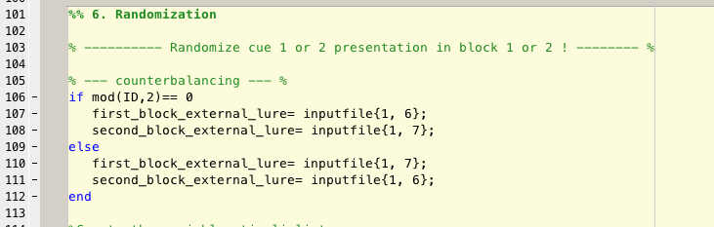

**2. Randomize cue and stimuli order. (Randomized)**  
Now randomize the cues in the first and second block, at the same time, randomize the order of the rows.

If room A has cue 1 in first block, in the second block it has cue 2.

At the same time, room A position in first and second block are randomized.

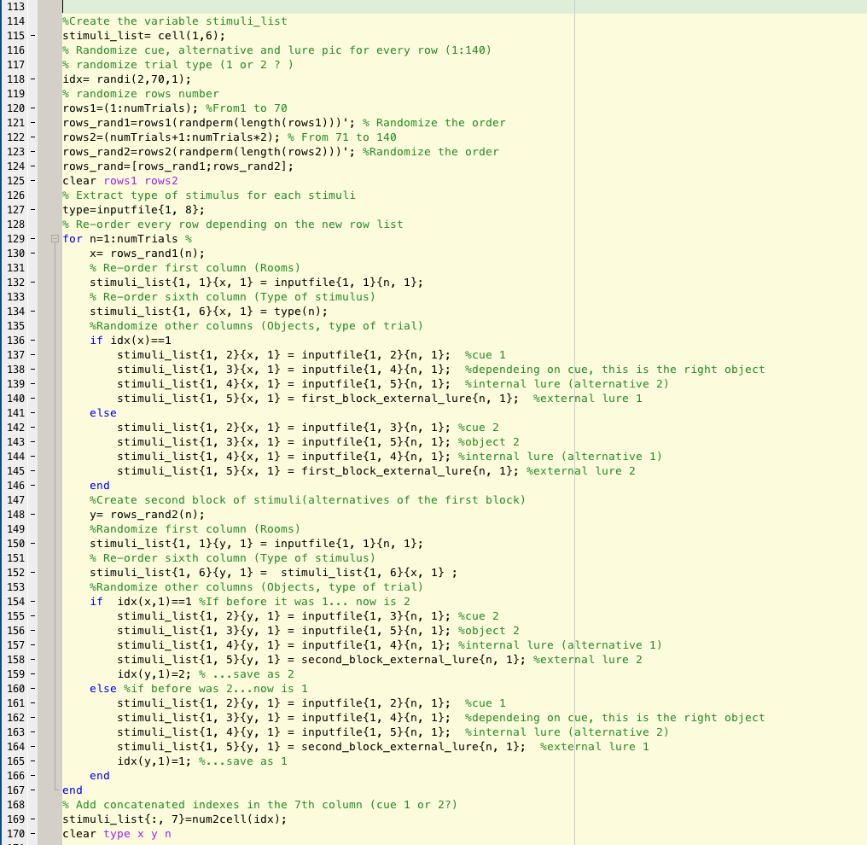

**3. Sorted depending on ISI trial type definition. (Counterbalanced- Group A)**

The stimuli are now scanned to find those who are of type 1 (room with objects, task trials) or 0 (control trials). Then, they are sorted depending on the ISI trial order:  
if the ISI calculation said that the optimal order is 1 0 0 0 1, it will order the stimuli that way.

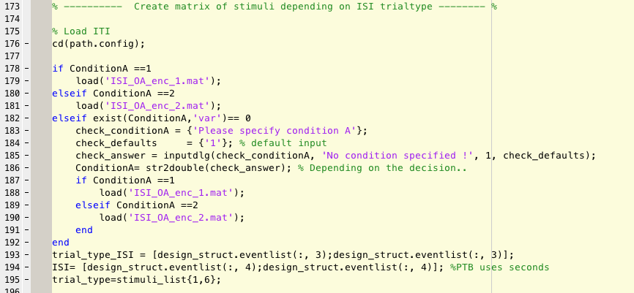  
  
  
**Output variables:**

**Stimuli_list**

1 Room

2 Cue

3 Alternative 1 (right one)

4 Alternative 2 (internal lure)

5 External lure

6 Type of trial (1 or 0)

7 Type of cue (1 or 2)

**Stimuli_list_ordered:** ordered by ISI trial type order

1 Room

2 Cue

3 Alternative 1 (right one)

4 Alternative 2 (internal lure)

5 External lure

6 Type of trial (1 or 0)

7 Type of cue (1 or 2)