**Randomization and counterbalancing of the stimuli in the script**

**(Retrieval)**

* ID
* Session
* Condition A = ISI type
* Condition B = Response type (1= Ja/Nein; 2=Nein/Ja)
* Condition C = Type of stimuli retrieval (1= A1 B2, 2= A2 B1)

**1 . Choose stimuli to be presented (Counterbalanced – Condition C)**

After loaded the encoding stimuli list, depending on Condition C , the stimuli list index for retrieval is created.

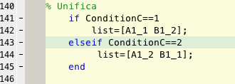

**2. Extract the selected stimuli from encoding stimuli list (Build up the list)**  
The rows selected during the previous step, are now extracted from stimuli list encoding and saved into stimuli list.

At the same time, rows order is randomized. (rows_rand)

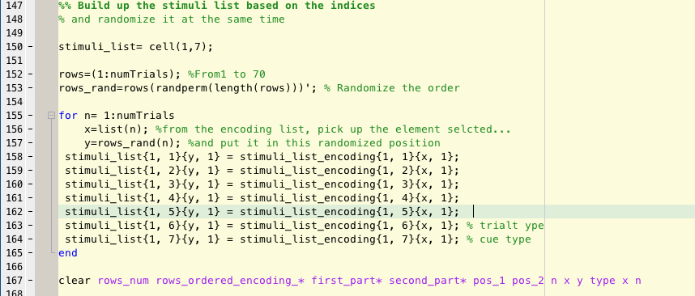

**3. Sorted depending on ISI trial type definition. (Counterbalanced- Condition A)**

The stimuli are now scanned to find those who are of type 1 (room with objects, task trials) or 0 (control trials). Then, they are sorted depending on the ISI trial order:  
if the ISI calculation said that the optimal order is 1 0 0 0 1, it will order the stimuli that way.

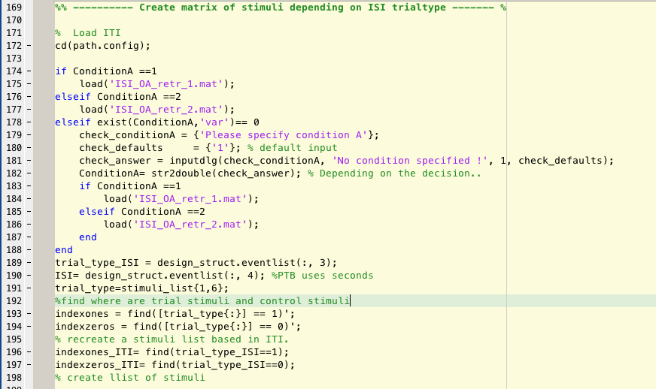

**4. Answers are converted depending on the Ja/Nein position on the screen (Counterbalanced- Condition B)**

Answers to room classification depends on the way are presented on the screen. If condition B = 1 , ´Ja´ is left and ´Nein´ is right, is condition B= 2, the other way around.  
Here the answers are converted depending on the counterbalancing group.

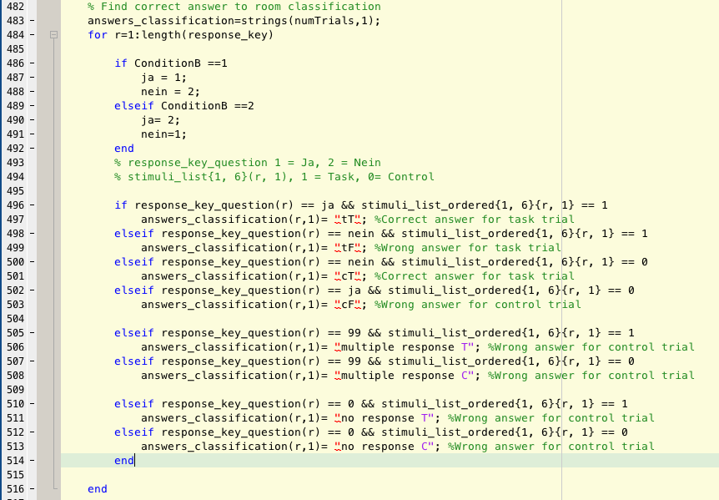

**Output variables:**

**Stimuli_list**

1 Room

2 Cue

3 Alternative 1 (right one)

4 Alternative 2 (internal lure)

5 External lure

6 Type of trial (1 or 0)

7 Type of cue (1 or 2)

**Stimuli_list_ordered:** ordered by ISI trial type order

1 Room

2 Cue

3 Alternative 1 (right one)

4 Alternative 2 (internal lure)

5 External lure

6 Type of trial (1 or 0)

7 Type of cue (1 or 2)