OCT Data Collector　Instruction Manual rev1.1

**1. Start-up**

Run “OctDataCollector.exe”.

OCT Data Collector main screen

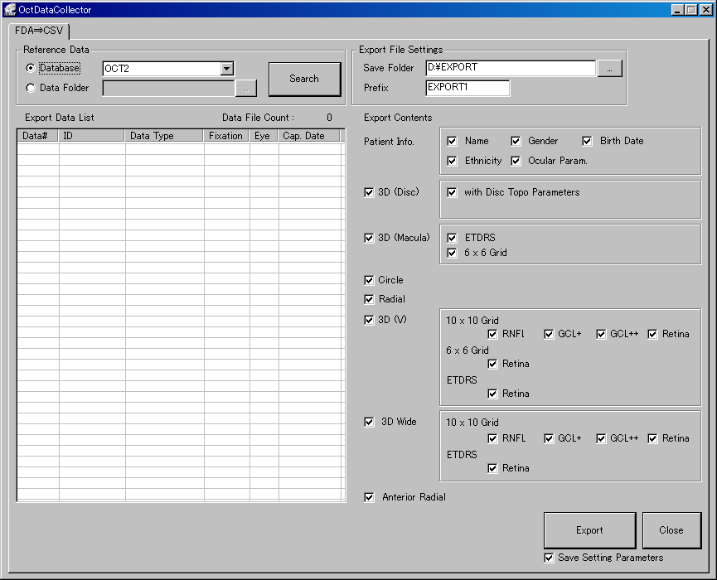

**2. Select data**

Select data for output from database or data folder where analysis files are stored (hereafter called as data folder).

**2.1 Select database or data folder**

**In case of database** Choose [Database] and select a database name from pull-down list.

**In case of data folder** Choose [Folder] then click to specify a folder name, otherwise input a folder path directly.

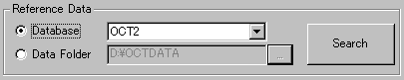

* 1. **Select data**
* Click [Search] to start data search.

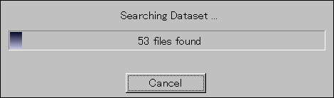

Data search window

* Put tick mark on data which you like to output.

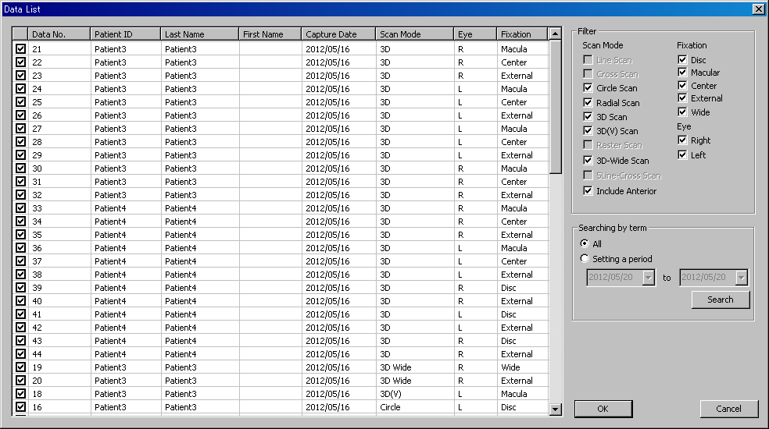

Data list window

**＊　Refine your search by capture condition**

　　Search options are shown on [Filter].

|  |  |
| --- | --- |
|  | Item |
| Scan Mode | Circle Scan |
| Radial Scan |
| 3D Scan |
| 3D(V) Scan |
| 3D Wide Scan |
| Include Anterior |
| Fixation | Disc |
| Macula |
| Center |
| External |
| Wide |
| Eye | Right |
| Left |

**※In case of searching data within selected period.**

In [Searching by term], tick in [Setting a period], specify the desired period, and click [Search].

(In order not to search by term, tick in [All] and click [Search].)

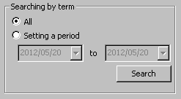

* Click [OK] to finish data selection.

※Selected data are listed in [Export Data List].

　　(“Data File Count” shows the number of selected data. ）

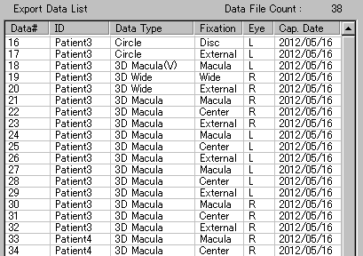

1. **File Export setting**

* Input in [Save Folder] the path to the folder to export files, or browse the folder by clicking .



* Input the prefix of exported file name.

(If nothing is input, “DEFAULT” would be the prefix.)

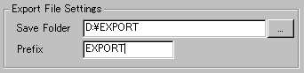

* Tick in check box in [Patient Info.] to select the patient information exported with data.

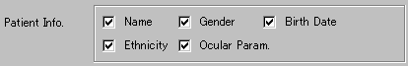

|  |  |
| --- | --- |
| item | details |
| Name | Name of patient （Last Name and First Name) |
| Gender | Male or Female |
| Birth Date | Date of birth |
| Ethnicity | Asian, Caucasian, etc |
| Ocular Param. | Ocular parameter  (Spherical value, Cylinder value, corneal curvature, axial length) |

* Select the protocol and contents of data to export.

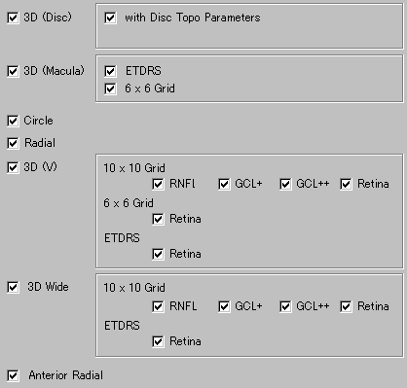

|  |  |  |  |  |
| --- | --- | --- | --- | --- |
| Item | Data to Export | Layer | Setting Detail | |
| 3D (Disc) | Disc　3D Scan | NFL | With Disc Topo Parameter | To export with Disc analysis |
| 3D (Macula) | Macular　3D Scan | Retina | ETDRS | To export average thickness of each ETDRS section |
| 6 x 6 Grid | To export average thickness of 6x6 grids |
| Circle | Circle Scan | NFL |  |  |
| Radial | Radial Scan | Retina |  |  |
| 3D(V) | Macular　3D(V) Scan | RNFL  GCL+  GCL++  Retina | 10x10　Grid | To export average value of 10x10 Grid in selected layer |
| 6x6 Grid | To export average value of 6x 6 Gred in Retina thickness |
| ETDRS | To export average thickness of each retina thickness’s ETDRS |
| 3D Wide | Wide Scan | RNFL  GCL+  GCL++  Retina | 10x10　Grid | To export average value of 10x 10 Grid in selected layer |
| ETDRS | To export average thickness of each retina thickness’s ETDRS |
| Anterior Radial | Anterior Segment Radial Scan | Cornea |  |  |

※Please refer APPENDIX 1 for details of exported contents.

※Please refer APPENDIX 2 for condition of each exported data.

1. **Export**

* Click [export] to start exporting.

※While exporting, the progress bar is displayed as below. If you cancel exporting, click [Cancel].

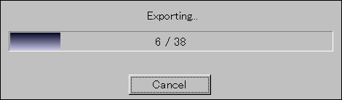

※In case when files with the same file name exist in the folder to export, its file name is listed as follows.

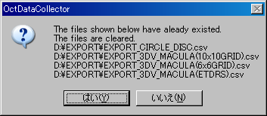

* In order to write over the current data…… select “YES”. Then the current data in the folder is deleted, and start exporting.

* In order to keep the current data…… select “NO”, and then exporting is canceled. Try to export it again after copying the file to another folder, or changing [prefix].

* When exporting has done, the message saying ”The data output has been completed” is displayed.

1. **Exit the Application**

* Click [Close]

※ In order to save the current setting, check the box of [Save Setting Parameters] and then close the application.

**< APPENDIX 1 > contents of the exported file.**

**◆Additional information（patient / capture information） … common info.**

|  |  |
| --- | --- |
| item | Notes |
| Export Software Ver. | Version of the data collector. |
| Export Date | Year / month / day |
| Export Time | Hour / minute /second |
| Data No. | Data file Number. （FDS/FDA file） |
| Patient ID |  |
| Last Name |  |
| First Name |  |
| Gender | Male / Female  n/a　　　　… No data |
| DOB | Birthday  （No data shown as ”n/a”） |
| Ethnicity |  |
| Eye | R ... OU  L 　... OS |
| Capture Date | Year / month / day |
| Capture Time | Hour / minute /second |
| Scan Size |  |
| Scan Resolution |  |
| Fixation | Disc / Macula / Center / wide  External fixation |
| Image Quality |  |
| OCT Focus Mode | Vetrious  Choroidal  Cornea  Deep pos |
| Model Name |  |
| Capture Software Ver. |  |
| Analysis Software Ver. |  |
| Analysis Mode | Fine  Basic |
| Sph. Power | unit: Diopter |
| Cyl. Power | unit: Diopter |
| Corneal Radius | unit: mm |
| Axial Length | unit: mm |
| Contents | RNFL / GCL+ / GCL++ / Retina / Cornea |

**◆3D (Disc)**

File name：XXX_3D_DISC.csv

Exported scan size: 6.0 x 6.0 mm / 4.5 x 4.5 mm

|  |  |  |
| --- | --- | --- |
| item | Note | Unit |
| Total | Average thickness of circular | um |
| 4_T | Average thickness of each 4sector | um |
| 4_S |
| 4_N |
| 4_I |
| 12_T | Average thickness of each12sector | um |
| 12_TS |
| 12_ST |
| 12_S |
| 12_SN |
| 12_NS |
| 12_N |
| 12_NI |
| 12_IN |
| 12_I |
| 12_IT |
| 12_TI |
| Disc Area* | Disc area | mm2 |
| Cup Area* | Cup area | mm2 |
| Rim Area* | Rim area | mm2 |
| Cup Volume* | Cup volume | mm3 |
| Rim Volume* | Rim volume | mm3 |
| C/D Area Ratio* | C/D area ratio |  |
| Linear C/D Ratio* | Square root of C/D area |  |
| Vertical C/D Ratio* | Vertical C/D ratio |  |
| Disc Dia.(V) * | Vertical disc diameter | mm |
| Disc Dia.(H) * | Horizontal disc diameter | mm |

*) Disc topography is applied to “3D Disc, size6.0 x 6.0, resolution 512 x 128”.

12sectors

4sectors

**S**

**SN**

**NS**

**NI**

**IN**

**I**

**IT**

**ST**

**TI**

**TS**

**N**

**T**

**I**

**N**

**T**

**S**

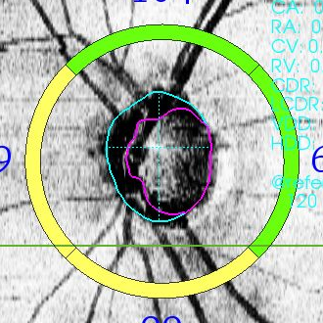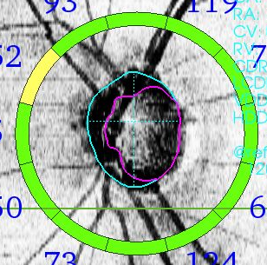

*This chart is OS. At the OD these grids are mirrored.

**◆3D (Macula) - ETDRS**

File name: XXX_3D_MACULA(ETDRS).csv

Exported scan size: 6.0 x 6.0 mm

|  |  |  |
| --- | --- | --- |
| item | Note | Unit |
| ETDRS_Center | Average thickness of each grid. | um |
| ETDRS_In_T |
| ETDRS_In_S |
| ETDRS_In_N |
| ETDRS_In_I |
| ETDRS_Out_T |
| ETDRS_Out_S |
| ETDRS_Out_N |
| ETDRS_Out_I |
| Average Thickness | Average thickness of total grid area. | um |
| Center Thickness | The point of ETDRS grids center.  （thickness of the center point) | um |
| Total Volume |  | mm3 |

*This chart is OS. At the OD these grids are mirrored.

**Out_I**

**Out_N**

**In_N**

**Center**

**In_I**

**In_S**

**In_T**

**Out_T**

**Out_S**

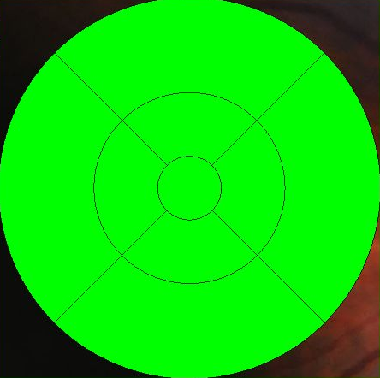

**◆3D (Macula) – 6 x 6 Grid**

Filename: XXX_3D_MACULA (6x6GRID).csv

All 3D macula scan

|  |  |  |
| --- | --- | --- |
| item | note | unit |
| 01_01 | Average thickness of the each grid. (6 x 6 grid)  Each grid named as below. | um |
| 02_01 |
| 03_01 |
| 04_01 |
| 05_01 |
| 06_01 |
| 01_02 |
| 02_02 |
| ・ |
| ・ |
| ・ |
| ・ |
| 05_06 |
| 06_06 |
| Total Volume |  | mm3 |

**6_1**

**6_6**

**1_1**

**1_6**

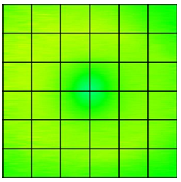

**1_1**

**6_6**

**6_1**

**1_6**



OD

OS

**◆Circle**

File name: XXX_CIRCLE_DISC.csv

|  |  |  |
| --- | --- | --- |
| item | Note | Unit |
| Total | Average thickness of circular | um |
| 4_T | Average thickness of each 4sector. | um |
| 4_S |
| 4_N |
| 4_I |
| 12_T | Average thickness of each 12sector. | um |
| 12_TS |
| 12_ST |
| 12_S |
| 12_SN |
| 12_NS |
| 12_N |
| 12_NI |
| 12_IN |
| 12_I |
| 12_IT |
| 12_TI |

※The name of each sector are same as “3D Disc”.

**◆Radial**

File name： XXX_RADIAL_MACULA.csv

|  |  |  |
| --- | --- | --- |
| item | Note | Unit |
| ETDRS_Center | Average thickness of each grid. | um |
| ETDRS_In_T |
| ETDRS_In_S |
| ETDRS_In_N |
| ETDRS_In_I |
| ETDRS_Out_T |
| ETDRS_Out_S |
| ETDRS_Out_N |
| ETDRS_Out_I |
| Average Thickness | E Average thickness of total grid area. | um |

※The name of each sector are same as “3D(Macula) – ETDRS”.

**◆3D(V)** - **10x10Grid**

Filename：XXX_3DV_MACULA(10x10GRID).csv

|  |  |  |
| --- | --- | --- |
| item | Note | Unit |
| Total | Average thickness of circular | um |
| Superior |  | um |
| Inferior |  | um |
| 01_01 | Average thickness of each grid. | um |
| 02_01 |
| 03_01 |
| 04_01 |
| 05_01 |
| 06_01 |
| 07_01 |
| 08_01 |
| 09_01 |
| 10_01 |
| 01_02 |
| 02_02 |
| 03_02 |
| 04_02 |
|  |
|  |
|  |
|  |
|  |
| 08_10 |
| 09_10 |
| 10_10 |

**10_1**

**1_1**

**2_1**

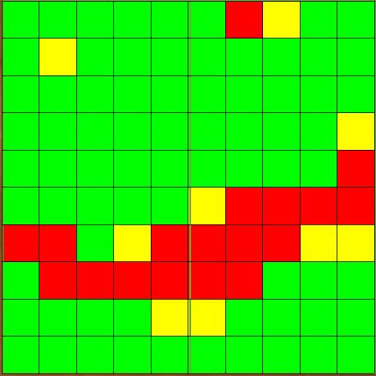

**1_2**

**2_1**

**1_1**

**10_1**

**10_2**



**10_2**

**1_2**

**10_10**

**1_10**

**10_10**

**1_10**

OS

OD

**◆3D(V)** **- 6x6Grid**

File name：　XXX_3DV_MACULA(6x6GRID).csv

|  |  |  |
| --- | --- | --- |
| item | Note | Unit |
| 01_01 | Average thickness of each grid. | um |
| 02_01 |
| 03_01 |
| 04_01 |
| 05_01 |
| 06_01 |
| 01_02 |
| 02_02 |
| ・ |
| ・ |
| ・ |
| ・ |
| 05_06 |
| 06_06 |
| Total Volume |  | mm3 |

※The name of each sector are same as “3D(Macula) – Grid”

**◆3D(V) - ETDRS**

Filename: XXX_3DV_MACULA(ETDRS).csv

|  |  |  |
| --- | --- | --- |
| item | Note | Unit |
| ETDRS_Center | Average thickness of each ETDRS grid. | um |
| ETDRS_In_T |
| ETDRS_In_S |
| ETDRS_In_N |
| ETDRS_In_I |
| ETDRS_Out_T |
| ETDRS_Out_S |
| ETDRS_Out_N |
| ETDRS_Out_I |
| Average Thickness | Average thickness of total grid area. | um |
| Center Thickness | The point of ETDRS grids center.  （thickness of the center point) | um |
| Total Volume |  | mm3 |

※The name of each sector are same as “3D(Macula) – ETDRS”.

**◆3D Wide - 10x10Grid**

ファイル名： XXX_3D_WIDE(10x10GRID).csv

|  |  |  |
| --- | --- | --- |
| item | Note | Unit |
| 01_01 | Average thickness of each grid. | um |
| 02_01 |
| 03_01 |
| 04_01 |
| 05_01 |
| 06_01 |
| 07_01 |
| 08_01 |
| 09_01 |
| 10_01 |
| 01_02 |
| 02_02 |
| 03_02 |
| 04_02 |
| ・ |
| ・ |
| ・ |
| ・ |
| ・ |
| 08_10 |
| 09_10 |
| 10_10 |

※The name of each sector are same as “3D(V) – 10x10Grid”

**◆3D Wide - ETDRS**

Filename:XXX_3D_WIDE(ETDRS).csv

|  |  |  |
| --- | --- | --- |
| item | Note | Unit |
| ETDRS_Center | Average thickness of each ETDRS grid. | um |
| ETDRS_In_T |
| ETDRS_In_S |
| ETDRS_In_N |
| ETDRS_In_I |
| ETDRS_Out_T |
| ETDRS_Out_S |
| ETDRS_Out_N |
| ETDRS_Out_I |

※The name of each sector are same as “3D(Macula) – ETDRS”.

**◆Anterior Radial**

File name：XXX_RADIAL_ANTERIOR.csv

|  |  |  |
| --- | --- | --- |
| item | Note | Unit |
| Center Thickness | thickness of the center point | um |
| Center Curve Radius  (H) | Horizontal curve | mm |
| Center Curve Radius  (V) | Vertical curve | mm |

**< APPENDIX 2 > Exported data**

Data collector can export the csv-data of scan as below.

◆3D(Disc)

|  |  |  |
| --- | --- | --- |
| Scan protocol | Scan size | fixation |
| 3D | 6.0x6.0mm  4.5x4.5mm | Disc  External |

◆3D(Macula) – ETDRS

|  |  |  |
| --- | --- | --- |
| Scan protocol | Scan size | fixation |
| 3D | 6.0x6.0mm | Macula  Center  External |

◆3D(Macula) – 6x6 Grid

|  |  |  |
| --- | --- | --- |
| Scan protocol | Scan size | fixation |
| 3D | 8.2x3.0mm  6.0x6.0mm  4.5x4.5mm  3.0x3.0mm | Macula  Center  External |

◆Circle

|  |  |  |
| --- | --- | --- |
| Scan protocol | Scan size | fixation |
| Circle | φ3.4mm | Disc  External |

◆Radial

|  |  |  |
| --- | --- | --- |
| Scan protocol | Scan size | fixation |
| Radial | φ6.0mm | Macula  Center  Disc  External |

◆3D(V) – 10x10 Grid

◆3D(V) – 6x6 Grid

◆3D(V) – ETDRS

|  |  |  |
| --- | --- | --- |
| Scan protocol | Scan size | fixation |
| 3D(V) | 7.0x7.0mm | Macula  External |

◆3D(V) – 10x10 Grid

◆3D(V) – ETDRS

|  |  |  |
| --- | --- | --- |
| Scan protocol | Scan size | fixation |
| 3D Wide | 12.0x9.0mm | Wide  External |

◆Radial Anterior

|  |  |  |
| --- | --- | --- |
| Scan protocol | Scan size | fixation |
| Radial | 6.0x6.0mm | External |

End.