General
Analysis periods:
- Area: 155-156E & 18.5-19.5S (overlapping of peaks)
- Baseline: 1. Nov – 31. Mar of 2019-2022 (only summer months without cyclones occurring then)
  - Exclusion periods:
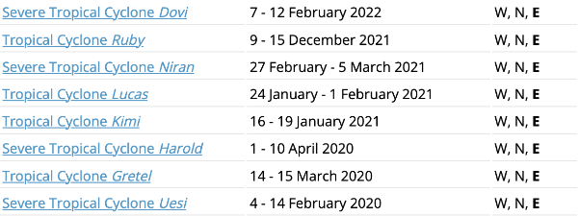
- Fina peak on 21-22nd December 2011 (followed by gales on 25-26th)
- Alfred peak: 27-28th February 2025

Wind and Wave analysis
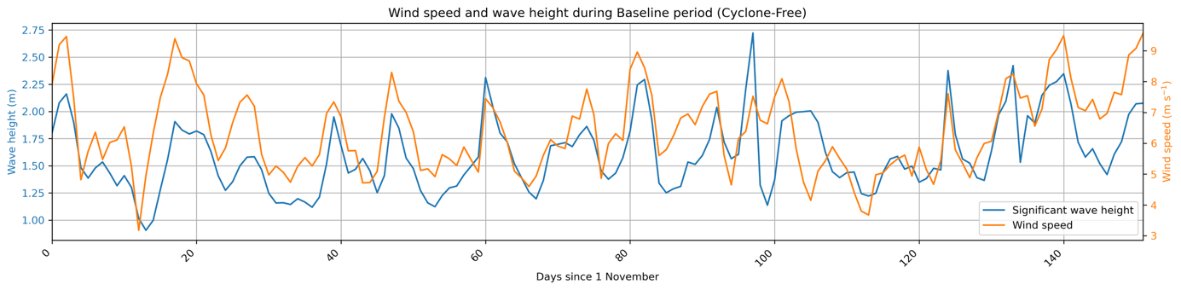
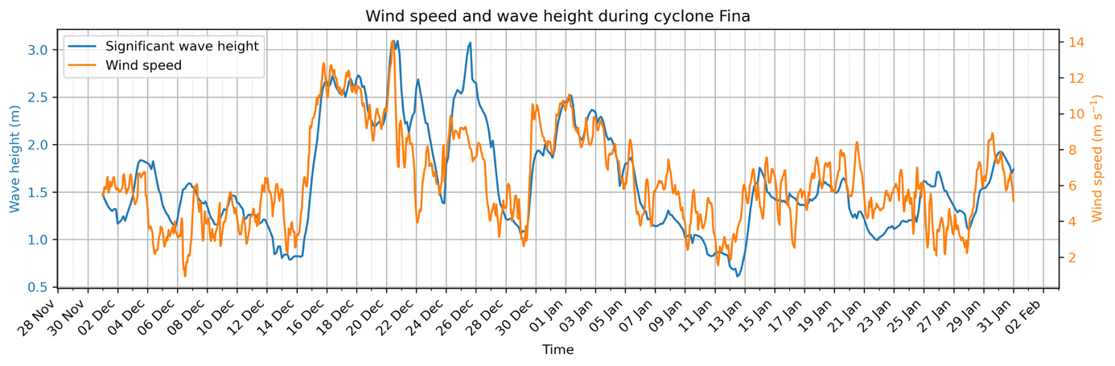
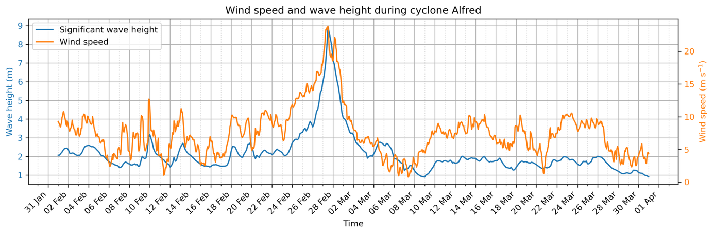

MLD
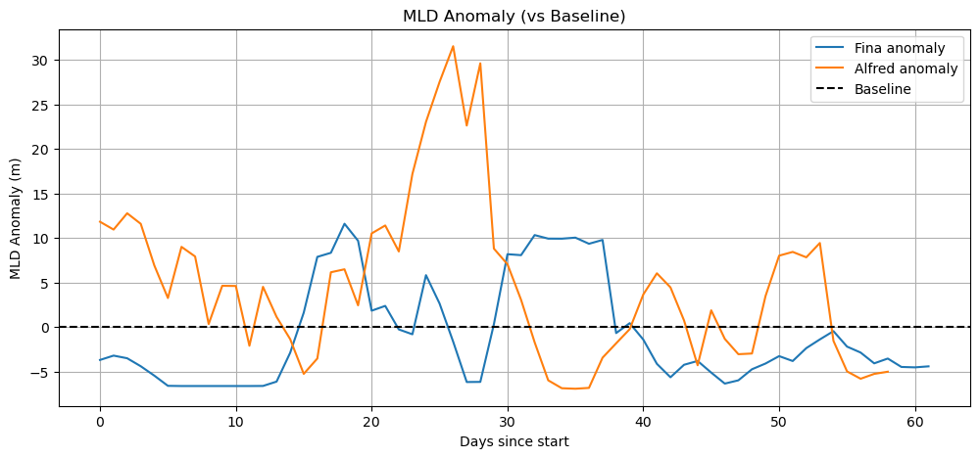
More mixing through more wind and wave
Nitrate
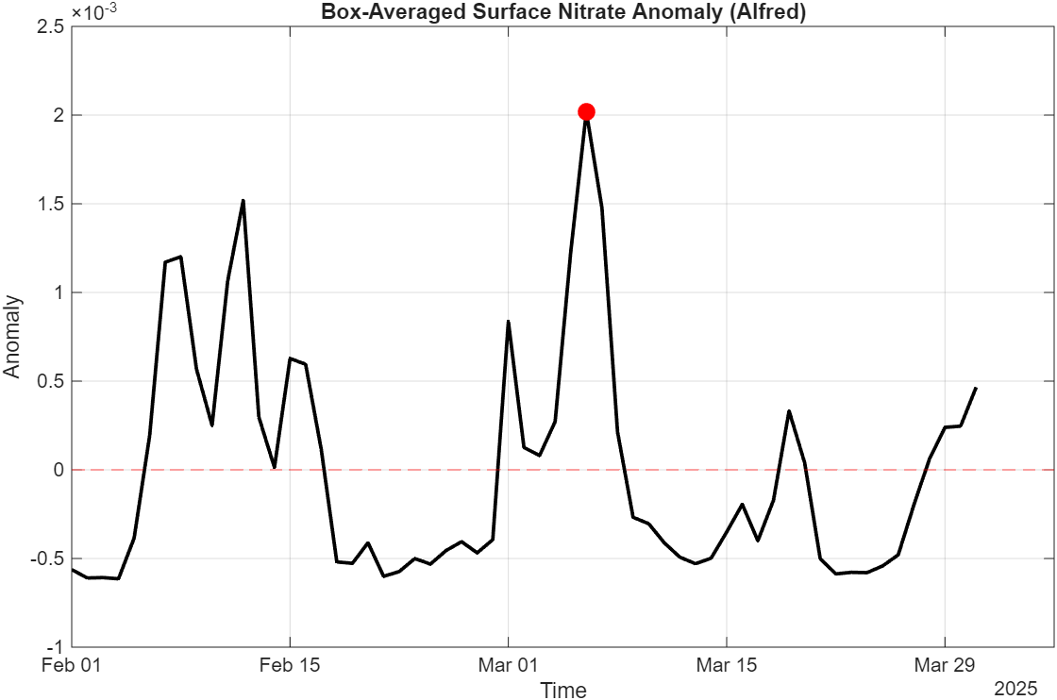
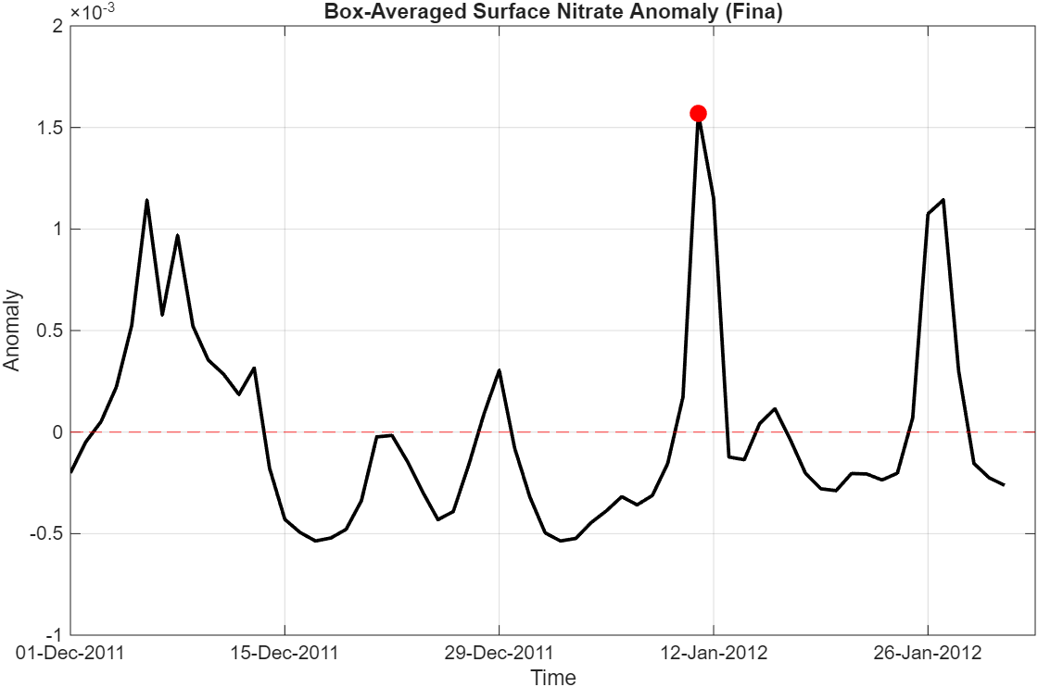
delayed effect? Maybe stired up through mixing and after «relaxing», it gets «trapped» in higher levels?
Chl-a
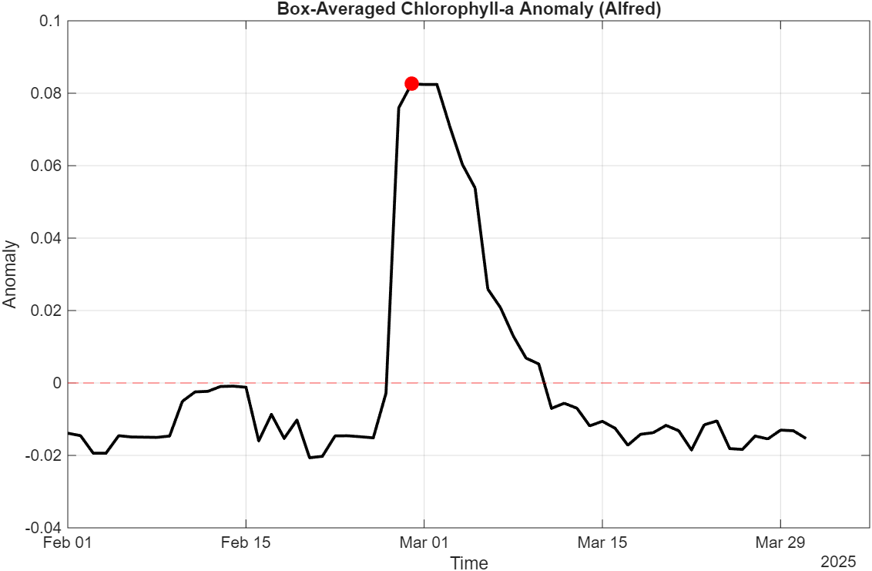
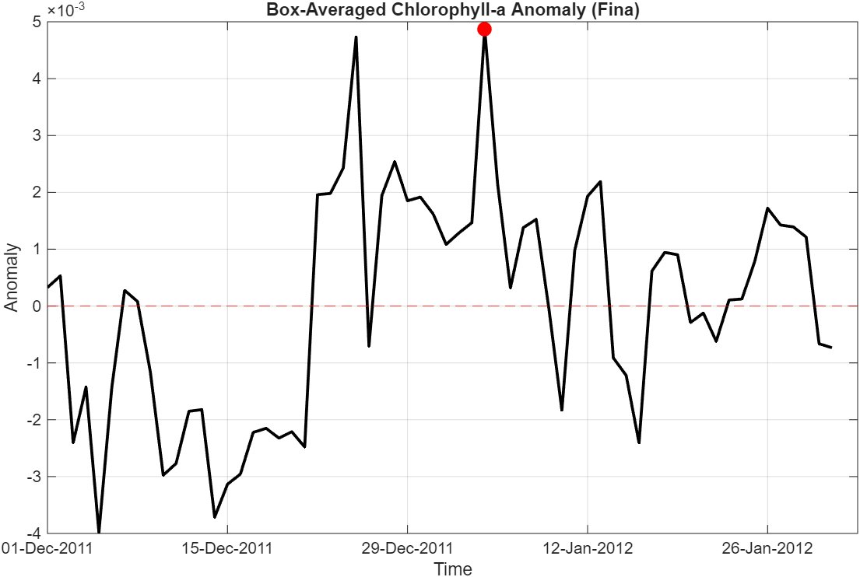
Instantly higher, redistribution of lower algae higher up (instant increase doesn’t mean new growth)
NPP of biomass and suspended matter
NPP = the rate at which phytoplankton produce new organic matter via photosynthesis

BIOMASS:

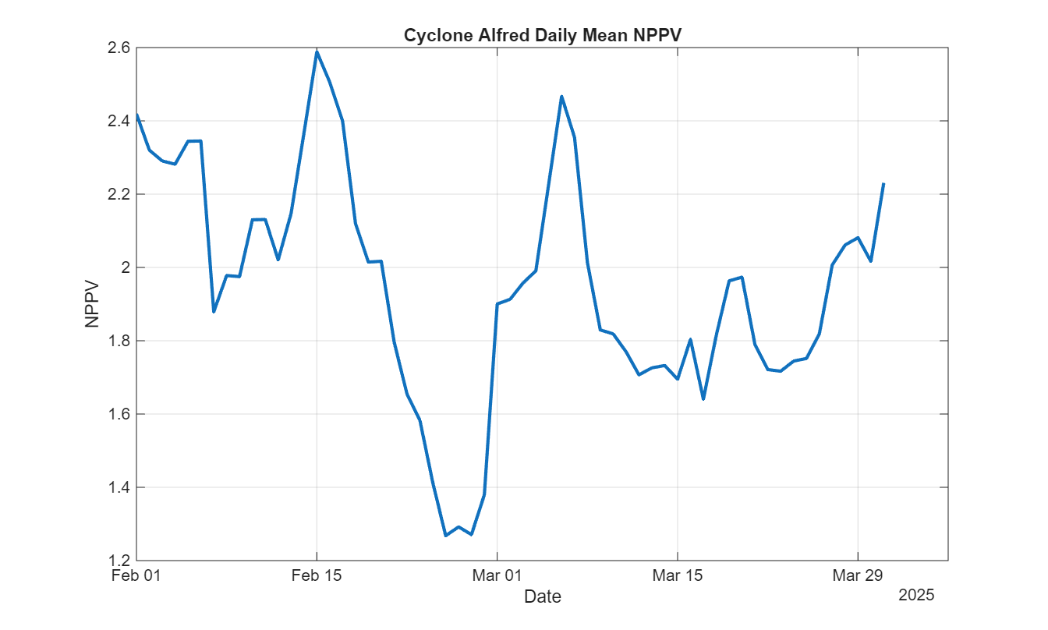
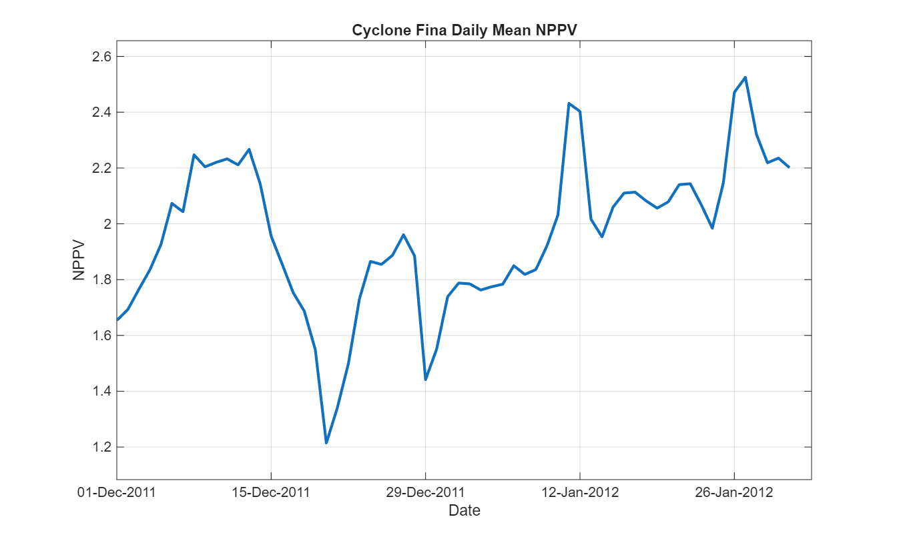

SUSPENDED MATTER

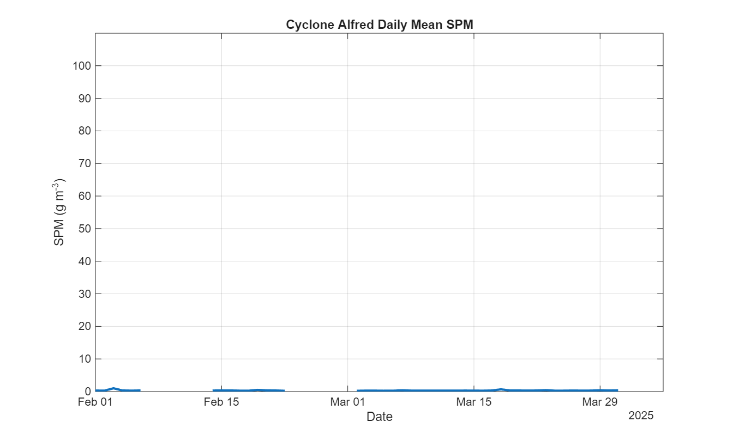

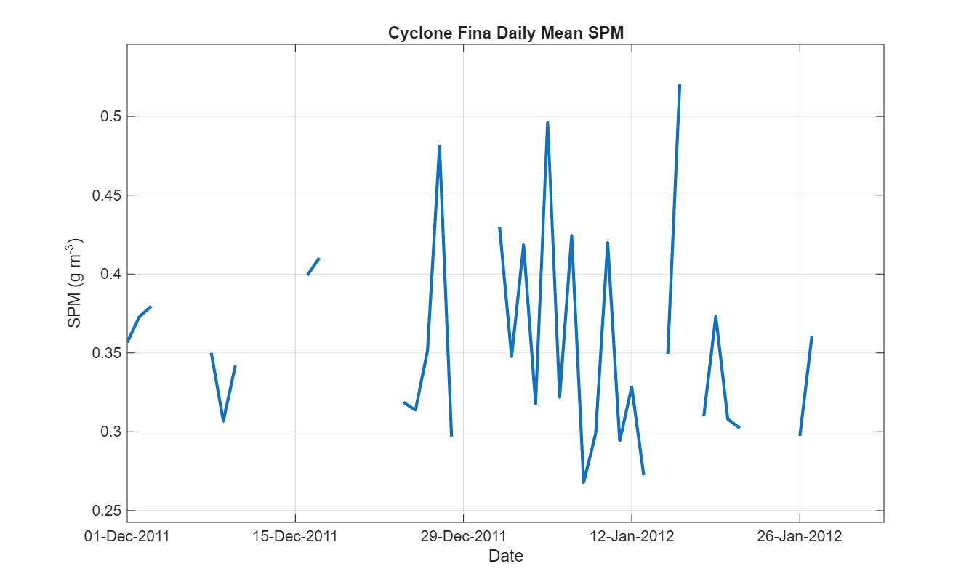
Maybe delayed response like with nitrate?

Statistical tests (t test) and map of it, where is difference significant and where not
P values for every lat lon cell gives matrix that gives mapl, npt just average of the whole box but spatially explicit

Take larger area and show in maps the overlapping

