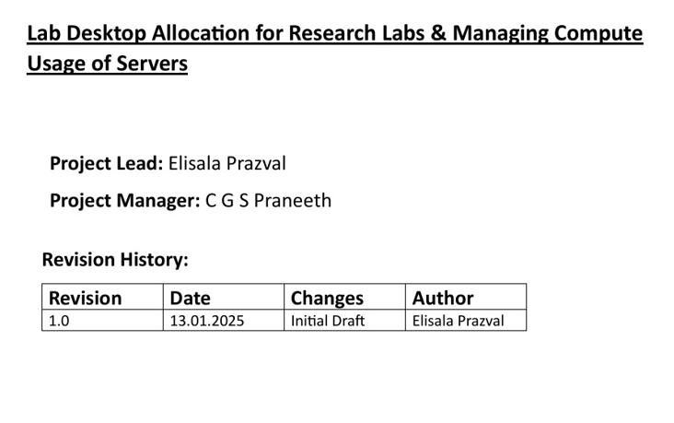

**TEAM NUMBER – 2 (FN)**

**1. ELISALA PRAZVAL - B220841CS**

**2. C G S PRANEETH - B220234CS**

**3. C. HIMAJALA REDDY – B220243CS**

**USE-CASE DIAGRAM**

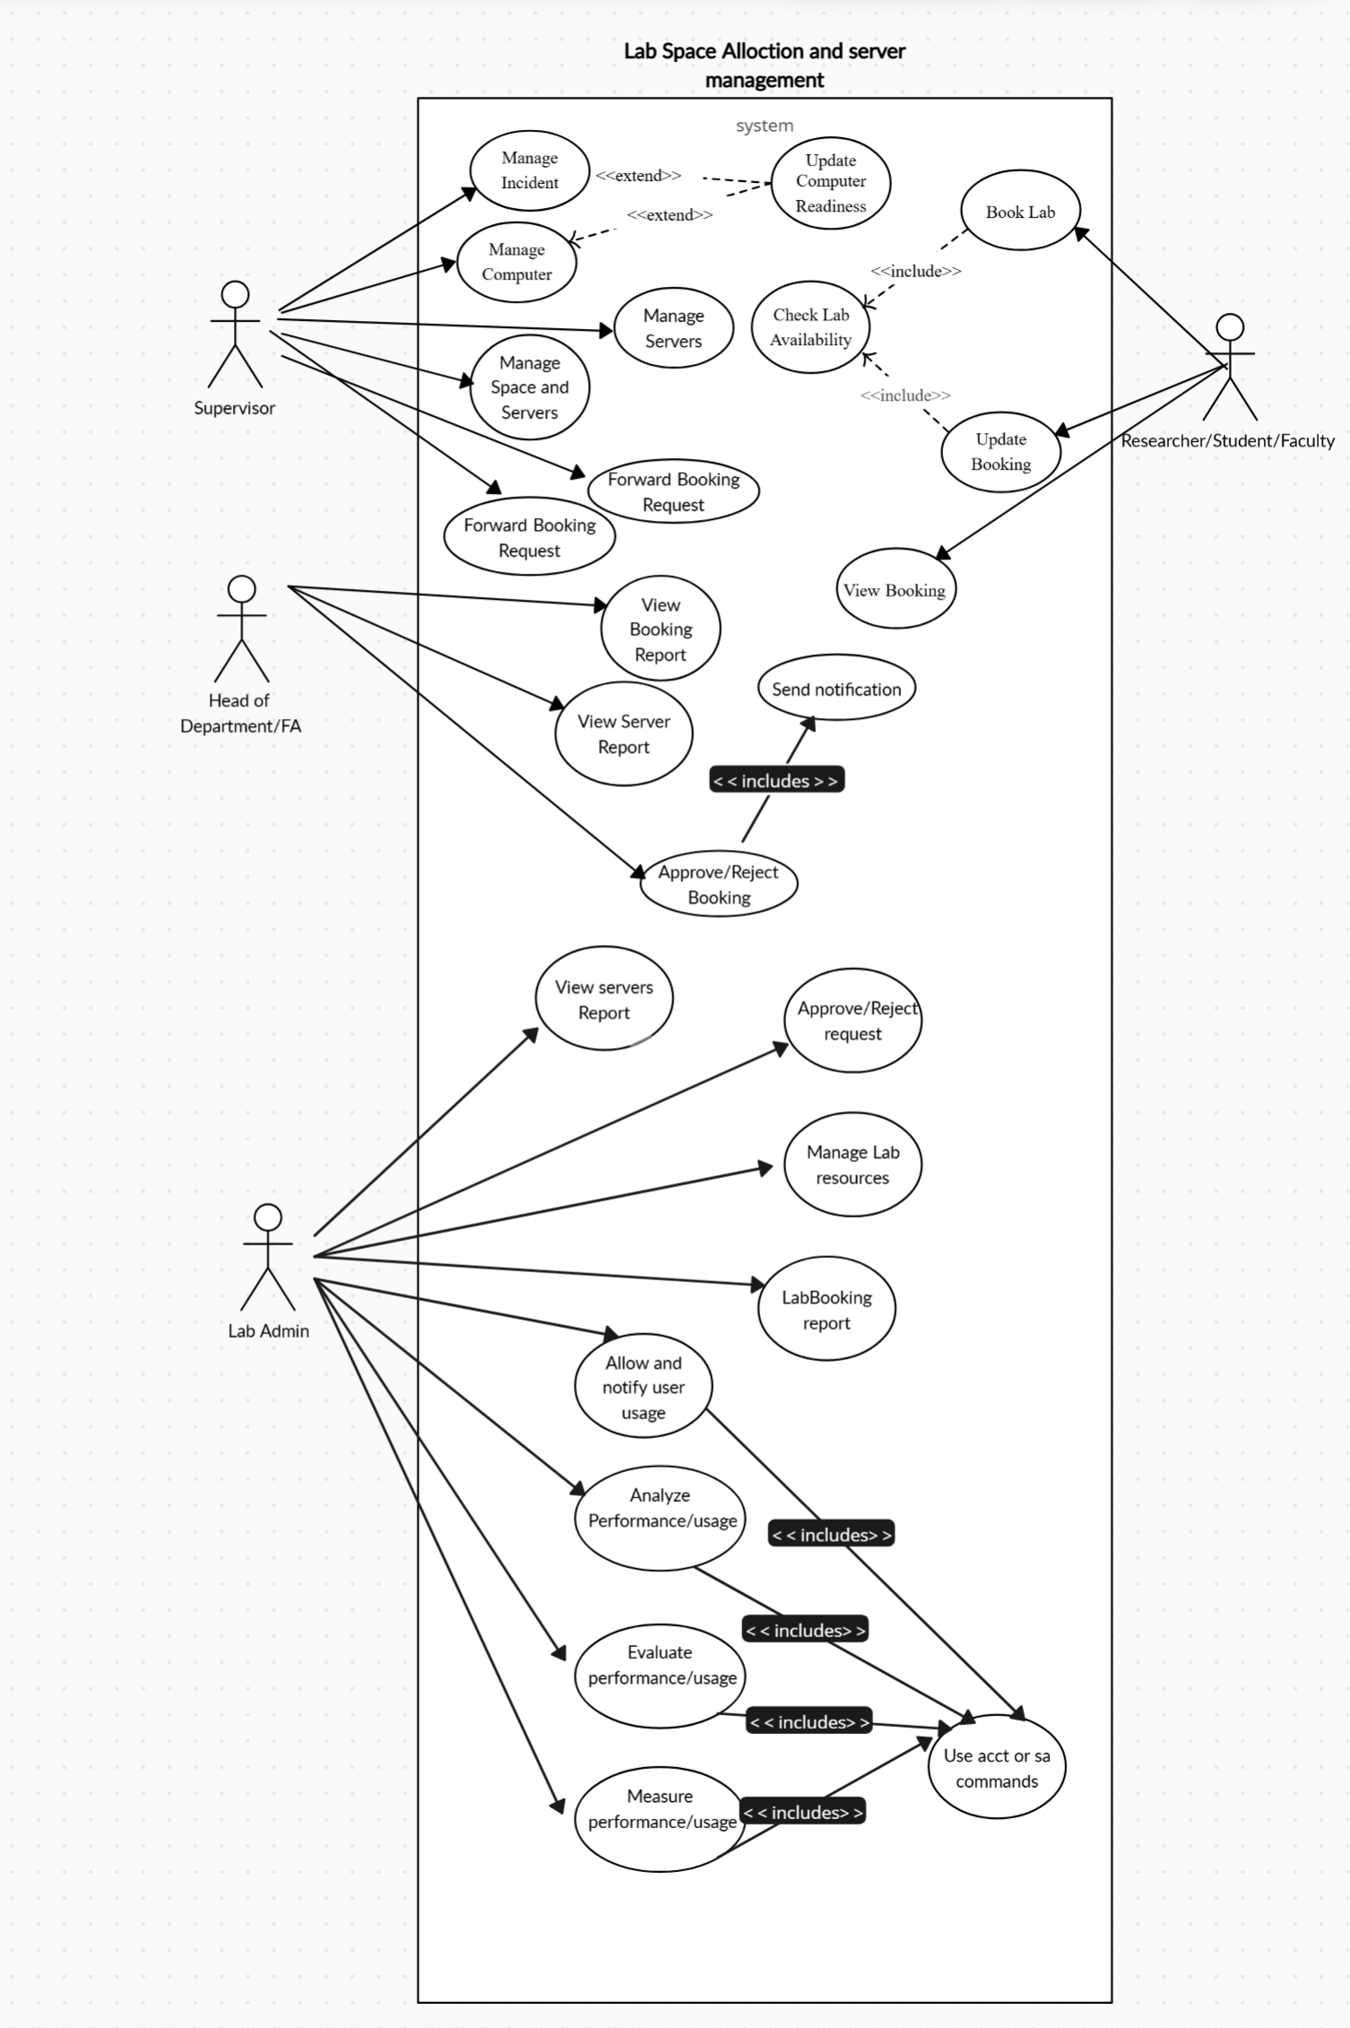

Submit feedback

Monitor usage

Req.Server

< < includes > >

**FUNCTIONAL REQUIREMENTS:**

These define the core functionalities of the system.

**Inventory Management:**

* Maintain a centralized inventory of all desktops, lab equipment, and resources.
* Track resource availability in real-time.
* Update resource status (available, booked, blocked, etc.).

**Resource Booking & Allocation:**

* Allow users to book lab desktops and resources based on availability.
* Implement a priority-based allocation system (e.g., faculty, researchers, students).
* Enable automated/manual approval for certain bookings if required.

**Server Allocation Mechanism:**

* Allocate server resources dynamically based on user requests and workload.
* Allow manual or automated allocation of servers for specific tasks.
* Implement priority-based allocation (e.g., faculty, researchers, students).
* Enable reallocation of resources based on real-time demand.
* Restrict server access based on user roles (admin, faculty, student, researcher).
* Provide real-time monitoring of allocated servers.
* Send alerts for resource overuse or failures.

**User Access & Authentication:**

* Implement role-based access control (RBAC) (e.g., admin, faculty, student).
* Enable SSO (Single Sign-On) or integration with institutional login for authentication.
* Allow admin privileges to manage access and permissions for different users.
* Implement role-based login functionality to ensure users can only access permitted resources.

**Real-Time Monitoring & Dashboard:**

* Provide an interactive dashboard for administrators to monitor resource usage.
* Display only user usage time instead of live system health metrics.
* Send alerts and notifications for critical issues or high resource consumption.

**Integration with Existing Research Tools:**

* Enable API-based integration with existing lab tools, research software, and cloud services.
* Allow exporting data and reports in multiple formats for research documentation.

**Feedback & Reporting Mechanism:**

* Provide a feedback system for users to report issues or suggest improvements.
* Generate usage analytics and reports for administrators to track system efficiency.
* Allow incident reporting for malfunctioning resources.

**2. Non-Functional Requirements**

These define the system's quality attributes and constraints.

**Performance:**

* Ensure fast response time for system interactions.
* Optimize server efficiency to handle multiple users.
* Use caching to reduce database load.

**Scalability:**

* Support expansion of server allocation capabilities as demand increases.

**Availability & Reliability:**

* Ensure 99.9% uptime with automatic failover mechanisms for uninterrupted service.
* Maintain redundant data backups to prevent data loss.
* Implement proactive monitoring with automated alerts for potential failures.
* Use load distribution strategies to prevent system overloads.

**Security:**

* Use encryption for secure data transmission.
* Implement multi-factor authentication (MFA).
* Restrict unauthorized access with role-based permissions.
* Enable session timeouts and auto-logout.

**Usability:**

* Provide a user-friendly interface with documentation and tooltips.

**Maintainability & Extensibility:**

* Use a modular system for easy updates.
* Support automatic updates with minimal downtime.

**Compliance & Legal Requirements:**

* Adhere to data privacy laws (e.g., GDPR, institutional policies).
* Maintain audit trails for compliance tracking.

**DATABASE DESIGN**

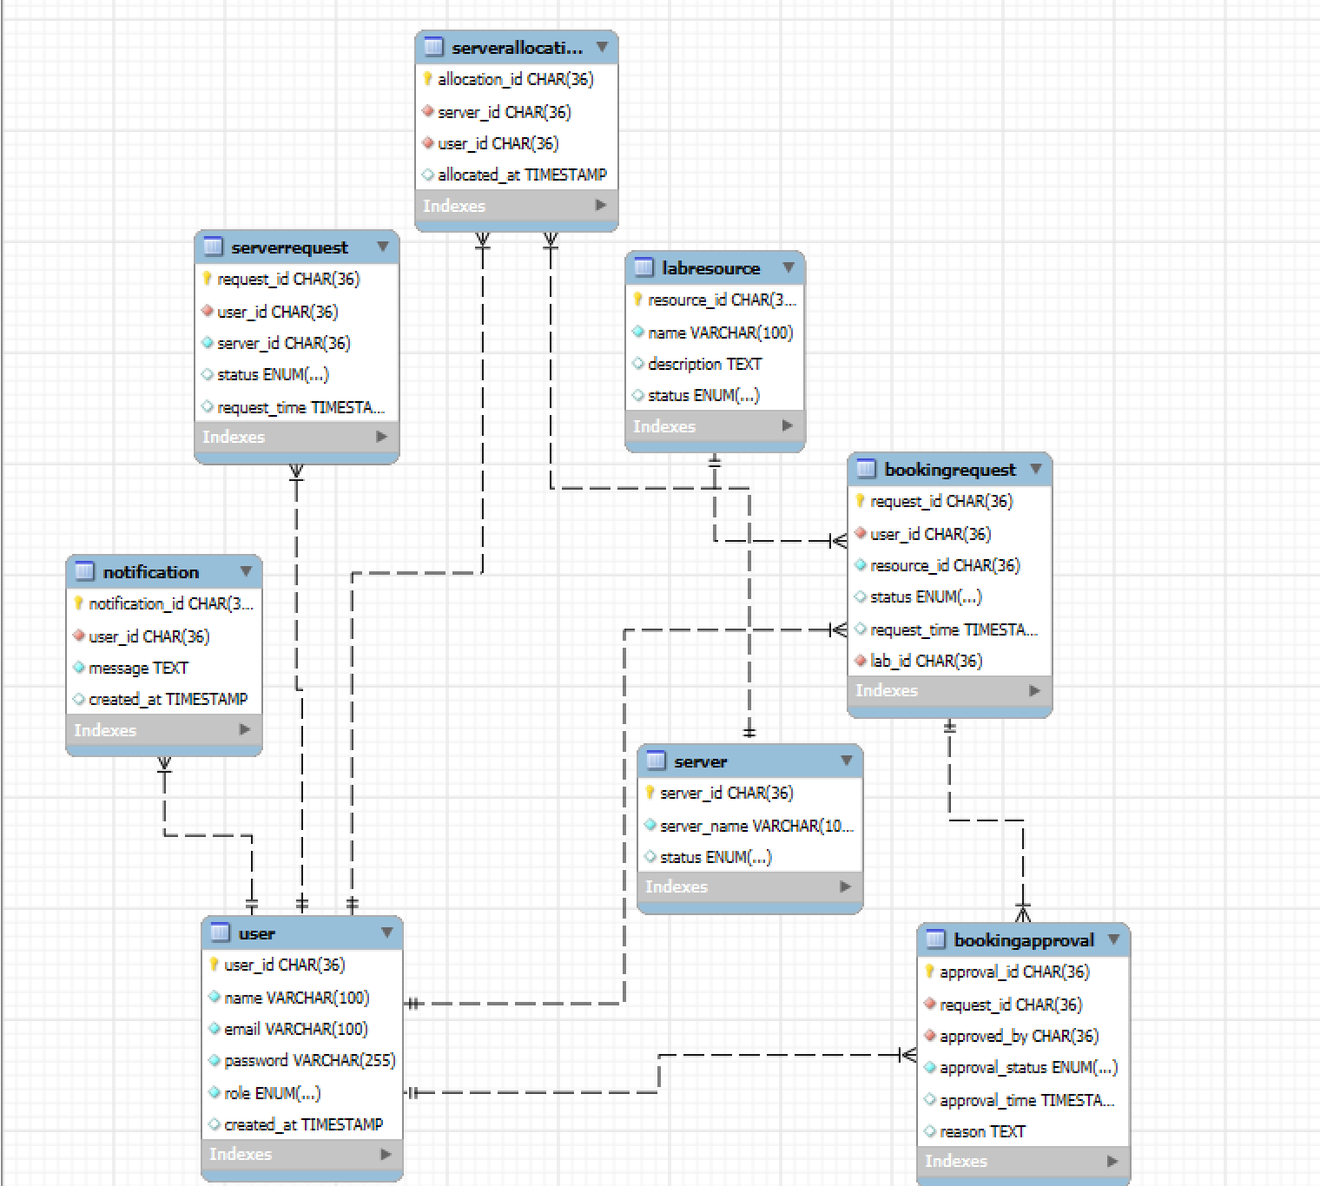

**CLASS DIAGRAM**

