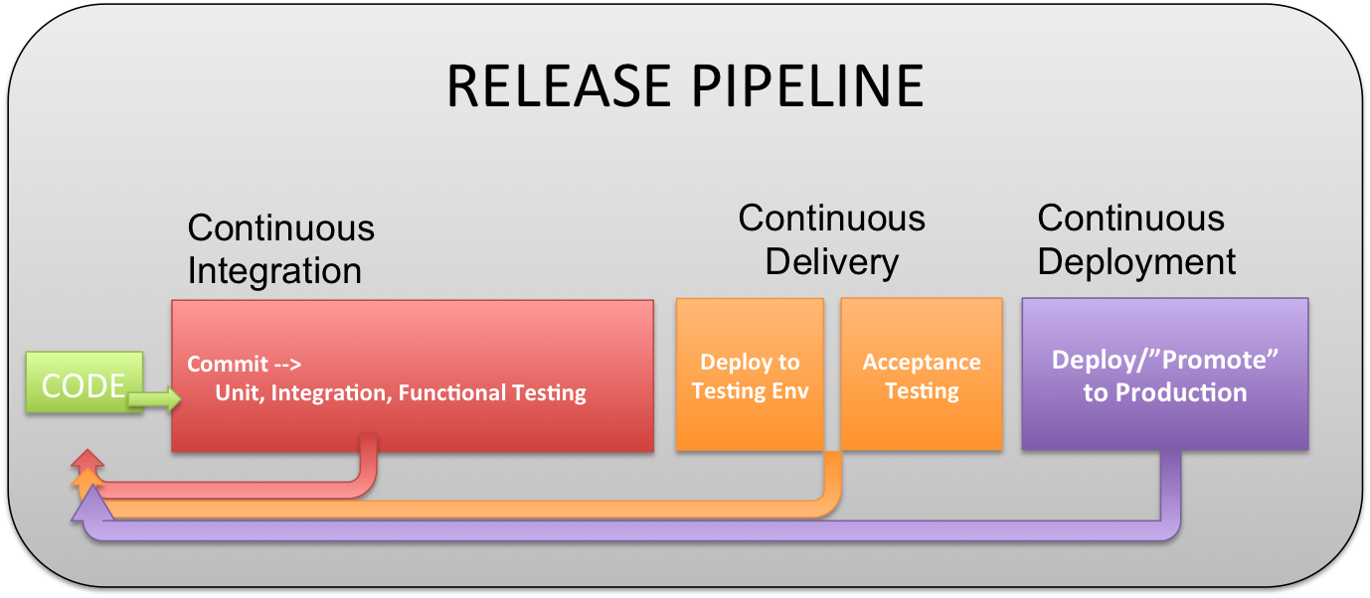

# Continuous Delivery/Continus Deployment Research

#### Justin van de laar

Inhoud

Continuous Delivery/Continus Deployment Research 1

Introduction 3

Introduction 3

Before word 3

Reading Guide 3

Main research question 4

Sub questions 5

What is defined as Continus delivery 5

What is defined as Continus deployment 5

Pro and Cons of Continus delivery 5

Pro and Cons of Continus deployment 5

How do professional software company’s Continus delivery/deployment 5

(What for effect has Continus delivery/deployment on the architecture) 5

# Introduction

## Introduction

## Before word

## Reading Guide

# Main research question

Possible ideas:

1. How does Continus Delivery/Deployment benefits your software project?
2. How does Continus Delivery/Deployment affects the architecture of the project?
3. What do you need to achieve Continus Delivery/Deployment in your project? (Main question)
4. What do you need to implement to achieve Continus Delivery/Deployment in your project?
5. What is better for the project to use? Continus Delivery or Continus deployment.

# Sub questions

## What is defined as Continus delivery

## What is defined as Continus deployment

## Pro and Cons of Continus delivery

## Pro and Cons of Continus deployment

## What do professional software companies to achieve Continus delivery/deployment

## What for effect has Continus delivery/deployment on your software architecture