2019311521 Choyouji

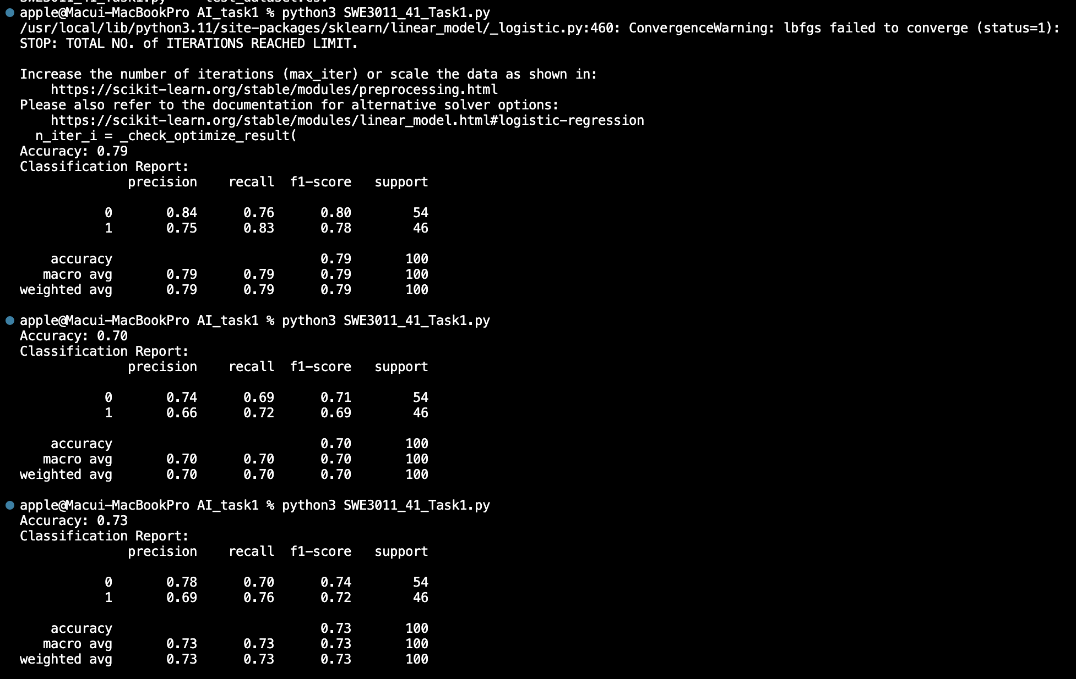

The result of logistic_regression, random_forest, naïve_bayes_classifier in order.