Orgasitional structure

Training and development

Employee engagement

Teamwork and collaboration

Ethics and code of conduct

19/09/2023

Verbs

1. Analyse
2. Estimate
3. Focus
4. Assess
5. Publish
6. Imply
7. Prioritise
8. Assist

Nouns (A/An/The)

1. Analysis, analist
2. Estimation
3. Focus
4. Assessment
5. Publication
6. Implication
7. Priority, Priorization
8. Assistance

Example of newsletter

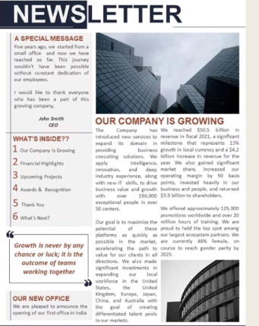

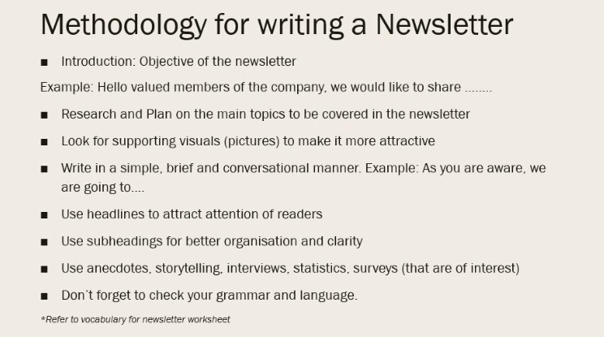

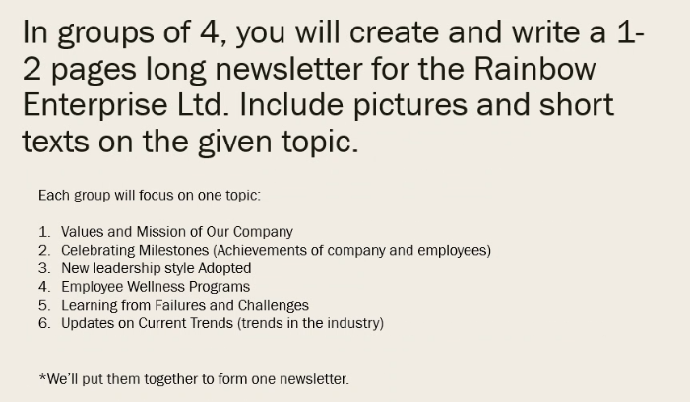

Team 1 : Joice, Jade, Sarobidy, Felaniaina

Team 2 : Manoa, Élisée, Pierre, Angelin

Team 3 : Shanone, Maeva, Loic, Ethan

Air conditionner Company

<https://www.linkedin.com/pulse/2023-2030-air-conditioner-market-trends>

26/09/2023

To bestow: give a reward/an honour/a gift

Coerce: to convince someone forcefully

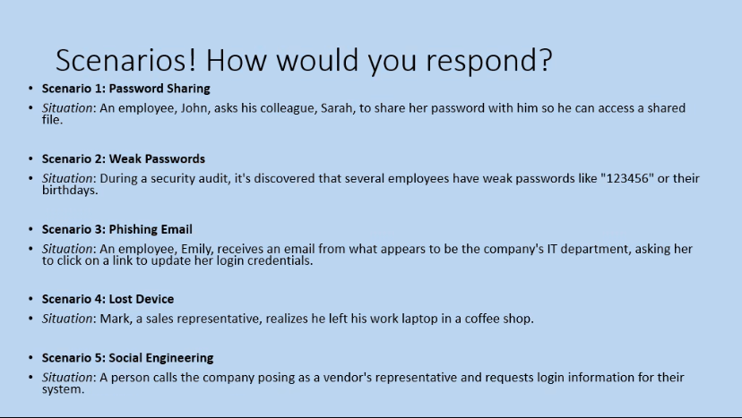

Scenario 3

1. **Contact the IT department directly to confirm whether the email is legitimate.** She can do this by calling the IT department number listed on the company website or by sending an email to a known IT department email address.

**If Emily confirms that the email is legitimate, she can then click on the link to update her login credentials.** However, she should be careful to enter her login credentials on a secure website. She can check the security of the website by looking for the lock icon in the address bar and by making sure the URL starts with "https://".

Scenario 4 :

1. **Immediately contact the coffee shop to let them know that he left his laptop there.** Ask if someone has turned it in or if they can keep an eye out for it.
2. **Report the lost laptop to his IT department.** They can help him to secure his company's data and take any necessary steps to prevent unauthorized access to his laptop.
3. **Change all of his passwords, including his work email password, his password for his password manager, and any other passwords that were stored on his laptop.**
4. **Monitor his credit reports and bank accounts for any suspicious activity.**

If Mark is unable to recover his laptop, he should also consider filing a police report. This will create a record of the theft and may help him to get his laptop back if it is found.

Scenario 1: Sarah need to respond it is against company policy, contact someone from IT department, share the file with a more secure platform from him

Scenario 2: guidance on what is a strong password, training session, implementing a password policy, they need to update their password and change it to make it more secure

Scenario 3 : reported to the it department to identify if it is a phising attempt, don’t click on link and provide personal information

Scenario 4: it department informed, protocole for reporting lost or stolen devices, they can log the device or secure the device remotely

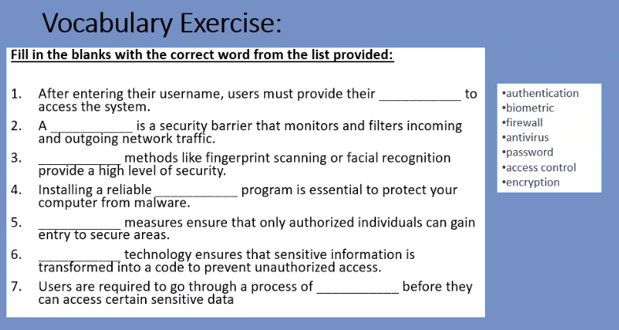

1. Password
2. Firewall
3. Biometric
4. Antivirus
5. Access control
6. Encryption
7. Authentication

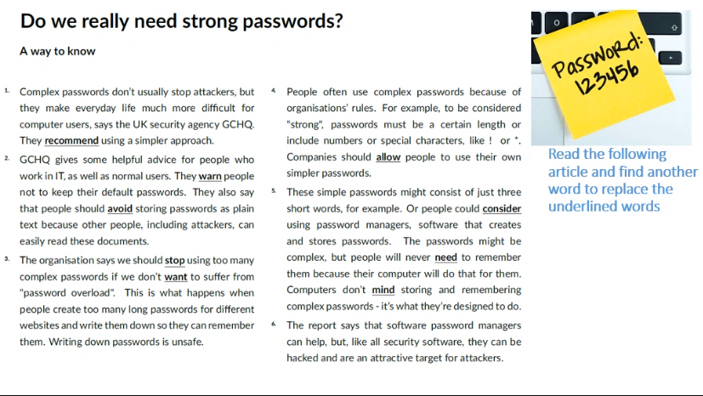

* **recommend:** suggest, advise, (propose)
* **warn:** (alert), caution, (admonish,) notify, advise
* **avoid:** (steer clear of, eschew, shun), refrain from, avert,
* **stop:** cease, discontinue, (halt)
* **want:** (desire), wish (for), (crave), like
* **allow:** permit, let, authorize
* **consider:** think about, think of, contemplate, (ponder)
* **need:** (require,) have to, (must)
* **mind:** care about, (object to, be bothered by), bother

exclamation mark, asterisk

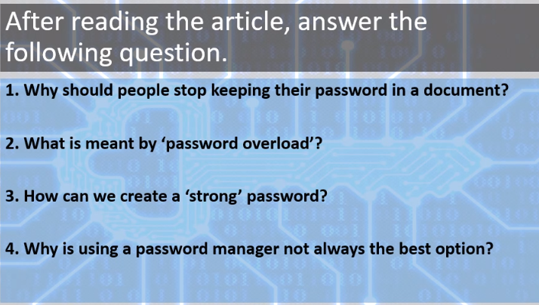

Essay title: should password be change regularly

03/10/2023

1. Other attackers can read those documents
2. Having too many long passwords which can create confusions
3. Certain length, should include special characters and numbers
4. It can still be hack

To what extent do you agree that passwords should be changes regularly?

Introduction

1 sentence: Hook (phrase d’accroche) grabs the attention of the reader (can’t : question, copy the essay question), Interesting fact about the topic, Quote, Contextualisation, background information

Review: introduction writing

Write a short introduction

Remember to: Start with a hook or attention-grabber that introduces the topic. Provide necessary background information. Present your thesis statement.

In today's digital world, people often debate whether we should regularly change our passwords. Some believe it boosts security, while others have doubts. This essay explores this practice and suggests that while it's necessary in some cases, a universal approach might not be the best way to ensure online safety.

* Topic sentence : introduces the main idea (1 main idea but can have sub ideas)
* Reason for the argument
* Elaboration
* Example 🡪 Transition/Linking words

Concluding Line

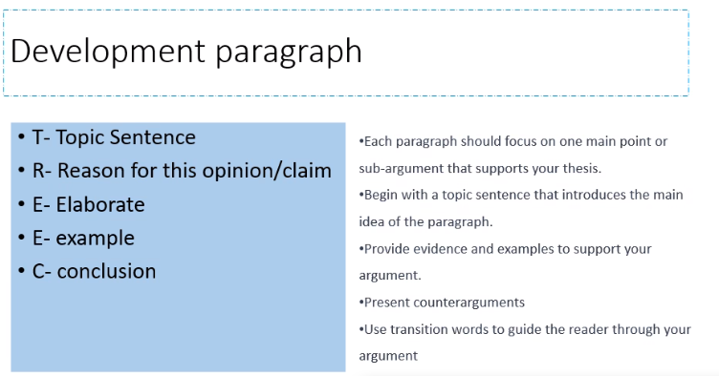

•Each paragraph should focus on one main point or sub-argument that supports your thesis.

•Begin with a topic sentence that introduces the main idea of the paragraph.

•Provide evidence and examples to support your argument.

•Present counterarguments

•Use transition words to guide the reader through your argument

One reason for not changing passwords frequently is that it can lead to less security. When passwords change too often, people might pick ones that are easy to guess, like "12345," which isn't safe. Additionally, individuals could write down their passwords or store them where others can find them, creating risks.

Furthermore, giving too much attention to changing passwords might make us miss other important security threats. Cybercriminals use tricky methods, such as tricking individuals into revealing their passwords, and they don't care if passwords change frequently. It's better to focus on other security measures, such as using more than one way to prove someone's identity during login, keeping software up-to-date, and learning how to stay safe online.

Conclusion:

* Sum up
* State your final opinion/ position (mixed opinion; for)
* Call to action/ An information/ statement that you want others to remember or think about.

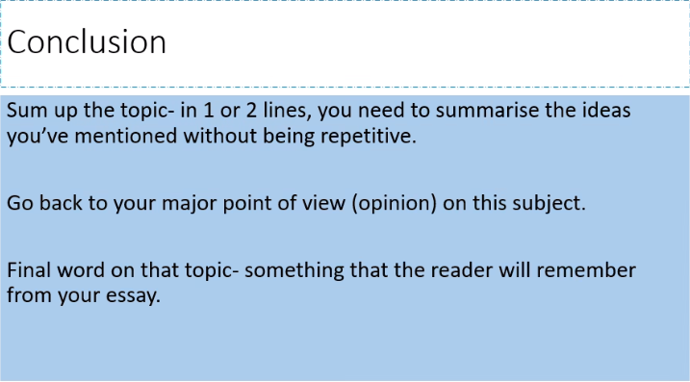

Regularly changing passwords may not always enhance security; it can lead to weaker passwords and distract from addressing more significant online threats like phishing and malware.

To conclude, to sum up: in light of the above, all in all, based on the aforementioned, in a nutshell.

10/10/2023

Word of the week

1. Moving away from the main topic: Digress
2. When you are not good at something: Inept
3. To agree about something: Concur

Report Writing

Find the different Types of report that can be written in the workplace, reasons for writing these different types.

Drawing from your experience, when was a report written during your internship.

Types of report:

* Annual report
* Incident report
* Progress report
* Technical report
* Financial report
* HR report
* Sales report
* Internship Report
* Project Report

Informative, analytical

To keep track, to record

Reference

Types of Business Reports

|  |  |
| --- | --- |
| Informative Reports | Analytical Reports |
| Summarise information and data on a given topic | Conduct Research and Collect data  Offer an analysis of data  Provide recommendations |
| Example: report in allocation of funds for a business trip | Example: Looking for a location to open a new branch/store |

Answer the following questions:

1. According to Vivek, what are the purposes of business reports in his company?
2. As for Jason, what is the most common report written in the company?
3. What is the importance of reports in the business setting? (refer to answers provided in the video)
4. What are the tips given for increased readability in business reports?
5. Purposes of business reports: summarise, weekly updates, visual information, on operations, profits and loss margins and where people are schedule
6. Forecast is the most common (forecast: trying to predict what will happen)
7. Communication of the agenda, transfer of knowledge, different perspectives on subjects, investigation about the process, to keep track of progress (goals have been achieved), convey findings to clients, keep people in the loop (être au courant, keep in form), visual aid for prospective clients
8. Short, concise, simple, clear, nice layout, correct spelling, cover important points, keep it factual, and know your audience.

Business report writing worksheet

1. Introduction D
2. Findings A, C
3. Conclusions E
4. Recommendations B

Expenditure (dépenses)

Structure:

1. Introduction/Background information
2. Presentation of synthesised facts and findings/Reasons
3. Recommendations/Proposed solutions/Actions/Measures
4. Conclusion/Brief summary of report

Appendices (annexes)

Act 2

The aim of this report is assess ways in which

Certainly, here are some useful expressions to complete your list:

1. **The purpose of the report (the purpose of the report is to look at):**

- The primary objective of this report is to examine...

- This report has been prepared with the aim of analyzing...

- Our main focus in this report is to investigate...

2. **Who asked for the report (it was commissioned by):**

- This report was commissioned by [Name of the organization/person] to...

- The request for this report came from [Name of the requesting party] who sought to...

- [Name of the requesting party] tasked us with preparing this report to...

3. **Concluding (In conclusion, this report notes that ...):**

- To sum up, it is evident from this report that...

- In summary, the findings of this report indicate that...

- In closing, this report highlights that...

4. **Making recommendations:**

- Based on the analysis conducted, we recommend that...

- It is our suggestion that [specific action] be taken in light of these findings.

- In light of these findings, we propose the following actions be taken:

Feel free to incorporate these expressions into your report to enhance its clarity and coherence.

1. This report seeks to evaluate/in form/assess ….

Our main focus in this report is to …

The primary objective is to…

This report aims to investigate/examine/compare/describe/evaluate

1. The request for this report was from …

Upon the request of …

This report was effected mainly owing to …

1. All in all,

In light of the above, it can be concluded

1. The following suggestion can be made

The subsequent actions/ set of actions can be taken

Presenting problems:

* the first issue is that
* The main shortcoming (disadvantage, limitation)
* A further limitation is

When you are referring to a research:

* It was found that
* Customers have completed a feedback form on
* Comments from the staff or clients have shown a need for
* The survey has revealed that …

Moving from one idea to another:

* With regard to
* In spite of (en dépit de)
* In contrast
* Moving on to
* Subsequently
* Consequently
* As a result
* For that reason

This is mainly because

Giving suggestions:

* In order to respond to these problems, the company should…
* We should start to consider how best we can introduce or implement a new set of actions for further improvement

17/10/2023

Reporting verbs: Observed, proposed, look into, regarded as, conducted, claimed, stated, share, recommend, consider, describe, show, maintain, suggest, highlight, define, outline, identify, address,

Write a report based on the details given in the worksheet on the following topic: unpaid overtime and possible solutions for the employees (200-300 words)

24/10/2023

1. D__r__t 🡪 stop something

Disrupt

1. D___s_ 🡪 To invent/create

Devise

Oral paper:

* 3 sections 🡪 Theme
  + An article
  + Audio/Video 🡪 not more than 3 mins
  + Picture/Screenshot
* 20 minutes of preparation
* 5 minutes of presentation
* 5 minutes of questioning(Questions on presentations)
* Mise en situation (Problem to solve) 10 minutes

**Oral simulation new user onboarding**

Author: Anssi Junnonen in 2016 in a website www.

Main theme of the article

Main ideas of the article

Summarise in your own words

Offer an analysis of the article

Same process of the article

07/11/2023

2 types of mindset: growth mindset and fixed mindset

14/11/2023

Resilient

|  |  |
| --- | --- |
| Fixed mindset | Growth mindset |
| I can’t do this |  |
| I give up | I continue to do this until I’m successful, I will try a different approach, I can learn anything if I try different ways to do this |
| My work isn’t good enough | I can improve my work, I can do better |
| This is too hard | This is challenging |
| My friend is better at this than me | I can learn from him/her |
| I’m not good at this | I can certainly improve with effort and practice, if I practice I can get better at this |
| I’m brilliant at this | I can try something else, I need to move on and do certain things, I can help overs to grow, |
| My work is fine as it is | Let me get the feedback of someone else, |
| This isn’t my strength | Yet, I can focus on my existing strength |
| I don’t understand it | I will seek help and learn |
| He’s smarter than me | I can be inspired by him/her |
| She finds it easier than I do | I can do It along with her, we can do it together |

Oral

28th november: Kim, Joïce, Fitia, Elisée, Andi, Manoa

5th December: Shanone, Felaniaina, Loïc, Kevin,

# Presentation of Documents: ORAL SIMULATION PRACTICE on cyberwarfare

**FILL IN THE GAPS IN YOUR OWN WORDS**

**Introduction:**

Goodmorning Sir or Madam, today I will delve into the main theme of this paper which is **the implication of cyber threats (attack) on global security.** I will draw from two key information sources: a detailed extract of article on Russian cyber attacks which was published by **theconversation.com** on the 1st of March 2022 and written by **Justin Pelletier** and a thought-provoking video by NATO entitled **How could cyber-attacks affect you** I will then describe **the screenshot of the research on finding** to know what is the biggest threat to the United States. Let's navigate this landscape together to better comprehend this issue.

Let's begin with the extract of the article titled "Cyber Warfare," we learn about **various techniques used in cyber warfare**,(diverse types/forms of cyber-attacks), including denial of service, data theft, and system control. Focusing on the Russian cyberattacks on Ukraine, these assaults targeted **government and telecommunications facilities in Ukraine**, employing a powerful new malware. Preceding the military invasion, Ukraine endured weeks of cyber warfare, featuring a fake **ransomware note** and the destruction of personal **data** —a tactic employed as part of a multi-year campaign. Drawing from this article, I think that it shows how crucial **cybersecurity and defense against cyberattacks are for national security (to prevent such cyberattacks, it is ti implement cybersecurity measures to prevent such cyberattacks** or else it could lead to a third World war.

Now, shifting to NATO's perspective, the video provides **an overview of cyberattacks/cyberwarfare informations (provide a concise overview of cyberwarfare in the world).** It underscores (highlight) the real-time nature of information, emphasizing how cyberattacks possess the capacity to disrupt **critical infrastructures such as hospitals, networks, transports and expose personal data** Furthermore, NATO draws attention to its own defense capabilities. In response to these evolving threats, NATO is actively **cooperating/ raising awareness** among allies, leveraging cutting-edge technology, and collaborating with partners to **provide training and education on cyberwarfare mitigation/destruction (éliminer)** I think that NATO is taking the required initiatives as we have seen in Document 1, the prevention and mitigation of cyberwarfare is important if we want to protect collective peace, global economy and security.

In connection with these two previous documents, the picture seems to demonstrate **the responses/the perspectives/opinions of a group of 200 participants** on what could be the greatest threat to the United States and it’s interests. According to 45.1% of participants, **cyberwarfare** would be the greatest threat followed by 26.1% of participants who declared that terrorism would be the greatest threat.

I would agree/disagree with the majority because………………................................

**Based on these two impactful documents and the screen capture,** the gravity of cyber threats on both national and global security cannot be overstated. The interconnectedness of these challenges demands proactive measures, **international collaborations** and continuous education. We must be **aware/careful/vigilant** and resilient in the face of evolving cyber adversaries. The collaboration between nations and organizations is **essential/paramount for a secure** digital future.

At this point, I invite any questions or thoughts you may have.