ESCUELA SECUNDARIA TÉCNICA 101

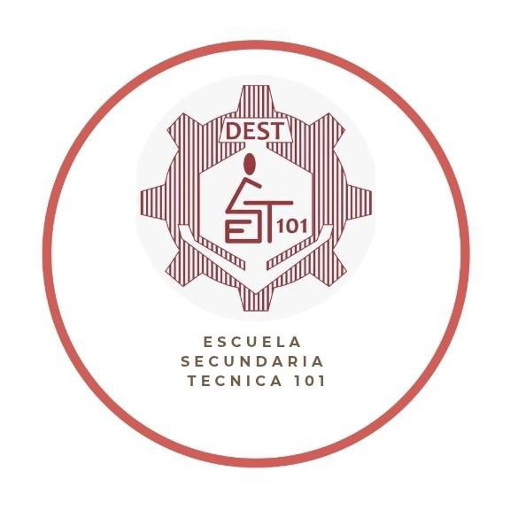
CUADERNO DE TRABAJO
Por la Superación de México, México, México.

I N G L E S
I I I

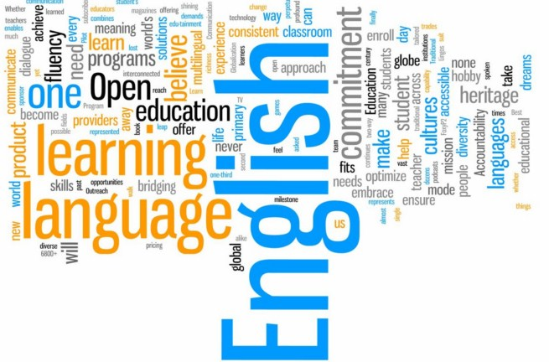

ACTIVIDADES
Actividad 1: . Verbo 'To Be'
PDA: Construye oraciones cortas afirmativas, negativas e interrogativas utilizando la conjugación correcta del verbo 'to be' en tiempo presente y pasado, enfocándose en descripciones personales o estados simples.
Complete the sentences with the correct form of the verb 'to be' in present or past tense. Use affirmative, negative or interrogative forms.
a) He _____ at school yesterday.
b) _____ they your classmates?
c) I _____ not ready today.
d) She _____ very tired last night.
e) _____ you happy now?
2. Fill in the blanks with the correct form of the verb in the present simple.
a) My brother _____ (play) soccer on weekends.
b) They _____ (not watch) TV in the morning.
c) _____ your friend live in Arandas?
d) I always _____ (eat) cereal for breakfast.
e) We _____ (not go) to the same school.
3. Use the present continuous to complete the sentences.
a) She _____ (read) a book now.
b) They _____ (not study) at the moment.
c) _____ you listening to music?
d) My friends _____ (play) basketball.
e) I _____ (write) my homework.
4. Write the sentences using the past simple tense.
a) He _____ (visit) his grandma last Sunday.
b) We _____ (not go) to the cinema.
c) _____ she call you yesterday?
d) I _____ (have) a good day.
e) They _____ (not arrive) on time.
5. Complete the sentences with the past continuous tense.
a) I _____ (watch) TV when you called.
b) What _____ you _____ (do) at 7pm?
c) She _____ (not sleep) at 10pm.
d) They _____ (walk) in the park.
e) He _____ (not study) when I saw him.

Actividad 2: Future Simple (Simple)
PDA: Aplica correctamente el auxiliar will o la forma going to para completar frases sencillas que expresan planes futuros inmediatos o predicciones.
Fill in the blanks with the correct form of the verb in future simple.
a) I _____ (call) you later.
b) They _____ (not come) to the party.
c) _____ you help me?
d) She _____ (travel) to Canada.
e) We _____ (not forget) your birthday.

Actividad 3: Future Continuous
PDA: Distingue y utiliza la estructura del "Future Continuous" para describir una acción que estará sucediendo en un momento específico del futuro (ej., I will be traveling).
Complete the sentences with the future continuous tense.
a) This time tomorrow, I _____ (fly) to Mexico.
b) He _____ (not work) at 10pm.
c) _____ they _____ (study) at noon?
d) We _____ (stay) at a hotel.
e) You _____ (not wait) long.
8. Use 'would' to complete the sentences.
a) I _____ like some tea.
b) She _____ (not go) if it rains.
c) _____ you help me?
d) They _____ love to visit Paris.
e) He _____ (not eat) that.
9. Complete the sentences using present perfect.
a) I _____ (finish) my homework.
b) _____ you ever visited Guanajuato?
c) She _____ (not see) that movie.
d) We _____ (live) here for five years.
e) They _____ (not eat) lunch yet.
10. Write the sentences in past perfect tense.
a) He _____ (leave) before I arrived.
b) I _____ (not study) for the test.
c) _____ you already eaten?
d) They _____ (finish) the game.
e) She _____ (not call) me.

