**Creating A Responsive Mobile First Web Page**

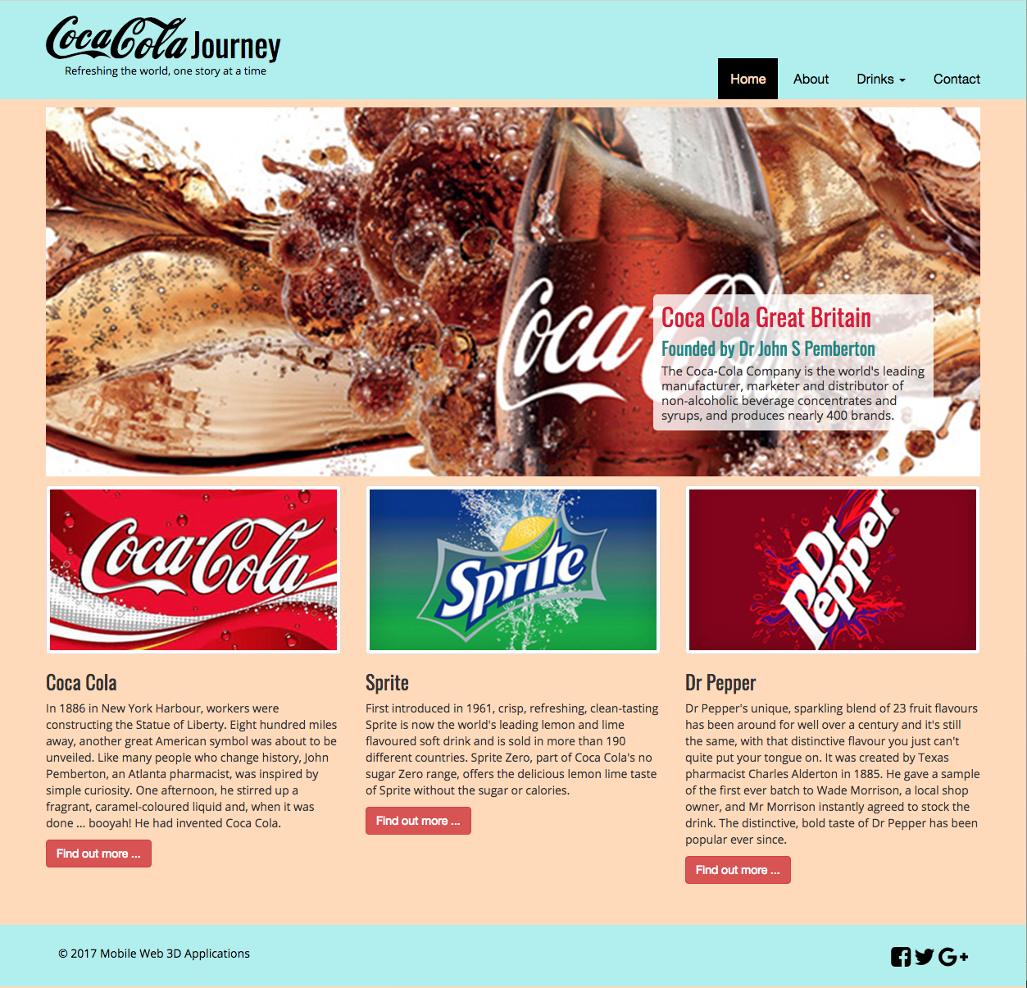

Things left to do:

* You should also try out the container class, see Figure 20. You will need to add a div block after the header navbar to scope the logo and navigation menu and add the .container class. For the main contents and footer, you only need to change container-fluid to container.
* As the comp in Figure 3 looks like it is calling for the .container class, I’ll leave it like this for now.
* You should use Photoshop CC to scale them up to something like 400x224 resolution.
* Further, edit the text in the 3 images to get roughly equal sized blocks.
* Add these links to your index.html file now. Remember the video on the two ways to [import new fonts into your website](https://www.youtube.com/watch?v=Hwq_Mr12bcI). Use the Google fonts or Da Font site to download the Open San and Oswald fonts and install them in the same way as the Coca Cola fonts. If you use your download versions you will needs to declare three @face-font{} rule at the top of your custom.css file.

@media breakpoints

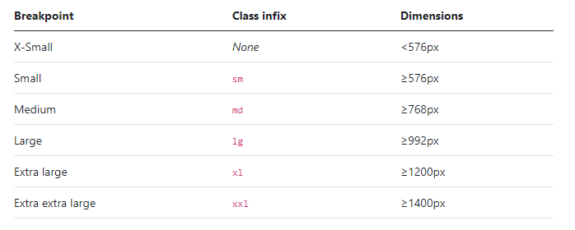

The CSS rules are largely done for the main contents for the mobile, i.e. the smallest screen size. However, currently we are defaulting to the Bootstrap .card class for the mobile, which is 16 px, maybe a bit large, so consider adjusting to 12 or 13 px. However, remember these values propagate up, so they will need adjusting for each of the larger screen sizes later. We can now move on to either create the CSS rules for styling the header and footer or modify these rules for the tablet and desktop main contents. Let’s move on to styling the header, then the footer, and then modify the whole lot for the tablet and desktop.

That is somewhat different from the temporary logo we had before. Not perfect, we haven’t attempted the Trade Mark ™, for example, and the curl running under the Coca is below the line of the text. Also, we have defaults to whatever Bootstrap font is for the ‘Journey’ and ‘Refreshing …’ However, you get the picture, you can develop it some more.

Again, you can look up what each CSS rule does, some you can eliminate in a final tidy up because they are there just to visualise the block element as they style, e.g. border-style solid and border-color yellow with border-width 1px will produce nothing unless you actually add a border-width greater than 0px.

It is important to understand that in Bootstrap the .navbar-toggler-icon uses an image, but this image can change color by simply changing the: stroke='rgba(255, 255, 255, 1.0), color. Similarly, you can change the width of the stroke: stroke-width='2', I have just set this to 4. IMHO, I think this Bootstrap 4 method for creating a hamburger menu button is a retrograde step from the Bootstrap 3 method using the .icon-bar class. But, there you go, might look around for a better method.

Tip, you will need to create a range of main_3D.jpg image resolutions to scale the background main_3D div tag with for all media screen breakpoints. For example, you could prepare, in Photoshop, main_3D.jpg images for x res 290, 400, 538, 768, 970, and 1400. You might like to prepare your main_3D.jpg images for the actual Bootstrap media breakpoints.

To be clear, you will need a main_3D.jpg image that will look ok on screens less than 576 px, one for between 576 px and 768 px, and so on. This should allow for smooth scaling between a mobile retina display and a large high res desktop. Tip, you can also choose the most appropriate main_3D.jpg image as you visualise the screen breaks point when you scale the browser up and down.