COIT11238 – TCP/IP Principals and Protocals

Term 1, 2026

Week 2

Name: Elish Niraula
ID: 12313870
Lecturer / Tutor: Suresh Talam

Task 1: Setting Static IP Addresses
This task demonstrates three methods of assigning static IP addresses on Linux hosts using GNS3.

Network Topology
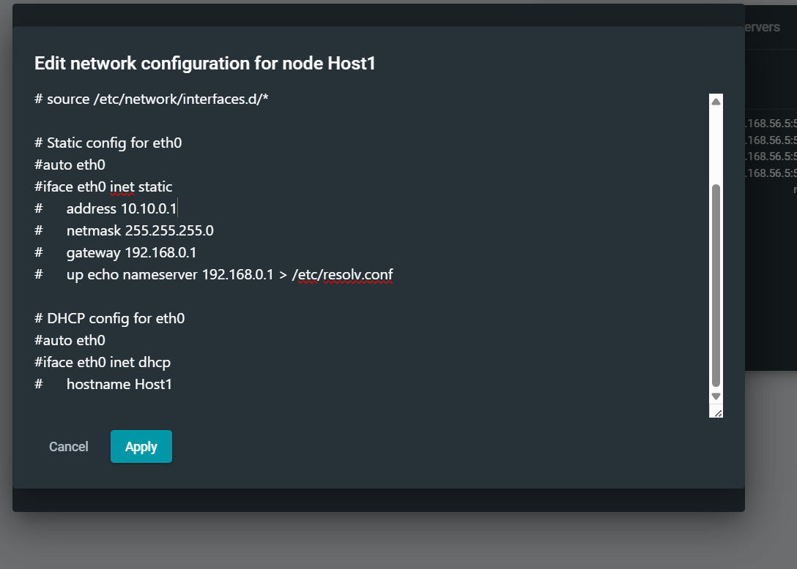
Figure 1: Network topology with 4 hosts and 1 switch.

Host Configuration (GNS3 GUI)

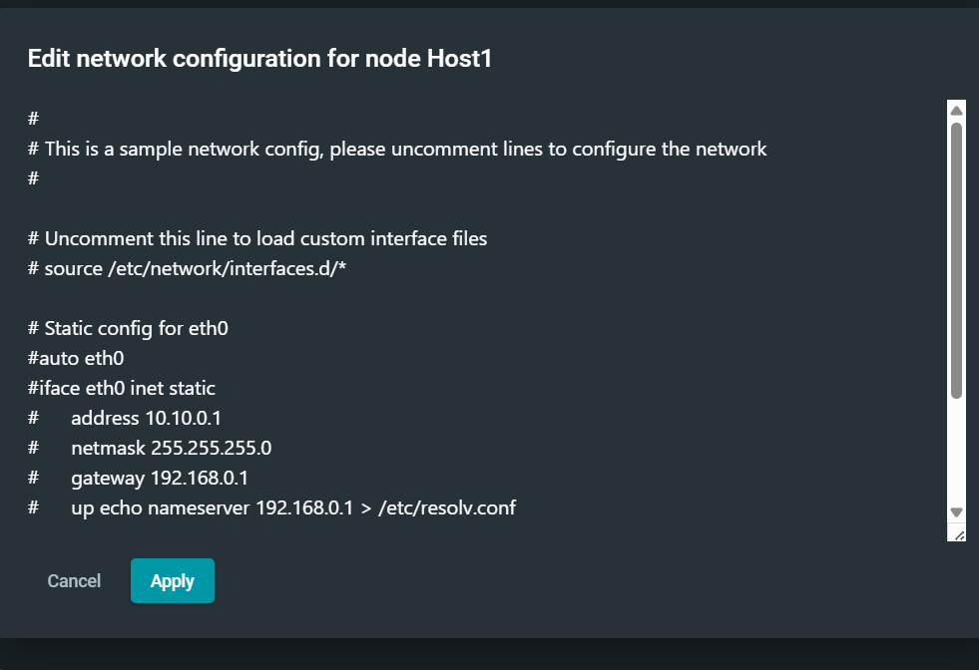
Figure 2: Static IP configuration for Host1 and Host2.

Manual Configuration using /etc/network/interfaces
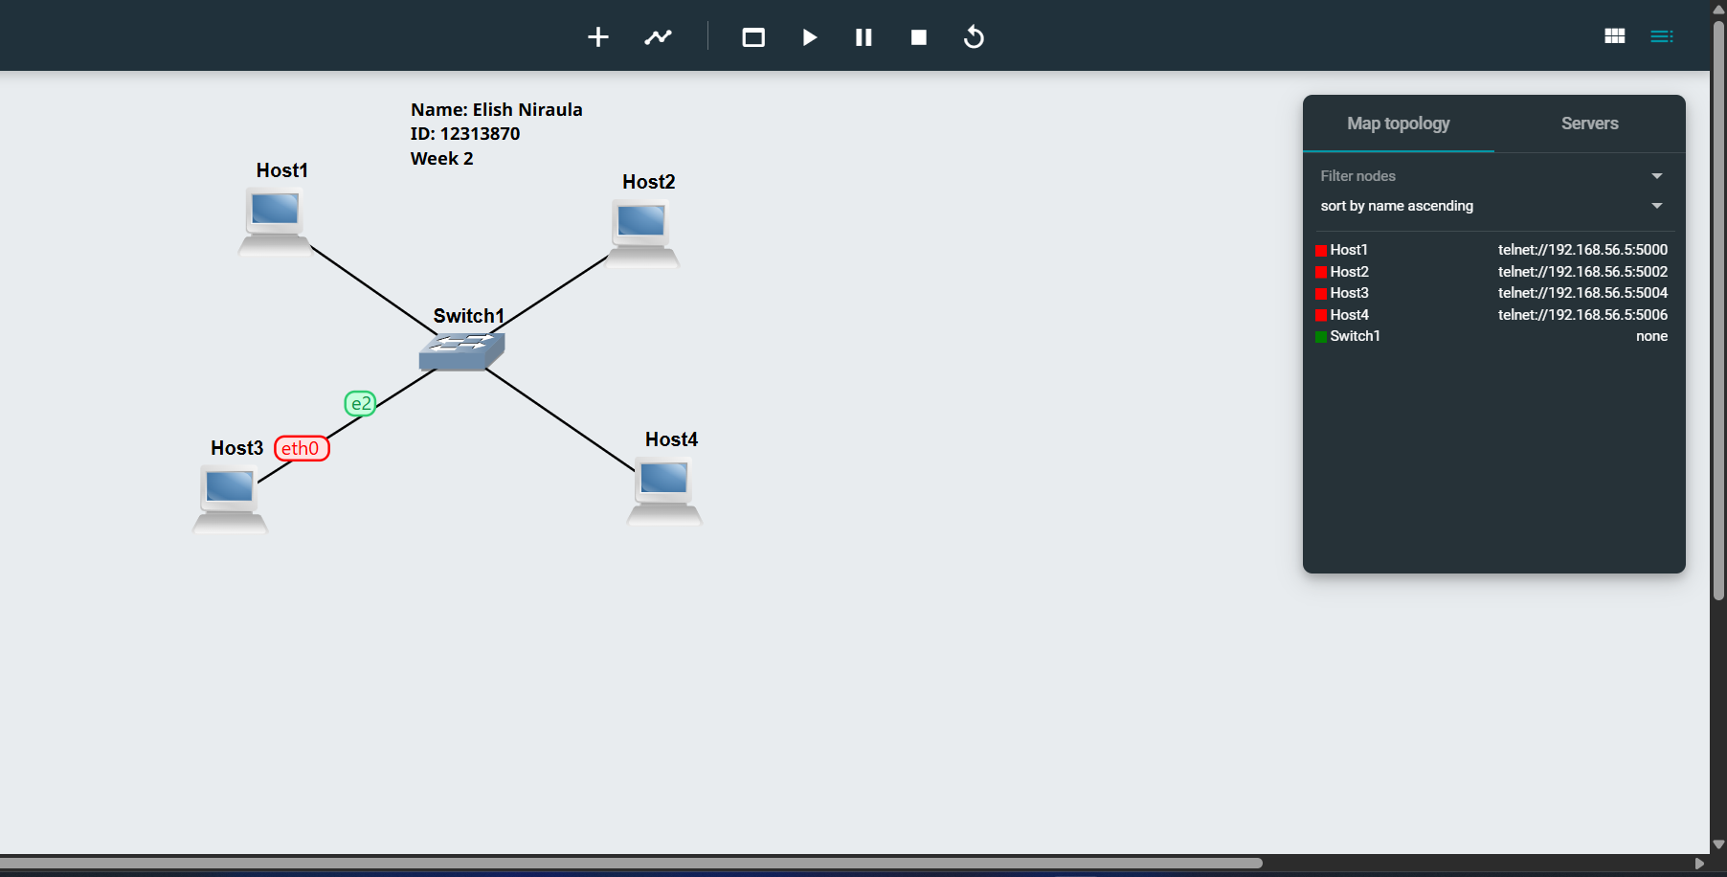
Figure 3: Editing network interface file.

Verification of IP Addresses
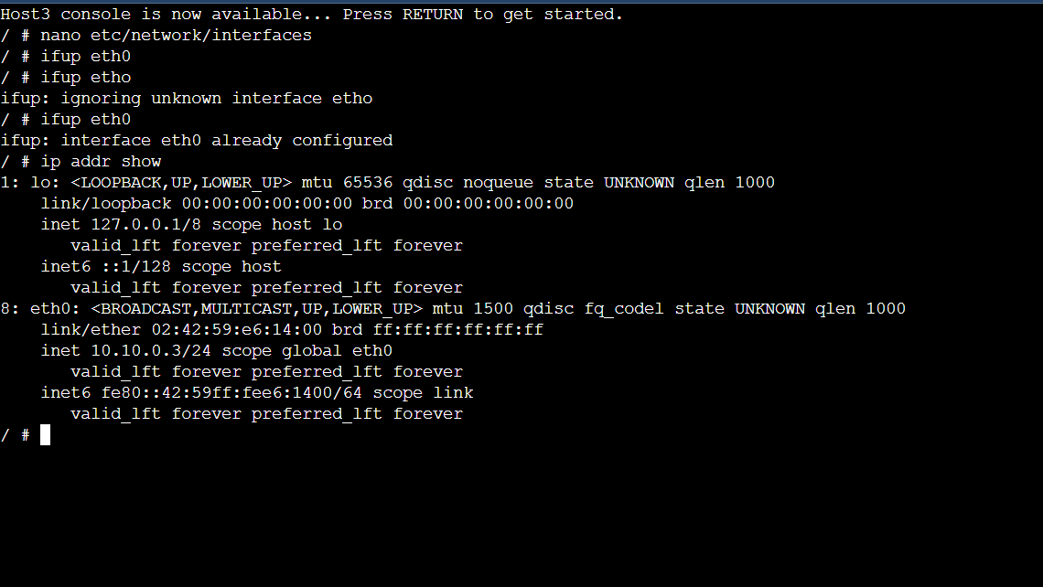
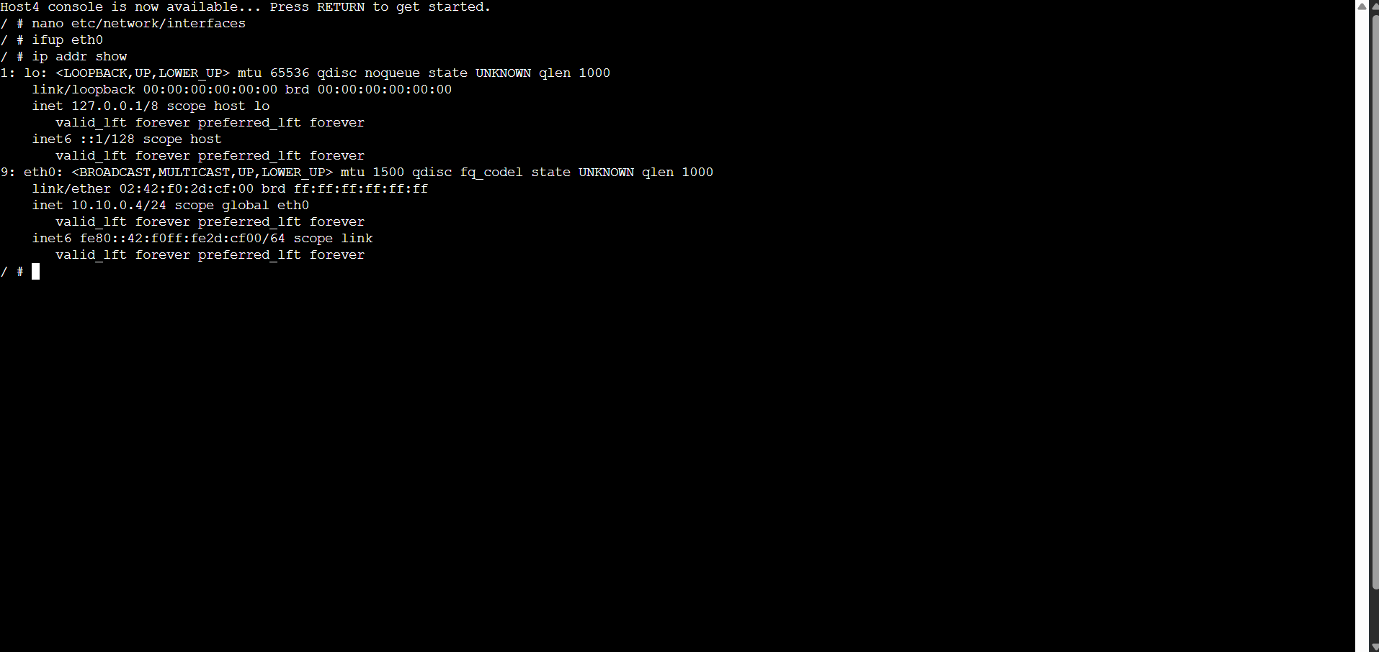
Figure 4: IP address verification using ip addr show.

Task 2: Testing Network Connectivity with Ping

Successful Ping Test
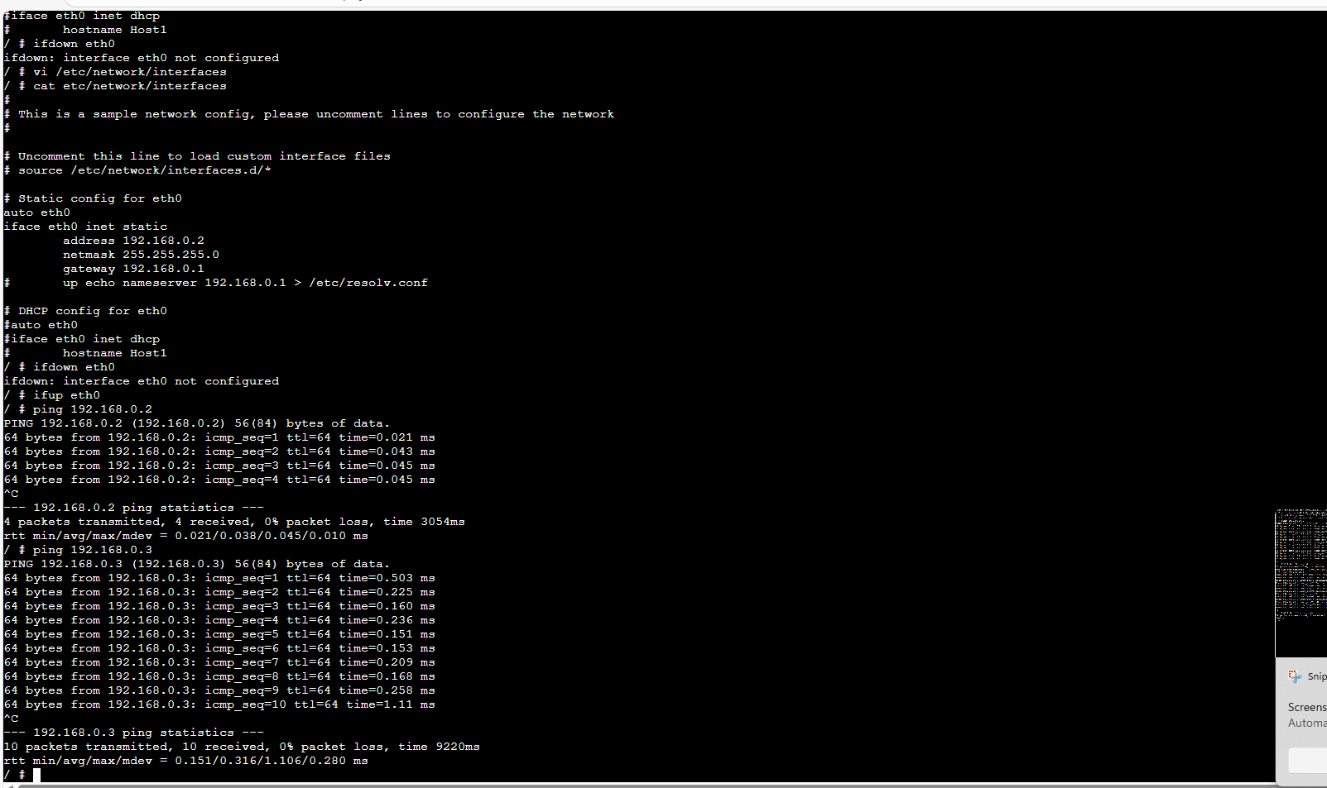
Figure 5: Successful ping showing connectivity and RTT.

Ping to Invalid Host
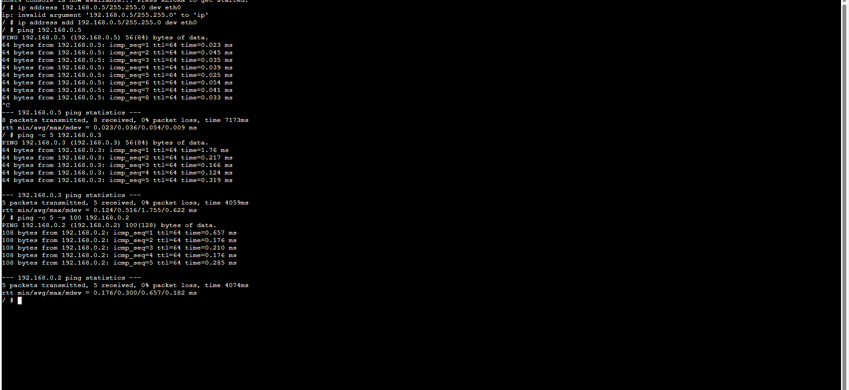
Figure 6: Ping failure showing destination unreachable.

Ping with Options
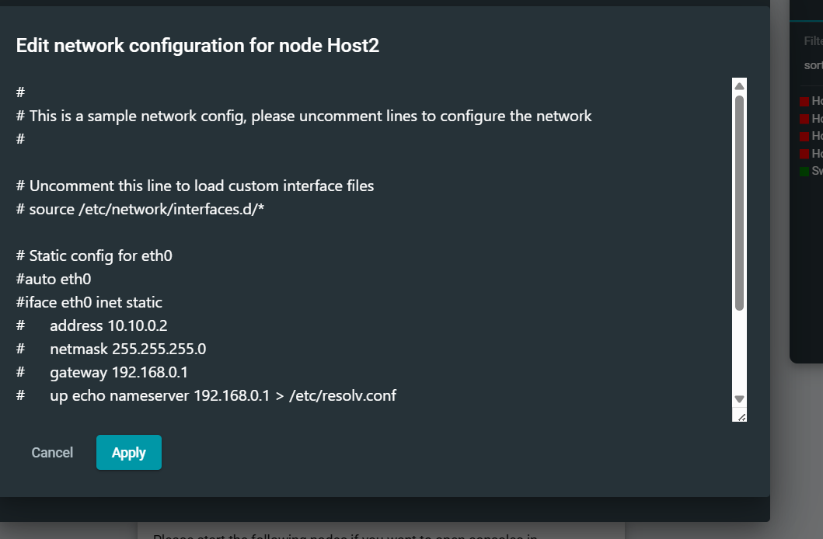
Figure 7: Ping using options (-c, -s) to modify behavior.

Conclusion
This lab demonstrated static IP configuration using different methods and tested connectivity using ping. The results confirmed correct network setup and communication between hosts.

