COIT12206 Week 5 Tutorial - VLAN Configuration Report

Student Details
Name: Elish Niraula
ID: 12313870
Week: 5

Task 1: VLAN Setup on Switch
In Task 1, four Linux hosts and one Open vSwitch were configured in GNS3.
All hosts were assigned IP addresses in the same subnet:
Host1: 10.10.1.101
Host2: 10.10.1.102
Host3: 10.10.1.103
Host4: 10.10.1.104
Connectivity test using ping showed successful communication between all hosts.
VLAN Configuration:
Based on the student ID (870), VLAN IDs used:
VLAN 870 → Host1 & Host2
VLAN 900 → Host3 & Host4
Switch configuration commands:
ovs-vsctl set port eth1 tag=870
ovs-vsctl set port eth2 tag=870
ovs-vsctl set port eth3 tag=900
ovs-vsctl set port eth4 tag=900
After VLAN configuration, hosts in different VLANs were isolated and could not communicate.
Screenshots of done task 1:
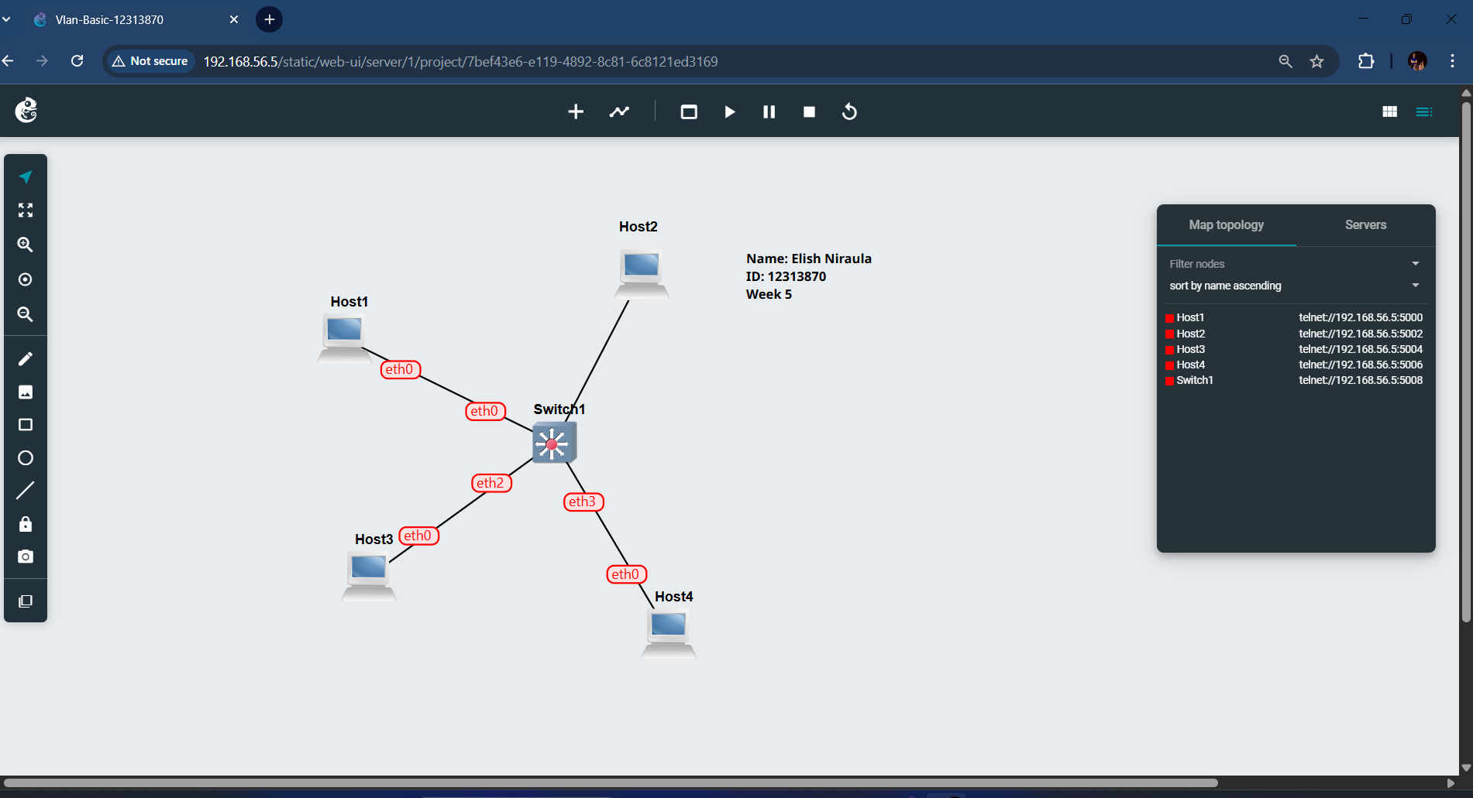

Connectivity of the host and switch.

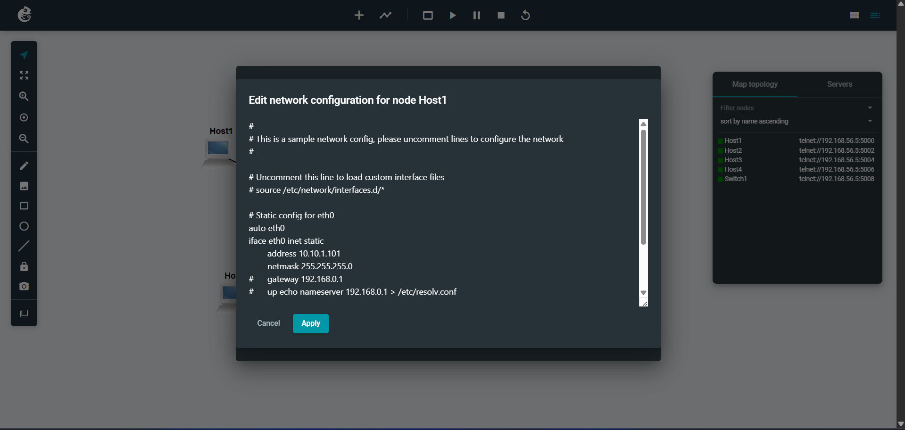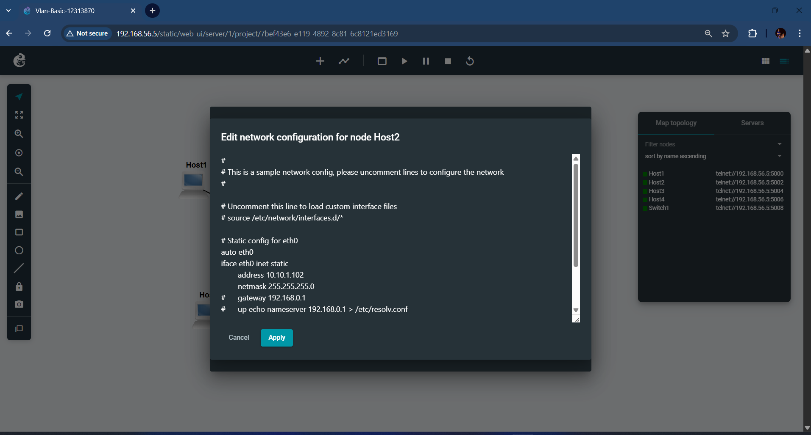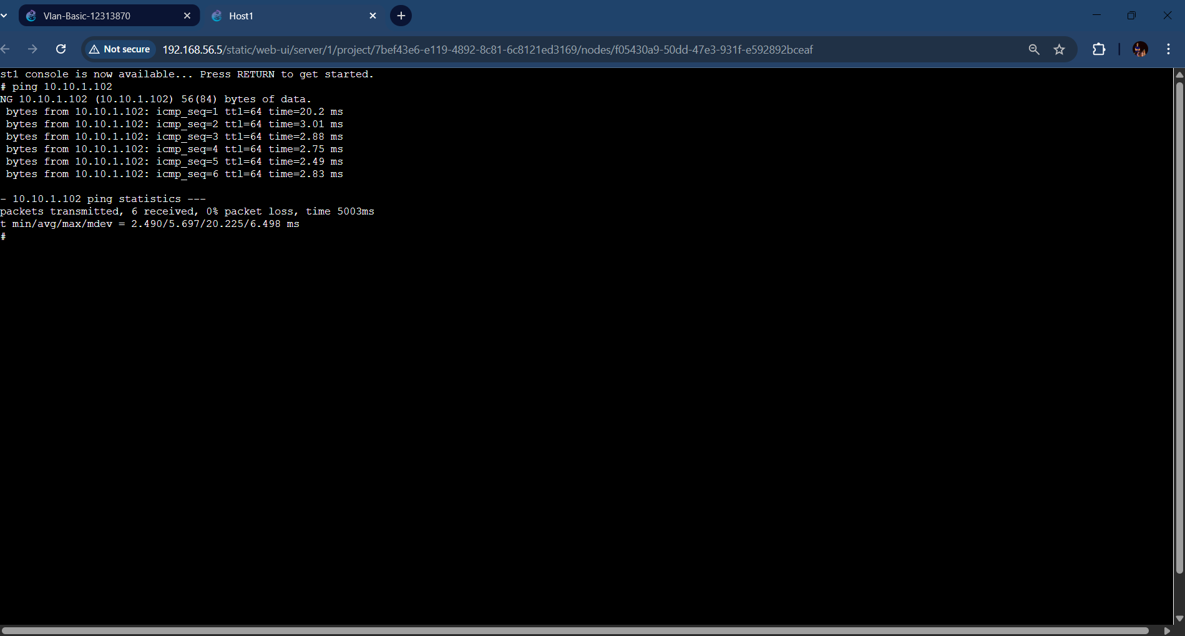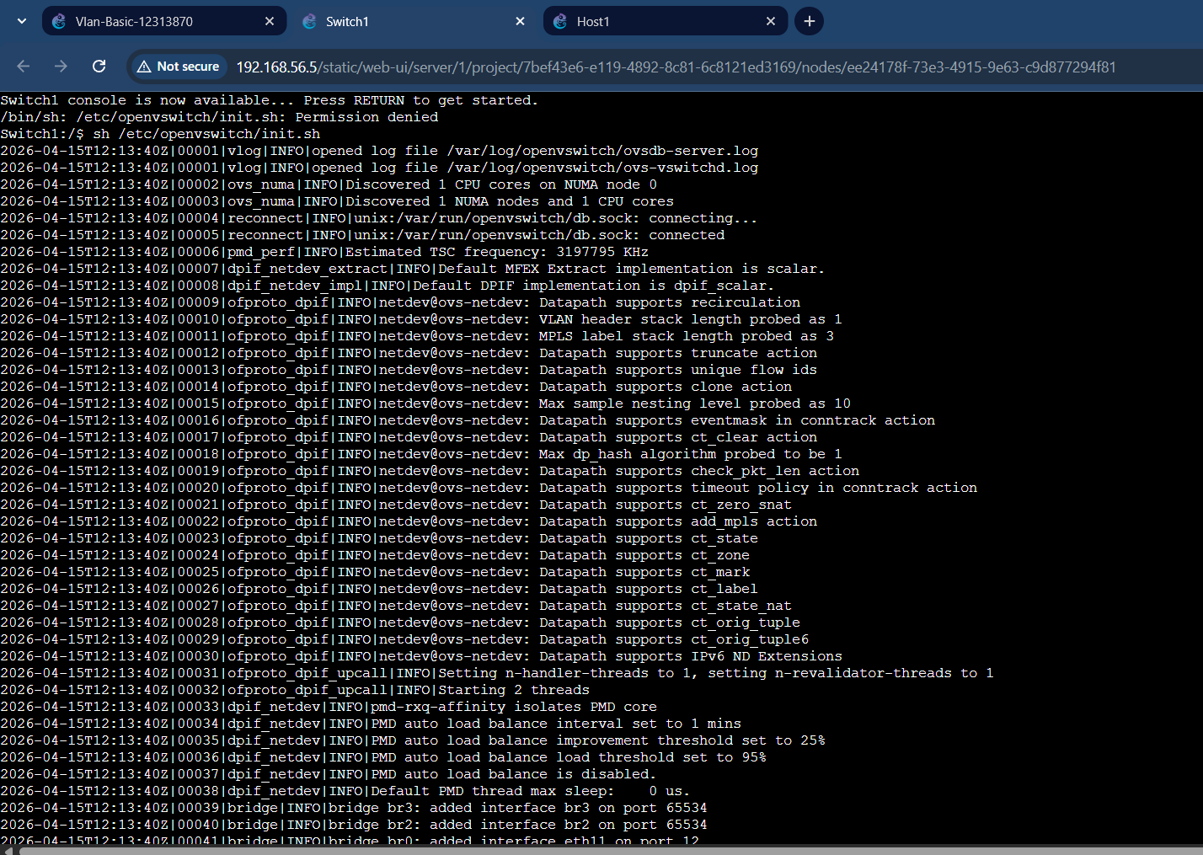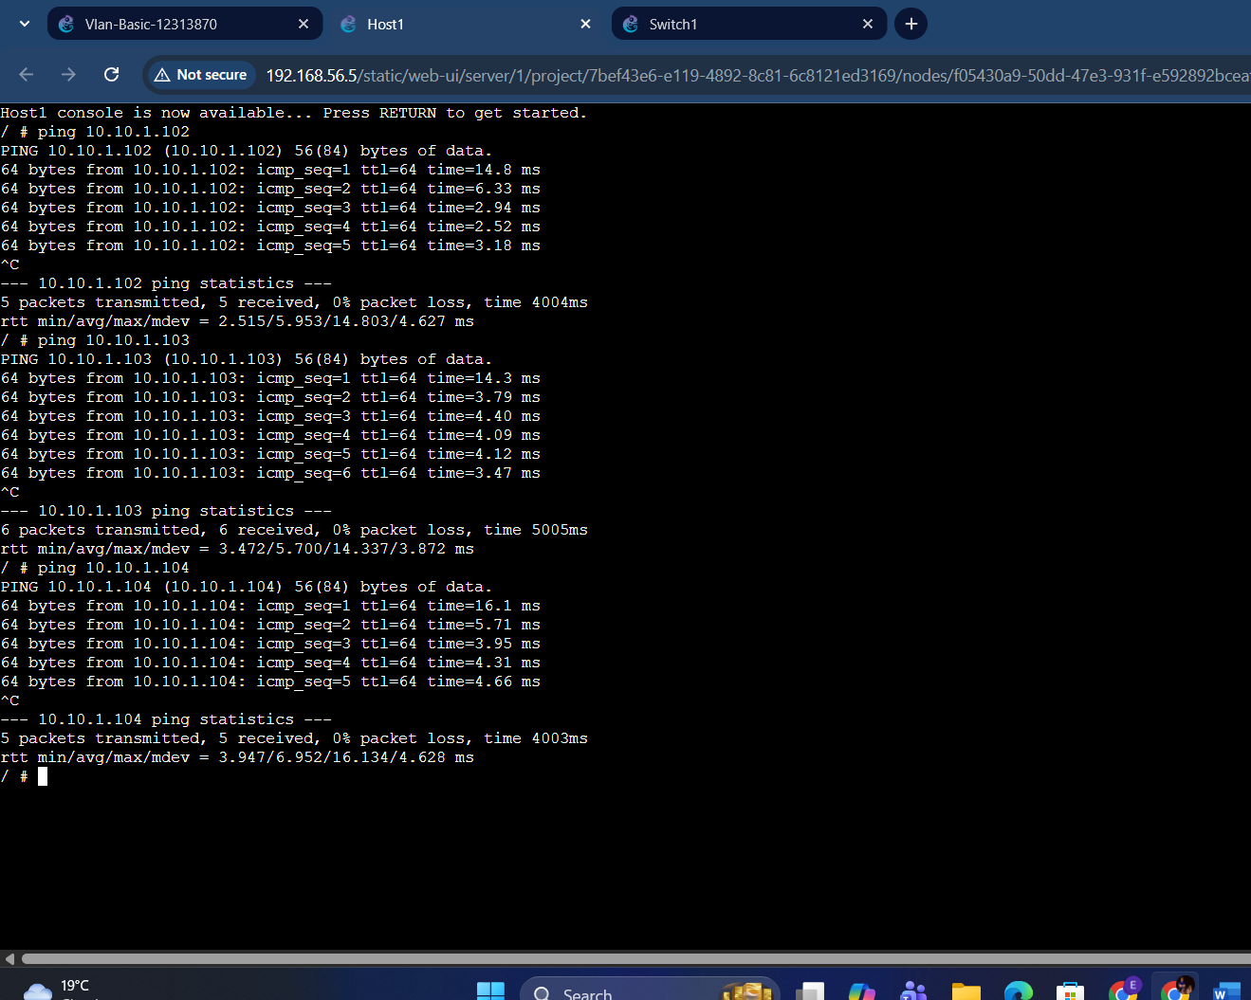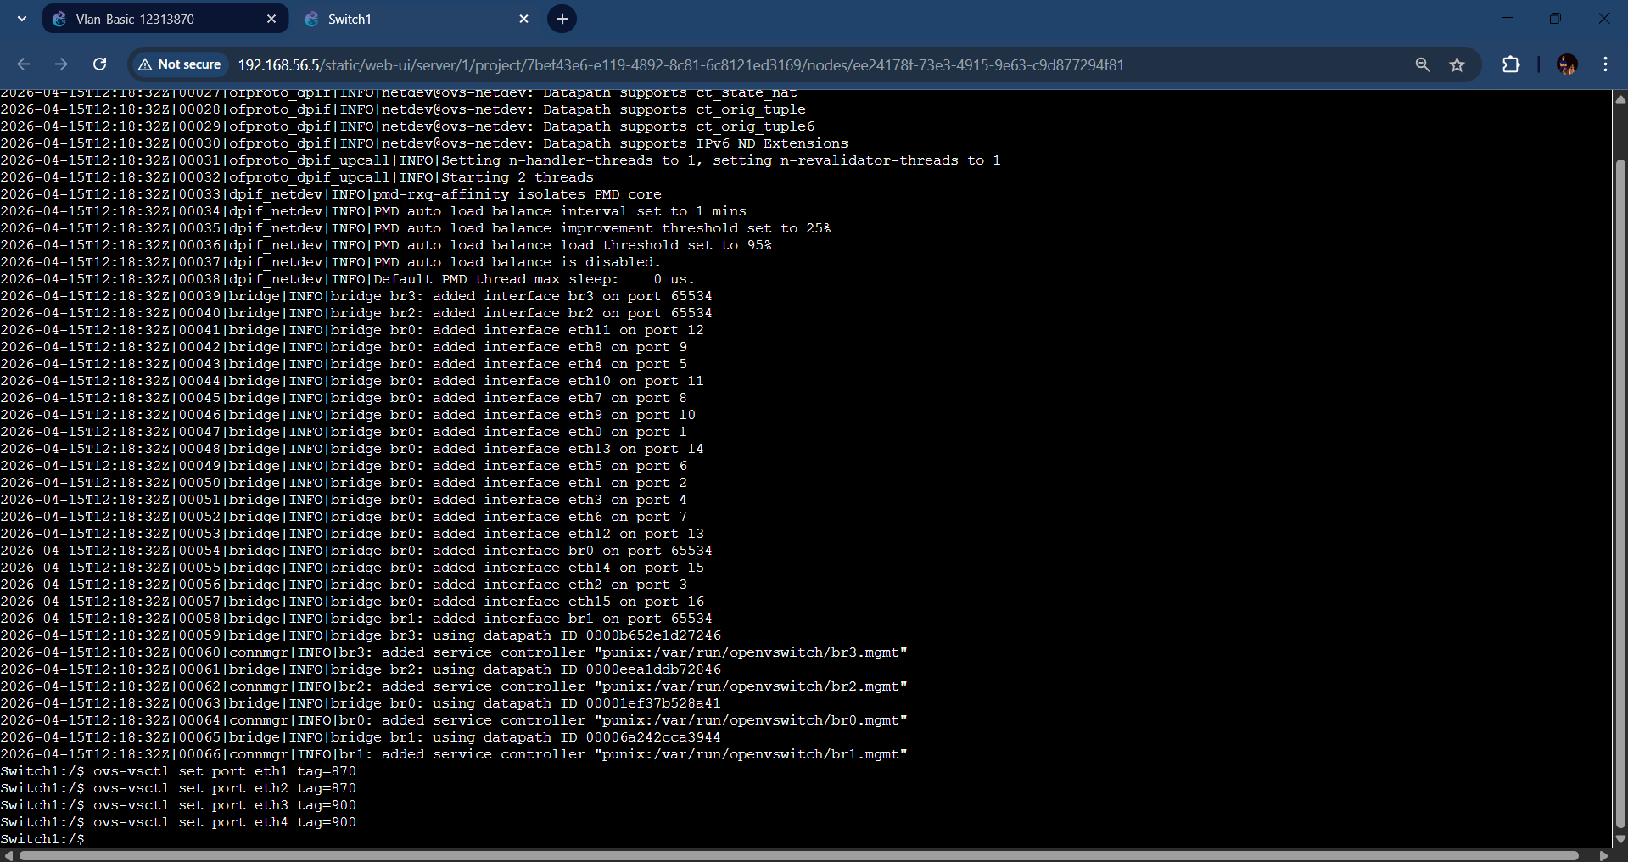

Task 2: VLAN Setup with Router
In Task 2, a Linux router was added to enable inter-VLAN communication.
Hosts were divided into two subnets:
VLAN 870 → 10.10.1.0/24
VLAN 900 → 10.10.2.0/24
Switch trunk configuration:
ovs-vsctl set port eth0 trunks=[]
Router configuration:
ip link add link eth0 name eth0.10 type vlan id 10
ip link add link eth0 name eth0.20 type vlan id 20
IP assignment:
ip address add 10.10.1.1/24 dev eth0.10
ip address add 10.10.2.1/24 dev eth0.20
Interfaces were brought up:
ip link set dev eth0.10 up
ip link set dev eth0.20 up
After configuration, all hosts successfully communicated across VLANs via the router.
Screenshots of task 2:
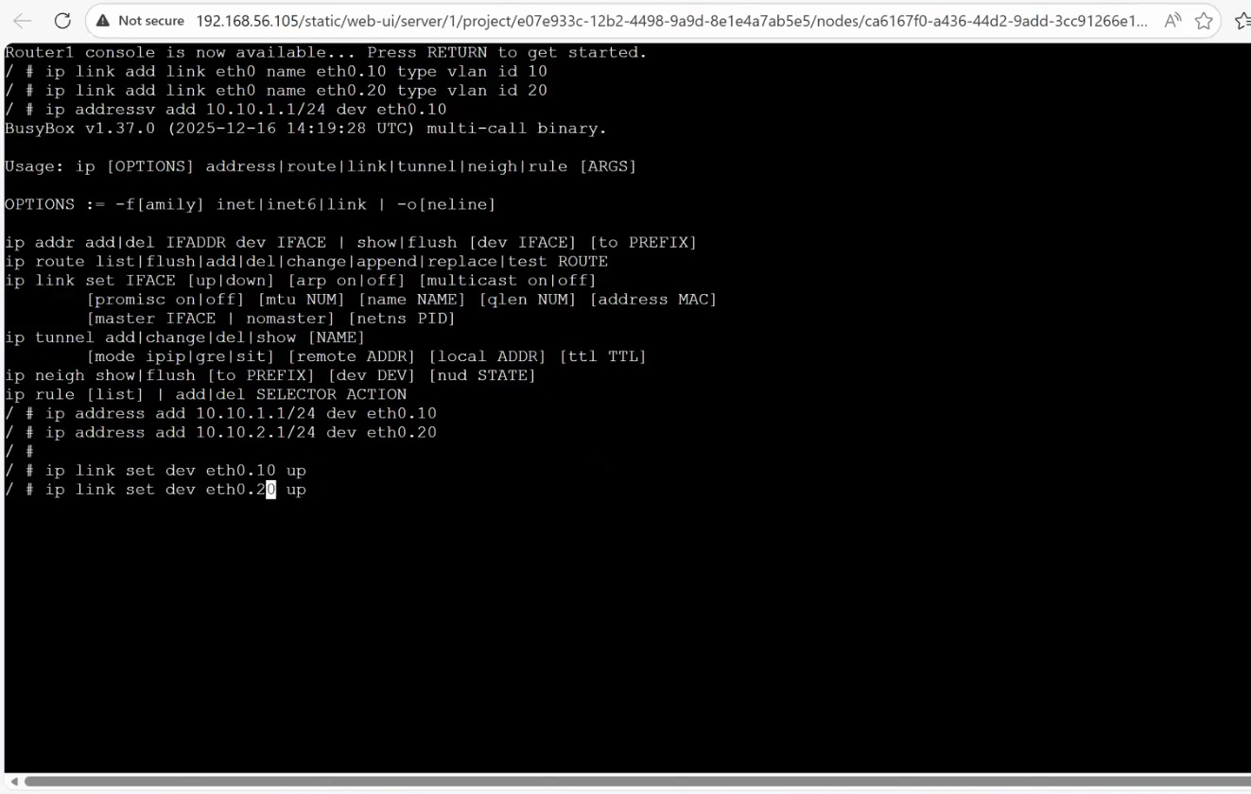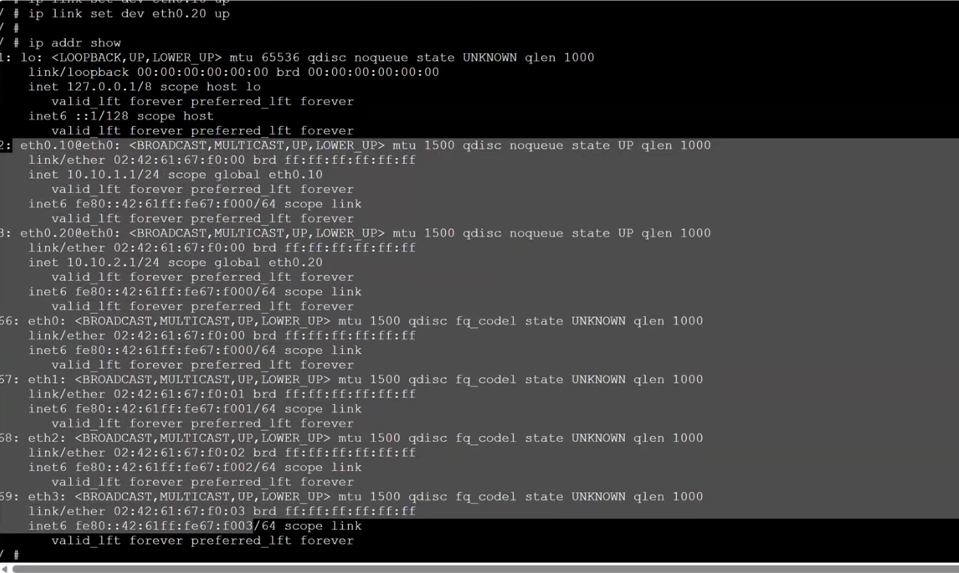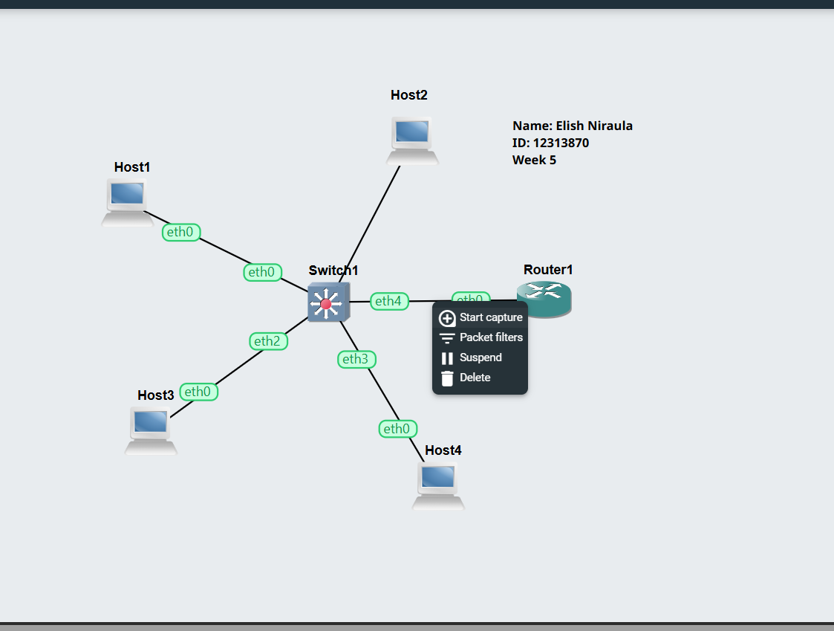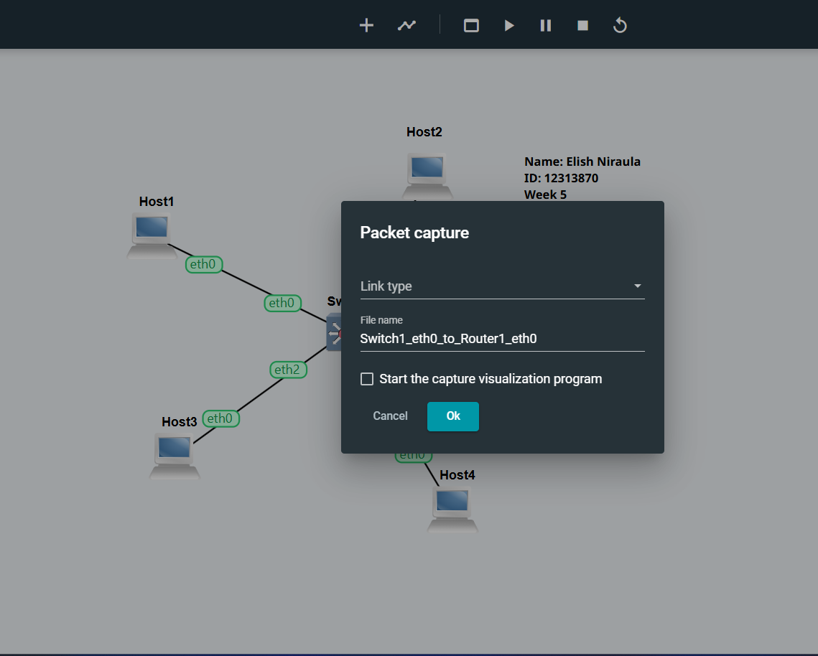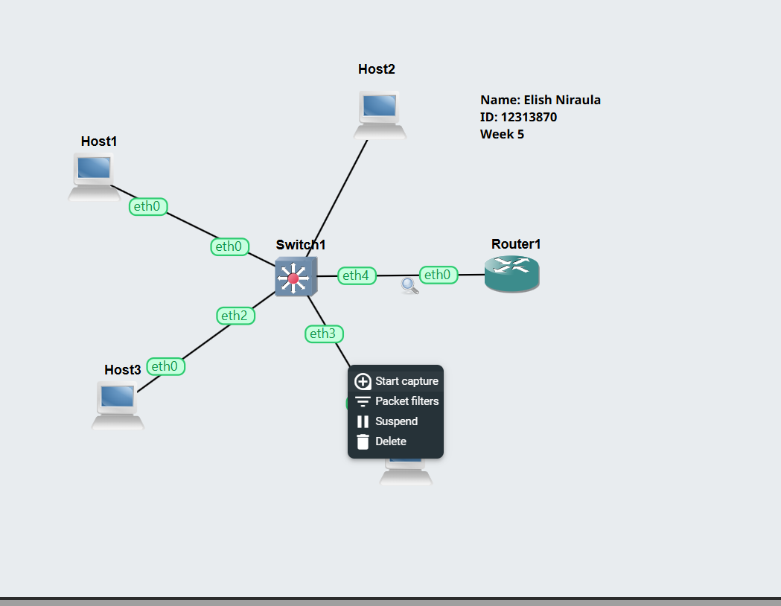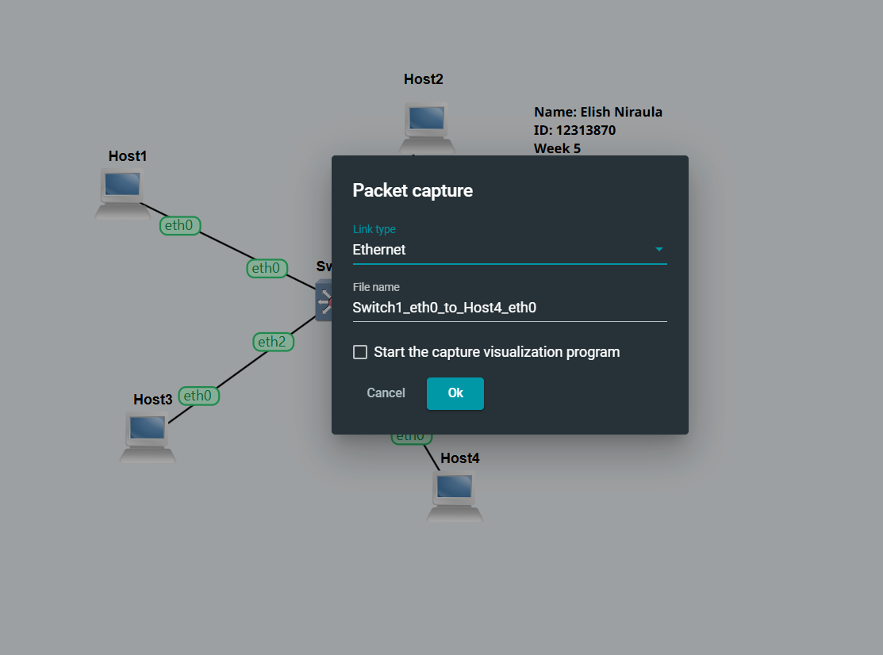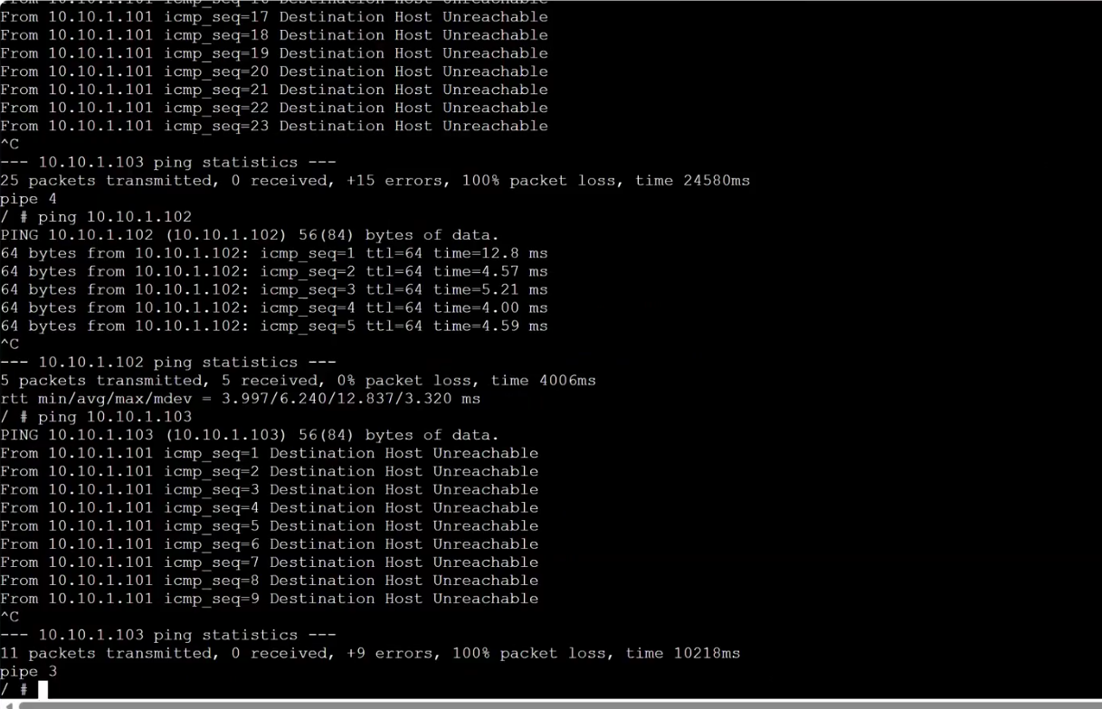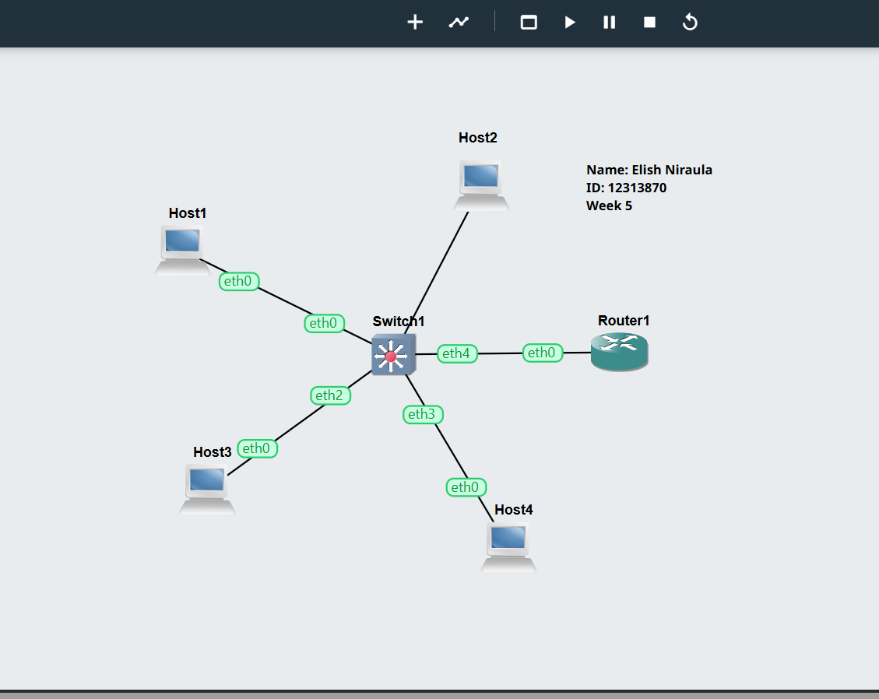

Results
• Successful VLAN segmentation in Task 1.
• Inter-VLAN routing achieved in Task 2.
• Ping tests confirmed connectivity.

Reflection
This lab helped in understanding VLAN concepts and their implementation using Open vSwitch.
Initially, VLANs restricted communication between hosts, demonstrating network segmentation.
With the addition of a router and trunk configuration, inter-VLAN communication was successfully achieved.
This practical exercise improved understanding of switching, tagging, trunk ports, and routing between networks.

