Villa Somalia SCADA Design Report
Oct 12, 2026 · @Eli

1. Introduction
This report sets out the SCADA design for the Villa Somalia hybrid power plant and is submitted for the client's approval. It answers the client's review comments on the earlier drawing set.

Project
The plant supplies the Office of the President and the Office of the Prime Minister in Mogadishu. It combines a 1,516 kWp PV array, a 3,340 kWh battery and two diesel generators on an 11 kV switchboard, with no utility grid connection.

Scope of the SCADA
The SCADA monitors every part of the plant on one system and lets authorised users switch breakers and change selected settings. It covers:
- PV inverters, battery, generators and the embedded energy management system (EMS)
- The 11 kV switchboard, the two office transformer stations and their LV distribution boards
- Transformers, auxiliary supplies, UPS, weather station, and fire detection and suppression
Three functions stay outside the SCADA and keep working if it fails:
- Dispatch of PV, battery and generators stays with the EMS.
- Electrical protection stays with the protection relays.
- Emergency stop and fire trips are hardwired and act directly on the equipment.

Reference documents
Document | Content
Drawing set VILLA_SOMALIA_05_10_2026 | Layouts, single-line diagram, communication schematic, civil and earthing drawings
Client review comments | SCADA, I/O list, communication, cybersecurity and datasheet requirements
Villa_Somalia_SCADA_Device_and_IO_List_Rev1.xlsx | Device list, protocols, I/O list, I/O rows, communication points (Attachment B)

2. Compliance table
Every client comment is answered in this report or its attachments. Items still awaiting supplier data are listed in section 14.
No. | Client comment | Response | Section
1 | Please submit for approval | This report with attachments A to E | All
2 | Provide complete SCADA design aligned with the BESS and PV side and the rest of the equipment, including the GIS combiner panel, LVDBs and generators | A redundant controller pair and one SCADA covering every equipment group, with screen mock-ups | 3, 4, 5, 6, 12, Attachment E
3 | Complete I/O list with all analogue and digital signals: VCB breakers, relays of the GIS combiner panel, inverter transformers, RMU, DGs, combiner panels, weather station, UPS, auxiliary power, fire detection and suppression | 244 hardwired signals and 463 communication points, listed signal by signal, including the PV inverter AC breakers and the battery combiner panels | 7, Attachment B
4 | Submit communication architecture, protocols, network topology, cybersecurity provisions, and integration with GIS, LVDBs, generators, PV and BESS | Protocol for every link, redundant fibre ring, five-zone security design | 5, 6, 8, 9
5 | Provide datasheets for PPC controllers, field devices, servers and HMI, and the operational sequence | Bill of materials with model numbers; datasheets attached; operating sequences | 11, 13, Attachment C

3. Design basis
The design is based on the equipment in drawing set VILLA_SOMALIA_05_10_2026 and the assumptions below.

Plant equipment
Equipment | Rating or model | Quantity
PV array | 2,106 modules x 720 Wp = 1,516 kWp | 1
PV string inverters NB01 to NB04 | Sungrow SG350HX, 350 kW | 4
Power line communication box (PLC box) | Converts inverter data to Ethernet | 1
Battery energy storage system | Sungrow ST3340UX, 3,340 kWh | 1
Embedded energy management system | Supplied with the PV and battery package | 1
Diesel generators DG1, DG2, with step-up transformer | DG1 550 kVA, DG2 660 kVA; step-up transformer 1.5 MVA, 11/0.4 kV | 2
11 kV switchboard, 1250 A busbar | Panels AH1 to AH8 | 1
Office transformer stations: RMU with ST260E relay, 630 kVA transformer, 10-way LVDB | President and Prime Minister | 2
Auxiliary transformer | 100 kVA | 1
Neutral earthing resistor (panel AH8) | 63.5 ohm, 100 A, 10 s | 1
Weather station | Kipp & Zonen SMP12-A, Gill WindSonic, temperature sensors, Meteocontrol blue'Log XM | 1
Battery fire detection and suppression | Per battery supplier | 1

11 kV switchboard panels
Panel | Function
AH1 | Diesel generator incomer
AH2 | PV incomer
AH3 | Battery incomer
AH4 | Feeder to the Office of the President
AH5 | Auxiliary transformer feeder
AH6 | Feeder to the Office of the Prime Minister
AH7 | Spare feeder
AH8 | Neutral earthing resistor

Assumptions
- Islanded plant. The single-line diagram shows no utility incomer.
- Control voltage. The switchgear auxiliary supply is 110 V DC. This sets the I/O module variants.
- Remote operation. The 11 kV breakers, RMU switches and LVDB incomers are motorised.
- EMS interface. The embedded EMS offers Modbus TCP to an external controller.
- PV data path. Inverter data reaches the controller from the PLC box over Ethernet, as on the existing communication sheet.
- Relay protocol. The 11 kV relays offer IEC 61850 or Modbus TCP.
- Signal counts. Signals per device are typical values, to be checked against the terminal schedules.

Standards
Standard | Applied to
IEC 61850 | Communication with the 11 kV protection relays
IEC 60870-5-104 | Link between the controller and the SCADA servers
IEC 62443 | Structure of the cybersecurity provisions
Modbus TCP and RTU | EMS, PLC box, generator controllers, meters, RMU relays, weather logger

4. System architecture
A hot standby pair of Siemens SICAM A8000 CP-8050 controllers collects every signal in the plant and passes it to two SCADA servers. Controller A is in control; controller B follows it and takes over if A fails. It reads five groups of devices over the network and six rows of hardwired signals.
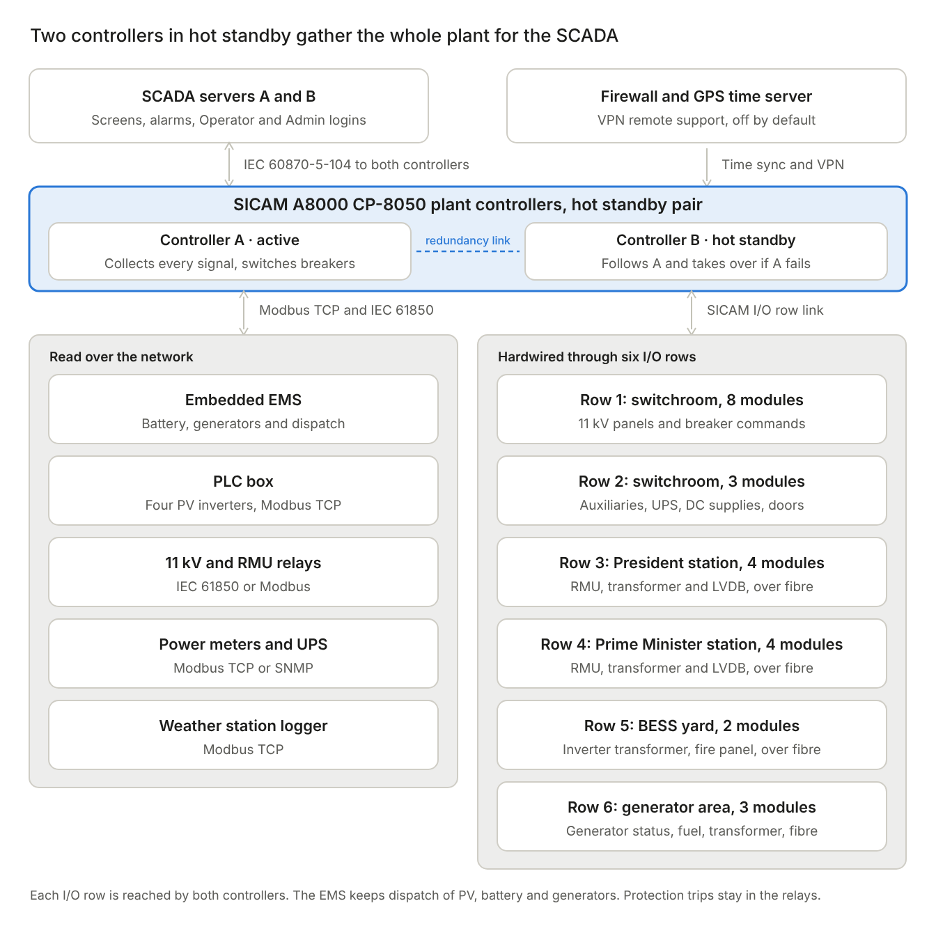
SCADA architecture · redundant controller pair, 5 network sources, 6 I/O rows
Status and measurements flow up to the SCADA; breaker commands and permitted EMS settings flow down. A command passes three checks before a breaker moves: the SCADA checks the user's role, the controller checks interlocks and the local/remote switch, and the command module checks that only one output operates.

Components and their roles
Component | Role | Location
SICAM A8000 CP-8050, hot standby pair A and B | Plant controller: collects all signals, time-stamps events, executes breaker commands, passes settings to the EMS; B takes over if A fails | 11 kV switchroom, in the SCADA cabinet beside the switchboard
SCADA servers A and B (SICAM SCC) | Screens, alarms, trends, reports, user logins and audit log; B takes over if A fails | Control room
Operator workstation | Day-to-day operation | Control room
Embedded EMS | Dispatch of PV, battery and generators | BESS area
Protection relays | Protection of the 11 kV and RMU circuits | 11 kV switchboard and office stations
I/O rows 1 to 6 | Hardwired signals from the field | Near the equipment they serve

Division of duties
Function | Carried out by | If the SCADA or controller fails
Dispatch of PV, battery and generators | EMS | Continues
Electrical protection | Relays | Continues
Emergency stop and fire trips | Hardwired circuits | Continue
Monitoring, alarms, event record | Controller and SCADA | Continue on the standby controller or server; lost only if both fail
Remote breaker switching | Controller and SCADA | Continues on the standby; if both controllers fail, breakers are operated locally
Generator start if the EMS fails | Generator controllers, on dead busbar | Continues
Load shedding on under-frequency | Relays AH6 and AH4 | Continues

5. Scope of monitoring and control
Each equipment group reaches the controller over a communication protocol, by hardwired contacts, or both. Critical states are hardwired as well as communicated, so they stay visible if a link fails.
Equipment | By protocol | Hardwired | Monitored | Controlled from SCADA
PV inverters NB01 to NB04 | Modbus TCP from the PLC box | Main LV breaker and the four inverter AC breakers to row 5 | Power, voltages, currents, energy, temperature, insulation, state, fault codes | None; output is set by the EMS
Embedded EMS | Modbus TCP | None | Plant power balance, operating mode, generator requests, alarms | Operating mode, state-of-charge limits, generator thresholds, battery power limit, C-rate limit (Admin only)
Battery ST3340UX | Through the EMS | Fire, E-stop, door and main LV breaker to row 5 | State of charge and health, power, cell limits, charge and discharge limits, combiner panel status, alarms | Through the EMS only
Diesel generators DG1, DG2 | Modbus from each generator controller | Breaker status, running, alarm, E-stop, fuel level and step-up transformer LV breaker to row 6 | Electrical output, engine values, counters, warnings, shutdown causes | Start and stop in manual mode
11 kV switchboard AH1 to AH8 (the GIS combiner panel) | IEC 61850 or Modbus TCP from the relays | Breaker, earth switch, local/remote, spring, gas, relay healthy to row 1, including the AH8 breaker | Currents, voltages, power, energy, trips and events | Breaker open and close on AH1 to AH7
RMUs at the office stations | Modbus RTU from the ST260E relays, through gateways | Switch positions, trips, gas, local/remote and RMU UPS to rows 3 and 4 | Currents, trips, switch positions | Ring switches and transformer breaker
LVDBs at the office stations | Modbus TCP from power meters | Incomer and 10 feeder statuses to rows 3 and 4 | Voltage, current, power, energy, harmonics | Incomer open and close
Transformers (inverter, DG step-up, auxiliary, 2 x 630 kVA) | None | Temperature, pressure and oil level contacts, and the auxiliary transformer fuse, to the nearest row | Alarms and trips | None
UPS and DC supplies | Modbus TCP or SNMP | Status contacts and DC voltages to row 2 | Battery state, faults, bus voltages | None
Fire detection and suppression | None | Pre-alarm, fire, fault, release and isolation to row 5 | All panel states | None; reset at the panel only
Weather station | Modbus TCP from the blue'Log | None | Irradiance, wind, ambient and module temperature | None

Integration with each system named by the client
- GIS combiner panel. Relays report over IEC 61850 or Modbus TCP; positions and commands are also hardwired to row 1.
- LVDBs. Power meters report over Modbus TCP; breaker positions are hardwired to rows 3 and 4.
- Generators. The generator controllers report over Modbus; critical states are duplicated by contacts to row 6.
- PV. Inverter data arrives from the PLC box over Modbus TCP.
- BESS. Battery data arrives through the EMS; safety states are hardwired to row 5.

6. Integration with the PV and BESS systems
The PV and battery arrive as one supplier package with its own EMS. The SCADA connects to that package at three defined points and never duplicates its control. This section fixes the boundary so both parties can design and test to it.
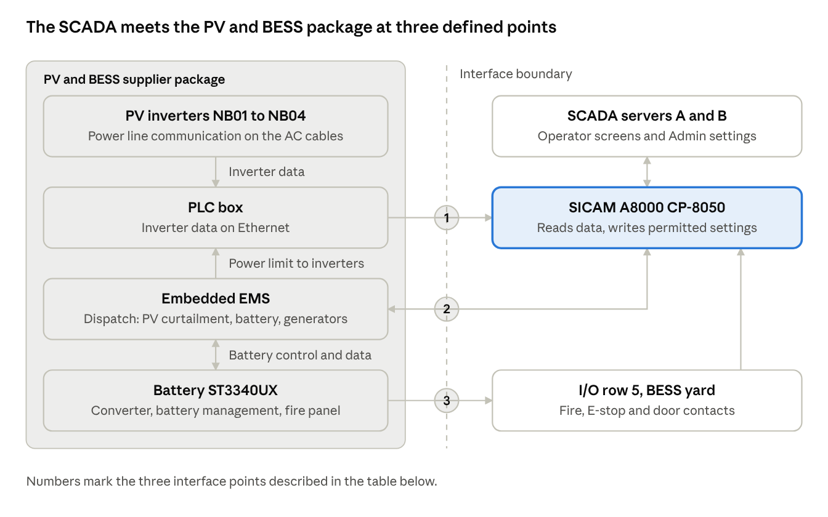
PV and BESS interface · 3 interface points across the supplier boundary
Everything left of the boundary is designed, configured and warranted by the PV and BESS supplier. Everything right of it is the SCADA scope. The 11 kV incomers for PV (AH2) and battery (AH3) are on the SCADA side: they are monitored and switched through the relays and I/O row 1.

Interface points
No. | Interface | From and to | Protocol and medium | Direction | Content
1 | PV data | PLC box to CP-8050 | Modbus TCP, Ethernet on the fibre ring | Read only | Inverter measurements, energy, states, fault codes, link health
2 | EMS | EMS and CP-8050, both ways | Modbus TCP, Ethernet on the fibre ring | Read; write permitted settings only | Read: plant power balance, battery data, generator requests, mode, alarms. Write: mode, state-of-charge limits, generator thresholds, battery power limit, C-rate limit, fault reset
3 | Safety contacts | Battery fire panel, emergency stop, container door and the PV and battery LV breakers to I/O row 5 | Dry contacts, hardwired | Read only | Fire panel states, emergency stop, door open, LV breaker positions and trips

Control authority
Each function has one place where it is executed and one route by which it may be changed. The SCADA never commands what the EMS controls; it changes EMS behaviour only through the EMS's own settings.
Function | Executed by | Changed by | SCADA role
PV output and curtailment | EMS, through the PLC box | EMS settings | Monitor
Battery charge and discharge | EMS and battery converter | Admin, through EMS setpoints | Monitor; Admin setpoints
Grid forming: voltage and frequency | Battery converter | Supplier settings only | Monitor
Battery C-rate limit for calibration | Battery, through the EMS | Admin only | Admin command, if the EMS exposes it
Generator start and stop, automatic | EMS, by hardwired start contact to the generator controllers | Admin, through EMS thresholds | Monitor
Generator start and stop, manual | Generator controller | Operator | Command
11 kV breakers AH2 (PV) and AH3 (battery) | CP-8050 and secured command outputs | Operator | Command with interlocks
Protection settings | Relays | Protection engineer, locally | Monitor trips
Emergency stop and fire trip | Hardwired circuits | Nobody, remotely | Monitor
Load shedding on under-frequency | Relays AH6, then AH4 | Protection engineer, locally | Monitor trips; reclose feeders
The EMS's own local screen remains available for supplier service, under a separate Admin password, so settings are not changed from two places in normal operation.

Interface signals
Source | Read points | Write points | Examples
PLC box, 4 inverters | About 88 | 8, used only if the EMS allows | Active and reactive power, AC and DC values, energy, temperature, insulation, fault codes
EMS | About 14 | 9 | Plant power balance, mode, generator request, setpoints, fault reset
Battery, through the EMS | About 27 | None | State of charge and health, cell limits, charge and discharge limits, alarm levels, combiner panel status
Hardwired, I/O row 5 | 18 | None | Fire panel states, emergency stop, container door, LV breakers, inverter AC breakers
The point-by-point list is in Attachment B, sheets Comms Points and IO List. It will be replaced by the supplier's point tables when received.

Responsibilities at the interface
Item | PV and BESS supplier | SCADA contractor
Modbus point tables for the EMS and PLC box | Provides | Maps into the controller and SCADA
Settings that may be written remotely | Defines and confirms in writing | Implements, Admin role only
Network ports and IP addresses | Provides ports; agrees addresses | Issues the address and VLAN plan; provides cabling and switch ports
Time synchronisation | Configures NTP on the EMS and PLC box | Provides the GPS time server
Alarm list and alarm levels | Provides its alarm list | Maps it to levels 1 to 3
Fire, emergency stop and door contacts | Provides potential-free contacts at a terminal | Wires them to I/O row 5
Equipment names and tags | Uses the single-line diagram names (NB01 to NB04, AH1 to AH8, DG1, DG2) | Uses the same names on every screen and in the I/O list
Default passwords on the EMS and PLC box | Changes them and hands them over | Records them in the site register
Interface test | Attends, with the EMS in test mode | Leads and records

Interface test
Both parties test the interface together at commissioning and sign the results.
- Read points. Each value on the SCADA matches the EMS or PLC box display.
- Write points. Each permitted setting is changed by an Admin and confirmed at the EMS. Each forbidden write is confirmed blocked, and an Operator login is confirmed unable to write.
- Link loss. Each link is disconnected; the SCADA raises an alarm, marks values stale and blocks commands. On reconnection it recovers without intervention.
- Safety contacts. Each contact is operated at source and seen on the SCADA.
- Time stamps. An event recorded by the EMS and by the SCADA shows the same time.

7. I/O summary
The plant has 244 hardwired signals on 24 I/O modules in six rows, with 27% spare channels. Row 5, in the BESS and inverter yard, is the fullest at 19% spare; a third input module can be added there if more yard signals appear. A further 463 signals arrive over communication links. The full signal-by-signal list is in Attachment B: sheet IO List for hardwired signals and sheet Comms Point List for communication points.

I/O rows
Each row is a panel of I/O modules placed near the equipment it serves. Field contacts are wired a short distance to that panel, and one link carries all its signals to the controllers. Both controllers reach every row; only the active one reads inputs and drives outputs.
Row | Location | Interface to controller | Link | Equipment wired | Modules | Signals
1 | 11 kV switchroom, SCADA cabinet | CI-8532, electrical | Copper | 11 kV panels AH1 to AH8, alarm beacon | 8 | 87
2 | 11 kV switchroom, SCADA cabinet | CI-8532, electrical | Copper | Auxiliary transformer, UPS, DC supplies, switchroom E-stop and doors | 3 | 25
3 | President office station | CI-8533, optical | Fibre | RMU, 630 kVA transformer, LVDB, RMU UPS | 4 | 43
4 | Prime Minister office station | CI-8533, optical | Fibre | RMU, 630 kVA transformer, LVDB, RMU UPS | 4 | 43
5 | BESS and inverter transformer yard | CI-8533, optical | Fibre | Inverter transformer, PV and BESS LV breakers, inverter AC breakers, fire panel, BESS E-stop and door | 2 | 26
6 | Generator area | CI-8533, optical | Fibre | Generator status and fuel level, DG step-up transformer and its LV breaker | 3 | 20
Total |  |  |  |  | 24 | 244
The controller accepts up to 16 rows of 8 modules, so 10 rows remain free for expansion.

Modules
Module | Function | Quantity | Channels | Used | Spare
DI-8112 | Digital input, 16 channels | 17 | 272 | 208 | 64
DO-8221 | Secured command output, 12 channels | 4 | 48 | 30 | 18
DO-8212 | Relay output, 8 channels | 1 | 8 | 2 | 6
AI-8320 | Analogue input, 4 channels | 2 | 8 | 4 | 4
Total |  | 24 | 336 | 244 | 92

Hardwired versus communicated
Source | Signals | Examples
Hardwired digital inputs | 208 | Breaker positions, trips, transformer alarms, fire panel states
Hardwired commands | 32 | Breaker open and close, alarm beacon
Hardwired analogue inputs | 4 | Generator fuel levels, DC bus voltages
Communication points | 463 | Measurements, energy, engine values, battery data, settings
Breaker commands use the secured command module, which checks that only one output operates and that the coil circuit is intact before switching. Analogue inputs are used only for sensors without a communication port.

8. Communication architecture
All devices share one Ethernet network built on two core switches and a fibre ring. No single cable, switch, power supply or SCADA server failure removes the operators' view of the plant.
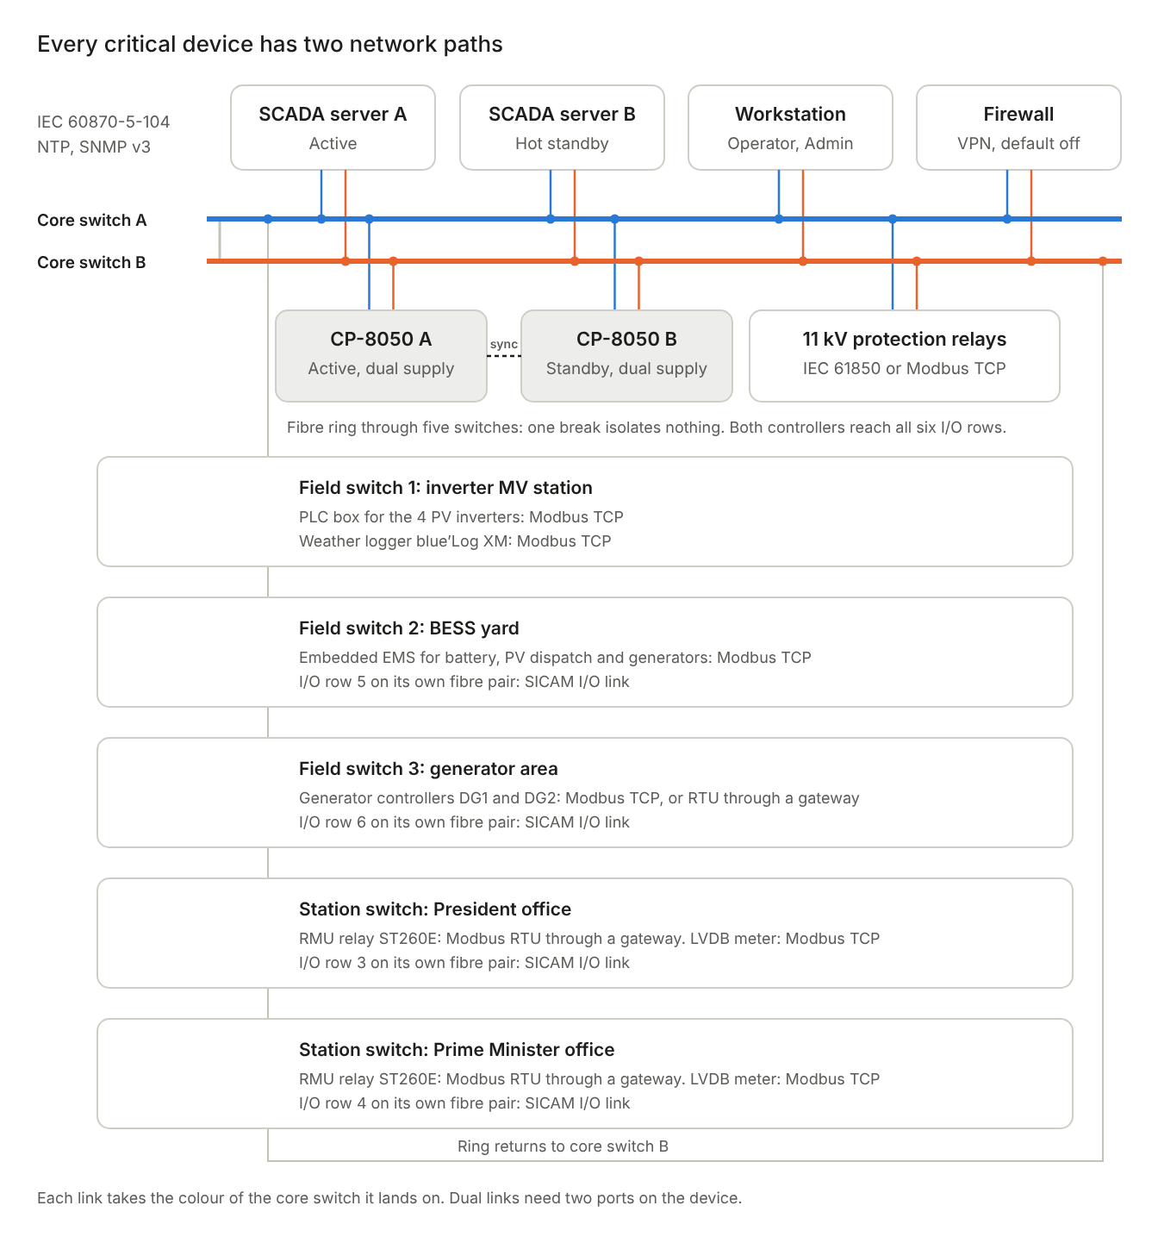
communication network · 2 core switches, 5-switch fibre ring, protocol per device
The SCADA servers, workstation, firewall, both controllers and the 11 kV relays each connect to both core switches. The field and station switches form one fibre ring that leaves core switch A and returns to core switch B.

Protocols by link
Link | Protocol | Medium | Redundant path
Controllers A and B to SCADA servers A and B | IEC 60870-5-104 | Ethernet | Both core switches
Controller to 11 kV relays | IEC 61850, or Modbus TCP | Ethernet | Both core switches
PV inverters to PLC box | Power line communication | AC power cables | None needed; local
Controller to PLC box | Modbus TCP | Fibre ring | Ring
Controller to EMS (battery and generator data) | Modbus TCP | Fibre ring | Ring
Controller to generator controllers | Modbus TCP, or Modbus RTU through a gateway | Fibre ring | Ring
Controller to RMU relays (ST260E) | Modbus RTU through a station gateway | RS485, then fibre ring | Ring
Controller to power meters, weather logger, UPS | Modbus TCP or SNMP | Fibre ring or copper | Ring
Controllers to I/O rows 1 and 2 | SICAM I/O link | Copper, in the cabinet | None; same cabinet
Controller to I/O rows 3 to 6 | SICAM I/O link, optical | Dedicated fibre pair | None; see below
All devices to GPS time server | NTP | Ethernet | Both core switches
Network devices to SCADA servers | SNMP v3, syslog | Ethernet | Both core switches
Remote support | VPN through the firewall | Internet | None; off by default
Controller A to controller B | Redundancy synchronisation (Siemens) | Direct cable between the controllers, to confirm | Through the core switches, to confirm

Failure cases
Failure | Effect
One fibre cut in the ring | Traffic reroutes the other way; nothing is lost
One core switch fails | Dual-connected devices continue on the other switch
One field or station switch fails | Only devices on that switch are lost; the ring stays up
SCADA server A fails | Server B takes over with the same screens and history
One controller power supply fails | The second supply carries the controller
Mains supply to the SCADA cabinet fails | UPS and the station DC supply carry the SCADA and network
Active controller fails | The standby controller takes over; the SCADA view and remote switching continue; a level 2 alarm is raised
Fibre pair to a remote I/O row is cut | Hardwired signals from that location are lost until repaired; network data from that location still arrives through the ring
Both controllers fail | SCADA loses its view; the EMS, relays and hardwired trips continue; breakers are operated locally

Remaining single points
- Remote I/O row links. Each runs on one fibre pair. Siemens will confirm whether the optical row link can run as a ring; if not, a small CP-8031 controller at a site would put its signals on the ring.
- The controller. Controllers A and B run as a hot standby pair, so it is no longer a single point. Each I/O row interface remains single; its failure loses only that row.
- Single-port devices. The EMS, PLC box and generator controllers have one network port each, so they rely on the ring rather than on two connections.

9. Cybersecurity
The plant network is closed by default: no device can be reached from outside unless an Admin opens a time-limited VPN session. The provisions follow the structure of IEC 62443, and each layer assumes the one outside it might fail.

Network zones
Zone | Devices | Rule
SCADA | SCADA servers, workstation, engineering laptop | Reaches the controller only
Control | Controller, EMS | Only the controller writes settings to the EMS
Substation | Relays, power meters, gateways, I/O rows | Read and commanded by the controller only
Monitoring | PLC box, weather logger, UPS, time server | Read only
External | Firewall outside interface | Blocked unless an Admin opens a VPN session
Zones are separated by VLANs on the managed switches, by separate ports on the controller, and by firewall rules that deny all traffic not listed in section 8.

Provisions by layer
Layer | Provision
Perimeter | Firewall with deny-by-default rules; no port forwarding; no direct internet route to any control device
Remote access | VPN with multi-factor authentication; off by default; enabled per session by an Admin; closes on a timer; every session logged
Vendor access | Named, time-limited accounts through the same VPN; no permanent vendor access
Network | Managed switches with unused ports disabled, port security, encrypted management (HTTPS, SSH, SNMP v3)
Controller | Role-based access, encrypted engineering access, unused services disabled, event logs sent to the SCADA servers
SCADA | Individual logins, no shared accounts; minimum 12-character passwords; lockout after 5 failed attempts; logout after 15 idle minutes
Workstations | Application allow-listing, USB storage blocked, endpoint protection
Field devices | Default passwords changed on relays, EMS, PLC box, meters and generator controllers before the site test
Physical | Locked cabinets and control room; cabinet and panel door contacts raise alarms

Logging, time and recovery
- Audit log. Every login, command and setting change is recorded with user name and time, and kept for at least 12 months.
- Time. All devices synchronise to a GPS time server, so events from different devices can be put in order.
- Backups. Configurations of the controller, SCADA, switches, firewall and relays are backed up after every change, with one copy kept offline. Restore is tested at the site test.
- Patching. Firmware versions are frozen at the factory test. Updates are applied only after vendor release and Admin approval.
- Recovery. A written procedure covers local operation of breakers and generators if both controllers or both SCADA servers fail. If the EMS fails, the generators start on their own and supply the plant (section 11).

Decision for the client
No plant data leaves the site in the proposed design. If the client wants remote reporting or a vendor monitoring portal, it would need an outbound-only encrypted link, and the client should approve it explicitly given the nature of the site.

10. User roles and alarms
The SCADA has two user levels. An Operator runs the plant day to day; an Admin can also change how the plant behaves. Each person has an individual login, and every action is logged.

Permissions
Function | Operator | Admin
View all screens, trends, alarms and reports | Yes | Yes
Acknowledge alarms | Yes | Yes
Open and close breakers, with select and confirm | Yes | Yes
Start and stop a generator in manual mode | Yes | Yes
Clear level 3 (minor) faults and warnings | Yes | Yes
Clear level 1 and level 2 faults | No | Yes
Change EMS operating mode and setpoints | No | Yes
Enable or disable the battery C-rate limit for calibration | No | Yes
Change generator mode between automatic and manual | No | Yes
Create and remove users, reset passwords | No | Yes
Enable a remote support session | No | Yes
Export the audit log | No | Yes
Settings that act on the battery depend on the EMS accepting them over Modbus. If the EMS does not expose the C-rate limit, that function stays on the EMS's own screen under its own Admin password.

Alarm levels
Level | Meaning | Examples | Cleared by
1, critical | Equipment tripped or safety at risk | Protection trip, fire, emergency stop, transformer trip, UPS battery low | Admin, after the cause is found; protection trips also need a reset at the relay
2, major | Function lost or degraded | Relay unhealthy, gas pressure low, generator alarm, communication lost | Admin
3, minor | Warning; the plant still runs normally | Temperature alarm, spring not charged, door open, surge arrester failed | Operator
The battery management system may number its own alarm levels differently. Its levels will be mapped to these three during configuration.

Breaker switching rules
- Remote commands are accepted only when the breaker's local/remote switch is in remote.
- The operator selects the breaker, then confirms in a second step.
- The controller blocks a command that breaks an interlock, such as closing a breaker onto an earthed circuit, or energising the busbar through AH1 or AH3 while AH8 is open.
- The secured command module checks that only one output operates and that the coil circuit is intact.
- Before any work on equipment, the breaker position is checked physically, since screen status depends on communication.

11. Operational sequence
The battery forms the plant's voltage and frequency, PV follows it, and the generators start only when the battery runs low. The EMS carries out these sequences; the SCADA shows each step and lets authorised users intervene. Thresholds below are proposed starting values, to be set with the EMS supplier at commissioning.

Operating modes
Mode | Condition | Battery | PV | Generators
Day, PV surplus | PV exceeds load | Forms the grid, charging | Full output; curtailed by the EMS when the battery is full | Off
Day, PV shortfall | PV below load | Forms the grid, discharging | Full output | Off
Night | No PV | Forms the grid, discharging | Off | Off
Low battery | State of charge below 20% | Charging from the generator | Full output if available | One running; second starts if load requires
Generator only | Battery unavailable | Off | Limited to keep the generator above minimum load | Running, forming the grid
Manual | Admin selects manual | As commanded | As commanded | As commanded

Generator start and stop
- State of charge falls below 20% and PV cannot cover the load.
- The EMS requests a start from the lead generator.
- The generator controller starts the engine, synchronises it to the busbar and closes its breaker.
- The generator is loaded to at least 30% of its rating; spare output charges the battery.
- If load exceeds 80% of the running generator, the second generator starts.
- At 80% state of charge, or when PV covers the load again, the generator unloads and its breaker opens.
- The engine cools down, then stops. The lead generator alternates to even out running hours.
The SCADA shows each step and raises an alarm if a generator fails to start, synchronise or stop.

Black start
- After a total shutdown, all 11 kV breakers are open except AH8, which stays closed unless it has tripped.
- AH8 is confirmed closed, or closed first, so the 11 kV system is earthed through the neutral earthing resistor before the busbar is energised. The controller blocks closing AH1 or AH3 while AH8 is open.
- If the battery is healthy, it energises its transformer and the 11 kV busbar through AH3.
- If the battery is not available, a generator energises the busbar through AH1.
- The auxiliary transformer feeder AH5 closes, then the office feeders AH4 and AH6, with a delay between steps.
- The PV incomer AH2 closes; the inverters reconnect and ramp up.
The EMS supplier provides this sequence in its functional description, states which steps it carries out automatically and which need an operator command from the SCADA, and demonstrates it at commissioning.

Requirements on the EMS and fallback
The design relies on the embedded EMS for dispatch, with no separate plant controller. The EMS supplier must therefore provide the functions below, and the plant must keep supplying the offices if the EMS fails. They are part of the EMS specification and are tested at commissioning.
- Generator start and stop. The EMS starts and stops each generator through a hardwired start contact to the generator controller, so the start does not depend on the CP-8050, the SCADA or the network. A Modbus command may duplicate it. The EMS applies the start below 20% and stop at 80% state of charge, the second-generator rule at 80% of the running generator, the 30% minimum load and lead and lag alternation.
- PV curtailment. The EMS limits the inverters through the PLC box when the battery is full, or when a generator would fall below its minimum load. Output is ramped down rather than tripped. The supplier states the response time from the EMS to the inverters.
- Black start. The EMS supplier provides the black-start sequence above in writing, including AH8 being closed first, and marks each step as automatic or by operator command.
- EMS failure. The CP-8050 monitors the EMS heartbeat and raises a level 1 alarm when it stops. Each generator controller is set to start on its own on a dead busbar, or when the EMS start contact is lost, and to form the grid alone. The offices are then resupplied from the generators without the EMS, and the battery stays off until the EMS is restored.
- Load shedding. If a generator is overloaded and frequency falls, the 11 kV relays shed load by under-frequency protection (81): AH6, the Prime Minister feeder, first, and AH4, the President feeder, last. Proposed settings are 48.5 Hz for 1 s on AH6 and 47.5 Hz for 0.5 s on AH4, to be confirmed by the protection study. The auxiliary feeder AH5 is not shed. Feeders are reclosed by operator command once frequency is stable.

Fault responses
Event | Automatic response | Operator action
Protection trip on a feeder | Relay opens the breaker; level 1 alarm; remote reclose blocked | Find the cause; reset at the relay; Admin clears the alarm
Fire in the battery container | Hardwired trip of the battery; suppression releases; EMS starts a generator | Follow the site fire procedure; no remote reset
Emergency stop pressed | Hardwired stop of battery, PV and generators | Investigate; reset locally
Battery fault | EMS starts a generator and moves to generator-only mode | Call the Admin
Communication lost to a device | Level 2 alarm; values shown as stale; commands to that device blocked | Check the network; check breaker positions physically
Active controller failure | Standby controller takes over; level 2 alarm; SCADA view and remote switching continue | Repair or replace the failed controller; it rejoins as standby
SCADA server A failure | Server B takes over | Repair server A
EMS failure or EMS heartbeat lost | Level 1 alarm; generators start on dead busbar and supply the plant; battery off | Call the PV and BESS supplier; check generator loading
Generator overload, frequency falling | Relays shed AH6, then AH4, by under-frequency protection | Reduce load; reclose the feeders from the SCADA when frequency is stable
Failure of both controllers | Watchdog contact drops; alarm beacon sounds; EMS and relays continue | Operate locally under the recovery procedure

Battery C-rate calibration (Admin only)
- The Admin logs in and confirms a generator is available as backup.
- The Admin disables the C-rate limit. The action is logged.
- The calibration cycle runs under supervision.
- The Admin re-enables the limit. An alarm reminds the Admin if it stays disabled beyond a set time.

12. HMI screens
The SCADA opens on a single-line overview of the whole plant; every other screen is one click away from it. Mock-ups of the main screens are shown below and the full set is in Attachment E. They are submitted for approval of layout and content; the final screens are built in SICAM SCC to the same layout before the factory test.
Screen | Content | Controls available
Plant overview | Live single-line diagram: generators, battery, PV, 11 kV busbar, office feeders; power at each point; breaker states; plant mode; summary alarms | Breaker open and close (Operator)
11 kV switchboard | Each panel AH1 to AH8: breaker and earth switch positions, local/remote, gas, relay status, currents, voltages, power, energy | Breaker open and close
Office stations | One screen per station: RMU positions, transformer alarms, LVDB incomer and 10 feeders, load and energy | RMU switches, transformer breaker, LV incomer
PV system | Four inverters: power, voltages, currents, temperature, insulation, state, fault codes; total PV output; weather data and performance ratio | None
Battery | State of charge and health, power, cell voltage and temperature limits, charge and discharge limits, alarms, fire panel state | EMS settings (Admin)
Generators | Each generator: electrical output, engine values, fuel level, running hours, starts, breaker, warnings and shutdowns | Start and stop in manual mode; mode change (Admin)
Energy management | EMS mode, power balance, setpoints, generator start and stop thresholds | Mode and setpoints (Admin); C-rate limit (Admin)
Auxiliaries | Auxiliary transformer, UPS, DC supplies, switchroom temperature, doors | None
Alarms | Active alarms by level, with acknowledge; alarm history | Acknowledge; clear by level and role
Event log | Time-stamped record of every state change, command and login | Filter, export (Admin)
Trends | Any measured value over time | Select values and period
Reports | Daily, monthly and yearly energy by source, generator fuel and hours, availability | Export (Admin)
Communication status | Health of every device link, switch, I/O row and server | None
User management | Users and roles | Admin only
I/O list | Every signal with its tag, I/O row, module and channel or protocol source, alarm level and live value | Filter, export
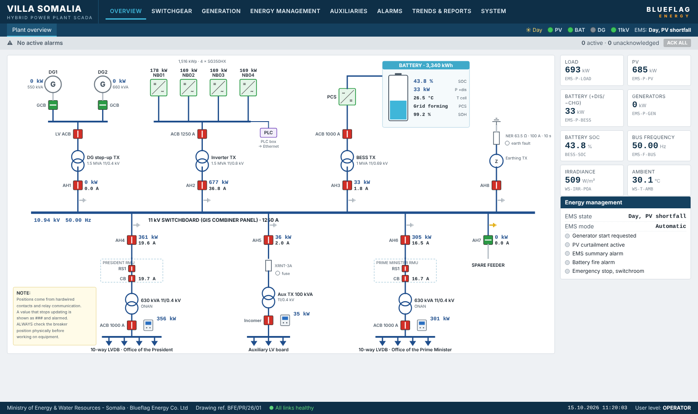
Plant overview · mock-up of the opening screen, a live single-line diagram of the whole plant
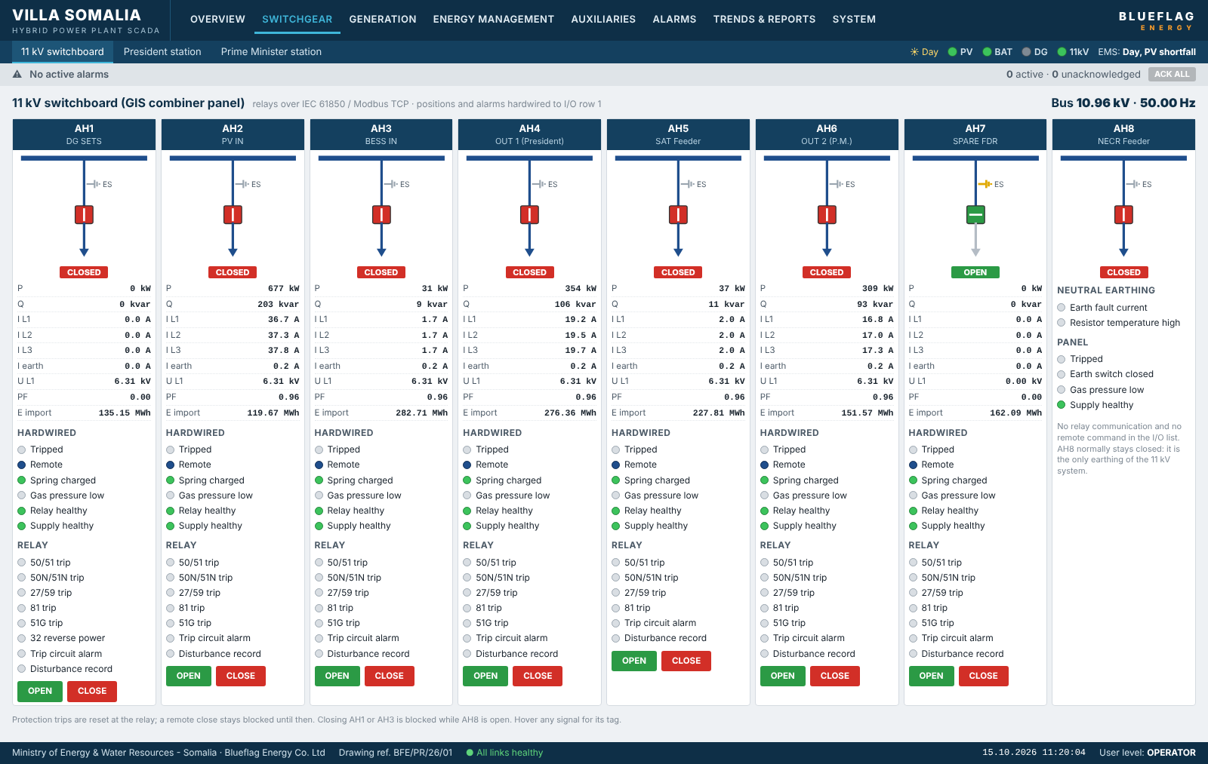
11 kV switchboard · mock-up, panels AH1 to AH8 with positions, relay status and measurements
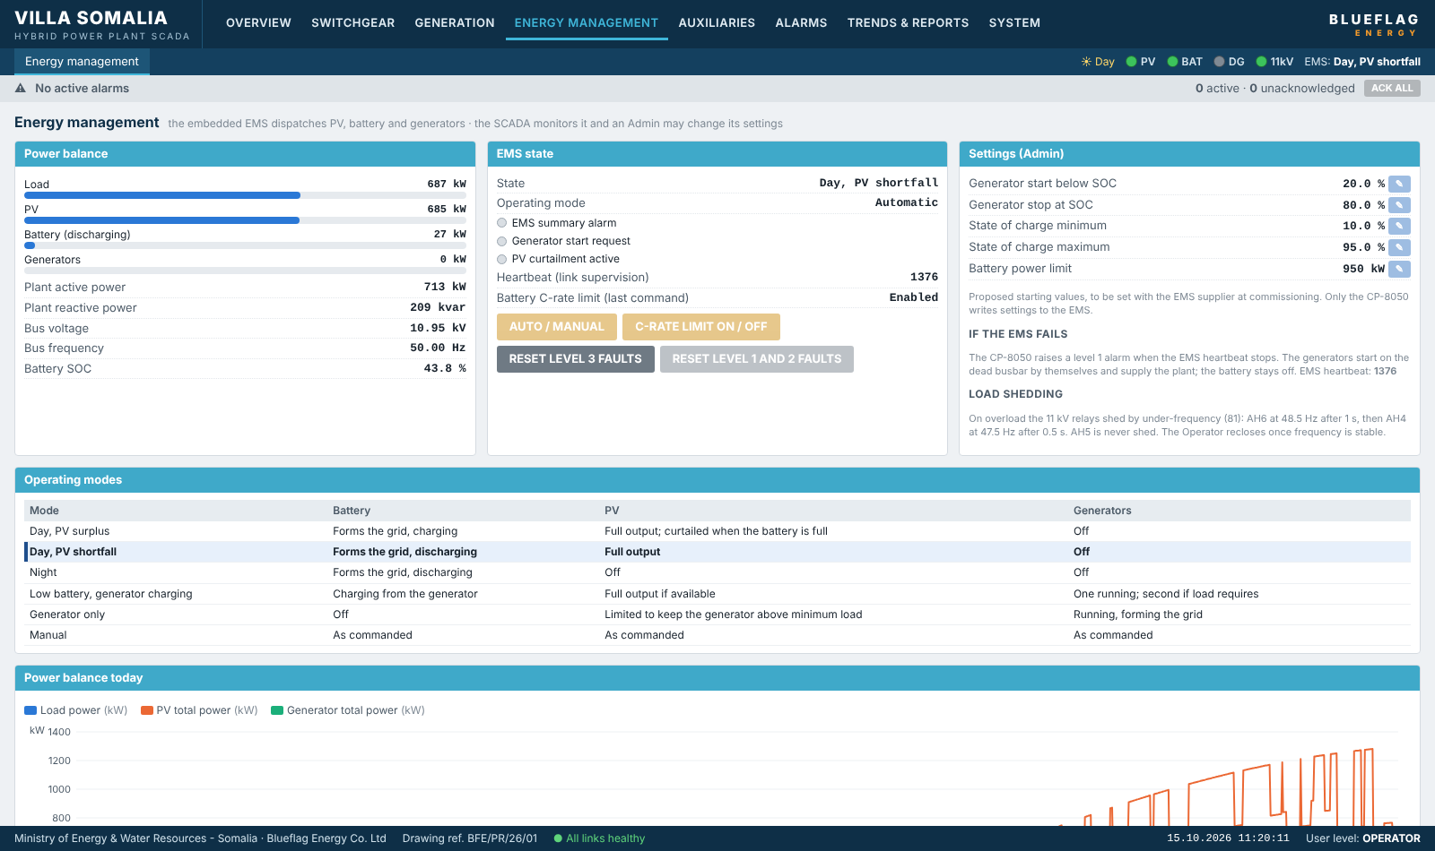
Energy management · mock-up, EMS state, power balance, operating modes and Admin settings

Screen conventions
- Colours. Breaker closed and open, alarm levels and stale values each use one consistent colour throughout.
- Stale data. A value from a device that has stopped communicating is greyed and marked, never shown as live.
- Commands. Every command opens a confirmation dialog naming the equipment and the action.
- Role visibility. Controls a user may not operate are hidden or disabled for that user's role.

13. Equipment and datasheets
The SCADA uses Siemens for the controller, I/O and SCADA software, and industrial-grade network and power equipment. Datasheets for each item are collected in Attachment C. Product numbers marked "to confirm" will be taken from the supplier quotations.

Controller and I/O (Siemens SICAM A8000)
Item | Model | Product number | Qty
Plant controller (processor module), hot standby pair | CP-8050 | 6MF2805-0AA00 | 2
Power supply, 100 to 240 V DC/AC, 45 W | PS-8642 | 6MF2864-2AA00 | 4
Ethernet interface, 5 ports | CI-8520 | 6MF2852-0AA00 | 2
Flash card, 2 GB | SICAM flash card | 6MF1213-1GA05-0AA0 | 2
Digital input, 16 channels | DI-8112 | 6MF2811-2AA00 | 17
Secured command output | DO-8221 | To confirm | 4
Relay output, 8 channels | DO-8212 | 6MF2821-2AA00 | 1
Analogue input, 4 channels | AI-8320 | 6MF2832-0AA00 | 2
Remote I/O interface, electrical | CI-8532 | 6MF2853-2AA00 | 2
Remote I/O interface, optical | CI-8533 | To confirm | 4
Protocol licences: IEC 60870-5-104, Modbus TCP, IEC 61850, redundancy if licensed separately | For CP-8050 | To confirm | 2 sets

SCADA, network and power
Item | Manufacturer and model | Qty
SCADA servers, active and hot standby | Siemens SIMATIC IPC647E | 2
SCADA software, redundant licence | Siemens SICAM SCC | 1
Operator workstation with two monitors | Dell OptiPlex 7000 series | 1
Engineering laptop with SICAM Device Manager | Dell Latitude 5430 Rugged | 1
Core switches | Moxa EDS-G512E | 2
Field and station switches | Moxa EDS-510E | 5
Fibre transceivers | Moxa SFP-1GLXLC | 14
Serial gateways for RMU relays | Moxa MGate MB3170 | 2
Firewall with VPN | Fortinet FortiGate Rugged 60F | 1
GPS time server | Meinberg LANTIME M300 | 1
Power meters for LVDBs and auxiliary board | Schneider Electric PowerLogic PM5560 | 3
24 V DC power supplies | Siemens SITOP PSU8200 24 V/20 A | 6
UPS for the SCADA cabinet | APC Smart-UPS SRT 3000 VA | 1
SCADA cabinet | Rittal VX25, 800 x 2000 x 800 mm | 1
Outdoor I/O panels, IP55 minimum | Rittal AX | 4
Alarm sounder and beacon | Pfannenberg PATROL | 1
Armoured single-mode fibre, 12 core | To suit | 3 routes

Spares
Item | Qty | Reason
Configured flash card for the CP-8050 | 1 | Controller B is the running spare; the card restores a replaced controller quickly
DI-8112, DO-8221, CI-8533 | 1 each | One of each module type on site
Field switch and fibre transceivers | 1 and 2 | Network repair
The controllers are supplied as a hot standby pair. I/O row 1 has its own CI-8532 interface rather than sitting on the controller backplane, so both controllers reach it. Siemens will confirm the redundancy function and licence, the switchover time, and how the I/O rows connect to both controllers.

Datasheets in Attachment C
- Siemens SICAM A8000: CP-8050, PS-8642, CI-8520, CI-8532, CI-8533, DI-8112, DO-8221, DO-8212, AI-8320
- Siemens SIMATIC IPC647E and SICAM SCC
- Moxa EDS-G512E, EDS-510E, SFP-1GLXLC, MGate MB3170
- Fortinet FortiGate Rugged 60F; Meinberg LANTIME M300
- Schneider Electric PM5560; Siemens SITOP PSU8200; APC Smart-UPS SRT
- Field devices from their suppliers: PLC box, EMS, generator controllers, 11 kV relays, ST260E, fire panel, UPS

14. Open points and attachments
The design is complete in structure; the items below will finalise quantities and part numbers. None of them changes the architecture.

Open points
No. | Item | From | Affects
1 | EMS make, model, protocol and point table; which settings can be written remotely, including the C-rate limit | PV designer | Sections 5, 6, 10, 11; communication points
2 | PLC box model and point table | PV designer | Sections 5, 6; communication points
3 | Generator controller make and model; whether fuel level is read by the controller | Generator supplier | Row 6 signals and analogue inputs
4 | 11 kV relay model and protocol | Switchgear supplier | Protocol licences; possible gateway
5 | Switchgear, RMU, transformer and fire panel terminal schedules | Equipment suppliers | Final I/O list
6 | Auxiliary control voltage | Electrical designer | I/O module variants
7 | Whether RMU switches and LVDB incomers are motorised | RMU and LVDB suppliers | Command outputs at rows 3 and 4
8 | Cable routes and distances to the office stations, BESS yard and generator area | Civil designer | Fibre or copper for remote rows; fibre lengths
9 | Space for the SCADA cabinet in the 11 kV room, and the location of the control room | Civil designer and client | Equipment location
10 | Product numbers for DO-8221, CI-8533 and the protocol licences; fibre limits for CI-8533 | Siemens | Section 13
11 | Proposed additional generator signals (breaker tripped, shutdown alarm, controller healthy, charger fault, fuel leak) | Client approval | Row 6
12 | Hot standby controller pair: redundancy function and licence, switchover time, connection of the I/O rows to both controllers, product numbers | Siemens | Sections 4, 7, 8, 13
13 | Remote reporting link, if wanted | Client decision | Section 9
14 | Voltage transformers on the 11 kV panels or busbar. None are shown on the drawings, yet the relay voltages and the 27/59 and 81 protection need them | Switchgear supplier and electrical designer | Sections 5, 7; relay communication points
15 | Whether the EMS exposes the battery combiner panel status | PV and BESS supplier | Battery communication points
16 | EMS functional description: generator start contact and Modbus commands, PV curtailment path and response time, black-start steps marked automatic or by operator, behaviour on loss of the CP-8050 link | PV and BESS supplier | Section 11; EMS communication points
17 | Generator controller start input for the EMS contact; dead-bus automatic start and island operation without the EMS | Generator supplier | Section 11; generator settings
18 | Under-frequency load-shedding settings and shedding order (AH6 first, AH4 last) | Client and protection engineer | Section 11; relay settings

Attachments
Attachment | Content | Status
A | SCADA architecture drawing, SCADA overview following the single-line diagram, PV and BESS interface drawing, and communication network drawing | To be drawn in the project title block from sections 4, 6 and 8
B | Device and I/O list (Villa_Somalia_SCADA_Device_and_IO_List_Rev1.xlsx) | Rev 1, complete
C | Datasheets | To be collected from suppliers
D | Panel layouts and wiring diagrams | After terminal schedules are received
E | HMI screen mock-ups: 12 screens from the HMI demonstration, including a battery fire (Villa_Somalia_SCADA_Attachment_E_HMI_Screens.pdf) | Rev 1, complete; final screens built in SICAM SCC

